Feedback Form

Annual Acquisition Report

Public Information Session – April 8, 2022

Feedback Provided by:
Name: Click or tap here to enter text.
Title: Click or tap here to enter text.
Organization: Click or tap here to enter text.
Email: Click or tap here to enter text.
Date: Click or tap here to enter text.

Following the April 8^{h} public information session on the Annual Acquisition Report (AAR), the Independent Electricity System Operator (IESO) is seeking feedback from participants on a variety of questions and details included in the report and session on April 8 to help further inform the path forward on meeting the needs identified in the AAR.
The referenced presentation can be found on the AAR webpage.
Please provide feedback by April, 27 2022 to engagement@ieso.ca. Also, please feel free to send any questions or request for clarification on the AAR in advance of the April 20 engagement session. This will ensure the IESO is prepared to help inform stakeholder feedback before the April 27 deadline.

Same Technology Expansions
Topic | Feedback
What procurement/negotiation timelines (i.e., contract execution) and forward period would be required to support a 2025 in-service date?

Is there any other external support (e.g., from the IESO) that would be needed to help proponents meet expedited development timelines?

What considerations should be given for community engagement and/or indigenous participation?

Forward Capacity Auction
Topic | Feedback
Expanded participation and eligibility for resources
Demand curve parameters
Interactions with the annual capacity auction including target capacities
Input into the design of longer commitment periods
Other business/engagement/participation considerations associated with longer forward periods

Expedited Procurement
Topic | Feedback
What incentives are sufficient to encourage expedited project development to meet the 2025 needs (e.g., term length, pricing adders, reduced RFP requirements)?
What procurement timelines (i.e., contract execution) and forward period would be required to support a 2025 in-service date?
Is there any other external support (e.g., from the IESO) that would be needed to help proponents meet expedited development timelines?
What considerations should be given for community engagement and/or Indigenous participation?

General Comments/Feedback
This section can include insight on the proposed additional mechanisms including:
- Whether these are the right mechanisms to support in-service dates of 2025/26?
- Are the proposed timelines for the expedited process achievable?
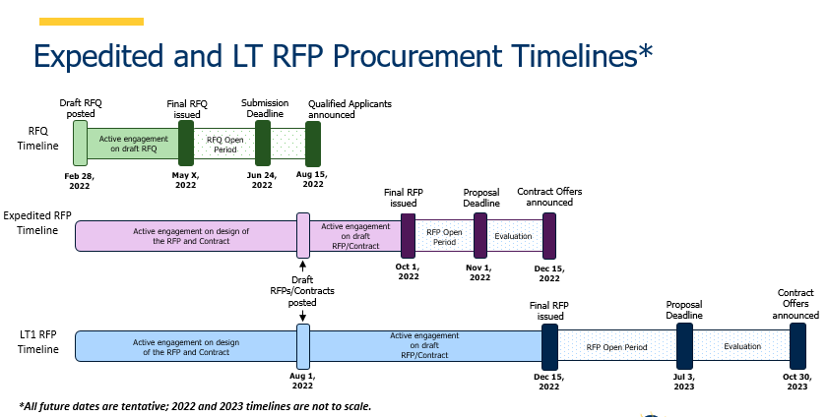
General Feedback (expand this text box as required):

