
PUBLIC
LIST

IESO Charge Types and Equations

Issue 7.1
MMM DD, 2026

This document is provided for stakeholder engagement purposes. Proposed changes, to be effective for the 2026 capacity auction, are indicated based on the current version of the document. Please note that additional changes to this document may be incorporated as part of future engagement on design enhancements to the capacity auction or other IESO activities prior to it taking effect.
This document enumerates the various charge types and equations used in the IESO settlements process for IESO-administered markets.
LST-84

IMP_LST_0001

Document Change History
Issue | Reason for Issue | Date
Refer to Issue 86.0 (IMP_LST_0001) for changes prior to Market Transition.
1.0 | Market Transition | November 11, 2024
2.0 | Issued in advance of MRP Go Live – May 1, 2025 | April 25, 2025
3.0 | Updated in advance of Baseline 53.1 | May 30, 2025
4.0 | Updated for Baseline 54.0 | September 10, 2025
5.0 | Issued in advance of Baseline 54.1 | November 17, 2025
6.0 | Updated for Baseline 54.1 | December 3, 2025
7.0 | Updated for Custom Baseline; Adjustments to Real-Time Make-Whole Payments and OEB Uniform Transmission Rate Order | April 1, 2026
7.1 | Issued in advance of Baseline XX.X | MMM DD, 2026

Related Documents
Document ID | Document Title
MAN-116 | Market Manual 5: Settlements, Part 5.5: IESO-Administered Markets Settlement Amounts
MAN-117 | Market Manual 5: Settlements, Part 5.6: Non-Market Settlement Programs

Table of Contents

Table of Contents i
List of Tables ii
List of Figures iii
Table of Changes iv
Market Manual Conventions v
1. Introduction 1
1.1. Purpose 1
1.2. Scope 1
1.3. Tax Treatment 2
1.4. Contact Information 2
2. Active IESO Charge Types and Equations 4
2.1. Variable Descriptions 4
2.2. Charge Types and Equations 8
2.3. Rounding Conventions – by Charge Type 154
2.4. Settlement of Physical Bilateral Contracts 219
3. Inactive IESO Charge Types and Equations 227
3.1. Variable Descriptions 227
3.2. Charge Types and Equations 240
3.3. Rounding Conventions – by Settlement Variable 331
3.4. Rounding Conventions – by Charge Type 339
3.5. Settlement of Physical Bilateral Contracts 371
3.6. Exemptions from the Day-Ahead Import Failure Charge, Day-Ahead Export Failure Charge, and Day-Ahead Linked Wheel Failure Charge 379
References 389

List of Tables
Table 2-1: Variable Descriptions for Active Charge Types and Equations 4
Table 2-2: Description of Column References for Charge Types and Equations 8
Table 2-3: Financial Market Charge Types and Equations 10
Table 2-4: Physical Market Charge Types and Equations 10
Table 2-5: Description of Column References for Rounding Conventions – by Individual Charge Type 155
Table 2-6: Rounding Conventions – by Individual Charge Type 157
Table 2-7: Day-Ahead Market: Market Price of Energy Applied to Location of Physical Bilateral Contract 219
Table 2-8: Real-Time Market: Market Price of Energy Applied to Location of Physical Bilateral Contract 220
Table 2-9: Derived Quantities Example 1 222
Table 2-10: Derived Quantities Example 2 222
Table 2-11: Derived Quantities Example 3 223
Table 2-12: Derived Quantities Example 4 223
Table 2-13: Allocation of Hourly Uplift Components 224
Table 3-1: Variable Descriptions for Inactive Charge Types and Equations 227
Table 3-2: Inactive Charge Types and Equations in the Physical Market 240
Table 3-3: Rounding Conventions by Settlement Variable 331
Table 3-4: Rounding Conventions by Charge Type 339
Table 3-5: Energy Pricing – Location of Bilateral Contract 371
Table 3-6: Bilateral Contract Quantities 372
Table 3-7: Derived Quantities Example 1 373
Table 3-8: Derived Quantities Example 2 373
Table 3-9: Derived Quantities Example 3 374
Table 3-10: Derived Quantities Example 4 374
Table 3-11: Time Resolution of Bilateral Contract Quantities and Rounding 375
Table 3-12: Allocation of Hourly Uplift Components Between Buying and Selling Market Participants 376

List of Figures
Figure 3-1: Example of an Import Transaction that PASSES the “Offer Price Test” 385
Figure 3-2: Example of an Import Transaction that FAILS the “Offer Price Test” 386
Figure 3-3: Example of an Export Transaction that PASSES the “Offer Price Test” 387
Figure 3-4: Example of an Export Transaction that PASSES the “Offer Price Test” 388

Table of Changes
Reference (Section and Paragraph) | Description of Change
Charge Type 1323 | Updated to reflect amendments made under MR-00493-R00: 2026 Capacity Auction Enhancements

Market Manual Conventions
The standard conventions for market manuals are as follows:
- The word ‘shall’ denotes a mandatory requirement;
- References to market rule sections and sub-sections may be abbreviated in accordance with the following representative format: ‘MR Ch.1 ss.1.1-1.2’ (i.e. market rules, Ch.1, sections 1.1 to 1.2);
- References to market manual sections and sub-sections may be abbreviated in accordance with the following representative format: ‘MM 1.5 ss.1.1-1.2’ (i.e. market manual 1.5, sections 1.1 to 1.2);
- Internal references to sections and sub-sections within this manual take the representative format: ‘sections 1.1 – 1.2’;
- Terms and acronyms used in this market manual in its appended documents that are italicized have the meanings ascribed thereto in MR Ch.11;
- All user interface labels and options that appear on the IESO gateway and tools are formatted with the bold font style; and
- Data fields are identified in all capitals.
Unless otherwise noted, usage of variable subscripts and superscripts within this document shall mirror the same usage within MR Ch.9. One notable exception is the usage of notation to sum across settlement amounts for charge type “c”. This is noted within the applicable equations.
– End of Section –

Introduction

Purpose
The purpose of this document is to provide the reader with the formulas and variable definitions behind each different charge type implemented in the IESO settlements process, including tax treatment. Furthermore, this document relates each charge type to the high-level description of the settlement amount within the IESO market rules and, where applicable, notes any aspects of the implementation of the charge type itself.
This document must be read in conjunction with the applicable market rules. Where there is a conflict between this document and the market rules, the market rules shall prevail.

Scope
This document provides the formulas and the Harmonized Sales Tax (HST) tax treatment for each charge type implemented in the IESO settlements system. This document does not, however, provide the format of the information provided to market participants on settlement statements with respect to each charge type. For more information on these topics, refer to the Format Specifications for Settlement Statement Files and Data Files document located on the Technical Interfaces webpage under ‘Commercial Reconciliation’.
This document is structured as follows:
Section 2: Active IESO Charge Types and Equations
Section 2.1: This section contains a description of the variables that are specific to charge types associated with applicable law within section 2.2. Variables not defined in this section are as defined in MR Ch.9 Appendix 9.2 or within the relevant market rule that is specific to the charge type.
Section 2.2: This section contains all active IESO charge types and equations that are either:
- part of the IESO-administered market, or
- associated with non-market settlement programs as mandated by applicable law, administered by the IESO.
Section 2.3: This section contains a description of rounding conventions for charge type calculations within section 2.2.
Section 2.4: This section contains a description of physical bilateral contract quantities, their usage by the settlements system, and their use by market participants as a vehicle for transferring components of hourly uplifts.
Section 3: Inactive IESO Charge Types and Equations
Similar to subsections within section 2, however the provisions of section 3 are applicable to those IESO charge types and equations that are no longer active and have been retained in the event that a re-calculation of the charge type is required. The charge types included in this section are:
- expired (i.e. program has ended);
- replaced with another charge type;
- replaced with an updated calculation (i.e. due to new variable or exclusion/addition of charge type to be uplifted); or
- retired under the Market Renewal Program (MRP), effective on the commencement of market transition.
This section also includes section 3.6 which describes how day-ahead import, export and linked wheel transactions are subject to an “Offer Price Test” in order to determine if they are exempt from the Day-Ahead Failure Charges (charge types 1135, 1136 and 1134) which has been retired under MRP.

Tax Treatment
The IESO is a registrant for purposes of the Excise Tax Act and all or substantially all of the supplies made by the IESO are taxable for GST/HST purposes.
The IESO administers the IESO-administered markets in compliance with the current provisions of the Excise Tax Act and the published rulings, administrative policies, and assessing practices of the Canada Revenue Agency. The IESO conducts regular tax reviews with its advisors to ensure that transactions within the IESO-administered markets comply with the foregoing.
Market participants should consult their own legal and tax advisors for advice with respect to the tax consequences of transactions in the IESO-administered markets.

Contact Information
Changes to this document are managed via the IESO Change Management process. Stakeholders are encouraged to participate in the evolution of this document via this process.
As part of the authorization and registration process, market participants are required to identify a Settlements Contact. If a market participant has not identified a specific contact, the IESO will seek to contact the Primary Contact unless alternative arrangements have been established between the IESO and the market participant.
To contact the IESO, you can email IESO Customer Relations at customer.relations@ieso.ca or use telephone or mail. Telephone numbers and the mailing address can be found on the IESO website. IESO Customer Relations staff will respond as soon as possible.
If you have a specific inquiry regarding a settlement amount on any of your settlement statements, refer to MM 5.10 for further details.
– End of Section –

Active IESO Charge Types and Equations
The provisions of this section include all active charge types that are:
- part of the IESO-administered market; and
- associated with non-market settlement programs as mandated by applicable law, administered by the IESO.

Variable Descriptions
The following Table 2-1 contains descriptions of variables that are specific to charge types associated with applicable law within section 2.2.
Variables not defined in this table are as defined in MR Ch.9 Appendix 9.2 or within the relevant market rule that is specific to the charge type.
Table 2-1: Variable Descriptions for Active Charge Types and Equations
Key to the Table Below
Variable used within Section 2 | Data Description | Description | Maximum Rounding Convention in Settlement Statements or Data Files | Relevant Reference and Other Information
EEQ | Excluded Energy Quantity | The total volume of energy (MWh) supplied to Fort Frances Power Corporation Distribution Inc. by Abitibi-Consolidated Inc. during the month. | 3 | Refer to regulations.
EGEI_{k} | Embedded Generator Energy Injection | The total volume of energy (MWh) supplied by embedded generators during the month to distributors who are market participants and to all embedded distributors to whom the market participant ‘k’ is the host distributor, adjusted for losses as required by the OEB, Retail Settlement Code. | 3 | Refer to regulations.
ETS | Export Transmission Service Tariff Rate | Export Transmission Service Tariff Rate in units of $/MWh. | 2 | Subject to the OEB “Ontario Transmission Rate Order”.
GA_AQEW_{g,k,h,M}^{m,t} | Allocated Quantity of Energy Withdrawn for elements of the Global Adjustment distribution | Allocated quantity in MWh of energy withdrawn by market participant or Distributor ‘k’ at RWM ‘m’ in metering interval ‘t’ of settlement hour ‘h’ in month ‘M’ for element “g”.  Where ‘g’ is 1 for Class A Market Participant or Consumer load, and 2 for energy withdrawn by Generator ‘k’ in the course of providing Ancillary Services. |  | Refer to regulations.
GAR_{B} | Global Adjustment Rate for Class B | GA Class B Rate. |  | Refer to regulations.
GRP | Generator Regulated Price | A regulated price ($/MWh) with respect to output of OPG’s regulated generating stations, set by the OEB. | 2 | Subject to regulation by the Ontario Energy Board.
LCD_{k,h}^{m} | Line Connection Demand (KW) | Billing Demand for Line Connection Transmission Service (KW) for transmission customer ‘k’ at transmission delivery point ‘m’ during settlement hour ‘h’ in which LCD_{k,h}^{m} denotes the non-coincident peak demand for the month. | 3 | Subject to the OEB “Ontario Transmission Rate Order”.
NSD_{k,h}^{m} | Network Service Demand (KW) | The Billing Demand for Network Transmission Service (KW) is defined as the higher of:  transmission customer coincident peak demand (KW) in the hour of the month when the total hourly demand of all PTS customers is highest for the month; and  85% of the customer peak demand in any hour during the peak period 7 AM to 7 PM (local time) on business days defined by the IESO.  For the purposes of determining business days for calculating transmission charges, the IESO uses the holidays identified by the Ontario Energy Board.  The peak period hours will be between 0700 and 1900 hours Eastern Standard Time during winter (i.e. during standard time) and 0600 to 1800 hours during summer (i.e. during daylight savings time), in conformance with the meter time standard used by the IESO settlement systems. | 3 | Subject to the OEB “Ontario Transmission Rate Order”.
PDF_{k,m,d} | Peak Demand Factor | The Peak Demand Factor for Class A Market Participant or Distributor ‘k’ for month ‘m’ with effectiveness ratio ‘d’. |  | Subject to regulation by the Ontario Energy Board.
PGS_{h,M} | Allocated Quantity of Energy Withdrawn by OPG at Beck Pump Generating Station | Allocated quantity in MWh of energy withdrawn by OPG at Beck Pump Generating Station in metering interval ‘t’ of settlement hour ‘h’ for month ‘M’.
PTS-L | Provincial Transmission Service Line Connection Service Rate ($/KW) | Line Connection Transmission Tariff Service Rate in units of dollars per kilowatt. | 2 | Subject to the OEB “Ontario Transmission Rate Order”.
PTS-N | Provincial Transmission Service Network Service Rate ($/KW) | Network Transmission Tariff Service Rate in units of dollars per kilowatt. | 2 | Subject to the OEB “Ontario Transmission Rate Order”.
PTS-T | Provincial Transmission Service Transformation Connection Service Rate ($/KW) | Transformation Connection Service Transmission Tariff Rate in units of dollars per kilowatt. | 2 | Subject to the OEB “Ontario Transmission Rate Order”.
RPP_{l} | Regulated Price Plan | A fixed energy rate for all metering intervals based on consumption level l. |  | Subject to regulation by the Ontario Energy Board.
TCD_{k,h}^{m} | Transformation Connection Demand (KW) | Billing Demand for Transformation Connection Transmission Service (KW) for transmission customer ‘k’ at transmission delivery point m during settlement hour ‘h’ in which TCD_{k,h}^{m} denotes the non-coincident peak demand for the month. | 3 | Subject to the OEB “Ontario Transmission Rate Order”.
TD_{k,h,c} | Total Market Settlement Amount | Total settlement amount (dollars) for the market used in hourly uplift and calculations for various other non-hourly settlement amounts for market participant ‘k’ or transmission customer ‘k’ during settlement hour ‘h’ with respect to charge type ‘c’. | N/A | This is purely a notational term is used within the documentation to describe the aggregation of various settlement amounts.  A summation across charge type ‘c’ denotes an aggregation of all settlement amounts for that charge type for the time period concerned.  e.g.: ∑_{c}^{T} indicates a summation of all settlement amounts for charge type ‘c’ during all metering intervals ‘T’.
TLQ | Threshold Load Quantity | A threshold (kWh) with respect to monthly consumption of regulated customers, set by the OEB. |  | Subject to regulation by the Ontario Energy Board.
TP_{c} | Tariff price | A stipulated rate ($/MWh, $/KW) used in the calculation of a specific charge type ‘c’. | N/A | This is purely a notational term used within the documentation to describe the unique per MW or per MWh rate applied to specific quantities in order to calculate various settlement amounts.
U_{k} | Energy Storage Facility Injection | The total volume of energy (MWh) conveyed back into the IESO-controlled grid during the month by energy storage facilities associated with Class B market participant ‘k’ and the total volume of energy (MWh) conveyed back into the distribution system during the month by energy storage facilities that are Class B consumers of distributor ‘k’. |  | Refer to regulations.

Charge Types and Equations
The following tables contain all active IESO charge types and equations that are:
- part of the IESO-administered market; and
- associated with non-market settlement programs as mandated by applicable law, administered by the IESO.
Refer to section 3.2 for inactive IESO charge types and equations.
The following Table 2-2 provides a description of each of the column references for charge types and equations.
Table 2-2: Description of Column References for Charge Types and Equations
Key to the Table Below
Charge Type Number | The designation number for each charge type enumerated below – which corresponds to the charge type numbers used on settlement statements and invoices.
Charge Type Name | The name of the charge type, including, where applicable, the abbreviated name used to describe the settlement amount within the IESO market rules and market manuals.
Market Rules Reference | The relevant reference to the variable in question within the IESO market rules.
Equation | The equation used by the IESO settlements process to calculate the settlement amount for the charge type.
Settlement Resolution | The level of granularity by which the IESO settlements process calculates the settlement amount for the charge type, and provides the supporting data in the settlement data file.  Where:  - Interval calculations are performed on the basis of each relevant, 5-minute metering interval, which when a charge type is defined at the hourly level can be determined by dividing by 12;  - Hourly calculations are performed on the basis of each settlement hour;  - Daily calculations are performed on the basis of each calendar day;  - Monthly calculations are performed on the basis of a calendar month (equivalent to an energy market billing period);  - Quarterly calculations are performed on the basis of 3 month intervals;  - Yearly calculations are performed on the basis of a calendar year.
Cashflow | This column indicates whether or not the settlement amount for the charge type is:  “Due IESO” – which means, owed to the IESO by the market participant; *** or  “Due MP” – which means, owed to the market participant by the IESO; *** or  “Either Way” – which indicates that the settlement amount in question could be either owed to the IESO by the market participant or owed to the market participant by the IESO in any given time period (according to the applicable “Settlement Resolution”).  ***NOTE in cases where a Cashflow is designated as “Due IESO” or “Due MP” this should be read in the context of its intended use in the normal course of settlements. However, such cashflows can always be REVERSED in situations where an adjustment is applied to a market participant, or the application of a per-unit charge in order to offset an adjustment to another market participant.
HST Tax Treatment within Ontario | This column indicates the percentage levy as per the Harmonized Sales Tax (HST).  Zone used for Tax Basis is (ONZN) for Ontario.
HST Tax Treatment for U.S., Manitoba and Quebec Generation | This column indicates the percentage levy as per the Harmonized Sales Tax (HST).  Zones used for Tax Basis are (NYSI) for US Generation, (MBSI) for Manitoba Generation and (PQSI) for Quebec Generation.
HST Tax Treatment for US Load | This column indicates the percentage levy as per the Harmonized Sales Tax (HST).  Zone used for Tax Basis is (NYSI) for US Load.
HST Tax Treatment for Manitoba and Quebec Load | This column indicates the percentage levy as per the Harmonized Sales Tax (HST).  Zones used for Tax Basis are (MBSI) for Manitoba Load and (PQSI) for Quebec Load.
Comments | This column notes any charge types that are governed by various documentation other than the IESO market rules such as applicable law. References to other market manuals may be included here, where applicable.

Financial Market Charge Types and Equations
The following Table 2-3 describes the charge types and equations in the financial market.
Charge Type Number |  | Charge Type Name |  | Market Rules Reference |  | Equation |  | Settlement Resolution |  | Cashflow |  | HST Tax Treatment within Ontario  (%) |  | HST Tax Treatment for U.S., Manitoba, and Quebec Generation  (%) |  | HST Tax Treatment for U.S. Load  (%) |  | HST Tax Treatment for Manitoba and Quebec Load  (%) |  | Comments
52 | Transmission Rights Auction Settlement Debit |  | MR Ch.8 s.3.17 |  | 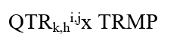  Where ‘TRMP’ is the price of each transmission right in a single round of a TR auction and expressed in up to 2 decimal places. |  | Daily |  | Due IESO |  | Exempt |  | Exempt |  | Exempt |  | Exempt
Table 2-3: Financial Market Charge Types and Equations

Physical Market Charge Types and Equations
The following Table 2-4 describes the charge types and equations in the physical market.
Table 2-4: Physical Market Charge Types and Equations
Charge Type Number | Charge Type Name | Market Rules Reference | Equation | Settlement Resolution | Cashflow | HST Tax Treatment within Ontario  (%) | HST Tax Treatment for U.S., Manitoba, and Quebec Generation  (%) | HST Tax Treatment for U.S. Load  (%) | HST Tax Treatment for Manitoba and Quebec Load  (%) | Comments
102 | TR Clearing Account Credit  (TRCAC) | MR Ch.9 s.4.9 | For loads:  For exporters:  Where:  - TRCAD_{L} =( ∑ _{K}TD_{C} / ∑_{K}TD_{C,C1} ) x TRCAD  - TRCAD_{E} = (∑ _{K}TD_{C1} / ∑_{K}TD_{C,C1} ) x TRCAD  - TRCAD = the total dollar value (in $ and up to 2 decimal places) of all disbursements from the TR clearing account authorized by the IESO Board in the current energy market billing period;  - C = the set of all monthly service charge types ‘c’ as follows: 650,651,652;  - C1 = the set of all monthly export transmission charge types ‘c’ as follows: 653;  - H = the set of all settlement hours ‘h’ in the energy market billing periods immediately preceding the current energy market billing period, as determined by IESO Board;  - T = the set of all metering intervals ‘t’ in the energy market billing periods immediately preceding the current energy market billing period, as determined by the IESO Board;  - M = the set of all registered wholesale meters ‘m’ excluding intertie metering points during energy market billing periods immediately preceding the current energy market billing period, as determined by the IESO Board;  - I = the set of all intertie metering points ‘i’ during energy market billing periods immediately preceding the current energy market billing period, as determined by the IESO Board; and  - K = the set of all market participants ‘k’ during energy market billing periods immediately preceding the current energy market billing period, as determined by the IESO Board. | Monthly (when applicable) | Due MP | 13 | N/A | 0 | 13 | The billing period is defined in  MM5.5: IESO-Administered Markets Settlement Amounts, section 2.22.1
104  MRP updated | Transmission Rights Settlement Credit  (TRSC) | MR Ch.9 s.3.8.1 | **The following is effective on the commencement of market transition. Refer to section 3 for the version in effect prior to the commencement of market transition.**  - If the injection TR zone of the transmission right is in the IESO control area:  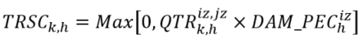  - If the withdrawal TR zone of the transmission right is in the IESO control area:  Where:  - ${DAM_PEC}_{h}^{iz}$ = the day-ahead market external congestion price for energy in injection TR zone ‘iz’ in settlement hour ‘h’; and  - ${DAM_PEC}_{h}^{jz}$= the day-ahead market external congestion price for energy in withdrawal TR zone ‘jz’ in settlement hour ‘h’. | Hourly | Due MP | 0 | 0 | 0 | 0
114 | Outage Cancellation/  Deferral Settlement Credit | MR Ch.9 s.4.14.12  and  MR Ch.5 s.6.7.4 | Manual Entry as per MR Ch.5 s.6.7.4. | Monthly | Due MP | 13 | N/A | N/A | N/A
115 | Unrecoverable Testing Costs Credit | MR Ch.9 s.4.14.12  and  MR Ch.4 s.5.3.4 | Manual Entry as per MR Ch.4 s.5.3.4. | Monthly | Due MP | 13 | 13 | 13 | 13
116 | Tieline Maintenance Reliability Credit | MR Ch.9 s.4.14.12  And  MR Ch.5 s.5.3.4 | Manual Entry as per MR Ch.5 s.5.3.4. | Monthly | Due MP | 13 | 13 | 13 | 13
118 | Emergency Energy Rebate | MR Ch.9 s.4.14.13  and  MR Ch.5 s.4.4A.1 | Where ‘H’ is the set of all settlement hours ‘h’ in the month.  Where ‘T’ is the set of all metering intervals ‘t’ in the set of all settlement hours ‘H’. | Monthly | Due MP | 13 | N/A | 0 | 13
119  MRP updated | Station Service Reimbursement Credit | MR Ch.9 ss.2.2.12-2.2.17 | **The set of charge types ‘c’ has been updated**  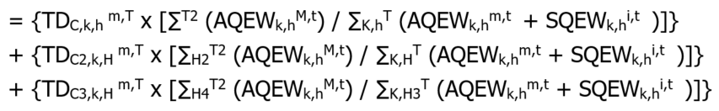  Where:  - T = the set of all metering intervals in settlement hour ‘h’;  - M = the eligible generation station service delivery point ‘m’ of market participant ‘k’;  - C = the set of the following hourly uplift charge type ‘c’ as follows: 186,250,252,254,451,1120,1865,1950,1970,1977,1980,1981;  - T2 = the set of all metering intervals in settlement hour ‘h’ where the eligible generation facility or electricity storage facility was a net injector of energy into the IESO-controlled grid;  - K = the set of all market participants;  - C2 = the set of the following non-hourly monthly charge type ‘c’ as follows: 102,164,165,166,167,168,450,452,454,460,550,1116,1118,1188,1650,1941,9920;  - C3 = the set of the following daily charge type ‘c’ as follows: 1119,1850,1851,1960,1967,1971,1982,1986;  - H = the set of all settlement hours ‘h’ in the billing period;  - H2 = the set of all settlement hours ‘h’ in the billing period where the eligible generation facility or electricity storage facility was a net injector of energy into the IESO-controlled grid;  - H3 = the set of all settlement hours ‘h’ in the day; and  - H4 = the set of all settlement hours ‘h’ in the day where the eligible generation facility or electricity storage facility was a net injector of energy into the IESO-controlled grid. | Monthly | Due MP | 13 | N/A | N/A | N/A
121 | Northern Energy Advantage Program Settlement Amount | N/A | 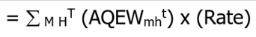  Where:  Rate is the program rate  ‘M’ is the set of all delivery points ‘m’ for all market participant-eligible facilities.  ‘H’ is the set of all settlement hours ‘h’ in the settlement period.  ‘T’ is the set of all metering intervals ‘t’ in the set of all settlement hours ‘H’. | Quarterly | Due MP | 0 | N/A | N/A | N/A | Eligibility, rates, and other implementation details subject to Ministry of Northern Development, Mines, Natural Resources and Forestry specifications.
123 | MACD Enforcement Activity Amount | N/A | Manual entry based on the values submitted by MACD. | Monthly | Due MP | 13 | N/A | N/A | N/A
142 | Regulated Price Plan Settlement Amount | N/A | NOTE: The equation identified below applies to low volume and designated consumers (as defined in Ontario Energy Board Act, 1998 and associated regulations) in the IESO-administered market.  For distributors, charge type 142 is applied once a month based on the values submitted by the distributor via On-line settlement forms:  - “Tiered Regulated Price Plan for Conventional Meters vs. Market Price – Variance”  - “Standard TOU Regulated Price Plan for Smart Meters vs. Market Price Variance”  - “ULO Regulated Price Plan for Smart Meters vs. Market Price Variance”  - “Regulated Price Plan – Final Variance Settlement Amount”  Regulated Price Plan Settlement Amount: | Monthly | Due LDCs Either way | 13 | N/A | N/A | N/A | Eligibility, rates, and other implementation details subject to government and OEB regulations.
143 | NUG Contract Adjustment Settlement Amount | N/A | Manual entry based on the values submitted by OEFC via On-line settlement form “NUG Adjustment Amount Information”, subject to Regulation. | Monthly | Due OEFC | 13 | N/A | N/A | N/A | Eligibility, rates, and other implementation details subject to government regulation.
144 | Regulated Nuclear Generation Adjustment Amount | N/A | 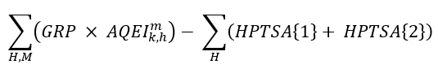  Where ‘T’ is the set of 12 metering intervals ‘t’ during settlement hour ‘h’. | Interval  or  Hourly | Due OPG | 13 | N/A | N/A | N/A | Eligibility, rates, and other implementation details subject to government regulation.
145 | Regulated Hydroelectric Generation Adjustment Amount | N/A | For dispatchable resources:  Incentive Payment = DAM Incentive + RT Incentive  For non-dispatchable resources:  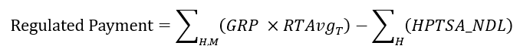  Or  Where:  ${DAMAvg}_{T}$is the average DAM hourly scheduled MW over a trade day  ${RTAvg}_{T}$ is the average hourly metered quantity over a trade day  “H” is all hours in the trade day | Monthly | Due OPG | 13 | N/A | N/A | N/A | Eligibility, rates, and other implementation details subject to OEB regulation.
147 | Class A – Global Adjustment Settlement Amount | N/A | 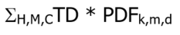  Where  ‘d’ is the ratio of the number of days in the month the Peak Demand Factor was effective compared to the total number of days in the month  and  ‘C’ is the set of the following charge types ‘c’:  193, 194, 195, 1450, 1460, 1462, 1464, 1466, 1468, 1469, 1475, 1478. | Monthly | Either Way | 13 | N/A | N/A | N/A | Eligibility, rates, and other implementation details subject to government regulation.  Charge type 147 is also used to settle Interruptible Rate Pilot participants starting with trade date July 1, 2023.
148 | Class B – Global Adjustment Settlement Amount | N/A | For Fort Frances Power Corporation Distribution Inc.:  (Σ_{H,M,C}TD – TD₁₄₇) x  MAX(( Σ _{H}^{M,T} AQEW_{k,h}^{m,t} + EGEI_{k} -EEQ),0) / Class B Load  For other Class B Market Participants and Distributors:  (Σ_{H,M,C}TD – TD₁₄₇) x  MAX((Σ _{H}^{M,T} AQEW_{k,h}^{m,t} + EGEI_{k} - GA_AQEW_{g,k,h,M}^{m,t} – PGS_{h,M} ),0) / Class B Load  Class B Load =  (Σ_{K} (MAX(Σ_{H}^{M,T} AQEW_{k,h}^{m,t} + EGEI_{k} - EEQ - Σ_{H}^{M,T} GA_AQEW_{g,k,h,M}^{m,t} - Σ_{Η} PGS_{h,M} ,0))) - Σ_{K} U_{k}  Where ‘H’ is the set of all settlement hours ‘h’ in the month.  Where ‘K’ is the set of all market participants ‘k’.  Where ‘M’ is the set of all delivery points ‘m’ of market participant ‘k’.  Where ‘C’ is the set of the following charge types ‘c’:  193, 194, 195, 1380, 1381, 1382, 1383, 1384, 1385, 1386, 1390, 1391, 1392, 1393, 1394, 1395, 1396, 1397, 1398, 1450, 1460, 1462, 1464, 1466, 1468, 1469, 1475, 1478. | Monthly | Either Way | 13 | N/A | N/A | N/A | Eligibility, rates, and other implementation details subject to government regulation.
149 | Regulated Price Plan Retailer Settlement Amount | N/A | Manual entry based on the values submitted by market participants via On-line settlement form “Retailer Payments for Contract Price vs. HOEP for Regulated Consumers with a Retail Contract”. | Monthly | Due LDCs | 13 | N/A | N/A | N/A | Implementation details subject to government regulation.
164 | Outage Cancellation/  Deferral Debit | MR Ch.5 s.6.7.4  and  MR Ch.9 s.4.14.12 | Where ‘H’ is the set of all settlement hours ‘h’ in the month.  Where ‘T’ is the set of all metering intervals ‘t’ in the set of all settlement hours H. | Monthly | Due IESO | 13 | N/A | 0 | 13
165 | Unrecoverable Testing Costs Debit | MR Ch.9 s.4.14.12  and  MR Ch.4 s.5.3.4 | Where ‘H’ is the set of all settlement hours ‘h’ in the month.  Where ‘T’ is the set of all metering intervals ‘t’ in the set of all settlement hours ‘H’. | Monthly | Due IESO | 13 | N/A | 0 | 13
166 | Tieline Maintenance Reliability Debit | MR Ch.9 s.4.14.12  and  MR Ch.5 s.5.3.4 | Where ‘H’ is the set of all settlement hours ‘h’ in the month.  Where ‘T’ is the set of all metering intervals ‘t’ in the set of all settlement hours ‘H’. | Monthly | Due IESO | 13 | N/A | 0 | 13
167 | Emergency Energy Debit | MR Ch.9 s.4.14.12  and  MR Ch.5 s.2.3.3A | Where ‘H’ is the set of all settlement hours ‘h’ in the month.  Where ‘c’ is any payments made for emergency energy during the applicable period.  Where ‘T’ is the set of all metering intervals ‘t’ in the set of all settlement hours ‘H’. | Monthly | Due IESO | 13 | N/A | 0 | 13
168 | TR Market Shortfall Debit | MR Ch.9 s.6.16.6.3 | For loads:  For exporters:  Where:  - TRCAD_{L} =( ∑ _{K}TD_{C} / ∑_{K}TD_{C,C1} ) x TRCAR  - TRCAD_{E} = (∑ _{K}TD_{C1} / ∑_{K}TD_{C,C1} ) x TRCAR  - TRCAC = the TR clearing account credit (in $ and up to 2 decimal places) collected from market participant ‘k’ in the current energy market billing period;  - TRCAR = the total dollar value (in $ and up to 2 decimal places) of TR shortfall recovery from the TR clearing account authorized by the IESO Board in the current energy market billing period;  - C = the set of all monthly service charge types ‘c’ as follows: 650,651,652; and  - C1 = the set of all monthly export transmission charge types ‘c’ as follows: 653. | Monthly | Due IESO | 13 | N/A | 0 | 13
169 | Station Service Reimbursement Debit | MR Ch.9 ss.2.2.12-2.2.17  and  4.14.12 | Where ‘c’ is charge type 119.  Where ‘H’ is the set of all settlement hours ‘h’ in the month.  Where ‘T’ is the set of all metering intervals ‘t’ in the set of all settlement hours ‘H’. | Monthly | Due IESO | 13 | N/A | 0 | 13
171 | Northern Energy Advantage Program Balancing Amount | N/A | 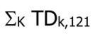  Where ‘k’ is part of a subset of eligible market participants ‘k’. | Quarterly | Due IESO | 0 | N/A | N/A | N/A | Eligibility, rates, and other implementation details subject to Ministry of Northern Development, Mines, Natural Resources and Forestry specifications.
173 | MACD Enforcement Activity Balancing Amount | N/A | 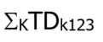  Where ‘K’ is the set of all market participants ‘k’.  Where TD_{k123} is the settlement amount of charge type 123 for the month for market participant ‘k’. | Monthly | Due IESO | 0 | N/A | N/A | N/A
186  MRP updated + name change | Intertie Failure Charge Uplift  (INFCU) | MR Ch.9 s.3.11 | **The set of charge types ‘c’ has been updated**  Where:  - C = the set of all charge types ‘c’ as follows: 1828,1829,1928,1929. | Hourly | Due MP | 13 | N/A | 0 | 13
192 | Regulated Price Plan Balancing Amount | N/A | 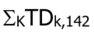  Where ‘K’ is the set of all market participants ‘k’.  Where TD_{k,142} is the total settlement amount of charge type 142 for the month for market participant ‘k’. | Monthly | Due IESO | 0 | N/A | N/A | N/A | Implementation details subject to government regulation.
193 | NUG Contract Adjustment Balancing Amount | N/A | TD₁₄₃ | Monthly | Due IESO | 0 | N/A | N/A | N/A | Implementation details subject to government regulation.
194 | Regulated Nuclear Generation Balancing Amount | N/A | TD₁₄₄ | Interval  or  Hourly | Due IESO | 0 | N/A | N/A | N/A | Implementation details subject to government regulation.
195 | Regulated Hydroelectric Generation Balancing Amount | N/A | TD₁₄₅ | Monthly | Due IESO | 0 | N/A | N/A | N/A | Implementation details subject to OEB regulation.
196 | Global Adjustment Balancing Amount | N/A | 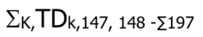  Where ‘K’ is the set of all market participants ‘k’.  Where TD_{k,147, 148} is the settlement amount of charge type 147 and 148 for the month for market participant ‘k’. | Monthly | Due IESO | 0 | N/A | N/A | N/A | Eligibility, rates, and other implementation details subject to government regulation.
197 | Global Adjustment - Special Programs Balancing Amount | N/A | 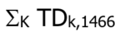  Where ‘K’ is the set of all market participants ‘k’.  Where TD_{k,1466} is the settlement amount of charge type 1466 for the month for market participant ‘k’. | Monthly | Due IESO | 0 | N/A | N/A | N/A | Implementation details subject to government regulation.
199 | Regulated Price Plan Retailer Balancing Amount | N/A | 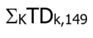  Where ‘K’ is the set of all market participants ‘k’.  Where TD_{k,149} is the settlement amount of charge type 149 for the month for market participant ‘k’. | Monthly | Due IESO | 0 | N/A | N/A | N/A | Implementation details subject to government regulation.
201 | 10 Minute Spinning Reserve Market Shortfall Rebate  (HUSA) | MR Ch.9 s.3.11 | Where:  - C = the set of all charge types ‘c’ as follows: 251. | Hourly | Due MP | 13 | N/A | 0 | 13
203 | 10 Minute Non-spinning Reserve Market Shortfall Rebate  (HUSA) | MR Ch.9 s.3.11 | Where:  - C = the set of all charge types ‘c’ as follows: 253. | Hourly | Due MP | 13 | N/A | 0 | 13
205 | 30 Minute Operating Reserve Market Shortfall Rebate  (HUSA) | MR Ch.9 s.3.11 | Where:  - C = the set of all charge types ‘c’ as follows: 255. | Hourly | Due MP | 13 | N/A | 0 | 13
206  MRP updated | 10-Minute Spinning Non-Accessibility Settlement Amount  (ORSCB) | MR Ch.9 ss.3.10.1, 3.10.6-3.10.16 | **The following is effective on the commencement of market transition. Refer to section 3 for the version in effect prior to the commencement of market transition.**  Dispatchable Loads, Dispatchable Electricity Storage Resources, and Non-Aggregated Dispatchable Generation Resources  Where:  - For a dispatchable electricity storage resource or a non-aggregated dispatchable generation resource:  - ${TAOR}_{k, h}^{m, t}=Max\left(0, {MAX_CAP}_{k, h}^{m, t}-{AQEI}_{k, h}^{m, t}\right)$  - ${MAX_CAP}_{k, h}^{m, t}$ = the maximum limit used in determining the real-time schedule in the dispatch scheduling and pricing process  - For a dispatchable load:  - ${TAOR}_{k, h}^{m, t}=Max\left(0, {AQEW}_{k, h}^{m, t}-{MC}_{k, h}^{m, t}\right)$  - ${MC}_{k, h}^{m, t}$ = the minimum consumption level, equal to the quantity in the price-quantity pair where the bid price is the maximum market clearing price  Aggregated Dispatchable Generation Resources that are not Pseudo-Units  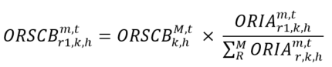  Where:  - M = the set of all delivery points ‘m’ of the aggregated group of dispatchable generation resources  - ${TAOR}_{k, h}^{m, t}=Max\left(0, {MAX_CAP}_{k, h}^{m, t}-{AQEI}_{k, h}^{m, t}\right)$  - ${MAX_CAP}_{k, h}^{m, t}$ = the maximum limit used in determining the real-time schedule in the dispatch scheduling and pricing pass  - ${ORIA}_{r, k, h}^{m, t}$ is calculated as:  - ${ORIA}_{r1, k, h}^{m, t}=Min\left(0, {TAOR}_{k, h}^{m, t}-{RT_QSOR}_{r1, k, h}^{m, t}\right)$  - ${ORIA}_{r2, k, h}^{m, t}=Min\left[0, Max\left(0, {TAOR}_{k, h}^{m, t}-{RT_QSOR}_{r1, k, h}^{m, t}\right)-{RT_QSOR}_{r2, k, h}^{m, t}\right]$  - ${ORIA}_{r3, k, h}^{m, t}=Min\left[0, Max\left(0, {TAOR}_{k, h}^{m, t}-{R{T_QSOR}_{ }}_{r1, k, h}^{m, t} -{RT_QSOR}_{r2, k, h}^{m, t}\right)-{RT_QSOR}_{r3, k, h}^{m, t}\right]$  - ${ORSCB}_{k, h}^{M, t}=Min\left[0, \sum_{R}^{M}{\left({NORD}_{r, k, h}^{m, t}×RT_{PROR}_{r, k, h}^{m, t}\right)}\right]$ and is the total amount of non-accessibility operating reserve for the aggregated group and is prorated in charge types 206, 208 and 210, as applicable.  - ${NORD}_{r, k, h}^{m, t}$ is calculated as:  - ${NORD}_{r1, k, h}^{m, t}={Min({RT_QSOR}_{r1, k, h}^{m, t},TAOR}_{ k, h}^{m, t})+{REAH}_{r1, k, h}^{m, t}-{RT_QSOR}_{r1, k, h}^{m, t}$  - ${NORD}_{r2, k, h}^{m, t}={Min[{RT_QSOR}_{r2, k, h}^{m, t},Max(0,TAOR}_{ k, h}^{m, t}-{RT_QSOR}_{r2, k, h}^{m, t})]+{REAH}_{r2, k, h}^{m, t}-{RT_QSOR}_{r2, k, h}^{m, t}$  - ${NORD}_{r3, k, h}^{m, t}={Min[{RT_QSOR}_{r3, k, h}^{m, t},Max(0,TAOR}_{ k, h}^{m, t}-{RT_QSOR}_{r1, k, h}^{m, t}-{RT_QSOR}_{r2, k, h}^{m, t})]+{REAH}_{r3, k, h}^{m, t}-{RT_QSOR}_{r3, k, h}^{m, t}$  - ${REAH}_{r, k, h}^{m, t}$ is calculated as follows for each type of class r reserve:  $${REAH}_{r, k, h}^{m, t}={TREAH}_{r, k, h}^{M, t}×\frac{{EAH}_{k, h}^{m, t}}{\sum^{M}{{EAH}_{k,h}^{m,t}}}$$  - ${EAH}_{k, h}^{m, t}=Max\left(0, {TAOR}_{k, h}^{m, t}-\sum_{R}{{R{T_QSOR}_{ }}_{r, k, h}^{m, t}}\right)$  - When $\sum_{ }^{M}{{EAH}_{k, h}^{m, t}}$ = 0, then ${TREAH}_{r, k, h}^{M, t}$ = 0, and when $\sum_{ }^{M}{{EAH}_{k, h}^{m, t}}$ > 0, then ${TREAH}_{r, k, h}^{M, t}$ is calculated as follows:  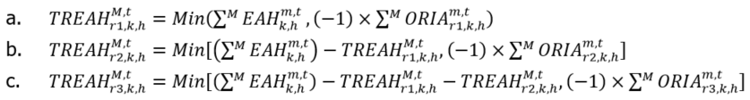  Dispatchable Generation Resources that are Pseudo-Units  - For a combustion turbine resource:  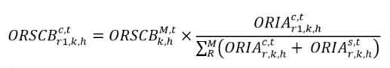  Where:  - ‘M’ = the set of all delivery points ‘c’ and ‘s’ of the aggregated group of dispatchable generation resources  - ${ORIA}_{r, k, h}^{c, t}$ is calculated as:  and where:  - For a steam turbine resource:  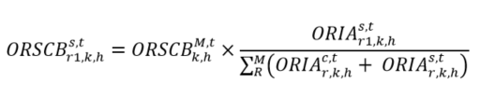  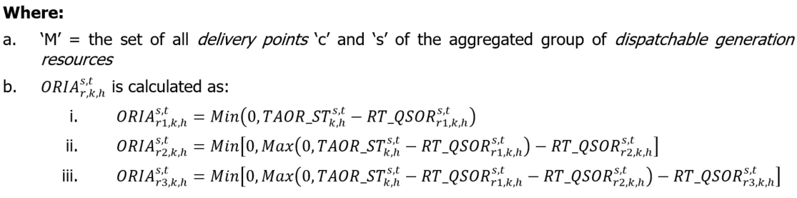  and where:  - P1 = the set of the resource’s pseudo-units ‘p’ where ${AQEI}_{k, h}^{c, t}$ >= minimum loading point and is not operating in single cycle mode;  - C1 = the set of the resource’s combustion turbine resources ‘c’ associated with the steam turbine resource and ${AQEI}_{k, h}^{c, t}$ >= minimum loading point and is not operating in single cycle mode; and  - D = the set of pseudo-unit operating regions ‘d1’, ‘d2’, and ‘d3’.  For both the combustion turbine resource and the steam turbine resource  ${ORSCB}_{k, h}^{M, t}$ is the total amount of non-accessibility operating reserve for the aggregated group and is prorated in charge types 206, 208 and 210, as applicable, to determine the operating reserve non-accessibility charge for each combustion turbine resource and steam turbine resource of the aggregated group.  Where:  - ‘M’ = the set of all delivery points ‘c’ and ‘s’ of the aggregated group of dispatchable generation resources  - ${NORD}_{r, k, h}^{c, t}$ for the combustion turbine resource is calculated as:  - ${NORD}_{r1, k, h}^{c, t}={Min({RT_QSOR}_{r1, k, h}^{c, t},TAOR_CT}_{ k, h}^{c, t})+{REAH}_{r1, k, h}^{c, t}-{RT_QSOR}_{r1, k, h}^{c, t}$  - ${NORD}_{r2, k, h}^{c, t}={Min[{RT_QSOR}_{r2, k, h}^{c, t},Max(0,TAOR_CT}_{ k, h}^{c, t}-{RT_QSOR}_{r1, k, h}^{c, t})]+{REAH}_{r2, k, h}^{c, t}-{RT_QSOR}_{r2, k, h}^{c, t}$  - ${NORD}_{r3, k, h}^{c, t}={Min[{RT_QSOR}_{r3, k, h}^{c, t},Max(0,TAOR_CT}_{ k, h}^{c, t}-{RT_QSOR}_{r1, k, h}^{c, t}-{RT_QSOR}_{r2, k, h}^{c, t})]+{REAH}_{r3, k, h}^{c, t}-{RT_QSOR}_{r3, k, h}^{c, t}$  - ${NORD}_{r, k, h}^{s, t}$ for the steam turbine resource is calculated as:  - ${NORD}_{r1, k, h}^{s, t}={Min({RT_QSOR}_{r1, k, h}^{s, t},TAOR_CT}_{ k, h}^{s, t})+{REAH}_{r1, k, h}^{s, t}-{RT_QSOR}_{r1, k, h}^{s, t}$  - ${NORD}_{r2, k, h}^{s, t}={Min[{RT_QSOR}_{r2, k, h}^{s, t},Max(0,TAOR_CT}_{ k, h}^{s, t}-{RT_QSOR}_{r1, k, h}^{s, t})]+{REAH}_{r2, k, h}^{s, t}-{RT_QSOR}_{r2, k, h}^{s, t}$  - ${NORD}_{r3, k, h}^{s, t}={Min[{RT_QSOR}_{r3, k, h}^{s, t},Max(0,TAOR_CT}_{ k, h}^{s, t}-{RT_QSOR}_{r1, k, h}^{s, t}-{RT_QSOR}_{r2, k, h}^{s, t})]+{REAH}_{r3, k, h}^{s, t}-{RT_QSOR}_{r3, k, h}^{s, t}$  - ${REAH}_{r, k, h}^{c, t}$ for the combustion turbine resource is calculated as follows for each type of class r reserve:  $${REAH}_{r, k, h}^{c, t}={TREAH}_{r, k, h}^{M, t}×\frac{{EAH}_{k, h}^{c, t}}{\sum^{M}{\left({EAH}_{k, h}^{c, t}+{EAH}_{k, h}^{s, t}\right)}}$$  - ${REAH}_{r, k, h}^{s, t}$for the steam turbine resource is calculated as follows for each type of class r reserve:  $${REAH}_{r, k, h}^{s, t}={TREAH}_{r, k, h}^{M, t}×\frac{{EAH}_{k, h}^{s, t}}{\sum^{M}{\left({EAH}_{k, h}^{c, t}+{EAH}_{k, h}^{s, t}\right)}}$$  - ${EAH}_{k, h}^{c, t}=Max\left(0, {TAOR_CT}_{k, h}^{c, t}-\sum_{R}{{R{T_QSOR}_{ }}_{r, k, h}^{c, t}}\right)$ for the combustion turbine resource  - ${EAH}_{k, h}^{s, t}=Max\left(0, {TAOR_ST}_{k, h}^{s, t}-\sum_{R}{{R{T_QSOR}_{ }}_{r, k, h}^{s, t}}\right)$ for the steam turbine resource  - When $\sum^{M}{{(EAH}_{k, h}^{c, t}}+ {EAH}_{k, h}^{s, t})$=0, then ${TREAH}_{r, k, h}^{M, t}$=0, and when $\sum^{M}{{(EAH}_{k, h}^{c, t}}+ {EAH}_{k, h}^{s, t})$>0, then  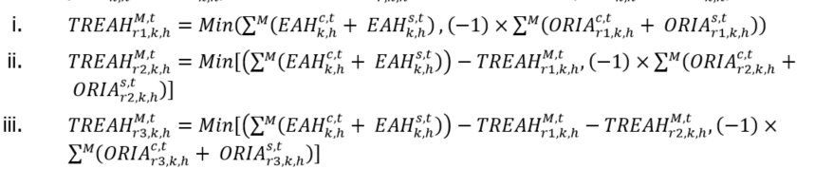 | Interval | Due IESO | 13 | N/A | N/A | N/A
208  MRP updated | 10-Minute Non-Spinning Non-Accessibility Settlement Amount  (ORSCB) | MR Ch.9 ss.3.10.1, 3.10.6-3.10.16 | **The following is effective on the commencement of market transition. Refer to section 3 for the version in effect prior to the commencement of market transition.**  Dispatchable Loads, Dispatchable Electricity Storage Resources, and Non-Aggregated Dispatchable Generation Resources  Where:  - For a dispatchable electricity storage resource or a non-aggregated dispatchable generation resource:  - ${TAOR}_{k, h}^{m, t}=Max\left(0, {MAX_CAP}_{k, h}^{m, t}-{AQEI}_{k, h}^{m, t}\right)$  - ${MAX_CAP}_{k, h}^{m, t}$ = the maximum limit used in determining the real-time schedule in the dispatch scheduling and pricing process  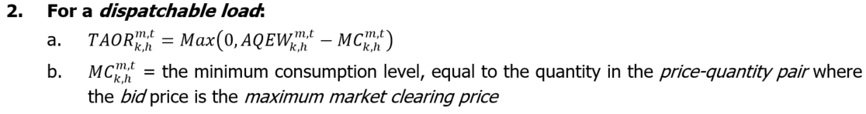  Aggregated Dispatchable Generation Resources that are not Pseudo-Units  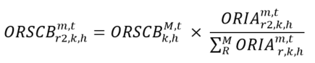  Where:  - ‘M’ = the set of all delivery points ‘m’ of the aggregated group of dispatchable generation resources  - ${TAOR}_{k, h}^{m, t}=Max\left(0, {MAX_CAP}_{k, h}^{m, t}-{AQEI}_{k, h}^{m, t}\right)$  - ${MAX_CAP}_{k, h}^{m, t}$ = the maximum limit used in determining the real-time schedule in the dispatch scheduling and pricing process  - ${ORIA}_{r, k, h}^{m, t}$ is calculated as:  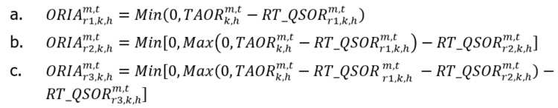  - ${ORSCB}_{k, h}^{M, t}=Min\left[0, \sum_{R}^{M}{\left({NORD}_{r, k, h}^{m, t}×RT_{PROR}_{r, k, h}^{m, t}\right)}\right]$ and is the total amount of non-accessibility operating reserve for the aggregated group and is prorated in charge types 206, 208 and 210, as applicable.  - ${NORD}_{r, k, h}^{m, t}$ is calculated as:  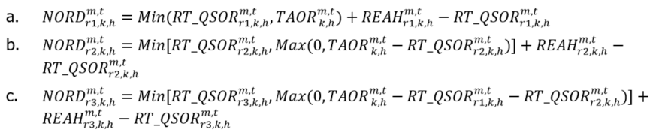  - ${REAH}_{r, k, h}^{m, t}$ is calculated as follows for each type of class r reserve:  $${REAH}_{r, k, h}^{m, t}={TREAH}_{r, k, h}^{M, t}×\frac{{EAH}_{k, h}^{m, t}}{\sum^{M}{{EAH}_{k,h}^{m,t}}}$$  - ${EAH}_{k, h}^{m, t}=Max\left(0, {TAOR}_{k, h}^{m, t}-\sum_{R}{{R{T_QSOR}_{ }}_{r, k, h}^{m, t}}\right)$  - When $\sum_{ }^{M}{{EAH}_{k, h}^{m, t}}$ = 0, then ${TREAH}_{r, k, h}^{M, t}$ = 0, and when $\sum_{ }^{M}{{EAH}_{k, h}^{m, t}}$ > 0, then ${TREAH}_{r, k, h}^{M, t}$ is calculated as follows:  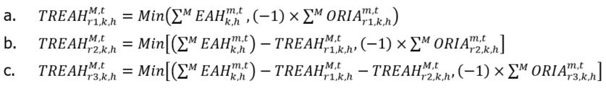  Dispatchable Generation Resources that are Pseudo-Units  - For a combustion turbine resource:  $${ORSCB}_{r2,k, h}^{c, t}={ORSCB}_{k, h}^{M, t}×\frac{{ORIA}_{r2,k,h}^{c,t}}{\sum_{R}^{M}{\left({ORIA}_{r, k, h}^{c, t}+ {ORIA}_{r, k, h}^{s, t}\right)}}$$  Where:  - ‘M’ = the set of all delivery points ‘c’ and ‘s’ of the aggregated group of dispatchable generation resources;  - ${ORIA}_{r, k, h}^{c, t}$ is calculated as:  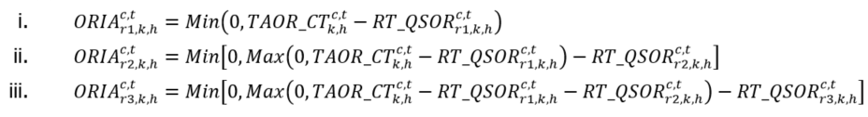  and where:  - ${TAOR_CT}_{k, h}^{c, t}=Max\left(0, {MAX_CAP}_{k, h}^{c, t}-{AQEI}_{k, h}^{c, t}\right)$ when ${AQEI}_{k, h}^{c, t}$ >= minimum loading point  - ${TAOR_CT}_{k, h}^{c, t}=$ 0 when ${AQEI}_{k, h}^{c, t}$ < minimum loading point  - For a steam turbine resource:  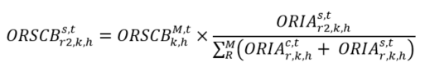  Where:  - ‘M’ = the set of all delivery points ‘c’ and ‘s’ of the aggregated group of dispatchable generation resources  - ${ORIA}_{r, k, h}^{s, t}$ is calculated as:  - ${ORIA}_{r1, k, h}^{s, t}=Min\left(0, {TAOR_ST}_{k, h}^{s, t}-{RT_QSOR}_{r1, k, h}^{s, t}\right)$  - ${ORIA}_{r2, k, h}^{s, t}=Min\left[0, Max\left(0, {TAOR_ST}_{k, h}^{s, t}-{RT_QSOR}_{r1, k, h}^{s, t}\right)-{RT_QSOR}_{r2, k, h}^{s, t}\right]$  - ${ORIA}_{r3, k, h}^{s, t}=Min\left[0, Max\left(0, {TAOR_ST}_{k, h}^{s, t}-{RT_QSOR}_{r1, k, h}^{s, t}-{RT_QSOR}_{r2, k, h}^{s, t}\right)-{RT_QSOR}_{r3, k, h}^{s, t}\right]$  and where:  - ${TAOR_ST}_{k, h}^{s, t}$ = $Max \left[0, \left(\sum_{D}^{P1}{{RT_ORRQ}_{k, d}^{p}}\right)-\left(\sum_{ }^{C1}{{MAX_CAP}_{k, h}^{c, t}}\right)-{AQEI}_{k, h}^{s, t}\right]$  - P1 = the set of the resource’s pseudo-units ‘p’ where ${AQEI}_{k, h}^{c, t}$ >= minimum loading point and is not operating in single cycle mode;  - C1 = the set of the resource’s combustion turbine resources ‘c’ associated with the steam turbine resource and ${AQEI}_{k, h}^{c, t}$ >= minimum loading point and is not operating in single cycle mode; and  - D = the set of pseudo-unit operating regions ‘d1’, ‘d2’, and ‘d3’.  For both the combustion turbine resource and the steam turbine resource  ${ORSCB}_{k, h}^{M, t}$ is the total amount of non-accessibility operating reserve for the aggregated group and is prorated in charge types 206, 208 and 210, as applicable, to determine the operating reserve non-accessibility charge for each combustion turbine resource and steam turbine resource of the aggregated group.  Where:  - ‘M’ = the set of all delivery points ‘c’ and ‘s’ of the aggregated group of dispatchable generation resources  - ${NORD}_{r, k, h}^{c, t}$ for the combustion turbine resource is calculated as:  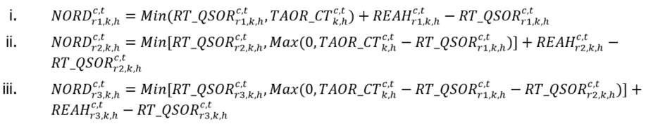  - ${NORD}_{r, k, h}^{s, t}$ for the steam turbine resource is calculated as:  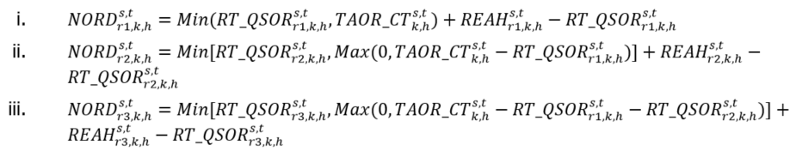  - ${REAH}_{r, k, h}^{c, t}$ for the combustion turbine resource is calculated as follows for each type of class r reserve:  $${REAH}_{r, k, h}^{c, t}={TREAH}_{r, k, h}^{M, t}×\frac{{EAH}_{k, h}^{c, t}}{\sum^{M}{\left({EAH}_{k, h}^{c, t}+{EAH}_{k, h}^{s, t}\right)}}$$  - ${REAH}_{r, k, h}^{s, t}$for the steam turbine resource is calculated as follows for each type of class r reserve:  $${REAH}_{r, k, h}^{s, t}={TREAH}_{r, k, h}^{M, t}×\frac{{EAH}_{k, h}^{s, t}}{\sum^{M}{\left({EAH}_{k, h}^{c, t}+{EAH}_{k, h}^{s, t}\right)}}$$  - ${EAH}_{k, h}^{c, t}=Max\left(0, {TAOR_CT}_{k, h}^{c, t}-\sum_{R}{{R{T_QSOR}_{ }}_{r, k, h}^{c, t}}\right)$ for the combustion turbine resource  - ${EAH}_{k, h}^{s, t}=Max\left(0, {TAOR_ST}_{k, h}^{s, t}-\sum_{R}{{R{T_QSOR}_{ }}_{r, k, h}^{s, t}}\right)$ for the steam turbine resource  - When $\sum^{M}{{(EAH}_{k, h}^{c, t}}+ {EAH}_{k, h}^{s, t})$=0, then ${TREAH}_{r, k, h}^{M, t}$=0, and when $\sum^{M}{{(EAH}_{k, h}^{c, t}}+ {EAH}_{k, h}^{s, t})$>0, then  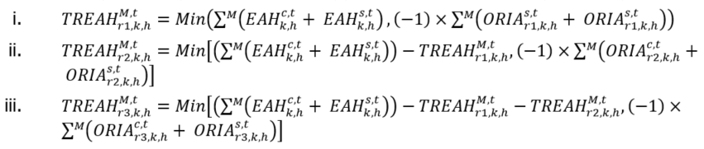 | Interval | Due IESO | 13 | N/A | N/A | N/A
210  MRP updated | 30-Minute Non-Accessibility Settlement Amount  (ORSCB) | MR Ch.9 ss.3.10.1, 3.10.6-3.10.16 | **The following is effective on the commencement of market transition. Refer to section 3 for the version in effect prior to the commencement of market transition.**  Dispatchable Loads, Dispatchable Electricity Storage, and Non-Aggregated Dispatchable Generation Resources  Where:  - For a dispatchable electricity storage resource or a non-aggregated dispatchable generation resource:  - ${TAOR}_{k, h}^{m, t}=Max\left(0, {MAX_CAP}_{k, h}^{m, t}-{AQEI}_{k, h}^{m, t}\right)$  - ${MAX_CAP}_{k, h}^{m, t}$ = the maximum limit used in determining the real-time schedule in the dispatch scheduling and pricing process  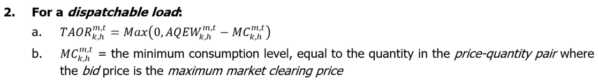  Aggregated Dispatchable Generation Resources that are not Pseudo-Units  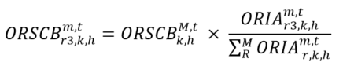  Where:  - ‘M’ = the set of all delivery points ‘m’ of the aggregated group of dispatchable generation resources  - ${TAOR}_{k, h}^{m, t}=Max\left(0, {MAX_CAP}_{k, h}^{m, t}-{AQEI}_{k, h}^{m, t}\right)$  - ${MAX_CAP}_{k, h}^{m, t}$ = the maximum limit used in determining the real-time schedule in the dispatch scheduling and pricing process  - ${ORIA}_{r, k, h}^{m, t}$ is calculated as:  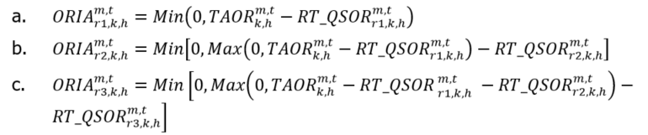  - ${ORSCB}_{k, h}^{M, t}=Min\left[0, \sum_{R}^{M}{\left({NORD}_{r, k, h}^{m, t}×RT_{PROR}_{r, k, h}^{m, t}\right)}\right]$ and is the total amount of non-accessibility operating reserve for the aggregated group and is prorated in charge types 206, 208 and 210, as applicable.  - ${NORD}_{r, k, h}^{m, t}$ is calculated as:  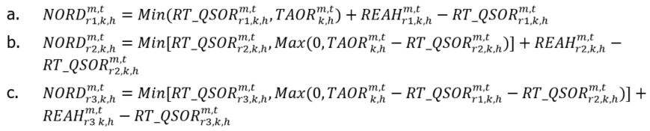  - ${REAH}_{r, k, h}^{m, t}$ is calculated as follows for each type of class r reserve:  $${REAH}_{r, k, h}^{m, t}={TREAH}_{r, k, h}^{M, t}×\frac{{EAH}_{k, h}^{m, t}}{\sum^{M}{{EAH}_{k,h}^{m,t}}}$$  - ${EAH}_{k, h}^{m, t}=Max\left(0, {TAOR}_{k, h}^{m, t}-\sum_{R}{{R{T_QSOR}_{ }}_{r, k, h}^{m, t}}\right)$  - When $\sum_{ }^{M}{{EAH}_{k, h}^{m, t}}$ = 0, then ${TREAH}_{r, k, h}^{M, t}$ = 0, and when $\sum_{ }^{M}{{EAH}_{k, h}^{m, t}}$ > 0, then ${TREAH}_{r, k, h}^{M, t}$ is calculated as follows:  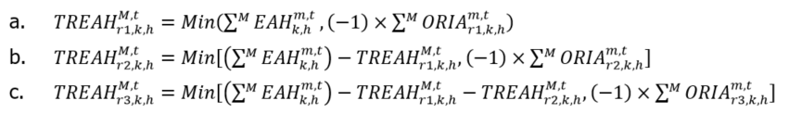  Dispatchable Generation Resources that are Pseudo-Units  - For a combustion turbine resource:  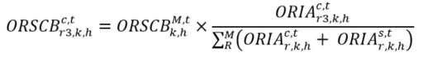  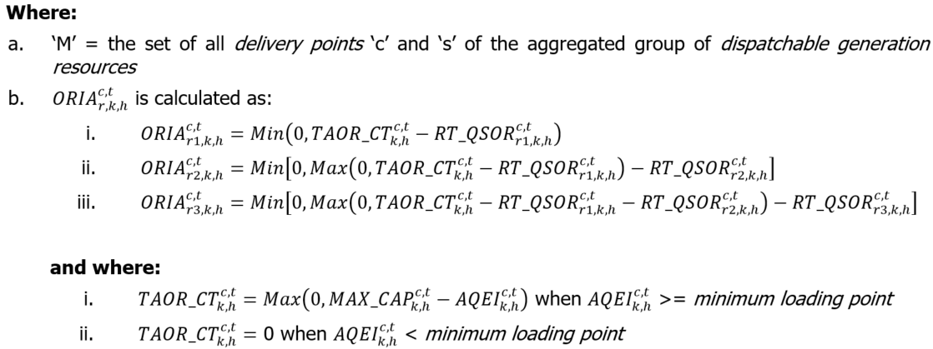  - For a steam turbine resource:  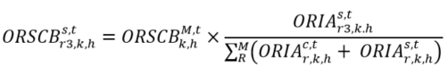  Where:  - ‘M’ = the set of all delivery points ‘c’ and ‘s’ of the aggregated group of dispatchable generation resources  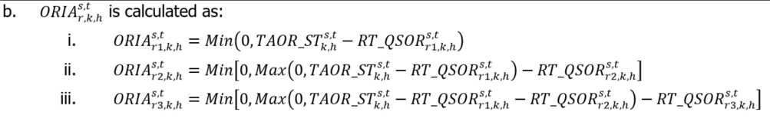  and where:  - ${TAOR_ST}_{k, h}^{s, t}$ = $Max \left[0, \left(\sum_{D}^{P1}{{RT_ORRQ}_{k, d}^{p}}\right)-\left(\sum_{ }^{C1}{{MAX_CAP}_{k, h}^{c, t}}\right)-{AQEI}_{k, h}^{s, t}\right]$  - P1 = the set of the resource’s pseudo-units ‘p’ where ${AQEI}_{k, h}^{c, t}$ >= minimum loading point and is not operating in single cycle mode;  - C1 = the set of the resource’s combustion turbine resources ‘c’ associated with the steam turbine resource and ${AQEI}_{k, h}^{c, t}$ >= minimum loading point and is not operating in single cycle mode; and  - D = the set of pseudo-unit operating regions ‘d1’, ‘d2’, and ‘d3’.  For both the combustion turbine resource and the steam turbine resource  ${ORSCB}_{k, h}^{M, t}$ is the total amount of non-accessibility operating reserve for the aggregated group and is prorated in charge types 206, 208 and 210, as applicable, to determine the operating reserve non-accessibility charge for each combustion turbine resource and steam turbine resource of the aggregated group.  Where:  - ‘M’ = the set of all delivery points ‘c’ and ‘s’ of the aggregated group of dispatchable generation resources  - ${NORD}_{r, k, h}^{c, t}$ for the combustion turbine resource is calculated as:  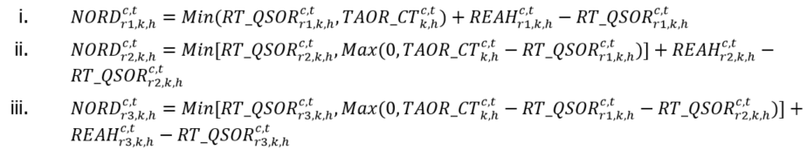  - ${NORD}_{r, k, h}^{s, t}$ for the steam turbine resource is calculated as:  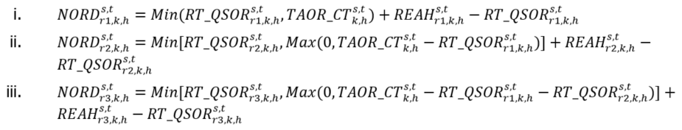  - ${REAH}_{r, k, h}^{c, t}$ for the combustion turbine resource is calculated as follows for each type of class r reserve:  $${REAH}_{r, k, h}^{c, t}={TREAH}_{r, k, h}^{M, t}×\frac{{EAH}_{k, h}^{c, t}}{\sum^{M}{\left({EAH}_{k, h}^{c, t}+{EAH}_{k, h}^{s, t}\right)}}$$  - ${REAH}_{r, k, h}^{s, t}$for the steam turbine resource is calculated as follows for each type of class r reserve:  $${REAH}_{r, k, h}^{s, t}={TREAH}_{r, k, h}^{M, t}×\frac{{EAH}_{k, h}^{s, t}}{\sum^{M}{\left({EAH}_{k, h}^{c, t}+{EAH}_{k, h}^{s, t}\right)}}$$  - ${EAH}_{k, h}^{c, t}=Max\left(0, {TAOR_CT}_{k, h}^{c, t}-\sum_{R}{{R{T_QSOR}_{ }}_{r, k, h}^{c, t}}\right)$ for the combustion turbine resource  - ${EAH}_{k, h}^{s, t}=Max\left(0, {TAOR_ST}_{k, h}^{s, t}-\sum_{R}{{R{T_QSOR}_{ }}_{r, k, h}^{s, t}}\right)$ for the steam turbine resource  - When $\sum^{M}{{(EAH}_{k, h}^{c, t}}+ {EAH}_{k, h}^{s, t})$=0, then ${TREAH}_{r, k, h}^{M, t}$=0, and when $\sum^{M}{{(EAH}_{k, h}^{c, t}}+ {EAH}_{k, h}^{s, t})$>0, then  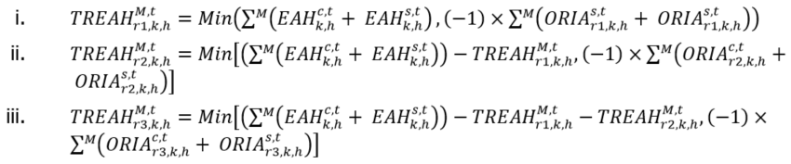 | Interval | Due IESO | 13 | N/A | N/A | N/A
212  MRP new | Day-Ahead Market 10-Minute Spinning Reserve Settlement Credit  (HORSA{1}) | MR Ch.9 s.3.1.10 |  | Hourly | Due MP | 13 | N/A | N/A | N/A
213  MRP new | Real-Time 10-Minute Spinning Reserve Settlement Credit  (HORSA{2}) | MR Ch.9 s.3.1.11 | 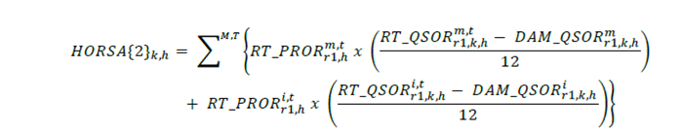 | Interval | Either Way | 13 | N/A | N/A | N/A
214  MRP new | Day-Ahead Market 10-Minute Non-Spinning Reserve Settlement Credit  (HORSA{1}) | MR Ch.9 s.3.1.10 |  | Hourly | Due MP | 13 | 13 | 13 | 13
215  MRP new | Real-Time 10-Minute Non-Spinning Reserve Settlement Credit  (HORSA{2}) | MR Ch.9 s.3.1.11 | 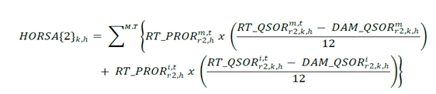 | Interval | Either Way | 13 | 13 | 13 | 13
216  MRP new | Day-Ahead Market 30-Minute Operating Reserve Settlement Credit  (HORSA{1}) | MR Ch.9 s.3.1.10 |  | Hourly | Due MP | 13 | 13 | 13 | 13
217  MRP new | Real-Time 30-Minute Operating Reserve Settlement Credit  (HORSA{2}) | MR Ch.9 s.3.1.11 | 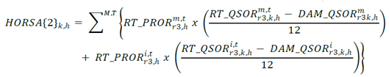 | Interval | Either Way | 13 | 13 | 13 | 13
250  MRP updated + name change | 10-Minute Spinning Reserve Hourly Uplift  (HUSA) | MR Ch.9 s.3.11 | **The set of charge types ‘c’ has been updated**  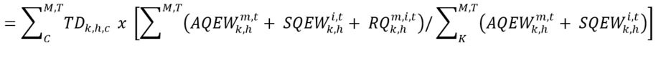  Where:  - C = the set of all charge types ‘c’ as follows: 206,212,213. | Hourly | Due IESO | 13 | N/A | 0 | 13
251 | 10 Minute Spinning Market Reserve Shortfall Debit  (ORSSD_{k,r,h}) | MR Ch.9 s.3.9.2 | Manual Entry as per MR Ch.9 s.3.9.2 where the value below which ORESF_{k,r,h}^{m,t} shall be set at zero equals ∞. | Interval | Due IESO | 13 | 13 | N/A | N/A
252  MRP updated + name change | 10-Minute Non-Spinning Reserve Hourly Uplift  (HUSA) | MR Ch.9 s.3.11 | **The set of charge types ‘c’ has been updated**  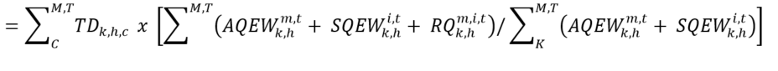  Where:  - C = the set of all charge types ‘c’ as follows: 208,214,215. | Hourly | Due IESO | 13 | N/A | 0 | 13
253 | 10 Minute Non-spinning Market Reserve Shortfall Debit  (ORSSD_{k,r,h}) | MR Ch.9 s.3.9.2 | Manual Entry as per MR Ch.9 s.3.9.2 where the value below which ORESF_{k,r,h}^{m,t} shall be set at zero equals ∞. | Interval | Due IESO | 13 | 13 | N/A | N/A
254  MRP updated + name change | 30 Minute Operating Reserve Hourly Uplift  (HUSA) | MR Ch.9 s.3.11 | **The set of charge types ‘c’ has been updated**  Where:  - C = the set of all charge types ‘c’ as follows: 210,216,217. | Hourly | Due IESO | 13 | N/A | 0 | 13
255 | 30 Minute Operating Reserve Market Shortfall Debit  (ORSSD_{k,r,h}) | MR Ch.9 s.3.9.2 | Manual Entry as per MR Ch.9 s.3.9.2 where the value below which ORESF_{k,r,h}^{m,t} shall be set at zero equals ∞. | Interval | Due IESO | 13 | 13 | N/A | N/A
400 | Black Start Capability Settlement Credit | MR Ch.9 s.4.2.2 | Manual Entry as per MR Ch.9 s.4.2.2. | Monthly | Due MP | 13 | N/A | N/A | N/A
404 | Regulation Service Settlement Credit | MR Ch.9 s.4.2.3 | Manual Entry as per MR Ch.9 s.4.2.3. | Monthly | Due MP | 13 | N/A | N/A | N/A
410 | IESO-Controlled Grid Special Operations Credit | MR Ch.5 s.8.2.6 | Manual Entry as per MR Ch.5 s.8.2.6. | Monthly | Either way | 13 | N/A | N/A | N/A
450 | Black Start Capability Settlement Debit | MR Ch.9 s.4.2.2 | Where ‘H’ is the set of all settlement hours ‘h’ in the month.  Where ‘T’ is the set of all metering intervals ‘t’ in the set of all settlement hours ‘H’. | Monthly | Due IESO | 13 | N/A | 0 | 13
451 | Hourly Reactive Support and Voltage Control Settlement Debit | MR Ch.9 s.4.2.4 | Where:  - C = the set of all charge types ‘c’ as follows: 1401,1402,1404,1405,1451. | Hourly | Due IESO | 13 | N/A | 0 | 13
452 | Monthly Reactive Support and Voltage Control Settlement Debit | MR Ch.9 s.4.2.4 | Where ‘C’ is the set of the following charge types ‘c’ as follows: 1403,1406,1407,1408,1409,1417  Where ‘H’ is the set of all settlement hours ‘h’ in the month.  Where ‘T’ is the set of all metering intervals ‘t’ in the set of all settlement hours ‘H’. | Monthly | Due IESO | 13 | N/A | 0 | 13
454 | Regulation Service Settlement Debit | MR Ch.9 s.4.2.3 | Where ‘H’ is the set of all settlement hours ‘h’ in the month.  Where ‘T’ is the set of all metering intervals ‘t’ in the set of all settlement hours ‘H’. | Monthly | Due IESO | 13 | N/A | 0 | 13
460 | IESO-Controlled Grid Special Operations Debit | MR Ch.5 s.8.2.6 | Where ‘H’ is the set of all settlement hours ‘h’ in the month.  Where ‘T’ is the set of all metering intervals ‘t’ in the set of all settlement hours ‘H’. | Monthly | Either way | 13 | N/A | 0 | 13
500 | Must Run Contract Settlement Credit | MR Ch.9 s.4.2.1 | Manual Entry as per MR Ch.9 s.4.2.1. | Monthly | Due MP | 13 | N/A | N/A | N/A
550 | Must Run Contract Settlement Debit | MR Ch.9 s.4.2.1 | Where ‘H’ is the set of all settlement hours ‘h’ in the month.  Where ‘T’ is the set of all metering intervals ‘t’ in the set of all settlement hours ‘H’. | Monthly | Due IESO | 13 | N/A | 0 | 13
600 | Network Service Credit | MR Ch.9 s.4.1 | 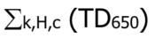  Where ‘H’ is the set of the settlement hours ‘h’ in the month during which the Network Service Demand occurs at every delivery point defined for Transmission Network Service charges. | Monthly | Due applicable transmitters | 13 | N/A | N/A | N/A | Subject to the OEB “Ontario Transmission Rate Order”.
601 | Line Connection Service Credit | MR Ch.9 s.4.1 | 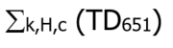  Where ‘H’ is the set of all settlement hours ‘h’ in the month during which the Line Connection Service Demand occurs at every delivery point defined for Transmission Line Connection Service charges. | Monthly | Due applicable transmitters | 13 | N/A | N/A | N/A | Subject to the OEB “Ontario Transmission Rate Order”.
602 | Transformation Connection Service Credit | MR Ch.9 s.4.1 | 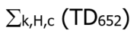  Where ‘H’ is the set of all settlement hours ‘h’ in the month during which the Transformation Connection Demand occurs at every delivery point defined for Transmission Transformation Connection Service charges. | Monthly | Due applicable transmitters | 13 | N/A | N/A | N/A | Subject to the OEB “Ontario Transmission Rate Order”.
603 | Export Transmission Service Credit | MR Ch.9 s.4.1 | 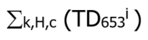  Where ‘H’ is the set of all settlement hours ‘h’ in the month.  Where ‘i’ is an intertie metering point ‘i’ where an export transaction occurred during the month.  Each charge type 603 line detail record line item is therefore totaled on the basis of TD₆₅₃ per intertie metering point ‘i’ per month. | Monthly | Due applicable transmitter | 13 | N/A | N/A | N/A | Subject to the OEB “Ontario Transmission Rate Order”.
650 | Network Service Charge | MR Ch.9 s.4.1 | 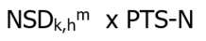  The Billing Demand for Network Transmission Service (kW) is defined as the higher of:  Transmission customer coincident peak demand (kW) in the hour of the month when the total hourly demand of all PTS customers is highest for the month; and  85% of the customer peak demand in any hour during the peak period. | Monthly | Due IESO | 13 | N/A | N/A | N/A | Subject to the OEB “Ontario Transmission Rate Order”.
651 | Line Connection Service Charge | MR Ch.9 s.4.1 | 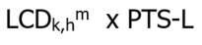  Where ‘h’ is the settlement hour of the current billing period in which LCD_{k,h}^{m} denotes the non-coincident peak demand for the month. | Monthly | Due IESO | 13 | N/A | N/A | N/A | Subject to the OEB “Ontario Transmission Rate Order”.
652 | Transformation Connection Service Charge | MR Ch.9 s.4.1 | 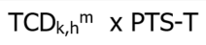  Where ‘h’ is the settlement hour of the current billing period in which TCD_{k,h}^{m} denotes the non-coincident peak demand for the month. | Monthly | Due IESO | 13 | N/A | N/A | N/A | Subject to the OEB “Ontario Transmission Rate Order”.
653 | Export Transmission Service Charge | MR Ch.9 s.4.1 | 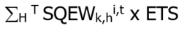  Where ‘H’ is the set of all settlement hours ‘h’ in the month.  Where ‘T’ is the set of all metering intervals ‘t’ during the set of settlement hours ‘H’. | Monthly | Due IESO | 13 | N/A | 0 | 13 | Subject to the OEB “Ontario Transmission Rate Order”.
700 | Dispute Resolution Settlement Amount | MR. Ch.9 s.6.10.4 | Manual Entry as per MR Ch.9 s.6.10.4. | Monthly | Due MP | 13 | 13 | 0 | 13 | Note: tax would follow original disputed transaction
703 | Rural and Remote Settlement Credit | N/A | Manual Entry as per Regulation. | Monthly | Due MP | 13 | N/A | N/A | N/A | Ontario Regulation 442/01  Refer to Ministry of Energy website for details.
705 | Ontario Fair Hydro Plan First Nations On-reserve Delivery Amount | N/A | Manual entry based on:  (1) the values submitted via on-line settlement form “First Nations On-Reserve Delivery Credit (FNDC)” | Monthly | Due LDCs either way | 13 | N/A | N/A | N/A | Eligibility, rates, and other implementation details subject to government and OEB regulations.
706 | Ontario Fair Hydro Plan Distribution Rate Protection Amount | N/A | Manual entry based on:  (1) the values submitted via on-line settlement form “Distribution Rate Protection (DRP)” | Monthly | Due LDCs either way | 13 | N/A | N/A | N/A | Eligibility, rates, and other implementation details subject to government and OEB regulations.
750 | Dispute Resolution Balancing Amount (IESO) | MR. Ch.9 s.6.10.4 | 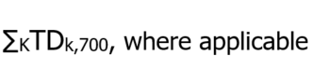 | Monthly | Due IESO | N/A | N/A | N/A | N/A
751 | Dispute Resolution Board Service Debit | MR. Ch.9 s.3.2.7 | Manual entry as per 3.2.5-3.2.7 | Monthly | Due IESO | 13 | 13 | 13 | 13
753 | Rural and Remote Settlement Debit | N/A | 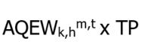 | Monthly | Due IESO | 13 | N/A | N/A | N/A | Ontario Regulation 442/01  Refer to Ministry of Energy website for details.
755 | MOE - Ontario Fair Hydro Plan First Nations On-reserve Delivery Balancing Amount | N/A | 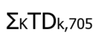  Where ‘K’ is the set of all market participants ‘k’.  Where TDk,705 is the total settlement amount of charge type 705 for the month for market participant ‘k’. | Monthly | Due Ministry of Energy | N/A | N/A | N/A | N/A | Eligibility, rates, and other implementation details subject to government and OEB regulations.
756 | MOE - Ontario Fair Hydro Plan Distribution Rate Protection Balancing Amount | N/A | 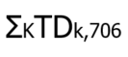  Where ‘K’ is the set of all market participants ‘k’.  Where TDk,706 is the total settlement amount of charge type 706 for the month for market participant ‘k’. | Monthly | Due Ministry of Energy | N/A | N/A | N/A | N/A | Eligibility, rates, and other implementation details subject to government and OEB regulations.
850 | Market Participant Default Settlement Debit (Recovery) | MR Ch.2 s.8.6 | Manual Entry as per MR Ch.2 s.8.6. | Monthly | Due IESO | 13 | 13 | 13 | 13
851 | Market Participant Default Interest Debit | MR Ch.2 ss.8.3 and  8.5 | Manual Entry as per MR Ch.2 ss.8.3 and 8.5. | Monthly | Due IESO | N/A | N/A | N/A | N/A
900 | GST/HST Credit | N/A | 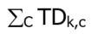  A summation of all Goods and Services Tax Credits or Harmonized Sales Tax Credits payable to market participant ‘k’ across all charge types ‘c’.  Where ‘C’ is the set of all charge types ‘c’. |  | Due MP | N/A | N/A | N/A | N/A | Only appear as “SC” record types.
950 | GST/HST Debit | N/A | 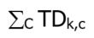  A summation of all Goods and Services Tax Debits or Harmonized Sales Tax Debits payable by market participant ‘k’ across all charge types ‘c’.  Where ‘C’ is the set of all charge types ‘c’. |  | Due IESO | N/A | N/A | N/A | N/A | Only appear as “SC” record types.
1100  MRP new | Day-Ahead Market Energy Settlement Amount for Generators  (HPTSA{1}) | MR Ch.9 ss.3.1.2 and  3.1.3 | 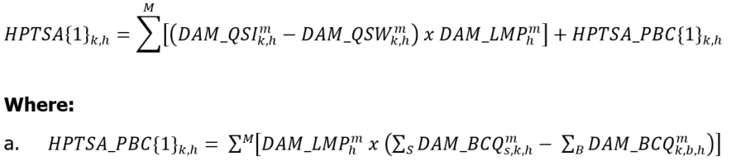 | Hourly | Due MP | 13 | N/A | N/A | N/A
1101  MRP updated + name change | Real-Time Energy Settlement Amount for Generators  (HPTSA{2}) | MR Ch.9 ss.3.1.5 and 3.1.6 | **The following is effective on the commencement of market transition. Refer to section 3 for the version in effect prior to the commencement of market transition.**  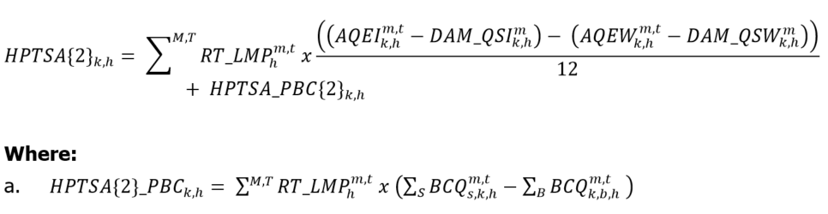 | Interval | Either Way | 13 | N/A | N/A | N/A
1102  MRP new | Day-Ahead Market Energy Settlement Amount for Dispatchable Loads  (HPTSA{1}) | MR Ch.9 ss.3.1.2 and 3.1.3 | 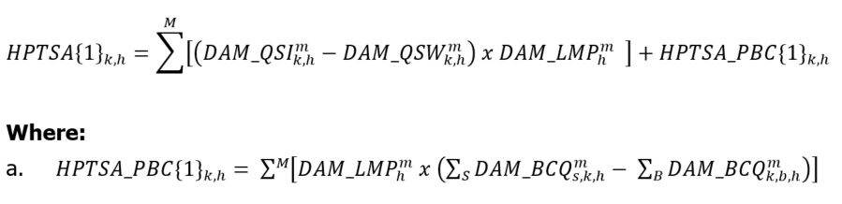 | Hourly | Due IESO | 13 | N/A | N/A | N/A
1103  MRP updated | Real-Time Energy Settlement Amount for Dispatchable Loads  (HPTSA{2}) | MR Ch.9 ss.3.1.5 and 3.1.6 | **The following is effective on the commencement of market transition. Refer to section 3 for the version in effect prior to the commencement of market transition.**  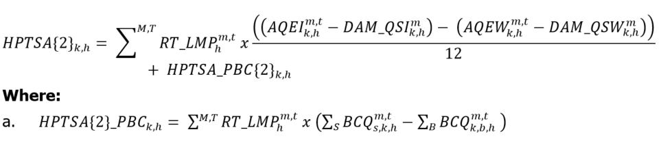 | Interval | Either Way | 13 | N/A | N/A | N/A
1104  MRP new | Day-Ahead Market Energy Settlement Amount for Price Responsive Loads  (HPTSA{1}) | MR Ch.9 ss.3.1.2 and 3.1.4 | 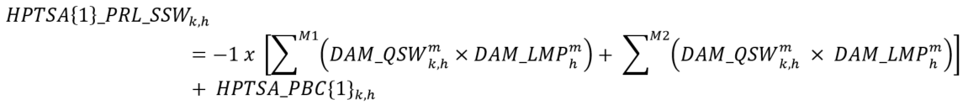  Where:  - ${HPTSA_PBC\{1\}}_{k,h}= \sum^{M1}{\left[{DAM_LMP}_{h}^{m} x \left(\sum_{S}{{DAM_BCQ}_{s,k,h}^{m}}- \sum_{B}{{DAM_BCQ}_{k,b,h}^{m}}\right)\right]}$  - M1 = the set of all delivery points ‘m’ for price responsive loads and self-scheduling electricity storage resources that are registered to withdraw; and  - M2 = the set of all delivery points ‘m’ for price responsive loads associated with load equipment used as physical hourly demand response resources to fulfill capacity obligations. | Hourly | Due IESO | 13 | N/A | N/A | N/A
1105  MRP new | Real-Time Energy Settlement Amount for Price Responsive Loads  (HPTSA{2}) | MR Ch.9 ss.3.1.5 and 3.1.7 | 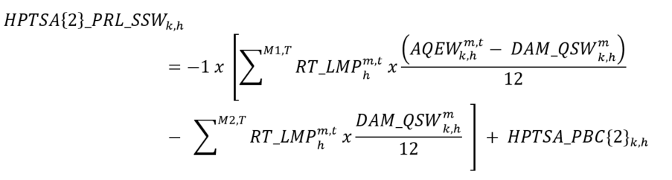  Where:  - $HPTS{A\{2\}_PBC}_{k,h}= \sum^{M,T}{{RT_LMP}_{h}^{m,t} x \left(\sum_{S}{{BCQ}_{s,k,h}^{m,t}-\sum_{B}{{BCQ}_{k,b,h}^{m,t}} }\right)}$  - M1 = the set of all delivery points ‘m’ for price responsive loads and self-scheduling electricity storage resources that are registered to withdraw; and  - M2 = the set of all delivery points ‘m’ for price responsive loads associated with load equipment used as physical hourly demand response resources to fulfill capacity obligations. | Interval | Either Way | 13 | N/A | N/A | N/A
1106  MRP new | Day-Ahead Market Energy Settlement Amount for Virtual Transactions to Sell  (HVTSA{1}) | MR Ch.9 s.3.1.8 | 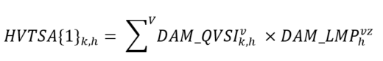 | Hourly | Due MP | N/A | N/A | N/A | N/A
1107  MRP new | Real-Time Energy Settlement Amount for Virtual Transactions to Sell  (HVTSA{2}) | MR Ch.9 s.3.1.9 | 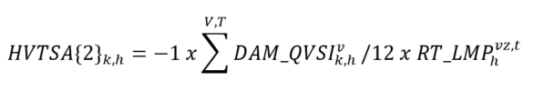 | Interval | Due IESO | N/A | N/A | N/A | N/A
1108  MRP new | Day-Ahead Market Energy Settlement Amount for Virtual Transactions to Buy  (HVTSA{1}) | MR Ch.9 s.3.1.8 | 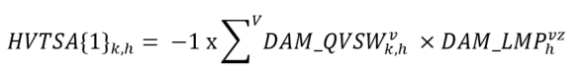 | Hourly | Due IESO | N/A | N/A | N/A | N/A
1109  MRP new | Real-Time Energy Settlement Amount for Virtual Transactions to Buy  (HVTSA{2}) | MR Ch.9 s.3.1.9 | 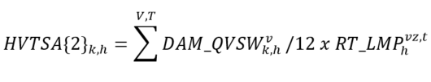 | Interval | Due MP | N/A | N/A | N/A | N/A
1110  MRP new | Day-Ahead Market Energy Settlement Amount for Imports  (HPTSA{1}) | MR Ch.9 ss.3.1.2 and 3.1.3 | 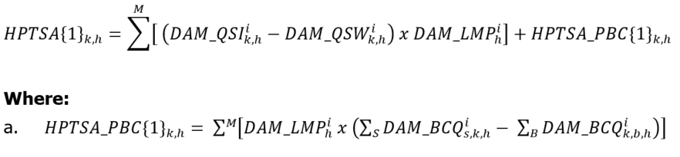 | Hourly | Due MP | N/A | 13 | N/A | N/A
1111  MRP updated | Real-Time Energy Settlement Amount for Imports  (HPTSA{2}) | MR Ch.9 ss.3.1.5 and 3.1.6 | **The following is effective on the commencement of market transition. Refer to section 3 for the version in effect prior to the commencement of market transition.**  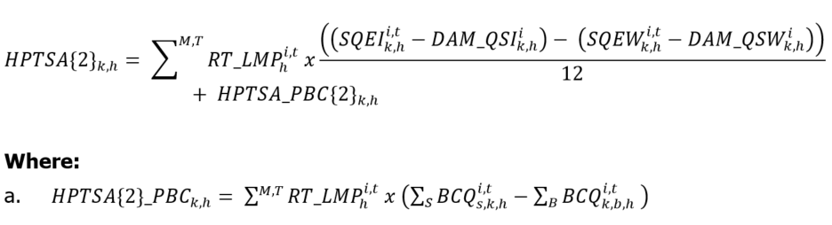 | Interval | Either Way | N/A | 13 | N/A | N/A
1112  MRP new | Day-Ahead Market Energy Settlement Amount for Exports  (HPTSA{1}) | MR Ch.9 ss.3.1.2 and 3.1.3 | 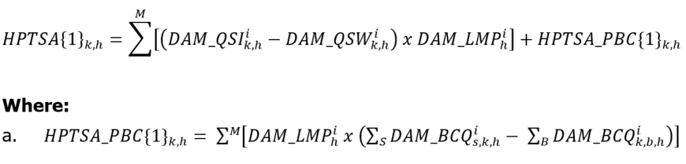 | Hourly | Due IESO | N/A | N/A | 0 | 13
1113  MRP updated | Real-Time Energy Settlement Amount for Exports  (HPTSA{2}) | MR Ch.9 ss.3.1.5 and 3.1.6 | **The following is effective on the commencement of market transition. Refer to section 3 for the version in effect prior to the commencement of market transition.**  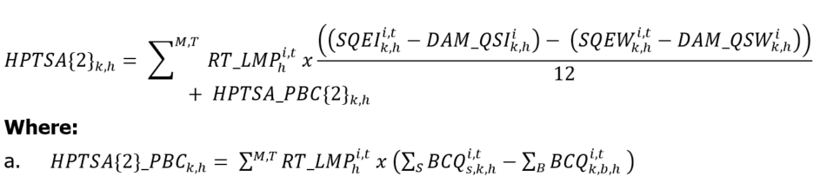 | Interval | Either Way | N/A | N/A | 0 | 13
1115  MRP updated + name change | Non-Dispatchable Load Energy Settlement Amount  (HPTSA_NDL) | MR Ch.9 ss.3.1.5 and 3.2 | **The following is effective on the commencement of market transition. Refer to section 3 for the version in effect prior to the commencement of market transition.**  ${HPTSA_NDL}_{k,h}= -1 x \left({DAM_LMP}_{h}^{z}+{LFDA}_{h}\right) x \sum^{T}{\left({AQEW}_{k,h}^{m,t}-{AQEI}_{k,h}^{m,t}\right) }$ + $HPTSA_PBC{\left\{2\right\}}_{k, h}$  Where:  - $HPTS{A\{2\}_PBC}_{k,h}= \sum^{M,T}{{DAM_LMP}_{h}^{z} x \left(\sum_{S}{{BCQ}_{s,k,h}^{m,t}-\sum_{B}{{BCQ}_{k,b,h}^{m,t}} }\right)}$  - ${LFDA}_{h}=\frac{{Real_Time Purchase Cost_Benefit}_{h}+{DAM Volume Factor Cost_Benefit}_{h}}{\sum_{K,h}^{M,T}{({AQEW-AQEI)}_{k,h}^{m,t}}}$  and where:  - M2 = the set of all hourly demand response resources ‘d’ that are not associated with load equipment registered as price responsive loads;  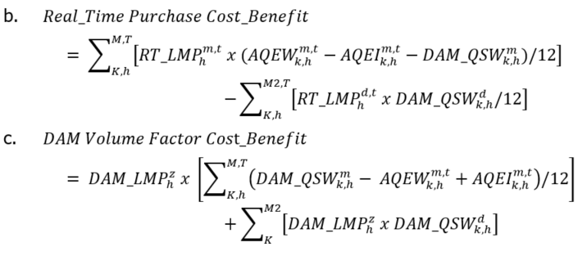 | Hourly | Due IESO | 13 | N/A | N/A | N/A
1116  MRP new | Internal Congestion and Loss Residual  (ICLR) | MR Ch.9 s.4.7 | 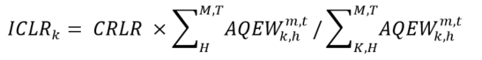  Where:  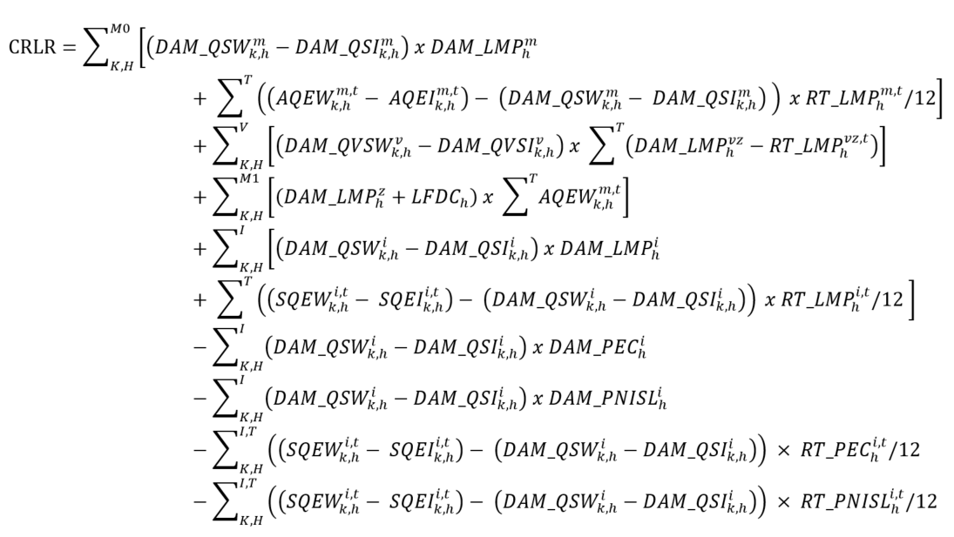  and where:  - H = the set of all settlement hours ‘h’ in the current energy market billing period’;  - M1 = the set of all delivery points ‘m’ for non-dispatchable loads; and  - M0 = the set of all delivery points ‘m’ except those for non-dispatchable loads. | Monthly | Either Way | 13 | N/A | N/A | N/A
1117  MRP new | Day-Ahead Market Net External Congestion Residual  (DAM_NECR) | MR Ch.9 s.3.8.2 | Where:  - ${TRSC}_{k,h}$ = the transmission rights settlement credit settlement amount calculated for charge type 104 in accordance with MR Ch.9 s.3.8.1. | Hourly | Accumulates in the TR Clearing Account | N/A | N/A | N/A | N/A
1118  MRP new | Real-Time External Congestion Residual Uplift  (RT_ECRU) | MR Ch.9 ss.4.8.1-  4.8.4 | For loads:  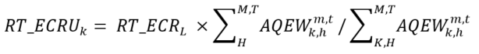  For exporters:  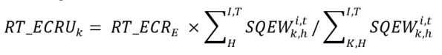  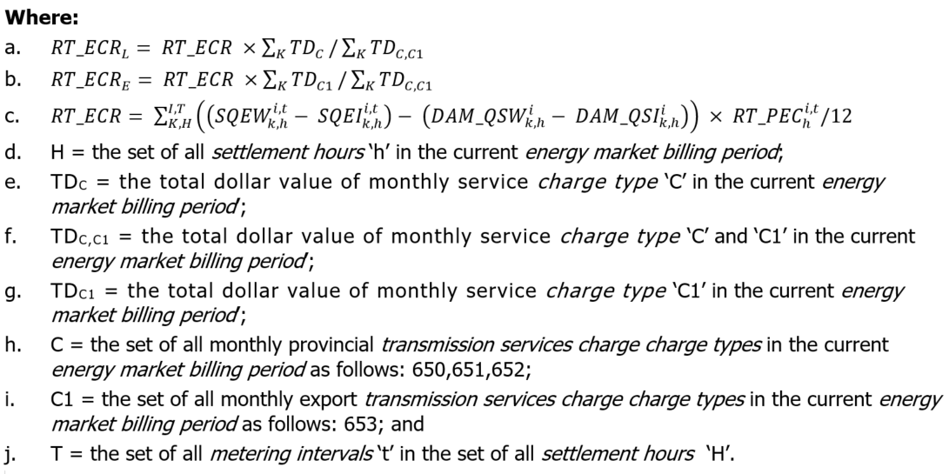 | Monthly | Either Way | 13 | N/A | 0 | 13
1119  MRP new | Day-Ahead Market Net Interchange Scheduling Limit Residual Uplift  (DAM_NISLRU) | MR Ch.9 ss.4.8.5-4.8.7 | 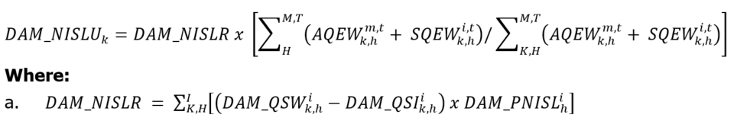 | Daily | Either Way | 13 | N/A | 0 | 13
1120  MRP new | Real-Time Net Interchange Scheduling Limit Residual Uplift  (RT_NISLRU) | MR Ch.9 ss.3.11 and 4.8.8 | 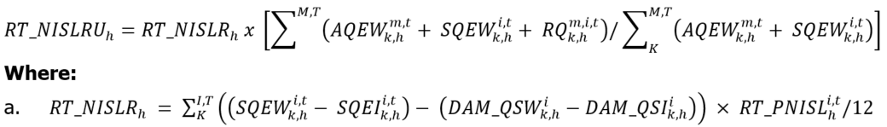 | Hourly | Either Way | 13 | N/A | 0 | 13
1138  MRP name change | Fuel Cost Compensation Credit  (FCC) | MR Ch.9 s.4.11 | Manual entry based on values submitted by market participants with GOG-eligible resources via Online settlement form “Fuel Cost Compensation”, subject to MR Ch.9 s.4.11. | Hourly | Due MP | 13 | N/A | N/A | N/A
1148 | GA Energy Storage Injection Reimbursement | N/A | U_{k} x GAR_{B} | Monthly | Due MP | 13 | N/A | N/A | N/A | Eligibility and other implementation details subject to government regulation.
1188  MRP name change | Fuel Cost Compensation Credit Uplift  (FCCU) | MR Ch.9 s.4.14.8 | Where:  - ${FCC}_{k}^{m}$ = the fuel cost compensation settlement amount calculated for charge type 1138 in accordance with MR Ch.9 s.4.11 for market participant ‘k’ at delivery point ‘m’; and  - H = the set of all settlement hours ‘h’ in the energy market billing period. | Monthly | Due IESO | 13 | N/A | 0 | 13
1314 | Capacity Obligation – Availability Payment  (CAAP) | MR Ch.9 s.4.13.1 | 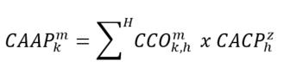  Where:  - H = the set of all settlement hours ‘h’ within the availability window of all business days in the relevant energy market billing period. | Monthly | Due MP | 13 | 13 | N/A | N/A
1315  MRP updated | Capacity Obligation – Availability Charge  (CAAC) | MR Ch.9 s.4.13.2 | **The following is effective on the commencement of market transition. Refer to section 3 for the version in effect prior to the commencement of market transition.**  In regards to a capacity market participant participating with an hourly demand response resource or a capacity dispatchable load resource:  Where:  - H = the set of all settlement hours ‘h’ within the availability window during the relevant trading day;  - If the capacity market participant did not submit a demand response energy bid for its hourly demand response resource or capacity dispatchable load resource, as the case may be, for settlement hour ‘h’ in the day-ahead market or failed to maintain such energy bid through the real- time market, ${DREBQ}_{k,h}^{m}$ = 0;  - In regards to hourly demand response resource, if the demand response energy bids submitted for settlement hour ‘h’ in either the day-ahead market or the real-time market does not form part of energy bids spanning at least four consecutive settlement hours during the relevant availability window, ${DREBQ}_{k,h}^{m}$ = 0;  - If the demand response energy bid submitted in the day-ahead market for settlement hour ‘h’ is not equal to the demand response energy bid submitted in the real-time market for the same settlement hour, ${DREBQ}_{k,h}^{m}$ shall be equal to the lesser of the two demand response energy bids; and  - Notwithstanding any of the foregoing, ${DREBQ}_{k,h}^{m}$ shall not exceed the ${CARC}_{k}^{m}$ for the hourly demand response resource or capacity dispatchable load resource, as the case may be.  In regards to a capacity market participant participating with a capacity generation resource, system-backed capacity import resource, generator-backed capacity import resource or capacity storage resource:  Where:  - H = the set of all settlement hours ‘h’ within the availability window during the relevant trading day;  - If the capacity market participant did not submit an energy offer in the day-ahead market or failed to maintain such energy offer in accordance with the applicable market manual for settlement hour ‘h’, ${CAEO}_{k,h}^{m}$ = 0;  - If the energy offer submitted in the day-ahead market for settlement hour ‘h’ is not equal to the energy offer submitted in the pre-dispatch process for the same settlement hour, ${CAEO}_{k,h}^{m}$ shall be equal to the lesser of the two energy offers; and  - If a capacity storage resource receives a non-zero energy dispatch instruction within the relevant availability window, the${CAEO}_{k,h}^{m}$ for the remaining settlement hours of the availability window after receiving such non-zero energy dispatch instruction shall be equal to the energy offer applicable to the settlement hour in which they receive such non-zero energy dispatch instruction. | Daily | Due IESO | 13 | 13 | N/A | N/A
1316 | Capacity Obligation – Administration Charge  (CAADM) | MR Ch.9 s.4.13.4 | 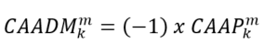  Where:  - ${CAAP}_{k}^{m}$ = the capacity obligation availability payment settlement amount, calculated in accordance with MR Ch.9 s.4.13.1, for capacity market participant ‘k’ at delivery point or intertie metering point ‘m’ for the relevant energy market billing period. | Monthly | Due IESO | 13 | 13 | N/A | N/A
1317 | Capacity Obligation – Dispatch Charge  (CADC) | MR Ch.9 s.4.13.3 | 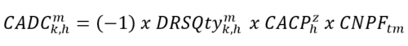  Where:  - h = a settlement hour in which the hourly demand response resource failed to comply with its activation notice, as determined in accordance with the applicable market manual. | Hourly | Due IESO | 13 | 13 | N/A | N/A
1318 | Capacity Obligation – Capacity Charge  (CACC) | MR Ch.9 s.4.13.5 | 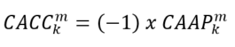  Where:  - ${CAAP}_{k}^{m}$ = the capacity obligation availability payment settlement amount, calculated in accordance with MR Ch.9 s.4.13.1, for capacity market participant ‘k’ at delivery point or intertie metering point ‘m’ for the relevant energy market billing period. | Monthly | Due IESO | 13 | 13 | N/A | N/A
1319 | Capacity Obligation – Buy-Out Charge | MR Ch.9 s.4.13.9 | 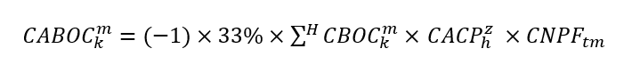  Where:  - H = the set of all settlement hours ‘h’ within the availability window of all trading days from the buy-out effective date to the end of the commitment period. | Monthly | Due IESO | 13 | 13 | N/A | N/A
1320  MRP updated | Capacity Obligation – Dispatch Test Payment and Emergency Activation Payment | MR Ch.9 s.4.13.11 | **The following is effective on the commencement of market transition. Refer to section 3 for the version in effect prior to the commencement of market transition.**  For capacity obligation dispatch test activations  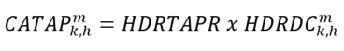  For capacity obligation emergency operating state activations  - For hourly demand response resource that is not associated with load equipment registered as a price responsive load  $${CAEOP}_{k,h}^{m}=Max(0, {HDRBP}_{k,h}^{m}-Max\left(0, {DAM_LMP}_{h}^{z}+ {LFDA}_{h}\right)) x {HDRDC}_{k,h }^{m}$$  Where:  - ${LFDA}_{h}$ = the load forecast deviation adjustment for settlement hour ‘h’ determined in accordance with MR Ch.9 s.3.2.3.  - For hourly demand response resource that is associated with load equipment registered as a price responsive load | Hourly | Due MP | 13 | 13 | N/A | N/A
1321 | Capacity Obligation – Capacity Import Call Failure Charge  (CACIF) | MR Ch.9 s.4.13.6 | 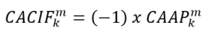  Where:  - ${CAAP}_{k}^{m}$ = the capacity obligation availability payment settlement amount, calculated in accordance with MR Ch.9 s.4.13.1, for capacity market participant ‘k’ at delivery point or intertie metering point ‘m’ for the relevant energy market billing period. | Monthly | Due IESO | N/A | 13 | N/A | N/A
1322 | Capacity Obligation – Capacity Deficiency Charge  (CACD) | MR Ch.9 s.4.13.7 | 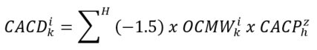  Where:  - H = the set of all settlement hours ‘h’ within the availability window of all trading days within the relevant energy market billing period. | Monthly | Due IESO | N/A | 13 | N/A | N/A
1323 | Capacity Obligation – In-Period Cleared UCAP Adjustment Charge  (CAIPA) | MR Ch.9 s.4.13.8 | 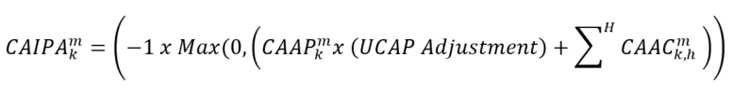  Where:  - ${CAAP}_{k}^{m}$ = the capacity obligation availability payment settlement amount for capacity market participant ‘k’ at delivery point ‘m’ for the relevant energy market billing period, calculated pursuant to MR Ch.9 s.4.13.1;  - ${CAAC}_{k,h}^{m}$ = the capacity obligation availability charge settlement amount for capacity market participant ‘‘k’ at delivery point ‘m’ for settlement hour ‘h’, as calculated pursuant to MR Ch.9 s.14.13.2;  - H = the set of all settlement hours ‘h’ within the availability window of the relevant energy market billing period; and  - UCAP Adjustment = a de-rate (in %) based on the hourly demand response resource’s delivered performance during a capacity auction capacity test, as determined in accordance with the applicable market manual. If the capacity market participant has filed a notice of disagreement in regards to the outcomes of the capacity auction capacity test in accordance with MR Ch.9 s.6.8, and but for filing such notice of disagreement the capacity market participant would have forfeited any of its capacity obligation pursuant to MR Ch.7 s.19.4.18, then the UCAP Adjustment shall be the value the IESO initially determined in accordance with the applicable market manual. Following the resolution of the notice of disagreement, the IESO shall make adjustments on the applicable recalculated settlement statement to:  I. Apply the de-rate % determined to be correct following the resolution of the notice of disagreement to all energy market billing periods to which the settlement amount applied; and  II. Notwithstanding (I), if the de-rate % determined to be correct following the resolution of the notice of disagreement is such that the capacity market participant would have forfeited all of its capacity obligation pursuant to MR Ch.7 s.19.4.18 but for filing such notice of disagreement, the de-rate % applicable to the energy market billing periods referred to in clause (iii) of s.4.13.8 shall equal 100%. | Monthly | Due IESO | 13 | N/A | N/A | N/A
1324 | Capacity Obligation – Availability Charge True-up Payment  (CAACT) | MR Ch.9 s.4.13.12 | 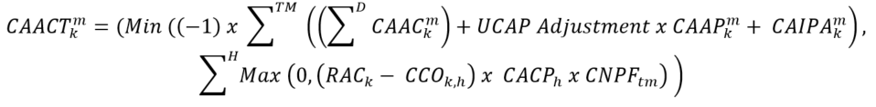  Where:  - ${CAAC}_{k}^{m}$ = the capacity obligation availability charge settlement amount for capacity market participant ‘k’ at delivery point or intertie metering point ‘m’ for the relevant trading day, as calculated as the sum of the capacity obligation availability charge settlement amount of each settlement hour within the relevant availability window determined pursuant to MR Ch.9 s.14.13.2.1;  - UCAP Adjustment = a de-rate (in %) determined in accordance with MR Ch.9 s.4.13.8;  - ${CAAP}_{k}^{m}$ = the capacity obligation availability payment settlement amount for capacity market participant ‘k’ at delivery point ‘m’ for the relevant energy market billing period, as calculated pursuant to MR Ch.9 s.4.13.1;  - ${CAIPA}_{k}^{m}$ = the capacity obligation in-period cleared UCAP adjustment charge settlement amount for capacity market participant ‘k’ at delivery point ‘m’ for the relevant energy market billing period, as calculated pursuant to MR Ch.9 s.4.13.8;  - D = the set of all trading days within the relevant energy market billing period’;  - TM = the set of all energy market billing periods within the relevant obligation period; and  - H = the set of all settlement hours ‘h’ within the availability window of the relevant obligation period. |  | Due MP | 13 | 13 | N/A | N/A
1325 | Capacity Obligation – Capacity Auction Charges True-up Payment  (CACT) | MR Ch.9 s.4.13.13 | 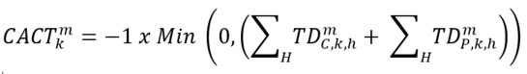  Where:  - ${TD}_{C,k,h}^{m}$ = the total dollar value of all settlement amounts ‘C’ for capacity market participant ‘k’ at delivery point ‘m’ in settlement hour ‘h’ in the relevant obligation period, where:  - ‘C’ is the set of the settlement amounts applied in accordance with MR Ch.9 ss. 4.13.2, 4.13.2.1, 4.13.4, 4.13.5, 4.13.6, 4.13.7 and 4.13.8.  - ${TD}_{P,k,h}^{m}$ = the total dollar value of all settlement amounts ‘P’ for capacity market participant ‘k’ at delivery point ‘m’ in settlement hour ‘h’ in the relevant obligation period, where:  - ‘P’ is the set of the settlement amounts applied in accordance with MR Ch.9 ss. 4.13.1 and 4.13.12.  - H = the set of all settlement hours ‘h’ within the availability window of the relevant obligation period. |  | Due MP | 13 | 13 | N/A | N/A
1350 | Capacity Based Recovery Amount for Class A Loads  (CAU) | MR Ch.9 s.4.13.14 | 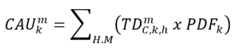  Where:  - H = the set of all settlement hours ‘h’ in the relevant energy market billing period;  - M = the set of all delivery points ‘m’ of market participant ‘k’;  - ${TD}_{C,k,h}^{m}$ = the total dollar value of all settlement amounts ‘C’ for capacity market participant ‘k’ at delivery point ‘m’ in settlement hour ‘h’ in the relevant energy market billing period, where  - ‘C’ is the set of the settlement amounts applied in accordance with MR Ch.9 ss. 4.13.1, 4.13.2, 4.13.9, 4.13.11, 4.13.12, and 4.13.13; and  - ${PDF}_{k}$ = the Peak Demand Factor for ‘Class A Market Participant’ or Distributor ‘k’ for the relevant energy market billing period, as determined in accordance with applicable law, where if the ‘Class A Market Participant’ or Distributor ‘k’ ceases to be a ‘Class A Market Participant’ in respect of the relevant load facility during the relevant energy market billing period, the ${PDF}_{k}$ shall be pro-rated accordingly. | Monthly | Due IESO | 13 | N/A | N/A | N/A | Refer to comments under charge type 147
1351 | Capacity Based Recovery Amount for Class B Loads  (CAU) | MR Ch.9 s.4.13.14.2 | For Fort Frances Power Corporation Distribution Inc.:  Where:  - TD_{C,k,h}^{m} = total dollar value of all settlement amounts ‘C’ for capacity market participant ‘k’ at delivery point ‘m’ in settlement hour ‘h’ in the relevant energy market billing period, where ‘C’ is the set of the settlement amounts applied in accordance with MR Ch.9 ss. 4.13.1, 4.13.2, 4.13.9, 4.13.11, 4.13.12, and 4.13.13;  - TD_{C1350,k,h}^{m} = total dollar value of settlement amounts applied pursuant to section 4.13.14.1 for capacity market participant ‘k’ at delivery point ‘m’ in settlement hour ‘h’ in the relevant energy market billing period.  For other Class B Market Participants and Distributors:  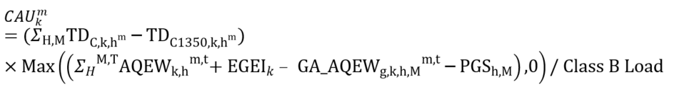  Where:  - TD_{C,k,h}^{m} = total dollar value of all settlement amounts ‘C’ for capacity market participant ‘k’ at delivery point ‘m’ in settlement hour ‘h’ in the relevant energy market billing period, where ‘C’ is the set of the settlement amounts applied in accordance with MR Ch.9 ss. 4.13.1, 4.13.2, 4.13.9, 4.13.11, 4.13.12 and 4.13.13.  - TD_{C1350,k,h}^{m} = total dollar value of settlement amounts applied pursuant to MR Ch.9 s.4.13.14.1for capacity market participant ‘k’ at delivery point ‘m’ in settlement hour ‘h’ in the relevant energy market billing period;  - Class B load is calculated as follows:  Where:  - H = the set of all settlement hours ‘h’ in the relevant energy market billing period.  - M = the set of all delivery points ‘m’ of market participant ‘k’.  - C = the set of the following charge types ‘c’: 1314 to 1320, 1321, 1322. | Monthly | Due IESO | 13 | N/A | N/A | N/A | Refer to comments under charge type 148
1400 | OPA Contract Adjustment Settlement Amount | N/A | Manual entry based on the values submitted by the former OPA via On-line settlement form “Global Adjustment Amount Information”, subject to Regulation. | Monthly | Due IESO | 13 | N/A | N/A | N/A | Implementation details subject to government regulation
1401 | Incremental Loss Settlement Credit | MR Ch.9 s.4.2.4 | Calculated as per ancillary service contracts. | Hourly | Due MP | 13 | N/A | N/A | N/A | Reactive Support and Voltage Control Service
1402 | Hourly Condense System Constraints Settlement Credit | MR Ch.9 s.4.2.4 | Calculated as per ancillary service contracts. | Hourly | Due MP | 13 | N/A | N/A | N/A | Reactive Support and Voltage Control Service
1403 | Speed-no-load Settlement Credit | MR Ch.9 s.4.2.4 | Calculated as per ancillary service contracts. | Monthly | Due MP | 13 | N/A | N/A | N/A | Reactive Support and Voltage Control Service
1404 | Condense Unit Start-up and OM&A Settlement Credit | MR Ch.9 s.4.2.4 | Calculated as per ancillary service contracts. | Hourly | Due MP | 13 | N/A | N/A | N/A | Reactive Support and Voltage Control Service
1405 | Hourly Condense Energy Costs Settlement Credit | MR Ch.9 s.4.2.4 | Calculated as per ancillary service contracts. | Hourly | Due MP | 13 | N/A | N/A | N/A | Reactive Support and Voltage Control Service
1406 | Monthly Condense Energy Costs Settlement Credit | MR Ch.9 s.4.2.4 | Calculated as per ancillary service contracts. | Monthly | Due MP | 13 | N/A | N/A | N/A | Reactive Support and Voltage Control Service
1407 | Condense Transmission Tariff Reimbursement Settlement Credit | MR Ch.9 s.4.2.4 | Calculated as per ancillary service contracts. | Monthly | Due MP | 13 | N/A | N/A | N/A | Reactive Support and Voltage Control Service
1408 | Condense Availability Cost Settlement Credit | MR Ch.9 s.4.2.4 | Calculated as per ancillary service contracts. | Monthly | Due MP | 13 | N/A | N/A | N/A | Reactive Support and Voltage Control Service
1409 | Monthly Condense System Constraints Settlement Credit | MR Ch.9 s.4.2.4 | Calculated as per ancillary service contracts. | Monthly | Due MP | 13 | N/A | N/A | N/A | Reactive Support and Voltage Control Service
1410 | Renewable Energy Standard Offer Program Settlement Amount | N/A | Manual entry based on the values submitted by market participants via On-line settlement forms: “Licenced Distributor Claims for the Renewable Energy Standard Offer Program” and “Embedded Distributor Claims for the Renewable Energy Standard Offer Program”. | Monthly | Due LDCs Either way | 13 | N/A | N/A | N/A
1412 | Feed-In Tariff Program Settlement Amount | N/A | Manual entry based on the values submitted by market participants via On-line settlement form “Feed-In Tariff Program”. | Monthly | Due LDCs Either way | 13 | N/A | N/A | N/A
1413 | Renewable Generation Connection – Monthly Compensation Amount Settlement Credit | N/A | Manual entry based on the values submitted by the OEB. | Monthly | Due LDCs Either way | 13 | N/A | N/A | N/A | Recipients, compensation amounts and other implementation details subject to OEB regulation.
1414 | Hydroelectric Contract Initiative Settlement Amount | N/A | Manual entry based on the values submitted by the market participant. | Monthly | Due LDCs Either way | 13 | N/A | N/A | N/A
1416 | Conservation and Demand Management – Compensation Settlement Credit | N/A | Manual entry based on the values submitted by the OEB and/or as stipulated by contracts held with the IESO. | Monthly | Due LDCs Either way | 13 | N/A | N/A | N/A
1417 | Daily Condense Energy Costs Settlement Credit | MR Ch.9 s.4.2.4 | Calculated as per ancillary service contracts. | Daily | Due MP | 13 | N/A | N/A | N/A | Reactive Support and Voltage Control Service
1418 | Biomass Non-Utility Generation Contracts Settlement Amount | N/A | Manual entry based on the values submitted by market participants via Online IESO. | Monthly | Due LDCs Either way | 13 | N/A | N/A | N/A
1419 | Energy from Waste (EFW) Contracts Settlement Amount | N/A | Manual entry based on the values submitted by market participants via Online IESO. | Monthly | Due LDCs Either way | 13 | N/A | N/A | N/A
1420 | Ontario Electricity Support Program Settlement Amount | N/A | Manual entry based on the values submitted by market participants via Online IESO. | Monthly | Due LDCs, USMPs and service providers | 0 | N/A | N/A | N/A | Implementation details subject to Ontario Regulation 314/15
1425 | Hydroelectric Standard Offer Program Settlement Amount | N/A | Manual Entry. | Monthly | Due LDCs either way | 13 | N/A | N/A | N/A
1427 | Renewables Funding Amount | N/A | Manual entry as per Ontario Transfer Payment Agreement. | Monthly | Due IESO | 13 | N/A | N/A | N/A | Ontario Regulation 735/20
1428 | Small Hydro Program Settlement Amount | N/A | Manuel Entry. | Monthly | Due LDCs either way | 13 | N/A | N/A | N/A | November 1, 2024
1429 | Pre-Development Costs Settlement Amount | N/A | Manual entry as per Ontario Transfer Payment Agreement. | Monthly | Due IESO | 0 | N/A | N/A | N/A | May 1, 2025
1450 | OPA Contract Adjustment Balancing  Amount | N/A | 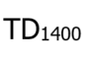 | Monthly | Due IESO | 0 | N/A | N/A | N/A | Implementation details subject to government regulation
1451 | Incremental Loss Offset Settlement Amount | MR Ch.9 s.4.2.4 | Calculated as per ancillary service contracts. | Hourly | Due IESO | 13 | N/A | N/A | N/A | Reactive Support and Voltage Control Service
1457 | Ontario Electricity Rebate Balancing Amount | N/A | 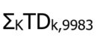  Where ‘K’ is the set of all market participants ‘k’.  Where TDk,9983 is the settlement amount of charge type 9983 for the month for market participant ‘k’. | Monthly | Due Ministry of Energy | 0 | N/A | N/A | N/A | Implementation details subject to Ontario Regulation 363/16 and 364/16
1460 | Renewable Energy Standard Offer Program Balancing Amount | N/A | 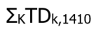  Where ‘K’ is the set of all market participants ‘k’.  Where TDk,1410 is the total settlement amount of charge type 1410 for the month for market participant ‘k’. | Monthly | Due IESO | 0 | N/A | N/A | N/A
1462 | Feed-In Tariff Balancing Amount | N/A | 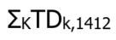  Where ‘K’ is the set of all market participants ‘k’.  Where TDk,1412 is the total settlement amount of charge type 1412 for the month for market participant ‘k’. | Monthly | Due IESO | 0 | N/A | N/A | N/A
1463 | Renewable Generation Connection – Monthly Compensation Amount Settlement Debit | N/A | 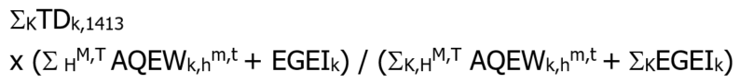  Where ‘H’ is the set of all settlement hours ‘h’ in the month.  Where ‘K’ is the set of all market participants ‘k’.  Where ‘M’ is the set of all delivery points ‘m’ of market participant ‘k’.  Where TDk,1413 is the total settlement amount of charge type 1413 for the month for market participant ‘k’. | Monthly | Due MPs | 13 | N/A | N/A | N/A | Cost recovery implementation details set out in Ontario Regulation 330/09
1464 | Hydroelectric Contract Initiative Balancing Amount | N/A | 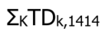  Where ‘K’ is the set of all market participants ‘k’.  Where TDk,1414 is the total settlement amount of charge type 1414 for the month for market participant ‘k’. | Monthly | Due IESO | 0 | N/A | N/A | N/A
1466 | Conservation and Demand Management – Compensation Balancing Amount | N/A | 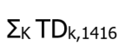  Where ‘K’ is the set of all market participants ‘k’.  Where TDk,1416 is the settlement amount of charge type 1416 for the month for market participant ‘k’. | Monthly | Due IESO | 0 | N/A | N/A | N/A
1467 | Ontario Rebate for Electricity Consumers (8% Provincial Rebate) Balancing Amount | N/A | 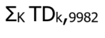  Where ‘K’ is the set of all market participants ‘k’.  Where TDk,9982 is the settlement amount of charge type 9982 for the month for market participant ‘k’. | Monthly | Due Ministry of Energy | 0 | N/A | N/A | N/A | Implementation details subject to Ontario Regulation 363/16
1468 | Biomass Non-Utility Generation Contracts Balancing Amount | N/A | 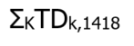  Where ‘K’ is the set of all market participants ‘k’.  Where TDk,1418 is the total settlement amount of charge type 1418 for the month for market participant ‘k’. | Monthly | Due IESO | 0 | N/A | N/A | N/A
1469 | Energy from Waste (EFW) Contracts Balancing Amount | N/A | 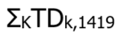  Where ‘K’ is the set of all market participants ‘k’.  Where TDk,1419 is the total settlement amount of charge type 1419 for the month for market participant ‘k’. | Monthly | Due IESO | 0 | N/A | N/A | N/A
1475 | Hydroelectric Standard Offer Program Balancing Amount | N/A | 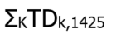  Where ‘K’ is the set of all market participants ‘k’.  Where TDk,1425 is the total settlement amount of charge type 1425 for the month for market participant ‘k’. | Monthly | Due IESO | 0 | N/A | N/A | N/A
1477 | COVID-19 Energy Assistance Program (CEAP) Settlement Amount | N/A | Manual entry based on the values submitted via the relevant on-line settlement form “COVID-19 Energy Assistance Program” for residential consumers. | Monthly | Due LDCs and USMPs | 0 | N/A | N/A | N/A | Implementation details subject to OEB order EB-2020-0186 and EB-2020-0163
1478 | Small Hydro Program Balancing Amount | N/A | ΣKTDk,1428  Where ‘K’ is the set of all market participants ‘k’.  Where TDk,1428 is the total settlement amount of charge type 1428 for the month for market participant ‘k’. | Monthly | Due IESO | 0 | N/A | N/A | N/A
1479 | Pre-Development Costs Settlement Balancing Amount | N/A | TD₁₄₂₉ | Monthly | Due IESO | 0 | N/A | N/A | N/A | May 1, 2025
1487 | Non-Hydro Renewables Funding Balancing Amount | N/A | TD₁₄₂₇ | Monthly | Due IESO | 13 | N/A | N/A | N/A | Ontario Regulation 735/20
1600 | Forecasting Service Settlement Amount | MR Ch.9 s.4.12 | Manual entry based on the values submitted by the forecasting entity. | Monthly | Due MP | 13 | N/A | N/A | N/A
1650 | Forecasting Service Balancing Amount | MR Ch.9 ss.4.12 and 4.14.12 | Where ‘C’ is charge type ‘c’ 1600.  Where ‘H’ is the set of all settlement hours ‘h’ in the month.  Where ‘T’ is the set of all metering intervals ‘t’ in the set of all settlement hours ‘H’. | Monthly | Due IESO | 13 | N/A | 0 | 13
1750 | Dispute Resolution Balancing Amount (Market) | MR. Ch.9 s.6.10.4 | Where ‘C’ is charge type ‘c’ 700.  Where ‘H’ is the set of all settlement hours ‘h’ in the month.  Where ‘T’ is the set of all metering intervals ‘t’ in the set of all settlement hours ‘H’. | Monthly | Due MP | 13 | N/A | 0 | 13
1753 | MOE - Rural and Remote Settlement Debit | N/A | Manual entry based on:  (1) the values submitted via on-line settlement form “Rural or Remote Rate Protection (RRRP) – Fixed Rate Credit”. | Monthly | Due Ministry of Energy | N/A | N/A | N/A | N/A | Implementation details subject to government and OEB regulations.
1800  MRP new | Day-Ahead Market Make-Whole Payment – Energy  (DAM_MWP – DAM_COMP1)  Component 1 | MR Ch.9 ss.3.4.7, 3.4.14, and 3.4.15 | Dispatchable Generation Resources that are not Pseudo-Units and Dispatchable Electricity Storage that are Registered to Inject  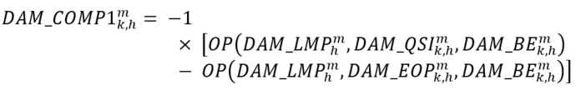  Dispatchable Generation Resources that are Pseudo-Units: Combustion Turbine  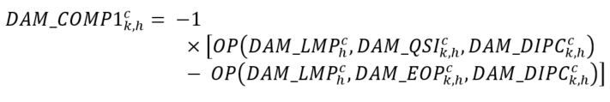  Dispatchable Generation Resources that are Pseudo-Units: Steam Turbine  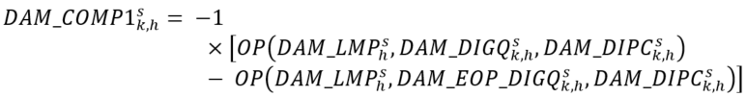 | Hourly | Due MP | 13 | N/A | N/A | N/A
1800  MRP new | Day-Ahead Market Make-Whole Payment – Energy  (DAM_MWP – DAM_COMP1)  Component 1 | MR Ch.9 ss.3.4.13.1-3.4.13.4 | Dispatchable Generation Resources – Hydroelectric Generation Resources Not Associated with Linked Forebays  Hourly Basis Equation:  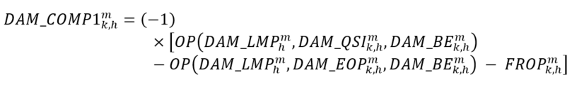  Per-Start Equation:  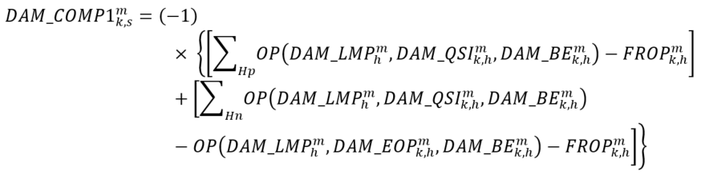  Where:  s = a start event consisting of a set of settlement hours for market participant ‘k’ at delivery point ‘m’, as determined in accordance with the applicable market manual;  Hp = the set of all settlement hours within start ‘s’ where $OP\left({DAM_LMP}_{h}^{m}, {DAM_QSI}_{k, h}^{m}, {DAM_BE}_{k, h}^{m}\right)$ is positive, excluding those settlement hours in which the resource has a reliability constraint;  Hn = the set of all settlement hours within a start ‘s’ where $OP\left({DAM_LMP}_{h}^{m}, {DAM_QSI}_{k, h}^{m}, {DAM_BE}_{k, h}^{m}\right)$ is negative and ${DAM_QSI}_{k, h}^{m}$ is greater than ${DAM_EOP}_{k, h}^{m}$, excluding those settlement hours in which the resource has a reliability constraint or a binding constraint referred to in MR Ch.9 s.3.4.4.4;  and where ${FROP}_{k,h}^{m}$ shall be determined as follows under both the Hourly Basis Equation and Per-Start Equation:  if ${DAM_QSI}_{k,h}^{m}$ is not equal to ${FR_UL}_{k}^{m,f}$, or the resource does not have a forbidden region, then ${FROP}_{k,h}^{m}=0$  otherwise:  Where:  ${FR_UL}_{k}^{m,f}$ = the forbidden region upper limit from forbidden region set ‘f’ where ${DAM_QSI}_{k,h}^{m}$ = ${FR_UL}_{k}^{m,f}$, as submitted by market participant ‘k’ for delivery point ‘m’ as daily dispatch data;  ${FR_LL}_{k}^{m,f}$ = the forbidden region lower limit from forbidden region set ‘f’ where ${DAM_QSI}_{k,h}^{m}$ = ${FR_UL}_{k}^{m,f}$, as submitted by market participant ‘k’ for delivery point ‘m’ as daily dispatch data; and  f = (1…N) of the forbidden region set {${FR_UL}_{k}^{m,f}$, ${FR_LL}_{k}^{m,f}$} and N is the maximum number of forbidden regions submitted by market participant ‘k’ for delivery point ‘m’ as daily dispatch data. | Hourly | Due MP | 13 | N/A | N/A | N/A
1800  MRP new | Day-Ahead Market Make-Whole Payment – Energy  (DAM_MWP – DAM_COMP1)  Component 1 | MR Ch.9 ss.3.4.13.2, 3.4.13.4 and 3.4.13.5 | Dispatchable Generation Resources – Hydroelectric Generation Resources Associated with Linked Forebays  The resource has:  Attained Max Starts, then:  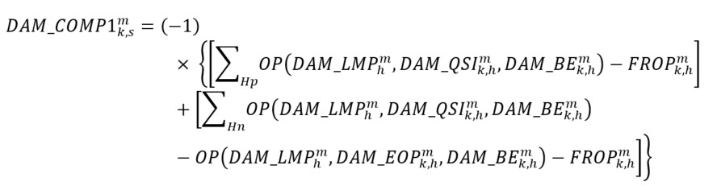  Where:  s = a start event consisting of a set of settlement hours for market participant ‘k’ at delivery point ‘m’, as determined in accordance with the applicable market manual;  Hp = the set of all settlement hours within start ‘s’ where $OP\left({DAM_LMP}_{h}^{m}, {DAM_QSI}_{k, h}^{m}, {DAM_BE}_{k, h}^{m}\right)$ is positive, excluding those settlement hours in which the resource has a reliability constraint;  Hn = the set of all settlement hours within a start ‘s’ where $OP\left({DAM_LMP}_{h}^{m}, {DAM_QSI}_{k, h}^{m}, {DAM_BE}_{k, h}^{m}\right)$ is negative and ${DAM_QSI}_{k, h}^{m}$ is greater than ${DAM_EOP}_{k, h}^{m}$, excluding those settlement hours in which the resource has a reliability constraint or a binding constraint referred to in MR Ch.9 s.3.4.4.4;  and where ${FROP}_{k,h}^{m}$ shall be determined as follows:  if ${DAM_QSI}_{k,h}^{m}$ is not equal to ${FR_UL}_{k}^{m,f}$, or the resource does not have a forbidden region, then ${FROP}_{k,h}^{m}=0$  otherwise:  Where:  ${FR_UL}_{k}^{m,f}$ = the forbidden region upper limit from forbidden region set ‘f’ where ${DAM_QSI}_{k,h}^{m}$ = ${FR_UL}_{k}^{m,f}$, as submitted by market participant ‘k’ for delivery point ‘m’ as daily dispatch data;  ${FR_LL}_{k}^{m,f}$ = the forbidden region lower limit from forbidden region set ‘f’ where ${DAM_QSI}_{k,h}^{m}$ = ${FR_UL}_{k}^{m,f}$, as submitted by market participant ‘k’ for delivery point ‘m’ as daily dispatch data; and  f = (1…N) of the forbidden region set {${FR_UL}_{k}^{m,f}$, ${FR_LL}_{k}^{m,f}$} and N is the maximum number of forbidden regions submitted by market participant ‘k’ for delivery point ‘m’ as daily dispatch data.  The resource has:  Not Attained Max Starts; or  Attained Max Starts but has a day-ahead schedule with settlement hours with a reliability constraint; or  Attained Max Starts but has a day-ahead schedule with settlement hours that are not within a start event, as determined in accordance with the applicable market manual, then:  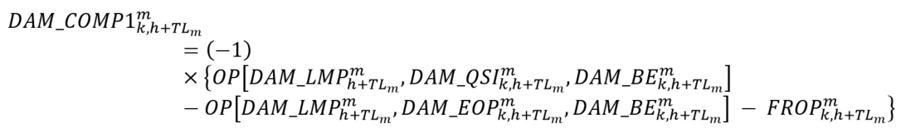  NOTE: hydroelectric generation resources associated with linked forebays, which are subject to this calculation of the DAM_MWP, shall only receive a DAM_MWP settlement amount for a settlement hour when the condition as set out in MR Ch.9 s.3.4.13.5.3 is true for such settlement hour.  Where ${FROP}_{k,h+{TL}_{m}}^{m}$ shall be determined as follows:  if ${DAM_QSI}_{k,h+{TL}_{m}}^{m}$ is not equal to ${FR_UL}_{k}^{m,f}$, or the resource does not have a forbidden region, then ${FROP}_{k,h+{TL}_{m}}^{m}=0$  otherwise:  Where:  ${TL}_{m}$= the time-lag, for each delivery point ‘m’, equal to the number of hours downstream that the delivery point is from the furthest upstream delivery point determined by the time-lag, submitted by the market participant in the daily dispatch data for the linked forebay;  ${FR_UL}_{k}^{m,f}$ = the forbidden region upper limit from forbidden region set ‘f’ where ${DAM_QSI}_{k,h+{TL}_{m}}^{m}$ = ${FR_UL}_{k}^{m,f}$, as submitted by market participant ‘k’ for delivery point ‘m’ as daily dispatch data;  ${FR_LL}_{k}^{m,f}$ = the forbidden region lower limit from forbidden region set ‘f’ where ${DAM_QSI}_{k,h+{TL}_{m}}^{m}$ = ${FR_UL}_{k}^{m,f}$, as submitted by market participant ‘k’ for delivery point ‘m’ as daily dispatch data; and  f = (1…N) of the forbidden region set {${FR_UL}_{k}^{m,f}$, ${FR_LL}_{k}^{m,f}$} and N is the maximum number of forbidden regions submitted by market participant ‘k’ for delivery point ‘m’ as daily dispatch data. | Hourly | Due MP | 13 | N/A | N/A | N/A
1800  MRP new | Day-Ahead Market Make-Whole Payment – Energy  (DAM_MWP – DAM_COMP1)  Component 1 | MR Ch.9 s.3.4.8 | Dispatchable Loads and Dispatchable Electricity Storage Resources that are Registered to Withdraw  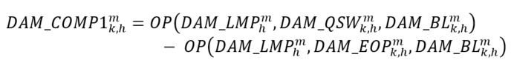 | Hourly | Due MP | 13 | N/A | N/A | N/A
1800  MRP new | Day-Ahead Market Make-Whole Payment – Energy  (DAM_MWP – DAM_COMP1)  Component 1 | MR Ch.9 s.3.4.9 | Non-HDR Price Responsive Loads and Self-Scheduling Electricity Storage Resources that are Registered to Withdraw  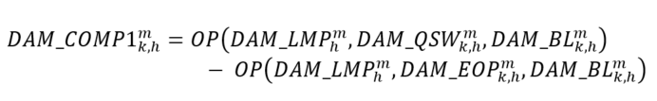 | Hourly | Due MP | 13 | N/A | N/A | N/A
1800  MRP new | Day-Ahead Market Make-Whole Payment – Energy  (DAM_MWP - DAM_COMP1)  Component 1 | MR Ch.9 s.3.4.10 | Physical Hourly Demand Response Price Responsive Loads  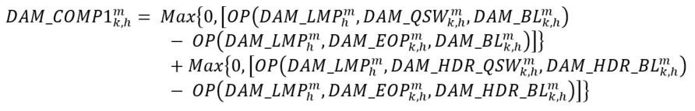  Where:  m = the delivery point for the price responsive load and the physical hourly demand response resource associated with the price responsive load for metered market participant ‘‘k’. | Hourly | Due MP | 13 | N/A | N/A | N/A
1800  MRP new | Day-Ahead Market Make-Whole Payment – Energy  (DAM_MWP – DAM_COMP1)  Component 1 | MR Ch.9 s.3.4.11 | Boundary Entity Resources – Imports  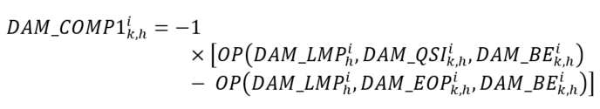 | Hourly | Due MP | N/A | 13 | N/A | N/A
1800  MRP new | Day-Ahead Market Make-Whole Payment – Energy  (DAM_MWP – DAM_COMP1)  Component 1 | MR Ch.9 s.3.4.12 | Boundary Entity Resources – Exports  - 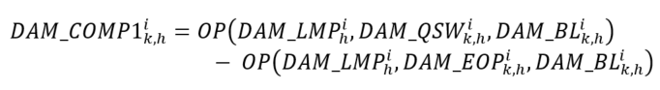 | Hourly | Due MP | N/A | N/A | 13 | 13
1801  MRP new | Day-Ahead Market Make-Whole Payment – 10-Minute Spinning Reserve  (DAM_MWP – DAM_COMP2)  Component 2 | MR Ch.9 ss.3.4.7,  3.4.14, and  3.4.15 | Dispatchable Generation Resources that are not Pseudo-Units and Dispatchable Electricity Storage Resources that are Registered to Inject  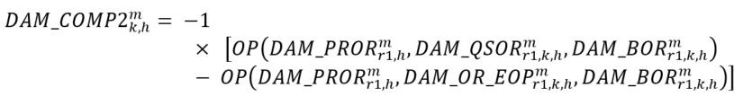  Dispatchable Generation Resources that are Pseudo-Units: Combustion Turbine  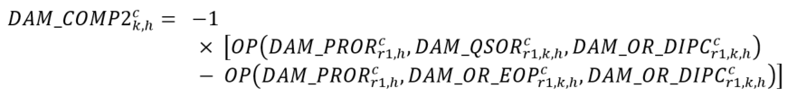  Dispatchable Generation Resources that are Pseudo-Units: Steam Turbine  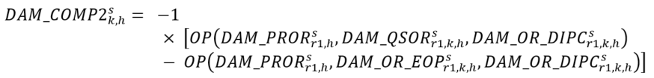 | Hourly | Due MP | 13 | N/A | N/A | N/A
1801  MRP new | Day-Ahead Market Make-Whole Payment – 10-Minute Spinning Reserve  (DAM_MWP – DAM_COMP2)  Component 2 | MR Ch.9 ss.3.4.13.3 and  3.4.13.4 | Dispatchable Generation Resources – Hydroelectric Generation Resources Not Associated with Linked Forebays  Hourly Basis Equation:  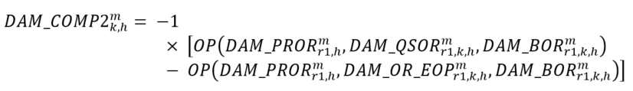  Per-Start Equation:  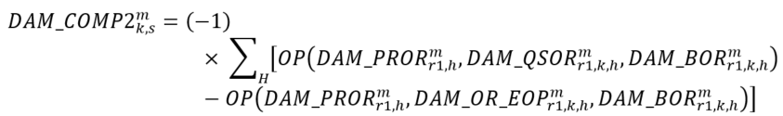  Where:  s = a start event consisting of a set of settlement hours for market participant ‘k’ at delivery point ‘m’, as determined in accordance with the applicable market manual; and  H = the set of all settlement hours within start ‘s’. | Hourly | Due MP | 13 | N/A | N/A | N/A
1801  MRP new | Day-Ahead Market Make-Whole Payment – 10-Minute Spinning Reserve  (DAM_MWP – DAM_COMP2)  Component 2 | MR Ch.9 s.3.4.13.5 | Dispatchable Generation Resources – Hydroelectric Generation Resources Associated with Linked Forebays  The resource has:  Attained Max Starts, then:  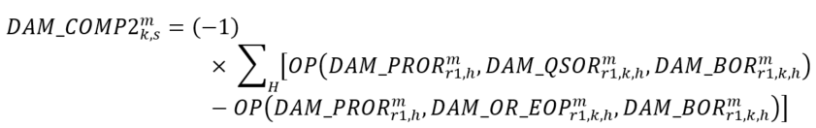  Where:  s = a start event consisting of a set of settlement hours for market participant ‘k’ at delivery point ‘m’, as determined in accordance with the applicable market manual; and  H = the set of all settlement hours within start ‘s’.  The resource has:  Not Attained Max Starts; or  Attained Max Starts but has a day-ahead schedule with settlement hours with a reliability constraint; or  Attained Max Starts but has a day-ahead schedule with settlement hours that are not within a start event, as determined in accordance with the applicable market manual, then:  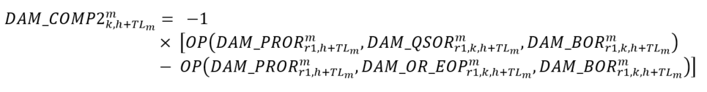  NOTE: hydroelectric generation resources associated with linked forebays, which are subject to this calculation of the DAM_MWP, shall only receive a DAM_MWP settlement amount for a settlement hour when the condition as set out in MR Ch.9 s.3.4.13.5.3 is true for such settlement hour.  Where:  ${TL}_{m}$ = the time-lag, for each delivery point ‘m’, equal to the number of hours downstream that the delivery point is from the furthest upstream delivery point determined by the time-lag, submitted by the market participant in the daily dispatch data for the linked forebay. | Hourly | Due MP | 13 | N/A | N/A | N/A
1801  MRP new | Day-Ahead Market Make-Whole Payment – 10-Minute Spinning Reserve  (DAM_MWP – DAM_COMP2)  Component 2 | MR Ch.9 s.3.4.8 | Dispatchable Loads and Dispatchable Electricity Storage Resources that are Registered to Withdraw  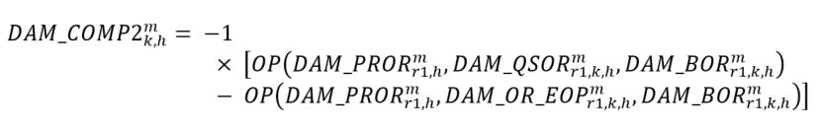 | Hourly | Due MP | 13 | N/A | N/A | N/A
1802  MRP new | Day-Ahead Market Make-Whole Payment – 10-Minute Non-Spinning Reserve  (DAM_MWP – DAM_COMP2)  Component 2 | MR Ch.9 ss.3.4.7, 3.4.14, and  3.4.15 | Dispatchable Generation Resources that are not Pseudo-Units and Dispatchable Electricity Storage Resources that are Registered to Inject  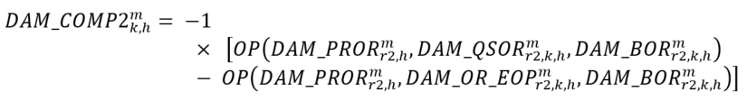  Dispatchable Generation Resources that are Pseudo-Units: Combustion Turbine  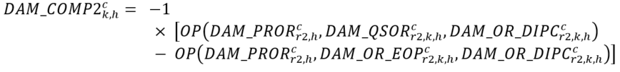  Dispatchable Generation Resources that are Pseudo-Units: Steam Turbine  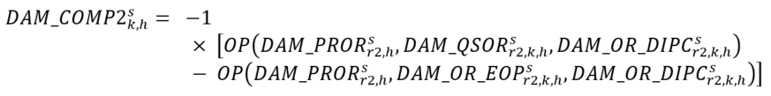 | Hourly | Due MP | 13 | N/A | N/A | N/A
1802  MRP new | Day-Ahead Market Make-Whole Payment – 10-Minute Non-Spinning Reserve  (DAM_MWP – DAM_COMP2)  Component 2 | MR Ch.9 ss.3.4.13.3 and  3.4.13.4 | Dispatchable Generation Resources – Hydroelectric Generation Resources Not Associated with Linked Forebays  Hourly Basis Equation:  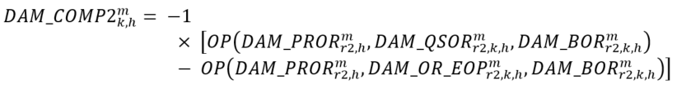  Per-Start Equation:  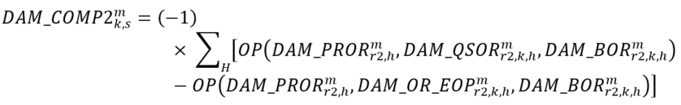  Where:  s = a start event consisting of a set of settlement hours for market participant ‘k’ at delivery point ‘m’, as determined in accordance with the applicable market manual; and  H = the set of all settlement hours within start ‘s’. | Hourly | Due MP | 13 | N/A | N/A | N/A
1802  MRP new | Day-Ahead Market Make-Whole Payment – 10-Minute Non-Spinning Reserve  (DAM_MWP – DAM_COMP2)  Component 2 | MR Ch.9 s.3.4.13.5 | Dispatchable Generation Resources – Hydroelectric Generation Resources Associated with Linked Forebays  The resource has  Attained Max Starts, then:  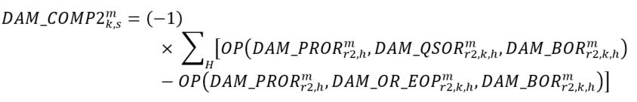  Where:  s = a start event consisting of a set of settlement hours for market participant ‘k’ at delivery point ‘m’, as determined in accordance with the applicable market manual; and  H = the set of all settlement hours within start ‘s’.  The resource has:  Not Attained Max Starts; or  Attained Max Starts but has a day-ahead schedule with settlement hours with a reliability constraint; or  Attained Max Starts but has a day-ahead schedule with settlement hours that are not within a start event, as determined in accordance with the applicable market manual, then:  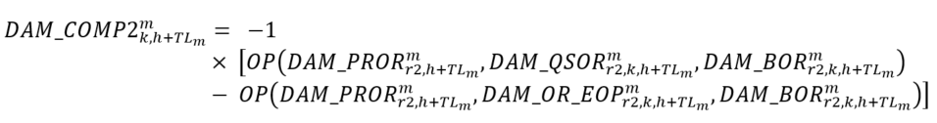  NOTE: hydroelectric generation resources associated with linked forebays, which are subject to this calculation of the DAM_MWP, shall only receive a DAM_MWP settlement amount for a settlement hour when the condition as set out in MR Ch.9 s.3.4.13.5.3 is true for such settlement hour.  Where:  ${TL}_{m}$ = the time-lag, for each delivery point ‘m’, equal to the number of hours downstream that the delivery point is from the furthest upstream delivery point determined by the time-lag, submitted by the market participant in the daily dispatch data for the linked forebay. | Hourly | Due MP | 13 | N/A | N/A | N/A
1802  MRP new | Day-Ahead Market Make-Whole Payment – 10-Minute Non-Spinning Reserve  (DAM_MWP – DAM_COMP2)  Component 2 | MR Ch.9 s.3.4.8 | Dispatchable Loads and Dispatchable Electricity Storage Resources that are Registered to Withdraw  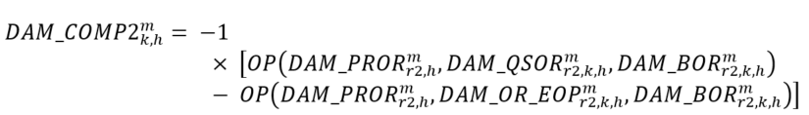 | Hourly | Due MP | 13 | N/A | N/A | N/A
1802  MRP new | Day-Ahead Market Make-Whole Payment – 10-Minute Non-Spinning Reserve  (DAM_MWP – DAM_COMP2)  Component 2 | MR Ch.9 s.3.4.11 | Boundary Entity Resources - Imports  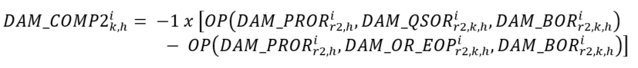 | Hourly | Due MP | N/A | 13 | N/A | N/A
1802  MRP new | Day-Ahead Market Make-Whole Payment – 10-Minute Non-Spinning Reserve  (DAM_MWP – DAM_COMP2)  Component 2 | MR Ch.9 s.3.4.12 | Boundary Entity Resources – Exports  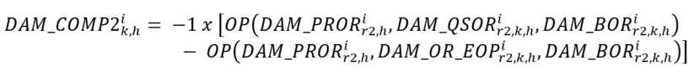 | Hourly | Due MP | N/A | N/A | 13 | 13
1803  MRP new | Day-Ahead Market Make-Whole Payment – 30-Minute Operating Reserve  (DAM_MWP – DAM_COMP2)  Component 2 | MR Ch.9 ss.3.4.7, 3.4.14, and  3.4.15 | Dispatchable Generation Resources that are not Pseudo-Units and Dispatchable Electricity Storage Resources that are Registered to Inject  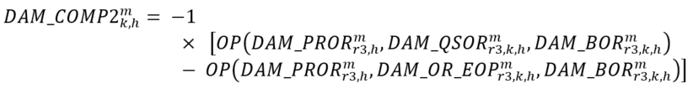  Dispatchable Generation Resources that are Pseudo-Units: Combustion Turbine  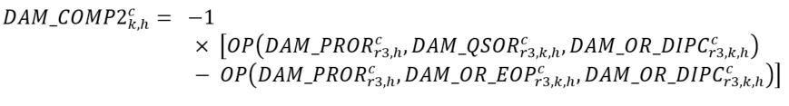  Dispatchable Generation Resources that are Pseudo-Units: Steam Turbine  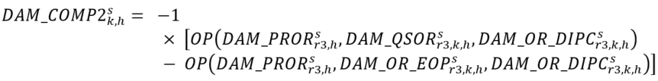 | Hourly | Due MP | 13 | N/A | N/A | N/A
1803  MRP new | Day-Ahead Market Make-Whole Payment – 30-Minute Operating Reserve  (DAM_MWP – DAM_COMP2)  Component 2 | MR Ch.9 ss.3.4.13.3 and  3.4.13.4 | Dispatchable Generation Resources – Hydroelectric Generation Resources Not Associated with Linked Forebays  Hourly Basis Equation:  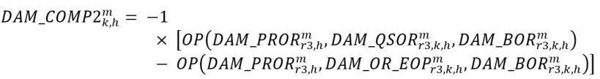  Per-Start Equation:  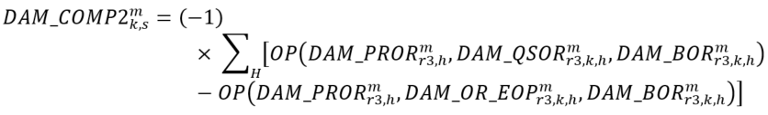  Where:  s = a start event consisting of a set of settlement hours for market participant ‘k’ at delivery point ‘m’, as determined in accordance with the applicable market manual; and  H = the set of all settlement hours within start ‘s’. | Hourly | Due MP | 13 | N/A | N/A | N/A
1803  MRP new | Day-Ahead Market Make-Whole Payment – 30-Minute Operating Reserve  (DAM_MWP – DAM_COMP2)  Component 2 | MR Ch.9 s.3.4.13.5 | Dispatchable Generation Resources – Hydroelectric Generation Resources Associated with Linked Forebays  The resource has  Attained Max Starts, then:  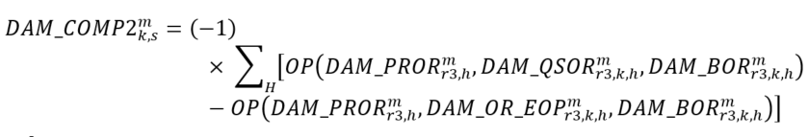  Where:  s = a start event consisting of a set of settlement hours for market participant ‘k’ at delivery point ‘m’, as determined in accordance with the applicable market manual; and  H = the set of all settlement hours within start ‘s’.  The resource has:  Not Attained Max Starts; or  Attained Max Starts but has a day-ahead schedule with settlement hours with a reliability constraint; or  Attained Max Starts but has a day-ahead schedule with settlement hours that are not within a start event, as determined in accordance with the applicable market manual, then:  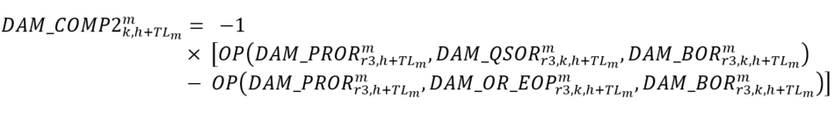  NOTE: hydroelectric generation resources associated with linked forebays, which are subject to this calculation of the DAM_MWP, shall only receive a DAM_MWP settlement amount for a settlement hour when the condition as set out in MR Ch.9 s.3.4.13.5.3 is true for such settlement hour.  Where:  ${TL}_{m}$ = the time-lag, for each delivery point ‘m’, equal to the number of hours downstream that the delivery point is from the furthest upstream delivery point determined by the time-lag, submitted by the market participant in the daily dispatch data for the linked forebay. | Hourly | Due MP | 13 | N/A | N/A | N/A
1803  MRP new | Day-Ahead Market Make-Whole Payment – 30-Minute Operating Reserve  (DAM_MWP – DAM_COMP2)  Component 2 | MR Ch.9 s.3.4.8 | Dispatchable Loads and Dispatchable Electricity Storage Resources that are Registered to Withdraw  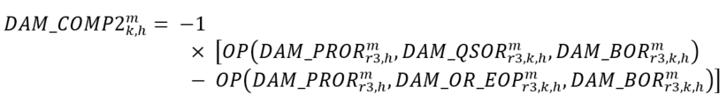 | Hourly | Due MP | 13 | N/A | N/A | N/A
1803  MRP new | Day-Ahead Market Make-Whole Payment – 30-Minute Operating Reserve  (DAM_MWP – DAM_COMP2)  Component 2 | MR Ch.9 s.3.4.11 | Boundary Entity Resources – Imports  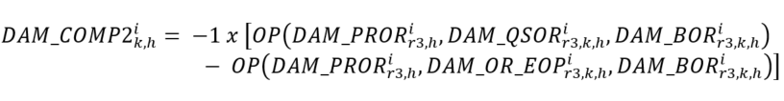 | Hourly | Due MP | N/A | 13 | N/A | N/A
1803  MRP new | Day-Ahead Market Make-Whole Payment – 30-Minute Operating Reserve  (DAM_MWP – DAM_COMP2)  Component 2 | MR Ch.9 s.3.4.12 | Boundary Entity Resources - Exports  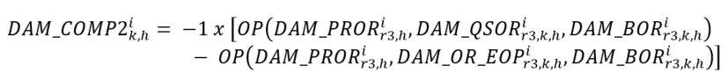 | Hourly | Due MP | N/A | N/A | 13 | 13
1804  MRP new | Day-Ahead Market Generator Offer Guarantee – Energy  (DAM_GOG – DAM_GOG_COMP1)  Component 1 | MR Ch.9 ss.4.4.6, 4.4.15, and  4.4.22 | GOG-eligible Resources that are not Pseudo-Units  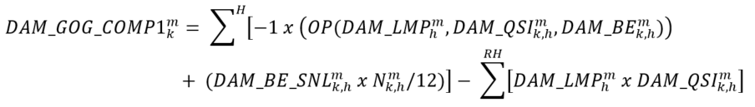  Where:  H = the set of settlement hours within the relevant day-ahead commitment period;  RH = the set of contiguous settlement hours with day-ahead schedules for the ramp-up period;  $N_{k,h}^{m}$= the number of metering intervals in settlement hour ‘h’ during which delivery point ‘m’ for market participant ‘k’ was synchronized and injecting energy into the IESO-controlled grid; and  if the combustion turbine resource or steam turbine resource is registered as a pseudo-unit but is not operating as a pseudo-unit and has a minimum constraint applied for combined cycle operation consistent with combustion turbine commitment, then ${DAM_QSI}_{k,h}^{m}$ will be replaced with ${DAM_EOP}_{k,h}^{m}$ for those settlement hours in which they have such constraint.  GOG-eligible Resources that are Pseudo-Units: Combustion Turbine  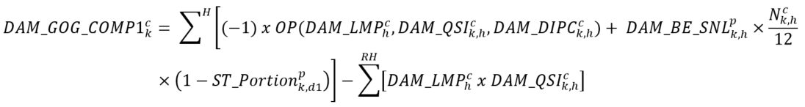  Where:  H = the set of settlement hours within the combustion turbine resource‘s relevant day-ahead commitment period;  RH = the set of contiguous settlement hours that the combustion turbine resource has a day-ahead schedule for the ramp-up period, scheduled greater than zero but less than the combustion turbine resource‘s minimum loading point;  p = the pseduo-unit associated with combustion turbine resource delivery point ‘c’; and  $N_{,h}^{c}$= the number of metering intervals in settlement hour ‘h’ during which combustion turbine resource delivery point ‘c’ for market participant ‘k’ was synchronized and injecting energy into the IESO-controlled grid.  GOG-eligible Resources that are Pseudo-Units: Steam Turbine  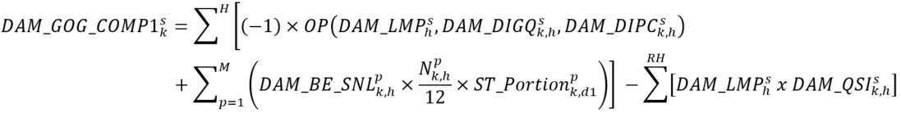Where:  H = the set of all settlement hours within the steam turbine resource’s day-ahead commitment period when at least one of the pseudo-units associated with the steam turbine resource has a day-ahead schedule greater than or equal to its respective pseudo-unit’s minimum loading point;  M = the set of all pseudo-units ‘p’ associated with steam turbine resource delivery point ‘s’ that have a day-ahead schedule greater than or equal to their respective minimum loading point in settlement hour ‘h’;  RH = the set of all settlement hours in the steam turbine resource’s day-ahead operational commitment when all of the pseudo-units associated with the steam turbine resource are scheduled less than their minimum loading point; and  $N_{k,h}^{p}$= the number of metering intervals in the settlement hour ‘h’ during which the combustion turbine resource associated with pseudo-unit ‘p’ for market participant ‘k’ was synchronized and injecting energy into the IESO-controlled grid. | Hourly | Either Way | 13 | N/A | N/A | N/A
1805  MRP new | Day-Ahead Market Generator Offer Guarantee – Operating Reserve  (DAM_GOG – DAM_GOG_COMP2)  Component 2 | MR Ch.9 ss.4.4.7, 4.4.16, and 4.4.23 | GOG-eligible Resources that are not Pseudo-Units  Where:  H = the set of settlement hours within the relevant day-ahead commitment period.  GOG-eligible Resources that are Pseudo-Units: Combustion Turbine  Where:  H = the set of settlement hours within the combustion turbine resource’s relevant day-ahead commitment period.  GOG-eligible Resources that are Pseudo-Units: Steam Turbine  Where:  H = the set of all settlement hours within the steam turbine resource’s day-ahead commitment period when at least one of the pseudo-units associated with the steam turbine resource has a day-ahead schedule greater than or equal to its respective pseudo-unit’s minimum loading point. | Hourly | Either Way | 13 | N/A | N/A | N/A
1806  MRP new | Day-Ahead Market Generator Offer Guarantee – Over Midnight  (DAM_GOG – DAM_GOG_COMP3)  Component 3 | MR Ch.9 ss.4.4.8, 4.4.17, and 4.4.24 | NOTE: this charge type has -1 added before the summation sign as it has been separated from the larger DAM_GOG equation within the market rules, in which this component would have been subtracted from the total settlement amount.  GOG-eligible Resources that are not Pseudo-Units  Where:  H = the set of settlement hours within the day-ahead commitment period that are required to complete the resource’s minimum generation block run-time that began in Day 0;  ${\text{MLP}}_{\text{k}}^{\text{m}}$= the minimum loading point of the GOG-eligible resource for Day 0 for market participant ‘k’ for delivery point ‘m’; and  $N_{k,h}^{m}$= the number of metering intervals in settlement hour ‘h’ during which delivery point ‘m’ for market participant ‘k’ was synchronized and injecting energy into the IESO-controlled grid.  GOG-eligible Resources that are Pseudo-Units: Combustion Turbine  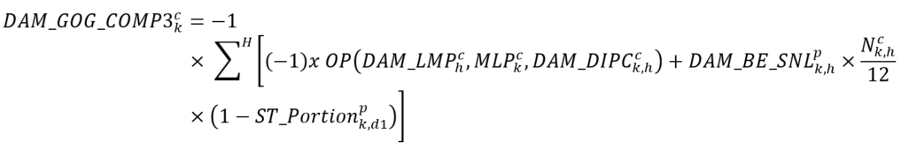  Where:  H = the set of settlement hours within the day-ahead commitment period that are required to complete the associated pseudo-unit’s minimum generation block run-time that began in Day 0;  p = the pseudo-unit associated with combustion turbine resource delivery point ‘c’;  ${\text{MLP}}_{\text{k}}^{\text{c}}$= the minimum loading point of the combustion turbine resource associated with combustion turbine resource delivery point ‘c’; and  $N_{k,h}^{c}$= the number of metering intervals in settlement hour ‘h’ during which combustion turbine resource delivery point ‘c’ for market participant ‘k’ was synchronized and injecting energy into the IESO-controlled grid.  GOG-eligible Resources that are Pseudo-Units: Steam Turbine  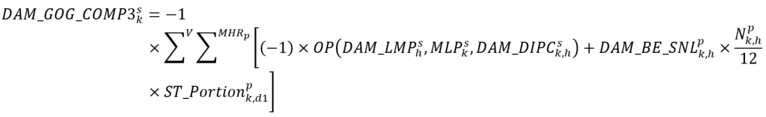  Where:  V = the set of all pseudo-units ‘p’ associated with steam turbine resource delivery point ‘s’ whose associated combustion turbine resource has a variant #2 (per MR Ch.9. s.4.4.13) day-ahead operational commitment that overlaps with the steam turbine resource day-ahead operational commitment;  MHRp = the set of all settlement hours within the day-ahead commitment period that are required to complete minimum generation block run-time that began in Day 0 for pseudo-unit ‘p’ associated with the steam turbine resource;  ${\text{MLP}}_{\text{k}}^{\text{s}}$= the minimum loading point of steam turbine resource associated with pseudo-unit 'p’ for market participant ‘k’; and  $N_{k,h}^{p}$= the number of metering intervals in the settlement hour ‘h’ during which the combustion turbine resource associated with pseudo-unit ’p’ for market participant ‘k’ was synchronized and injecting energy into the IESO-controlled grid. | Hourly | Either Way | 13 | N/A | N/A | N/A
1807  MRP new | Day-Ahead Market Generator Offer Guarantee – Start-up  (DAM_GOG – DAM_GOG_COMP4)  Component 4 | MR Ch.9 ss.4.4.9, 4.4.18, and 4.4.25 | GOG-eligible Resources that are not Pseudo-Units  achieves minimum loading point within the first six metering intervals of the first settlement hour of its day-ahead operational commitment:  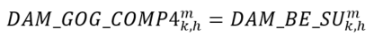  achieves minimum loading point after the first six metering intervals of the start of its minimum generation block run-time but before the 19th metering interval following the start of its minimum generation block run-time:  Where:  N_INT = the number of metering intervals after the first six metering intervals that the GOG-eligible resource took to achieve its minimum loading point.  otherwise: ${DAM_GOG_COMP4}_{k,h}^{m}=0$  GOG-eligible Resources that are Pseudo-Units: Combustion Turbine  achieves minimum loading point within the first six metering intervals of the first settlement hour of its day-ahead operational commitment:  achieves minimum loading point after the first six metering intervals of the start of its day-ahead operational commitment but before the 19th metering interval following the start of its day-ahead operational commitment:  Where:  N_INT = the number of metering intervals after the first six metering intervals that the combustion turbine resource took to achieve its minimum loading point  otherwise: ${DAM_GOG_COMP4}_{k,h}^{c}=0$  GOG-eligible Resources that are Pseudo-Units: Steam Turbine  Where:  C = the set of all combustion turbine resource delivery points 'c’ associated with steam turbine resource delivery point ‘s’;  ${DAM_GOG_COMP4}_{k,x}^{c}$ = determined in accordance with MR Ch.9 s.4.4.18 for combustion turbine resource delivery point ‘‘c’ for market participant ‘k’ for day-ahead commitment period ‘x’; and  Xc = the set of all day-ahead operational commitment periods 'x’ for combustion turbine resource delivery point ‘c’ that are entitled to a day-ahead market generator offer guarantee settlement amount pursuant to MR Ch.9 s.4.4.12 (variant #1) that overlap with the steam turbine resource’s day-ahead commitment period. | Hourly | Due MP | 13 | N/A | N/A | N/A
1808  MRP new | Day-Ahead Market Generator Offer Guarantee – DAM Make-Whole Payment Offset  (DAM_GOG – DAM_GOG_COMP5)  Component 5 | MR Ch.9 ss.4.4.11, 4.4.20, and 4.4.26 | NOTE: this charge type has -1 added before the summation sign as it has been separated from the larger DAM_GOG equation within the market rules, in which this component would have been subtracted from the total settlement amount.  GOG-eligible Resources that are not Pseudo-Units  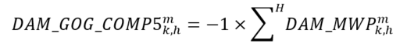  Where:  H = the set of settlement hours within the relevant day-ahead commitment period.  GOG-eligible Resources that are Pseudo-Units: Combustion Turbine  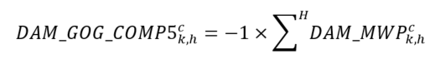  Where:  H = the set of settlement hours within the combustion turbine resource’s relevant day-ahead commitment period.  GOG-eligible Resources that are Pseudo-Units: Steam Turbine  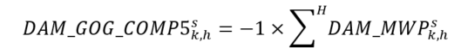  Where:  H = the set of all settlement hours within the steam turbine resource’s day-ahead commitment period when at least one of the pseudo-units associated with steam turbine resource delivery point ‘s’ has a day-ahead schedule greater than or equal to its respective minimum loading point. | Hourly | Due IESO | 13 | N/A | N/A | N/A
1815  MRP new | Day-Ahead Market Balancing Credit - Energy  (DAM_BCE) | MR Ch.9 s.3.3 | GOG-eligible Resources  Boundary Entity Resources  for an import transaction:  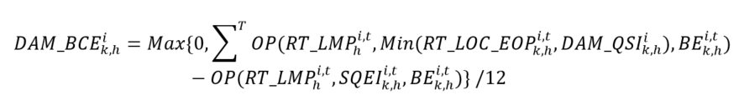  for an export transaction:  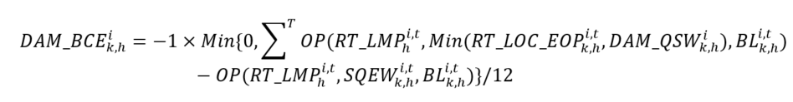 | Interval | Due MP | 13 | 13 | 13 | 13
1816  MRP new | Day-Ahead Market Balancing Credit – Operating Reserve  (DAM_BCOR) | MR Ch.9 s.3.3 | GOG-eligible Resources  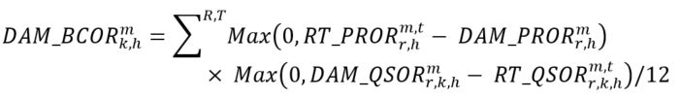  Boundary Entity Resources  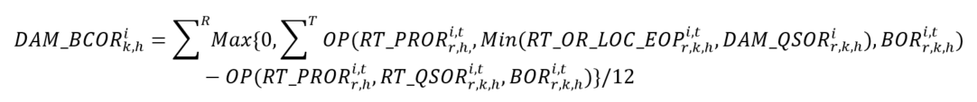 | Interval | Due MP | 13 | 13 | 13 | 13
1828  MRP new | Day-Ahead Market Import Failure Charge  (DAM_IMFC) | MR Ch.9 ss.3.7A.1 and 3.7A.2 | Where: | Interval | Due IESO | N/A | 13 | N/A | N/A
1829  MRP new | Day-Ahead Market Export Failure Charge  (DAM_EXFC) | MR Ch.9 ss.3.7A.1 and 3.7A.3 | Where: | Interval | Due IESO | N/A | N/A | 0 | 13
1830 | Tariff Response charge for Exports | MR Ch.10 s.4.6 | -1 x $\sum_{T}{{SQEW}_{k,h}^{i,t}}/12 x PRICE$ | Hourly | Due IESO | N/A | N/A | 0 | N/A | Ontario regulation 25/25
1850  MRP new | Day-Ahead Market Uplift  (DAM_UPL) | MR Ch.9 s.4.14.3 | 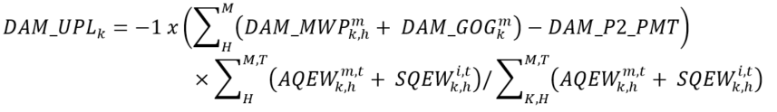  Where:  ${DAM_MWP}_{k,h}^{m}$ = is the day-ahead market make-whole payment settlement amount for charge types 1800, 1801, 1802 and 1803, calculated in accordance with MR Ch.9 s.3.4 for market participant ‘k’ at delivery point ‘m’ for settlement hour ‘h’;  ${DAM_GOG}_{k}^{m}=$is the day-ahead market generator offer guarantee settlement amount for charge types 1804, 1805, 1806, 1807 and 1808, calculated in accordance with MR Ch.9 s.4.4 for market participant ‘k’ at delivery point ‘m’; and  $\text{DAM_P2_PMT }$ = calculated in accordance with MR Ch.9 s.4.14.5. | Daily | Due IESO | 13 | N/A | 0 | 13
1851  MRP new | Day-Ahead Market Reliability Scheduling Uplift  (DRSU – EL_DRSU) | MR Ch.9 s.4.14.4 | Load Resources, Electricity Storage Resources that are Registered to Withdraw, and Boundary Entity Resources – Export Transactions  Where:  $V_DRSU_{k}$ = the DRSU settlement amount calculated for charge type 1852 in accordance with MR Ch.9 s.4.14.4.1 for market participant ‘k’ at delivery point ‘v’ for virtual zonal resources; and  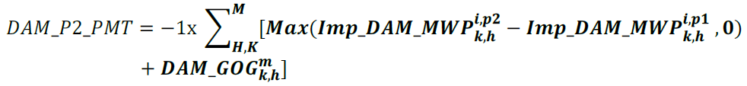  and where :  ${Imp_DAM_MWP}_{k,h}^{i,p2}= Max\left[0, {DAM_COMP1}_{k,h}^{i}+{DAM_COMP2}_{k,h}^{i}\right]$ and each component is determined as follows:  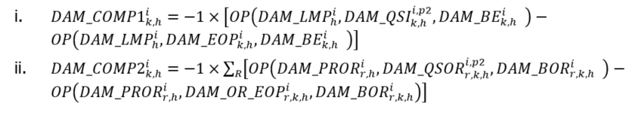  ${Imp_DAM_MWP}_{k,h}^{i,p1}= Max\left[0, {DAM_COMP1}_{k,h}^{i}+{DAM_COMP2}_{k,h}^{i}\right]$ and each component is determined as follows:  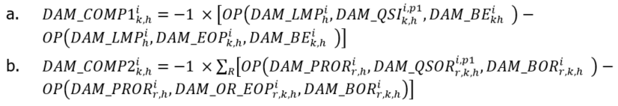  ${\text{DAM_GOG}}_{\text{k,h}}^{\text{m}}$ = calculated in accordance with MR Ch.9 s.4.4. | Daily | Due IESO | 13 | N/A | 0 | 13
1852  MRP new | Day-Ahead Market Reliability Scheduling Uplift – Virtual Transactions to Sell  (DRSU -V_DRSU) | MR Ch.9 ss.4.14.4-4.14.4.1 | Virtual Zonal Resources with Day-Ahead Schedules to Inject Energy  Where:  $$DAM_NDL_OF=Max\left[\sum_{H,K}^{M}{ (DAM_QSW_{k,h}^{m,p2} +DAM_HDR_QSW_{k,h}^{m1,p2}-AQEW_{,h}^{m,t},0)}\right]$$  and where:  M = the set of all delivery points ‘m’ for non-dispatchable loads and physical hourly demand response resources that are not associated with load equipment registered as price responsive loads;  m1 = the set of all delivery points ‘m’ for physical hourly demand response resources; and  p2 = Pass 2: Reliability Scheduling and Commitment of the day-ahead market calculation engine. | Daily | Due IESO | N/A | N/A | N/A | N/A
1865  MRP new | Day-Ahead Market Balancing Credit Uplift  (DAM_BCU) | MR Ch.9 s.3.11 | Where:  C = the set of all charge types ‘c’ as follows: 1815,1816. | Hourly | Due IESO | 13 | N/A | 0 | 13
1880 | Tariff Response Charge for Exports Balancing Amount | MR Ch.10 s.4.6 | -1 x$\sum_{K}{TD_{k}}1830$ | Hourly | Due IESO | N/A | N/A | 0 | N/A | Ontario Regulation 25/25
1900  MRP new | Real-Time Make-Whole Payment – Lost Cost for Energy  (RT_MWP - RT_ELC) | MR Ch.9 ss.3.5.6.1, 3.5.9 and 3.5.10 | Dispatchable Generation Resources that are not Pseudo-Units and Dispatchable Electricity Storage Resources that are Registered to Inject  Where:  the disptachable generation resource is registered as a hydroelectric generation resource, ${RT_QSI}_{k,h}^{m,t}$ is greater than ${FR_LL}_{k}^{m,f}$, and ${RT_QSI}_{k,h}^{m,t}$is less than or equal to ${FR_UL}_{k}^{m,f}$, then  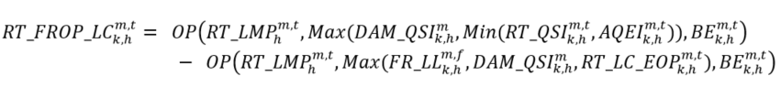  Where:  ${FR_UL}_{k}^{m,f}$ = the forbidden region upper limit from forbidden region set ‘f’ where ${RT_QSI}_{k,h}^{m,t}$ <= ${FR_UL}_{k}^{m,f}$, as submitted by market participant ‘k’ for delivery point ‘m’ as daily dispatch data;  ${FR_LL}_{k}^{m,f}$ = the forbidden region lower limit from forbidden region set ‘f’ where ${RT_QSI}_{k,h}^{m,t}$ > ${FR_LL}_{k}^{m,f}$, as submitted by market participant ‘k’ for delivery point ‘m’ as daily dispatch data; and  f = (1…N) of the forbidden region set {${FR_UL}_{k}^{m,f}$, ${F_LL}_{k}^{m,f}$} and N is the maximum number of forbidden regions submitted by market participant ‘k’ for delivery point ‘m’ as daily dispatch data.  Otherwise ${RT_FROP_LC}_{k,h}^{m,t}$ shall equal zero.  Dispatchable Generation Resources that are Pseudo-Units: Combustion Turbine  Dispatchable Generation Resources that are Pseudo-Units: Steam Turbine  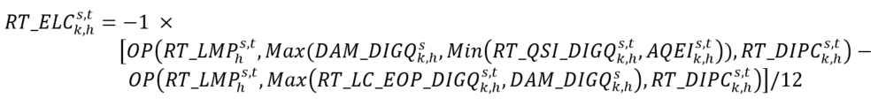 | Interval | Due MP | 13 | N/A | N/A | N/A
1900  MRP new | Real-Time Make-Whole Payment – Lost Cost for Energy  (RT_MWP – RT_ELC) | MR Ch.9 s.3.5.7 | Dispatchable Loads and Dispatchable Electricity Storage Resources that are Registered to Withdraw  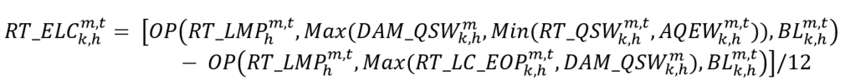 | Interval | Due MP | 13 | N/A | N/A | N/A
1900  MRP new | Real-Time Make-Whole Payment – Lost Cost for Energy  (RT_MWP – RT_ELC) | MR Ch.9 s.3.5.8 | Boundary Entity Resources – Exports  Export transaction dispatched with a reason code associated with manual dispatch out-of-merit:  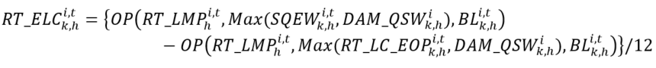  Export transaction dispatched with a reason code associated with a pre-dispatch pricing discrepancy: | Interval | Due MP | N/A | N/A | 13 | 13
1901  MRP new | Real-Time Make-Whole Payment – Lost Cost for 10-Minute Spinning Reserve  (RT_MWP – RT_OLC) | MR Ch.9 ss.3.5.6, 3.5.9, and 3.5.10 | Dispatchable Generation Resources that are not Pseudo-Units and Dispatchable Electricity Storage Resources that are Registered to Inject  Dispatchable Generation Resources that are Pseudo-Units: Combustion Turbine  Dispatchable Generation Resources that are Pseudo-Units: Steam Turbine | Interval | Due MP | 13 | N/A | N/A | N/A
1901  MRP new | Real-Time Make-Whole Payment – Lost Cost for 10-Minute Spinning Reserve  (RT_MWP – RT_OLC) | MR Ch.9 s.3.5.7 | Dispatchable Loads and Dispatchable Electricity Storage Resources that are Registered to Withdraw | Interval | Due MP | 13 | N/A | N/A | N/A
1902  MRP new | Real-Time Make-Whole Payment – Lost Cost for 10-Minute Non-Spinning Reserve  (RT_MWP – RT_OLC) | MR Ch.9 ss.3.5.6, 3.5.9, and 3.5.10 | Dispatchable Generation Resources that are not Pseudo-Units and Dispatchable Electricity Storage Resources that are Registered to Inject  Dispatchable Generation Resources that are Pseudo-Units: Combustion Turbine  Dispatchable Generation Resources that are Pseudo-Units: Steam Turbine | Interval | Due MP | 13 | N/A | N/A | N/A
1902  MRP new | Real-Time Make-Whole Payment – Lost Cost for 10-Minute Non-Spinning Reserve  (RT_MWP – RT_OLC) | MR Ch.9 s.3.5.7 | Dispatchable Loads and Dispatchable Electricity Storage Resources that are Registered to Withdraw | Interval | Due MP | 13 | N/A | N/A | N/A
1902  MRP new | Real-Time Make-Whole Payment – Lost Cost for 10-Minute Non-Spinning Reserve  (RT_MWP – RT_OLC) | MR Ch.9 s.3.5.8 | Boundary Entity Resources – Exports  Export transaction dispatched with a reason code associated with manual dispatch out-of-merit:  Export transaction dispatched with a reason code associated with a pre-dispatch pricing discrepancy: | Interval | Due MP | N/A | N/A | 13 | 13
1902  MRP new | Real-Time Make-Whole Payment – Lost Cost for 10-Minute Non-Spinning Reserve  (RT_MWP – RT_OLC) | MR Ch.9 s.3.5.8 | Boundary Entity Resources – Imports  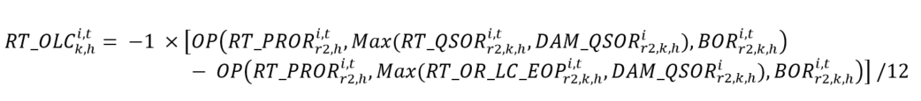 | Interval | Due MP | N/A | 13 | N/A | N/A
1903  MRP new | Real-Time Make-Whole Payment – Lost Cost for 30-Minute Operating Reserve  (RT_MWP – RT_OLC) | MR Ch.9 ss.3.5.6, 3.5.9, and 3.5.10 | Dispatchable Generation Resources that are not Pseudo-Units and Dispatchable Electricity Storage Resources that are Registered to Inject  Dispatchable Generation Resources that are Pseudo-Units: Combustion Turbine  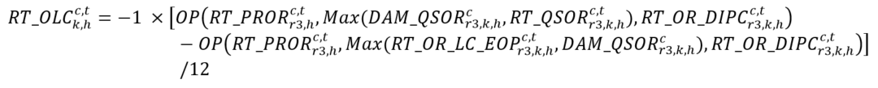  Dispatchable Generation Resources that are Pseudo-Units: Steam Turbine  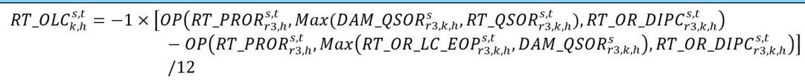 | Interval | Due MP | 13 | N/A | N/A | N/A
1903  MRP new | Real-Time Make-Whole Payment – Lost Cost for 30-Minute Operating Reserve  (RT_MWP – RT_OLC) | MR Ch.9 s.3.5.7 | Dispatchable Loads and Dispatchable Electricity Storage Resources that are Registered to Withdraw | Interval | Due MP | 13 | N/A | N/A | N/A
1903  MRP new | Real-Time Make-Whole Payment – Lost Cost for 30-Minute Operating Reserve  (RT_MWP – RT_OLC) | MR Ch.9 s.3.5.8 | Boundary Entity Resources – Exports  Export transaction dispatched with a reason code associated with manual dispatch out-of-merit:  Export transaction dispatched with a reason code associated with a pre-dispatch pricing discrepancy: | Interval | Due MP | N/A | N/A | 13 | 13
1903  MRP new | Real-Time Make-Whole Payment – Lost Cost for 30-Minute Operating Reserve  (RT_MWP – RT_OLC) | MR Ch.9 s.3.5.8 | Boundary Entity Resources – Imports | Interval | Due MP | N/A | 13 | N/A | N/A
1904  MRP new | Real-Time Make-Whole Payment – Lost Opportunity Cost for Energy  (RT_MWP – RT_ELOC) | MR Ch.9 ss.3.5.6.2, 3.5.9, and 3.5.10 | Dispatchable Generation Resources that are not Pseudo-Units and Dispatchable Electricity Storage Resources that are Registered to Inject  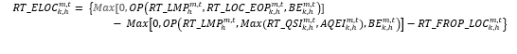  Where:  if the dispatchable generation resource is registered as a hydroelectric generation resource, ${RT_QSI}_{k,h}^{m,t}$ is greater than ${FR_LL}_{k}^{m,f}$, and ${RT_QSI}_{k,h}^{m,t}$ is less than or equal to ${FR_UL}_{k}^{m,f}$, then  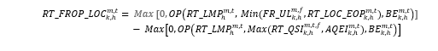  Where:  ‘${FR_UL}_{k}^{m,f}$’ = the forbidden region upper limit from forbidden region set ‘f’ where ${RT_QSI}_{k,h}^{m}$ <= ${FR_UL}_{k}^{m,f}$, as submitted by market participant ‘k’ for delivery point ‘m’ as daily dispatch data;  ‘${FR_LL}_{k}^{m,f}$’ = the forbidden region lower limit from forbidden region set ‘f’ where ${RT_QSI}_{k,h}^{m}$ > ${FR_LL}_{k}^{m,f}$, as submitted by market participant ‘k’ for delivery point ‘m’ as daily dispatch data; and  ‘f’ = (1…N) of the forbidden region set {${FR_UL}_{k}^{m,f}$, ${FR_LL}_{k}^{m,f}$} and N is the maximum number of forbidden regions submitted by market participant ‘k’ for delivery point ‘m’ as daily dispatch data.  Otherwise ${RT_FROP_LOC}_{k,h}^{m,t}$ shall equal zero.  Dispatchable Generation Resources that are Pseudo-Units: Combustion Turbine  Dispatchable Generation Resources that are Pseudo-Units: Steam Turbine  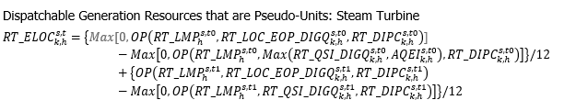  Where:  t0 = metering interval ‘t’ in settlement hour ‘‘h’ when none of the combustion turbine resources associated with the steam turbine resources have a real-time schedule that is less than its respective minimum loading point; and  t1 = metering interval ‘t’ in settlement hour ‘‘h’ when (1) at least one combustion turbine resource associated with the steam turbine resource has a real-time schedule greater than or equal to its minimum loading point; and (2) at least one of the combustion turbine resources associated with the steam turbine resource has a real-time schedule that is less than its respective minimum loading point.  Note: For greater certainty, ‘t1’ and ‘t0’ metering intervals are mutually exclusive, and the calculation will be conducted using either the ‘t1’ or ‘t0’ variables, depending on whether the relevant metering interval meets the criteria of ‘t1’ or ‘t0’, respectively. | Interval | Due MP | 13 | N/A | N/A | N/A
1904  MRP new | Real-Time Make-Whole Payment – Lost Opportunity Cost for Energy  (RT_MWP – RT_ELOC) | MR Ch.9 s.3.5.7 | Dispatchable Loads and Dispatchable Electricity Storage Resources that are Registered to Withdraw  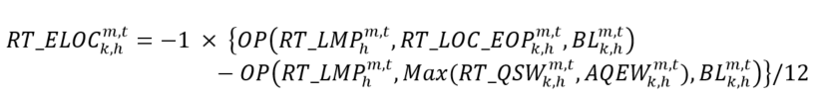 | Interval | Due MP | 13 | N/A | N/A | N/A
1905  MRP new | Real-Time Make-Whole Payment – Lost Opportunity Cost for 10-Minute Spinning Reserve  (RT_MWP – RT_OLOC) | MR Ch.9 ss.3.5.6, 3.5.9, and 3.5.10 | Dispatchable Generation Resources that are not Pseudo-Units and Dispatchable Electricity Storage Resources that are Registered to Inject  Where:  if the dispatchable generation resource is registered as a hydroelectric generation resource and ${RT_QSI}_{k,h}^{m,t}$ is greater than ${FR_LL}_{k}^{m,f}$, and ${RT_QSI}_{k,h}^{m,t}$is less than or equal to ${FR_UL}_{k}^{m,f},$then  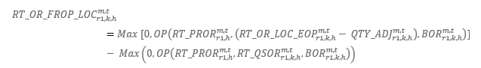  Where:  - ${QTY_ADJ}_{r1,k,h}^{m,t} =Max\left({0,QTY_DIFF}_{r1,k,h}^{m,t}- {FR_QTY_AVAIL}_{r1,k,h}^{m,t}\right)$  - ${QTY_DIFF}_{r1,k,h}^{m,t} = {RT_OR_LOC_EOP}_{r1,k,h}^{m,t}- {RT_QSOR}_{r1,k,h}^{m,t}$  - ${FR_QTY_AVAIL}_{r1,k,h}^{m,t} =Max\left[0, Max\left({DAM_QSI}_{k,h}^{m}, Min\left({RT_QSI}_{k,h}^{m,t} , {AQEI}_{k,h}^{m,t}\right)\right)-Max\left({FR_LL}_{k,h}^{m,t}, {DAM_QSI}_{k,h}^{m},{RT_LC_EOP}_{k,h}^{m,t}\right)\right]$  - ‘${FR_LL}_{k}^{m,f}$’ is the forbidden region lower limit from forbidden region set ‘f’ where ${\text{RT_QSI}}_{\text{k, h}}^{\text{m,t}}$> ${FR_LL}_{k}^{m,f}$, as submitted by market participant ‘k’ for delivery point ‘m’ as daily dispatch data.  - ‘f’ = (1…N) of the forbidden region set {${FR_UL}_{k}^{m,f}$, ${FR_LL}_{k}^{m,f}$} and ‘N’ is the maximum number of forbidden regions submitted by market participant ‘k’ for delivery point ‘m’ as daily dispatch data.  Dispatchable Generation Resources that are Pseudo-Units: Combustion Turbine  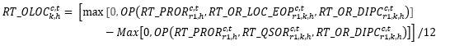  Dispatchable Generation Resources that are Pseudo-Units: Steam Turbine  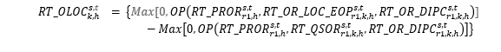 | Interval | Due MP | 13 | N/A | N/A | N/A
1905  MRP new | Real-Time Make-Whole Payment – Lost Opportunity Cost for 10-Minute Spinning Reserve  (RT_MWP – RT_OLOC) | MR Ch.9 s.3.5.7 | Dispatchable Loads and Dispatchable Electricity Storage Resources that are Registered to Withdraw  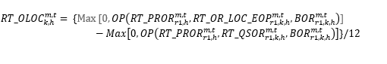I | Interval | Due MP | 13 | N/A | N/A | N/A
1906  MRP new | Real-Time Make-Whole Payment – Lost Opportunity Cost for 10-Minute Non-Spinning Reserve  (RT_MWP – RT_OLOC) | MR Ch.9 ss.3.5.6, 3.5.9, and 3.5.10 | Dispatchable Generation Resources that are not Pseudo-Units and Dispatchable Electricity Storage Resources that are Registered to Inject  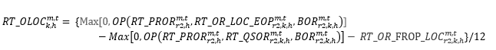  Where:  if the dispatchable generation resource is registered as a hydroelectric generation resource and ${RT_QSI}_{k,h}^{m,t}$ is greater than ${FR_LL}_{k}^{m,f}$, and ${RT_QSI}_{k,h}^{m,t}$is less than or equal to ${FR_UL}_{k}^{m,f},$then  $${RT_OR_FROP_LOC}_{r2,k,h}^{m,t} =Max[0,OP\left({RT_PROR}_{r2,h}^{m,t},\left({RT_OR_LOC_EOP}_{r2,k,h}^{m,t}- {QTY_ADJ}_{r2,k,h}^{m,t}\right), {BOR}_{r2,k,h}^{m,t}\right)] - Max\left(0, OP\left({RT_PROR}_{r2,h}^{m,t},{RT_QSOR}_{r2,k,h}^{m,t},{BOR}_{r2,k,h}^{m,t}\right)\right)$$  Where:  - ${QTY_ADJ}_{r2,k,h}^{m,t} =Max\left({0,QTY_DIFF}_{r2,k,h}^{m,t}- {FR_QTY_AVAIL}_{r2,k,h}^{m,t}\right)$  - ${QTY_DIFF}_{r2,k,h}^{m,t} = {RT_OR_LOC_EOP}_{r2,k,h}^{m,t}- {RT_QSOR}_{r2,k,h}^{m,t}$  - ${FR_QTY_AVAIL}_{r2,k,h}^{m,t} = {FR_QTY_AVAIL}_{r1,k,h}^{m,t}- \left({RT_OR_LOC_EOP}_{r1,k,h}^{m,t}- {QTY_ADJ}_{r1,k,h}^{m,t}- {RT_QSOR}_{r1,k,h}^{m,t}\right)$  - ‘${FR_LL}_{k}^{m,f}$’ is the forbidden region lower limit from forbidden region set ‘f’ where ${\text{RT_QSI}}_{\text{k, h}}^{\text{m,t}}$> ${FR_LL}_{k}^{m,f}$, as submitted by market participant ‘k’ for delivery point ‘m’ as daily dispatch data.  - ‘f’ = (1…N) of the forbidden region set {${FR_UL}_{k}^{m,f}$, ${FR_LL}_{k}^{m,f}$} and ‘N’ is the maximum number of forbidden regions submitted by market participant ‘k’ for delivery point ‘m’ as daily dispatch data.  Dispatchable Generation Resources that are Pseudo-Units: Combustion Turbine  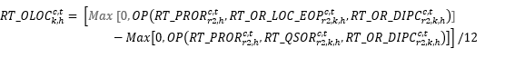  Dispatchable Generation Resources that are Pseudo-Units: Steam Turbine | Interval | Due MP | 13 | N/A | N/A | N/A
1906  MRP new | Real-Time Make-Whole Payment – Lost Opportunity Cost for 10-Minute Non-Spinning Reserve  (RT_MWP – RT_OLOC) | MR Ch.9 s.3.5.7 | Dispatchable Loads and Dispatchable Electricity Storage Resources that are Registered to Withdraw  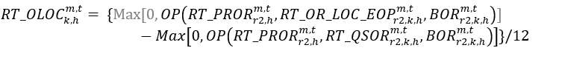 | Interval | Due MP | 13 | N/A | N/A | N/A
1907  MRP new | Real-Time Make-Whole Payment – Lost Opportunity Cost for 30-Minute Operating Reserve  (RT_MWP – RT_OLOC) | MR Ch.9 ss.3.5.6, 3.5.9, and 3.5.10 | Dispatchable Generation Resources that are not Pseudo-Units and Dispatchable Electricity Storage that are Registered to Inject  Where:  if the dispatchable generation resource is registered as a hydroelectric generation resource and ${RT_QSI}_{k,h}^{m,t}$ is greater than ${FR_LL}_{k}^{m,f}$, and ${RT_QSI}_{k,h}^{m,t}$is less than or equal to ${FR_UL}_{k}^{m,f},$then  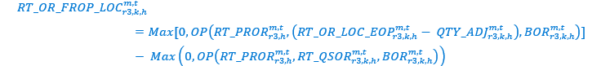  Where:  - ${QTY_ADJ}_{r3,k,h}^{m,t} =Max\left({0,QTY_DIFF}_{r3,k,h}^{m,t}- {FR_QTY_AVAIL}_{r3,k,h}^{m,t}\right)$  - ${QTY_DIFF}_{r3,k,h}^{m,t} = {RT_OR_LOC_EOP}_{r3,k,h}^{m,t}- {RT_QSOR}_{r3,k,h}^{m,t}$  - ${FR_QTY_AVAIL}_{r3,k,h}^{m,t} = {FR_QTY_AVAIL}_{r2,k,h}^{m,t}- \left({RT_OR_LOC_EOP}_{r2,k,h}^{m,t}- {QTY_ADJ}_{r2,k,h}^{m,t}- {RT_QSOR}_{r2,k,h}^{m,t}\right)$  - ‘${FR_LL}_{k}^{m,f}$’ is the forbidden region lower limit from forbidden region set ‘f’ where ${\text{RT_QSI}}_{\text{k, h}}^{\text{m,t}}$> ${FR_LL}_{k}^{m,f}$, as submitted by market participant ‘k’ for delivery point ‘m’ as daily dispatch data.  - ‘f’ = (1…N) of the forbidden region set {${FR_UL}_{k}^{m,f}$, ${FR_LL}_{k}^{m,f}$} and ‘N’ is the maximum number of forbidden regions submitted by market participant ‘k’ for delivery point ‘m’ as daily dispatch data.  Dispatchable Generation Resources that are Pseudo-Units: Combustion Turbine  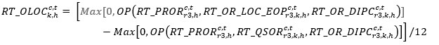  Dispatchable Generation Resources that are Pseudo-Units: Steam Turbine | Interval | Due MP | 13 | N/A | N/A | N/A
1907  MRP new | Real-Time Make-Whole Payment – Lost Opportunity Cost for 30-Minute Operating Reserve  (RT_MWP – RT_OLOC) | MR Ch.9 s.3.5.7 | Dispatchable Loads and Dispatchable Electricity Storage Resources that are Registered to Withdraw  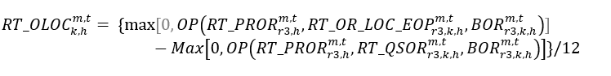 | Interval | Due MP | 13 | N/A | N/A | N/A
1908  MRP new | Real-Time Make-Whole Payment - Operating Reserve Non-Accessibility Lost Cost Reversal  (RT_MWP - RT_OLC_RC) | MRs Ch.9 ss.3.10.2, 3.10.4, 3.10.5, 3.10.18, 3.10.21,  3.10.24 | Dispatchable Loads, Dispatchable Electricity Storage Resources, and Dispatchable Generation Resources that are not Pseudo-Units  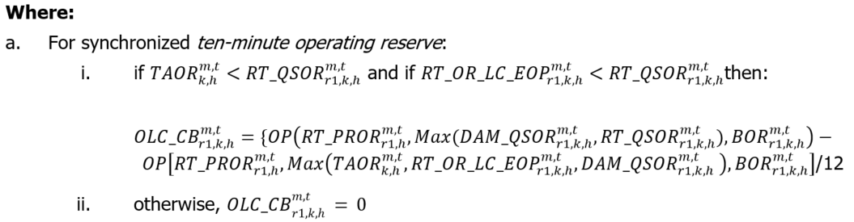  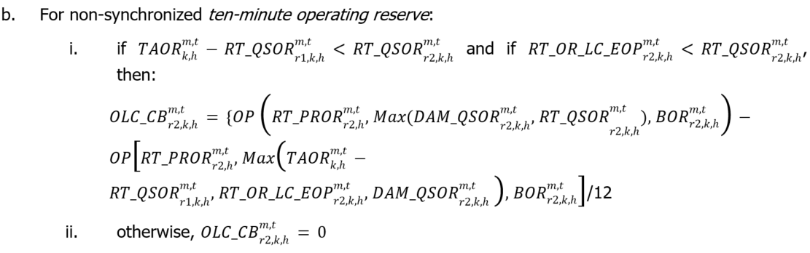  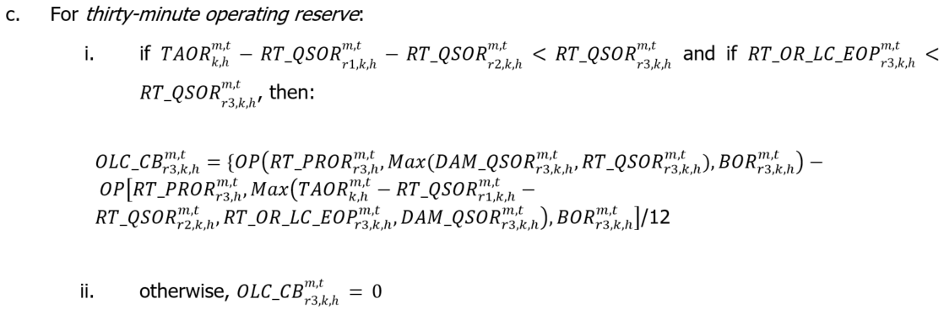  Dispatchable Generation Resources that are Pseudo-Units  Combustion turbine resource:  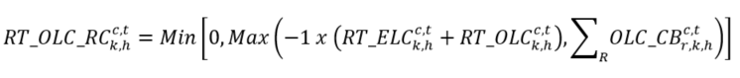  Where:  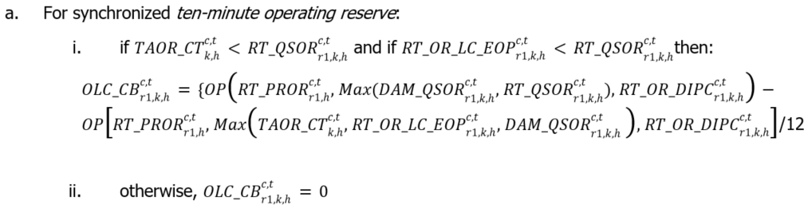  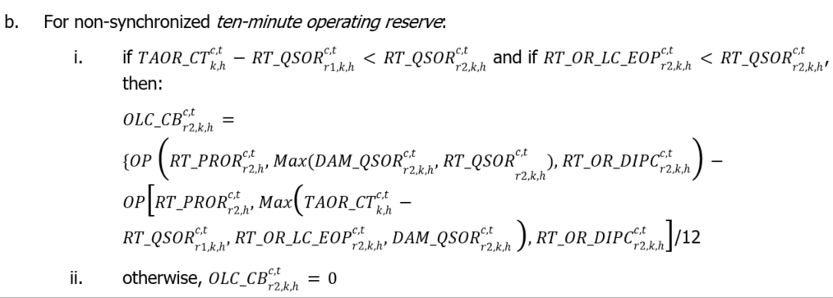  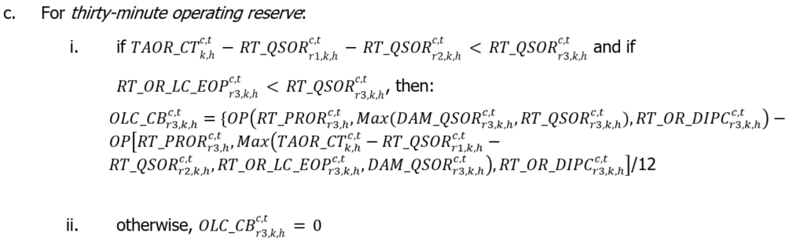  Steam turbine resource:  Where:  For synchronized ten-minute operating reserve:  if ${TAOR_ST}_{k, h}^{s, t}<{RT_QSOR}_{r1, k, h}^{s, t}$ and if  ${RT_OR_LC_EOP}_{r1, k, h}^{s, t}<{RT_QSOR}_{r1, k, h}^{s, t}$then:  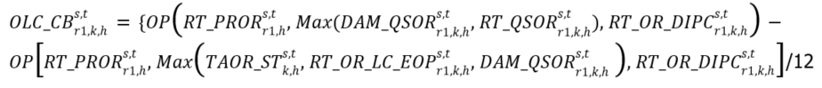  otherwise, ${OLC_CB}_{r1, k, h}^{s, t}=0$  For non-synchronized ten-minute operating reserve:  if ${TAOR_ST}_{k, h}^{s, t}-{RT_QSOR}_{r1, k, h}^{s, t}<{RT_QSOR}_{r2, k, h}^{s, t}$ and if ${RT_OR_LC_EOP}_{r2, k, h}^{, t}<{RT_QSOR}_{r2, k, h}^{s, t}$, then:  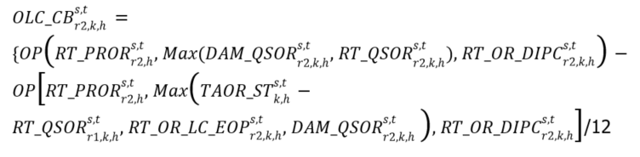  otherwise, ${OLC_CB}_{r2, k, h}^{s, t}=0$  For thirty-minute operating reserve:  if ${TAOR_ST}_{k, h}^{s, t}-{RT_QSOR}_{r1, k, h}^{s, t}-{RT_QSOR}_{r2, k, h}^{s, t}<{RT_QSOR}_{r3, k, h}^{s, t}$and if  ${RT_OR_LC_EOP}_{r3, k, h}^{s, t}<{RT_QSOR}_{r3, k, h}^{s, t}$, then:  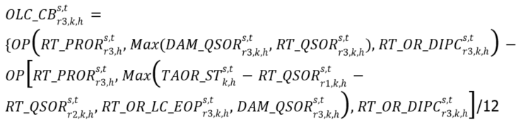  otherwise, ${OLC_CB}_{r3, k, h}^{s, t}=0$ | Interval | Due IESO | 13 | N/A | N/A | N/A
1909  MRP new | Real-Time Make-Whole Payment - Operating Reserve Non-Accessibility Lost Opportunity Cost Reversal  (RT_MWP - RT_OLOC_RC) | MRs Ch.9 ss.3.10.2, 3.10.4, 3.10.5, 3.10.19, 3.10.22, 3.10.25 | Dispatchable Loads, Dispatchable Electricity Storage Resources and Dispatchable Generation Resources that are not Pseudo-Units  Where:  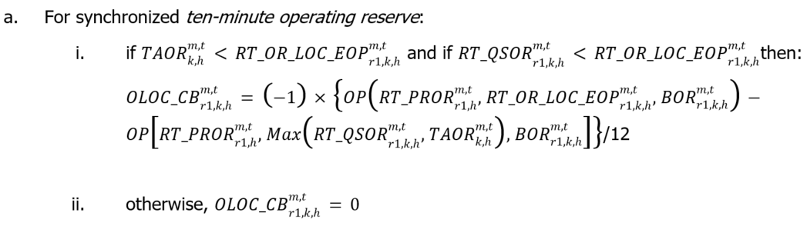  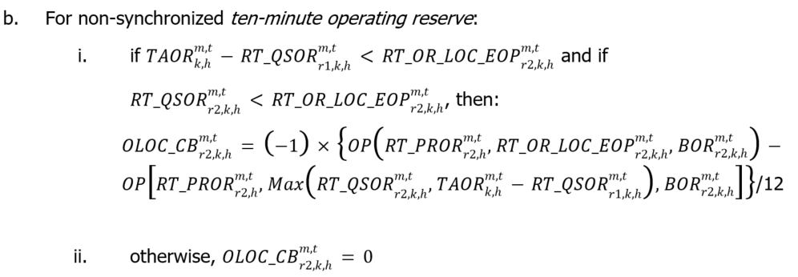  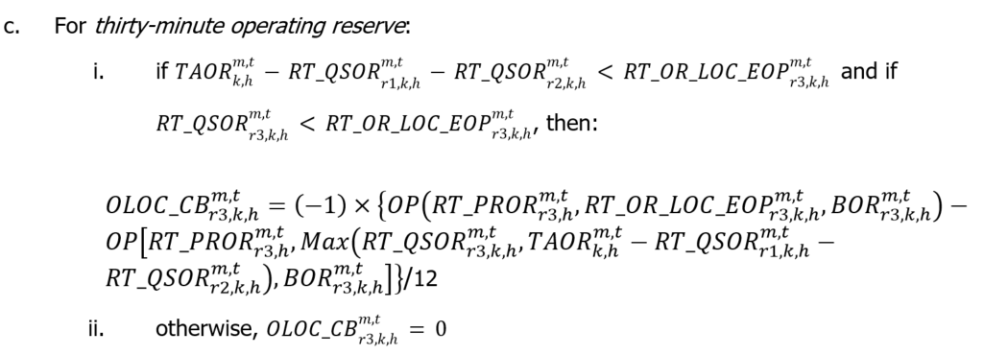  Dispatchable Generation Resources that are Pseudo-Units  Combustion turbine resource:  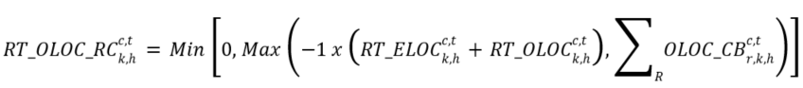  Where:  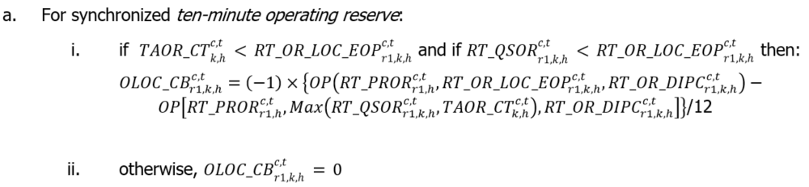  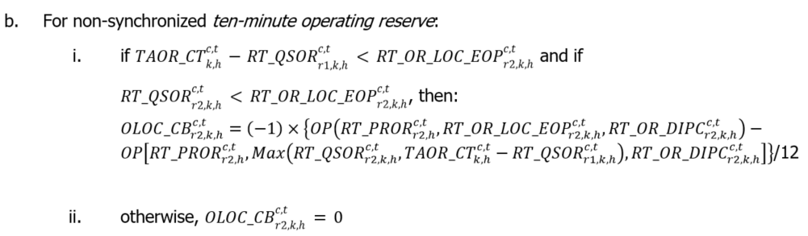  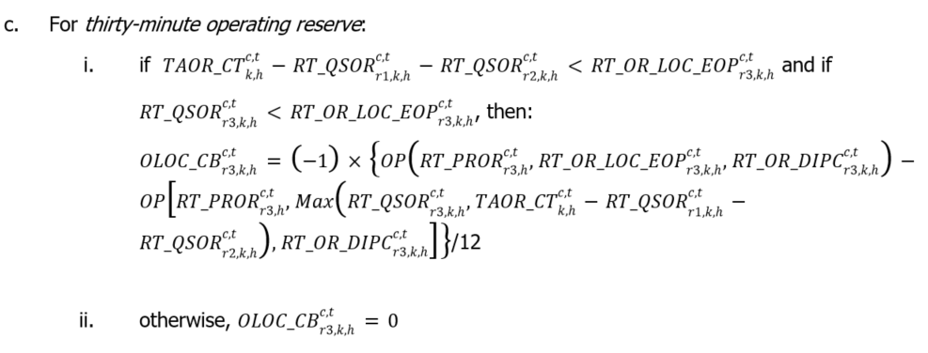  Steam turbine resource:  Where:  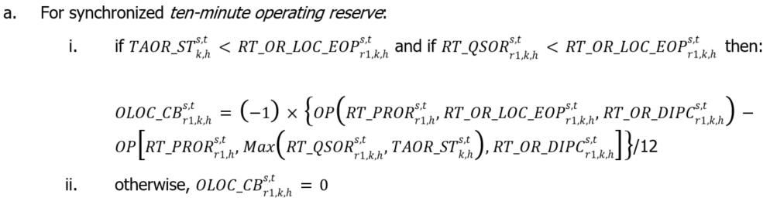  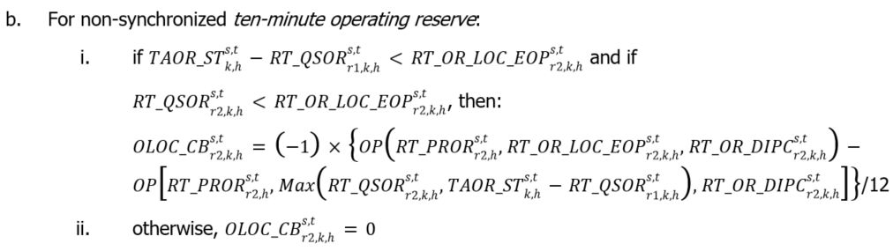  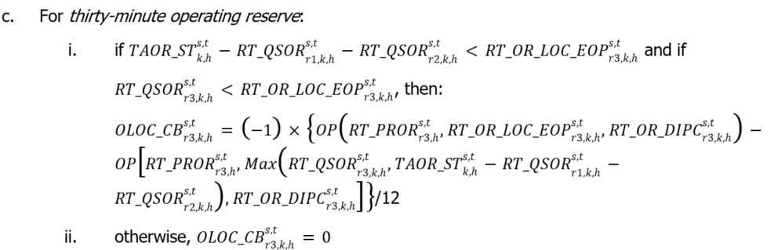 | Interval | Due IESO | 13 | N/A | N/A | N/A
1910  MRP new | Real-Time Generator Offer Guarantee – Energy  (RT_GOG – RT_GOG_COMP1)  Component 1 | MR Ch.9 ss.4.5.6, 4.5.15, and 4.5.22 | GOG-eligible Resources that are not Pseudo-Units  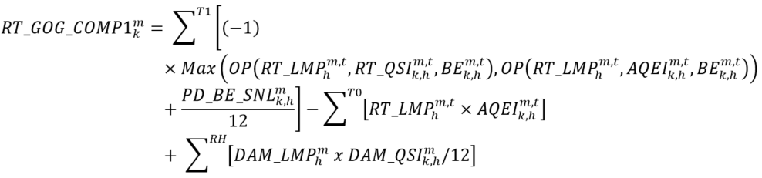  Where:  T1 = the set of contiguous metering intervals ‘t’ within the real-time commitment period or the real-time reliability commitment period, as the case may be;  T0 = the set of all metering intervals between the time when the resource is synchronized and injecting energy into the IESO-controlled grid and the time when the resource achieves its minimum loading point;  RH = the set of contiguous settlement hours ‘h’ with day-ahead schedules for the ramp-up period in the day-ahead market that do not overlap with a pre-dispatch operational commitment; and  if the combustion turbine resource or steam turbine resource is registered as a pseudo-unit but is not operating as a pseudo-unit and has a minimum constraint applied for combined cycle operation consistent with combustion turbine commitment, then ${RT_QSI}_{k,h}^{m,t}$ will be replaced with $RT_LC{_EOP}_{k,h}^{m,t}$ for those metering intervals in which they have such constraint.  GOG-eligible Resources that are Pseudo-Units: Combustion Turbine  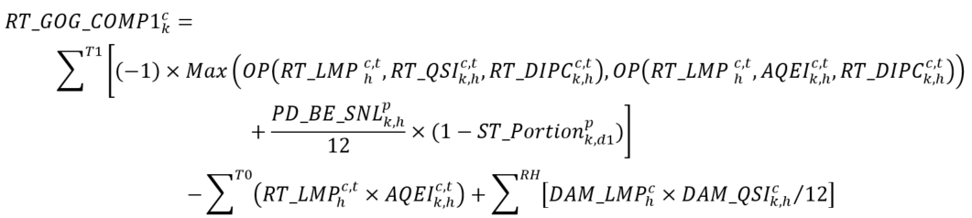  Where:  T1 = the set of contiguous metering intervals ‘t’ within the real-time commitment period or the real-time reliability commitment period, as the case may be, for the combustion turbine resource;  p = the pseudo-unit associated with combustion turbine resource delivery point ‘c’;  T0 = the set of all metering intervals ‘t’ between the time when the combustion turbine resource is synchronized and injecting energy into the IESO-controlled grid and the time when the combustion turbine resource achieves its minimum loading point; and  RH = the set of contiguous settlement hours ‘h’ with day-ahead schedules for the ramp-up period in the day-ahead market that do not overlap with a pre-dispatch operational commitment.  GOG-eligible Resources that are Pseudo-Units: Steam Turbine  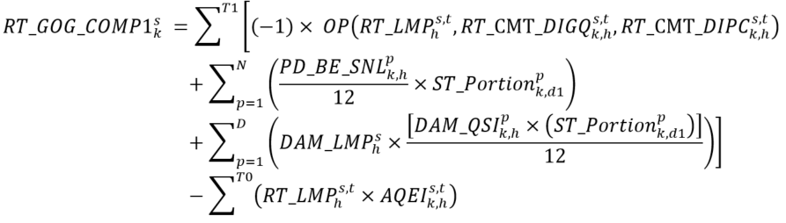  Where:  T1 = the set of all metering intervals ‘t’ in the steam turbine resource’s real-time commitment period where at least one of the associated pseudo-units‘ real-time schedule is greater than or equal to its minimum loading point in accordance with a pre-dispatch operational commitment;  N = the set of all pseudo-units ‘p’ associated with steam turbine resource delivery point ‘s’ that are eligible for a real-time generator offer guarantee settlement amount in metering interval ‘t’ of settlement hour ‘h’;  D = the set of all pseudo-units ‘p’ associated with steam turbine resource delivery point ‘s’ that have: (i) a pre-dispatch operational commitment greater than its minimum loading point in metering interval ‘t’; (ii) an associated combustion turbine resource that is injecting energy into the IESO-controlled grid in an amount greater than or equal to its minimum loading point in metering interval ‘t’; and (iii) a day-ahead schedule less than its minimum loading point in metering interval ‘t’; and  T0 = the set of all metering intervals ‘t’ in the steam turbine resource’s real-time commitment period when: (i) the steam turbine resource is injecting energy into the IESO-controlled grid in an amount that is less than its 1-on-1 minimum loading point; and (ii) none of the associated pseudo-units have a day-ahead schedule. | Interval | Either Way | 13 | N/A | N/A | N/A
1911  MRP new | Real-Time Generator Offer Guarantee – Operating Reserve  (RT_GOG – RT_GOG_COMP2)  Component 2 | MR Ch.9 ss. 4.5.7, 4.5.16, and 4.5.23 | GOG-eligible Resources that are not Pseudo-Units  Where:  T1 = the set of contiguous metering intervals ‘t’ within the real-time commitment period or the real-time reliability commitment period, as the case may be.  GOG-eligible Resources that are Pseudo-Units: Combustion Turbine  Where:  T1 = the set of contiguous metering intervals ‘t’ within the real-time commitment period or the real-time reliability commitment period, as the case may be, for the combustion turbine resource.  GOG-eligible Resources that are Pseudo-Units: Steam Turbine  Where:  T1 = the set of all metering intervals ‘t’ in the steam turbine resource’s real-time commitment period where at least one of the associated pseudo-units is greater than or equal to its minimum loading point in accordance with a pre-dispatch operational commitment. | Interval | Either Way | 13 | N/A | N/A | N/A
1912  MRP new | Real-Time Generator Offer Guarantee – Over Midnight  (RT_GOG – RT_GOG_COMP3)  Component 3 | MR Ch.9 ss.4.5.8, 4.5.17, and 4.5.24 | NOTE: this charge type has -1 added before the summation sign as it has been separated from the larger RT_GOG equation within the market rules, in which this component would have been subtracted from the total settlement amount.  GOG-eligible Resources that are not Pseudo-Units  Where:  T2 = the set of contiguous metering intervals ‘t’ beginning with the first metering interval of Day 1 and ending with the metering interval in Day 1 in which the resource completes its minimum generation block run-time that began in Day 0; and  ${\text{MLP}}_{\text{k}}^{\text{m}}$= the minimum loading point of the resource for Day 1 for market participant ‘k’ for delivery point ‘m’.  GOG-eligible Resources that are Pseudo-Units: Combustion Turbine  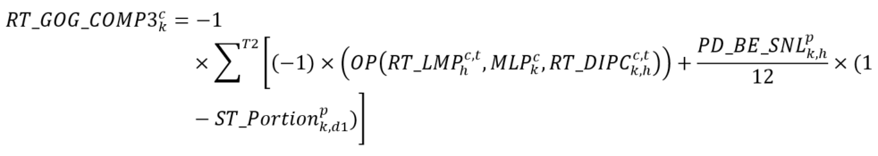  Where:  T2 = the set of contiguous metering intervals ‘t’ beginning with the first metering interval of Day 1 and ending with the metering interval in Day 1 in which the resource completes its minimum generation block run-time that began in Day 0;  ${\text{MLP}}_{\text{k}}^{\text{c}}$= the minimum loading point of the combustion turbine resource associated with combustion turbine resource delivery point ‘c’; and  p = the pseudo-unit associated with combustion turbine resource delivery point ‘c’.  GOG-eligible Resources that are Pseudo-Units: Steam Turbine  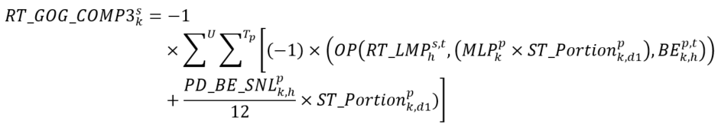  Where:  U = the set of all pseudo-units ‘p’ associated with steam turbine resource delivery point ‘s’ that have a real-time schedule in the first settlement hour of Day 1 to complete its minimum generation block run-time as part of a pre-dispatch operational commitment that began in Day 0 and forms part of the steam turbine resource’s real-time commitment period;  Tp = the set of metering intervals ‘t’ where: (i) the associated pseudo-unit had a real-time schedule in the first settlement hour of Day 1 to complete its minimum generation block run-time; and (ii) the combustion turbine resource associated with pseudo-unit ‘p’ actually injected energy into the IESO-controlled grid in an amount equal to or greater than its minimum loading point; and  ${\text{MLP}}_{\text{k}}^{\text{p}}$= the minimum loading point of pseudo-unit 'p’ for market participant ‘k’ for Day 1. | Interval | Either Way | 13 | N/A | N/A | N/A
1913  MRP new | Real-Time Generator Offer Guarantee – Start-up  (RT_GOG – RT_GOG_COMP4)  Component 4 | MR Ch. ss.4.5.9, 4.5.18, and 4.5.25 | GOG-eligible Resources that are not Pseudo-Units  achieves minimum loading point within the first six metering intervals of the start of its minimum generation block run-time:  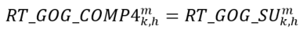  achieves minimum loading point after the first six metering intervals of the start of its minimum generation block run-time but before the 19th metering interval following the start of its minimum generation block run-time:  Where N_INT = the number of metering intervals after the first six metering intervals that the resource took to achieve its minimum loading point.  otherwise: $RT{_GOG_COMP4}_{k,h}^{m}=0$  In determining ${RT_GOG_SU}_{k,h}^{m}$, if the resource:  has either (a) a stand-alone pre-dispatch operational commitment; or (b) an advanced pre-dispatch operational commitment, that extends for longer than or equal to the resource’s minimum generation block run-time plus its minimum generation block down-time for the hot thermal state, then:  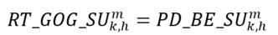  receives an advanced pre-dispatch operational commitment that extends for a period that is less than the resource’s minimum generation block run-time plus its minimum generation block down-time for the hot thermal state, then:  otherwise, ${RT_GOG_SU}_{k,h}^{m}=0$  GOG-eligible Resources that are Pseudo-Units: Combustion Turbine  For a pre-dispatch operational commitment where the associated pseudo-unit has a stand-alone pre-dispatch operational commitment or where the associated pseudo-unit receives a pre-dispatch operational commitment in advance of an existing day-ahead market operational commitment by a period that is greater than or equal to the resource’s minimum generation block run-time plus its minimum generation block down-time for the hot thermal state:  if the combustion turbine resource achieved its minimum loading point within the first six metering intervals of the start of the pre-dispatch operational commitment:  if the combustion turbine resource achieved its minimum loading point after the first six metering intervals of the start of its pre-dispatch operational commitment but before the 19th metering interval following the start of its pre-dispatch operational commitment:  Where: ${N_INT}_{k}^{c}$ = the number of metering intervals after the first six metering intervals that the combustion turbine resource took to achieve its minimum loading point.  otherwise, $RT_{GOG_COMP4}_{k}^{c}=0$  For a pre-dispatch operational commitment where the associated pseudo-unit has a pre-dispatch operational commitment in advance of an existing day-ahead market operational commitment by a period that is less than the resource’s minimum generation block run-time plus its minimum generation block down-time for the hot thermal state:  if the combustion turbine resource achieved its minimum loading point within the first six metering intervals of the start of the pre-dispatch operational commitment:  if the combustion turbine resource achieved its minimum loading point after the first six metering intervals of the start of its pre-dispatch operational commitment but before the 19th metering interval following the start of its pre-dispatch operational commitment:  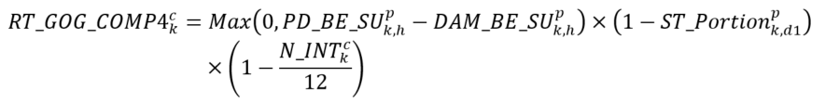  Where: ${N_INT}_{k}^{c}$ = the number of metering intervals after the first six metering intervals that the combustion turbine resource took to achieve its minimum loading point.  otherwise, $RT_{GOG_COMP4}_{k}^{c}=0$  GOG-eligible Resources that are Pseudo-Units: Steam Turbine  Where:  C = the set of all combustion turbine resource delivery points 'c’ associated with steam turbine resource delivery point ‘s’;  ${\text{RT_GOG_COMP4}}_{\text{k,x}}^{\text{c}}$= determined in accordance with MR Ch.9 s.4.5.18 for combustion turbine resource delivery point ‘‘c’ for market participant ‘k’ for day-ahead commitment period ‘x’; and  Xc = the set of all pre-dispatch operational commitments 'x’ that are classified as variant 1 and were incurred by combustion turbine resource ‘c’ during the steam turbine resource’s real-time commitment period. | Interval | Due MP | 13 | N/A | N/A | N/A
1914  MRP new | Real-Time Generator Offer Guarantee – RT Make-Whole Payment Offset  (RT_GOG – RT_GOG_COMP5)  Component 5 | MR Ch.9 ss.4.5.11, 4.5.20, and 4.5.26 | NOTE: this charge type has -1 added before the summation sign as it has been separated from the larger RT_GOG equation within the market rules, in which this component would have been subtracted from the total settlement amount.  GOG-eligible Resources that are not Pseudo-Units  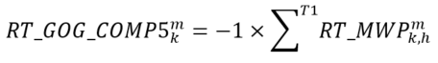  Where:  T1 = the set of contiguous metering intervals ‘t’ within the real-time commitment period or the real-time reliability commitment period, as the case may be.  GOG-eligible Resources that are Pseudo-Units: Combustion Turbine  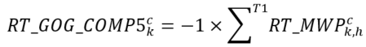  Where:  T1 = the set of contiguous metering intervals ‘t’ within the real-time commitment period or the real-time reliability commitment period, as the case may be, for the combustion turbine resource.  GOG-eligible Resources that are Pseudo-Units: Steam Turbine  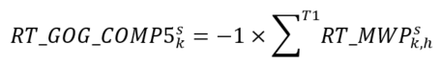  Where:  T1 = the set of all metering intervals ‘t’ in the steam turbine resource’s real-time commitment period where at least one of the associated pseudo-units is greater than or equal to its minimum loading point in accordance with a pre-dispatch operational commitment. | Interval | Due IESO | 13 | N/A | N/A | N/A
1915  MRP new | Real-Time Generator Offer Guarantee – Operating Reserve Non-Accessibility Reversal  (RT_GOG - RT_GOG_CB) | MRs Ch.9 ss.3.10.3, 3.10.4, 3.10.5, 3.10.26-3.10.34 | GOG-eligible Resources that are not Pseudo-Units  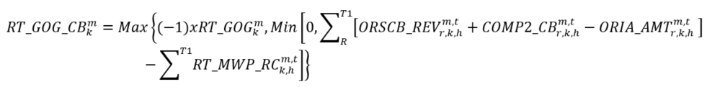  Where:  T1 = the set of all metering intervals ‘t’ beginning from the first metering interval that the generation unit is at minimum loading point within a real-time commitment period or a real-time reliability commitment period until the last metering interval that the generation unit is at minimum loading point within such real-time commitment period or a real-time reliability commitment period, as applicable;  ${RT_MWP_RC}_{k,h}^{m,t}$ = the real-time make-whole payment reversal charge settlement amount determined in accordance with MR Ch.9 ss.3.10.17-3.10.19 for charge types 1908 and 1909;  ${RSCB_REV}_{r,k, h}^{m, t}$ = (-1) x ${ORSCB}_{r,k, h}^{m, t}$  ${COMP2_CB}_{r, k, h}^{m, t}$ and ${ORIA_AMT}_{r, k, h}^{m, t}$ are calculated as follows:  For synchronized ten-minute operating reserve  if ${TAOR}_{k, h}^{m, t}<{RT_QSOR}_{r1, k, h}^{m, t}$, then  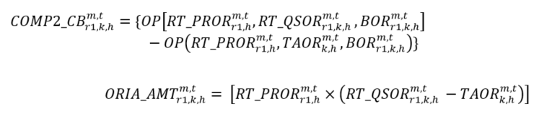  otherwise, ${COMP2_CB}_{r1, k, h}^{m, t}=0$ and ${ORIA_AMT}_{r1, k, h}^{m, t}= 0$  For non-synchronized ten-minute operating reserve  if ${TAOR}_{k, h}^{m, t}-{RT_QSOR}_{r1, k, h}^{m, t}<{RT_QSOR}_{r2, k, h}^{m, t}$, then  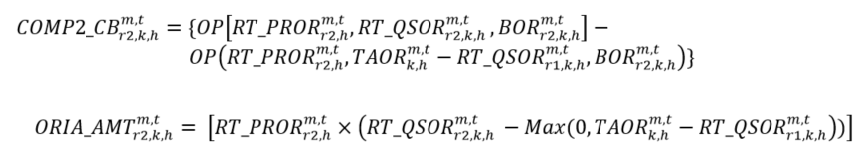  otherwise, ${COMP2_{CB}}_{r2, k, h}^{m, t}=0$ and ${ORIA_AMT}_{r2, k, h}^{m, t}= 0$  For thirty-minute operating reserve  if ${TAOR}_{k, h}^{m, t}-{RT_QSOR}_{r1, k, h}^{m, t}-{RT_QSOR}_{r2, k, h}^{m, t}<{RT_QSOR}_{r3, k, h}^{m, t}$, then  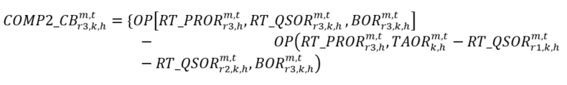  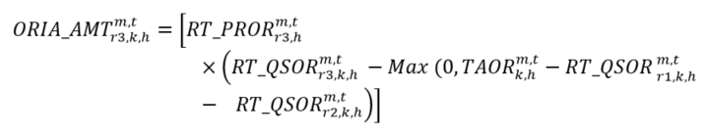  otherwise, ${COMP2_CB}_{r3, k, h}^{m, t}=0$ and ${ORIA_AMT}_{r3, k, h}^{m, t}= 0$  GOG-eligible Resources that are Pseudo-Units  Combustion turbine resource:  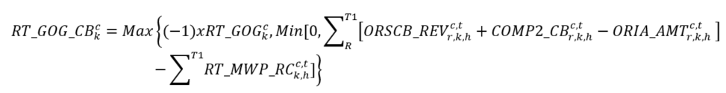  Where:  T1 = the set of all metering intervals ‘t’ beginning from the first metering interval that the combustion turbine resource is at minimum loading point within a real-time commitment period or a real-time reliability commitment period until the last metering interval that the combustion turbine resource is at minimum loading point within such real-time commitment period or a real-time reliability commitment period, as applicable;  ${RT_MWP_RC}_{k,h}^{c,t}$ = the real-time make-whole payment reversal charge settlement amount determined in accordance with MR Ch.9 ss.3.10.20-3.10.22 for charge types 1908 and 1909;  ${ORSCB_REV}_{r,k, h}^{c, t}$ = (-1) x ${ORSCB}_{r,k, h}^{c, t}$  ${COMP2_CB}_{r, k, h}^{c, t}$ and ${ORIA_AMT}_{r, k, h}^{c, t}$ are calculated as follows:  For synchronized ten-minute operating reserve  if ${TAOR_CT}_{k, h}^{c, t}<{RT_QSOR}_{r1, k, h}^{c, t}$, then  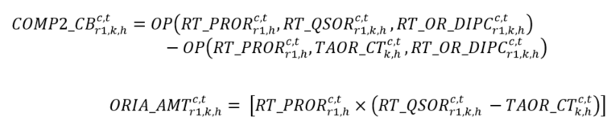  otherwise ${COMP2_CB}_{r1, k, h}^{c, t}=0$ and ${ORIA_AMT}_{r1, k, h}^{c, t}= 0$  For non-synchronized ten-minute operating reserve  if ${TAOR_CT}_{k, h}^{c, t}-{RT_QSOR}_{r1, k, h}^{c, t}<{RT_QSOR}_{r2, , h}^{c, t}$, then  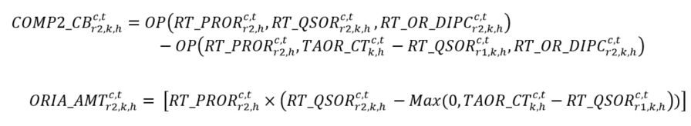  otherwise ${COMP2_CB}_{r2, k, h}^{c, t}=0$ and ${ORIA_AMT}_{r2, k, h}^{c, t}= 0$  For thirty-minute operating reserve  if ${TAOR_CT}_{k, h}^{c, t}-{RT_QSOR}_{r1, k, h}^{c, t}-{RT_QSOR}_{r2, k, h}^{c, t}<{RT_QSOR}_{r3, k, h}^{c, t}$, then  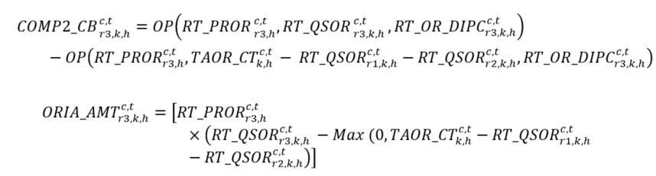  otherwise ${COMP2_CB}_{r3, k, h}^{c, t}=0$ and ${ORIA_AMT}_{r3, k, h}^{c, t}= 0$  Steam turbine resource:  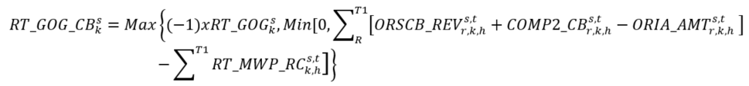  Where:  T1 = the set of all metering intervals ‘t’ beginning from the first metering interval that the steam turbine resource is at minimum loading point within a real-time commitment period or a real-time reliability commitment period until the last metering interval that the steam turbine resource is at minimum loading point within such real-time commitment period or a real-time reliability commitment period, as applicable;  ${RT_MWP_RC}_{k,h}^{s,t}$ = the real-time make-whole payment reversal charge settlement amount determined in accordance with MR Ch.9 ss.3.10.23-3.10.25 for charge types 1908 and 1909;  $${ORSCB_REV}_{k, h}^{s, t}={-1 × ORSCB}_{k, h}^{s, t}×\frac{\sum_{R}{{RT_OR_CMT_DIGQ}_{r, k, h}^{s, t}}}{\sum_{R}{{RT_SOR}_{, k, h}^{s, t}}}$$  $${RT_GOG_TAR_ST}_{k, h}^{s, t}={TAOR_ST}_{k, h}^{s, t}×\frac{\sum_{R}{{RT_OR_CMT_DIGQ}_{r, k, h}^{s, t}}}{\sum_{R}{{RT_QSOR}_{r, k, h}^{s, t}}}$$  ${COMP2_CB}_{r, k, h}^{s, t}$ and ${ORIA_AMT}_{r, k, h}^{s, t}$ are calculated as follows:  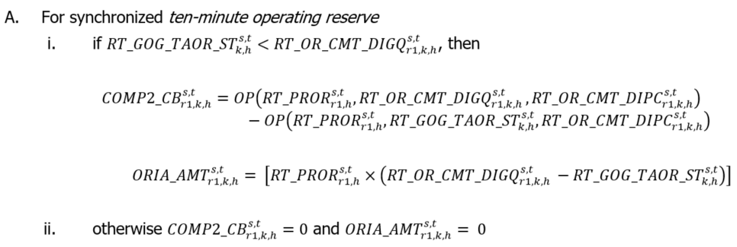  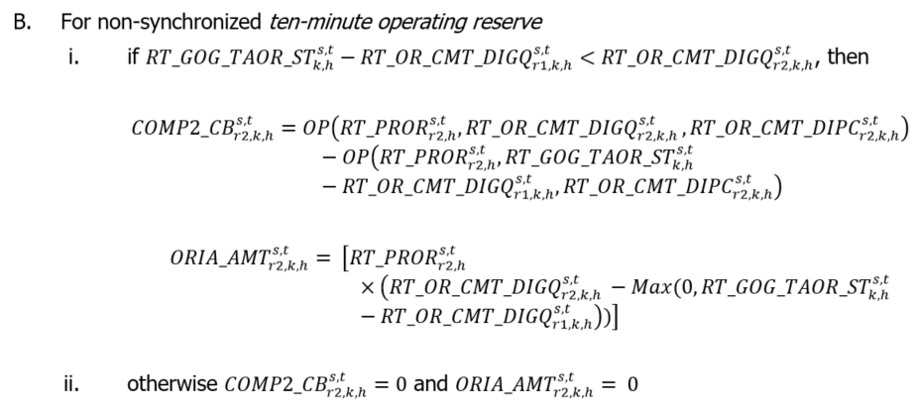  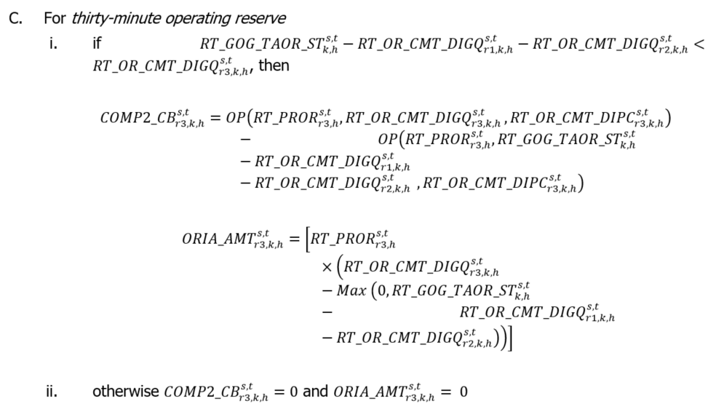 | Interval | Due IESO | 13 | N/A | N/A | N/A
1917  MRP new | Real-Time Ramp-Down Settlement Amount  (RT_RDSA) | MR Ch.9 s.4.6 | GOG-eligible Resources that are not Pseudo-Units  receives a real-time schedule less than its minimum loading point during a period when the GOG-eligible resource has a day-ahead schedule:  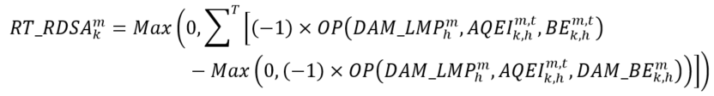  receives a real-time schedule less than its minimum loading point during a period when the GOG-eligible resource does not have a day-ahead schedule:  Where:  T = ramp-down period determined as the set of all metering intervals 't’ beginning with the first metering interval that the GOG-eligible resource is scheduled in the real-time market less than its minimum loading point and ends with the first metering interval following the start of ‘T’ in which the real-time schedule is zero or in which there is no real-time schedule; and  ${\text{BE}}_{\text{k,h}}^{\text{m,t}}$ = the matrix of ‘n’ price-quantity pairs offered by market participant ‘k’ to supply energy during the settlement hour ‘h’ determined in accordance with the applicable market manual, where price is adjusted by being multiplied by the ramp-down factor specified in the applicable market manual.  GOG-eligible Resources that are Pseudo-Units: Combustion Turbine  receives a real-time schedule less than its minimum loading point during a period when the GOG-eligible resource has a day-ahead schedule:  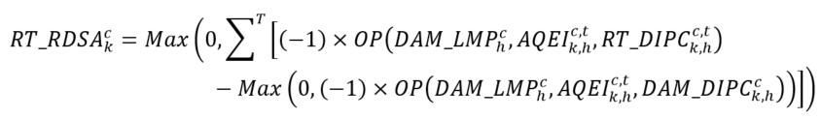  receives a real-time schedule less than its minimum loading point during a period when the GOG-eligible resource does not have a day-ahead schedule:  Where:  T = ramp-down period determined as the set of all metering intervals 't’ beginning with the first metering interval that the GOG-eligible resource is scheduled in the real-time market less than its minimum loading point and ends with the first metering interval following the start of ‘T’ in which the real-time schedule is zero or in which there is no real-time schedule; and  ${\text{RT_DIPC}}_{\text{k,h}}^{\text{c,t}}$ = the matrix of ‘n’ price-quantity pairs during the settlement hour ‘h’ determined in accordance with the applicable market manual, where price is adjusted by being multiplied by the ramp-down factor specified in the applicable market manual.  GOG-eligible Resources that are Pseudo-Units: Steam Turbine  receives a real-time schedule less than its 1-on-1 minimum loading point during a period when the GOG-eligible resource has a day-ahead schedule:  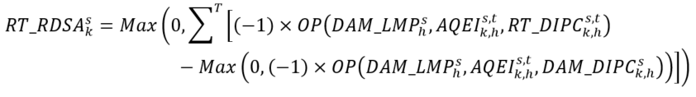  receives a real-time schedule less than its 1-on-1 minimum loading point during a period when the GOG-eligible resource does not have a day-ahead schedule:  Where:  T = ramp-down period determined as the set of all metering intervals 't’ beginning with the first metering interval that the GOG-eligible resource is scheduled in the real-time market less than its 1-on-1 minimum loading point and ends with the first metering interval following the start of ‘T’ in which the real-time schedule is zero or in which there is no real-time schedule; and  ${\text{RT_DIPC}}_{\text{k,h}}^{\text{s,t}}$ = the matrix of ‘n’ price-quantity pairs, during the settlement hour ‘h’ determined in accordance with the applicable market manual, where price is adjusted by being multiplied by the ramp-down factor specified in the applicable market manual. | Interval | Due MP | 13 | N/A | N/A | N/A
1920  MRP new | Generator Failure Charge – Market Price Component  (GFC_MPC) | MR Ch.9 ss.4.10.5, 4.10.8, and 4.10.9 | GOG-eligible Resources that are not Pseudo-Units  if the market participant provides less than four hours of advance notice of a given generator failure or fails to provide such notice:  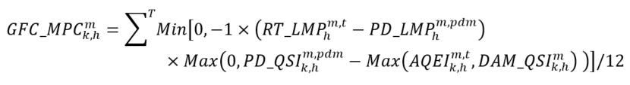  if the market participant provides four hours or greater advance notice of a given generator failure:  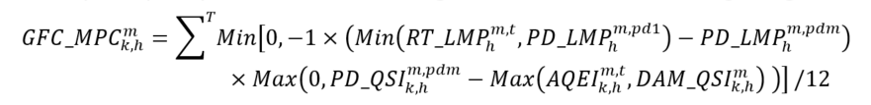  Where:  T = the set of all metering intervals within settlement hour ‘h’ during which a generator failure is determined, in accordance with the applicable market manual, to have occurred at delivery point ‘m’.  GOG-eligible Resources that are Pseudo-Units: Combustion Turbine  if the market participant provides less than four hours of advance notice of a given generator failure or fails to provide such notice:  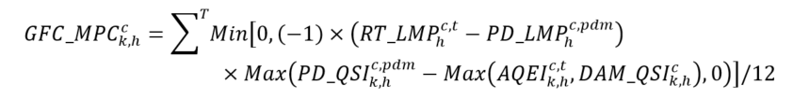  if the market participant provides four hours or greater advance notice of a given generator failure:  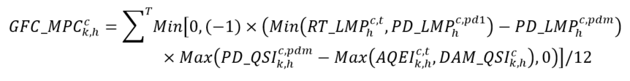  Where:  T = the set of all metering intervals at within settlement hour ‘h’ during which a generator failure is determined, in accordance with the applicable market manual, to have occurred at combustion turbine resource delivery point ‘c’.  GOG-eligible Resources that are Pseudo-Units: Steam Turbine  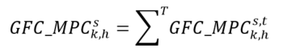  if the market participant provides less than four hours of advance notice of a given generator failure or fails to provide such notice:  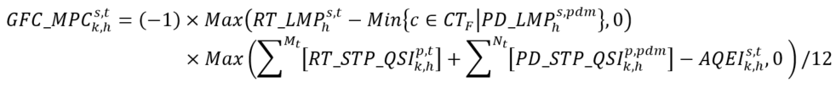  if the market participant provides four hours or greater advance notice of a given generator failure:  Where:  T = the set of all metering intervals within settlement hour ‘h’ during which a generator failure is determined, in accordance with the applicable market manual, to have occurred at steam turbine resource delivery point ‘s’ .  CTF = the set of all combustion turbine resources associated with steam turbine resource delivery point ‘s’ having a combustion turbine resource failure interval or are operating in single cycle mode during metering interval ‘t’;  Mt = the set of all pseudo-units associated with the steam turbine resource delivery point ‘s’ whose associated combustion turbine resource does not have a combustion turbine resource failure interval and are not operating in single cycle mode during metering interval ‘t’; and  Nt = the set of all pseudo-units associated with the steam turbine resource delivery point ‘s’ whose associated combustion turbine resource has a combustion turbine resource failure interval or are operating in single cycle mode during metering interval ‘t’. | Interval | Due IESO | 13 | N/A | N/A | N/A
1921  MRP new | Generator Failure Charge – Guarantee Cost Component  (GFC_GCC) | MR Ch.9 ss.4.10.6, 4.10.10, and 4.10.11 | GOG-eligible Resources that are not Pseudo-Units  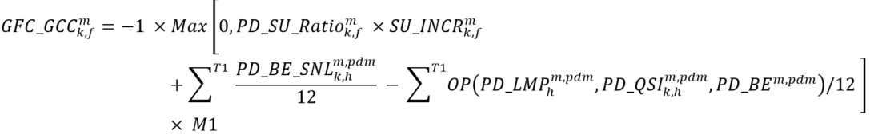  Where:  T1 = the set of all contiguous metering intervals at delivery point ‘m’ of the relevant generator failure, determined in accordance with the applicable market manual;  M1 = the prorating factor based on the quantity of energy that the resource failed to deliver and calculated as:  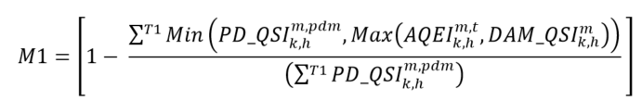  if the pre-dispatch operational commitment violated by the generator failure ‘f’:  advances a day-ahead operational commitment; and  the number of advancement hours of the advanced pre-dispatch operational commitment is less than its minimum generation block run-time plus its minimum generation block down-time, then  if the pre-dispatch operational commitment violated by the generator failure ‘f’:  is an extended pre-dispatch operational commitment, then ${SU_INCR}_{k,f}^{m} = 0$  otherwise, ${SU_INCR}_{k,f}^{m} = {PD_BE_SU}_{k,f}^{m,pdm}$  ${\text{PD_SU_Ratio}}_{\text{k,f}}^{\text{m}}$ = prorating factor for market participant ‘k’ at delivery point ‘m’ for generator failure ‘f’, and calculated as:  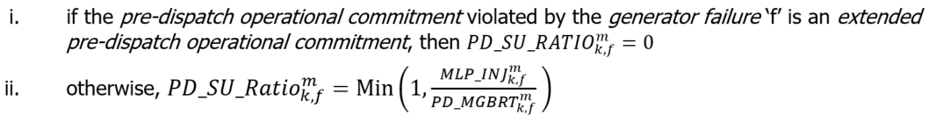  Where:  ${\text{MLP_INJ}}_{\text{k,f}}^{\text{m}}$ = the number of metering intervals where the GOG-eligible resource for market participant ‘k’ injects energy into the IESO-controlled grid at delivery point ‘m’ in an amount less than its minimum loading point during the minimum generation block run-time associated with the pre-dispatch operational commitment associated with generator failure ‘f’; and  ${\text{PD_MGBRT}}_{\text{k,f}}^{\text{m}}$ = the number of metering intervals of the minimum generation block run-time associated with the pre-dispatch operational commitment associated with generator failure ‘f’ for market participant ‘k’ at delivery point ‘m’.  GOG-eligible Resources that are Pseudo-Units: Combustion Turbine  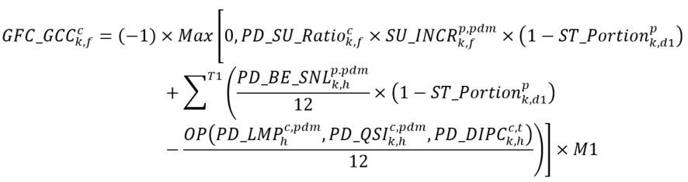  Where:  T1 = the set of all contiguous metering intervals at combustion turbine resource delivery point ‘c’ of the relevant generator failure, determined in accordance with the applicable market manual;  M1 = the prorating factor based on the quantity of energy that the resource failed to deliver and calculated as:  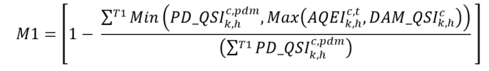  if the pre-dispatch operational commitment violated by the failure ‘f’ bridges with a day-ahead operational commitment and the number of advancement hours of the advanced pre-dispatch operational commitment is less than its minimum generation block run-time plus its minimum generation block down-time:  if the pre-dispatch operational commitment violated by the generator failure ‘f’:  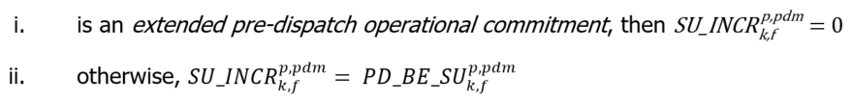  ${\text{PD_SU_Ratio}}_{\text{k,f}}^{\text{c}}$ = prorating factor for market participant ‘k’ at combustion turbine resource delivery point ‘c’ for generator failure ‘f’, and calculated as:  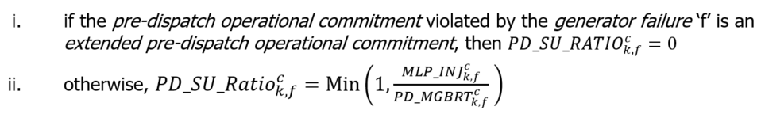  Where:  ${\text{MLP_INJ}}_{\text{k,f}}^{\text{ c}}$ = the number of metering intervals where the GOG-eligible resource for market participant ‘k’ injects energy into the IESO-controlled grid at combustion turbine resource delivery point ‘c’ in an amount less than its minimum loading point during the minimum generation block run-time associated with the pre-dispatch operational commitment associated with generator failure ‘f’; and  ${\text{PD_MGBRT}}_{\text{k,f}}^{\text{ c}}$ = for market participant ‘k’ at combustion turbine resource delivery point ‘c’, the number of metering intervals of the minimum generation block run-time associated with the pre-dispatch operational commitment associated with generator failure ‘f’.  GOG-eligible Resources that are Pseudo-Units: Steam Turbine  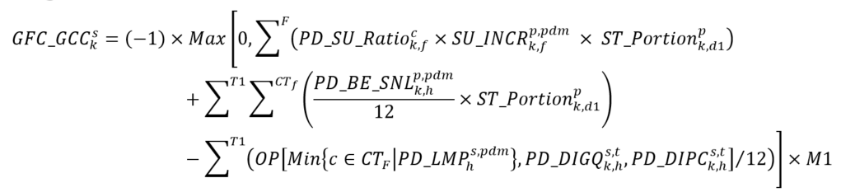  Where:  T1 = the set of all contiguous metering intervals at steam turbine resource delivery point ‘s’ of the relevant generator failure, determined in accordance with the applicable market manual;  M1 = the prorating factor based on the quantity of energy that the resource failed to deliver and calculated as:  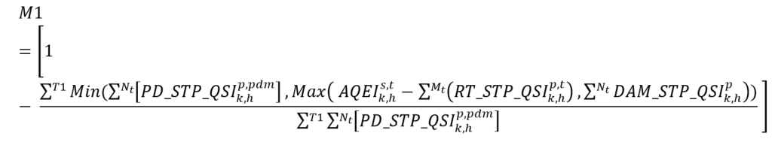  if the combustion turbine resource’s pre-dispatch operational commitment violated by failure ‘f’ bridges with a day-ahead operational commitment and the number of pre-dispatch advancement hours is less than its minimum generation block run-time plus its minimum generation block down-time:  if the pre-dispatch operational commitment violated by the generator failure ‘f’:  is an extended pre-dispatch operational commitment, then ${SU_INCR}_{k,f}^{p,pdm} = 0$  otherwise, ${SU_INCR}_{k,f}^{p,pdm} = {PD_BE_SU}_{k,f}^{p,pdm}$  ${\text{PD_SU_Ratio}}_{\text{k,f}}^{\text{c}}$ = prorating factor for market participant ‘k’ at combustion turbine resource delivery point ‘c’ for generator failure ‘f’, and calculated as:  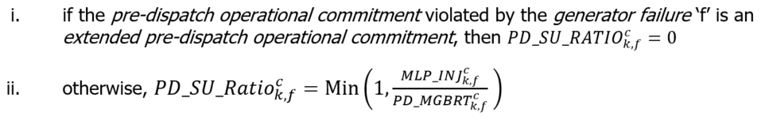  Where:  CTf = the set of all combustion turbine resources associated with steam turbine delivery point ‘s’ having a combustion turbine resource failure interval during metering interval ‘t’;  Mt = the set of all pseudo-units associated with steam turbine resource delivery point ‘s’ whose associated combustion turbine resource does not have a combustion turbine resource failure interval and are not operating in single cycle mode during metering interval ‘t’;  Nt = the set of all pseudo-units associated with steam turbine resource delivery point ‘s’ whose associated combustion turbine resource has a combustion turbine resource failure interval or are operating in single cycle mode during metering interval ‘t’;  F = the set of all combustion turbine resource or steam turbine resource failures ‘f’ occurring during the period ‘T1’;  ${\text{MLP_INJ}}_{\text{k,f}}^{\text{c}}$ = the number of metering intervals where the GOG-eligible resource for market participant ‘k’ injects energy into the IESO-controlled grid at combustion turbine resource delivery point ‘c’ in an amount less than its minimum loading point during the minimum generation block run-time associated with the pre-dispatch operational commitment associated with generator failure ‘f’; and  ${\text{PD_MGBRT}}_{\text{k,f}}^{\text{c}}$ = for market participant ‘k’ at combustion turbine resource delivery point ‘c’, the number of metering intervals of the minimum generation block run-time associated with the pre-dispatch operational commitment associated with generator failure ‘f’. | Hourly | Due IESO | 13 | N/A | N/A | N/A
1927  MRP new | Real-Time Intertie Offer Guarantee  (RT_IOG) | MR Ch.9 s.3.6 | Where:  $\text{IOG}{\text{_Offset}}_{\text{k,h}}^{\text{i}}$ = the real-time intertie offer guarantee settlement amount offset for market participant 'k’ in settlement hour ‘h’ in respect of intertie metering point ‘i’, and calculated as:  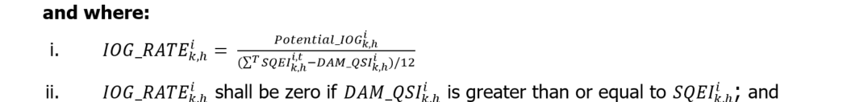  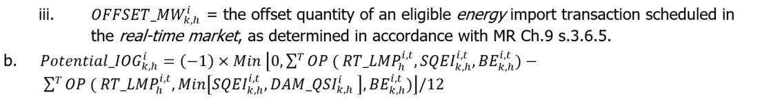 | Hourly | Due MP | N/A | 13 | N/A | N/A
1928  MRP new | Real-Time Import Failure Charge  (RT_IMFC) | MR Ch.9 ss.3.7.1-3.7.4 | 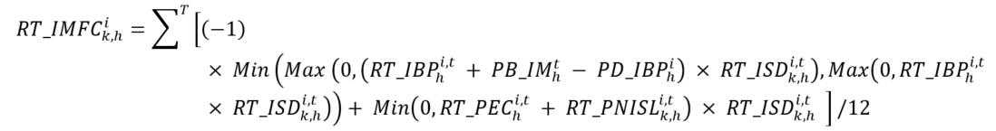  Where: | Interval | Due IESO | N/A | 13 | N/A | N/A
1929  MRP new | Real-Time Export Failure Charge  (RT_EXFC) | MR Ch.9 ss.3.7.1-3.7.2, and 3.7.5 – 3.7.6 | 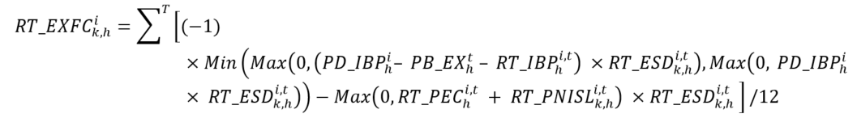  Where: | Interval | Due IESO | N/A | N/A | 0 | 13
1930  MRP new | Day-Ahead Market Reference Level Settlement Charge  (DAM_RLSC) | MR Ch.9 s.5.2 | Where:  ${\text{DAM_PLCP}}_{\text{k,h}}^{\text{m}}$ = the price component Pn of N-by-2 matrix ${(DAM_RLL}_{k,h}^{m})$ of price-quantity pairs where ‘n’ is the highest indexed row of the matrix such that ${DAM_QSI}_{k,h}^{m}≤ Q_{n}$. | Hourly | Due IESO | 13 | N/A | N/A | N/A
1931  MRP new | Real-Time Reference Level Settlement Charge  (RT_RLSC) | MR Ch.9 s.5.3 | Where:  ${\text{RT_PLCP}}_{\text{k,h}}^{\text{m}}$ = the price component Pn of N-by-2 matrix ${(RT_RLL}_{k,h}^{m})$ of price-quantity pairs where ‘n’ is the highest indexed row of the matrix such that ${RT_QSI}_{k,h}^{m}≤ Q_{n}$. | Hourly | Due IESO | 13 | N/A | N/A | N/A
1932  MRP new | Mitigation Amount for Physical Withholding – Energy  (EXP_PWSC – PW_E) | MR Ch.9 s.5.4.1.1 | NOTE: this charge type has -1 added before the summation sign as it has been separated from the larger ex-post mitigation for physical withholding equation within the market rules, in which the total settlement amount is multiplied by -1 because it is an amount owing to the IESO.  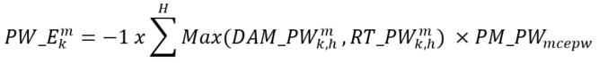  Where:  H = the set of settlement hours ‘h’ of the trading day for which the IESO determined that the market participant engaged in physical withholding in the day-ahead market, the real-time market, or both;  ${PM_PW}_{mcepw}$= the persistence multiplier applicable to the relevant trading day for the market control entity for physical withholding ‘mcepw’ that the registered market participant for the applicable resource designated, as determined with the applicable market manual; and  Where:  h = the settlement hour in the relevant trading day for which the IESO determined that the market participant engaged in physical withholding in the day-ahead market; and  ${MWhs Failed}_{k,h}^{m}$ = the quantity of energy (in MWhs) for market participant ‘k’ at delivery point ‘m’ for settlement hour ‘h’, as determined in accordance with the following:  if the IESO is assessing physical withholding in only the real-time market, it is deemed to be zero; and  otherwise, it is determined by subtracting the market participant’s energy offer from the energy reference quantity value or alternative reference quantity value, as the case may be, of the resource associated with the offer.  Where:  T = the set of all metering intervals ‘t’ in settlement hour ‘h’ for which the IESO determined that the market participant engaged in physical withholding in the real-time market; and  ${MWhs Failed}_{k,h}^{m,t}$ = the quantity of energy (in MWhs) for market participant ‘k’ at delivery point ‘m’ in metering interval ‘t’ of settlement hour ‘h’, as determined in accordance with the following:  if the IESO is assessing physical withholding in only the day-ahead market, it is deemed to be zero; and  otherwise, it is determined by subtracting the market participant’s energy offer from the energy offer reference quantity value or alternative reference quantity value, as the case may be, of the resource associated with the offer. | Daily | Due IESO | 13 | N/A | N/A | N/A
1933  MRP new | Mitigation Amount for Physical Withholding – 10S Operating Reserve  (EXP_PWSC – PW_OR) | MR Ch.9 s.5.4.1.2 | NOTE: this charge type has -1 added before the summation sign as it has been separated from the larger ex-post mitigation for physical withholding equation within the market rules, in which the total settlement amount is multiplied by -1 because it is an amount owing to the IESO.  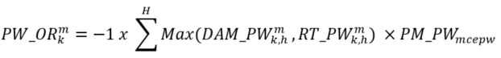  Where:  H = the set of settlement hours ‘h’ of the trading day for which the IESO determined that the market participant engaged in physical withholding in either the day-ahead market or the real-time market;  ${PM_PW}_{mcepw}$= the persistence multiplier applicable to the relevant trading day for the market control entity for physical withholding ‘mcepw’ that the registered market participant for the applicable resource designated, as determined with the applicable market manual;  Where:  h = the settlement hour in the relevant trading day for which the IESO determined that the market participant engaged in physical withholding in the day-ahead market; and  ${MWs Failed}_{r1,k,h}^{m}$ = the quantity of spinning ten-minute operating reserve (in MWs) for market participant ‘k’ at delivery point ‘m’ for settlement hour ‘h’, as determined in accordance with the following:  if the IESO is assessing physical withholding in only the real-time market, it is deemed to be zero; and  otherwise, it is determined by subtracting the market participant’s operating reserve offer from the operating reserve reference quantity value or alternative reference quantity value, as the case may be, of the resource associated with the offer.  Where:  T = the set of all metering intervals ‘t’ in settlement hour ‘h’ for which the IESO determined that the market participant engaged in physical withholding in the real-time market; and  ${MWs Failed}_{r1,k,h}^{m,t}$ = the quantity of spinning ten-minute operating reserve (in MWs) for market participant ‘k’ at delivery point ‘m’ in metering interval ‘t’ of settlement hour ‘h’, as determined in accordance with the following:  if the IESO is assessing physical withholding in only the day-ahead market, it is deemed to be zero; and  otherwise, it is determined by subtracting the market participant’s operating reserve offer from the operating reserve reference quantity value or alternative reference quantity value, as the case may be, of the resource associated with the offer. | Daily | Due IESO | 13 | N/A | N/A | N/A
1934  MRP new | Mitigation Amount for Physical Withholding – 10N Operating Reserve  (EXP_PWSC –PW_OR) | MR Ch.9 s.5.4.1.2 | NOTE: this charge type has -1 added before the summation sign as it has been separated from the larger ex-post mitigation for physical withholding equation within the market rules, in which the total settlement amount is multiplied by -1 because it is an amount owing to the IESO.  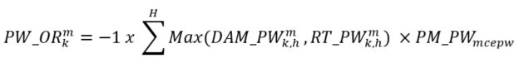  Where:  H = the set of settlement hours ‘h’ of the trading day for which the IESO determined that the market participant engaged in physical withholding in either the day-ahead market or the real-time market;  ${PM_PW}_{mcepw}$= the persistence multiplier applicable to the relevant trading day for the market control entity for physical withholding ‘mcepw’ that the registered market participant for the applicable resource designated, as determined with the applicable market manual;  Where:  h = the settlement hour in the relevant trading day for which the IESO determined that the market participant engaged in physical withholding in the day-ahead market; and  ${MWs Failed}_{r2,k,h}^{m}$ = the quantity of non-spinning ten-minute operating reserve (in MWs) for market participant ‘k’ at delivery point ‘m’ for settlement hour ‘h’, as determined in accordance with the following:  if the IESO is assessing physical withholding in only the real-time market, it is deemed to be zero; and  otherwise, it is determined by subtracting the market participant’s operating reserve offer from the operating reserve reference quantity value or alternative reference quantity value, as the case may be, of the resource associated with the offer.  Where:  T = the set of all metering intervals ‘t’ in settlement hour ‘h’ for which the IESO determined that the market participant engaged in physical withholding in the real-time market; and  ${MWs Failed}_{r2,k,h}^{m,t}$ = the quantity of non-spinning ten-minute operating reserve (in MWs) for market participant ‘k’ at delivery point ‘m’ in metering interval ‘t’ of settlement hour ‘h’, as determined in accordance with the following:  if the IESO is assessing physical withholding in only the day-ahead market, it is deemed to be zero; and  otherwise, it is determined by subtracting the market participant’s operating reserve offer from the operating reserve reference quantity value or alternative reference quantity value, as the case may be, of the resource associated with the offer. | Daily | Due IESO | 13 | N/A | N/A | N/A
1935  MRP new | Mitigation Amount for Physical Withholding – 30R Operating Reserve  (EXP_PWSC – PW_OR) | MR Ch.9 s.5.4.1.2 | NOTE: this charge type has -1 added before the summation sign as it has been separated from the larger ex-post mitigation for physical withholding equation within the market rules, in which the total settlement amount is multiplied by -1 because it is an amount owing to the IESO.  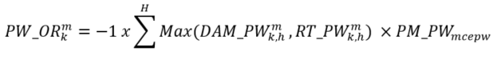  Where:  H = the set of settlement hours ‘h’ of the trading day for which the IESO determined that the market participant engaged in physical withholding in either the day-ahead market or the real-time market;  ${PM_PW}_{mcepw}$= the persistence multiplier applicable to the relevant trading day for the market control entity for physical withholding ‘mcepw’ that the registered market participant for the applicable resource designated, as determined with the applicable market manual;  Where:  h = the settlement hour in the relevant trading day for which the IESO determined that the market participant engaged in physical withholding in the day-ahead market; and  ${MWs Failed}_{r3,k,h}^{m}$ = the quantity of thirty-minute operating reserve (in MWs) for market participant ‘k’ at delivery point ‘m’ for settlement hour ‘h’, as determined in accordance with the following:  if the IESO is assessing physical withholding in only the real-time market, it is deemed to be zero; and  otherwise, it is determined by subtracting the market participant’s operating reserve offer from the operating reserve reference quantity value or alternative reference quantity value, as the case may be, of the resource associated with the offer.  Where:  T = the set of all metering intervals ‘t’ in settlement hour ‘h’ for which the IESO determined that the market participant engaged in physical withholding in the real-time market; and  ${MWs Failed}_{r3,k,h}^{m,t}$ = the quantity of thirty-minute operating reserve (in MWs) for market participant ‘k’ at delivery point ‘m’ in metering interval ‘t’ of settlement hour ‘h’, as determined in accordance with the following:  if the IESO is assessing physical withholding in only the day-ahead market, it is deemed to be zero; and  otherwise, it is determined by subtracting the market participant’s operating reserve offer from the operating reserve reference quantity value or alternative reference quantity value, as the case may be, of the resource associated with the offer. | Daily | Due IESO | 13 | N/A | N/A | N/A
1936  MRP new | Mitigation Amount for Intertie Economic Withholding – Energy  (EXP_EWSC – EW_E) | MR Ch.9 s.5.5.1.1 | NOTE: this charge type has -1 added before the summation sign as it has been separated from the larger ex-post mitigation for intertie economic withholding equation within the market rules, in which the total settlement amount is multiplied by -1 because it is an amount owing to the IESO.  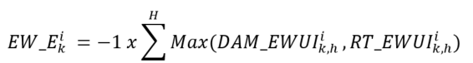  Where:  H = the set of settlement hours ‘h’ of the trading day for which the IESO determined that the market participant engaged in intertie economic withholding in the day-ahead market, real-time market, or both;  Where:  h = the settlement hour for which the IESO determined that the market participant engaged in intertie economic withholding in the day-ahead market; and  ${MWhs Failed}_{k,h}^{i}$ = the quantity of energy (in MWhs) for market participant ‘k’ at intertie metering point ‘i’ for settlement hour ‘h’, as determined in accordance with the following:  if the IESO is assessing intertie economic withholding in only the real-time market, it is deemed to be zero; and  otherwise, it is determined by subtracting the market participant’s energy offer from the energy reference quantity value of the resource associated with the offer.  Where:  T = the set of all metering intervals ‘t’ in settlement hour ‘h’ for which the IESO determined that the market participant engaged in intertie economic withholding in the real-time market; and  ${MWhs Failed}_{k,h}^{i,t}$ = the quantity of energy (in MWhs) for market participant ‘k’ at intertie metering point ‘i’ for settlement hour ‘h’, as determined in accordance with the following:  if the IESO is assessing intertie economic withholding in only the day-ahead market, it is deemed to be zero; and  otherwise, it is determined by subtracting the market participant’s energy offer from the energy reference quantity value of the resource associated with the offer. | Daily | Due IESO | N/A | 13 | 0 | 13
1937  MRP new | Mitigation Amount for Intertie Economic Withholding – 10N Operating Reserve  (EXP_EWSC –EW_OR) | MR Ch.9 s.5.5.1.3 | NOTE: this charge type has -1 added before the summation sign as it has been separated from the larger ex-post mitigation for intertie economic withholding equation within the market rules, in which the total settlement amount is multiplied by -1 because it is an amount owing to the IESO.  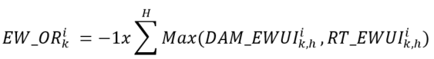  Where:  H = the set of settlement hours ‘h’ of the trading day for which the IESO determined that the market participant engaged in intertie economic withholding in either the day-ahead market or the real-time market;  Where:  h = the settlement hour for which the IESO determined that the market participant engaged in intertie economic withholding in the day-ahead market; and  ${MWs Failed}_{r2,k,h}^{i}$ = the quantity of non-spinning ten-minute operating reserve (in MWs) for market participant ‘k’ at intertie metering point ‘i’ for settlement hour ‘h’, as determined in accordance with the following:  if the IESO is assessing intertie economic withholding in only the real-time market, it is deemed to be zero; and  otherwise, it is determined by subtracting the market participant’s operating reserve offer from the operating reserve reference quantity value of the resource associated with the offer.  Where:  T = the set of all metering intervals ‘t’ in settlement hour ‘h’ for which the IESO determined that the market participant engaged in intertie economic withholding in the real-time market; and  ${MWs Failed}_{r2,k,h}^{i,t}$ = the quantity of non-spinning ten-minute operating reserve (in MWs) for market participant ‘k’ at intertie metering point ‘i’ for metering interval ‘t’ in settlement hour ‘h’, as determined in accordance with the following:  if the IESO is assessing intertie economic withholding in only the day-ahead market, it is deemed to be zero; and  otherwise, it is determined by subtracting the market participant’s operating reserve offer from the operating reserve reference quantity value of the resource associated with the offer. | Daily | Due IESO | N/A | 13 | 0 | 13
1938  MRP new | Mitigation Amount for Intertie Economic Withholding – 30R Operating Reserve  (EXP_EWSC – EW_OR) | MR Ch.9 s.5.5.1.3 | NOTE: this charge type has -1 added before the summation sign as it has been separated from the larger ex-post mitigation for intertie economic withholding equation within the market rules, in which the total settlement amount is multiplied by -1 because it is an amount owing to the IESO.  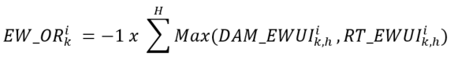  Where:  H = the set of settlement hours ‘h’ of the trading day for which the IESO determined that the market participant engaged in intertie economic withholding in either the day-ahead market or the real-time market;  Where:  h = the settlement hour for which the IESO determined that the market participant engaged in intertie economic withholding in the day-ahead market; and  ${MWs Failed}_{r3,k,h}^{i}$ = the quantity of thirty-minute operating reserve (in MWs) for market participant ‘k’ at intertie metering point ‘i’ for settlement hour ‘h’, as determined in accordance with the following:  if the IESO is assessing intertie economic withholding in only the real-time market, it is deemed to be zero; and  otherwise, it is determined by subtracting the market participant’s operating reserve offer from the operating reserve reference quantity value of the resource associated with the offer.  Where:  T = the set of all metering intervals ‘t’ in settlement hour ‘h’ for which the IESO determined that the market participant engaged in intertie economic withholding in the real-time market; and  ${MWs Failed}_{r3,k,h}^{i,t}$ = the quantity of thirty-minute operating reserve (in MWs) for market participant ‘k’ at intertie metering point ‘i’ for metering interval ‘t’ in settlement hour ‘h’, as determined in accordance with the following:  if the IESO is assessing intertie economic withholding in only the day-ahead market, it is deemed to be zero; and  otherwise, it is determined by subtracting the market participant’s operating reserve offer from the operating reserve reference quantity value of the resource associated with the offer. | Daily | Due IESO | N/A | 13 | 0 | 13
1939  MRP new | Mitigation Amount for Intertie Economic Withholding – Make-Whole Payment  (EXP_EWSC – EW_MWP) | MR Ch.9 s.5.5.1.2 | NOTE: this charge type has -1 added before the summation sign as it has been separated from the larger ex-post mitigation for intertie economic withholding equation within the market rules, in which the total settlement amount is multiplied by -1 because it is an amount owing to the IESO.  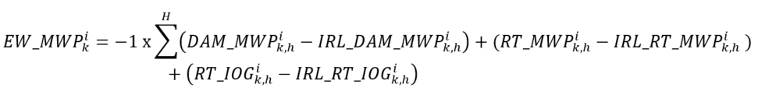  Where:  H = the set of settlement hours ‘h’ of the trading day for which the IESO determined that the market participant engaged in intertie economic withholding in the day-ahead market, the real-time market, or both;  ${IRL_DAM_MWP}_{k,h}^{i}$= the day-ahead market make-whole payment amount calculated in accordance with MR Ch.9 s.3.4 utilizing the resource’s intertie reference level value that was used by the IESO to assess intertie economic withholding in accordance with MR Ch.7 s.22.18;  ${IRL_RT_MWP}_{k,h}^{i}$ = the real-time make-whole payment amount calculated in accordance with 9.3.5 utilizing the resources intertie reference level value that was used by the IESO to assess intertie economic withholding in accordance with MR Ch.7 s.22.18; and  ${IRL_RT_IOG}_{k,h}^{i}$ = the real-time intertie offer guarantee amount calculated in accordance with MR Ch.9 s.3.6 utilizing the resource’s intertie reference level value that was used by the IESO to assess intertie economic withholding in accordance with MR Ch.7 s.22.18. | Daily | Due IESO | N/A | 13 | 0 | 13
1940  MRP new | Reference Level and Reference Quantity Independent Review Process Settlement Amount | MR Ch.7 s.22.8.14 | Manual entry as per MR Ch.7 s.22.8.14. | Monthly | Due IESO | 13 | N/A | N/A | N/A
1941  MRP new | Reference Level and Reference Quantity Independent Review Process Recovery Amount (Market) | MR Ch.9 s.4.14.12 | Manual entry as per MR Ch.7 s.22.8.11.2. | Monthly | Due IESO | 13 | N/A | 0 | 13
1950  MRP new | Real-Time Make-Whole Payment Uplift  (RT_MWPU) | MR Ch.9 s.3.11 | Where:  C = the set of all charge types ‘c’ as follows: 1900,1901,1902,1903,1904,1905,1906,1907,1908,1909. | Hourly | Due IESO | 13 | N/A | 0 | 13
1960  MRP new | Real-Time Generator Offer Guarantee Uplift  (RT_GOGU) | MR Ch.9 s.4.14.2 | 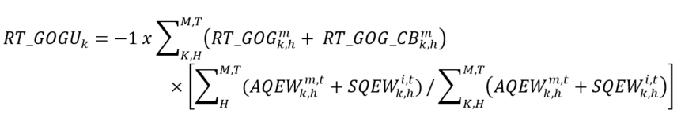  Where:  ${RT_GOG}_{k,h}^{m}$ = the real-time generator offer guarantee settlement amount calculated for charge types 1910,1911,1912,1913, and 1914 in accordance with MR Ch.9 s.4.5 for market participant ‘k’ at delivery point ‘m’ for settlement hour ‘h’; and  ${RT_GOG_CB}_{k,h}^{m}$ = the real-time generator offer guarantee clawback settlement amount calculated for charge type 1915 in accordance with MR Ch.9 ss.3.10.26-3.10.34 for market participant ‘k’ at delivery point ‘m’ for settlement hour ‘h’. | Daily | Due IESO | 13 | N/A | 0 | 13
1967  MRP new | Real-Time Ramp-Down Settlement Amount Uplift  (RT_RDSAU) | MR Ch.9 s.4.14.11 | Where:  ${RT_RDSA}_{k}^{m}$ = the real-time ramp-down settlement amount calculated for charge type 1927 in accordance with MR Ch.9 s.4.6 for market participant ‘k’ at delivery point ‘m’. | Daily | Due IESO | 13 | N/A | 0 | 13
1970  MRP new | Generator Failure Charge – Market Price Component Uplift  (GFC_MPCU) | MR Ch.9 s.3.11 | Where:  C = the set of all charge types ‘c’ as follows: 1920. | Hourly | Due MP | 13 | N/A | 0 | 13
1971  MRP new | Generator Failure Charge – Guarantee Cost Component Uplift  (GFC_GCCU) | MR Ch.9 s.4.14.1 | Where:  ${GFC_GCC}_{k,f}^{m}$ = the generator failure charge – guarantee cost component calculated for charge type 1921 in accordance with MR Ch.9 s.4.10 for market participant ‘k’ at delivery point ‘m’ for generator failure ‘f’; and  F = the set of all generator failures ‘f’. | Daily | Due MP | 13 | N/A | 0 | 13
1977  MRP new | Real-Time Intertie Offer Guarantee Uplift  (RT_IOGU) | MR Ch.9 s.3.11 | Where:  C = the set of all charge types ‘c’ as follows: 1927. | Hourly | Due IESO | 13 | N/A | 0 | 13
1980  MRP new | Day-Ahead Market Reference Level Settlement Charge Uplift  (DAM_RLSCU) | MR Ch.9 s.3.11 | Where:  C = the set of all charge types ‘c’ as follows: 1930. | Hourly | Due MP | 13 | N/A | 0 | 13
1981  MRP new | Real-Time Reference Level Settlement Charge Uplift  (RT_RLSCU) | MR Ch.9 s.3.11 | Where:  C = the set of all charge types ‘c’ as follows: 1931. | Hourly | Due MP | 13 | N/A | 0 | 13
1982  MRP new | Mitigation Amount for Physical Withholding Uplift  (EXP_PWSU) | MR Ch.9 s.4.14.9 | Where:  ${EXP_PWSC}_{k}^{m}$ = the mitigation for physical withholding settlement amount calculated for charge types 1932, 1933, 1934 and 1935 in accordance with MR Ch.9 s.5.4 for market participant ‘k’ at delivery point ‘m’; and  H = the set of all settlement hours ‘h’ in the relevant trading day. | Daily | Due MP | 13 | N/A | 0 | 13
1986  MRP new | Mitigation Amount for Intertie Economic Withholding Uplift  (EXP_EWSCU) | MR Ch.9 s.4.14.10 | Where:  ${EXP_EWSC}_{k}^{i}$ = the mitigation for intertie economic withholding settlement amount calculated for charge types 1936, 1937, 1938 and 1939 in accordance with MR Ch.9 s.5.5 for market participant ‘k’ at intertie metering point ‘i’; and  H = the set of all settlement hours ‘h’ in the relevant trading day. | Daily | Due MP | 13 | N/A | 0 | 13
2148 | Class B Global Adjustment Prior Period Correction Settlement Amount | N/A | Manual entry based on post-final changes to input data for charge type 148. | Monthly | Due MP | 13 | N/A | N/A | N/A
2470 | MOE - Ontario Electricity Support Program Balancing Amount | N/A | 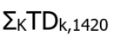  Where ‘K’ is the set of all market participants ‘k’.  Where TDk,1420 is the settlement amount of charge type 1420 for the month for market participant ‘k’. | Monthly | Due Ministry of Energy | 0 | N/A | N/A | N/A | Implementation details subject to government and OEB regulations.
9920 | Adjustment Account Credit  (AAC) | MR Ch.9 s.6.20.5.3 | Where ‘AAD’ is the total dollar value of all disbursements from the IESO adjustment account authorized by the IESO Board in the current energy market billing period, in accordance with MR Ch.9 s.6 and expressed in up to 3 decimal places.  Where ‘H’ is the set of all settlement hours ‘h’ in the billing periods immediately preceding the current billing period, as determined by IESO Board.  Where ‘T’ is the set of all metering intervals ‘t’ in the set of all settlement hours ‘H’.  Where ‘M’ is the set of all delivery points ‘m’ and intertie metering points ‘i’  Where ‘K’ is the set of all market participants ‘k’. | Monthly (when applicable) | Due MP | 13 | N/A | 0 | 13
9980 | Smart Metering Charge | N/A | Manual entry based on the values submitted by the Smart Metering Entity. | Monthly | Due IESO | 13 | N/A | N/A | N/A | Subject to Ontario Regulation 453/06 and the applicable OEB rate order.
9982 | Ontario Rebate for Electricity Consumers (8% Provincial Rebate) Settlement Amount | N/A | Manual entry based on:  (1) the values submitted via on-line settlement form “Ontario Rebate for Electricity Consumers (OREC) – LDC and USMP”;  and  (2) 8 per cent of the base invoice amount for market participant consumers who have an eligible account with the IESO | Monthly | Due LDCs, Unit Sub-Meter Providers and eligible MPs | 0 | N/A | N/A | N/A | Implementation details subject to Ontario Regulation 363/16
9983 | Ontario Electricity Rebate Settlement Amount | N/A | Manual entry based on:  (1) the values submitted via on-line settlement forms “Ontario Electricity Rebate (OER) – LDC & USMP”;  and  (2) 33.2 per cent of the base invoice amount for market participant consumers who have an eligible account with the IESO | Monthly | Due LDCs, Unit Sub-Meter Providers and eligible MPs | 0 | N/A | N/A | N/A | Implementation details subject to Ontario Regulation 363/16 and 364/16
9984 | COVID-19 Energy Assistance Program (CEAP) Balancing Amount | N/A | 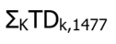  Where ‘K’ is the set of all market participants ‘k’.  Where TDk,1477 is the settlement amount of charge type 1420 for the month for market participant ‘k’. | Monthly | Due Ministry of Energy | 0 | N/A | N/A | N/A | Implementation details subject to OEB order EB-2020-0186 and EB-2020-0163
9990 | IESO Administration Charge | MR Ch.9 s.4.3.1 | Where ‘H’ is the set of all settlement hours ‘h’ in the month.  Where ‘T’ is the set of all metering intervals ‘t’ in the set of all settlement hours ‘H’. | Monthly | Due IESO | 13 | N/A | 0 | 13 | TP rate subject to OEB regulation.
9996 | Recovery of Costs | MR Ch.2 App.3.4 | Manual entry as per MR Ch.2 App.3.4 | Monthly | Due IESO | 13 | N/A | N/A | N/A

Rounding Conventions – by Charge Type

General Notes
- All settlement amounts reported by the IESO settlements system are expressed in dollars and are rounded to the nearest cent (e.g. to two decimal places) on settlement statements, although some settlement calculations may only yield 1 significant digit to the right of the decimal place. In these instances, the financial amount is NOT further rounded to the nearest ten cents.
- Table 2-5 provides a description of each of the column references for rounding conventions by charge type.
- Table 2-6 lists all the rounding conventions by charge type. This table:
- references significant digits to the right of the decimal place. This should NOT be confused with the number of decimal places allowable in some columns on the settlement statements and data files as set out in Format Specifications for Settlement Statement Files and Data Files document. This document is located on the Technical Interfaces webpage under ‘Commercial Reconciliation’;
- does not include the final rounding step to the nearest cent, as this is done for ALL settlement amounts. Rather, it describes any intermediate calculations (particularly, those involving division) that involve rounding prior to the final calculation of the settlement amount.
Table 2-5: Description of Column References for Rounding Conventions – by Individual Charge Type
Column Name | Description
Charge Type Number | This table contains an entry for each active charge type listed in section 2.2.
Charge Type Name | The name of each of the charge types.
INPUT VARIABLES  Least number of significant digits to the right of the decimal | In terms of assessing the accuracy of the final settlement amount, this column is derived from the settlement variable received by the settlement system with the LEAST number of significant digits to the right of the decimal place.
INPUT VARIABLES  Maximum number of significant digits to the right of the decimal | In terms of assessing the accuracy of the final settlement amount, this column is derived from the settlement variable received by the settlement system with the MAXIMUM number of significant digits to the right of the decimal place.
Intermediate Rounding done by Settlements? | This column indicates whether or not any INTERMEDIATE rounding is done by the IESO settlement process. This does NOT include the final rounding of settlement amounts to 2 decimal places as the last step in the calculation of ALL charge types.
INTERMEDIATE CALCULATION 1 (where intermediate rounding occurs) | This column ONLY describes an intermediate calculation of the settlement amount in which rounding occurs PRIOR to the final rounding of the settlement amount to the nearest cent.
DISPOSITION OF INTERMEDIATE CALCULATION 1 | This column describes the disposition of the rounded value resulting from Intermediate Calculation 1.
INTERMEDIATE CALCULATION 2 (where intermediate rounding occurs) | This column ONLY describes an intermediate calculation of the settlement amount in which rounding occurs PRIOR to the final rounding of the settlement amount to the nearest cent.
DISPOSITION OF INTERMEDIATE CALCULATION 2 | This column describes the disposition of the rounded value resulting from Intermediate Calculation 2.
Table 2-6: Rounding Conventions – by Individual Charge Type
Charge Type Number | Charge Type Name | INPUT VARIABLES  Least number of significant digits to the right of the decimal | INPUT VARIABLES  Maximum number of significant digits to the right of the decimal | Intermediate Rounding done by Settlements? | INTERMEDIATE CALCULATION 1  (where intermediate rounding occurs) | DISPOSITION OF INTERMEDIATE CALCULATION 1 | INTERMEDIATE CALCULATION 2  (where intermediate rounding occurs) | DISPOSITION OF INTERMEDIATE CALCULATION 2
52 | Transmission Rights Auction Settlement Debit | 0 | 2 | No
102 | TR Clearing Account Credit | 1 | 3 | No
104 | Transmission Rights Settlement Credit | 0 | 2 | No
114 | Outage Cancellation/ Deferral Settlement Credit | 2 | 2 | No
115 | Unrecoverable Testing Costs Credit | 2 | 2 | No
116 | Tieline Maintenance Reliability Credit | 2 | 2 | No
118 | Emergency Energy Rebate | 1 | 3 | No
119 | Station Service Reimbursement Credit | 2 | 3 | No
121 | Northern Energy Advantage Program Settlement Amount | 1 | 3 | No
123 | MACD Enforcement Activity Amount | 2 | 2 | No
142 | Regulated Price Plan Settlement Amount | 1 | 3 | No
143 | NUG Contract Adjustment Settlement Amount | 1 | 3 | No
144 | Regulated Nuclear Generation Adjustment Amount | 1 | 3 | No
145 | Regulated Hydroelectric Generation Adjustment Amount | 1 | 3 | No
147 | Class A – Global Adjustment Settlement Amount | 1 | 3 | No
148 | Class B – Global Adjustment Settlement Amount | 1 | 3 | No
149 | Regulated Price Plan Retailer Settlement Amount | 1 | 3 | No
164 | Outage Cancellation/ Deferral Debit | 1 | 3 | No
165 | Unrecoverable Testing Costs Debit | 1 | 3 | No
166 | Tieline Maintenance Reliability Debit | 1 | 3 | No
167 | Emergency Energy Debit | 1 | 3 | No
168 | TR Market Shortfall Debit | 1 | 3 | No
169 | Station Service Reimbursement Debit | 1 | 3 | No
171 | Northern Energy Advantage Program Balancing Amount | 1 | 3 | No
173 | MACD Enforcement Activity Balancing Amount | 2 | 2 | No
186 | Intertie Failure Charge Uplift | 1 | 3 | No
192 | Regulated Price Plan Balancing Amount | 2 | 2 | No
193 | NUG Contract Adjustment Balancing Amount | 2 | 2 | No
194 | Regulated Nuclear Generation Balancing Amount | 2 | 2 | No
195 | Regulated Hydroelectric Generation Balancing Amount | 2 | 2 | No
196 | Global Adjustment Balancing Amount | 2 | 2 | No
197 | Global Adjustment-Special Programs Balancing Amount | 2 | 2 | No
199 | Regulated Price Plan Retailer Balancing Amount | 2 | 2 | No
201 | 10 Minute Spinning Reserve Market Shortfall Rebate | 1 | 3 | No
203 | 10 Minute Non-spinning Reserve Market Shortfall Rebate | 1 | 3 | No
205 | 30 Minute Operating Reserve Market Shortfall Rebate | 1 | 3 | No
206 | 10-Minute Spinning Non-Accessibility Settlement Amount | 1 | 3 | Yes | REAH =  $${TREAH}_{r, k, h}^{M, t}×\frac{{EAH}_{k, h}^{m, t}}{ \sum_{ }^{M}{{EAH}_{k, h}^{m, t}}}$$  Resulting Decimals: 3 | Used to calculate adjusted operating reserve provided for aggregated generation resources
208 | 10-Minute Non-Spinning Non-Accessibility Settlement Amount | 1 | 3 | Yes | REAH =  $${TREAH}_{r, k, h}^{M, t}×\frac{{EAH}_{k, h}^{m, t}}{ \sum_{ }^{M}{{EAH}_{k, h}^{m, t}}}$$  Resulting Decimals: 3 | Used to calculate adjusted operating reserve provided for aggregated generation resources
210 | 30-Minute Non-Accessibility Settlement Amount | 1 | 3 | Yes | REAH =  $${TREAH}_{r, k, h}^{M, t}×\frac{{EAH}_{k, h}^{m, t}}{ \sum_{ }^{M}{{EAH}_{k, h}^{m, t}}}$$  Resulting Decimals: 3 | Used to calculate adjusted operating reserve provided for aggregated generation resources
212 | Day-Ahead Market 10-Minute Spinning Reserve Settlement Credit | 1 | 3 | No
213 | Real-Time 10-Minute Spinning Reserve Settlement Credit | 1 | 3 | Yes | Numerator: Difference between RT_QSOR – DAM_QSOR  Denominator: 12  Resulting Decimals: 3
214 | Day-Ahead Market 10-Minute Non-Spinning Reserve Settlement Credit | 1 | 3 | No
215 | Real-Time Market 10-Minute Non-Spinning Reserve Settlement Credit | 1 | 3 | Yes | Numerator: Difference between RT_QSOR – DAM_QSOR  Denominator: 12  Resulting Decimals: 3
216 | Day-Ahead Market 30-Minute Operating Reserve Settlement Credit | 1 | 3 | No
217 | Real-Time Market 30-Minute Operating Reserve Settlement Credit | 1 | 3 | Yes | Numerator: Difference between RT_QSOR – DAM_QSOR  Denominator: 12  Resulting Decimals: 3
250 | 10-Minute Spinning Reserve Hourly Uplift | 1 | 3 | No
251 | 10 Minute Spinning Market Reserve Shortfall Debit | 1 | 3 | No
252 | 10-Minute Non-Spinning Reserve Hourly Uplift | 1 | 3 | No
253 | 10 Minute Non-spinning Market Reserve Shortfall Debit | 1 | 3 | No
254 | 30 Minute Operating Reserve Hourly Uplift | 1 | 3 | No
255 | 30 Minute Operating Reserve Market Shortfall Debit | 1 | 3 | No
400 | Black Start Capability Settlement Credit | 2 | 2 | No
404 | Regulation Service Settlement Credit | 2 | 2 | No
410 | IESO-Controlled Grid Special Operations Credit | 2 | 2 | No
450 | Black Start Capability Settlement Debit | 1 | 3 | No
451 | Hourly Reactive Support and Voltage Control Settlement Debit | 1 | 3 | No
452 | Monthly Reactive Support and Voltage Control Settlement Debit | 1 | 3 | No
454 | Regulation Service Settlement Debit | 1 | 3 | No
460 | IESO-Controlled Grid Special Operations Debit | 2 | 2 | No
500 | Must Run Contract Settlement Credit | 2 | 2 | No
550 | Must Run Contract Settlement Debit | 1 | 3 | No
600 | Network Service Credit | 2 | 3 | No
601 | Line Connection Service Credit | 2 | 3 | No
602 | Transformation Connection Service Credit | 2 | 3 | No
603 | Export Transmission Service Credit | 1 | 2 | No
650 | Network Service Charge | 2 | 3 | No
651 | Line Connection Service Charge | 2 | 3 | No
652 | Transformation Connection Service Charge | 2 | 3 | No
653 | Export Transmission Service Charge | 1 | 2 | No
700 | Dispute Resolution Settlement Credit | 2 | 2 | No
703 | Rural and Remote Settlement Credit | 2 | 2 | No
705 | Ontario Fair Hydro Plan First Nations On-reserve Delivery Amount | 2 | 2 | No
706 | Ontario Fair Hydro Plan Distribution Rate Protection Amount | 2 | 2 | No
750 | Dispute Resolution Settlement Debit | 2 | 2 | No
751 | Dispute Resolution Board Service Debit | 2 | 2 | No
753 | Rural and Remote Settlement Debit | 2 | 3 | No
755 | MOE - Ontario Fair Hydro Plan First Nations On-reserve Delivery Balancing Amount | 2 | 2 | No
756 | MOE - Ontario Fair Hydro Plan Distribution Rate Protection Balancing Amount | 2 | 2 | No
850 | Market Participant Default Settlement Debit (recovery) | 2 | 2 | No
851 | Market Participant Default Interest Debit | 2 | 2 | No
900 | GST/HST Credit | 2 | 2 | No
950 | GST/HST Debit | 2 | 2 | No
1100 | Day-Ahead Market Energy Settlement Amount for Generators | 1 | 3 | No
1101 | Real-Time Energy Settlement Amount for Generators | 1 | 3 | Yes | AQEI multiplied by 12  AQEW multiplied by 12  Resulting Decimals: 3  Numerator: BCQ  Denominator: 12  Resulting Decimals: 3 | AQEI or AQEW multiplied by RT_LMP.  BCQ quantities multiplied by RT_LMP when applicable.
1102 | Day-Ahead Market Energy Settlement Amount for Dispatchable Loads | 1 | 3 | No
1103 | Real-Time Energy Settlement Amount for Dispatchable Loads | 1 | 3 | Yes | AQEI multiplied by 12  AQEW multiplied by 12  Resulting Decimals: 3  Numerator: BCQ  Denominator: 12  Resulting Decimals: 3 | AQEI or AQEW multiplied by RT_LMP.  BCQ quantities multiplied by RT_LMP when applicable.
1104 | Day-Ahead Market Energy Settlement Amount for Price Responsive Loads | 1 | 3 | No
1105 | Real-Time Energy Settlement Amount for Price Responsive Loads | 1 | 3 | Yes | AQEW multiplied by 12  Resulting Decimals: 3  Numerator: BCQ  Denominator: 12  Resulting Decimals: 3 | AQEW quantity multiplied by RT_LMP.  BCQ quantities multiplied by RT_LMP when applicable.
1106 | Day-Ahead Market Energy Settlement Amount for Virtual Transactions to Sell | 1 | 3 | No
1107 | Real-Time Energy Settlement Amount for Virtual Transactions to Sell | 1 | 3 | No
1108 | Day-Ahead Market Energy Settlement Amount for Virtual Transactions to Buy | 1 | 3 | No
1109 | Real-Time Energy Settlement Amount for Virtual Transactions to Buy | 1 | 3 | No
1110 | Day-Ahead Market Energy Settlement Amount for Imports | 1 | 3 | No
1111 | Real-Time Energy Settlement Amount for Imports | 1 | 3 | Yes | Numerator: BCQ  Denominator: 12  Resulting Decimals: 3 | BCQ quantities multiplied by RT_LMP when applicable.
1112 | Day-Ahead Market Energy Settlement Amount for Exports | 1 | 3 | No
1113 | Real-Time Energy Settlement Amount for Exports | 1 | 3 | Yes | Numerator: BCQ  Denominator: 12  Resulting Decimals: 3 | BCQ quantities multiplied by RT_LMP when applicable.
1115 | Non-Dispatchable Load Energy Settlement Amount | 1 | 3 | Yes | AQEI multiplied by 12  AQEW multiplied by 12  Resulting Decimals: 3  Numerator: BCQ  Denominator: 12  Resulting Decimals: 3 | AQEI or AQEW multiplied by DAM_LMP.  BCQ quantities multiplied by DAM_LMP when applicable.
1116 | Internal Congestion and Loss Residual | 1 | 3 | Yes | AQEI multiplied by 12  AQEW multiplied by 12  Resulting Decimals: 3 | AQEI or AQEW multiplied by RT_LMP.
1117 | Day-Ahead Market Net External Congestion Residual | 1 | 3 | No
1118 | Real-Time External Congestion Residual Uplift | 1 | 3 | Yes | RT_ECR_{L}  RT_ECR_{E}  Resulting Decimals: 2 | Distributed to either Loads or Exports.
1119 | Day-Ahead Market Net Interchange Scheduling Limit Residual Uplift | 1 | 3 | No
1120 | Real-Time Net Interchange Scheduling Limit Residual Uplift | 1 | 3 | No
1138 | Fuel Cost Compensation Credit | 2 | 2 | No
1148 | GA Energy Storage Injection Reimbursement | 2 | 2 | No
1188 | Fuel Cost Compensation Credit Uplift | 1 | 3 | No
1314 | Capacity Obligation – Availability Payment | 1 | 3 | No
1315 | Capacity Obligation – Availability Charge | 1 | 3 | No
1316 | Capacity Obligation – Administration Charge | 1 | 3 | No
1317 | Capacity Obligation – Dispatch Charge | 1 | 3 | No
1318 | Capacity Obligation – Capacity Charge | 1 | 3 | No
1319 | Capacity Obligation – Buy-Out Charge | 1 | 3 | No
1320 | Capacity Obligation – Dispatch Test Payment and Emergency Activation Payment | 1 | 3 | No
1321 | Capacity Obligation – Capacity Import Call Failure Charge | 1 | 3 | No
1322 | Capacity Obligation – Capacity Deficiency Charge | 1 | 3 | No
1323 | Capacity Obligation – In-Period Cleared UCAP Adjustment Charge | 1 | 3 | No
1324 | Capacity Obligation – Availability Charge True-up Payment | 1 | 3 | No
1325 | Capacity Obligation – Capacity Auction Charges True-up Payment | 1 | 3 | No
1350 | Capacity Based Recovery Amount for Class A Loads | 1 | 3 | No
1351 | Capacity Based Recovery Amount for Class B Loads | 1 | 3 | No
1400 | OPA Contract Adjustment Settlement Amount | 1 | 2 | No
1401 | Incremental Loss Settlement Credit | 1 | 6 | No
1402 | Hourly Condense System Constraints Settlement Credit | 1 | 5 | No
1403 | Speed-no-load Settlement Credit | 1 | 2 | No
1404 | Condense Unit Start-up and OM&A Settlement Credit | 1 | 2 | No
1405 | Hourly Condense Energy Costs Settlement Credit | 1 | 2 | No
1406 | Monthly Condense Energy Costs Settlement Credit | 1 | 2 | No
1407 | Condense Transmission Tariff Reimbursement Settlement Credit | 2 | 3 | No
1408 | Condense Availability Cost Settlement Credit | 1 | 2 | No
1409 | Monthly Condense System Constraints Settlement Credit | 1 | 2 | No
1410 | Renewable Energy Standard Offer Program Settlement Amount | 1 | 3 | No
1412 | Feed-In Tariff Program Settlement Amount | 1 | 3 | No
1413 | Renewable Generation Connection – Monthly Compensation Amount Settlement Credit | 1 | 3 | No
1414 | Hydroelectric Contract Initiative Settlement Amount | 1 | 3 | No
1416 | Conservation and Demand Management - Compensation Settlement Credit | 1 | 3 | No
1417 | Daily Condense Energy Costs Settlement Credit | 1 | 2 | No
1418 | Biomass Non-Utility Generation Contracts Settlement Amount | 1 | 3 | No
1419 | Energy from Waste (EFW) Contracts Settlement Amount | 1 | 3 | No
1420 | Ontario Electricity Support Program Settlement Amount | 2 | 2 | No
1425 | Hydroelectric Standard Offer Program Settlement Amount | 2 | 2 | No
1450 | OPA Contract Adjustment Balancing  Amount | 2 | 2 | No
1451 | Incremental Loss Offset Settlement Amount | 2 | 2 | No
1457 | Ontario Electricity Rebate Balancing Amount | 2 | 2 | No
1460 | Renewable Energy Standard Offer Program Balancing Amount | 2 | 2 | No
1462 | Feed-In Tariff Program Balancing Amount | 2 | 2 | No
1463 | Renewable Generation Connection – Monthly Compensation Amount Settlement Debit | 1 | 3 | No
1464 | Hydroelectric Contract Initiative Balancing Amount | 2 | 2 | No
1466 | Conservation and Demand Management - Compensation Balancing Amount | 2 | 2 | No
1467 | Ontario Rebate for Electricity Consumers (8% Provincial Rebate) Balancing Amount | 2 | 2 | No
1468 | Biomass Non-Utility Generation Contracts Balancing Amount | 2 | 2 | No
1469 | Energy from Waste (EFW) Contracts Balancing Amount | 2 | 2 | No
1475 | Hydroelectric Standard Offer Program Balancing Amount | 2 | 2 | No
1477 | COVID-19 Energy Assistance Program (CEAP) Settlement Amount | 2 | 2 | No
1600 | Forecasting Service Settlement Amount | 1 | 3 | No
1650 | Forecasting Service Balancing Amount | 1 | 3 | No
1750 | Dispute Resolution Balancing Amount (Market) | 2 | 2 | No
1753 | MOE - Rural and Remote Settlement Debit | 2 | 2 | No
1800 | Day-Ahead Market Make-Whole Payment – Energy  Dispatchable Generation Resources | 1 | 3 | Yes | OP(DAM_LMP, DAM_QSI, DAM_BE)  OP(DAM_LMP, DAM_EOP, DAM_BE)  Resulting Decimals: 2  For Combustion Turbines:  OP(DAM_LMP, DAM_QSI, DAM_DIPC)  OP(DAM_LMP, DAM_EOP, DAM_DIPC)  Resulting Decimals: 2  For Steam Turbines:  OP(DAM_LMP, DAM_DIGQ, DAM_DIPC)  OP(DAM_LMP, DAM_EOP_DIGQ, DAM_DIPC)  Resulting Decimals: 2 | Profits are compared as applicable.
1800 | Day-Ahead Market Make-Whole Payment – Energy  Hydroelectric Generation Resources Not Associated with Linked Forebays | 1 | 3 | Yes | OP(DAM_LMP, DAM_QSI, DAM_BE)  OP(DAM_LMP,DAM_EOP, DAM_BE)  Forbidden Region Operating Profit:  OP(DAM_LMP, FR_UL, DAM_BE)  OP(DAM_LMP, MAX(DAM_EOP, FR_LL), DAM_BE)  Resulting Decimals: 2 | Profits are compared as applicable.
1800 | Day-Ahead Market Make-Whole Payment – Energy  Hydroelectric Generation Resources Associated with Linked Forebays | 1 | 3 | Yes | OP(DAM_LMP, DAM_QSI, DAM_BE)  OP(DAM_LMP, DAM_EOP, DAM_BE)  Forbidden Region Operating Profit:  OP(DAM_LMP, FR_UL, DAM_BE)  OP(DAM_LMP, MAX(DAM_EOP, FR_LL), DAM_BE)  Resulting Decimals: 2 | Profits are compared as applicable.
1800 | Day-Ahead Market Make-Whole Payment – Energy  Dispatchable Loads | 1 | 3 | Yes | OP(DAM_LMP, DAM_QSW, DAM_BL)  OP(DAM_LMP, DAM_EOP, DAM_BL)  Resulting Decimals: 2 | Profits are compared as applicable.
1800 | Day-Ahead Market Make-Whole Payment – Energy  Non-HDR Price Responsive Loads | 1 | 3 | Yes | OP(DAM_LMP, DAM_QSW, DAM_BL)  OP(DAM_LMP, DAM_EOP, DAM_BL)  Resulting Decimals: 2 | Profits are compared as applicable.
1800 | Day-Ahead Market Make-Whole Payment – Energy  Physical Hourly Demand Response Price Responsive Loads | 1 | 3 | Yes | OP(DAM_LMP, DAM_QSW, DAM_BL)  OP(DAM_LMP, DAM_EOP, DAM_BL)  OP(DAM_LMP, DAM_HDR_QSW, DAM_HDR_BL)  OP(DAM_LMP, DAM_EOP, DAM_HDR_BL)  Resulting Decimals: 2 | Profits are compared as applicable.
1800 | Day-Ahead Market Make-Whole Payment – Energy  Boundary Entity Resource – Imports | 1 | 3 | Yes | OP(DAM_LMP, DAM_QSI, DAM_BE)  OP(DAM_LMP, DAM_EOP, DAM_BE)  Resulting Decimals: 2 | Profits are compared as applicable.
1800 | Day-Ahead Market Make-Whole Payment – Energy  Boundary Entity Resource – Exports | 1 | 3 | Yes | OP(DAM_LMP, DAM_QSW, DAM_BL)  OP(DAM_LMP, DAM_EOP, DAM_BL)  Resulting Decimals: 2 | Profits are compared as applicable.
1801 | Day-Ahead Market Make-Whole Payment – 10-Minute Spinning Reserve  Dispatchable Generation Resources | 1 | 3 | Yes | OP(DAM_PROR, DAM_QSOR, DAM_BOR)  OP(DAM_PROR, DAM_OR_EOP, DAM_BOR)  For Combustion Turbines:  OP(DAM_PROR, DAM_QSOR, DAM_OR_DIPC)  OP(DAM_PROR, DAM_OR_EOP, DAM_OR_DIPC)  For Steam Turbines:  OP(DAM_PROR, DAM_QSOR, DAM_OR_DIPC)  OP(DAM_PROR, DAM_OR_EOP, DAM_OR_DIPC)  Resulting Decimals: 2 | Profits are compared as applicable.
1801 | Day-Ahead Market Make-Whole Payment – 10-Minute Spinning Reserve  Hydroelectric Generation Resources not Associated with Linked Forebays | 1 | 3 | Yes | OP(DAM_PROR, DAM_QSOR, DAM_BOR)  OP(DAM_PROR, DAM_OR_EOP, DAM_BOR)  Resulting Decimals: 2 | Profits are compared as applicable.
1801 | Day-Ahead Market Make-Whole Payment – 10-Minute Spinning Reserve  Hydroelectric Generation Resources Associated with Linked Forebays | 1 | 3 | Yes | OP(DAM_PROR, DAM_QSOR, DAM_BOR)  OP(DAM_PROR, DAM_OR_EOP, DAM_BOR)  Resulting Decimals: 2 | Profits are compared as applicable.
1801 | Day-Ahead Market Make-Whole Payment – 10-Minute Spinning Reserve  Dispatchable Loads | 1 | 3 | Yes | OP(DAM_PROR, DAM_QSOR, DAM_BOR)  OP(DAM_PROR, DAM_OR_EOP, DAM_BOR)  Resulting Decimals: 2 | Profits are compared as applicable.
1802 | Day-Ahead Market Make-Whole Payment – 10-Minute Non-Spinning Reserve  Dispatchable Generation Resources | 1 | 3 | Yes | OP(DAM_PROR, DAM_QSOR, DAM_BOR)  OP(DAM_PROR, DAM_OR_EOP, DAM_BOR)  For Combustion Turbines:  OP(DAM_PROR, DAM_QSOR, DAM_OR_DIPC)  OP(DAM_PROR, DAM_OR_EOP, DAM_OR_DIPC)  For Steam Turbines:  OP(DAM_PROR, DAM_QSOR, DAM_OR_DIPC)  OP(DAM_PROR, DAM_OR_EOP, DAM_OR_DIPC)  Resulting Decimals: 2 | Profits are compared as applicable.
1802 | Day-Ahead Market Make-Whole Payment – 10-Minute Non-Spinning Reserve  Hydroelectric Generation Resources not Associated with Linked Forebays | 1 | 3 | Yes | OP(DAM_PROR, DAM_QSOR, DAM_BOR)  OP(DAM_PROR, DAM_OR_EOP, DAM_BOR)  Resulting Decimals: 2 | Profits are compared as applicable.
1802 | Day-Ahead Market Make-Whole Payment – 10-Minute Non-Spinning Reserve  Hydroelectric Generation Resources Associated with Linked Forebays | 1 | 3 | Yes | OP(DAM_PROR, DAM_QSOR, DAM_BOR)  OP(DAM_PROR, DAM_OR_EOP, DAM_BOR)  Resulting Decimals: 2 | Profits are compared as applicable.
1802 | Day-Ahead Market Make-Whole Payment – 10-Minute Non-Spinning Reserve  Dispatchable Loads | 1 | 3 | Yes | OP(DAM_PROR, DAM_QSOR, DAM_BOR)  OP(DAM_PROR, DAM_OR_EOP, DAM_BOR)  Resulting Decimals: 2 | Profits are compared as applicable.
1802 | Day-Ahead Market Make-Whole Payment – 10-Minute Non-Spinning Reserve  Boundary Entity Resources - Imports | 1 | 3 | Yes | OP(DAM_PROR, DAM_QSOR, DAM_BOR)  OP(DAM_PROR, DAM_OR_EOP, DAM_BOR)  Resulting Decimals: 2 | Profits are compared as applicable.
1802 | Day-Ahead Market Make-Whole Payment – 10-Minute Non-Spinning Reserve  Boundary Entity Resources - Exports | 1 | 3 | Yes | OP(DAM_PROR, DAM_QSOR, DAM_BOR)  OP(DAM_PROR, DAM_OR_EOP, DAM_BOR)  Resulting Decimals: 2 | Profits are compared as applicable.
1803 | Day-Ahead Market Make-Whole Payment – 30-Minute Operating Reserve  Dispatchable Generation Resources | 1 | 3 | Yes | OP(DAM_PROR, DAM_QSOR, DAM_BOR)  OP(DAM_PROR, DAM_OR_EOP, DAM_BOR)  For Combustion Turbines:  OP(DAM_PROR, DAM_QSOR, DAM_OR_DIPC)  OP(DAM_PROR, DAM_OR_EOP, DAM_OR_DIPC)  For Steam Turbines:  OP(DAM_PROR, DAM_QSOR, DAM_OR_DIPC)  OP(DAM_PROR, DAM_OR_EOP, DAM_OR_DIPC)  Resulting Decimals: 2 | Profits are compared as applicable.
1803 | Day-Ahead Market Make-Whole Payment – 30-Minute Operating Reserve  Hydroelectric Generation Resources not Associated with Linked Forebays | 1 | 3 | Yes | OP(DAM_PROR, DAM_QSOR, DAM_BOR)  OP(DAM_PROR, DAM_OR_EOP, DAM_BOR)  Resulting Decimals: 2 | Profits are compared as applicable.
1803 | Day-Ahead Market Make-Whole Payment – 30-Minute Operating Reserve  Hydroelectric Generation Resources Associated with Linked Forebays | 1 | 3 | Yes | OP(DAM_PROR, DAM_QSOR, DAM_BOR)  OP(DAM_PROR, DAM_OR_EOP, DAM_BOR)  Resulting Decimals: 2 | Profits are compared as applicable.
1803 | Day-Ahead Market Make-Whole Payment – 30-Minute Operating Reserve  Dispatchable Loads | 1 | 3 | Yes | OP(DAM_PROR, DAM_QSOR, DAM_BOR)  OP(DAM_PROR, DAM_OR_EOP, DAM_BOR)  Resulting Decimals: 2 | Profits are compared as applicable.
1803 | Day-Ahead Market Make-Whole Payment – 30-Minute Operating Reserve  Boundary Entity Resources - Imports | 1 | 3 | Yes | OP(DAM_PROR, DAM_QSOR, DAM_BOR)  OP(DAM_PROR, DAM_OR_EOP, DAM_BOR)  Resulting Decimals: 2 | Profits are compared as applicable.
1803 | Day-Ahead Market Make-Whole Payment – 30-Minute Operating Reserve  Boundary Entity Resources - Exports | 1 | 3 | Yes | OP(DAM_PROR, DAM_QSOR, DAM_BOR)  OP(DAM_PROR, DAM_OR_EOP, DAM_BOR)  Resulting Decimals: 2 | Profits are compared as applicable.
1804 | Day-Ahead Generator Offer Guarantee – Energy | 1 | 3 | Yes | OP(DAM_LMP, DAM_QSI, DAM_BE)  (DAM_LMP x DAM_QSI)  For Combustion Turbines:  OP(DAM_LMP, DAM_QSI, DAM_DIPC)  For Steam Turbines:  OP(DAM_LMP, DAM_DIGQ, DAM_DIPC)  Resulting Decimals: 2 | Profits are compared as applicable.
1805 | Day-Ahead Generator Offer Guarantee – Operating Reserve | 1 | 3 | Yes | OP(DAM_PROR, DAM_QSOR, DAM_BOR)  For Combustion Turbines:  OP(DAM_PROR, DAM_QSOR, DAM_OR_DIPC)  For Steam Turbines:  OP(DAM_PROR, DAM_QSOR, DAM_OR_DIPC)  Resulting Decimals: 2 | Profits are compared as applicable.
1806 | Day-Ahead Market Generator Offer Guarantee – Over Midnight | 1 | 3 | Yes | OP(DAM_LMP, MLP, DAM_BE)  For Combustion Turbines:  OP(DAM_LMP, MLP, DAM_DIPC)  For Steam Turbines:  OP(DAM_LMP, MLP, DAM_DIPC)  Resulting Decimals: 2 | Profits are compared as applicable.
1807 | Day-Ahead Market Generator Offer Guarantee – Start-up | 1 | 2 | No
1808 | Day-Ahead Market Generator Offer Guarantee – DAM Make-Whole Payment Offset | 1 | 2 | No
1815 | Day-Ahead Market Balancing Credit - Energy | 1 | 3 | Yes | AQEI multiplied by 12  Resulting Decimals: 3 | Deduct from DAM_QSI | For import transactions:  OP(RT_LMP, Min(RT_LOC_EOP, DAM_QSI), BE)  OP(RT_LMP, SQEI, BE)  For export transactions:  OP(RT_LMP, Min(RT_LOC_EOP, DAM_QSW), BL)  OP(RT_LMP, SQEW, BL)  Resulting Decimals: 2 | Profits are compared as applicable.
1816 | Day-Ahead Market Balancing Credit – Operating Reserve | 1 | 3 | Yes | OP(RT_PROR, Min(RT_OR_LOC_EOP, DAM_QSOR), BOR)  OP(RT_PROR, RT_QSOR, BOR)  Resulting Decimals: 2 | Profits are compared as applicable.
1828 | Day-Ahead Market Import Failure Charge | 1 | 3 | No
1829 | Day-Ahead Market Export Failure Charge | 1 | 3 | No
1830 | Tariff Response Charge for Exports | 1 | 3 | No
1850 | Day-Ahead Market Uplift | 1 | 3 | No
1851 | Day-Ahead Market Reliability Scheduling Uplift | 1 | 3 | Yes | DAM_P2_PMT  V_DRSU  Resulting Decimals: 2 | Subtracted from each other to determine the amount of uplift to be apportioned to exports and loads
1852 | Day-Ahead Market Reliability Scheduling Uplift – Virtual Transactions to Sell | 1 | 3 | Yes | Pass 1:  OP(DAM_LMP, DAM_QSI, DAM_BE)  OP(DAM_LMP, DAM_EOP_OR, DAM_BE)  Pass 2:  OP(DAM_LMP, DAM_QSI, DAM_BE)  OP(DAM_LMP, DAM_EOP_OR, DAM_BE)  Resulting Decimals: 2 | Subtracted from each other to calculate the DAM_MWP in Pass 1 & Pass 2
1865 | Day-Ahead Market Balancing Credit Uplift | 1 | 3 | No
1880 | Tariff Response Charge for Exports Balancing Amount | 1 | 3 | No
1900 | Real-Time Make-Whole Payment – Lost Cost for Energy  Dispatchable Generation Resources | 1 | 3 | Yes | AQEI multiplied by 12  Resulting Decimals: 3 | Compare with RT_QSI | OP(RT_LMP, Max(DAM_QSI, MIN(RT_QSI,AQEI)), BE)  OP(RT_LMP, Max(RT_LC_EOP, DAM_QSI), BE)  Forbidden Region Operating Profit:  OP(RT_LMP, Max(DAM_QSI, MIN(RT_QSI,AQEI)), BE)  OP(RT_LMP, Max(FR_LL, RT_LC_EOP, DAM_QSI), BE)  For Combustion Turbines:  OP(RT_LMP, Max(DAM_QSI, MIN(RT_QSI,AQEI)), RT_DIPC)  OP( RT_LMP, Max(RT_LC_EOP, DAM_QSI), RT_DIPC)  For Steam Turbines:  OP(RT_LMP, Max(DAM_DIGQ, MIN(RT_QSI_DIGQ, AQEI)), RT_DIPC)  OP(RT_LMP, Max(RT_LC_EOP_DIGQ,DAM_DIGQ), RT_DIPC)  Resulting Decimals: 2 | Profits are compared as applicable.
1900 | Real-Time Make-Whole Payment – Lost Cost for Energy  Dispatchable Loads | 1 | 3 | Yes | AQEW multiplied by 12  Resulting Decimals: 3 | Compare with RT_QSW | OP(RT_LMP, MAX(DAM_QSW, MIN(RT_QSW, AQEW)), BL)  OP(RT_LMP, Max(RT_LC_EOP, DAM_QSW), BL)  Resulting Decimals: 2
1900 | Real-Time Make-Whole Payment – Lost Cost for Energy  Boundary Entity Resources - Exports | 1 | 3 | Yes | OP(RT_LMP, MAX(SQEW, DAM_QSW), BL)  OP(RT_LMP, Max(RT_LC_EOP, DAM_QSW), BL)  OP(MIN(RT_LMP, PD_LMP), MAX(SQEW, DAM_QSW), BL)  OP(MIN(RT_LMP, PD_LMP), Max(RT_LC_EOP, DAM_QSW), BL)  Resulting Decimals: 2 | Profits are compared as applicable.
1901 | Real-Time Make-Whole Payment – Lost Cost for 10-Minute Spinning Reserve  Dispatchable Generation Resources | 1 | 3 | Yes | OP(RT_PROR, Max(DAM_QSOR, RT_QSOR), BOR)  OP(RT_PROR, Max(RT_OR_LC_EOP, DAM_QSOR), BOR)  For Combustion Turbines:  OP(RT_PROR, Max(DAM_QSOR, RT_QSOR), RT_OR_DIPC)  OP(RT_PROR, Max(RT_OR_LC_EOP, DAM_QSOR), RT_OR_DIPC)  For Steam Turbines:  OP(RT_PROR, Max(DAM_QSOR, RT_QSOR), RT_OR_DIPC)  OP(RT_PROR, Max(RT_OR_LC_EOP, DAM_QSOR), RT_OR_DIPC)  Resulting Decimals: 2 | Profits are compared as applicable.
1901 | Real-Time Make-Whole Payment – Lost Cost for 10-Minute Spinning Reserve  Dispatchable Loads | 1 | 3 | Yes | OP(RT_PROR, Max(DAM_QSOR, RT_QSOR), BOR)  OP(RT_PROR, Max(RT_OR_LC_EOP, DAM_QSOR), BOR)  Resulting Decimals: 2 | Profits are compared as applicable.
1902 | Real-Time Make-Whole Payment – Lost Cost for 10-Minute Non-Spinning Reserve  Dispatchable Generation Resources | 1 | 3 | Yes | OP(RT_PROR, Max(DAM_QSOR, RT_QSOR), BOR)  OP(RT_PROR, Max(RT_OR_LC_EOP, DAM_QSOR), BOR)  For Combustion Turbines:  OP(RT_PROR, Max(DAM_QSOR, RT_QSOR), RT_OR_DIPC)  OP(RT_PROR, Max(RT_OR_LC_EOP, DAM_QSOR), RT_OR_DIPC)  For Steam Turbines:  OP(RT_PROR, Max(DAM_QSOR, RT_QSOR), RT_OR_DIPC)  OP(RT_PROR, Max(RT_OR_LC_EOP, DAM_QSOR), RT_OR_DIPC)  Resulting Decimals: 2 | Profits are compared as applicable.
1902 | Real-Time Make-Whole Payment – Lost Cost for 10-Minute Non-Spinning Reserve  Dispatchable Loads | 1 | 3 | Yes | OP(RT_PROR, Max(DAM_QSOR, RT_QSOR), BOR)  OP(RT_PROR, Max(RT_OR_LC_EOP, DAM_QSOR), BOR)  Resulting Decimals: 2 | Profits are compared as applicable.
1902 | Real-Time Make-Whole Payment – Lost Cost for 10-Minute Non-Spinning Reserve  Boundary Entity Resources - Exports | 1 | 3 | Yes | OP(RT_PROR, Max(DAM_QSOR, RT_QSOR), BOR)  OP(RT_PROR, Max(RT_OR_LC_EOP, DAM_QSOR), BOR)  Resulting Decimals: 2 | Profits are compared as applicable.
1902 | Real-Time Make-Whole Payment – Lost Cost for 10-Minute Non-Spinning Reserve  Boundary Entity Resources - Imports | 1 | 3 | Yes | OP(RT_PROR, Max(DAM_QSOR, RT_QSOR), BOR)  OP(RT_PROR, Max(RT_OR_LC_EOP, DAM_QSOR), BOR)  Resulting Decimals: 2 | Profits are compared as applicable.
1903 | Real-Time Make-Whole Payment – Lost Cost for 30-Minute Operating Reserve  Dispatchable Generation Resources | 1 | 3 | Yes | OP(RT_PROR, Max(DAM_QSOR, RT_QSOR), BOR)  OP(RT_PROR, Max(RT_OR_LC_EOP, DAM_QSOR), BOR)  For Combustion Turbines:  OP(RT_PROR, Max(DAM_QSOR, RT_QSOR), RT_OR_DIPC)  OP(RT_PROR, Max(RT_OR_LC_EOP, DAM_QSOR), RT_OR_DIPC)  For Steam Turbines:  OP(RT_PROR, Max(DAM_QSOR, RT_QSOR), RT_OR_DIPC)  OP(RT_PROR, Max(RT_OR_LC_EOP, DAM_QSOR), RT_OR_DIPC)  Resulting Decimals: 2 | Profits are compared as applicable.
1903 | Real-Time Make-Whole Payment – Lost Cost for 30-Minute Operating Reserve  Dispatchable Loads | 1 | 3 | Yes | OP(RT_PROR, Max(DAM_QSOR, RT_QSOR), BOR)  OP(RT_PROR, Max(RT_OR_LC_EOP, DAM_QSOR), BOR)  Resulting Decimals: 2 | Profits are compared as applicable.
1903 | Real-Time Make-Whole Payment – Lost Cost for 30-Minute Operating Reserve  Boundary Entity Resources - Exports | 1 | 3 | Yes | OP(RT_PROR, Max(DAM_QSOR, RT_QSOR), BOR)  OP(RT_PROR, Max(RT_OR_LC_EOP, DAM_QSOR), BOR)  Resulting Decimals: 2 | Profits are compared as applicable.
1903 | Real-Time Make-Whole Payment – Lost Cost for 30-Minute Operating Reserve  Boundary Entity Resources - Imports | 1 | 3 | Yes | OP(RT_PROR, Max(DAM_QSOR, RT_QSOR), BOR)  OP(RT_PROR, Max(RT_OR_LC_EOP, DAM_QSOR), BOR)  Resulting Decimals: 2 | Profits are compared as applicable.
1904 | Real-Time Make-Whole Payment – Lost Opportunity Cost for Energy  Dispatchable Generation Resources | 1 | 3 | Yes | AQEI multiplied by 12  Resulting Decimals: 3 | Compare with RT_QSI. | OP(RT_LMP, RT_LOC_EOP, BE)  OP(RT_LMP, Max(RT_QSI, AQEI), BE)  FROP = OP(RT_LMP, Min(FR_UL, RT_LOC_EOP), BE) - OP(RT_LMP, Max(RT_QSI, AQEI), BE)  For Combustion Turbines:  OP(RT_LMP, RT_LOC_EOP, RT_DIPC)  OP(RT_LMP, Max(RT_QSI,AQEI), RT_DIPC)  For Steam Turbines:  OP(RT_LMP, RT_LOC_EOP_DIGQ, RT_DIPC)  OP(RT_LMP, Max(RT_QSI_DIGQ, AQEI), RT_DIPC)  OP(RT_LMP, RT_QSI_DIGQ, RT_DIPC)  Resulting Decimals: 2 | Profits are compared as applicable.
1904 | Real-Time Make-Whole Payment – Lost Opportunity Cost for Energy  Dispatchable Loads | 1 | 3 | Yes | AQEW multiplied by 12  Resulting Decimals: 3 | Compare with RT_QSW. | OP(RT_LMP, RT_LOC_EOP, BL)  OP(RT_LMP, Max(RT_QSW, AQEW), BL)  Resulting Decimals: 2 | Profits are compared as applicable.
1905 | Real-Time Make-Whole Payment – Lost Opportunity Cost for 10-Minute Spinning Reserve  Dispatchable Generation Resources | 1 | 3 | Yes | OP(RT_PROR, RT_OR_LOC_EOP, BOR)  OP(RT_PROR, RT_QSOR, BOR)  Forbidden Region:  OP(RT_PROR, (RT_OR_LOC_EOP – QTY_ADJ), BOR) –  Max (0, OP(RT_PROR, RT_QSOR, BOR)  For Combustion Turbines:  OP(RT_PROR, RT_OR_LOC_EOP, RT_OR_DIPC)  OP(RT_PROR, RT_QSOR, RT_OR_DIPC)  For Steam Turbines:  OP(RT_PROR, RT_OR_LOC_EOP, RT_OR_DIPC)  OP(RT_PROR, RT_QSOR, RT_OR_DIPC)  Resulting Decimals: 2 | Profits are compared as applicable.
1905 | Real-Time Make-Whole Payment – Lost Opportunity Cost for 10-Minute Spinning Reserve  Dispatchable Loads | 1 | 3 | Yes | OP(RT_PROR, RT_OR_LOC_EOP, BOR)  OP(RT_PROR, RT_QSOR, BOR)  Resulting Decimals: 2 | Profits are compared as applicable.
1906 | Real-Time Make-Whole Payment – Lost Opportunity Cost for 10-Minute Non-Spinning Reserve  Dispatchable Generation Resources | 1 | 3 | Yes | OP(RT_PROR, RT_OR_LOC_EOP, BOR)  OP(RT_PROR, RT_QSOR, BOR)  Forbidden Region:  OP(RT_PROR, (RT_OR_LOC_EOP – QTY_ADJ), BOR) –  Max (0, OP(RT_PROR, RT_QSOR, BOR)  For Combustion Turbines:  OP(RT_PROR, RT_OR_LOC_EOP, RT_OR_DIPC)  OP(RT_PROR, RT_QSOR, RT_OR_DIPC)  For Steam Turbines:  OP(RT_PROR, RT_OR_LOC_EOP, RT_OR_DIPC)  OP(RT_PROR, RT_QSOR, RT_OR_DIPC)  Resulting Decimals: 2 | Profits are compared as applicable.
1906 | Real-Time Make-Whole Payment – Lost Opportunity Cost for 10-Minute Non-Spinning Reserve  Dispatchable Loads | 1 | 3 | Yes | OP(RT_PROR, RT_OR_LOC_EOP, BOR)  OP(RT_PROR, RT_QSOR, BOR)  Resulting Decimals: 2 | Profits are compared as applicable.
1907 | Real-Time Make-Whole Payment – Lost Opportunity Cost for 30-Minute Operating Reserve  Dispatchable Generation Resources | 1 | 3 | Yes | OP(RT_PROR, RT_OR_LOC_EOP, BOR)  OP(RT_PROR, RT_QSOR, BOR)  Forbidden Region:  OP(RT_PROR, (RT_OR_LOC_EOP – QTY_ADJ), BOR) –  Max (0, OP(RT_PROR, RT_QSOR, BOR)  For Combustion Turbines:  OP(RT_PROR, RT_OR_LOC_EOP, RT_OR_DIPC)  OP(RT_PROR, RT_QSOR, RT_OR_DIPC)  For Steam Turbines:  OP(RT_PROR, RT_OR_LOC_EOP, RT_OR_DIPC)  OP(RT_PROR, RT_QSOR, RT_OR_DIPC)  Resulting Decimals: 2 | Profits are compared as applicable.
1907 | Real-Time Make-Whole Payment – Lost Opportunity Cost for 30-Minute Operating Reserve  Dispatchable Loads | 1 | 3 | Yes | OP(RT_PROR, RT_OR_LOC_EOP, BOR)  OP(RT_PROR, RT_QSOR, BOR)  Resulting Decimals: 2 | Profits are compared as applicable.
1908 | Real-Time Make-Whole Payment - Operating Reserve Non-Accessibility Lost Cost Reversal | 1 | 3 | Yes | For 10S:  OP(RT_PROR_R1, MAX(DAM_QSOR_R1, RT_QSOR_R1), BOR_R1)  OP(RT_PROR_R1, Max(TAOR, RT_OR_LC_EOP_R1, DAM_QSOR_R1), BOR_R1)  Resulting Decimals: 2  For 10N: OP(RT_PROR_R2, MAX(DAM_QSOR_R2, RT_QSOR_R2), BOR_R2)  OP(RT_PROR_R2, Max(TAOR-RT_QSOR_R1, RT_OR_LC_EOP_R2, DAM_QSOR_R2) BOR_R2)  Resulting Decimals: 2  For 30N: OP(RT_PROR_R3, MAX(DAM_QSOR_R3, RT_QSOR_R3), BOR_R3)  OP(RT_PROR_R3, Max(TAOR-RT_QSOR_R1-RT_QSOR_R2, RT_OR_LC_EOP_R3, DAM_QSOR_R3), BOR_R3)  Resulting Decimals: 2 | Profits are compared as applicable
1909 | Real-Time Make-Whole Payment - Operating Reserve Non-Accessibility Lost Opportunity Cost Reversal | 1 | 3 | Yes | For 10S:  OP(RT_PROR_R1, RT_OR_LOC_EOP_R1, RT_OR_DIPC_R1)  OP(RT_PROR_R1, Max(RT_QSOR_R1, TAOR_CT) RT_OR_DIPC_R1)  Resulting Decimals: 2  For 10N: OP(RT_PROR_R2, RT_OR_LOC_EOP_R2, RT_OR_DIPC_R2)  OP(RT_PROR_R2, Max(TAOR-RT_QSOR_R1, RT_QSOR_R2), RT_OR_DIPC_R2)  Resulting Decimals: 2  For 30N: OP(RT_PROR_R3, RT_OR_LOC_EOP_R3, RT_OR_DIPC_R3)  OP(RT_PROR_R3, MAX(RT_QSOR_R3, TAOR-RT_QSOR_R1-RT_QSOR_R2), BOR_R3)  Resulting Decimals: 2 | Profits are compared as applicable
1910 | Real-Time Generator Offer Guarantee - Energy | 1 | 3 | Yes | AQEI multiplied by 12  Resulting Decimals: 3 | Operating profit calculation. | OP(RT_LMP, RT_QSI, BE)  OP(RT_LMP, AQEI, BE)  RT_LMP x AQEI  DAM_LMP x DAM_QSI  Resulting Decimals: 2 | Profits are compared as applicable.
1911 | Real-Time Generator Offer Guarantee – Operating Reserve | 1 | 3 | Yes | OP(RT_PROR, RT_QSOR, BOR)  Resulting Decimals: 2
1912 | Real-Time Generator Offer Guarantee – Over Midnight | 1 | 3 | Yes | OP(RT_LMP, MLP, BE)  Resulting Decimals: 2
1913 | Real-Time Generator Offer Guarantee – Start-up | 1 | 2 | No
1914 | Real-Time Generator Offer Guarantee – RT Make-Whole Payment Offset | 1 | 2 | No
1915 | Real-Time Generator Offer Guarantee – Operating Reserve Non-Accessibility Reversal | 1 | 3 | Yes | For 10S:  OP(RT_PROR_R1, RT_QSOR_R1, BOR_R1)  OP(RT_PROR_R1, TAOR, BOR_R1)  Resulting Decimals: 2  For 10N:  OP(RT_PROR_R2, RT_QSOR_R2, BOR_R2)  OP(RT_PROR_R2, TAOR-T_QSOR_R1, BOR_R2)  Resulting Decimals: 2  For 30N:  OP(RT_PROR_R3, RT_QSOR_R3, BOR_R3)  OP(RT_PROR_R3, TAOR-T_QSOR_R1-RT_QSOR_R2, BOR_R3)  Resulting Decimals: 2  For ST Case:  ORSCB_REV= -1 x ORSCB x (RT_OR_CMT_DIGQ/RT_QSOR)  Resulting Decimals: 2  RT_GOG_TAOR_ST= TAOR_ST x (RT_OR_CMT_DIGQ/RT_QSOR)  Resulting Decimals: 3  ORIA_AMT  For 10S: RT_PROR_R1 (RT_QSOR_R1-TAOR)  Resulting Decimals: 2  For 10N:  RT_PROR_R2 (RT_QSOR_R2-MAX(0, TAOR-RT_QSOR_R1))  Resulting Decimals: 2  For 30N:  RT_PROR_R3 (RT_QSOR_R3-MAX(0, TAOR-RT_QSOR_R1-RT_QSOR_R2))  Resulting Decimals: 2 | Profits are compared as applicable.
1917 | Real-Time Ramp-Down Settlement Amount | 1 | 3 | Yes | OP(DAM_LMP, AQEI, BE)  OP(DAM_LMP, AQEI, DAM_BE)  OP(RT_LMP, AQEI, BE)  Resulting Decimals: 2 | Profits are compared as applicable.
1920 | Generator Failure Charge – Market Price Component | 1 | 3 | No
1921 | Generator Failure Charge – Guarantee Cost Component | 1 | 3 | Yes | Numerator: PD_BE_SNL  Denominator: 12  Resulting Decimals: 2  PD_SU_Ratio  Resulting Decimals: 5 | Sum to the GCC amount. | M1  Resulting Decimals: 5 | Multiplied by the GCC amount.
1927 | Real-Time Intertie Offer Guarantee | 1 | 3 | No
1928 | Real-Time Import Failure Charge | 1 | 3 | No
1929 | Real-Time Export Failure Charge | 1 | 3 | No
1930 | Day-Ahead Market Reference Level Settlement Charge | 1 | 2 | No
1931 | Real-Time Reference Level Settlement Charge | 1 | 2 | No
1932 | Mitigation Amount for Physical Withholding - Energy | 1 | 3 | No
1933 | Mitigation Amount for Physical Withholding – 10S Operating Reserve | 1 | 3 | No
1934 | Mitigation Amount for Physical Withholding – 10N Operating Reserve | 1 | 3 | No
1935 | Mitigation Amount for Physical Withholding – 30R Operating Reserve | 1 | 3 | No
1936 | Mitigation Amount for Intertie Economic Withholding - Energy | 1 | 3 | No
1937 | Mitigation Amount for Intertie Economic Withholding – 10N Operating Reserve | 1 | 3 | No
1938 | Mitigation Amount for Intertie Economic Withholding – 30R Operating Reserve | 1 | 3 | No
1939 | Mitigation Amount for Intertie Economic Withholding – Make-Whole Payment | 1 | 2 | No
1950 | Real-Time Make-Whole Payment Uplift | 1 | 3 | No
1960 | Real-Time Generator Offer Guarantee Uplift | 1 | 3 | No
1967 | Real-Time Ramp-Down Settlement Amount Uplift | 1 | 3 | No
1970 | Generator Failure Charge – Market Price Component Uplift | 1 | 3 | No
1971 | Generator Failure Charge – Guarantee Cost Component Uplift | 1 | 3 | No
1977 | Real-Time Intertie Offer Guarantee Uplift | 1 | 3 | No
1980 | Day-Ahead Market Reference Level Settlement Charge Uplift | 1 | 3 | No
1981 | Real-Time Reference Level Settlement Charge Uplift | 1 | 3 | No
1982 | Mitigation Amount for Physical Withholding Uplift | 1 | 3 | No
1986 | Mitigation Amount for Intertie Economic Withholding Uplift | 1 | 3 | No
2148 | Class B Global Adjustment Prior Period Correction Settlement Amount | 2 | 2 | No
2470 | MOE - Ontario Electricity Support Program Balancing Amount | 2 | 2 | No
9920 | Adjustment Account Credit | 1 | 1 | No
9980 | Smart Metering Charge | 2 | 2 | No
9983 | Ontario Electricity Rebate Settlement Amount | 2 | 2 | No
9984 | COVID-19 Energy Assistance Program (CEAP) Balancing Amount | 2 | 2 | No
9990 | IESO Administration Charge | 2 | 3 | No
9996 | Recovery of Costs | 2 | 2 | No

Settlement of Physical Bilateral Contracts

Market Price of Energy Applied to Location of Physical Bilateral Contract
(MR Ch.8 s. 2.1)
The settlement process will apply the applicable market price for energy according to the location of the physical bilateral contract in accordance with MR Ch.8 s.2.1.3.2 and is summarized in the following tables for each timeframe.
Table 2-7: Day-Ahead Market: Market Price of Energy Applied to Location of Physical Bilateral Contract
Location of Physical Bilateral Contract | Settlement of Selling Market Participant  Debit the physical bilateral contract quantity of energy sold at the… | Settlement of Buying Market Participant  Credit the physical bilateral contract quantity of energy bought at the… | Charge Type
Non-dispatchable delivery point – generation resource | N/A | N/A | N/A
Non-dispatchable delivery point – load resource | N/A | N/A | N/A
Price responsive loads  Self-scheduling electricity storage resources | $${\text{DAM_LMP}}_{\text{h}}^{\text{m}}$$ | $${\text{DAM_LMP}}_{\text{h}}^{\text{m}}$$ | Charge Type  1104
Dispatchable delivery point  - generation resource  - electricity storage resource (injecting or withdrawing)  - dispatchable load | $${\text{DAM_LMP}}_{\text{h}}^{\text{m}}$$ | $${\text{DAM_LMP}}_{\text{h}}^{\text{m}}$$ | Charge type  1100  1102
Intertie metering point | $${DAM_LMP}_{h}^{i}$$ | $${DAM_LMP}_{h}^{i}$$ | Charge type  1110  1112

Table 2-8: Real-Time Market: Market Price of Energy Applied to Location of Physical Bilateral Contract
Location of Physical Bilateral Contract | Settlement of Selling Market Participant  Debit the physical bilateral contract quantity of energy sold at the… | Settlement of Buying Market Participant  Credit the physical bilateral contract quantity of energy bought at the… | Charge Type
Non-dispatchable delivery point  – load resource | $${DAM_LMP}_{h}^{z}$$ | $${DAM_LMP}_{h}^{z}$$ | Charge type  1115
Price responsive loads  Self-scheduling electricity storage resources | $${RT_LMP}_{h}^{m,t}$$ | $${RT_LMP}_{h}^{m,t}$$ | Charge type  1105
Dispatchable delivery point  - generation resource  - electricity storage resource (injecting or withdrawing)  - dispatchable load | $${RT_LMP}_{h}^{m,t}$$ | $${RT_LMP}_{h}^{m,t}$$ | Charge type  1101  1103
Intertie metering point | $${RT_LMP}_{h}^{i,t}$$ | $${RT_LMP}_{h}^{i,t}$$ | Charge type  1111  1113

These settlement debits and credits are included in the overall settlement amounts calculated for the energy charge types noted in the tables above under the two-settlement system, in accordance with MR Ch.9 s.3.1-3.2.

The Nature of the Bilateral Contract Quantity
(MR Ch.8 s.2.3)
Physical bilateral contract data, submitted by selling market participants to the IESO in the day-ahead market and/or real-time market must contain the information in accordance with MR Ch.8 s.2.2. Selling market participants shall submit physical bilateral contract data for the same delivery point or intertie metering point on the same trading day in one of the two following forms in accordance with MR Ch.8 s.2.3:

- absolute quantities of energy, as described in MR Ch.8 s.2.3.1.2; and
- derived quantity of energy, as described in MR Ch.8 s.2.3.1.1.

The derived quantity of energy option is only available for real-time market physical bilateral contracts and where one of the two parties to the physical bilateral contract is the metered market participant for the registered wholesale meter associated with the delivery point.
The following examples illustrate the submission of physical bilateral contract data using the derived quantity of energy, where:
- the delivery point chosen by the selling market participant must belong to either the selling market participant or the buying market participant;
- if the delivery point is designated as a sub-type ‘I’ (injection) delivery point, 100% of all injected energy for each metering interval in each applicable settlement hour shall be used regardless of any physical allocation data;
- if the delivery point is designated as a sub-type ‘W’ (withdrawal) delivery point, 100% of all withdrawn energy for each metering interval in each applicable settlement hour shall be used regardless of any physical allocation data; and
- quantities of energy in the physical bilateral contract data are total quantities of energy for each settlement hour and not quantities of energy for metering intervals within the settlement hour.

Table 2-9: Derived Quantities Example 1
Derived Quantities Example 1: Delivery point belongs to the SELLING market participant and is a sub-type ‘I’ (injection) delivery point.
(note parity with EXAMPLE 3)
metering interval | 1 | 2 | 3 | 4 | 5 | 6 | 7 | 8 | 9 | 10 | 11 | 12
ENERGY QUANTITY | 10 | 10 | 10 | 0 | 0 | 0 | 10 | 10 | 0 | 0 | 10 | 10
ENERGY FLOW  Injection (I)  Withdrawal (W) | I | I | I | I | I | I | W | W | I | I | I | I
BCQ value used for settlement purposes (for both the buying and selling market participant) | 10 | 10 | 10 | 0 | 0 | 0 | 0 | 0 | 0 | 0 | 10 | 10
Total Quantity for the hour | 50

Table 2-10: Derived Quantities Example 2
Derived Quantities Example 2: Delivery point belongs to the SELLING market participant and is a sub-type ‘W’ (Withdrawal) delivery point.
(note parity with EXAMPLE 4)
metering interval | 1 | 2 | 3 | 4 | 5 | 6 | 7 | 8 | 9 | 10 | 11 | 12
ENERGY QUANTITY | 10 | 10 | 10 | 0 | 0 | 0 | 10 | 10 | 0 | 0 | 10 | 10
ENERGY FLOW  Injection (I)  Withdrawal (W) | I | I | I | W | W | W | W | W | W | W | I | I
BCQ value used for settlement purposes (for both the buying and selling market participant) | 0 | 0 | 0 | 0 | 0 | 0 | 10 | 10 | 0 | 0 | 0 | 0
Total Quantity for the hour | 20

Table 2-11: Derived Quantities Example 3
Derived Quantities Example 3: Delivery point belongs to the BUYING market participant and is a sub-type ‘I’ (injection) delivery point.
(note parity with EXAMPLE 1)
metering interval | 1 | 2 | 3 | 4 | 5 | 6 | 7 | 8 | 9 | 10 | 11 | 12
ENERGY QUANTITY | 10 | 10 | 10 | 0 | 0 | 0 | 10 | 10 | 0 | 0 | 10 | 10
ENERGY FLOW  Injection (I)  Withdrawal (W) | I | I | I | I | I | I | W | W | I | I | I | I
BCQ value used for settlement purposes (for both the buying and selling market participant) | 10 | 10 | 10 | 0 | 0 | 0 | 0 | 0 | 0 | 0 | 10 | 10
Total Quantity for the hour | 50
Table 2-12: Derived Quantities Example 4
Derived Quantities Example 4: Delivery point belongs to the BUYING market participant and is a sub-type ‘W’ (Withdrawal) delivery point.
(note parity with EXAMPLE 2)
metering interval | 1 | 2 | 3 | 4 | 5 | 6 | 7 | 8 | 9 | 10 | 11 | 12
ENERGY QUANTITY | 10 | 10 | 10 | 0 | 0 | 0 | 10 | 10 | 0 | 0 | 10 | 10
ENERGY FLOW  Injection (I)  Withdrawal (W) | I | I | I | W | W | W | W | W | W | W | I | I
BCQ value used for settlement purposes (for both the buying and selling market participant) | 0 | 0 | 0 | 0 | 0 | 0 | 10 | 10 | 0 | 0 | 0 | 0
Total Quantity for the hour | 20

Allocation of Hourly Uplift Components Between Buying and Selling Market Participants
The settlement process will collect physical bilateral contract data in accordance with MR Ch.9 s.2.7, and for each physical bilateral contract data, the settlement process will allocate hourly uplift components assigned to the selling market participant and the buying market participant in accordance with MR Ch.8 s.2.1.3.4 and MR Ch.9 s.3.10.
Each hourly uplift component (not the individual charge types themselves) may be selected in any combination when the physical bilateral contract data is submitted by the selling market participant. Confirmation of this selection is included within the settlement statement support data files as record type ‘B’. Detailed information is provided in the document Format Specifications for Settlement Statement Files and Data Files document located on the Technical Interfaces webpage under ‘Commercial Reconciliation’.
The hourly uplift components that may be allocated are included in Table 2-13.
Table 2-13: Allocation of Hourly Uplift Components
Hourly Uplift Component Group | Associated Charge Types | Comments
Operating Reserve Settlement Credit (ORSC) | 250  252  254 | Separate charge types for recovery of HORSA settlement amounts paid to market participants for each class of operating reserve.
Intertie Failure Charge Rebate (IFCR) | 186 | Aggregation of the following charge types:  - charge type 1828 Day-Ahead Market Import Failure Charge  - charge type 1829 Day-Ahead Market Export Failure Charge  - charge type 1928 Real-Time Import Failure Charge  - charge type 1929 Real-Time Export Failure Charge
Intertie Offer Guarantee Settlement Credit (IOGSC) | 1977 | Recovery of charge type 1927 Real-Time Intertie Offer settlement amount paid to market participants.
Operating Reserve Shortfall Settlement Debit (ORSSD) | 201  203  205 | Separate charge types for distribution of ORSSD settlement amounts received from market participants for shortfalls in the provision of each class of operating reserve.
Generator Failure Charge Rebate  (GFCR) | 1970 | Distribution of charge type 1920 Generator Failure Charge – Market Price Component received from market participants.
Day-Ahead Market Settlement Credit (DAMSC) | 1865 | Aggregation of the following charge types:  - charge type 1815 Day-Ahead Market Balancing Credit – Energy  - charge type 1816 Day-Ahead Market Balancing Credit – Operating Reserve
Real-Time Market Settlement Credit (RTMSC) | 1950 | Aggregation of the following charge types:  - charge types 1900 to 1907 for Real-Time Make-Whole Payment settlement amounts

Reallocate Quantity
The effect of selecting an hourly uplift component group within the physical bilateral contract data, is the creation of a “Reallocate Quantity (RQ)”.
The RQ is:
- specific to a single physical bilateral contract and is exactly equal to the quantity of energy involved in the physical bilateral contract itself;
- specific to a single market participant and is equal to the sum of all RQ quantities for which the market participant is the selling market participant, minus the sum of all RQ quantities for which the market participant is the buying market participant;
- specific to a single market participant for a particular hourly uplift component group and is equal to the sum of all RQ quantities designated to for that particular hourly uplift component group within the physical bilateral contract data for which the market participant is the selling market participant, minus the sum of all RQ quantities for which the market participant is the buying market participant.
- applied to the calculation of the settlement amounts for each charge type associated with the hourly uplift component group as per Table 2-4.
Therefore, when calculating the RQ quantity for a particular hourly uplift charge type for market participant ‘k’ at a delivery point ‘m’ and intertie metering point ‘i’ in metering interval ‘t’ of settlement hour ‘h’, the reallocate quantity is expressed according to the MR Ch.9 Appendix 9.2 s.6.1.9:

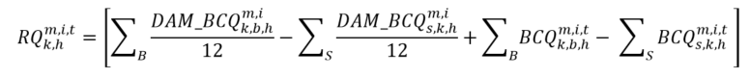
The RQ quantity is then used to either increase or decrease the settlement amount for the hourly uplift charge type ‘c’ in accordance with MR Ch.9 s.3.10 as follows:
Note:

Where:

The calculation of the applicable hourly uplift charge type ’c’ will yield a net credit to the buying market participant as a result of the reallocated quantity exceeding their actual/scheduled withdrawals of energy for the metering interval ‘t’ in question.
The above mechanism applies to those “associated charge types” that are enumerated in the table at the beginning of this section 2.4.3. Refer to section 2.2 for specific listings of charge types and their respective equations.

- End of Section -

Inactive IESO Charge Types and Equations
The provisions of this section are applicable to those IESO charge types and equations that are no longer active, as further described in section 1.2, and have been retained in the event that a re-calculation of the charge type is required.
All market rule and market manual references, in this section, are to those market rules and market manuals that were in effect prior to the commencement of market transition, unless otherwise stated.

Variable Descriptions
The following Table 3-1 contains descriptions of variables used within section 3.2. Variables not defined in this table are as defined in section 2.1.
Table 3-1: Variable Descriptions for Inactive Charge Types and Equations
Key to the Table Below
Variable used within Section 3 | Data Description | Description | Market Rules Reference | Relation to the corresponding variable description within the IESO Market Rules
BR_{r} | Operating Reserve Offers | A matrix of n price-quantity pairs offered by market participant ‘k’ to supply class r operating reserve during settlement hour ‘h’. | 9.3.5.2 | Same as IESO market rules.
CAEO^{m}_{h,k} | Capacity Auction Energy Offer | The quantity of auction capacity for settlement hour ‘h’ (in MW) made available by capacity auction resource for capacity market participant ‘k’ at delivery point or intertie metering point ‘m’ in the relevant settlement hour of the availability window determined as the lesser of the resource’s energy offers submitted in the day-ahead commitment process, pre-dispatch, and real-time energy market, as applicable. | 9.3.1.10 | Same as IESO market rules
CBMP_{k} | Total net volume of electricity withdrawn from the IESO-controlled grid by applicable Class B market participant or licensed distributor that is also a market participant for the month | The total net volume of electricity withdrawn from the IESO-controlled grid by applicable Class B market participant (as that term is defined in the regulation) or licensed distributor that is a market participant ‘k’ for the month. | N/A | N/A – Refer to regulations.
CBRR | Global adjustment Class B recovery rate | Global Adjustment Class B recovery rate for the month per Ontario Regulation 429/04. | N/A | N/A – Refer to regulations.
CGC | Submitted Combined Guaranteed Costs | A financial amount consisting of fuel cost components defined on a per-start basis for a given generation unit calculated in a manner consistent with the applicable market manual, and encompassing the following elements:  - Fuel and operation and maintenance (O&M) costs associated with unit synchronization to the IESO-controlled grid for a given start-up event (costs submitted via Online IESO).  - Fuel and O&M costs associated with moving the generation unit from a valid start to its minimum loading point (costs submitted via Online IESO). | 9.4.7B | Same as IESO market rules.
DA_BE_{k,h}^{m,t} | Energy Offer submitted into the schedule of record at a delivery point | Energy offers submitted in day-ahead, represented as an N by 2 matrix of price-quantity pairs for each market participant ‘k’ at delivery point ‘m’ during metering interval ‘t’ of settlement hour ‘h’ arranged in ascending order by the offered price in each price-quantity pair where offered prices ‘P’ are in column 1 and offered quantities ‘Q’ are in column 2. | 9.3.1.2B.7 | Same as IESO market rules.
DA_BE_{k,h}^{i,t} | Energy Offer submitted into the schedule of record at a intertie metering point | Energy offers submitted in day-ahead, represented as an N by 2 matrix of price-quantity pairs for each market participant ‘k’ at intertie metering point ‘i’ during metering interval ‘t’ of settlement hour ‘h’ arranged in ascending order by the offered price in each price-quantity pair where offered prices ‘P’ are in column 1 and offered quantities ‘Q’ are in column 2. | 9.3.8A.2B and 9.3.8B.2 | Same as IESO market rules
DA_BL_{k,h}^{i,t} | Energy Bids submitted into the schedule of record | Energy bids submitted in day-ahead, represented as an N by 2 matrix of price-quantity pairs for each market participant ‘k’ at intertie metering point ‘i’ during metering interval ‘t’ of settlement hour ‘h’ arranged in ascending order by the offered price in each price-quantity pair where offered prices ‘P’ are in column 1 and offered quantities ‘Q’ are in column 2. | 9.3.1.2B.7 and 9.3.8D.2 | Same as IESO market rules
DA_CGC | Submitted Day-Ahead Combined Guaranteed Costs | EFFECTIVE OCTOBER 13, 2011, THIS VARIABLE IS NO LONGER USED IN THE CALCULATION OF ANY SETTLEMENT.  A financial amount consisting of fuel cost components defined on a per-start basis for a given generation unit calculated in a manner consistent with the applicable market manual, and encompassing the following elements:  - Fuel and operation and maintenance (O&M) costs associated with unit synchronization to the IESO-controlled grid for a given start-up event (costs submitted via IESO Gateway).  - Fuel and O&M costs associated with moving the generation unit from a valid start to its minimum loading point (costs submitted via IESO Gateway). | 9.4.7D.1 | Same as IESO market rules
DA_DQSI_{k,h}^{m,t} | Schedule of Record Dispatch Quantity of Energy Scheduled for Injection at a delivery point | Day-ahead constrained quantity scheduled for injection by market participant ‘k’ at delivery point ‘m’ during metering interval ‘t’ of settlement hour ‘h’. | 9.3.1.2A | Same as IESO market rules.
DA_DQSI_{k,h}^{i,t} | Schedule of Record Dispatch Quantity of Energy Scheduled for Injection at an intertie metering point | Day-ahead constrained quantity scheduled for injection by market participant ‘k’ at intertie metering point ‘i’ during metering interval ‘t’ of settlement hour ‘h’. | 9.3.1.2A | Same as IESO market rules.
DA_DQSW_{k,h}^{i,t} | Schedule of Record Dispatch Quantity of Energy Scheduled for Withdrawal | Day-ahead constrained quantity scheduled for withdrawal by market participant 'k' at intertie metering point 'i' during metering interval 't' of settlement hour 'h'. | 9.3.1.2A | Same as IESO market rules.
DA_ELMP_{h}^{m,t} | Pre-dispatch constrained schedule price for an intertie metering point in the export zone | Day-ahead constrained schedule intertie price at the delivery point ‘m’ of the sink for the export transaction during metering interval ‘t’ of settlement hour ‘h’. | 9.3.1.2A | Same as IESO market rules.
DA_ILMP_{h}^{m,t} | Pre-dispatch constrained schedule price for an intertie metering point in the import zone | Day-ahead constrained schedule intertie price at the delivery point ‘m’ of the source for the import transaction during metering interval ‘t’ of settlement hour ‘h’. | 9.3.1.2A | Same as IESO market rules.
DA_SNLC_{k,h}^{m} | Speed-no-load costs submitted into the schedule of record at a delivery point | As-offered speed-no-load cost associated with three-part offers for a given settlement hour ‘h’ for market participant ‘k’ at delivery point ‘m’. | 9.3.1.2B.7 | Same as IESO market rules.
DA_SNLC_{k,h}^{p} | Speed-no-load costs submitted into the schedule of record at a pseudo-unit | As-offered speed-no-load cost associated with three-part offers for a given settlement hour ‘h’ for market participant ‘k’ at pseudo-unit ‘p’. | 9.3.1.2B.7 | Same as IESO market rules.
DA_SUC_{k,h}^{m} | Start-up costs submitted into the schedule of record at a delivery point | As-offered start-up cost associated with three-part offers for a given settlement hour ‘h’ for market participant ‘k’ at delivery point ‘m’ where settlement hour ‘h’ is the initial hour in the DACP start event. | 9.3.1.2B.7 | Same as IESO market rules.
DA_SUC_{k,h}^{p} | Start-up costs submitted into the schedule of record at a pseudo-unit | As-offered start-up cost associated with three-part offers for a given settlement hour ‘h’ for market participant ‘k’ at pseudo-unit ‘p’ where settlement hour ‘h’ is the initial hour in the DACP start event. | 9.3.1.2B.7 | Same as IESO market rules.
DIPC_{k,h}^{m,t} | Derived Interval Price Curve | Energy price curves derived per interval from submitted hourly day-ahead PSU energy offers, represented as a N by 2 matrix of price-quantity pairs for each market participant ‘k’ at delivery point ‘m’ (where ‘m’ is a CT or ST delivery point) during metering interval ‘t’ of settlement hour ‘h’ arranged in ascending order by the offered price in each price quantity pair where offered prices ‘P’ are in column 1 and offered quantities ‘Q’ are in column 2. | 9.3.1.11 | Same as IESO market rules.  Refer to Market Manual 9.5, Appendix B for a detailed description of DIPC.
DIGQ_{k,h}^{m,t} | Derived Interval Guaranteed Quantity | Portion of the day-ahead constrained quantity scheduled for injection that is eligible for DA-PCG for market participant ‘k’ at pseudo unit ‘p’ during metering interval ‘t’ of settlement hour ‘h’ | 9.3.1.11 | Same as IESO market rules.  Refer to Market Manual 9.5, Appendix C for a detailed description of DIGQ.
DQSI_{k,h}^{m,t} | Dispatch Quantity of Energy Scheduled for Injection | Dispatch quantity of energy scheduled for injection in the real-time schedule by market participant ‘k’ at location ‘m’ in metering interval ‘t’ of settlement hour ‘h’. | 9.3.1.3  and  9.3.1.4A | Same as IESO market rules.  N.B. Location m is further subject to the functional deferral described in section 3.1.4A of Chapter 9 of the market rules (ref. 9.3.1.4A).
DQSR_{r,k,h}^{m,t} | Dispatch Quantity Schedule of Operating Reserve | Dispatch quantity schedule of class r reserve for market participant ‘k’ at location ‘m’ in metering interval ‘t’ of settlement hour ‘h’. | 9.3.1.4  and  9.3.1.4A | Same as IESO market rules.  N.B. Location m is further subject to the functional deferral described in section 3.1.4A of Chapter 9 of the market rules (ref. 9.3.1.4A).
DQSW_{k,h}^{m,t} | Dispatch Quantity of Energy Scheduled for Withdrawal | Dispatch quantity of energy scheduled for withdrawal in the real-time schedule by market participant ‘k’ at location ‘m’ in metering interval ‘t’ of settlement hour ‘h’. | 9.3.1.3  and  9.3.1.4A | Same as IESO market rules.  N.B. Location m is further subject to the functional deferral described in section 3.1.4A of Chapter 9 of the market rules (ref. 9.3.1.4A).
DRACP | Demand Response Auction Clearing Price | The demand response auction clearing price for the commitment period and zone. | N/A | Refer to Market Manual 5.5
DRACP_{h} | Hourly Demand Response Auction Clearing Price | The demand response auction clearing price for the commitment period and zone divided by the hours of availability for a day. | N/A | Refer to Market Manual 5.5
DRBOC_{k} | Demand Response Buy-Out Capacity | The buy-out capacity is an amount that is being reduced from the demand response capacity obligation for demand response market participant ‘k’. | N/A | Refer to Market Manual 5.5
DRCO_{k} | Demand Response Capacity Obligation (MW) | The demand response capacity obligation amount for the commitment period and zone for demand response market participant ‘k’. The initial capacity obligation is acquired through the demand response auction and subject to being reduced via the buy-out process. | N/A | Refer to Market Manual 5.5
DREBQ^{m}_{k,h} | Demand Response Energy Bid Quantity | The quantity (in MW) of auction capacity made available by an hourly demand response resource or capacity dispatchable load resource for capacity market participant ‘k’ at delivery point ‘m’ in settlement hour ‘h’ of the availability window, determined as the lesser of the resource’s energy bids submitted in the day-ahead commitment process, pre-dispatch, and real-time energy market, as applicable, and where such value exceeds the $\text{CAR}{{\text{C}}_{k}}^{\text{m}}$ for the resource in the relevant energy market billing, the $DREB{Q^{m}}_{k,h}$ shall equal such $\text{CAR}{{\text{C}}_{k}}^{\text{m}}$ | 9.3.1.10 | Same as IESO market rules
DRNPF | Demand Response Non-Performance Factor | The non-performance factor as listed in section 7.1 of Market Manual 12 that corresponds and applies to the month being settled. | N/A | Refer to Market Manual 5.5
EIM_{k,h} | Operating Profit Function for the IMPORT of Energy under the Intertie Offer/Bid Guarantee Settlement Credit | This Operating Profit function is used for the calculation of the Intertie Offer/Bid Guarantee Settlement Credit (IOBG) with respect the IMPORT of energy. | 9.3.8A | EIM_{k,h} IS NOT A VARIABLE  EIM_{k,h} is the output of a particular usage of the Operating Profit (OP) function defined within Chapter 9, section 3.8A.  EIM_{k,h} Input variables into the Operating Profit (OP) Function include:  MQSI, EMP, and BE.
EMP_{h}^{i,t} | 5-minute Energy Market Price at the Interties | Energy market price applicable to intertie metering point ‘i’ in metering interval ‘t’ of settlement hour ‘h’. | 9.3.1.3 | Same as IESO market rules.
EMP_{h}^{m,t} | 5-minute Energy Market Price within Ontario | Energy market price applicable to RWM ‘m’ in metering interval ‘t’ of settlement hour ‘h’. | 9.3.1.3 | Same as IESO market rules.
EMP_{h}^{REF,t} | 5-minute Energy Market Reference Price | Reference energy market price used to value losses in the calculation of the Transmission Charge Reduction Fund during in metering interval ‘t’ of settlement hour ‘h’. | 9.3.1.3  and  9.3.6.2 | Same as IESO market rules.
FP_{h}^{m} | Fixed Energy Rate | A fixed energy rate for all metering intervals in settlement hour ‘h’. | N/A – subject to regulations made pursuant to Ontario Energy Board Act, 1998 until March 31, 2005 and by the OEB under such regulations commencing April 1, 2005. | N/A – Refer to regulations.
FPC_{h}^{m} | Rate for a designated group of charge types (refer to description of charge type 141) | This variable is reserved for charge type 141 and applies with respect to charges for the period commencing December 1, 2002 and ending March 31, 2005. Refer to Ontario Regulation 436/02 and Ontario Regulation 98/05. | N/A – subject to regulations made pursuant to Ontario Energy Board Act, 1998. | N/A – Refer to regulations
HOEP_{h} | Hourly Ontario Energy Price | Hourly Ontario Energy Price in settlement hour ‘h’. | 9.3.1.3 | Same as IESO market rules.
IOG_FV_{k,h}^{i} | IOG Floor Value | EFFECTIVE OCTOBER 13, 2011, THIS VARIABLE IS NO LONGER USED IN THE CALCULATION OF ANY SETTLEMENT.  The IOG_FVk,hi is a floor value (in dollars to the nearest cent) derived from:  The day-ahead offer prices for the import transaction submitted by the market participant over the range of the pre-dispatch of record constrained quantity scheduled for that import transaction; and  Real-time offer prices for the import transaction at the corresponding location in the corresponding settlement hour for any additional energy scheduled above and beyond the pre-dispatch of record constrained quantity scheduled for that import transaction:  NOTE: The IOG_FV_{k,h}^{i} is formulated in the manner described in Chapter 9, section 3.8A.8 of the IESO market rules and is used in the formulation of the intertie offer guarantee adjustment (refer to also, section 2.2 entry for charge type 1137 within this document). | 9.3.8A.8 | Same as IESO market rules  Refer to Chapter 9, section 3.8A.8 for details concerning its formulation.
MDCAA | Monthly deferred Class A amount to be recovered | The monthly deferred Class A amount to be recovered which equals one twelfth of the total Global Adjustment allocated to Class A customers that was deferred in April, May and June of 2020. | N/A | N/A – Refer to regulations.
MDCBA | Monthly deferred Class B amount to be recovered | The monthly deferred Class B amount to be recovered equals one twelfth of the total Global Adjustment allocated to Class B customers that was deferred in April, May and June of 2020. | N/A | N/A – Refer to regulations.
MC_{h}^{m} | Minimum Consumption | Used for the OR non-accessibility charges and the calculation of the self-induced dispatchable load CMSC clawback under Business Rule 2. The minimum consumption is equal to the quantity in the price quantity pair where the bidding price is MMCP (i.e., $2000) at RWM metering point ‘m’ for settlement hour ‘h’. | 9.3.5.1A, 9.3.4.2
MI | Ordered matrix of MQSI_{k,h}^{i,t} and corresponding IOG settlement amounts | Used for the calculation of the IOG OFFSET settlement amount. A matrix of X pairs of market schedule quantities scheduled for injection by market participant ‘k’ at all intertie metering points ‘i’ in metering interval ‘t’ of settlement hour ‘h’ (MQSI_{k,h}^{i,t}) paired with the corresponding component of the intertie offer guarantee settlement credit for each intertie metering point ‘i’. Refer to equation in Chapter 9, section 3.8A.4 of the IESO market rules for further details. | 9.3.8A.4 | Same as IESO market rules.
MLP_{k,h}^{m,t} | Minimum Loading Point | Minimum output of energy the market participant ‘k’ at delivery point ‘m’ can maintain without ignition support in metering interval ‘t’ of settlement hour ‘h’. | 9.3.1.2B.7 | Same as IESO market rules.
MLP_CONS_{k,h}^{m,t} | Minimum Loading Point for a steam turbine resource or a combustion turbine resource associated to a pseudo unit | Minimum output of energy the market participant ‘k’ at delivery point ‘m’ can maintain without ignition support in metering interval ‘t’ of settlement hour ‘h’. | 9.3.1.2B.7 | Same as IESO market rules.  Refer to Market Manual 9.4, section 4.1.2.2 for a detailed description of constraints applied for PCG eligible combined cycle plants.
MQSI_{k,h}^{m,t} | Market Quantity Scheduled for Injection | Market quantity scheduled for injection in the market schedule by market participant ‘k’ at RWM or intertie metering point ‘m’ in metering interval ‘t’ of settlement hour ‘h’. | 9.3.1.3 | Same as IESO market rules.
MQSI{adj}_{k,h}^{m,t} | Adjusted Market Quantity Scheduled for Injection | EFFECTIVE OCTOBER 13, 2011, THIS VARIABLE IS NO LONGER USED IN THE CALCULATION OF ANY SETTLEMENT. Used for the calculation of the IOG OFFSET settlement amount. MQSI{adj}k,h i,t is each (and where applicable, adjusted) quantity of energy scheduled for injection in the market schedule by market participant ‘k’ at an intertie metering point ‘i’ in metering interval ‘t’ of settlement hour ‘h’ corresponding with each quantity, MQSIx*,k,h i,t in matrix MI, row x*. | 9.3.8A.4 | Same as IESO market rules.
MQSW_{k,h}^{m,t} | Market Quantity Scheduled for Withdrawal | Market quantity scheduled for withdrawal in the market schedule by market participant ‘k’ at RWM or intertie metering point ‘m’ in metering interval ‘t’ of settlement hour ‘h’. | 9.3.1.3 | Same as IESO market rules.
ONPAO | Ontario Power Generation Non-Prescribed Assets Output | OPG’s Non-Prescribed Assets are those generation assets operated and controlled by Ontario Power Generation in service as of January 1, 2006, excluding Lennox Generating Station, that are not prescribed assets under section 78.1 of the Ontario Energy Board Act, 1998 as amended by the “Electricity Restructuring Act, 2004”.  ONPAO refers to the generation output from OPG’s Non-Prescribed Assets, over each hour of the quarter adjusted to take account of volumes sold through forward contracts in effect as of January 1, 2005. For greater certainty, any output from ONPA resulting from fuel conversion by Ontario Power Generation in ONPA, or incremental output from ONPA resulting from refurbishment or expansion is to be excluded from ONPAO.  Incremental Output is defined as:  generation output x (new total installed capacity – installed capacity as of January 1, 2006) / new total installed capacity. | N/A | The formula for calculating the OPG Rebate is subject to Ministerial Directive made under Order-in-Council 1062/2006 (May 17, 2006).
OP | Operating Profit Function | The Operating Profit function is used for the calculation of the Congestion Management Settlement Credit (CMSC) with respect to constrained on/off payments for energy, operating reserve. It is also used for the calculation of the Day-Ahead Production Cost Guarantee components, the Day-Ahead Generator Withdrawal Charge, the Day-Ahead Import and Export failure charges, and the Import Offer Guarantee Settlement Credit. | 9.3.5.2  and  9.3.8A.2 | OP IS NOT A VARIABLE  OP is a mathematical function defined within Chapter 9, section 3.5.2. of the IESO market rules  Input variables include:  MQSI, MQSW, SQROR  AQEI, AQEW, AQOR  SQEI, SQEW,  DSQI, DSQW, DSQR  DA_DQSI, DA_DQSW, PD_DQSI, PD_DQSW  BE, BL, BR_{r}  PD_BE, PD_BL  DA_BE, DA_BL  EMP  MLP, MLP CONS  DIPC  OPCAP  OP is also used within Chapter 9, section 9.8A.2 of the IESO market rules to derive the Energy Import (EIM_{k,h}) sub-component of the Intertie Offer Settlement Credit (IOG) using the following input variables:  MQSI  BE  EMP
OPCAP_{k,h}^{m,t} | Operating Capacity | De-rating of the generation unit by market participant ‘k’ at delivery point ‘m’ in metering interval ‘t’ of settlement hour ‘h’. | 9.3.1.2B.7 | Same as IESO market rules.
OPE{adj}_{k,h}^{i} | Adjusted CMSC component for energy used in the DA-Ahead IOG | EFFECTIVE OCTOBER 13, 2011, THIS VARIABLE IS NO LONGER USED IN THE CALCULATION OF ANY SETTLEMENT.  This congestion management settlement credit settlement amount (CMSC) component is specifically used in the calculation of the Day-Ahead IOG for import transactions that are subject to a constrained-on event in the real-time market.  OPE{adj}_{k,h}^{i} is an adjusted component of The congestion management settlement credit settlement amount (CMSC) for market participant ‘k’ at intertie metering point ‘i’ for settlement hour ‘h’ in which the constrained schedule is the lesser of PDR_DQSI_{k,h}^{i,t} or DQSI_{k,h}^{i,t} but in all instances, greater than or equal to MQSI_{k,h}^{i,t} . | 9.3.8A.2A | ‘OP’ is a mathematical function used within Chapter 9, section 9.3.8A.2A of the IESO market rules to derive Day-Ahead Intertie Offer Guarantee. Please refer to the market rules for information regarding its formulation.
ORL | Ontario Power Generation Revenue Limit | For the period May 1, 2006 to April 30, 2007 ORL is equal to $46/ MWh.  For the period May 1, 2007 to April 30, 2008 ORL is equal to $47/ MWh.  For the period May 1, 2008 to April 30, 2009 ORL is equal to $48/ MWh. | N/A | The formula for calculating the OPG Rebate is subject to Ministerial Directive made under Order-in-Council 1062/2006 (May 17, 2006).
PAA | Pilot Auction Amount | Refers to the Pilot Auction administered by the Ontario Power Authority in the first half of 2006.  The volume in MWh over each hour in the quarter that is sold by Ontario Power Generation through the PA. | N/A | The formula for calculating the OPG Rebate is subject to Ministerial Directive made under Order-in-Council 1062/2006 (May 17, 2006).
PAORL | Pilot Auction Ontario Power Generation Revenue Limit | For the period May 1, 2006 to April 30, 2007 PAORL is equal to $51/ MWh.  For the period May 1, 2007 to April 30, 2008 PAORL is equal to $52/ MWh.  For the period May 1, 2008 to April 30, 2009 PAORL is equal to $53/ MWh. | N/A | The formula for calculating the OPG Rebate is subject to Ministerial Directive made under Order-in-Council 1062/2006 (May 17, 2006).
PAP | Pilot Auction Price | The weighted average auction price in $/ MWh over each hour of the quarter realized for the PAA by Ontario Power Generation. | N/A | The formula for calculating the OPG Rebate is subject to Ministerial Directive made under Order-in-Council 1062/2006 (May 17, 2006).
PD_BE_{k,h}^{i,t} | Energy Offer submitted into the Pre-dispatch | Energy offers submitted in Pre-dispatch, represented as an N by 2 matrix of price-quantity pairs for each market participant ‘k’ at intertie metering point ‘i’ during metering interval ‘t’ of settlement hour ‘h’ arranged in ascending order by the offered price in each price quantity pair where offered prices ‘P’ are in column 1 and offered quantities ‘Q’ are in column 2. | 9.3.1.2D | Same as IESO market rules.
PD_BL_{k,h}^{i,t} | Energy Bid submitted into the Pre-dispatch | Energy bids submitted in pre-dispatch, represented as an N by 2 matrix of price-quantity pairs for each market participant ‘k’ at intertie metering point ‘i’ during metering interval ‘t’ of settlement hour ‘h’ arranged in ascending order by the offered price in each price quantity pair where offered prices ‘P’ are in column 1 and offered quantities ‘Q’ are in column 2. | 9.3.1.2D | Same as IESO market rules.
PD_DQSI_{k,h}^{i,t} | Pre-dispatch quantity scheduled for injection at an intertie metering point | Pre- dispatch constrained quantity scheduled for injection by market participant ‘k’ at intertie metering point ‘i’ during metering interval ‘t’ of settlement hour ‘h’. | 9.3.1.2C | Same as IESO market rules
PD_DQSW_{k,h}^{i,t} | Pre-dispatch quantity scheduled for withdrawal at an intertie metering point | Pre- dispatch constrained quantity scheduled for withdrawal by market participant ‘k’ at intertie metering point ‘i’ during metering interval ‘t’ of settlement hour ‘h’. | 9.3.1.2C | Same as IESO market rules
PD_ELMP_{h}^{m,t} | Pre-dispatch constrained schedule price for an intertie metering point in the export zone | Pre-dispatch constrained schedule intertie price at the delivery point ‘m ’ of the sink for the export transaction during metering interval ‘t’ of settlement hour ‘h’. | 9.3.1.2C | Same as IESO market rules.
PD_EMP_{h}^{m,t} | Pre-dispatch energy market price for Ontario | Pre-dispatch projected energy market price applicable to all delivery points ‘m’ in the Ontario zone in metering interval ‘t’ of settlement hour ‘h’. | 9.3.1.2C | Same as IESO market rules
PD_ILMP_{h}^{m,t} | Pre-dispatch constrained schedule price for an intertie metering point in the import zone | Pre-dispatch constrained schedule intertie price at the delivery point ‘m’ of the source for the import transaction during metering interval ‘t’ of settlement hour ‘h’. | 9.3.1.2C | Same as IESO market rules.
PDR_BE_{k,h}^{i,t} | Energy Offer submitted into the pre-dispatch of record | EFFECTIVE OCTOBER 13, 2011, THIS VARIABLE IS NO LONGER USED IN THE CALCULATION OF ANY SETTLEMENT.  Energy offers submitted into the pre-dispatch of record, represented as an n by 2 matrix of price-quantity pairs for each market participant ‘k’ at intertie metering point ‘i’ during metering interval ‘t’ of settlement hour ‘h’ arranged in ascending order by the offered price in each price-quantity pair, where offered prices are in column 1 and offered quantities are in column 2. | 9.3.1.2B | Same as IESO market rules
PDR_DQSI_{k,h}^{i,t} | Pre-dispatch of record dispatch quantity scheduled for injection at an intertie metering point | EFFECTIVE OCTOBER 13, 2011, THIS VARIABLE IS NO LONGER USED IN THE CALCULATION OF ANY SETTLEMENT.  Pre-dispatch of record constrained quantity scheduled for injection by market participant ‘k’ for an import transaction at intertie metering point ‘i’ during metering interval ‘t’ of settlement hour ‘h’. | 9.3.1.2A | Same as IESO market rules
PDR_DQSI_{k,h}^{m,t} | Pre-dispatch of record dispatch quantity scheduled for injection at a delivery point | EFFECTIVE OCTOBER 13, 2011, THIS VARIABLE IS NO LONGER USED IN THE CALCULATION OF ANY SETTLEMENT.  Pre-dispatch of record constrained quantity scheduled for injection by market participant ‘k’ at delivery point ‘m’ during metering interval ‘t’ of settlement hour ‘h’. | 9.3.1.2A | Same as IESO market rules
RPPVA_{k} | Total volume of electricity distributed to prescribed Class B consumers | The total volume of electricity distributed to Class B consumers whose rates are determined under subsection 79.16 (1) of the Ontario Energy Board Act, 1998 during the month by licensed distributor ‘k’. | N/A | N/A – Refer to regulations.
SQROR_{r,k,h}^{m,t} | Scheduled Quantity of cl3ass r Operating Reserve | Market Schedule quantity in MW of class r reserve for market participant ‘k’ in metering interval ‘t’ of settlement hour ‘h’ at RWM ‘m’. | 9.3.1.4 | Same as IESO market rules.
X_{h}^{m,t} | Settlement Floor Price for exports | A settlement floor price for energy applicable to intertie metering point ‘m’ metering interval ‘t’ in settlement hour ‘h’ as set in the applicable market manual. The need for a settlement floor price other than MMCP shall remain in effect only until floor prices for energy offers from registered market participants that are variable generators or nuclear generators go into effect. | 9.3.1.3 | Same as IESO market rules

Charge Types and Equations
The following Table 3-2 contains all inactive charge types. For a description of each column heading, refer to Table 2-1.

Inactive – Physical Market Charge Types and Equations
Table 3-2: Inactive Charge Types and Equations in the Physical Market
Charge Type Number | Charge Type Name | Settlement Amount Acronym | Market Rules Reference | Equation | Settlement Resolution | Cashflow | HST Tax Treatment within Ontario  (%) | HST Tax Treatment for U.S., Manitoba, and Quebec  Generation  (%) | HST Tax Treatment for U.S. Load  (%) | HST Tax Treatment for Manitoba and Quebec Load  (%) | Comments
100 | Net Energy Market Settlement for Generators and Dispatchable Load | NEMSC_{k,h} | 9.3.3.2 | **CALCULATIONS FOR CHARGE TYPE 100 END APRIL 30, 2023**  For dispatchable facilities or an intertie metering point associated with:  - An injecting boundary entity;  - A withdrawing boundary entity where the associated intertie congestion price is less than zero;  - A withdrawing boundary entity conducting a wheeling through transaction that is linked as per Chapter 7, section 3.5.82 of the market rules  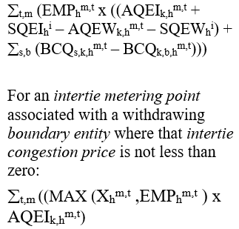 | Interval | Either Way | 13 | 13 | 0 | 13
101 | Net Energy Market Settlement for Non-dispatchable Load | NEMSC_{k,h} | 9.3 | **CALCULATIONS FOR CHARGE TYPE 101 END APRIL 30, 2023**  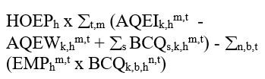 | Hourly | Either Way | 13 | N/A | N/A | N/A
103  MRP retired | Transmission Charge Reduction Fund | TCRF_{h} | 9.3.6.2  And  8.4.18 | 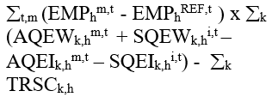 | Hourly | Accumulates in the TR Clearing Account | N/A | N/A | N/A | N/A | Refer to IESO market rules, Chapter 8 section 4.18 for further details.
104  MRP updated | Transmission Rights Settlement Credit | TRSC_{k,h} | 9.3.6.1 | **The following was effective prior to the commencement of market transition. Refer to section 2 for version in effect on the commencement of market transition.**  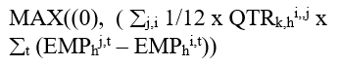 | Hourly | Due MP | 0 | 0 | 0 | 0
105  MRP retired | Congestion Management Settlement Credit for Energy | CMSC_{k,h} | 9.3.5.2  to  9.3.5.7 | 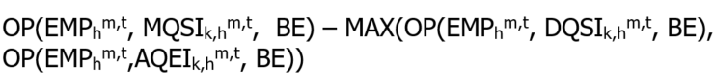  Subject to the mathematical sign of (DQSI-MQSI) being equal to the mathematical sign of (AQEI-MQSI). AQEI_{k,h}^{m,t} and EMP_{h}^{m,t} may be substituted with SQEI_{k,h} ^{i,t} and EMP_{h}^{i,t} respectively, where the application of this equation pertains to intertie metering point ‘i’.  or  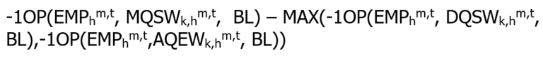  Subject to the mathematical sign of (DQSW-MQSW) being equal to the mathematical sign of (AQEW-MQSW). AQEW_{k,h}^{m,t} and EMP_{h}^{m,t} may be substituted with SQEW_{k,h} ^{i,t} and EMP_{h}^{i,t} respectively, where the application of this equation pertains to intertie metering point ‘i’.  or  For variable generators that are registered market participants whose registered facility is operating under a release notification for any given dispatch interval, and the facility’s market schedule quantity is less than the corresponding quantity in the constrained schedule for the same dispatch interval as a result of the market participant’s offers being partially or fully uneconomic:  Refer to 9.3.5.2 for the definition of the Operating Profit (OP) function referenced above. | Interval | Either Way | 13 | 13 | 13 | 13 | This charge type holds the market participant to the expected profits implied by the market schedule derived on dispatch data provided by that market participant.  Offer prices in matrix ‘BE’ may be revised down to a lower limit as described in 9.3.5.6. Refer to also: description of variable ‘BE’ in section 2.2.  The bid prices in the matrix BL may be revised as described in Market Manual 5: Settlements Part 5.5: Physical Markets Settlement Statements, section 1.6.8.
106  MRP retired | Congestion Management Settlement Credit for 10 Minute Spinning Reserve | CMSC_{r,k,h} | 9.3.5.2 | 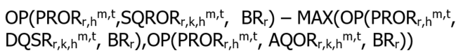  Refer to 9.3.5.2 for the definition of the Operating Profit (OP) function referenced above. | Interval | Either Way | 13 | N/A | N/A | N/A | This charge type holds the market participant to the expected profits implied by the market schedule derived on dispatch data provided by that market participant.
107  MRP retired | Congestion Management Settlement Credit for 10 Minute Non-spinning Reserve | CMSC_{r,k,h} | 9.3.5.2 | 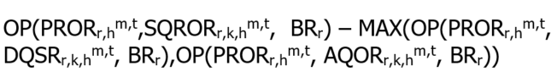  Refer to 9.3.5.2 for the definition of the Operating Profit (OP) function referenced above. | Interval | Either Way | 13 | N/A | N/A | N/A | This charge type holds the market participant to the expected profits implied by the market schedule derived on dispatch data provided by that market participant.
108  MRP retired | Congestion Management Settlement Credit for 30 Minute Operating Reserve | CMSC_{r,k,h} | 9.3.5.2 | 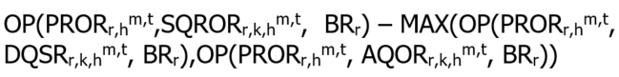  Refer to 9.3.5.2 for the definition of the Operating Profit (OP) function referenced above. | Interval | Either Way | 13 | N/A | N/A | N/A | This charge type holds the market participant to the expected profits implied by the market schedule derived on dispatch data provided by that market participant.
111 | Northern Pulp and Paper Mill Electricity Transition Program Settlement Amount | N/A | N/A | 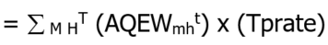  Where:  Tprate is the transition program rate  ‘M’ is the set of all delivery points ‘m’ for all market participant-eligible facilities.  ‘H’ is the set of all settlement hours ‘h’ in the settlement period.  ‘T’ is the set of all metering intervals ‘t’ in the set of all settlement hours ’H’.  ‘AQEW’ is limited to a maximum of 1,000,000 MWh annually per eligible market participant. | Quarterly | Due MP | 13 | N/A | N/A | N/A | Eligibility, rates, and other implementation details subject to Ministry of Natural Resources specifications.  This program ends on September 30, 2010.
112 | Ontario Power Generation Rebate | N/A | N/A | ** CALCULATIONS FOR CHARGE TYPE 112 END April 30, 2009 **  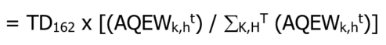  Where:  ‘K’ is the set of all Ontario market participants ‘k’  ‘H’ is the set of all settlement hours ‘h’ in the applicable quarter.  ‘T’ is the set of all metering intervals ‘t’ in the set of all settlement hours ‘H’. | May 1, 2006  to  April 30, 2009 | Due MP | 13 | N/A | N/A | N/A | The Ontario Power Generation Rebate payments will be based on the allocated quantity of energy withdrawn for the applicable quarter.
113  MRP retired | Additional Compensation for Administrative Pricing Credit | N/A | 7.8.4A.16  or  7.8.4A.10  or  7.13.6.2 | Manual Entry as per 7.8.4A.16, or 7.8.4A.10, or 7.13.6.2. | Monthly | Due MP | 13 | 13 | 0 | 13 | This charge will still be used for market suspension events
120  MRP retired | Local Market Power Debit | 9.4.8.2.2  And  Ch. 7, Appendix 7.6 |  | Manual Entry as per 9.4.8.2.2 | Monthly | Due IESO | 13 | 13 | 0 | 13
121 | Northern Industrial Electricity Rate Program Settlement Amount | N/A | N/A | ** PROGRAM END APRIL 30, 2022 AND REPLACED BY NORTHERN ENERGY ADVANTAGE PROGRAM SETTLEMENT AMOUNT UNDER THE SAME CHARGE TYPE **  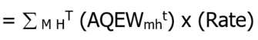  Where:  Rate is the program rate  ‘M’ is the set of all delivery points ‘m’ for all market participant-eligible facilities.  ‘H’ is the set of all settlement hours ‘h’ in the settlement period.  ‘T’ is the set of all metering intervals ‘t’ in the set of all settlement hours ‘H’. | Quarterly | Due MP | 0 | N/A | N/A | N/A | Eligibility, rates, and other implementation details subject to Ministry of Northern Development, Mines, Natural Resources and Forestry specifications.
122  MRP retired | Ramp Down Settlement Amount | RDSA_{k,h} | 9.3.5A.1 | Let ‘BE’ be a matrix of n price-quantity pairs offered by market participant ‘k’ to supply energy during the settlement hour immediately before the hour in which ramp-down begins, adjusted by a ramp-down factor (RDF) as specified in the applicable market manual.  Let OP(P,Q,B) be a function of Price (P), Quantity (Q) and an n x 2 matrix (B) of offered price-quantity pairs:  Where:  s* is the highest indexed row of BE such that Q_{s*} ≤ Q ≤ Q_{n} and where, Q₀=0  Using the terms below, let RDC_{k,h}^{m,t} be expressed as follows:  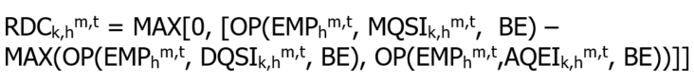  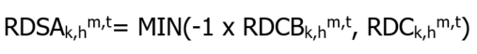 | Interval | Either Way | 13 | N/A | N/A | N/A | The RDF is defined in Market Manual 5: Settlements Part 5.5: Physical Markets Settlement Statements, section 1.6.31.
124  MRP retired | SEAL Congestion Management Settlement Credit Amount | N/A | N/A | Manual entry based on the values submitted by MACD | Monthly | Due MP | 13 | 13 | 13 | 13
130 | Intertie Offer Guarantee Settlement Credit – Energy | IOG_{k,h}  and  IOG_{k,h}OFFSET | 9.3.8A.1  9.3.8A.3  and  7.3.5.8.1 | **CALCULATIONS FOR CHARGE TYPE 130 END OCTOBER 12, 2011. CHARGE TYPE 130 REPLACED BY CHARGE TYPE 1131 EFFECTIVE OCTOBER 13, 2011.**  The Intertie Offer Guarantee settlement amount is derived from an hourly Energy Import sub component (EIM_{k,h}) as follows:  Refer to 9.3.8A.2 for the definition of the Operating Profit (OP) function referenced above.  Where ‘I’ is the set of relevant intertie metering points ‘i’.  Where ‘T’ is the set of all metering intervals ‘t’ during settlement hour ‘h’.  The IOG_OFFSET component of this charge type applied on a monthly basis and is calculated as follows:  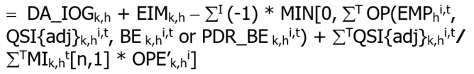  (Refer to 9.3.8A.4 for the derivation of the variable QSI{adj}_{k,h}^{i,t} , OPE’_{k,h}^{i} and the proper context of the matrix notation MI_{k,h}^{t}[n,1] used above ). | Hourly  (the IOG Offset is debited) | Either Way | N/A | 13 | 13 | 13 | Compensation for cumulative, hourly financial losses as implied by the market schedule for Imports of energy at an intertie metering point.  This amount is reduced by the IOG Offset when the import is part of an implied “wheeling through” transaction as described in section 3.5.8.1 of Chapter 7.
133  MRP retired | Generation Cost Guarantee Payment | N/A | 9.4.7B | Dispatchable delivery points:  Subject to:  Where ‘CGC’ is a Submitted Combined Guaranteed Costs variable, assessed in accordance with the applicable market manual (refer to also section 2.1 “Variable Description”).  Where ‘m’ is delivery point ‘m’ at which the generation unit incurring the relevant costs is located.  Where ‘T’ is a set of metering intervals ‘t’ from a valid start time until the earlier of:  - the end of minimum generation block run-time; or  - the end of the unit’s minimum run-time.  Where AQEI{limited}_{k,h}^{m,t} shall denote all allocated quantities in MWh of energy injected at delivery point ‘m’ irrespective of any submission of physical allocation data by market participant ‘k’ in metering interval ‘t’ of settlement hour ‘h’, up to the generation unit’s minimum loading point.  Where RT_COST is fuel and O&M cost component related to operation of the generation unit at its minimum loading point during its minimum generation block run-time (these costs are calculated based on the offer price associated with real-time dispatch).  - Where the COST function is defined as follows:  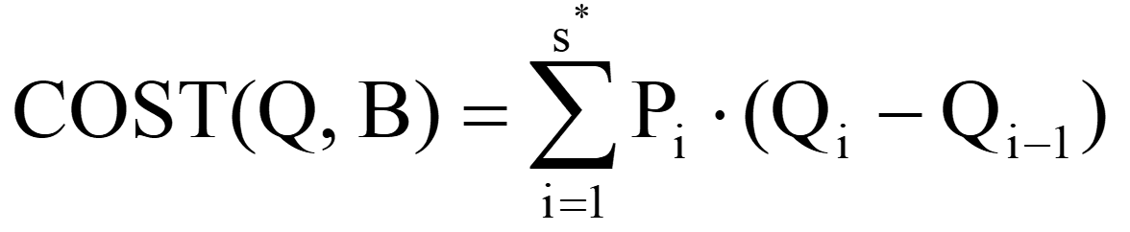  where:  - B is the n x 2 matrix (B) of offered price-quantity pairs (P_{i} , Q_{i})  - s* is the highest indexed row of B such that Q_{s*-1} ≤ Q ≤ Q_{s*} and where Q₀=0  - Where ‘H1’ is the set of all settlement hours ‘h’ during the period from beginning of the minimum generation block run-time until the end of the calculated minimum run time. We consider that the minimum generation block run-time starts with the first hour after we add the submitted number of ramp intervals to the valid start-up hour.  - Where ‘T*’ is the set of metering intervals ‘t’ in the set of all settlement hours ‘H1’  Where CMSC_REV _{k,h}^{m,t} is any real-time CMSC(TD _{k,h,105}^{m,t}) payment associated with allocated quantities in MWh of energy injected at delivery point ‘m’ irrespective of any submission of physical allocation data by market participant ‘k’ in metering interval ‘t’ of settlement hour ‘h’ up to the generation unit’s minimum loading point.  CMSC_REV is calculated using the following rules:  - Real-time CMSC (TD _{k,h,105}^{m,t}) for the same interval is greater than zero.  - If MQSI _{k,h}^{m,t} and max(DQSI _{k,h}^{m,t},AQEI _{k,h}^{m,t}) >= MLP, then CMSC_REV_{k,h}^{m,t} = 0.  - In the case of a constrained-off event:  - If MQSI _{k,h}^{m,t} < MLP, then CMSC_REV _{k,h}^{m,t} = TD _{k,h,105}^{m,t}  - If MQSI _{k,h}^{m,t} >= MLP and max(DQSI _{k,h}^{m,t},AQEI _{k,h}^{m,t}) <= MLP, then CMSC_REV _{k,h}^{m,t} = OP(EMP _{h}^{m,t},MLP,BE) – OP(EMP,max(DQSI _{k,h}^{m,t},AQEI _{k,h}^{m,t}),BE).  - In the case of a constrained-on event:  - If MQSI _{k,h}^{m,t} < MLP and min(DQSI _{k,h}^{m,t},AQEI _{k,h}^{m,t}) < MLP, then  CMSC_REV _{k,h}^{m,t} = TD _{k,h,105}^{m,t}  - If MQSI _{k,h}^{m,t} <= MLP and min(DQSI _{k,h}^{m,t}, AQEI _{k,h}^{m,t}) >=MLP, then  CMSC_REV _{k,h}^{m,t} = OP(EMP _{h}^{m,t},MQSI _{k,h}^{m,t},BE) – OP(EMP _{h}^{m,t},MLP,BE)  (Refer to applicable market manual)
134  MRP retired | Demand Response Credit | N/A | 9.4.7C  9.4.7F | Manual Entry for TDRP (Refer to “Market Manual 5: Settlements, Part 5.10: Transitional Demand Response Program”.  Manual Entry for ELRP (Refer to “Market Manual 10: Emergency Load Reduction Program (ELRP)”. | Monthly | Either way | 13 | N/A | NA | N/A | TDRP and ELRP suspended by the IESO.
135  MRP retired | Real-time Import Failure Charge | RT_IFC_{k,h} | 9.3.8C.3 | 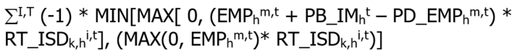  Where:  ‘I’ is the set of all intertie metering points ‘i’.  ‘T’ is the set of 12 metering intervals ‘t’ during settlement hour ‘h’.  RT_ISD_{k,h}^{i,t} = MAX (PD_DQSI_{k,h}^{i,t} – DQSI_{k,h}^{i,t}, 0) | Hourly | Due IESO | N/A | 13 | N/A | N/A | Subject to exemptions under the provisions of 9.3.8C.2.2.
136  MRP retired | Real-time Export Failure Charge | RT_EFC_{k,h} | 9.3.8C.5 | Where:  ‘I’ is the set of all intertie metering points ‘i’  ‘T’ is the set of 12 metering intervals ‘t’ during settlement hour ‘h’  RT_ESD_{k,h}^{i,t} = MAX (PD_DQSW_{k,h}^{i,t} – DQSW_{k,h}^{i,t}, 0) | Hourly | Due IESO | N/A | N/A | 0 | 13 | Subject to exemptions under the provisions of 9.3.8C.4.2.
137  MRP retired | Generation Cost Guarantee – Annual Carbon Charge Settlement Amount | N/A | 9.4.7B.1.2  7.2.2B | Manual entry based on the calculations outlined in Market Manual 4: Market Operations Part 4.6: Real-Time Generation Cost Guarantee Program, section 5.4 Fuel Cost Recovery Methodology. | Monthly | Due MP | 13 | N/A | N/A | N/A
140 | Fixed Energy Rate Settlement Amount | N/A | N/A | ** CHARGE TYPE 140 REPLACED BY CHARGE TYPE 142 EFFECTIVE JANUARY 1, 2005 **  NOTE: The equations identified below apply to low volume and designated consumers (as defined in Ontario Energy Board Act, 1998 and associated regulations) in the IESO-administered market. For distributors, charge type 140 is applied once a month based on the values submitted by the distributor on IMO_FORM_1562 (monthly adjustment) and IMO_FORM_1505 (May-Nov 2002 refund).  For IESO’s low volume and designated customers a fixed rate adjustment with a rate of 5.5 cents per kWh is applied on an interval basis using the equation below.  A manual adjustment is applied at the end of the month to apply a rate of 4.7 cents per kWh for energy withdrawn up to 750 kWhs.  Fixed Energy Rate Settlement Amount (dispatchable locations):  Where net uncovered consumption > 0:  Where net uncovered consumption = 0:  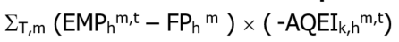  SUBJECT TO: Net uncovered consumption = MAX [Σ_{T,m} (AQEW_{k,h}^{m,t} - Σ_{s} BCQ_{s,k,h}^{m,t}),0]  Fixed Energy Rate Settlement Amount (non-dispatchable locations):  Where net uncovered consumption > 0:  Where net uncovered consumption = 0:  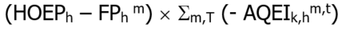  SUBJECT TO:  Net uncovered consumption = MAX [Σ_{T,m} (AQEW_{k,h}^{m,t} - Σ_{s} BCQ_{s,k,h}^{m,t}),0]  SUBJECT TO:  Net uncovered consumption = MAX [Σ_{T,m} (AQEW_{k,h}^{m,t} - Σ_{s} BCQ_{s,k,h}^{m,t}),0] | Hourly (type ‘DP’ records only.  Refer to Format Specifications for Settlement Statement Files and Data Files for further details) | Either Way | N/A | N/A | N/A | N/A | Eligibility, rates, and other implementation details subject to government regulation.
141 | Fixed Wholesale Charge Rate Settlement Amount | N/A | N/A | ** CALCULATIONS FOR CHARGE TYPE 141 END MARCH 31, 2005 **  NOTE: The equations identified below apply to distributors, low volume and designated consumers (as defined in Bill 4 and associated regulations) in the IESO-administered market. For distributors an additional charge type 141 record is provided to reflect any monthly submission of IMO_FORM_1562. Refer to IMO_FORM_1562 for further details.  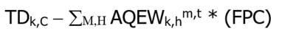  Where:  ‘H’ is all settlement hours ‘h’ during the billing period; and,  ‘C’ is a designated group of charge types ‘c’ prescribed by government regulation (and associated rulings by the Ontario Energy Board) and consisting of the cumulative sum of the following charge types:  150, 155, 168, 170, 182, 183, 184, 250, 252, 254, 450, 452, 454, 550, 753, 9990 | Monthly | Either Way | N/A | N/A | N/A | N/A | Eligibility, rates, and other implementation details subject to government regulation.
146 | Global Adjustment Settlement Amount | N/A | N/A | **CALCULATIONS FOR CHARGE TYPE 146 END DECEMBER 31, 2010. CHARGE TYPE 146 REPLACED BY CHARGE TYPES 147 AND 148 EFFECTIVE JANUARY 1, 2011.**  For Fort Frances Power Corporation Distribution Inc.:  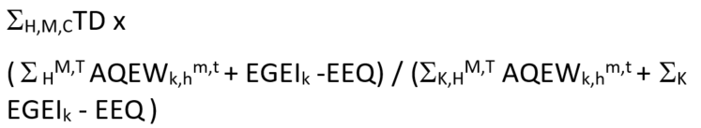  For other market participants:  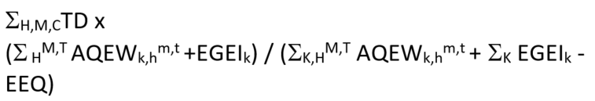  Where ‘H’ is the set of all settlement hours ‘h’ in the month.  Where ‘K’ is the set of all market participants ‘k’.  Where ‘M’ is the set of all delivery points ‘m’ of market participant ‘k’.  Where ‘C’ is the set of the following charge types ‘c’:  193, 194, 195, 197, 198, 1380, 1381, 1382, 1383, 1384, 1385, 1386, 1390, 1391, 1392, 1393, 1394, 1395, 1396, 1397, 1398, 1450, 1460, 1462 and 1464. | Monthly | Due MPs | 13 | N/A | N/A | N/A | Eligibility, rates, and other implementation details subject to government regulation.
150  MRP retired | Net Energy Market Settlement Uplift | N/A | 9.3.9.1 | 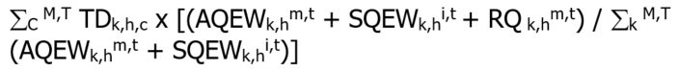  Where:  ‘C’ is the set of the following charge types ‘c’ as follows:  1101, 1103, 1111, 1113, 1114, 1115, 103, 104, 1131  ‘T’ is the set of 12 metering intervals ‘t’ during settlement hour ‘h’.  Where RQ_{k,h}^{m,t} is a reallocated quantity whereby market participant ‘k’ is a party to one or more physical bilateral contracts for settlement hour ‘h’ in which the NEMSC component of hourly uplift is to be reallocated between market participant ‘k’ and the other market participant that is a party to the contract in which: | Hourly | Either Way | 13 | N/A | 0 | 13
155  MRP retired | Congestion Management Settlement Uplift | N/A | 9.3.5.2  and  9.3.5.7 | 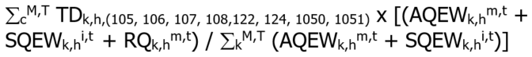  Where ‘T’ is the set of 12 metering intervals ‘t’ during settlement hour ‘h’.  Where RQ_{k,h}^{m,t} is a reallocated quantity whereby market participant ‘k’ is a party to one or more physical bilateral contracts for settlement hour ‘h’ in which the CMSC component of hourly uplift is to be reallocated between market participant ‘k’ and the other market participant that is a party to the contract in which: | Hourly  or  Monthly  (refer to 9.3.5.7) | Either Way | 13 | N/A | 0 | 13 | Pursuant to market rules, section 9.3.5.7, during an interim period, the disbursements of charge type 105 amounts adjusted as per section 9.3.5.6 may be made on a monthly basis.
161 | Northern Pulp and Paper Mill Electricity Transition Program Balancing Amount | N/A | N/A | 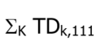  Where ‘k’ is part of a subset of eligible market participants ‘k’. | Quarterly | Due IESO | 0 | N/A | N/A | N/A | This program ends on September 30, 2010.
162 | Ontario Power Generation Rebate Debit | N/A | N/A | ** CALCULATIONS FOR CHARGE TYPE 162 END April 30, 2009 **  Payment (n) = ∑_{H} [(HOEP_{h} – ORL) x (ONPAO_{h} x 0.85 – PAA) +  (PAP – PAORL) x PAA)]  OPG rebate (n) = Max [ 0, Payment (n) – Payment (n-1) + NCF (n-1) ]  Where:  ‘H’ is the set of all settlement hours ‘h’ from May 1, 2006 to the end of the applicable quarter.  ‘n’ is the current quarter.  ‘n-1’ is the previous quarter.  NCF is the negative amount carried forward and calculated as NCF (n) = Min [ 0, Payment (n) – Payment (n-1) + NCF (n-1) ] | May 1, 2006 to  April 30, 2009 | Due IESO | N/A | N/A | N/A | N/A | The OPG rebate quarterly payment will be based on a cumulative calculation commencing May 1, 2006 to the end of each quarter less the same cumulative calculation to the end of the previous quarter.  Where the payment formula results in an amount owing to OPG for any quarter, no such payment will be made to OPG and any such amount will be carried forward into subsequent quarters.
163  MRP retired | Additional Compensation for Administrative Pricing Debit | N/A | 7.8.4A.16  or  7.8.4A.10  or  7.13.6.2,  and  9.4.8 | 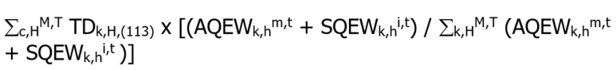  Where ‘H’ is the set of all settlement hours ‘h’ in the month.  Where ‘T’ is the set of all metering intervals ‘t’ in the set of all settlement hours ‘H’. | Monthly | Due IESO | 13 | N/A | 0 | 13 | This charge will still be used for market suspension events.
170  MRP retired | Local Market Power Rebate | N/A | 9.4.8.2.2  9.4.8.2.3  9.3.8A.5  9.3.8A.6  and  Ch. 7, Appendix 7.6 | Where ‘c’ denotes charge type 120 and that portion of charge type 130 related to the IOG OFFSET settlement amount.  Where ‘H’ is the set of all settlement hours ‘h’ in the month.  Where ‘T’ is the set of all metering intervals ‘t’ in the set of all settlement hours ‘H’. | Monthly | Due MP | 13 | N/A | 0 | 13
171 | Northern Industrial Electricity Rate Program Balancing Amount | N/A | N/A | ** PROGRAM END APRIL 30, 2022 AND REPLACED BY NORTHERN ENERGY ADVANTAGE PROGRAM BALANCING AMOUNT UNDER THE SAME CHARGE TYPE **  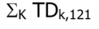  Where ‘k’ is part of a subset of eligible market participants ‘k’. | Quarterly | Due IESO | 0 | N/A | N/A | N/A
183  MRP retired | Generation Cost Guarantee Recovery Debit | N/A | 9.4.8.1.9 | Where:  ‘C’ is the set of the following charge types ‘c’ as follows:  133, 137  ‘H’ is the set of all settlement hours ‘h’ in the month.  ‘T’ is the set of all metering intervals ‘t’ in the set of all settlement hours ‘H’. | Monthly | Due IESO | 13 | N/A | 0 | 13
184 | Demand Response Debit | N/A | 9.4.7C  9.4.7F | Where: ‘H’ is all settlement hours ‘h’ during the billing period. | Monthly | Either way | 13 | N/A | 0 | 5 | TDRP and ELRP suspended by the IESO.
190 | Fixed Energy Rate Balancing Amount | N/A | N/A | ** CHARGE TYPE 190 REPLACED BY CHARGE TYPE 192 EFFECTIVE JANUARY 1, 2005 **  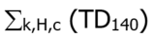  Where:  ‘H’ is all settlement hours ‘h’ during the trading day for all trading days during the interim period beginning December 1, 2002. | Hourly  (type ‘DP’ records only. Refer to: Format Specifications for Settlement Statement Files and Data Files for further details) | Either Way | N/A | N/A | N/A | N/A | Eligibility, rates, and other implementation details subject to government regulation.
191 | Fixed Wholesale Charge Rate Balancing Amount | N/A | N/A | ** CALCULATIONS FOR CHARGE TYPE 191 END MARCH 31, 2005 **  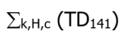  Where:  ‘H’ is all settlement hours ‘h’ during the billing period. | Monthly | Either Way | N/A | N/A | N/A | N/A | Eligibility, rates, and other implementation details subject to government regulation.
198 | Renewable Generation Balancing Amount | N/A | N/A | ** CALCULATIONS FOR CHARGE TYPE 198 END DECEMBER 31, 2010. **  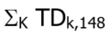  Where ‘K’ is the set of all market participants ‘k’.  Where TD_{k,148} is the settlement amount of charge type 148 for the month for market participant ‘k’. | Pending | Due IESO | 0 | N/A | N/A | N/A | Implementation details subject to government regulation.
200  MRP retired | 10 Minute Spinning Reserve Market Settlement Credit | ORSCk,h | 9.3.4.1 | 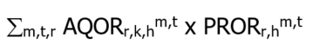 | Interval | Due MP | 13 | 13 | N/A | N/A
202  MRP retired | 10 Minute Non-spinning Reserve Market Settlement Credit | ORSC_{k,h} | 9.3.4.1 | 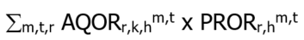 | Interval | Due MP | 13 | 13 | N/A | N/A
204  MRP retired | 30 Minute Operating Reserve Market Settlement Credit | ORSC_{k,h} | 9.3.4.1 | 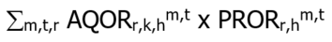 | Interval | Due MP | 13 | 13 | N/A | N/A
206  MRP updated | 10-Minute spinning non-Accessibility Settlement Amount | ORSCB_{r,k,h} | 9.3.4.2-9.3.4.3 | **The following was effective prior to the commencement of market transition. Refer to section 2 for version in effect on the commencement of market transition.**  For dispatchable loads and non-aggregated generators:  MIN(0,(TAOR_{k,h}^{m,t} – AQOR_{r1,k,h}^{m,t}) × PROR_{r1,h}^{m,t})  Where:  TAOR_{k,h}^{m,t} =  MAX(0,AQEW_{k,h}^{m,t} – MC_{h}^{m,t}) for dispatchable loads  or,  MAX(0,MAX_CAP_{k,h}^{m,t} – AQEI_{k,h}^{m,t}) for generators  For aggregated generators:  ORIA_CA_{r1,k,h}^{M,t} × ORCF_{r1,k,h}^{m,t} × PROR_{r1,h}^{m,t}  Where:  ORIA_CA_{r1,k,h}^{M,t} = MIN(0,TAOR_CA_{k,h}^{M,t} − ∑_{M} AQOR_{r1,k,h}^{m,t})  TAOR_CA_{k,h}^{M,t} =  MAX(0,∑_{M} (MAX_CAP_{k,h}^{m,t} – AQEI_{k,h}^{m,t}))  ORCF_{r1,k,h}^{m,t} = ORIA_{r1,k,h}^{m,t} / (∑_{M1} ORIA_{r1,k,h}^{m,t}), and M1 represents the set of all delivery points ‘m’ offering 10-minute synchronized OR  ORIA_{r1,k,h}^{m,t} = MIN(0,(TAOR_{k,h}^{m,t} – AQOR_{r1,k,h}^{m,t})) | Interval | Due IESO | 13 | N/A | N/A | N/A | Please refer to MR-00467
208  MRP updated | 10-Minute non-Spinning non-Accessibility Settlement Amount | ORSCB_{r,k,h} | 9.3.4.2-9.3.4.3 | **The following was effective prior to the commencement of market transition. Refer to section 2 for version in effect on the commencement of market transition.**  For dispatchable loads and non-aggregated generators:  MIN(0,(MAX(0,TAOR_{k,h}^{m,t} – AQOR_{r1,k,h}^{m,t}) - AQOR_{r2,k,h}^{m,t}) × PROR_{r2,h}^{m,t})  Where:  TAOR_{k,h}^{m,t} =  MAX(0,AQEW_{k,h}^{m,t} – MC_{h}^{m,t}) for dispatchable loads  or,  MAX(0,MAX_CAP_{k,h}^{m,t} – AQEI_{k,h}^{m,t}) for generators  For aggregated generators:  ORIA_CA_{r2,k,h}^{M,t} × ORCF_{r2,k,h}^{m,t} × PROR_{r2,h}^{m,t}  Where:  ORIA_CA_{r2,k,h}^{M,t} = MIN(0,TAOR_CA_{k,h}^{M,t} - ∑_{M} AQOR_{r2,k,h}^{m,t})  TAOR_CA_{k,h}^{M,t} =  MAX(0,∑_{M} (MAX_CAP_{k,h}^{m,t} – AQEI_{k,h}^{m,t}))  ORCF_{r2,k,h}^{m,t} = ORIA_{r2,k,h}^{m,t} / (∑_{M2} ORIA_{r2,k,h}^{m,t}), and M2 represents the set of all delivery points ‘m’ offering 10-minute non-synchronized OR  ORIA_{r2,k,h}^{m,t} = MIN(0,(TAOR_{k,h}^{m,t} – AQOR_{r2,k,h}^{m,t})) | Interval | Due IESO | 13 | N/A | N/A | N/A | Please refer to MR-00467
210  MRP updated | 30-Minute non-Accessibility Settlement Amount | ORSCB_{r,k,h} | 9.3.4.2-9.3.4.3 | **The following was effective prior to the commencement of market transition. Refer to section 2 for version in effect on the commencement of market transition.**  For dispatchable loads and non-aggregated generators:  MIN(0,(MAX(0,TAOR_{k,h}^{m,t} – AQOR_{r1,k,h}^{m,t} – AQOR_{r2,k,h}^{m,t}) - AQOR_{r3,k,h}^{m,t}) × PROR_{r3,h}^{m,t})  Where:  TAOR_{k,h}^{m,t} =  MAX(0,AQEW_{k,h}^{m,t} – MC_{h}^{m,t}) for dispatchable loads  or,  MAX(0,MAX_CAP_{k,h}^{m,t} – AQEI_{k,h}^{m,t}) for generators  For aggregated generators:  ORIA_CA_{r3,k,h}^{M,t} × ORCF_{r3,k,h}^{m,t} × PROR_{r3,h}^{m,t}  Where:  ORIA_CA_{r3,k,h}^{M,t} = MIN(0,TAOR_CA_{k,h}^{M,t} - ∑_{M} AQOR_{r3,k,h}^{m,t})  TAOR_CA_{k,h}^{M,t} =  MAX(0,∑_{M} (MAX_CAP_{k,h}^{m,t} – AQEI_{k,h}^{m,t}))  ORCF_{r3,k,h}^{m,t} = ORIA_{r3,k,h}^{m,t} / (∑_{M3} ORIA_{r3,k,h}^{m,t}), and M3 represents the set of all delivery points ‘m’ offering 30-minute OR  ORIA_{r3,k,h}^{m,t} = MIN(0,(TAOR_{k,h}^{m,t} – AQOR_{r3,k,h}^{m,t})) | Interval | Due IESO | 13 | N/A | N/A | N/A | Please refer to MR-00467
406 | Emergency Demand Response Program Credit | N/A | 9.4.2.3A | Manual Entry as per 9.4.2.3A | Monthly | Due MP | N/A | N/A | N/A | N/A | EDRP no longer contracted by the IESO.
702 | Debt Retirement Credit | N/A | 9.4.6 | ** CALCULATIONS FOR CHARGE TYPE 702 END MARCH 31, 2018 **  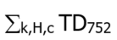 | Monthly | Due Ministry of Finance | 0 | N/A | N/A | N/A | Ontario Regulations 493/01 and 494/01  Refer to Ministry of Energy website for details.
704 | OPA Administration Credit | N/A | N/A | ** CALCULATIONS FOR CHARGE TYPE 704 END DECEMBER 31, 2016 **  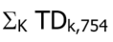  Where ‘K’ is the set of all market participants ‘k’.  Where TD_{k,754} is the settlement amount of charge type 754 for the month for market participant ‘k’. | Monthly | Due IESO | 13 | N/A | N/A | N/A | Implementation details subject to government regulation.
752 | Debt Retirement Charge | N/A | 9.4.6 | ** CALCULATIONS FOR CHARGE TYPE 702 END MARCH 31, 2018 **  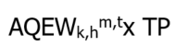  Where ‘k’ is part of a subset of market participants meeting the criteria of any government regulation defining the ultimate consumers of energy. | Monthly | Due IESO | 13 | N/A | N/A | N/A | Ontario Regulations 493/01 and 494/01  Refer to Ministry of Energy website for details.
754 | OPA Administration Charge | N/A | N/A | ** CALCULATIONS FOR CHARGE TYPE 704 END DECEMBER 31, 2016 **  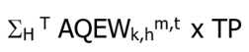  Where ‘H’ is the set of all settlement hours ‘h’ in the month.  Where ‘T’ is the set of all metering intervals ‘t’ in settlement hour ‘h’.  Where TP is the rate ($/MWh) for the OPA Administration Charge set by OEB. | Monthly | Due IESO | 13 | N/A | N/A | N/A | Eligibility, rates, and other implementation details subject to government regulation.
1050  MRP retired | Self-Induced Dispatchable Load CMSC Clawback | N/A | 9.3.5.1A | BUSINESS RULES are used in conjunction with the definitions below to specify the criteria by which the IESO will recover constrained off CMSC paid to dispatchable load facilities.  Business Rule 1 – Materiality: Constrained off CMSC is allowed for an interval during a constrained off event if the total amount of CMSC paid for the trade day to that dispatchable load is less than $4000. The daily total includes negative CMSC.  **BUSINESS RULE 1 –  MATERIALITY THRESHOLD END JUNE 1, 2019  Business Rule 2 – Non-Dispatchable Portion of Load: Constrained off CMSC is not allowed for an interval during a constrained off event if the CMSC is paid for portions of the dispatch where the load has bid greater than or equal to MMCP, indicating that it is a non-dispatchable in that range.  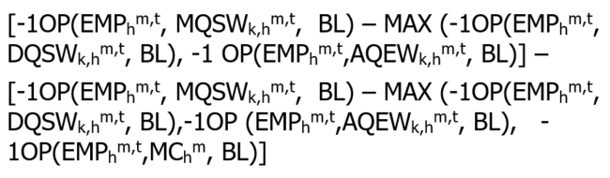  Where ‘MC’ is minimum consumption level and is equal to the quantity in the price quantity pair where the bidding price is MMCP (i.e., $2000).  This business rule applies unless CMSC is allowed because of materiality (defined by Business  Rule 1).  Business Rule 3 – Dispatch Deviation: Constrained off CMSC is not allowed for an interval during a constrained off event if the current 5-minute constrained schedule exceeds the revenue meter value in the previous interval plus 2.5 minutes of ramping. This business rule applies unless CMSC is allowed because of:  - Materiality (defined by Business Rule 1); or  - The load has been constrained off economically (defined below – ‘Economically constrained off interval’); or  - Operating reserve has been activated (defined below – ‘Operating Reserve Activation interval’); or  - The load is ramping (defined below – ‘Ramping interval’); or  - The load has been manually dispatched down for reliability (defined below – ‘Manual Dispatch for Reliability’).  Business Rule 4 – Facility off-line or unable to follow dispatch instructions: Constrained off CMSC is not allowed for an interval during a constrained off event if the constrained schedule is 0 MW and the consumption is less than 1 MW, or if the consumption is 0 MW.  This business rule applies unless CMSC is allowed because of:  - Materiality (defined by Business Rule 1); or  - The load has been constrained off economically (defined below – ‘Economically constrained off interval’); or  - Operating reserve has been activated (defined below – ‘Operating Reserve Activation interval’); or  - The load has been manually dispatched down for reliability (defined below – ‘Manual Dispatch for Reliability’).  In addition to the Business Rules 1 to 4 described above, constrained off CMSC is not allowed for hour ‘h’ if a dispatchable load changes its energy bid that results in a change in the facility’s market schedule and the ramping up or down of the dispatchable load.  Definitions – There are a number of definitions that are used in the specification of criteria for recovery of constrained off CMSC paid to dispatchable load facilities. These are:  Constrained-off event: A constrained off event comprises one or more consecutive intervals where the market schedule is greater than the constrained schedule and the market schedule is greater than the actual quantity of energy withdrawn. Both conditions must exist to be considered a constrained off event.  Economic Constrained–off interval: A dispatchable load is considered to be ‘economically constrained off’ in an interval if the relevant nodal price is greater than or equal to the bid price for either the current interval, the next interval or the previous interval. The inequality should be applied to the last MW constrained off.  Operating Reserve Activation Interval (ORA): A dispatchable load is considered to be dispatched in an interval as part of an activation of operating reserve if one or more of the following conditions exist:  - The constrained schedule is labeled with the reason code ‘ORA’.  - The interval is 1-3 intervals before an interval with the ‘ORA’ code.  - The interval is 1-3 intervals after an interval with the ‘ORA’ code.  Ramping Interval: A generation unit is considered to be ramping up or ramping down when the unconstrained schedule differs between consecutive hours. A dispatchable load is considered to be ‘ramping’ in an interval if one of the following exist:  - It is one of the first 3 intervals of the second hour when ramping up.  - It is one of the last 3 intervals of the first hour when ramping down.  Manual Dispatch for Reliability: A dispatchable load is considered to be a ‘manually constrained off for reliability’ if the IESO Control Room logs indicate that the IESO needed to constrain off the load for system or for local requirements. | Interval | Due IESO | 13 | N/A | N/A | N/A | The decision rule for ramping up or down is described in Market Manual 5.5: Settlements Part 5.5: Physical Markets Settlement Statements, section 1.6.9.3.
1051  MRP retired | Ramp-Down CMSC Claw Back | RDCB_{k,h} | 9.3.5.1G | 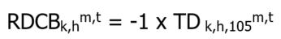  (Refer to applicable market manual) | Interval | Either Way | 13 | N/A | N/A | N/A | Conditions for the Ramp-Down CMSC Claw Back are described in Market Manual 5: Settlements Part 5.5: Physical Markets Settlement Statements, section 1.6.31.
1101  MRP updated + name change | Real-Time Energy Settlement Amount for Dispatchable Generators | NEMSC_{k,h} | 9.3.3.2 | **The following was effective prior to the commencement of market transition. Refer to section 2 for version in effect on the commencement of market transition.**  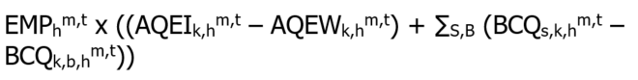 | Interval | Either Way | 13 | N/A | N/A | N/A
1103  MRP updated | Real-Time Energy Settlement Amount for Dispatchable Loads | NEMSC_{k,h} | 9.3.3.2 | **The following was effective prior to the commencement of market transition. Refer to section 2 for version in effect on the commencement of market transition.**  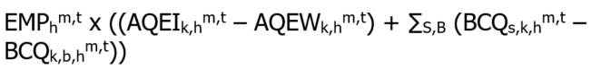 | Interval | Either Way | 13 | N/A | N/A | N/A
1111  MRP updated | Real-Time Energy Settlement Amount for Imports | NEMSC_{k,h} | 9.3.3.2 | **The following was effective prior to the commencement of market transition. Refer to section 2 for version in effect on the commencement of market transition.** | Interval | Either Way | N/A | 13 | N/A | N/A
1113  MRP updated | Real-Time Energy Settlement Amount for Exports | NEMSC_{k,h} | 9.3.3.2 | **The following was effective prior to the commencement of market transition. Refer to section 2 for version in effect on the commencement of market transition.** | Interval | Either Way | N/A | N/A | 0 | 13
1114  MRP retired | Real-Time Energy Settlement Amount for Non-Dispatchable Generators | NEMSC_{k,h} | 9.3 | 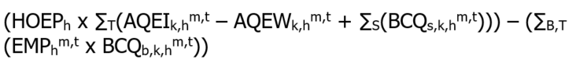 | Hourly | Either Way | 13 | N/A | N/A | N/A
1115  MRP updated + name change | Real-Time Energy Settlement Amount for Non-Dispatchable Loads | NEMSC_{k,h} | 9.3 | **The following was effective prior to the commencement of market transition. Refer to section 2 for version in effect on the commencement of market transition.**  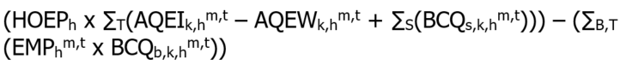 | Hourly | Either Way | 13 | N/A | N/A | N/A
1130 | Day-Ahead Intertie Offer Guarantee Settlement Credit | DA_IOG_{k,h} | 9.3.8A.2A | **CALCULATIONS FOR CHARGE TYPE 1130 END OCTOBER 12, 2011. CHARGE TYPE 1130 REPLACED BY CHARGE TYPE 1131 EFFECTIVE OCTOBER 13, 2011.**  The Day-Ahead Intertie Offer Guarantee settlement amount is derived as follows:  For all day-ahead import transactions other than those that are subject to a constrained on event in the real-time market:  Or, in the case of an import transaction subject to a constrained on event in the real-time market:  Refer to 9.3.8A.2A for the definition of the Operating Profit (OP) function referenced above.  Where:  ‘I’ is the set of relevant intertie metering points ‘i’.  ‘T’ is the set of all metering intervals ‘t’ during settlement hour ‘h’.  TD_{k,h,105}^{i} is that component of charge type 105 (“Congestion Management Settlement Credit for Energy”) applicable to market participant ‘k’ at intertie metering point ‘i’ during settlement hour ‘h’. | Hourly | Due MP | N/A | 13 | 13 | 13
1131  MRP retired | Intertie Offer Guarantee Settlement Credit | IOG_{k,h} | 9.3.8A | The Day-Ahead Intertie Offer Guarantee settlement amount is derived as follows:  Where  DA_IOG_COMP1:  DA_IOG_COMP2:  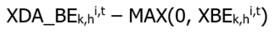  DA_IOG_COMP3:  Component 3 is calculated when:  the CMSC for energy (TD_{k,h,105}^{m,t}) for the same metering interval is a value other than zero.  For Component 3 (DA_IOG_COMP3), the six scenarios of the possible orderings of the generator’s DA_DQSI, DQSI and MQSI are as follows:  - DQSI >= MQSI >= DA_DQSI  - MQSI >= DQSI >= DA_DQSI  - DQSI > DA_DQSI > MQSI  - MQSI > DA_DQSI > DQSI  - DA_DQSI >= DQSI > MQSI  - DA_DQSI >= MQSI > DQSI  Scenario 1 and 2:  0  Scenario 3:  Scenario 4:  Scenario 5 and 6:  TD_{k,h,105}^{m,t}  Where  ‘I’ is the set of relevant intertie metering points ‘i’.  ‘T’ is the set of all metering intervals ‘t’ during settlement hour ‘h’.  ‘OP’ is the operating profit function defined in IESO market rules section 9.3.8A.2.  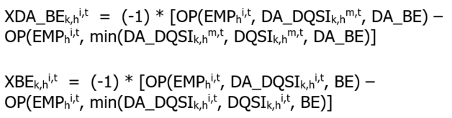  Where EMP_{h}^{i,t} = 0  The Intertie Offer Guarantee settlement amount is derived from an hourly Energy Import sub component (EIM_{k,h}) as follows:  RT-IOG_{k,h} = EIM_{k,h}  The Real-Time Intertie Offer Guarantee (RT-IOG_{k,h}) settlement amount is derived as follows:  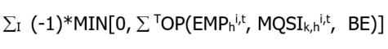  Where  ‘I’ is the set of relevant intertie metering points ‘i’.  ‘T’ is the set of all metering intervals ‘t’ during settlement hour ‘h’.  ‘OP’ is the operating profit function defined in IESO market rules section 9.3.8A.2.  The IOG_OFFSET component of this charge type is calculated as follows:  The Day-Ahead IOG rate:  DA_IOG_RATE = IF [DA_IOG is not NULL, DA_IOG / min(DA_DQSI, DQSI), 0]  The Real-Time IOG rate:  RT_IOG_RATE = IF[RT_IOG is NULL, 0, RT_IOG/DQSI]  The matrix is arranged in ascending order on DA_IOG_RATE and the day-ahead import quantities are offset against the day-ahead export schedule quantities:  DA_DQSW_REM = [MAX[0, DA_OFFSET_DQSW)]]  DA_OFFSET_DQSW = MIN[DA_DQSI, DQSI, DA_DQSW_REM]  The day-ahead IOG offset flag:  DA_OFFSET_FLAG = IF(DA_OFFSET_DQSW > [50% X MIN(DA_DQSI,DQIS)],Y,N)  The IOG offset rate:  IOG_SETTLEMENT_RATE = IF[DA_OFFSET_FLAG = ‘Y’, RT_IOG_RATE, MAX(RT_IOG_RATE, DA_IOG_RATE)]  Subject to:  MI[n,9] >= MIN[n-1,9]  MI[1,9] = MIN[MI[1 to N,9]]  MI[1 to N,9] <> 0  The Gross IOG amount:  IOG = IOG dollar amount associated with the used to calculate IOG_SETTLEMENT_RATE  The matrix is arranged in ascending order on IOG_SETTLEMENT_RATE and the real-time import quantities are offset against the real-time export schedule quantities:  RT_DQSW_REM = [MAX[0, DQSW – RT_OFFSET_DQSW)]]  RT_OFFSET_DQSW = MIN[DQSI, RT_DQSW_REM]  The IOG offset settlement amount:  IOG_OFFSET = (IOG_SETTLEMENT_RATE * RT_OFFSET_DQSW)  The IOG settlement amount:  NET_IOG = (IOG – IOG_OFFSET) | Hourly | Due MP | N/A | 13 | N/A | N/A
1133 | Day-Ahead Generation Cost Guarantee Payment | DA_GCG_{k,h} | 9.4.7D | **CALCULATIONS FOR CHARGE TYPE 1133 END OCTOBER 12, 2011. **  Dispatchable delivery points:  Subject to:  Where ‘DA_CGC’ is a Day-Ahead Combined Guaranteed Costs variable, assessed in accordance with the applicable market manual (refer to also section 2.1 “Variable Description”).  Where ‘m’ is delivery point ‘m’ at which the generation unit incurring the relevant costs is located.  Where ‘T’ is a set of metering intervals ‘t’ from a valid start time to the end of minimum generation block run-time.  Where AQEI{limited}_{k,h}^{m,t} shall denote all allocated quantities in MWh of energy injected at delivery point ‘m’ irrespective of any submission of physical allocation data by market participant ‘k’ in metering interval ‘t’ of settlement hour ‘h’ up to the generation unit’s minimum loading point.  Where DA_COST is fuel and O&M cost component related to operation of the generation unit at its minimum loading point during its minimum generation block run-time (these costs are calculated based on the offer price associated with Pre-dispatch of record).  - Where the COST function is defined as follows:  where:  - B is the n x 2 matrix (B) of offered price-quantity pairs (P_{i} , Q_{i})  - s* is the highest indexed row of B such that Q_{s*-1} ≤ Q ≤ Q_{s*} and where Q₀=0  - Where H2 is the set of all settlement hours ‘h’ during the period from the Pre-dispatch of Record ‘start hour’ until the end of minimum generation block run  - Where ‘T*’ is the set of metering intervals ‘t’ in the set of all settlement hours ‘H2’  Where CMSC_REV _{k,h}^{m,t} is any real-time CMSC(TD _{k,h,105}^{m,t}) payment associated with allocated quantities in MWh of energy injected at delivery point ‘m’ irrespective of any submission of physical allocation data by market participant ‘k’ in metering interval ‘t’ of settlement hour ‘h’ up to the generation unit’s minimum loading point.  CMSC_REV is calculated using the following rules:  - Real-time CMSC (TD _{k,h,105}^{m,t}) for the same interval is greater than zero.  - If MQSI _{k,h}^{m,t} and max(DQSI _{k,h}^{m,t},AQEI _{k,h}^{m,t}) >= MLP, then CMSC_REV_{k,h}^{m,t} = 0.  - In the case of a constrained-off event:  - If MQSI _{k,h}^{m,t} < MLP, then CMSC_REV _{k,h}^{m,t} = TD _{k,h,105}^{m,t}  - If MQSI _{k,h}^{m,t} >= MLP and max(DQSI _{k,h}^{m,t},AQEI _{k,h}^{m,t}) <= MLP, then  CMSC_REV _{k,h}^{m,t} = OP(EMP _{h}^{m,t},MLP,BE) – OP(EMP,max(DQSI _{k,h}^{m,t},AQEI _{k,h}^{m,t}),BE).  - In the case of a constrained-on event:  - If MQSI _{k,h}^{m,t} < MLP and min(DQSI _{k,h}^{m,t},AQEI _{k,h}^{m,t}) < MLP, then CMSC_REV _{k,h}^{m,t} = TD _{k,h,105}^{m,t}  - If MQSI _{k,h}^{m,t} <= MLP and min(DQSI _{k,h}^{m,t}, AQEI _{k,h}^{m,t}) >=MLP, then  CMSC_REV _{k,h}^{m,t} = OP(EMP _{h}^{m,t},MQSI _{k,h}^{m,t},BE) – OP(EMP _{h}^{m,t},MLP,BE)  (Refer to applicable market manual) | Hourly | Due MP | 13 | N/A | N/A | N/A
1134  MRP retired | Day-Ahead Linked Wheel Failure Charge | DA_LWFC_{k,h} | 9.3.8E | MAX[(-1) * [(DA_LWSD_{k,h}^{i}) * MAX[0,( DA_PS_{k,h}^{i} – PD_PS_{k,h}^{i})]], (RT_IFC_DALW_{k,h}^{i} + RT_EFC_DALW_{k,h}^{i})]  Where:  DA_LWSD_{k,h}^{i,t} = MAX[MAX (DA_DQSI_{k,h}^{i,t} – PD_DQSI_{k,h}^{i,t}, DA_DQSW_{k,h}^{i,t} – PD_DQSW_{k,h}^{i,t}),0]  RT_IFC_DALW_{k,h}^{i} = ∑^{I,T} (-1) * MIN[MAX[ 0, (EMP_{h}^{m,t} + PB_IM_{h}^{t} – PD_EMP_{h}^{m,t}) * MAX (DA_DQSI_{k,h}^{i,t} – PD_DQSI_{k,h}^{i,t}, 0)], (MAX(0, EMP_{h}^{m,t})* MAX (DA_DQSI_{k,h}^{i,t} – PD_DQSI_{k,h}^{i,t}, 0))]  RT_EFC_DALW_{k,h}^{i} = ∑^{I,T} (-1) * MIN[MAX[ 0, (PD_EMP_{h}^{m,t} – EMP_{h}^{m,t} – PB_EX_{h}^{t}) * MAX (DA_DQSW_{k,h}^{i,t} – PD_DQSW_{k,h}^{i,t}, 0)], (MAX(0, PD_EMP_{h}^{m,t}) * MAX (DA_DQSW_{k,h}^{i,t} – PD_DQSW_{k,h}^{i,t}, 0))]  Where:  ‘T’ is the set of 12 metering intervals ‘t’ during settlement hour ‘h’.  ‘I’ is the set of all intertie metering points ‘i’. | Hourly | Due IESO | N/A | 13 | 13 | 13
1135  MRP retired | Day-Ahead Import Failure Charge | DA_IFC_{k,h} | 9.3.8B | 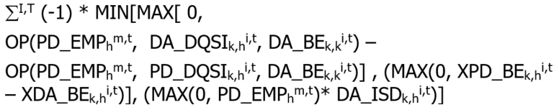  Where:  ‘OP’ is the operating profit function defined in IESO market rules section 9.3.8B.2.  ‘T’ is the set of all metering intervals ‘t’ in settlement hour ‘h’.  ‘I’ is the set of all intertie metering points ‘i’.  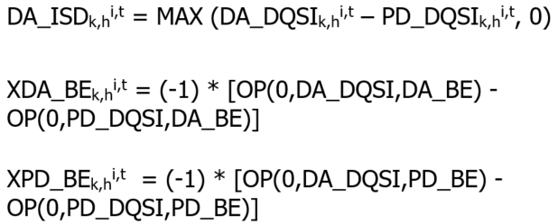 | Hourly | Due IESO | N/A | 13 | N/A | N/A | Subject to exemptions under the provisions of 9.3.8B.1.2
1136  MRP retired | Day-Ahead Export Failure Charge | DA_EFC_{k,h} | 9.3.8D | 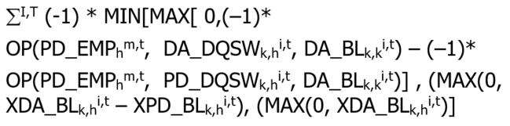  Where:  ‘OP’ is the operating profit function defined in IESO market rules section 9.3.8B.2.  ‘T’ is the set of all metering intervals ‘t’ in settlement hour ‘h’.  ‘I’ is the set of all intertie metering points ‘i’.  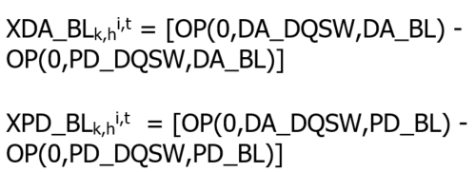 | Hourly | Due IESO | N/A | N/A | 0 | 13
1137 | Intertie Offer Guarantee Reversal | Context 1:  IOG_REV_{k,h}  Context 2:  DA_IOG {adj}_{k,h}^{i} | 9.3.8A.1.2  and  9.3.8A.7 to 9.3.8A.9 | **CALCULATIONS FOR CHARGE TYPE 1137 END OCTOBER 12, 2011.**  NOTE: This charge type is used in two separate contexts as follows:  Context 1:  When a day-ahead Intertie Offer Guarantee and a real-time Intertie Offer Guarantee apply to the same import transaction, the lower of the two is reversed by this charge type.  -1 x TD_{k,h,c}^{i}  Where:  ‘c’ is charge type 130 or 1130 as the case may be such that:  TD_{k,h,c} ^{i} = MIN (TD_{k,h,130}^{i} ,TD_{k,h,1130}^{i})  Context 2:  In cases where this charge type is used for the purposes of applying the intertie offer guarantee adjustment (DA_IOG{adj}_{k,h}^{i}), the settlement amount applied is DA_IOG{adj}_{k,h}^{i} and is calculated as follows:  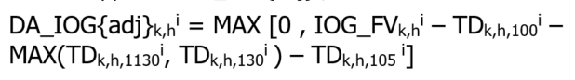  Where:  TD_{k,h,100}^{i,} TD_{k,h,1130}^{i} , TD_{k,h,130}^{i} and TD_{k,h,105}^{i} are the settlement amounts for charge types 100, 1130, 130 and 105 respectively, that are applicable to market participant ‘k’ during settlement hour ‘h’ at intertie metering point ‘i’. | Context 1:  Hourly  Context 2:  Hourly, but reported on the last trading day of the billing period | Context 1:  Due IESO  Context 2:  Due MP | N/A | 13 | 13 | 13 | Note:  Context 1 and Context 2 can both be applied to the same import.
1139 | Intertie Failure Charge Reversal | IFC_REV_{k,h} | 9.3.8C.6 | **CALCULATIONS FOR CHARGE TYPE 1139 END OCTOBER 12, 2011.**  When a Day-Ahead Import Failure Charge and a Real-time Import Failure Charge apply to the same import transaction, the lower of the two is reversed by this charge type.  -1 x TD_{k,h,c}^{i}  Where:  ‘c’ is charge type 135 or 1135 as the case may be such that:  TD_{k,h,c} ^{i} = MIN (-1 x TD_{k,h,135}^{i} ,-1 * TD_{k,h,1135}^{i}) | Hourly | Due IESO | N/A | 13 | N/A | N/A
1142 | Ontario Fair Hydro Plan Eligible RPP Consumer Discount Settlement Amount | N/A | N/A | ** CHARGE TYPE 1142 REPLACED BY CHARGE TYPE 142 EFFECTIVE NOVEMBER 1, 2019.**  Manual entry based on:  (1) the values submitted via on-line settlement forms “Regulated Price Plan vs. Market Price – Variance for Conventional Meters”, “Regulated Price Plan vs. Market Price – Variance for Smart Meters” and “Regulated Price Plan – Final Variance Settlement Amount”;  or  (2) For eligible  IESO market participant consumers:  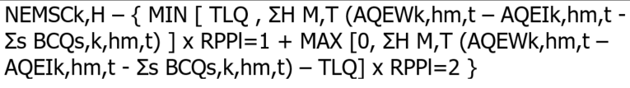 | Monthly | Due LDCs, Unit Sub-Meter Providers and eligible MPs either way | 13 | N/A | N/A | N/A | Eligibility, rates, and other implementation details subject to government and OEB regulations.
1143 | Ontario Fair Hydro Plan Eligible Non-RPP Consumer Discount Settlement Amount | N/A | N/A | **REPEALED EFFECTIVE NOVEMBER 1, 2019**  Manual entry based on:  (1) the values submitted via on-line settlement form “Ontario Fair Hydro Plan (OFHP) for Eligible Non-RPP Customers” | Monthly | Due LDCs, Unit Sub-Meter Providers and eligible MPs either way | 13 | N/A | N/A | N/A
1144 | Ontario Fair Hydro Plan Financing Entity Amount | N/A | N/A | **REPEALED EFFECTIVE NOVEMBER 1, 2019**  Manual entry based on:  (1) the values submitted via on-line settlement form “Ontario Fair Hydro Plan – Financing Entity Funding Expenses”; | Monthly | Due Financing Entity | N/A | N/A | N/A | N/A
1145 | Ontario Fair Hydro Plan Financing Entity Interest | N/A | N/A | **REPEALED EFFECTIVE NOVEMBER 1, 2019**  Manual entry based on:  (1) the values submitted via on-line settlement form “Ontario Fair Hydro Plan – Financing Entity Funding Expenses”; | Monthly | Due Financing Entity | N/A | N/A | N/A | N/A
1192 | Ontario Fair Hydro Plan Eligible RPP Consumer Discount Balancing Amount | N/A | N/A | ** CHARGE TYPE 1192 REPLACED BY CHARGE TYPE 192 EFFECTIVE NOVEMBER 1, 2019 **  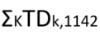  Where ‘K’ is the set of all market participants ‘k’.  Where TDk,1142 is the total settlement amount of charge type 1142 for the month for market participant ‘k’. | Monthly | Due IESO | N/A | N/A | N/A | N/A | Eligibility, rates, and other implementation details subject to government and OEB regulations.
1193 | Ontario Fair Hydro Plan Eligible Non-RPP Consumer Discount Balancing Amount | N/A | N/A | **REPEALED EFFECTIVE NOVEMBER 1, 2019**  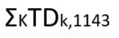  Where ‘K’ is the set of all market participants ‘k’.  Where TDk,1143 is the total settlement amount of charge type 1143 for the month for market participant ‘k’. | Monthly | Due IESO | N/A | N/A | N/A | N/A | Eligibility, rates, and other implementation details subject to government and OEB regulations.
1194 | Ontario Fair Hydro Plan Financing Entity Balancing Amount | N/A | N/A | **REPEALED EFFECTIVE NOVEMBER 1, 2019**  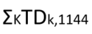  Where ‘K’ is the set of all market participants ‘k’.  Where TDk,1144 is the total settlement amount of charge type 1144 for the month for market participant ‘k’. | Monthly | Due IESO | N/A | N/A | N/A | N/A | Implementation details subject to government regulations
1195 | Ontario Fair Hydro Plan Financing Entity Balancing Interest | N/A | N/A | **REPEALED EFFECTIVE NOVEMBER 1, 2019**  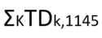  Where ‘K’ is the set of all market participants ‘k’.  Where TDk,1145 is the total settlement amount of charge type 1145 for the month for market participant ‘k’. | Monthly | Due IESO | N/A | N/A | N/A | N/A | Implementation details subject to government regulations
1300 | Capacity Based Demand Response Program Availability Payment Settlement Amount | N/A | N/A | **CALCULATIONS FOR CHARGE TYPE 1300 ENDED ON OCTOBER, 2018.**  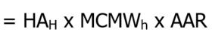  Where:  ‘AAR’ means ‘Adjusted Availability Rate’.  ‘H’ is the total hours a DRMP is available in a program month.  ‘HA’ means ‘Hours of Availability’.  ‘MCMW’ means ‘Monthly Contracted MW’. | Monthly | Due MP | 13 | N/A | N/A | N/A
1301 | Capacity Based Demand Response Program Availability Over-Delivery Settlement Amt | N/A | N/A | **CALCULATIONS FOR CHARGE TYPE 1301 ENDED ON OCTOBER, 2018.**  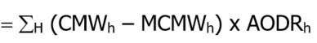  Applicable only in response to an ‘Open Standby Notification’.  Where:  ‘AODR’ means ‘Availability Over-Delivery Rate’.  ‘CMW’ means ‘Confirmed MW’.  ‘H’ is the set of all hours ‘h’ in the month where the ‘CMW’ exceeded the ‘MCMW’.  ‘MCMW’ means ‘Monthly Contracted MW’. | Monthly | Due MP | 13 | N/A | N/A | N/A
1302 | Capacity Based Demand Response Program Availability Set-Off Settlement Amount | N/A | N/A | **CALCULATIONS FOR CHARGE TYPE 1302 ENDED ON OCTOBER, 2018.**  The charge to a DRMP is highest of A, B or C:  A: Availability Set-Off (Reliability)  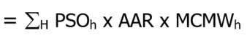  This formula applies when the Reliability Rate for a given Demand Response Account is less than 85% during any interval of an Activation Hour, or where the Participant is not Fully Available for Curtailment.  Where:  ‘AAR’ and ‘MCMW’ have the same meaning as in CT1300.  ‘H’ is the set of all activation hours ‘h’ for the activation period.  ‘PSO’ means ‘Performance Set-Off Factor’ as described in the market manual.  B: Availability Set-Off (Timely Confirmation)  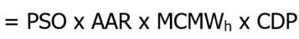  This formula applies when the Participant, regardless of Activation, has failed to deliver, or delivers late, a Confirmation that is required by the IESO.  Where:  ‘AAR’ and ‘MCMW’ have the same meaning as in CT1300.  ‘CDP’ (Contracted Dispatch Period) means four consecutive hours. Each Contracted Dispatch Period shall occur within the hours of Availability, and shall occur within and no more than once in accordance with the Daily Schedule.  ‘PSO’ has the same meaning as defined above.  C: Availability Set-Off (Low Confirmation)  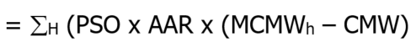  This formula applies when the Confirmed MW’s are less than 95% of the Monthly Contracted MW for a Confirmed Hour of the Contracted Dispatch Period.  Where:  ‘AAR’ and ‘MCMW’ have the same meaning as in CT1300.  ‘CMW’ has the same meaning as in CT1301.  ‘H’ is the set of all confirmed hours ‘h’ when the Confirmed MW’s are less than 95% of the Monthly Contracted MW for the Contracted Dispatch Period.  ‘PSO’ has the same meaning as defined above. | Monthly | Due IESO | 13 | N/A | N/A | N/A
1303 | Capacity Based Demand Response Program Utilization Payment Settlement Amount | N/A | N/A | **CALCULATIONS FOR CHARGE TYPE 1303 ENDED ON OCTOBER, 2018.**  Where:  ‘AAM’ (Actual Activated MWh), means the number of MWh Curtailed by a Participant when requested by the IESO, as measured through the use of electricity meter(s). Curtailment shall not exceed the product of the Activation MW and the activation period requested by the IESO, plus the lesser of an additional 15% of the Activation MW per hour of the activation period, OR 15 MWh per hour of the activation period.  ‘H’ is the total hours ‘h’ a DRMP is activated in a program month.  ‘HOEP’ means Hourly Ontario Energy Price.  ‘NG’ (Net Generation), means the MWh of net electricity generated by any contributor that is a behind the meter generator.  ‘UR’ (Utilization Rate), means the rates, expressed in $/MWh, as specified in the Demand Response Schedule. | Monthly | Due MP | 13 | N/A | N/A | N/A
1304 | Capacity Based Demand Response Program Utilization Set-Off Settlement Amount | N/A | N/A | **CALCULATIONS FOR CHARGE TYPE 1304 ENDED ON OCTOBER, 2018.**  The charge to a DRMP is highest of A, B or C:  A: Utilization Set-Off (Reliability)  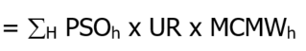  This formula applies when the Reliability Rate for a given Demand Response Account is less than 85% during any interval of an Activation Hour.  Where:  ‘H’ is the set of all activation hours ‘h’ for the activation period.  ‘PSO’ has the same meaning as in CT 1301.  ‘UR’ has the same meaning as in CT1303.  ‘MCMW’ has the same meaning as in CT1300.  B: Utilization Set-Off (Timely Confirmation)  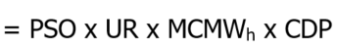  This formula applies when the DRMP, regardless of Activation, has failed to deliver, or delivers late, a Confirmation that is required by the IESO.  Where:  ‘CDP’ (Contracted Dispatch Period) means four consecutive hours. Each Contracted Dispatch Period shall occur within the hours of Availability, and shall occur within and no more than once in accordance with the Daily Schedule.  ‘MCMW’ has the same meaning as defined above.  ‘PSO’ has the same meaning as defined above.  ‘UR’ has the same meaning as defined above.  C: Utilization Set-Off (Low Confirmation)  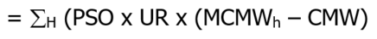  This formula applies when the Confirmed MW’s are less than 95% of the Monthly Contracted MW for a Confirmed Hour of the Contracted Dispatch Period.  Where:  ‘CMW’ has the same meaning as in CT1301.  ‘H’ is the set of all confirmed hours ‘h’ when the Confirmed MW’s are less than 95% of the Monthly Contracted MW for the Contracted Dispatch Period.  ‘MCMW’ has the same meaning as defined above.  ‘PSO’ has the same meaning as defined above.  ‘UR’ has the same meaning as defined above. | Monthly | Due IESO | 13 | N/A | N/A | N/A
1305 | Capacity Based Demand Response Program Planned Non-Performance Event Set-Off Amt | N/A | N/A | **CALCULATIONS FOR CHARGE TYPE 1305 ENDED ON OCTOBER, 2018.**  The Planned Non-Performance Availability Set-Off applies for any day for which a participant has requested a Non-Performance Event as part of either a Single Day Non-Performance Event or a part of an Extended Period Planned Non-Performance Event.  The monthly set-off calculation is the sum of all:  - Non-Activation Day Non-Performance Availability Set-Off s and  - Activation Day Non-Performance Availability Set-Offs.  For 1.) The Non-Activation Day Non-Performance Availability Set-Off amount is:  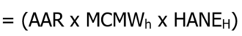  Where:  ‘AAR’ has the same meaning as in CT1300.  ‘HANE’ (Hours of Availability for a Non-Performance Event), represents the Hours of Availability for all days in the contract month for which a planned Non-Performance Event is requested and for which an Activation Notice is not received by the participant.  ‘MCMW’ has the same meaning as in CT1300.  For 2.) The Activation Day Non-Performance Availability Set-Off amount is:  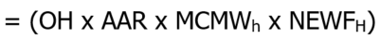  Where:  ‘AAR’ and ‘MCMW’ have the same meaning as in CT1300.  ‘OH’ (Opportunity Hours), means 64 if Option A is applicable to the Demand Response Account; or 32 if Option B is applicable to the Demand Response Account.  ‘NEWF’ (Non-Performance Event Weighting Factor), means 10%, unless the Actual Activated MWh per interval, as averaged over all of the Intervals in the Contracted Dispatch Period for the Activation, is greater than or equal to the product of the Monthly Contracted MW and 1/12 of an hour in which case ‘NEWF’ means 50%. | Monthly | Due IESO | 13 | N/A | N/A | N/A
1306 | Capacity Based Demand Response Program Measurement Data Set-Off Settlement Amt | N/A | N/A | **CALCULATIONS FOR CHARGE TYPE 1306 ENDED ON OCTOBER, 2018.**  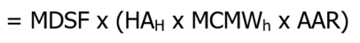  This formula applies when the complete set of weekly measurement data for a Demand Response Account are not received as per the CBDR Processing Timelines. The formula recovers a percentage of the availability payment for the applicable week.  Where:  ‘MDSF’ (Measurement Data Set-Off Factor), is an increasing factor for every week that the full data remains undelivered. The factor is equal to:  - 20% for the first week that the full data remains undelivered;  - 33% for the second week that the full data remains undelivered;  - 50% for the third week that the full data remains undelivered; and  - 100% for the fourth week that the full data remains undelivered.  ‘AAR’, ‘HA’ and ‘MCMW’ have the same meaning as in CT1300.  ‘H’ is the total hours a DRMP is available for the applicable week. | Monthly | Due IESO | 13 | N/A | N/A | N/A
1307 | Capacity Based Demand Response Program Buy-Down Settlement Amount | N/A | N/A | **CALCULATIONS FOR CHARGE TYPE 1307 ENDED ON OCTOBER, 2018.**  Buy-Down means the act by the DRMP chooses to reduce its Monthly Contracted MW and/or remove up to three Daily Schedules from participation in CBDR.  For the Buy-Down of Monthly Contracted MW the payment is:  = (MCMWR x BDR x HAE)  Where:  ‘MCMWR’ (Monthly Contracted MW Reduction), means the MW of demand reduction in the Monthly Contracted MWs.  ‘BDR’ (Buy-Down Rate), means the Buy-Down Rate, expressed in $/MW.  ‘HAE’ (Hours of Availability Elapsed), means the number of Hours of Availability that have elapsed in the Schedule Term up to the date that the reduction takes effect.  For the Buy-Down of the Daily Schedules the payment is:  = (MCMW x RD x BDR x HAE)  Where:  ‘BDR’ has the same meaning as defined above.  ‘HAE’ has the same meaning as defined above.  ‘MCMW’ has the same meaning as in CT1300.  ‘RD’ (Requested Days), means the number of Business Days per week from which the Hours of Availability are to be removed. | Monthly | Due IESO | 13 | N/A | N/A | N/A
1308 | Capacity Based Demand Response Program Performance Breach Settlement Amount | N/A | N/A | **CALCULATIONS FOR CHARGE TYPE 1308 ENDED ON OCTOBER, 2018.**  Performance breach amounts are calculated as defined in the market manual. | Monthly | Either way | 13 | N/A | N/A | N/A
1309 | Demand Response Pilot – Availability Payment | N/A | N/A | **CALCULATIONS FOR CHARGE TYPE 1309 ENDED ON APRIL, 2018.**  Calculated as per demand response pilot contracts. | Monthly | Due MP | 13 | N/A | N/A | N/A | Demand Response Pilot
1310 | Demand Response Pilot – Availability Clawback | N/A | N/A | **CALCULATIONS FOR CHARGE TYPE 1310 ENDED ON APRIL, 2018.**  Calculated as per demand response pilot contracts. | Hourly | Due IESO | 13 | N/A | N/A | N/A | Demand Response Pilot
1311 | Demand Response Pilot – Availability Charge | N/A | N/A | **CALCULATIONS FOR CHARGE TYPE 1311 ENDED ON APRIL, 2018.**  Calculated as per demand response pilot contracts. | Monthly | Due IESO | 13 | N/A | N/A | N/A | Demand Response Pilot
1312 | Demand Response Pilot – Availability Adjustment | N/A | N/A | **CALCULATIONS FOR CHARGE TYPE 1312 ENDED ON APRIL, 2018.**  Calculated as per demand response pilot contracts. | Monthly | Due IESO | 13 | N/A | N/A | N/A | Demand Response Pilot
1313 | Demand Response Pilot – Demand Response Bid Guarantee | N/A | N/A | **CALCULATIONS FOR CHARGE TYPE 1313 ENDED ON APRIL, 2018.**  Calculated as per demand response pilot contracts.  Notes:  - Bid guarantee as a payment is Due MP; bid guarantee as a clawback is Due IESO.  Bid guarantee is calculated per unit commitment period/event. | Monthly | Either Way | 13 | N/A | N/A | N/A | Demand Response Pilot
1315  MRP updated | Capacity Obligation – Availability Charge | CAAC^{m}_{k} | 4.7J.2.1 | **The following was effective prior to the commencement of market transition. Refer to section 2 for version in effect on the commencement of market transition.**  In regards to a capacity market participant participating with an hourly demand response resource or a capacity dispatchable load resource:  ∑_{H} (-1) x Max( 0, (CCO^{m}_{k,h} - DREBQ^{m}_{k,h})) x CACP^{z}_{h} x CNPF_{tm}  Where:  - ‘H’ is the set of all settlement hours within the availability window during the relevant trading day;  - If the capacity market participant did not submit a demand response energy bid for its hourly demand response resource or capacity dispatchable load resource, as the case may be, for settlement hour ‘h’ in the day-ahead commitment process or failed to maintain such energy bid through the real-time energy market, DREBQ^{m}_{k,h} = 0;  - In regards to hourly demand response resource, if the demand response energy bids submitted for settlement hour ‘h’ does not form part of energy bids spanning at least four consecutive settlement hours, DREBQ^{m}_{k,h} = 0;  - If the demand response energy bid submitted in the day-ahead commitment process for settlement hour ‘h’ is not equal to the demand response energy bid submitted in the real-time market for the same settlement hour, DREBQ^{m}_{k,h} shall be equal to the lesser of the two demand response energy bids; and  Notwithstanding any of the foregoing, DREBQ^{m}_{k,h} shall not exceed the CARC^{m}_{k} for the hourly demand response resource or capacity dispatchable load resource, as the case may be.  In regards to a capacity market participant participating with a capacity generation resource, system-backed capacity import resource, generator-backed capacity import resource or capacity storage resource:  ∑_{H} (-1) x Max( 0, (CCO^{m}_{k,h} - CAEO^{m}_{k,h})) x CACP^{z}_{h} x CNPF_{tm}  Where:  - ‘H’ is the set of all settlement hours within the availability window during the relevant trading day;  - If the capacity market participant did not submit an energy offer in the day-ahead commitment process or maintain such energy offer in accordance with the applicable market manual for settlement hour ‘h’, CAEO^{m}_{h,k} = 0;  - If the energy offer submitted in the day-ahead commitment process for settlement hour ‘h’ is not equal to the energy offer submitted in the pre-dispatch hour for the same settlement hour, CAEO^{m}_{h,k} shall be equal to the lesser of the two energy offers;  - If a capacity storage resource receives a non-zero energy dispatch instruction within the relevant availability window, the CAEO^{m}_{h,k} for the remaining settlement hours of the availability window after receiving such non-zero energy dispatch instruction shall be equal to the energy offer applicable to the settlement hour in which they receive such non-zero energy dispatch instruction. | Daily | Due IESO | 13 | 13 | N/A | N/A
1320  MRP updated | Capacity Obligation – Dispatch Test Payment and Emergency Activation Payment | CATAP^{m}_{k,h} and CAEOP^{m}_{k,h} | 9.4.7J.5 | **The following was effective prior to the commencement of market transition. Refer to section 2 for version in effect on the commencement of market transition.**  For capacity auction dispatch test activations:  HDRTAPR × HDRDC^{m}_{k,h}  For emergency operating state activations:  Max(0, HDRBP ^{m}_{k,h} – Max(0,HOEP_{h})) × HDRDC ^{m}_{k,h} | Hourly | Due MP | 13 | 13 | N/A | N/A
1330 | On behalf of the former OPA for the DR2 Program - Availability Payment Settlement Amount | N/A | N/A | **CALCULATIONS FOR CHARGE TYPE 1330 ENDED ON FEBRUARY 28, 2015.**  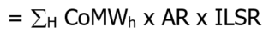  Where:  ‘CoMW’ (Contracted MW), means the MW specified in the DR2 Schedule(s) for a given Settlement Account which the Participant agrees to Load Shift in each On-Peak Contract hour.  ‘AR’ (Availability Rate), means the availability rate, expressed in $/MW, in the amount as specified by the OPA from time to time on the OPA Website pursuant to the DR2 Program Rules.  ‘H’ is the total On-Peak contract hours in a Contract Month.  ‘ILSR’ (Implied Load Shift Ratio), has the meaning as defined in  OPA’s DR2 Program Rules and is calculated as follows:  ILSR = (-1) x [Implied Load Shift - ((3/4)(Load Shift Credit))] / Implied Load Shift Requirement | Monthly | Due DR2-participants Either way | 13 | N/A | N/A | N/A | Former OPA DR2 Contract. The DR2 program was last settled on the February 2015 settlement statements and invoice.
1331 | On behalf of the former OPA for the DR2 Program - Availability Set-Off Settlement Amount | N/A | N/A | **CALCULATIONS FOR CHARGE TYPE 1331 ENDED ON FEBRUARY 28, 2015.**  The charge to a DR participant is the highest of amounts A, B or C plus amount D; where A, B and C cannot occur within an on-peak period that was subject to D.  A: Availability Set-Off (Reliability)  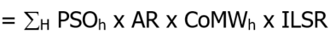  This formula applies when the Actual MW Reliability Ratio for a given Settlement Account is less than 95% during the Summer and Winter seasons and less than 90% during the shoulder seasons.  The Actual MW Reliability Ratio, which shall not be greater than 100%, shall be calculated as follows:  - For each On-Peak Contract Hour, the Actual MW Reliability Ratio is defined as the result of the baseline MW minus the actual MW divided by the confirmed MW.  ‘PSO’ (Performance Set-Off Factor) refers to a set of factors defined in the OPA DR2 Program Rules.  ‘AR’ has the same meaning as in CT1330.  ‘CoMW’ has the same meaning as in CT1330.  ‘H’ is the set of all hours ‘h’ in the On-Peak Contract period where the required reliability is not met.  ‘ILSR’ has the same meaning as in CT1330.  B: Availability Set-Off (Timely Confirmation)  This formula applies when the Participant has failed to deliver, or delivers late, a Confirmation that is required by the IESO pursuant to the DR2 Program Rules.  Where:  ‘PSO’ has the same meaning as defined above.  ‘AR’ has the same meaning as in CT1330.  ‘CoMW’ has the same meaning as in CT1330.  ‘H’ is the set of all hours in the On-Peak Contract period.  ‘ILSR’ has the same meaning as in CT1330.  C: Availability Set-Off (Low Confirmation)  This formula applies when the Confirmed MW is less than the product of the Required Reliability Ratio and the Contracted MW for one or more On-Peak Contract hours.  Where:  ‘PSO’ has the same meaning as defined above.  ‘AR’ has the same meaning as in CT1330.  ‘CoMW’ has the same meaning as in CT1330.  ‘CMW’ (Confirmed MW) means the number of MW available to shift by the Participant.  ‘H’ is the set of all confirmed hours ‘h’ when the Confirmed MW’s are:  - Less than 95% during the Summer and Winter seasons or  - Less than 90% during the shoulder seasons  of the Contracted MW.  ‘ILSR’ has the same meaning as in CT1330.  D: Availability Set-Off (Non-Performance)  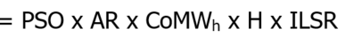  This formula applies when the Participant has taken an Extended Planned Non-Performance Event or Single Day Planned Non-Performance Event.  Where:  ‘PSO’ has the same meaning as defined above.  ‘AR’ has the same meaning as in CT1330.  ‘CoMW’ has the same meaning as in CT1330.  ‘H’ is the set of all hours in the On-Peak Contract period.  ‘ILSR’ has the same meaning as in CT1330. | Monthly | Due DR2-participants Either way | 13 | N/A | N/A | N/A | Former OPA Program Rules. The DR2 program was last settled on the February 2015 settlement statements and invoice.
1332 | On behalf of the former OPA for the DR2 Program - Utilization Payment Settlement Amount | N/A | N/A | **CALCULATIONS FOR CHARGE TYPE 1332 ENDED ON FEBRUARY 28, 2015.**  The monthly Utilization Payment to a DR2 participant is the sum of the weekly utilization payments for the contract month and calculated as follows:  Weekly Utilization payment  Where:  ‘GHDiff’ (Guaranteed weekly HOEP Differential), means the weekly differential rate, expressed in $/MWh, as specified by the OPA  ‘AHDiff’ (Actual weekly HOEP Differential), is equal to the average actual HOEP for all hours of the useable On-Peak Contract Periods in the Week less the average actual HOEP for all hours in the Off-Peak Period for the same Week.  ‘CoMWh’ (Contracted MWh), means the MWh specified in the DR2 Schedule(s) for a given Settlement Account which the Participant agrees to Load Shift in each On-Peak Contract Period.  ‘Curt’ (Curtailment), means the number of MWh Curtailed by a Participant for each useable on-peak contract period, and shifted to the off-peak period as measured through the use of electricity meter(s).  ‘P’ is the total number of On-Peak Contract Periods ‘p’ for a Participant in a Contract Week  ‘ILSR’ has the same meaning as in CT1330. | Monthly | Due DR2-participants Either way | 13 | N/A | N/A | N/A | Former OPA DR2 Contract. The DR2 program was last settled on the February 2015 settlement statements and invoice.
1333 | On behalf of the former OPA for the DR2 Program - Utilization Set-Off Settlement Amount | N/A | N/A | **CALCULATIONS FOR CHARGE TYPE 1333 ENDED ON FEBRUARY 28, 2015.**  The charge to a DR participant is highest of A, B or C where A, B and C cannot occur within an on-peak period that was subject to an Availability Set-Off (Non-Performance) event:  A: Utilization Set-Off (Reliability)  This formula applies when the Actual MWh Reliability Ratio for a given Settlement Account is less than 95% during the Summer and Winter seasons and less than 90% during the shoulder seasons.  The Actual MWh Reliability Ratio, which shall not be greater than 100%, shall be calculated as follows:  - For each On-Peak Contract Period, the Actual MWh Reliability Ratio is defined as the result of the baseline MWh minus the actual MWh divided by the product of the confirmed MW and the On-Peak Contract Hours.  Where:  ‘PSO’ (Performance Set-Off Factor) refers to a set of factors defined in the OPA’s Program Rules.  ‘GHDiff’ has the same meaning as in CT1332.  ‘AHDiff’ has the same meaning as in CT1332.  ‘CoMWh’ has the same meaning as in CT1332.  ‘P’ is the total number of On-Peak Contract Periods ‘p’ for a Participant in a Contract Month.  ‘ILSR’ has the same meaning as in CT1330.  B: Utilization Set-Off (Timely Confirmation)  This formula applies when the Participant has failed to deliver, or delivers late, a Confirmation that is required by the IESO pursuant to the DR2 Program Rules.  Where:  ‘PSO’ has the same meaning as defined above.  ‘GHDiff’ has the same meaning as in CT1332.  ‘AHDiff’ has the same meaning as in CT1332.  ‘CoMWh’ has the same meaning as in CT1332.  ‘P’ is the total such On-Peak Contract Periods ‘p’ for a Participant in a Contract Month when the Participant has failed to deliver, or delivers late, a Confirmation.  ‘ILSR’ has the same meaning as in CT1330.  C: Utilization Set-Off (Low Confirmation)  This formula applies when the Confirmed MWh are less than the product of the Required Reliability Ratio and the Contracted MWh for an On-Peak Contract Period.  Where:  ‘PSO’ has the same meaning as defined above.  ‘GHDiff’ has the same meaning as in CT1332.  ‘AHDiff’ has the same meaning as in CT1332.  ‘CoMWh’ has the same meaning as in CT1332.  ‘CMWh’ (Confirmed MWh) means the MWh available confirmed for shifting by the Participant.  ‘P’ is the total such On-Peak Contract Periods ‘p’ for a Participant in a Contract Month.  ‘ILSR’ has the same meaning as in CT1330. | Monthly | Due DR2-participants Either way | 13 | N/A | N/A | N/A | Former OPA DR2 Contract. The DR2 program was last settled on the February 2015 settlement statements and invoice.
1334 | On behalf of the former OPA for the DR2 Program – Meter Data Set-Off Settlement Amount | N/A | N/A | **CALCULATIONS FOR CHARGE TYPE 1334 ENDED ON FEBRUARY 28, 2015.**  = MDSF x (TD_{k,1330} / NoW_{k})  This formula applies when the complete set of weekly meter data for a Settlement Account is not received by 15:00 EST on the first Business Day of the following week. The formula recovers a percentage of the Availability Payment, as pro-rated for that week in question.  Where:  ‘MDSF’ (Meter Data Set-Off Factor), is an increasing factor for every week that the full data remains undelivered. The factor is equal to:  - 20% for the first week that the full data remains undelivered;  - 33% for the second week that the full data remains undelivered;  - 50% for the third week that the full data remains undelivered; and  - 100% for the fourth week that the full data remains undelivered.  TD_{k,1330} is the settlement amount of charge type 1330 for month ‘k’ for the DR2 participant.  ‘NoW’ (Number of Weeks) means the number of Weeks contained in the Contract month.  ‘k’ is the Contract month. | Monthly | Due DR2-participants Either way | 13 | N/A | N/A | N/A | Former OPA DR2 Contract. The DR2 program was last settled on the February 2015 settlement statements and invoice.
1335 | On behalf of the former OPA for the DR2 Program - Buy-Down Settlement Amount | N/A | N/A | **CALCULATIONS FOR CHARGE TYPE 1335 ENDED ON FEBRUARY 28, 2015.**  Buy-Down means the act by the Participant of reducing its Contracted MW and/or the number of On-Peak Contract hours from participation in DR2.  For the Buy-Down of Seasonal Contracted MW the payment is:  = (SCMWR x BDR x CHE)  Where:  ‘SCMWR’ (Seasonal Contracted MW Reduction), means the MW of demand reduction in the Seasonal Contracted MWs.  ‘BDR’ (Buy-Down Rate), means the Buy-Down Rate, expressed in $/MW.  ‘CHE’ (on-peak Contract Hours Elapsed), means the number of On-Peak Contract Hours that have elapsed in the Schedule Term up to the date that the reduction takes effect.  For the Buy-Down of the number of On-Peak Contract hours, the payment is:  = (CoMW x PRCH x BDR x CHE)  Where:  ‘CoMW’ has the same meaning as in CT1330.  ‘PRCH’ (Percent Reduction in Contract Hours), means the percent reduction in On-Peak Contract Hours requested.  ‘BDR’ has the same meaning as defined above.  ‘CHE’ has the same meaning as defined above. | Monthly | Due DR2-participants Either way | 13 | N/A | N/A | N/A | Former OPA DR2 Contract. The DR2 program was last settled on the February 2015 settlement statements and invoice.
1336 | On behalf of the former OPA for the DR2 Program - Miscellaneous Settlement Amount | N/A | N/A | **CALCULATIONS FOR CHARGE TYPE 1336 ENDED ON FEBRUARY 28, 2015.**  Reserved for DR2 payments or charges of a miscellaneous nature not specifically covered under Charge Types 1330 through 1335. | Monthly | Due DR2-participants Either way | 13 | N/A | N/A | N/A | Former OPA DR2 Contract. The DR2 program was last settled on the February 2015 settlement statements and invoice.
1340 | On behalf of the former OPA for the DR3 Program – Availability Payment Settlement Amount | N/A | N/A | **CALCULATIONS FOR CHARGE TYPE 1340 ENDED ON APRIL 30, 2015.**  = HA_{H} x MCMW_{h} x AAR  Where:  ‘HA’ (Hours of Availability), means those hours within which a Participant shall maintain a Contracted Dispatch Period to be available for potential Curtailment of that Participant’s Monthly Contracted MW.  ‘MCMW’ (Monthly Contracted MW), means the MW of demand reduction capacity for a specific Contract Month as identified in one or more DR3 Contact Schedule(s).  ‘AAR’ (Adjusted Availability Rate), means an amount equal to the Availability Rate, expressed in $/MWh, as increased by the Availability Premium or as decreased by the Availability Discount, as the case may be.  ‘H’ is the total hours a Participant is available in a Contract Month. | Monthly | Due DR3-participants Either way | 13 | N/A | N/A | N/A | Former OPA DR3 Contract. The DR3 program was last settled on the April 2015 settlement statements and invoice.
1341 | On behalf of the former OPA for the DR3 Program – Availability Over-Delivery Settlement Amt | N/A | N/A | **CALCULATIONS FOR CHARGE TYPE 1341 ENDED ON APRIL 30, 2015.**  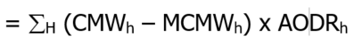  Applicable only in response to an open standby notification.  Where:  ‘CMW’ (Confirmed MW), means the number of MW available for Curtailment by the Participant. ‘CMW’ is limited to the lesser of the Monthly Contracted MW plus 15 MW and 130% of the Monthly Contracted MW.  ‘MCMW’ has the same meaning as in CT1340.  ‘AODR’ (Availability Over-Delivery Rate), means the over-delivery rate as specified by the OPA.  ‘H’ is the set of all hours ‘h’ in the Contract month where the ‘CMW’ exceeded the ‘MCMW’. | Monthly | Due DR3-participants Either way | 13 | N/A | N/A | N/A | Former OPA DR3 Contract. The DR3 program was last settled on the April 2015 settlement statements and invoice.
1342 | On behalf of the former OPA for the DR3 Program – Availability Set-Off Settlement Amount | N/A | N/A | **CALCULATIONS FOR CHARGE TYPE 1342 ENDED ON APRIL 30, 2015.**  The charge to a DR participant is highest of A, B or C:  A: Availability Set-Off (Reliability)  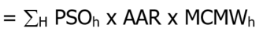  This formula applies when the Reliability Rate for a given Settlement Point is less than 85% during any meter interval of an Activation Hour, or where the Participant is not Fully Available for Curtailment as defined in the OPA DR3 Program Rules.  Where:  For each metered interval, the Reliability Rate at a settlement point is defined as the actual reduction divided by the requested reduction; however, the Reliability Rate cannot exceed 100%.  ‘PSO’ (Performance Set-Off Factor) refers to a set of factors defined in the OPA DR3 Program Rules.  ‘AAR’ has the same meaning as in CT1340.  ‘MCMW’ has the same meaning as in CT1340.  ‘H’ is the set of all activation hours ‘h’ for the activation period.  B: Availability Set-Off (Timely Confirmation)  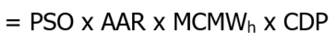  This formula applies when the Participant, regardless of Activation, has failed to deliver, or delivers late, a Confirmation that is required by the IESO pursuant to the DR3 Program Rules.  Where:  ‘CDP’ (Contracted Dispatch Period) means four consecutive hours. Each Contracted Dispatch Period shall occur within the hours of Availability, and shall occur within and no more than once in accordance with the Daily Schedule.  ‘PSO’ has the same meaning as defined above.  ‘AAR’ has the same meaning as in CT1340.  ‘MCMW’ has the same meaning as in CT1340.  C: Availability Set-Off (Low Confirmation)  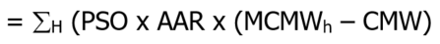  This formula applies when the Confirmed MW’s are less than 95% of the Monthly Contracted MW for a Confirmed Hour of the Contracted Dispatch Period.  Where:  ‘PSO’ has the same meaning as defined above.  ‘AAR’ has the same meaning as in CT1340.  ‘MCMW’ has the same meaning as in CT1340.  ‘CMW’ has the same meaning as in CT1341.  ‘H’ is the set of all confirmed hours ‘h’ when the Confirmed MW’s are less than 95% of the Monthly Contracted MW for the Contracted Dispatch Period. | Monthly | Due DR3-participants Either way | 13 | N/A | N/A | N/A | Former OPA DR3 Contract. The DR3 program was last settled on the April 2015 settlement statements and invoice.
1343 | On behalf of the former OPA for the DR3 Program – Utilization Payment Settlement Amount | N/A | N/A | **CALCULATIONS FOR CHARGE TYPE 1343 ENDED ON APRIL 30, 2015.**  Where:  ‘Curt’ (Curtailment), means the number of MWh Curtailed by a Participant when requested by the IESO, as measured through the use of electricity meter(s). Curtailment shall not exceed the product of the Activation MW and the activation period requested by the IESO, plus the lesser of an additional 15% of the Activation MW per hour of the activation period, OR 15 MWh per hour of the activation period.  ‘UR’ (Utilization Rate), means the rates, expressed in $/MWh, as specified by the OPA.  ‘NG’ (Net Generation), means the MWh of net electricity generated by any contributor that is a behind the meter generator.  ‘H’ is the total hours ‘h’ a Participant is activated in a Contract Month. | Monthly | Due DR3-participants Either way | 13 | N/A | N/A | N/A | Former OPA DR3 Contract. The DR3 program was last settled on the April 2015 settlement statements and invoice.
1344 | On behalf of the former OPA for the DR3 Program – Utilization Set-Off Settlement Amount | N/A | N/A | **CALCULATIONS FOR CHARGE TYPE 1344 ENDED ON APRIL 30, 2015.**  The charge to a DR participant is highest of A, B or C:  A: Utilization Set-Off (Reliability)  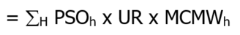  This formula applies when the Reliability Rate for a given Settlement Point is less than 85% during any meter interval of an Activation Hour.  Where:  For each metered interval, the Reliability Rate at a settlement point is defined as the actual reduction divided by the requested reduction; however, the Reliability Rate cannot exceed 100%.  ‘PSO’ (Performance Set-Off Factor) refers to a set of factors defined in the OPA’s Program Rules.  ‘UR’ has the same meaning as in CT1343.  ‘MCMW’ has the same meaning as in CT1340.  ‘H’ is the set of all activation hours ‘h’ for the activation period.  B: Utilization Set-Off (Timely Confirmation)  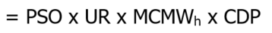  This formula applies when the Participant, regardless of Activation, has failed to deliver, or delivers late, a Confirmation that is required by the IESO pursuant to the DR3 Program Rules.  Where:  ‘CDP’ (Contracted Dispatch Period) means four consecutive hours. Each Contracted Dispatch Period shall occur within the hours of Availability and shall occur within and no more than once in accordance with the Daily Schedule.  ‘PSO’ has the same meaning as defined above.  ‘UR’ has the same meaning as in CT1343.  ‘MCMW’ has the same meaning as in CT1340  C: Utilization Set-Off (Low Confirmation)  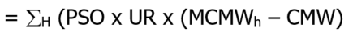  This formula applies when the Confirmed MW’s are less than 95% of the Monthly Contracted MW for a Confirmed Hour of the Contracted Dispatch Period.  Where:  ‘PSO’ has the same meaning as defined above.  ‘UR’ has the same meaning as in CT1343.  ‘MCMW’ has the same meaning as in CT1340.  ‘CMW’ has the same meaning as in CT1341.  ‘H’ is the set of all confirmed hours ‘h’ when the Confirmed MW’s are less than 95% of the Monthly Contracted MW for the Contracted Dispatch Period. | Monthly | Due DR3-participants Either way | 13 | N/A | N/A | N/A | Former OPA DR3 Contract. The DR3 program was last settled on the April 2015 settlement statements and invoice.
1345 | On behalf of the former OPA for the DR3 Program – Planned Non-Performance Event Set-Off Amt | N/A | N/A | **CALCULATIONS FOR CHARGE TYPE 1345 ENDED ON APRIL 30, 2015.**  The Planned Non-Performance Availability Set-Off applies for any day for which a participant has requested a Non-Performance Event as part of either a Single Day Non-Performance Event or a part of an Extended Period Planned Non-Performance Event.  The monthly set-off calculation is the sum of all:  - Non-Activation Day Non-Performance Availability Set-Off s and  - Activation Day Non-Performance Availability Set-Offs.  For 1.) The Non-Activation Day Non-Performance Availability Set-Off amount is:  = (AAR x MCMW_{h} x HANE_{H})  Where:  ‘AAR’ has the same meaning as in CT1340.  ‘MCMW’ has the same meaning as in CT1340.  ‘HANE’ (Hours of Availability for a Non-Performance Event), represents the Hours of Availability for all days in the contract month for which a planned Non-Performance Event is requested and for which an Activation Notice is not received by the participant.  For 2.) The Activation Day Non-Performance Availability Set-Off amount is:  = (OH x AAR x MCMW_{h} x NEWF_{H})  Where:  ‘OH’ (Opportunity Hours), means 64 if Option A is applicable to the Settlement Account; or 32 if Option B is applicable to the Settlement Account.  ‘AAR’ has the same meaning as in CT1340.  ‘MCMW’ has the same meaning as in CT1340.  ‘NEWF’ (Non-Performance Event Weighting Factor), means 50%, if the Actual Activated MWh per interval, as averaged over all of the Intervals in the Contracted Dispatch Period for the Activation, is greater than or equal to the product of the Monthly Contracted MW and 1/12 of an hour; or 100% otherwise. | Monthly | Due DR3-participants Either way | 13 | N/A | N/A | N/A | Former OPA DR3 Contract. The DR3 program was last settled on the April 2015 settlement statements and invoice.
1346 | On behalf of the former OPA for the DR3 Program – Meter Data Set-Off Settlement Amount | N/A | N/A | **CALCULATIONS FOR CHARGE TYPE 1346 ENDED ON APRIL 30, 2015.**  = MDSF x (HA_{H} x MCMW_{h} x AAR)  This formula applies when the complete set of weekly meter data and proof of any Forced Outage(s) for a Settlement Account is not received by 15:00 EST on the first Business Day of the following week. The formula recovers a percentage of the availability payment for the applicable week.  Where:  ‘MDSF’ (Meter Data Set-Off Factor), is an increasing factor for every week that the full data remains undelivered. The factor is equal to:  - 20% for the first week that the full data remains undelivered;  - 33% for the second week that the full data remains undelivered;  - 50% for the third week that the full data remains undelivered; and  - 100% for the fourth week that the full data remains undelivered.  ‘HA’ has the same meaning as in CT1340.  ‘MCMW’ has the same meaning as in CT1340.  ‘AAR’ has the same meaning as in CT1340.  ‘H’ is the total hours a Participant is available for the applicable week. | Monthly | Due DR3-participants Either way | 13 | N/A | N/A | N/A | Former OPA DR3 Contract. The DR3 program was last settled on the April 2015 settlement statements and invoice.
1347 | On behalf of the former OPA for the DR3 Program – Buy-Down Settlement Amount | N/A | N/A | **CALCULATIONS FOR CHARGE TYPE 1347 ENDED ON APRIL 30, 2015.**  Buy-Down means the act by the Participant of reducing its Monthly Contracted MW and/or removing Daily Schedules from participation in DR3.  For the Buy-Down of Monthly Contracted MW the payment is:  = (MCMWR x BDR x HAE)  Where:  ‘MCMWR’ (Monthly Contracted MW Reduction), means the MW of demand reduction in the Monthly Contracted MWs.  ‘BDR’ (Buy-Down Rate), means the Buy-Down Rate, expressed in $/MW.  ‘HAE’ (Hours of Availability Elapsed), means the number of Hours of Availability that have elapsed in the Schedule Term up to the date that the reduction takes effect.  For the Buy-Down of the Daily Schedules the payment is:  = (MCMW x RD x BDR x HAE)  Where:  ‘MCMW’ has the same meaning as in CT1340.  ‘RD’ (Requested Days), means the number of Business Days per week from which the Hours of Availability are to be removed.  ‘BDR’ has the same meaning as defined above.  ‘HAE’ has the same meaning as defined above. | Monthly | Due DR3-participants Either way | 13 | N/A | N/A | N/A | Former OPA DR3 Contract. The DR3 program was last settled on the April 2015 settlement statements and invoice.
1348 | On behalf of the former OPA for the DR3 Program – Miscellaneous Settlement Amount | N/A | N/A | **CALCULATIONS FOR CHARGE TYPE 1348 ENDED ON APRIL 30, 2015.**  Reserved for DR3 payments or charges of a miscellaneous nature not specifically covered under Charge Types 1340 through 1347. | Monthly | Due DR3-participants Either way | 13 | N/A | N/A | N/A | Former OPA DR3 Contract. The DR3 program was last settled on the April 2015 settlement statements and invoice.
1380 | Demand Response 2 Availability Payment Balancing Amount | N/A | N/A | **CALCULATIONS FOR CHARGE TYPE 1380 ENDED ON FEBRUARY 28, 2015.**  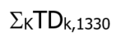  Where ‘K’ is the set of all DR2 participants ‘k’.  Where TD_{k,1330} is the settlement amount of charge type 1330 for the month for DR2 participant ‘k’. | Monthly | Due OPA | 0 | N/A | N/A | N/A | Former OPA DR2 Contract. The DR2 program was last settled on the February 2015 settlement statements and invoice.
1381 | Demand Response 2 Availability Set-Off Balancing Amount | N/A | N/A | **CALCULATIONS FOR CHARGE TYPE 1381 ENDED ON FEBRUARY 28, 2015.**  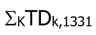  Where ‘K’ is the set of all DR2 participants ‘k’.  Where TD_{k,1331} is the settlement amount of charge type 1331 for the month for DR2 participant ‘k’. | Monthly | Due OPA | 0 | N/A | N/A | N/A | Former OPA DR2 Contract. The DR2 program was last settled on the February 2015 settlement statements and invoice.
1382 | Demand Response 2 Utilization Payment Balancing Amount | N/A | N/A | **CALCULATIONS FOR CHARGE TYPE 1382 ENDED ON FEBRUARY 28, 2015.**  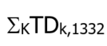  Where ‘K’ is the set of all DR2 participants ‘k’.  Where TD_{k,1332} is the settlement amount of charge type 1332 for the month for DR2 participant ‘k’. | Monthly | Due OPA | 0 | N/A | N/A | N/A | Former OPA DR2 Contract. The DR2 program was last settled on the February 2015 settlement statements and invoice.
1383 | Demand Response 2 Utilization Set-Off Balancing Amount | N/A | N/A | **CALCULATIONS FOR CHARGE TYPE 1383 ENDED ON FEBRUARY 28, 2015.**  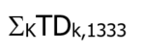  Where ‘K’ is the set of all DR2 participants ‘k’.  Where TD_{k,1333} is the settlement amount of charge type 1333 for the month for DR2 participant ‘k’. | Monthly | Due OPA | 0 | N/A | N/A | N/A | Former OPA DR2 Contract. The DR2 program was last settled on the February 2015 settlement statements and invoice.
1384 | Demand Response 2 Meter Data Set-Off Balancing Amount | N/A | N/A | **CALCULATIONS FOR CHARGE TYPE 1384 ENDED ON FEBRUARY 28, 2015.**  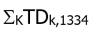  Where ‘K’ is the set of all DR2 participants ‘k’.  Where TD_{k,1334} is the settlement amount of charge type 1334 for the month for DR2 participant ‘k’. | Monthly | Due OPA | 0 | N/A | N/A | N/A | Former OPA DR2 Contract. The DR2 program was last settled on the February 2015 settlement statements and invoice.
1385 | Demand Response 2 Buy-Down Balancing Amount | N/A | N/A | **CALCULATIONS FOR CHARGE TYPE 1385 ENDED ON FEBRUARY 28, 2015.**  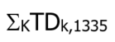  Where ‘K’ is the set of all DR2 participants ‘k’.  Where TD_{k,1335} is the settlement amount of charge type 1335 for the month for DR2 participant ‘k’. | Monthly | Due OPA | 0 | N/A | N/A | N/A | Former OPA DR2 Contract. The DR2 program was last settled on the February 2015 settlement statements and invoice.
1386 | Demand Response 2 Miscellaneous Balancing Amount | N/A | N/A | **CALCULATIONS FOR CHARGE TYPE 1386 ENDED ON FEBRUARY 28, 2015.**  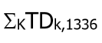  Where ‘K’ is the set of all DR2 participants ‘k’.  Where TD_{k,1336} is the settlement amount of charge type 1336 for the month for DR2 participant ‘k’. | Monthly | Due OPA | 0 | N/A | N/A | N/A | Former OPA DR2 Contract. The DR2 program was last settled on the February 2015 settlement statements and invoice.
1390 | Demand Response 3 Availability Payment Balancing Amount | N/A | N/A | **CALCULATIONS FOR CHARGE TYPE 1390 ENDED ON APRIL 30, 2015.**  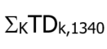  Where ‘K’ is the set of all DR3 participants ‘k’.  Where TD_{k,1340} is the settlement amount of charge type 1340 for the month for DR3 participant ‘k’. | Monthly | Due OPA | 0 | N/A | N/A | N/A | Former OPA DR3 Contract. The DR3 program was last settled on the April 2015 settlement statements and invoice.
1391 | Demand Response 3 Availability Over-Delivery Balancing Amount | N/A | N/A | **CALCULATIONS FOR CHARGE TYPE 1391 ENDED ON APRIL 30, 2015.**  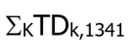  Where ‘K’ is the set of all DR3 participants ‘k’.  Where TD_{k,1341} is the settlement amount of charge type 1341 for the month for DR3 participant ‘k’. | Monthly | Due OPA | 0 | N/A | N/A | N/A | Former OPA DR3 Contract. The DR3 program was last settled on the April 2015 settlement statements and invoice.
1392 | Demand Response 3 Availability Set-Off Balancing Amount | N/A | N/A | **CALCULATIONS FOR CHARGE TYPE 1392 ENDED ON APRIL 30, 2015.**  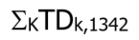  Where ‘K’ is the set of all DR3 participants ‘k’.  Where TD_{k,134}  ₂ is the settlement amount of charge type 1342 for the month for DR3 participant ‘k’. | Monthly | Due OPA | 0 | N/A | N/A | N/A | Former OPA DR3 Contract. The DR3 program was last settled on the April 2015 settlement statements and invoice.
1393 | Demand Response 3 Utilization Payment Balancing Amount | N/A | N/A | **CALCULATIONS FOR CHARGE TYPE 1393 ENDED ON APRIL 30, 2015.**  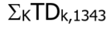  Where ‘K’ is the set of all DR3 participants ‘k’.  Where TD_{k,1343} is the settlement amount of charge type 1343 for the month for DR3 participant ‘k’. | Monthly | Due OPA | 0 | N/A | N/A | N/A | Former OPA DR3 Contract. The DR3 program was last settled on the April 2015 settlement statements and invoice.
1394 | Demand Response 3 Utilization Set-Off Balancing Amount | N/A | N/A | **CALCULATIONS FOR CHARGE TYPE 1394 ENDED ON APRIL 30, 2015.**  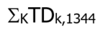  Where ‘K’ is the set of all DR3 participants ‘k’.  Where TD_{k,1344} is the settlement amount of charge type 1344 for the month for DR3 participant ‘k’. | Monthly | Due OPA | 0 | N/A | N/A | N/A | Former OPA DR3 Contract. The DR3 program was last settled on the April 2015 settlement statements and invoice.
1395 | Demand Response 3 Planned Non-Event Set-Off Balancing Amount | N/A | N/A | **CALCULATIONS FOR CHARGE TYPE 1395 ENDED ON APRIL 30, 2015.**  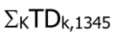  Where ‘K’ is the set of all DR3 participants ‘k’.  Where TD_{k,1345} is the settlement amount of charge type 1345 for the month for DR3 participant ‘k’. | Monthly | Due OPA | 0 | N/A | N/A | N/A | Former OPA DR3 Contract. The DR3 program was last settled on the April 2015 settlement statements and invoice.
1396 | Demand Response 3 Meter Data Set-Off Balancing Amount | N/A | N/A | **CALCULATIONS FOR CHARGE TYPE 1396 ENDED ON APRIL 30, 2015.**  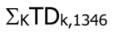  Where ‘K’ is the set of all DR3 participants ‘k’.  Where TD_{k,1346} is the settlement amount of charge type 1346 for the month for DR3 participant ‘k’. | Monthly | Due OPA | 0 | N/A | N/A | N/A | Former OPA DR3 Contract. The DR3 program was last settled on the April 2015 settlement statements and invoice.
1397 | Demand Response 3 Buy-Down Balancing Amount | N/A | N/A | **CALCULATIONS FOR CHARGE TYPE 1397 ENDED ON APRIL 30, 2015.**  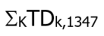  Where ‘K’ is the set of all DR3 participants ‘k’.  Where TD_{k,1347} is the settlement amount of charge type 1347 for the month for DR3 participant ‘k’. | Monthly | Due OPA | 0 | N/A | N/A | N/A | Former OPA DR3 Contract. The DR3 program was last settled on the April 2015 settlement statements and invoice.
1398 | Demand Response 3 Miscellaneous Balancing Amount | N/A | N/A | **CALCULATIONS FOR CHARGE TYPE 1398 ENDED ON APRIL 30, 2015.**  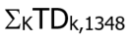  Where ‘K’ is the set of all DR3 participants ‘k’.  Where TD_{k,1348} is the settlement amount of charge type 1348 for the month for DR3 participant ‘k’. | Monthly | Due OPA | 0 | N/A | N/A | N/A | Former OPA DR3 Contract. The DR3 program was last settled on the April 2015 settlement statements and invoice.
1415 | Conservation Assessment Recovery | N/A | N/A | Where ‘H’ is the set of all settlement hours ‘h’ in the year 2009.  Where ‘K’ is the set of all non-LDC load market participants ‘k’.  Where ‘M’ is the set of all delivery points ‘m’ of market participant ‘k’.  Where ‘TD’ equals the value assessed by the OEB. | Monthly | Due Non-LDC Load | 13 | N/A | N/A | N/A | Implementation details subject to government regulation.
1421 | Capacity Agreement Settlement Credit | N/A | N/A | ** CALCULATIONS FOR CHARGE TYPE 1421 END DECEMBER 31, 2023 AS PER CONTRACT AGREEMENT**  Calculated as per capacity contracts. | Monthly | Either Way | 13 | 13 | N/A | 13
1422 | Capacity Agreement Penalty Settlement Amount | N/A | N/A | ** CALCULATIONS FOR CHARGE TYPE 1422 END DECEMBER 31, 2023 AS PER CONTRACT AGREEMENT**  Calculated as per capacity contracts. | Monthly | Either Way | 13 | 13 | N/A | 13
1423 | Energy Sales Agreement Settlement Credit | N/A | N/A | ** CALCULATIONS FOR CHARGE TYPE 1423 END DECEMBER 31, 2023 AS PER CONTRACT AGREEMENT**  Calculated as per energy sales contracts. | Monthly | Either Way | 13 | 13 | N/A | 13
1424 | Energy Sales Agreement Penalty Settlement Amount | N/A | N/A | ** CALCULATIONS FOR CHARGE TYPE 1424 END DECEMBER 31, 2023 AS PER CONTRACT AGREEMENT**  Calculated as per energy sales contracts. | Monthly | Either Way | 13 | 13 | N/A | 13
1428 | Small Hydro Program Settlement Amount | N/A | N/A | Manual Entry. | Monthly | Due LDCs either way | TBD | N/A | N/A | N/A
1465 | Ontario Clean Energy Benefit (-10%) Program Balancing Amount | N/A | N/A | ** PROGRAM END DECEMBER 31, 2015 **  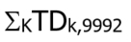  Where ‘K’ is the set of all market participants ‘k’.  Where TD_{k,9992} is the settlement amount of charge type 9992 for the month for market participant ‘k’. | Monthly | Due Ministry of Energy | 0 | N/A | N/A | N/A | Implementation details subject to Ontario Regulation 495/10.
1470 | Ontario Electricity Support Program Balancing Amount | N/A | N/A | ** CHARGE TYPE 1470 REPLACED BY CHARGE TYPE 2470 EFFECTIVE FEBRUARY 1, 2018 **  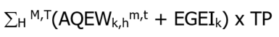  Where ‘H’ is the set of all settlement hours ‘h’ in the month.  Where ‘T’ is the set of all metering intervals ‘t’ in the set of all settlement hours ‘H’. | Monthly | Due IESO | 13 | N/A | N/A | N/A | Implementation details subject to Ontario Regulation 314/15.  TP rate subject to OEB regulation
1471 | Capacity Agreement Balancing Amount | N/A | N/A | ** CALCULATIONS FOR CHARGE TYPE 1471 END DECEMBER 31, 2023 AS PER CONTRACT AGREEMENT**  Σ_{K}TD_{k,1421}  Where ‘K’ is the set of all market participants ‘k’.  Where TD_{k,1421} is the total settlement amount of charge type 1421 for the month for market participant ‘k’. | Monthly | Either Way | 0 | N/A | N/A | N/A
1472 | Capacity Agreement Penalty Balancing Amount | N/A | N/A | ** CALCULATIONS FOR CHARGE TYPE 1472 END DECEMBER 31, 2023 AS PER CONTRACT AGREEMENT**  Σ_{K}TD_{k,1422}  Where ‘K’ is the set of all market participants ‘k’.  Where TD_{k},₁₄₂₂ is the total settlement amount of charge type 1422 for the month for market participant ‘k’. | Monthly | Either way | 0 | N/A | N/A | N/A
1473 | Energy Sales Agreement Balancing Amount | N/A | N/A | ** CALCULATIONS FOR CHARGE TYPE 1473 END DECEMBER 31, 2023 AS PER CONTRACT AGREEMENT**  Σ_{K}TD_{k,1423}  Where ‘K’ is the set of all market participants ‘k’.  Where TD_{k},₁₄₂₃ is the total settlement amount of charge type 1423 for the month for market participant ‘k’. | Monthly | Either way | 0 | N/A | N/A | N/A
1474 | Energy Sales Agreement Penalty Balancing Amount | N/A | N/A | ** CALCULATIONS FOR CHARGE TYPE 1474 END DECEMBER 31, 2023 AS PER CONTRACT AGREEMENT**  Σ_{K}TD_{k,1424}  Where ‘K’ is the set of all market participants ‘k’.  Where TD_{k},₁₄₂₄ is the total settlement amount of charge type 1424 for the month for market participant ‘k’. | Monthly | Either way | 0 | N/A | N/A | N/A
1500  MRP retired | Day-Ahead Production Cost Guarantee Payment – Component 1 and Component 1 Clawback | DA_PCG_COMP1 | 9.4.7D.4 | ∑^{T} (Component 1 – Component1 Clawback)  Component 1:  -1 x OP(EMP_{h}^{m,t}, MIN(DA_DQSI_{k,h}^{m,t}, DQSI_{k,h}^{m,t}, AQEI_{k,h}^{m,t}), DA_BE) + DA_SNLC_{k,h}^{m}/12  Component 1 Clawback:  -1 x OP(EMP_{h}^{m,t}, MIN(MLP_{k,h}^{m,t}, AQEI_{k,h}^{m,t}), DA_BE) + DA_SNLC_{k,h}^{m}/12  Where:  T is the set of metering intervals in the settlement hour h.  ‘OP’ is the operating profit function defined in IESO market rules section 9.3.8B.2.  For a combustion turbine resource associated to a pseudo unit:  Component 1:  -1 x OP(EMP_{h}^{m,t}, MIN(DA_DQSI_{k,h}^{m,t}, DQSI_{k,h}^{m,t}, AQEI_{k,h}^{m,t}), DIPC_{k,h}^{m,t}) + (DA_SNLC_{k,h}^{m}/12) * (1 – PST_{k,h}^{p,t})  Component 1 Clawback:  -1 x OP(EMP_{h}^{m,t}, MIN(MLP_CONS_{k,h}^{m,t}, AQEI_{k,h}^{m,t}), DIPC_{k,h}^{m,t}) + (DA_SNLC_{k,h}^{m}/12) * (1 – PST_{k,h}^{p,t})  For a steam turbine resource associated to a pseudo unit:  Component 1:  -1 x OP(EMP_{h}^{m,t}, MIN(DIGQ_{k,h}^{m,t}, DQSI_{k,h}^{m,t}, AQEI_{k,h}^{m,t}), DIPC_{k,h}^{m,t}) + (DA_SNLC_{k,h}^{m}/12) * PST_{k,h}^{p,t}  Component 1 Clawback:  -1 x OP(EMP_{h}^{m,t}, MIN(MLP_CONS_{k,h}^{m,t}, AQEI_{k,h}^{m,t}), DIPC_{k,h}^{m,t}) + (DA_SNLC_{k,h}^{m}/12) * PST_{k,h}^{p,t} | Hourly | Either Way | 13 | N/A | N/A | N/A | Component 1 applies to Variants 1, 2 and 3.  Component 1 Clawback applies to Variant 2 only.  For a description of Production Cost Guarantee Variants, refer to Market Rules 9.4.7D.2.1
1501  MRP retired | Day-Ahead Production Cost Guarantee Payment – Component 2 | DA_PCG_COMP2 | 9.4.7D.4 | Where:  T is the set of metering intervals in the settlement hour h.  XDA_BE_{k,h}^{m,t} = (-1) * [OP(EMP_{h}^{m,t},min(DA_DQSI_{k,h}^{m,t}, OPCAP_{k,h}^{m,t}), DA_BE) –  OP(EMP_{h}^{m,t}, min(DA_DQSI_{k,h}^{m,t}, OPCAP_{k,h}^{m,t}, max(DQSI_{k,h}^{m,t}, AQEI_{k,h}^{m,t})), DA_BE)]  XBE_{k,h}^{m,t} = (-1) * [OP(EMP_{h}^{m,t},min(DA_DQSI_{k,h}^{m,t}, OPCAP_{k,h}^{m,t}), BE) –  OP(EMP_{h}^{m,t}, min(DA_DQSI_{k,h}^{m,t}, OPCAP_{k,h}^{m,t}, max(DQSI_{k,h}^{m,t}, AQEI_{k,h}^{m,t})), BE)]  Where:  ‘OP’ is the operating profit function defined in IESO market rules section 9.3.8B.2.  EMP_{h}^{m,t} = 0.  For a combustion turbine and a steam turbine resources associated to a pseudo unit:  DA_BE is replaced with DIPC_{k,h}^{m,t}.  For a steam turbine resource associated to a pseudo unit:  DA_DQSI_{k,h}^{m,t} is replaced with the DIGQ_{k,h}^{m,t} | Hourly | Either Way | 13 | N/A | N/A | N/A | Component 2 applies to Variants 1, 2 and 3.  For a description of Production Cost Guarantee Variants, refer to Market Rules 9.4.7D.2.1
1502  MRP retired | Day-Ahead Production Cost Guarantee Payment – Component 3 and Component 3 Clawback | DA_PCG_COMP3 | 9.4.7D.4 | ∑^{T} (-1)*(Component 3 + Component 3 Clawback)  Where:  T is the set of metering intervals in the settlement hour h.  For Component 3, the six scenarios of the possible orderings of the generator’s DA_DQSI, DQSI and MQSI are as follows:  - DQSI >= MQSI >= DA_DQSI  - MQSI >= DQSI >= DA_DQSI  - DQSI > DA_DQSI > MQSI  - MQSI > DA_DQSI > DQSI  - DA_DQSI >= DQSI > MQSI  - DA_DQSI >= MQSI > DQSI  Component 3:  Component 3 is calculated when:  the CMSC for energy (TD_{k,h,105}^{m,t}) for the same metering interval is a value other than zero; and  the mathematical sign of (DQSI-MQSI) is equal to the mathematical sign of (AQEI-MQSI).  Scenario 1 and 2:  0  Scenario 3:  OP(EMP_{h}^{m,t}, MQSI_{k,h}^{m,t}, BE) – MAX(OP(EMP_{h}^{m,t}, DA_DQSI_{k,h}^{m,t}, BE), OP(EMP_{h}^{m,t},AQEI_{k,h}^{m,t}, BE))  Scenario 4:  OP(EMP_{h}^{m,t}, DA_DQSI_{k,h}^{m,t}, BE) – MAX(OP(EMP_{h}^{m,t}, DQSI_{k,h}^{m,t}, BE), OP(EMP_{h}^{m,t},AQEI_{k,h}^{m,t}, BE))  Scenario 5 and 6:  TD_{k,h,105}^{m,t}  Refer to Market Rules for a description of Scenarios 1 through 6.  Component 3 Clawback:  Component 3 Clawback is calculated when:  the event is a constrained-on event (i.e. Scenarios 3 and 5);  the minimum loading point is greater than the real-time unconstrained schedule; and  Component 3 (PCG_COMP3_{k,h}^{m,t}) for the same interval is a value other than zero.  MAX(OP(EMP_{h}^{m,t}, MLP_{k,h}^{m,t}, BE), OP(EMP_{h}^{m,t},AQEI_{k,h}^{m,t}, BE)) – OP(EMP_{h}^{m,t}, MQSI_{k,h}^{m,t}, BE)  For combustion turbine resources associated to a pseudo unit:  DA_BE is replaced with DIPC_{k,h}^{m,t}; and  MLP is replaced with MLP_CONS.  For steam turbine resources associated to a pseudo unit:  DA_BE is replaced with DIPC_{k,h}^{m,t},  MLP is replaced with MLP_CONS,  and  DA_DQSI_{k,h}^{m,t} is replaced with the DIGQ_{k,h}^{m,t}.  Where  ‘OP’ is the operating profit function defined in IESO market rules section 9.3.8B.2. | Hourly | Either Way | 13 | N/A | N/A | N/A | Component 3 applies to Variants 1, 2 and 3.  Component 3 Clawback applies to Variant 2 only.  For a description of Production Cost Guarantee Variants, refer to Market Rules 9.4.7D.2.1
1503  MRP retired | Day-Ahead Production Cost Guarantee Payment – Component 4 | DA_PCG_COMP4 | 9.4.7D.4 | 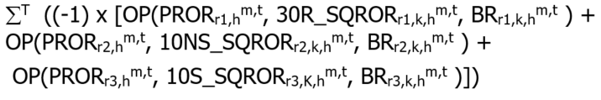  Where  T is the set of metering intervals in the settlement hour h.  ‘OP’ is the operating profit function defined in IESO market rules section 9.3.8B.2.  r1 = 30-minute operating reserve  r2 = 10-minute non-spinning operating reserve  r3 = 10-minute spinning operating reserve  30R_SQROR_{r1,k,h}^{m,t} = MAX[0,MIN(DA_DQSI_{k,h}^{m,t} – MQSI_{k,h}^{m,t}, SQROR_{r1,k,h}^{m,t})]  10NS_SQROR_{r2,k,h}^{m,t} = MAX[0,MIN(DA_DQSI_{k,h}^{m,t} – MQSI_{k,h}^{m,t} - 30R_SQROR_{r1,k,h}^{m,t} , SQROR_{r2,k,h}^{m,t})]  10S_SQROR_{r3,k,h}^{m,t} = MAX[0,MIN(DA_DQSI_{k,h}^{m,t} – MQSI_{k,h}^{m,t} - 30R_SQROR_{r1,k,h}^{m,t} – 10NS_SQROR_{r2,k,h}^{m,t} , SQROR_{r3,k,h}^{m,t})]  For combustion turbine resources and steam turbine resources associated to a pseudo unit:  DA_DQSI_{k,h}^{m,t} is replaced with the DIGQ_{k,h}^{m,t} | Hourly | Either Way | 13 | N/A | N/A | N/A | Component 4 applies to Variants 1, 2 and 3.  For a description of Production Cost Guarantee Variants, refer to Market Rules 9.4.7D.2.1
1504  MRP retired | Day-Ahead Production Cost Guarantee Payment – Component 5 | DA_PCG_COMP5 | 9.4.7D.4 | If first hour of the DACP start event is not HE24, then the start-up cost is calculated as follows:  Scenario 1 (achieves MLP before the 7th interval):  DA_SUC_{k,h}^{m}  Scenario 2 (achieves MLP between the 7th and 18th interval):  DA_SUC_{k,h}^{m} − (DA_SUC_{k,h}^{m} x 1/12 x SUC_INT)  Where  SUC_INT is the number of 5-minute intervals between and including Interval 7 and 18 the market participant takes to achieve MLP  Scenario 3 (achieves MLP after the start of the 18th interval):  0  For a combustion turbine resource associated to a pseudo unit:  Scenario 1 (achieves MLP before the 7th interval):  DA_SUC_{k,h}^{p} * (1 – PST_{k,h}^{p,t})  Scenario 2 (achieves MLP between the 7th and 18th interval):  DA_SUC_{k,h}^{p} * MLP_MF * (1 – PST_{k,h}^{p,t})  Scenario 3 (achieves MLP after the start of the 18th interval):  0  Where  MLP_MF = 1/12 * (12 - SUC_INT)  For a steam turbine resource associated to a pseudo unit:  Scenario 1 (achieves MLP before the 7th interval):  DA_SUC_{k,h}^{p} * (PST_{k,h}^{p,t})  Scenario 2 (achieves MLP between the 7th and 18th interval):  DA_SUC_{k,h}^{p} * MLP_MF * (PST_{k,h}^{p,t})  Scenario 3 (achieves MLP after the start of the 18th interval):  0.  If first hour of the DACP start event is HE24 and the resource has not achieved MLP before Interval 12, then the start-up cost is calculated as follows:  DA_SUC_{k,h}^{m} * 50%  For a combustion turbine resource associated to a pseudo unit:  DA_SUC_{k,h}^{m} * (1 – PST_{k,h}^{p,t}) * 50%  For a steam turbine resource associated to a pseudo unit:  DA_SUC_{k,h}^{m} * (PST_{k,h}^{p,t}) * 50% | Hourly | Due IESO | 13 | N/A | N/A | N/A | Component 5 applies to Variant 1 only.  For a description of Production Cost Guarantee Variants, refer to Market Rules 9.4.7D.2.1
1505  MRP retired | Day-Ahead Production Cost Guarantee Reversal |  | 9.4.7D.6 | For each DACP start event  If ∑_{H,C} TD_{k,h,c} < 0  Then ∑_{H,C} TD_{k,h,c}  Else 0  Where:  'C' is the set of the following charge types 'c' as follows:  1500, 1501, 1502, 1503, 1504  ‘H’ is the set of all settlement hours ‘h’ in the DACP start event. | Hourly | Due MP | 13 | N/A | N/A | N/A
1510  MRP retired | Day-Ahead Generator Withdrawal Charge | DA_GWC | 9.3.8F.2 | The Day-Ahead Generator Withdrawal Charge is calculated as follows:  If notification of the withdrawal is received 4 or more hours prior to first withdrawal hour:  ΜΙΝ(0,∑_{i=1} ^{n} (-1) * OP([MIN(PD_EMP_{h}^{m,t}, EMP_{h}^{m,t}), MLP_{k,h}^{m,t}, DA_BE_{k,h}^{m,t}))  Where:  n is the set of all metering intervals ‘t’ in settlement hour ‘h’ for the total number of hours with a committed day-ahead schedule for the DACP start event that are withdrawn  If notification of the withdrawal is received less than 4 hours prior to first withdrawal hour:  ΜΙΝ(0,∑_{i=1} ^{n} (-1) * OP(EMP_{h}^{m,t}, MLP_{k,h}^{m,t}, DA_BE_{k,h}^{m,t})  Where:  n is the set of all metering intervals ‘t’ in settlement hour ‘h’ for the total number of hours with a committed day-ahead schedule for the DACP start event that are withdrawn  For resources associated to a pseudo unit, the  DA_BE is replaced with DIPC_{k,h}^{m,t}; and the MLP is replaced with MLP_CONS. | Daily | Due IESO | 13 | N/A | N/A | N/A
1550  MRP retired | Day-Ahead Production Cost Guarantee Recovery Debit |  | 9.4.8.1.12 | Where:  'C' is the set of the following charge types 'c' as follows:  1500, 1501, 1502, 1503, 1504, 1505  'K' is the set of all market participants 'k'.  'M' is the set of all delivery points 'm' and intertie metering points 'i'.  ‘H’ is the set of all settlement hours ‘h’ in the day.  ‘T’ is the set of 12 metering intervals ‘t’ during settlement hour ‘h’. | Daily | Due IESO | 13 | N/A | 0 | 13
1560  MRP retired | Day-Ahead Generator Withdrawal Rebate |  | 9.4.8.2.14 | Where:  ‘c’ is charge type 1510.  'K' is the set of all market participants 'k'.  'M' is the set of all delivery points 'm' and intertie metering points 'i'.  ‘H’ is the set of all settlement hours ‘h’ in the day.  ‘T’ is the set of 12 metering intervals ‘t’ during settlement hour ‘h’. | Daily | Due MP | 13 | N/A | 0 | 13
6000 | Ontario Fair Hydro Plan - Regulatory Asset Transfer Amount | N/A | N/A | **REPEALED EFFECTIVE NOVEMBER 1, 2019**  Manual Entry | Monthly | Due Financing Entity | N/A | N/A | N/A | N/A | Implementation details subject to government regulations
6050 | Ontario Fair Hydro Plan - Regulatory Asset Transfer Balancing Amount | N/A | N/A | **REPEALED EFFECTIVE NOVEMBER 1, 2019**  Manual Entry | Monthly | Due IESO | N/A | N/A | N/A | N/A | Implementation details subject to government regulations
6147 | Class A Global Adjustment Deferral Recovery Amount | N/A | N/A | ** CALCULATIONS FOR CHARGE TYPE 6147 END DECEMBER 31, 2021 **  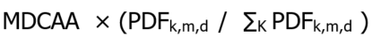  Where ‘K’ is the set of all market participants ‘k’. | Monthly | Due IESO | 13 | N/A | N/A | N/A | Ontario Regulation 429/04
6148 | Class B Global Adjustment Deferral Recovery Amount | N/A | N/A | ** CALCULATIONS FOR CHARGE TYPE 6148 END DECEMBER 31, 2021 **  CBRR × CBMzP_{k}  Where:  Class B Load =  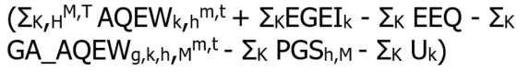  For Fort Frances Power Corporation Distribution Inc.:  For other applicable Class B market participants or licensed distributors that are also market participants:  Where ‘H’ is the set of all settlement hours ‘h’ in the month.  Where ‘K’ is the set of all market participants ‘k’.  Where ‘M’ is the set of all delivery points ‘m’ of market participant ‘k’. | Monthly | Due IESO | 13 | N/A | N/A | N/A | Ontario Regulation 429/04
9147 | Class A Global Adjustment Smoothing Balancing Amount | N/A | N/A | ** CALCULATIONS FOR CHARGE TYPE 9147 END DECEMBER 31, 2021 **  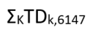  Where ‘K’ is the set of all market participants ‘k’.  Where TDk,6147 is the settlement amount of charge type 6147 for the month for market participant ‘k’. | Monthly | Due IESO | 0 | N/A | N/A | N/A | Ontario Regulation 429/04
9148 | Class B Global Adjustment Smoothing Balancing Amount | N/A | N/A | ** CALCULATIONS FOR CHARGE TYPE 9148 END DECEMBER 31, 2021 **  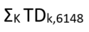  Where ‘K’ is the set of all market participants ‘k’.  Where TDk,6148 is the settlement amount of charge type 6148 for the current month for market participant ‘k’. | Monthly | Due IESO | 0 | N/A | N/A | N/A | Ontario Regulation 429/04
9992 | Ontario Clean Energy Benefit (-10%) Program Settlement Amount | N/A | N/A | **PROGRAM END DECEMBER 31, 2015**  Manual entry based on the values submitted by market participants via on-line settlement forms “Ontario Clean Energy Benefit  (-10%) – LDC” and “Ontario Clean Energy Benefit (-10%) – Unit Sub-Meter Provider”. | Monthly | Due LDCs and Unit Sub-Meter Providers Either way | 0 | N/A | N/A | N/A | Implementation details subject to Ontario Regulation 495/10.

Rounding Conventions – by Settlement Variable
The following Table 3-3 describes the rounding conventions used in the settlement process for each settlement variable.

Table 3-3: Rounding Conventions by Settlement Variable
Variable referenced in Section 3.2 | Data Description | Number of DECIMAL PLACES (values published by upstream systems) | MAXIMUM Number of SIGNIFICANT DIGITS to the right of the decimal (values received by CRS) | MAXIMUM Number of SIGNIFICANT DIGITS to the right of the decimal (externally passed from CRS in settlement statements or data files) | Comments
AQOR_{r,k,h}^{m,t} | Allocated Quantity of Operating Reserve | 1 | 1 | 1 | - Refer to SQROR.
BR_{r} | Operating Reserve Offers | N/A | 1 | 1 | - Not published via upstream IESO systems.  - Confirmations passed to market participants as bids/offers (“dispatch data”) are received.
CAEO^{m}_{h,k} | Capacity Auction Energy Offer | N/A | 1 | 1 | - Not published via upstream IESO system
CGC | Combined Guaranteed Costs | N/A | 2 | 2 | - Not published via upstream IESO systems.
DA_BE_{k,h}^{i,t} | Energy Offer submitted into the schedule of record | N/A | N/A | N/A | - Not published via upstream IESO systems.  - Confirmations passed to market participants as bids/offers (“dispatch data”) are received.
DA_BE_{k,h}^{m,t} | Energy Offer submitted into the schedule of record at a delivery point | N/A | N/A | N/A | - Not published via upstream IESO systems.  - Confirmations passed to market participants as bids/offers (“dispatch data”) are received.
DA_BL_{k,h}^{i,t} | Energy Bids submitted into the schedule of record | N/A | N/A | N/A | - Not published via upstream IESO systems.  - Confirmations passed to market participants as bids/offers (“dispatch data”) are received.
DA_DQSI_{k,h}^{i,t} | Schedule of record dispatch quantity scheduled for injection at an intertie metering point | 1 | 1 | 1 | - Not published via upstream IESO systems.  - Passed to market participants via dispatch messaging.
DA_DQSI_{k,h}^{m,t} | Schedule of record dispatch quantity scheduled for injection at a delivery point | 1 | 1 | 1 | - Not published via upstream IESO systems.  - Passed to market participants via dispatch messaging.
DA_DQSW_{k,h}^{i,t} | Schedule of record dispatch quantity scheduled for withdrawal at an intertie metering point | 1 | 1 | 1 | - Not published via upstream IESO systems.  - Passed to market participants via dispatch messaging.
DA_ELMP_{h}^{m,t} | Pre-dispatch constrained schedule price for an intertie metering point in the export zone | 2 | 2 | 2 | - MIM Publication.
DA_ILMP_{h}^{m,t} | Pre-dispatch constrained schedule price for an intertie metering point in the import zone | 2 | 2 | 2 | - MIM Publication.
DA_SNLC_{k,h}^{m} | Speed-no-load costs submitted into the schedule of record | 1 | 2 | 1 | - Not published via upstream IESO systems.  - Passed to market participants via dispatch messaging.
DA_SNLC_{k,h}^{p} | Speed-no-load costs for pseudo units submitted into the schedule of record | 1 | 2 | 1 | - Not published via upstream IESO systems.  - Passed to market participants via dispatch messaging.
DA_SUC_{k,h}^{m} | Start-up costs submitted into the schedule of record | 1 | 2 | 1 | - Not published via upstream IESO systems.  - Passed to market participants via dispatch messaging.
DA_SUC_{k,h}^{p} | Start-up costs for pseudo units submitted into the schedule of record | 1 | 2 | 1 | - Not published via upstream IESO systems.  - Passed to market participants via dispatch messaging.
DIPC_{k,h}^{m,t} | Derived Interval Price Curve | 1 | 2 | 1 | - Derived price curve and therefore not published on settlement statements.
DIGQ_{k,h}^{m,t} | Derived Interval Guaranteed Quantity | 1 | 1 | 1 | - Derived schedule quantity and therefore not published on settlement statements.
DQSI_{k,h}^{m,t} | Dispatch Quantity of Energy Scheduled for Injection | 1 | 1 | 1 | - Not published via upstream IESO systems.  - Passed to market participants via dispatch messaging.
DQSR_{r,k,h}^{m,t} | Dispatch Quantity Schedule of Operating Reserve | 1 | 1 | 1 | - Not published via upstream IESO systems.  - Passed to market participants via dispatch messaging.
DQSW_{k,h}^{m,t} | Dispatch Quantity of Energy Scheduled for Withdrawal | 1 | 1 | 1 | - Not published via upstream IESO systems.  - Passed to market participants via dispatch messaging.
DRACP | Demand Response Auction Clearing Price | 2 | 2 | 2 | - Published in post-auction report.
DRACP_{h} | Hourly Demand Response Auction Clearing Price | N/A | 2 | 2 | - Not published via upstream IESO systems.
DRBOC_{k} | Demand Response Buy-Out Capacity | N/A | 3 | 3 | - Not published via upstream IESO systems.
DRCO_{k} | Demand Response Capacity Obligation (MW) | 1 | 3 | 3 | - Published in private post-auction report.
DREBQ_{k} | Demand Response Energy Bid Quantity | N/A | 1 | 1 | - Not published via upstream IESO systems.
DRNPF | Demand Response Non-Performance Factor | N/A | 1 | 1 | - Not published via upstream IESO systems.
DRSQty | Demand Response Scheduled Quantity | N/A | 1 | 1 | - Not published via upstream IESO systems.
EIM_{k,h} | Operating Profit Function for the IMPORT of Energy under the Intertie Offer/Bid Guarantee Settlement Credit | N/A  Refer to section 3.4 | N/A  Refer to section 3.4 | N/A  Refer to section 3.4 | - This acronym is associated with the energy import component of the Intertie Offer/Bid Guarantee Settlement Credit.
EMP_{h}^{i,t} | 5-minute Energy Market Price at the Interties | 2 | 2 | 2 | - MIM Publication.
EMP_{h}^{m,t} | 5-minute Energy Market Price within Ontario | 2 | 2 | 2 | - MIM Publication.
EMP_{h}^{REF,t} | 5-minute Energy Market Reference Price | 2 | 2 | 2 | - MIM Publication.
FP_{h}^{m} | Fixed Energy Rate | N/A | 2 | 2 | - Not published via upstream IESO systems.
FPC_{h}^{m} | Rate for a designated group of charge types (refer to description of charge type 141)) | N/A | 2 | 2 | - Not published via upstream IESO systems.
HOEP_{h} | Hourly Ontario Energy Price | 2 | 2 | 2 | - MIM Publication.
MAX_CAP_{k,h}^{m,t} | Maximum Capacity | 2 | 3 | 3
MC_{h}^{m} | Minimum Consumption | 1 | 1 | 1
MI | Ordered matrix of and corresponding IOG settlement amounts | 1 and 2 | 2 | 2 | - Derived set of variables and therefore not published on settlement statements.
MLP_{k,h}^{m,t} | Minimum Loading Point | 1 | 1 | 1 | - Not published via upstream IESO systems.
MLP_CONS_{k,h}^{m,t} | Minimum Loading Point for a steam turbine resource or a combustion turbine resource associated to a pseudo unit | 1 | 1 | 1 | - Not published via upstream IESO systems.
MQSI_{k,h}^{m,t} | Market Quantity Scheduled for Injection | 1 | 1 | 1
MQSI{adj}_{k,h}^{m,t} | Adjusted Market Quantity Scheduled for Injection | 1 | 1 | 1 | - Derived variable and therefore not published on settlement statements.
MQSW_{k,h}^{m,t} | Market Quantity Scheduled for Withdrawal | 1 | 1 | 1
OP | Operating Profit Function | N/A  Refer to section 3.4 | N/A  Refer to section 3.4 | N/A  Refer to section 3.4 | - This acronym is associated with the operating profit equation used within the CMSC equation.
OPCAP_{k,h}^{m,t} | Operating Capacity | 1 | 1 | 1 | - Not published via upstream IESO systems.
PD_BE_{k,h}^{i,t} | Energy Offer submitted into the Pre-dispatch | N/A | 1 | 1 | - Not published via upstream IESO systems.  - Confirmations passed to market participants as bids/offers (“dispatch data”) are received.
PD_BL_{k,h}^{i,t} | Energy bids submitted into the Pre-dispatch | N/A | 1 | 1 | - Not published via upstream IESO systems.  - Confirmations passed to market participants as bids/offers (“dispatch data”) are received.
PD_DQSI_{k,h}^{i,t} | Pre-dispatch quantity scheduled for injection at an intertie metering point | 1 | 1 | 1 | - Not published via upstream IESO systems.  - Passed to market participants via dispatch messaging.
PD_DQSW_{k,h}^{i,t} | Pre-dispatch quantity scheduled for withdrawal at an intertie metering point | 1 | 1 | 1 | - Not published via upstream IESO systems.  - Passed to market participants via dispatch messaging.
PD_ELMP_{h}^{m,t} | Pre-dispatch constrained schedule price for an intertie metering point in the export zone | 2 | 2 | 2 | - MIM Publication.
PD_EMP_{h}^{m,t} | Pre-dispatch energy market price for Ontario | 2 | 2 | 2 | - MIM Publication.
PD_ILMP_{h}^{m,t} | Pre-dispatch constrained schedule price for an intertie metering point in the import zone | 2 | 2 | 2 | - MIM Publication.
SQEI_{k,h}^{i,t} | Scheduled Quantity of Energy Injected at an intertie metering point | 1 | 1 | 1
SQEW_{k,h}^{i,t} | Scheduled Quantity of Energy Withdrawn at an intertie metering point | 1 | 1 | 1
SQROR_{r,k,h}^{m,t} | Scheduled Quantity of class r Operating Reserve | 1 | 1 | 1

Rounding Conventions – by Charge Type
Refer to section 2.3 for general information regarding the contents of this Table 3-4 and a description of each column heading.
Table 3-4: Rounding Conventions by Charge Type
Charge Type Number | Charge Type Name | INPUT VARIABLES  Least number of significant digits to the right of the decimal | INPUT VARIABLES  Maximum number of significant digits to the right of the decimal | Intermediate Rounding done by Settlements? | INTERMEDIATE CALCULATION 1  (where intermediate rounding occurs) | DISPOSITION OF INTERMEDIATE CALCULATION 1 | INTERMEDIATE CALCULATION 2  (where intermediate rounding occurs) | DISPOSITION OF INTERMEDIATE CALCULATION 2
100 | Net Energy Market Settlement for Generators and Dispatchable Load | 1 | 3 | Yes | Numerator: BCQ  Denominator: 12  Resulting Decimals: 3 | BCQ quantities Multiplied by EMP when applicable.
101 | Net Energy Market Settlement for Non-dispatchable Load | 1 | 3 | Yes | Numerator: BCQ  Denominator: 12  Resulting Decimals: 3 | BCQ quantities Multiplied by EMP when applicable.
103 | Transmission Charge Reduction Fund | 2 | 3 | Yes | Numerator: Difference between SQEW – SQEI by intertie zone  Denominator: 12  Resulting Decimals: 3 | Resulting value included with the TCRF calculation at that particular zone for the metering interval in question.
104 | Transmission Rights Settlement Credit | 0 | 2 | Yes | Numerator: Summation of the zonal price difference  (EMP_{h}^{j,t} – EMP _{h}^{i,t})  Denominator: 12  Resulting Decimals: 5 | Multiplied by QTR for the settlement hour.
105 | Congestion Management Settlement Credit for Energy | 1 | 3 | Yes | AQEI multiplied by 12 or  AQEW multiplied by 12  Resulting Decimals: 3 | Used in the calculation of OP(EMP, AQEI, BE) or OP(EMP, AQEW, BL) as the case may be. | Numerators  OP(EMP, MQSI, BE)  OP(EMP, DQSI, BE)  OP(EMP, AQEI, BE)  OP(EMP, MQSW, BL)  OP(EMP, DQSW, BL)  OP(EMP, AQEW, BL)  Denominator: 12  Resulting Decimals: 2 | Profits compared as applicable.
106 | Congestion Management Settlement Credit for 10 Minute Spinning Reserve | 1 | 2 | Yes | Numerators  OP(PROR, MQSR, BR)  OP(PROR, DQSR, BR)  OP(PROR, AQOR, BR)  Denominator: 12  Resulting Decimals: 2 | Profits compared as applicable.
107 | Congestion Management Settlement Credit for 10 Minute Non-spinning Reserve | 1 | 2 | Yes | Numerators  OP(PROR, MQSR, BR)  OP(PROR, DQSR, BR)  OP(PROR, AQOR, BR)  Denominator: 12  Resulting Decimals: 2 | Profits compared as applicable.
108 | Congestion Management Settlement Credit for 30 Minute Operating Reserve | 1 | 2 | Yes | Numerators  OP(PROR, MQSR, BR)  OP(PROR, DQSR, BR)  OP(PROR, AQOR, BR)  Denominator: 12  Resulting Decimals: 2 | Profits compared as applicable.
111 | Northern Pulp and Paper Mill Electricity Transition Program Settlement Amount | 1 | 3 | No
112 | Ontario Power Generation Rebate | 2 | 3 | No
113 | Additional Compensation for Administrative Pricing Credit | 1 | 3 | Yes | For the calculation outlined in 7.8.4A.16 only:  for dispatchable facilities located within Ontario only  AQEI multiplied by 12 or  AQEW multiplied by 12  Resulting Decimals: 3 | (For the calculation outlined in 7.8.4A.16 only)  For dispatchable facilities located within Ontario only:  Used in the calculation of OP(EMP, AQEI, BE) or OP(EMP, AQEW, BL) as the case may be. | For the calculation outlined in 7.8.4A.16 only:  Numerators:  for dispatchable facilities located within Ontario:  OP(EMP, AQEI, BE)  OP(EMP, AQEW, BL)  for Imports or Exports:  OP(EMP, DQSI, BE)  OP(EMP, DQSW, BL)  Denominator: 12  Resulting Decimals: 2 | (For the calculation outlined in 7.8.4A.16 only)  The results are used in the final calculation
120 | Local Market Power Debit | 2 | 2 | No
121 | Northern Industrial Electricity Rate Program Settlement Amount | 1 | 3 | No
122 | Ramp Down Settlement Amount | 1 | 3 | Yes | AQEI multiplied by 12 or  AQEW multiplied by 12  Resulting Decimals: 3 | Used in the calculation of OP(EMP, AQEI, BE) or OP(EMP, AQEW, BL) as the case may be. | Numerators  OP(EMP, MQSI, BE)  OP(EMP, DQSI, BE)  OP(EMP, AQEI, BE)  OP(EMP, MQSW, BL)  OP(EMP, DQSW, BL)  OP(EMP, AQEW, BL)  Denominator: 12  Resulting Decimals: 2 | Profits compared as applicable.
124 | SEAL Congestion Management Settlement Credit Amount | 2 | 2 | No
130 | Intertie Offer Settlement Credit – Energy | 1 | 3 | Yes | Numerators  OP(EMP, MQSI, BE)  Denominator: 12  Resulting Decimals: 2 | Profits compared as applicable.
133 | Generator Cost Guarantee Payment | 1 | 3 | No
134 | Demand Response Credit | 2 | 2 | No
135 | Real-time Import Failure Charge | 1 | 3 | Yes | TERM 1 – Failure Charge  Numerator:  EMP + PB_IM – PD_EMP  Denominator: 12  Resulting Decimals: 2  TERM 2 – Price Cap  Numerator:  MAX(0,EMP) * RT_ISD  Denominator: 12  Resulting Decimals: 2 | TERM 1 and TERM 2 compared as applicable.
136 | Real-time Export Failure Charge | 1 | 3 | Yes | TERM 1 – Failure Charge  Numerator:  PD_EMP – EMP – PB_EX  Denominator: 12  Resulting Decimals: 2  TERM 2 – Price Cap  Numerator:  MAX(0,PD_EMP) * RT_ESD  Denominator: 12  Resulting Decimals: 2 | TERM 1 and TERM 2 compared as applicable.
137 | Generation Cost Guarantee – Annual Carbon Charge Settlement Amount | 1 | 3 | No
140 | Fixed Energy Rate Settlement Amount | 1 | 3 | No
141 | Fixed Wholesale Charge Rate Settlement Amount | 1 | 3 | No
142 | Regulated Price Plan Settlement Amount | 1 | 3 | No
144 | Regulated Nuclear Generation Adjustment Amount | 1 | 3 | No
145 | Regulated Hydroelectric Generation Adjustment Amount | 1 | 3 | No
146 | Global Adjustment Settlement Amount | 1 | 3 | No
150 | Net Energy Market Settlement Uplift | 1 | 3 | No
155 | Congestion Management Settlement Uplift | 1 | 3 | No
161 | Northern Pulp and Paper Mill Electricity Transition Program Balancing Amount | 1 | 3 | No
162 | Ontario Power Generation Rebate Debit | 1 | 3 | No
163 | Additional Compensation for Administrative Pricing Debit | 1 | 3 | No
170 | Local Market Power Rebate | 1 | 3 | No
171 | Northern Industrial Electricity Rate Program Balancing Amount | 1 | 3 | No
183 | Generator Cost Guarantee Recovery Debit | 1 | 3 | No
184 | Demand Response Debit | 2 | 2 | No
190 | Fixed Energy Rate Balancing Amount | 2 | 2 | No
191 | Fixed Wholesale Charge Rate Balancing Amount | 2 | 2 | No
198 | Renewable Generation Balancing Amount | 2 | 2 | No
200 | 10 Minute Spinning Reserve Market Settlement Credit | 1 | 2 | No
202 | 10 Minute Non-spinning Reserve Market Settlement Credit | 1 | 2 | No
204 | 30 Minute Operating Reserve Market Settlement Credit | 1 | 2 | No
206 | 10-Minute spinning non-Accessibility Settlement Amount | 1 | 3 | No
208 | 10-Minute non-Spinning non-Accessibility Settlement Amount | 1 | 3 | No
210 | 30-Minute non-Accessibility Settlement Amount | 1 | 3 | No
406 | Emergency Demand Response Credit | 2 | 2 | No
702 | Debt Retirement Credit | 2 | 2 | No
704 | OPA Administration Credit | 2 | 2 | No
752 | Debt Retirement Charge | 2 | 3 | No
754 | OPA Administration Charge | 1 | 3 | No
1050 | Self-Induced Dispatchable Load CMSC Clawback | 1 | 3 | Yes | AQEW multiplied by 12  Resulting Decimals: 3 | Used in the calculation of OP(EMP, AQEW, BL) as the case may be. | Numerators  OP(EMP, MQSW, BL)  OP(EMP, DQSW, BL)  OP(EMP, AQEW, BL)  OP(EMP, MC, BL)  Denominator: 12  Resulting Decimals: 2 | Profits compared as applicable.
1051 | Ramp-Down CMSC Claw Back | 2 | 2 | No
1101 | Real-Time Energy Settlement Amount for Dispatchable Generators | 1 | 3 | Yes | Numerator: BCQ  Denominator: 12  Resulting Decimals: 3 | BCQ quantities Multiplied by EMP when applicable.
1103 | Real-Time Energy Settlement Amount for Dispatchable Loads | 1 | 3 | Yes | Numerator: BCQ  Denominator: 12  Resulting Decimals: 3 | BCQ quantities Multiplied by EMP when applicable.
1111 | Real-Time Energy Settlement Amount for Imports | 1 | 3 | Yes | Numerator: BCQ  Denominator: 12  Resulting Decimals: 3 | BCQ quantities Multiplied by EMP when applicable.
1113 | Real-Time Energy Settlement Amount for Exports | 1 | 3 | Yes | Numerator: BCQ  Denominator: 12  Resulting Decimals: 3 | BCQ quantities Multiplied by EMP when applicable.
1114 | Real-Time Energy Settlement Amount for Non-Dispatchable Generators | 1 | 3 | Yes | Numerator: BCQ  Denominator: 12  Resulting Decimals: 3 | BCQ quantities Multiplied by EMP when applicable.
1115 | Real-Time Energy Settlement Amount for Non-Dispatchable Load | 1 | 3 | Yes | Numerator: BCQ  Denominator: 12  Resulting Decimals: 3 | BCQ quantities Multiplied by EMP when applicable.
1130 | Day-Ahead Intertie Offer Guarantee Settlement Credit | 1 | 3 | Yes | FOR EACH 5-MINUTE METERING INTERVAL:  Numerators  OP[EMP, MIN(DQSI, PDR_DQSI), PDR_BE]  Denominator: 12  Resulting Decimals: 2 | Results for each 5-minute metering interval are summed for the hour.  Profits compared as applicable.
1131 | Intertie Offer Guarantee Settlement Credit | 1 | 3 | Yes | For each 5 minute metering interval:  RT-IOG – Real Time IOG  Numerator  OP(EMP,MQSI,BE)  Denominator: 12  Resulting Decimal: 2  DA-IOG - Day-Ahead IOG  Component 1  Numerator  OP(EMP, Min(DA_DQSI,DQSI),DA_BE)  Denominator: 12  Resulting Decimal: 2  Component 2  Numerator  XDA_BE – MAX(0,XBE)  Denominator: 12  Resulting Decimal: 2  Component 3  Numerator  OP(EMP,MQSI,BE),  OP(EMP,DA_DQSI,BE)  OP(EMP,DQSI,BE)  Denominator: 12  Resulting Decimal: 2  IOG Rate  Resulting Decimal: 5 | For DA-IOG, Component 1, Component 2 and Component 3 are compared as applicable.  Results of RT-IOG and DA-IOG are compared in IOG OFFSET component.
1133 | Day-Ahead Generation Cost Guarantee Payment | 1 | 3 | No
1134 | Day-Ahead Linked Wheel Failure Charge | 1 | 3 | Yes | RT_EFC_DALW and RT_IFC_DALW for each 5-minute metering interval are summed for the hour.  Resulting Decimal: 2 | Results are compared as applicable.
1135 | Day-Ahead Import Failure Charge | 1 | 3 | Yes | TERM 1 – Operating  Profit („OP”) Function  used to calculate Failure  Charge  OP(PD_EMP, DA_DQSI,  DA_BE)  OP(PD_EMP, PD_DQSI,  DA_BE)  Resulting Decimals: 2  TERM 2 – Operating  Profit („OP”) Function  used to calculate Failure  Charge  OP(PD_EMP, DA_DQSI,  PD_BE)  OP(PD_EMP, PD_DQSI,  PD_BE)  Resulting Decimals: 2  TERM 3 – Price cap  Numerator  Max(0,PD_EMP) x DA_ISD  Denominator: 12  Resulting Decimals: 2 | TERM 1, TERM 2 and  TERM 3 compared as  applicable.
1136 | Day-Ahead Export Failure Charge | 1 | 3 | Yes | TERM 1 – Operating  Profit („OP”) Function  used to calculate Failure  Charge  OP(PD_EMP, DA_DQSW,  DA_BL)  OP(PD_EMP, PD_DQSW,  DA_BL)  Resulting Decimals: 2  TERM 2 – Operating  Profit („OP”) Function  used to calculate Failure  Charge  OP(PD_EMP, DA_DQSW,  PD_BL)  OP(PD_EMP, PD_DQSW,  PD_BL)  Resulting Decimals: 2 | TERM 1, TERM 2 and  TERM 3 compared as  applicable.
1137 | Intertie Offer Guarantee Reversal | 2 | 2 | No
1139 | Intertie Failure Charge Reversal | 2 | 2 | No
1142 | Ontario Fair Hydro Plan Eligible RPP Consumer Discount Settlement Amount | 2 | 2 | No
1143 | Ontario Fair Hydro Plan Eligible Non-RPP Consumer Discount Settlement Amount | 2 | 2 | No
1144 | Ontario Fair Hydro Plan Financing Entity Amount | 2 | 2 | No
1145 | Ontario Fair Hydro Plan Financing Entity Interest | 2 | 2 | No
1192 | Ontario Fair Hydro Plan Eligible RPP Consumer Discount Balancing Amount | 2 | 2 | No
1193 | Ontario Fair Hydro Plan Eligible Non-RPP Consumer Discount Balancing Amount | 2 | 2 | No
1194 | Ontario Fair Hydro Plan Financing Entity Balancing Amount | 2 | 2 | No
1195 | Ontario Fair Hydro Plan Financing Entity Balancing Interest | 2 | 2 | No
1300 | Capacity Based Demand Response Program Availability Payment Settlement Amount | 1 | 3 | No
1301 | Capacity Based Demand Response Program Availability Over-Delivery Settlement Amt | 1 | 3 | No
1302 | Capacity Based Demand Response Program Availability Set-Off Settlement Amount | 1 | 3 | No
1303 | Capacity Based Demand Response Program Utilization Payment Settlement Amount | 1 | 3 | No
1304 | Capacity Based Demand Response Program Utilization Set-Off Settlement Amount | 1 | 3 | No
1305 | Capacity Based Demand Response Program Planned Non-Performance Event Set-Off Amt | 1 | 3 | No
1306 | Capacity Based Demand Response Program Measurement Data Set-Off Settlement Amt | 1 | 3 | No
1307 | Capacity Based Demand Response Program Buy-Down Settlement Amount | 1 | 3 | No
1308 | Capacity Based Demand Response Program Performance Breach Settlement Amount | 1 | 3 | No
1309 | Demand Response Pilot – Availability Payment | 1 | 3 | No
1310 | Demand Response Pilot – Availability Clawback | 1 | 3 | No
1311 | Demand Response Pilot – Availability Charge | 1 | 3 | No
1312 | Demand Response Pilot – Availability Adjustment | 1 | 3 | No
1313 | Demand Response Pilot – Demand Response Bid Guarantee | 1 | 3 | No
1315 | Capacity Obligation – Availability Charge | 1 | 3 | No
1320 | Capacity Obligation – Dispatch Test Payment and Emergency Activation Payment | 1 | 3 | No
1330 | On behalf of Former OPA for the DR2 Program – Availability Payment Settlement Amount | 1 | 3 | No
1331 | On behalf of Former OPA for the DR2 Program – Availability Set-Off Settlement Amount | 1 | 3 | No
1332 | On behalf of Former OPA for the DR2 Program – Utilization Payment Settlement Amount | 1 | 3 | No
1333 | On behalf of Former OPA for the DR2 Program – Utilization Set-Off Settlement Amount | 1 | 3 | No
1334 | On behalf of Former OPA for the DR2 Program – Meter Data Set-Off Settlement Amount | 1 | 3 | No
1335 | On behalf of Former OPA for the DR2 Program – Buy-Down Settlement Amount | 1 | 3 | No
1336 | On behalf of Former OPA for the DR2 Program – Miscellaneous Settlement Amount | 1 | 3 | No
1340 | On behalf of Former OPA for the DR3 Program – Availability Payment Settlement Amount | 1 | 3 | No
1341 | On behalf of Former OPA for the DR3 Program – Availability Over-Delivery Settlement Amt | 1 | 3 | No
1342 | On behalf of Former OPA for the DR3 Program – Availability Set-Off Settlement Amount | 1 | 3 | No
1343 | On behalf of Former OPA for the DR3 Program – Utilization Payment Settlement Amount | 1 | 3 | No
1344 | On behalf of Former OPA for the DR3 Program – Utilization Set-Off Settlement Amount | 1 | 3 | No
1345 | On behalf of Former OPA for the DR3 Program – Planned Non-Performance Event Set-Off Amt | 1 | 3 | No
1346 | On behalf of Former OPA for the DR3 Program – Meter Data Set-Off Settlement Amount | 1 | 3 | No
1347 | On behalf of Former OPA for the DR3 Program – Buy-Down Settlement Amount | 1 | 3 | No
1348 | On behalf of Former OPA for the DR3 Program – Miscellaneous Settlement Amount | 1 | 3 | No
1380 | Demand Response 2 Availability Payment Balancing Amount | 2 | 2 | No
1381 | Demand Response 2 Availability Set-Off Balancing Amount | 2 | 2 | No
1382 | Demand Response 2 Utilization Payment Balancing Amount | 2 | 2 | No
1383 | Demand Response 2 Utilization Set-Off Balancing Amount | 2 | 2 | No
1384 | Demand Response 2 Meter Data Set-Off Balancing Amount | 2 | 2 | No
1385 | Demand Response 2 Buy-Down Balancing amount | 2 | 2 | No
1386 | Demand Response 2 Miscellaneous Balancing amount | 2 | 2 | No
1390 | Demand Response 3 Availability Payment Balancing Amount | 2 | 2 | No
1391 | Demand Response 3 Availability Over-Delivery Balancing Amount | 2 | 2 | No
1392 | Demand Response 3 Availability Set-Off Balancing Amount | 2 | 2 | No
1393 | Demand Response 3 Utilization Payment Balancing Amount | 2 | 2 | No
1394 | Demand Response 3 Utilization  Set-Off Balancing Amount | 2 | 2 | No
1395 | Demand Response 3 Planned Non-Performance Event Set-Off Balancing Amount | 2 | 2 | No
1396 | Demand Response 3 Meter Data Set-Off Balancing Amount | 2 | 2 | No
1397 | Demand Response 3 Buy-Down Balancing Amount | 2 | 2 | No
1398 | Demand Response 3 Miscellaneous Balancing Amount | 2 | 2 | No
1415 | Conservation Assessment Recovery | 1 | 3 | No
1421 | Capacity Agreement Settlement Credit | 0 | 2 | No
1422 | Capacity Agreement Penalty Settlement Amount | 0 | 2 | No
1423 | Energy Sales Agreement Settlement Credit | 0 | 3 | No
1424 | Energy Sales Agreement Penalty Settlement Amount | 0 | 2 | No
1427 | Non-Hydro Renewables Funding Amount | 2 | 2 | No
1465 | Ontario Clean Energy Benefit (-10%) Program Balancing Amount | 2 | 2 | No
1470 | Ontario Electricity Support Program Balancing Amount | 2 | 3 | No
1471 | Capacity Agreement Balancing Amount | 2 | 2 | No
1472 | Capacity Agreement Penalty Balancing Amount | 2 | 2 | No
1473 | Energy Sales Agreement Balancing Amount | 2 | 2 | No
1474 | Energy Sales Agreement Penalty Balancing Amount | 2 | 2 | No
1487 | Non-Hydro Renewables Funding Balancing Amount | 2 | 2 | No
1500 | Day-Ahead Production Cost Guarantee Payment – Component 1 and Component 1 Clawback | 1 | 3 | Yes | AQEI is multiplied by 12  Resulting decimal: 3 | Use in the calculation of OP(EMP,AQEI, DA_BE), | For each 5 minute metering interval:  Numerator  OP(EMP,AQEI, DA_BE),  OP(EMP,DQSI, DA_BE),  OP(EMP,DA_DQSI, DA_BE)  Denominator: 12  Resulting Decimal: 2  Numerator  DA_SNLC  Denominator: 12  Resulting decimal: 2  Results for each 5-minute metering interval are summed for the hour. | Profits are compared as applicable.
1501 | Day-Ahead Production Cost Guarantee Payment – Component 2 | 1 | 3 | Yes | AQEI is multiplied by 12  Resulting decimal: 3 | Use in the calculation of OP(EMP,AQEI, DA_BE),  OP(EMP,AQEI, BE) | For each 5 minute metering interval:  Numerator  OP(EMP,AQEI, DA_BE),  OP(EMP,DQSI, DA_BE),  OP(EMP,DA_DQSI, DA_BE)  OP(EMP,OPCAP, DA_BE)  OP(EMP,AQEI, BE),  OP(EMP,DQSI, BE),  OP(EMP,DA_DQSI, BE)  OP(EMP,OPCAP, BE)  Resulting Decimal: 2 | Profits are compared as applicable.
1502 | Day-Ahead Production Cost Guarantee Payment – Component 3 and Component 3 Clawback | 1 | 3 | Yes | AQEI is multiplied by 12  Resulting decimal: 3 | Use in the calculation of  OP(EMP,AQEI, BE), | For each 5 minute metering interval:  Numerator  OP(EMP,AQEI, BE),  OP(EMP,DQSI, BE),  OP(EMP,DA_DQSI, BE)  OP(EMP,MLP, BE)  Results for each 5-minute metering interval are summed for the hour.  Resulting Decimal: 2 | Profits are compared as applicable.
1503 | Day-Ahead Production Cost Guarantee Payment – Component 4 | 1 | 3 | Yes | For each 5 minute metering interval:  Numerators  OP(PROR,30R_SQROR,BR),  OP(PROR,10NS_SQROR,BR),  OP(PROR,10S_SQROR,BR),  Denominator: 12  Resulting Decimal: 2 | Profits are compared as applicable.
1504 | Day-Ahead Production Cost Guarantee Payment – Component 5 | 1 | 3 | No
1505 | Day-Ahead Production Cost Guarantee Reversal | 1 | 3 | No
1510 | Day-Ahead Generator Withdrawal Charge | 1 | 3 | Yes | For each 5 minute metering interval:  Numerators  OP(EMP,MLP,DA_BE) or  OP(PD_EMP,MLP,DA_BE)  Denominator: 12  Resulting Decimal: 2 | Results for each 5-minute metering interval are summed for the hour.
1550 | Day-Ahead Production Cost Guarantee Recovery Debit | 1 | 3 | No
1560 | Day-Ahead Generator Withdrawal Rebate | 1 | 3 | No
6000 | Ontario Fair Hydro Plan - Regulatory Asset Transfer Amount | 2 | 2 | No
6050 | Ontario Fair Hydro Plan - Regulatory Asset Transfer Balancing Amount | 2 | 2 | No
6147 | Class A Global Adjustment Deferral Recovery Amount | 1 | 3 | No
6148 | Class B Global Adjustment Deferral Recovery Amount | 1 | 3 | No
9147 | Class A Global Adjustment Smoothing Balancing Amount | 1 | 3 | No
9148 | Class B Global Adjustment Smoothing Balancing Amount | 1 | 3 | No
9992 | Ontario Clean Energy Benefit (-10%) Program Settlement Amount | 2 | 2 | No

Settlement of Physical Bilateral Contracts

Governing Rules
Settlement of physical bilateral contracts is discussed in section 2.1 of Chapter 8, of the IESO market rules. In summary this particular market rules section prescribes the prices to be applied to a Physical Bilateral Contract Quantity of Energy Sold (BCQ_{k,b,h}^{m,t}) or a Physical Bilateral Contract Quantity of Energy Bought (BCQ_{s,k,h}^{m,t}) at a delivery point or an intertie metering point. This treatment is summarized in the table below with respect to each settlement variable defined in section 3.1 and charge type described in section 3.2 of this document.
Table 3-5: Energy Pricing – Location of Bilateral Contract
Location of Bilateral Contract | Settlement of Selling Market Participant | Settlement of Buying Market Participant | Charge Type
Non-dispatchable delivery point | - Debit the Physical Bilateral Contract Quantity of Energy Sold (BCQ_{k,b,h}^{m,t}) at the 5-Minute Energy Market Price within Ontario (EMP_{h}^{m,t}). | - Credit the Physical Bilateral Contract Quantity of Energy Bought (BCQ_{s,k,h}^{m,t}) at the Hourly Ontario Energy Price (HOEP). | 101
Dispatchable delivery point | - Debit the Physical Bilateral Contract Quantity of Energy Sold (BCQ_{k,b,h}^{m,t}) at the 5-Minute Energy Market Price within Ontario (EMP_{h}^{m,t}). | - Credit the Physical Bilateral Contract Quantity of Energy Bought (BCQ_{s,k,h}^{m,t}) at the 5-Minute Energy Market Price within Ontario (EMP_{h}^{m,t}). | 100
Intertie Metering Point | - Debit the Physical Bilateral Contract Quantity of Energy Sold (BCQ_{k,b,h}^{m,t}) at the 5-minute Energy Market Price at the Interties (EMP_{h}^{i,t}). | - Credit the Physical Bilateral Contract Quantity of Energy Bought (BCQ_{s,k,h}^{m,t}) at the 5-minute Energy Market Price at the Interties (EMP_{h}^{i,t}). | 100
These financial credits and debits are then included in the overall settlement amounts calculated for charge types 100 and 101 as per the equations in section 3.2.

The Nature of the Bilateral Contract Quantity
Table 3-6: Bilateral Contract Quantities
Variable | Name | Description
BCQ_{s,k,h}^{m,t} | Physical Bilateral Contract Quantity of Energy bought. | Physical bilateral contract quantity of energy in MWh bought by buying market participant ‘k’ from selling market participant ‘s’ at RWM or intertie metering point ‘m’ for each metering interval ‘t’ in settlement hour ‘h’.
BCQ_{k,b,h}^{m,t} | Physical Bilateral Contract Quantity of Energy sold. | Physical bilateral contract quantity of energy in MWh sold by selling market participant ‘k’ to buying market participant ‘b’ at RWM or intertie metering point ‘m’ for each metering interval ‘t’ in settlement hour ‘h’.
The submission of physical bilateral contract data is governed by section 2.4 of Chapter 8 of the IESO market rules. Furthermore, section 2.3 of Chapter 8 describes 2 distinct “forms” of physical bilateral contract data that may be submitted by the selling market participant. Specifically, the two forms of such data are as follows:
- Absolute quantities: specifying the absolute quantity of energy in MWh sold by the selling market participant to the buying market participant for each settlement hour at a particular delivery point or intertie metering point; and
- Derived quantities***: specifying that the physical bilateral contract quantity shall be 100% of the energy sold by the selling market participant to the buying market participant for each settlement hour as derived from a particular delivery point value (i.e. NOT an intertie metering point).
Where:
- The delivery point chosen by the selling market participant must belong to either the selling market participant or the buying market participant.
- If the delivery point is designated as a sub-type ‘I’ (injection) delivery point, 100% of all injected energy for each metering interval in each applicable settlement hour shall be used regardless of any physical allocation data.
- If the delivery point is designated as a sub-type ‘W’ (withdrawal) delivery point, 100% of all withdrawn energy for each metering interval in each applicable settlement hour shall be used regardless of any physical allocation data.
*** Refer to Table 3-6 to Table 3-9 for examples of derived quantities.
Table 3-7: Derived Quantities Example 1
Derived Quantities Example 1: Delivery point belongs to the SELLING market participant and is a sub-type ‘I’ (injection) delivery point.
(note parity with EXAMPLE 3)
metering interval | 1 | 2 | 3 | 4 | 5 | 6 | 7 | 8 | 9 | 10 | 11 | 12
ENERGY QUANTITY | 10 | 10 | 10 | 0 | 0 | 0 | 10 | 10 | 0 | 0 | 10 | 10
ENERGY FLOW  Injection (I)  Withdrawal (W) | I | I | I | I | I | I | W | W | I | I | I | I
BCQ value used for settlement purposes (for both the buying and selling market participant) | 10 | 10 | 10 | 0 | 0 | 0 | 0 | 0 | 0 | 0 | 10 | 10
Total Quantity for the hour | 50 (REFER TO SECTION 3.5.3 FOR THE DATA PRESENTATION OF THE BILATERAL CONTRACT QUANTITY)

Table 3-8: Derived Quantities Example 2
Derived Quantities Example 2: Delivery point belongs to the SELLING market participant and is a sub-type ‘W’ (Withdrawal) delivery point.
(note parity with EXAMPLE 4)
metering interval | 1 | 2 | 3 | 4 | 5 | 6 | 7 | 8 | 9 | 10 | 11 | 12
ENERGY QUANTITY | 10 | 10 | 10 | 0 | 0 | 0 | 10 | 10 | 0 | 0 | 10 | 10
ENERGY FLOW  Injection (I)  Withdrawal (W) | I | I | I | W | W | W | W | W | W | W | I | I
BCQ value used for settlement purposes (for both the buying and selling market participant) | 0 | 0 | 0 | 0 | 0 | 0 | 10 | 10 | 0 | 0 | 0 | 0
Total Quantity for the hour | 20 (REFER TO SECTION 3.5.3 FOR THE DATA PRESENTATION OF THE BILATERAL CONTRACT QUANTITY)

Table 3-9: Derived Quantities Example 3
Derived Quantities Example 3: Delivery point belongs to the BUYING market participant and is a sub-type ‘I’ (injection) delivery point.
(note parity with EXAMPLE 1)
metering interval | 1 | 2 | 3 | 4 | 5 | 6 | 7 | 8 | 9 | 10 | 11 | 12
ENERGY QUANTITY | 10 | 10 | 10 | 0 | 0 | 0 | 10 | 10 | 0 | 0 | 10 | 10
ENERGY FLOW  Injection (I)  Withdrawal (W) | I | I | I | I | I | I | W | W | I | I | I | I
BCQ value used for settlement purposes (for both the buying and selling market participant) | 10 | 10 | 10 | 0 | 0 | 0 | 0 | 0 | 0 | 0 | 10 | 10
Total Quantity for the hour | 50 (REFER TO SECTION 3.5.3 FOR THE DATA PRESENTATION OF THE BILATERAL CONTRACT QUANTITY)

Table 3-10: Derived Quantities Example 4
Derived Quantities Example 4: Delivery point belongs to the BUYING market participant and is a sub-type ‘W’ (Withdrawal) delivery point.
(note parity with EXAMPLE 2)
metering interval | 1 | 2 | 3 | 4 | 5 | 6 | 7 | 8 | 9 | 10 | 11 | 12
ENERGY QUANTITY | 10 | 10 | 10 | 0 | 0 | 0 | 10 | 10 | 0 | 0 | 10 | 10
ENERGY FLOW  Injection (I)  Withdrawal (W) | I | I | I | W | W | W | W | W | W | W | I | I
BCQ value used for settlement purposes (for both the buying and selling market participant) | 0 | 0 | 0 | 0 | 0 | 0 | 10 | 10 | 0 | 0 | 0 | 0
Total Quantity for the hour | 20 (REFER TO SECTION 3.5.3 FOR THE DATA PRESENTATION OF THE BILATERAL CONTRACT QUANTITY)

Time Resolution of Bilateral Contract Quantities and Rounding
Where a physical bilateral contract takes place at a non-dispatchable delivery point, the Physical Bilateral Contract Quantity of Energy Bought is reported by settlement hour as per the market rules (because the Hourly Ontario Energy Price is applied to this quantity – refer to Chapter 9, section 3.3). At the same location however, the ‘Physical Bilateral Contract Quantity of Energy Sold’ is debited at the 5-minute energy market price. This latter, sold quantity must therefore be divided into 12, equal metering intervals (refer to Chapter 9, section 3.1.6 of the market rules) and rounded to the appropriate number of significant digits (refer to section 3.4 of this document). As a result, the summation of these 12, equal quantities may not equal the original, hourly value submitted in some circumstances due to this intermediate rounding. The table below summarizes this phenomenon in terms of the location sub-type and the applicable charge type used. Refer to section 3.4 of this document for further details.
Table 3-11: Time Resolution of Bilateral Contract Quantities and Rounding
 |  | Location Type | Charge Type | Time Resolution used for Settlements Purposes | Intermediate Rounding Applied within Settlements System?
BCQ_{s,k,h}^{m,t} | Physical Bilateral Contract Quantity of Energy bought. | Dispatchable Delivery Point (injection or withdrawal sub-type) | 100 | by metering interval | Yes – Refer to section 3.4
BCQ_{s,k,h}^{m,t} | Physical Bilateral Contract Quantity of Energy bought. | Non-Dispatchable Delivery Point (injection or withdrawal sub-type) | 101 | by settlement hour | No
BCQ_{s,k,h}^{m,t} | Physical Bilateral Contract Quantity of Energy bought. | Intertie metering point | 100 | by metering interval | Yes – Refer to section 3.4
BCQ_{k,b,h}^{m,t} | Physical Bilateral Contract Quantity of Energy sold. | Dispatchable Delivery Point (injection or withdrawal sub-type) | 100 | by metering interval | Yes – Refer to section 3.4
BCQ_{k,b,h}^{m,t} | Physical Bilateral Contract Quantity of Energy sold. | Non-Dispatchable Delivery Point (injection or withdrawal sub-type) | 101 | by metering interval | Yes – Refer to section 3.4
BCQ_{k,b,h}^{m,t} | Physical Bilateral Contract Quantity of Energy sold. | Intertie metering point | 100 | by metering interval | Yes – Refer to section 3.4

Allocation of Hourly Uplift Components Between Buying and Selling Market Participants
Hourly uplift is defined in section 3.9.1 of Chapter 9 of the IESO market rules and may be “disaggregated” (sic) on settlement statements into its component parts as per section 3.9.2. The following components hourly uplift charges may be allocated from the buying market participant to the selling market participant as per the physical bilateral contract data submitted by the selling market participant (refer to also, IESO market rules, Chapter 8, section 2.2.2).
Table 3-12: Allocation of Hourly Uplift Components Between Buying and Selling Market Participants
Hourly Uplift Component Group | Associated Charge Types | Comments
Net Energy Market Settlement Credit (NEMSC) Hourly Uplift Component (also known as the “Losses” component) | 150 | - This hourly uplift component is an aggregation of charge types 100 (NEMSC), 101 (NEMSC), 104 (TRSC), and 103 (TCRF),. The aggregation of these charge types mathematically resolves down to the value of the difference between AQEI, AQEW, SQEW and SQEI quantities valued at the 5-minute Energy Market Reference Price (EMP_{h}^{REF,t}) for each metering interval in the settlement hour.
Operating Reserve Settlement Credit (ORSC) Hourly Uplift Component | 250  252  254 | - Separate charge types for recovery of ORSC settlement amounts paid to market participants for each class of operating reserve.
Intertie Failure Charge Rebate (IFCR) Hourly Uplift Component | 186 | Two components as follows:  - Charge type 186: an aggregation of charge types 135 (Real-time Import Failure Charge), 136 (Real-time Export Failure Charge), 1134 (Day-Ahead Linked Wheel Failure Charge, 1135 (Day-Ahead Import Failure Charge) and 1136 (Day-Ahead Export Failure Charge). These charge types are primarily rebates back to market participants for amounts collected under these charges.
Congestion Management Settlement Credit (CMSC) Hourly Uplift Component | 155 | - Includes recovery of CMSC payments for energy and each class of operating reserve.
Transmission Rights Settlement Credit (TRSC) Hourly Uplift Component | NOT USED | - INCLUDED WITH THE “NET ENERGY MARKET SETTLEMENT CREDIT (NEMSC) Hourly Uplift COMPONENT”.  - REFER TO NOTE ABOVE.
Transmission Charge Reduction Fund (TCRF) Hourly Uplift Component | NOT USED | - INCLUDED WITH THE “NET ENERGY MARKET SETTLEMENT CREDIT (NEMSC) Hourly Uplift COMPONENT”.  - REFER TO NOTE ABOVE.
Operating Reserve Shortfall Settlement Debit (ORSSD) Hourly Uplift Component | 201  203  205 | - Separate charge types for distribution of ORSSD settlement amounts received from market participants for shortfalls in the provision of each class of operating reserve.
Each hourly uplift component group (i.e. not the individual charge types themselves) may be selected in any combination when the physical bilateral contract data is submitted by the selling market participant. Confirmation of this selection is included within the settlement statement supporting data files (type “B” records). A schematic overview of the format of type “B” records may be found within Table 3-2 of the IESO’s Technical Interface Document entitled, “Format Specification for Settlement Statement Files and Data Files”.
The effect of selecting an hourly uplift component group within physical bilateral contract data, is the creation of a “Reallocate Quantity (RQ)”.
The RQ specific to a single physical bilateral contract is exactly equal to the quantity of energy involved in the contract itself.
The RQ specific to a single market participant is equal to the sum of all RQ quantities for which the market participant is the selling market participant, minus the sum of all RQ quantities for which the market participant is the buying market participant.
The RQ specific to a single market participant for a particular hourly uplift component group is equal to the sum of all RQ quantities designated to for that particular hourly uplift component group within physical bilateral contract data for which the market participant is the selling market participant, minus the sum of all RQ quantities for which the market participant is the buying market participant.
This RQ quantity is then applied to the calculation of the settlement amounts for each charge type associated with the hourly uplift component group as per the table above.
Therefore, when calculating the RQ quantity for a particular hourly uplift charge type for market participant ‘k’ at a particular location ‘m’ during a particular metering interval ‘t’, the quantity may be expressed as follows:
RQ _{k,h}^{m,t} = ∑_{s,b} [BCQ_{k,b,h}^{m,t} - BCQ_{s,k,h}^{m,t}]

Where all variables are defined as per section 3.1.
The RQ quantity is then used to either augment or decrease the settlement amount for the hourly uplift charge type “c” as follows:
∑_{c}^{M,T} TD_{k,h,c} x [(AQEW_{k,h}^{m,t} + SQEW _{k,h}^{i,t} + RQ_{k,h}^{m,t}) / ∑_{k}^{M,T} (AQEW_{k,h}^{m,t} + SQEW_{k,h}^{i,t})]

Where all variables are defined as per section 3.1.

In the event that the term,
(AQEW_{k,h}^{m,t} + SQEW _{k,h}^{i,t} + RQ_{k,h}^{m,t}) < 0

Where:
RQ_{k,h}^{m,t} < 0 and |RQ_{k,h}^{m,t}| > |(AQEW_{k,h}^{m,t} + SQEW _{k,h}^{i,t})| and TD_{k,h,c} > 0

The calculation of the applicable hourly uplift charge type “c” will yield a net credit to the buying market participant as a result of the reallocated quantity exceeding their actual/scheduled withdrawals of energy for the metering interval ‘t’ in question.
The above mechanism applies to those “associated charge types” that are enumerated in the table at the beginning of this section. Refer to section 3.2 for specific listings of charge types and their respective equations.

Exemptions from the Day-Ahead Import Failure Charge, Day-Ahead Export Failure Charge, and Day-Ahead Linked Wheel Failure Charge

Purpose of this Section
This section describes how Day-Ahead Import transactions are subject to an “Offer Price Test” in order to determine if they are exempt from the Day-Ahead Import Failure Charge (charge type 1135), Day-Ahead Export Failure Charge (charge type 1136) and Day-Ahead Linked Wheel Failure Charge (charge type 1134).
Generally speaking the applicability of the five Intertie Failure charges is affected by the “Reason Codes” attached to the applicable interchange schedule received by the settlement process. The impact of these Reason Codes is outlined in Table 3-5 of the IESO Technical Interface document entitled, “Format Specifications for Settlement Statement Files and Data Files” (IMP_SPEC_0005). As noted in that table however, day-ahead import transactions arranged in the pre-dispatch-of-record that include the ‘AUTO’‘NY90’ or ‘ADQh’, or ‘ORA’ Reason Codes in the resulting real-time dispatch will be further subject to an “Offer Price Test” which determines whether or not the transaction in question is in fact exempt from the Day-Ahead Failure Charges.

Objective of the “Offer Price Test”
The main objective of the Offer Price Test is to grant an exemption from the DA-IFC, DA-EFC and DA-LWFC for those import and export transactions that make a best effort to ensure that they are scheduled in the real-time market. The Offer Price Test assesses “best effort” on the basis of the offer price of the transaction itself.

How the Offer Price Test Works
The Offer Price Test is a simple test that is performed on the first lamination of the real-time market import offer/or export bid. The “first lamination” is defined by the first two price-quantity (“p-q”) pairs in the real-time market offer curve, where:
- The first price-quantity pair contains an offer or bid price and a quantity of zero; and
- The second price-quantity pair contains the same offer or bid price as the first price-quantity pair and a non-zero quantity.
The Offer Price Test applies to any situation in which a day-ahead import or export transaction has a Reason Code, ‘AUTO’, ‘NY90’ ‘ADQh’, or ‘ORA’ assigned to the corresponding real-time import or export transaction at the same location. It is applicable to any intertie metering point where the underlying constrained scheduling point (CSP) is a “source” (i.e. applicable to imports only) or a “sink” (i.e. applicable to exports only).
If the transaction fails this test; it will not receive exemption status from the DA-IFC or DA-EFC. If the transaction passes this test, then it will be exempted from the DA-IFC or DA-EFC – without actually changing the Reason Code itself.

Input Data:
DA_DQSI_{k,h}^{i,t} | = | Day-ahead constrained quantity scheduled for injection by market participant ‘k’ at intertie metering point ‘i’ during metering interval ‘t’ of settlement hour ‘h’
PD_DQSI_{k,h}^{i,t} | = | Pre- dispatch constrained quantity scheduled for injection by market participant ‘k’ at intertie metering point ‘i’ during metering interval ‘t’ of settlement hour ‘h’.
PD_BE_{k,h}^{i,t} | = | Energy offers submitted in Pre-dispatch, represented as an N by 2 matrix of price-quantity pairs for each market participant ‘k’ at intertie metering point ‘i’ during metering interval ‘t’ of settlement hour ‘h’ arranged in ascending order by the offered price in each price quantity pair where offered prices ‘P’ are in column 1 and offered quantities ‘Q’ are in column 2
- MMCP | = | The Minimum Market Clearing Price.
DA_DQSW_{k,h} ^{i,t} |  | Day-ahead constrained quantity scheduled for withdrawal by market participant 'k' at intertie metering point 'i' during metering interval 't' of settlement hour 'h'
PD_DQSW_{k,h}^{i,t} |  | Pre- dispatch constrained quantity scheduled for withdrawal by market participant ‘k’ at intertie metering point ‘i’ during metering interval ‘t’ of settlement hour ‘h’.
PD_BL_{k,h}^{i,t} |  | Energy bids submitted in pre-dispatch, represented as an N by 2 matrix of price-quantity pairs for each market participant ‘k’ at intertie metering point ‘i’ during metering interval ‘t’ of settlement hour ‘h’ arranged in ascending order by the offered price in each price quantity pair where offered prices ‘P’ are in column 1 and offered quantities ‘Q’ are in column 2
+MMCP | = | The Maximum Market Clearing Price.

Decision Logic Applied During the Offer Price Test for Import
PART 1:
The first part of the test ensures that the original schedule-of-record schedule (DA_DQSI_{k,h}^{i,t}) for the import transaction is indeed GREATER THAN the resulting Pre-dispatch schedule (PD_DQSI_{k,h}^{i,t}) over the course of settlement hour ‘h’.
IF ∑^{T} DA_DQSI_{k,h}^{i,t} > ∑^{T} PD_DQSI_{k,h}^{i,t}
THEN
Proceed to PART 2
ELSE
END of the test for this transaction.

PART 2:
The second part of the test ensures that the first lamination (i.e. as defined by the first 2 price-quantity pairs) of the offer curve submitted into the pre-dispatch scheduling process:
- Was large enough to cover the entire quantity of the transaction originally scheduled by the schedule-of-record at the same market participant/intertie metering point combination (commonly referred to as a “MP/MSP/CSP triplet”); and,
- Was offered at the Minimum Market Clearing Price (-MMCP).

The test is as follows:
For each metering interval ‘t’ at intertie metering point ‘i’ where the transaction passed PART 1 for settlement hour ‘h’:
Let ‘B’ be matrix PD_BE_{k,h}^{i,t} (refer to above for definition).
IF B[2,2] ≥ DA_DQSI_{k,h}^{i,t} AND B[2,1] = -MMCP
THEN
Allow Reason Code to remain as-is, but exempt the transaction from the DA-IFC.
ELSE
Allow Reason Code to remain as-is, and do NOT exempt the transaction from the DA-IFC.

Implications:
- A day-ahead import transaction must be constrained down to a level lower than its original schedule-of-record schedule in order to receive exemption status;
- The entire amount of the constrained portion of the transaction must have been offered into the Pre-dispatch at –MMCP in order to receive exemption status (compare Figures 3-1 and 3-2 to refer to examples where this condition is met and not met respectively); and
- Only the first lamination (i.e. the first 2 p-q pairs) of the Pre-dispatch offer curve for each import transaction are relevant in performing this test (due to the existing market rule requirement that offer prices must be monotonically increasing).

Decision Logic Applied During the Offer Price Test for Export Transactions:
PART 1:
The first part of the test ensures that the original schedule-of-record (DA_DQSW_{k,h}^{i,t}) for the export transaction is indeed GREATER THAN the resulting Pre-dispatch schedule (PD_DQSW_{k,h}^{i,t}) over the course of settlement hour ‘h’.
IF ∑^{T} DA_DQSW_{k,h}^{i,t} > ∑^{T} PD_DQSW_{k,h}^{i,t}
THEN
Proceed to PART 2
ELSE
END of the test for this transaction.

PART 2:
The second part of the test ensures that the first lamination (i.e. as defined by the first 2 price-quantity pairs) of the offer curve submitted into the Pre-dispatch scheduling process:
- Was large enough to cover the entire quantity of the transaction originally scheduled by the schedule-of-record at the same market participant/intertie metering point combination (commonly referred to as a, “MP/MSP/CSP triplet”); and,
- Was offered at the Maximum Market Clearing Price (+MMCP).

The test is as follows:
For each metering interval ‘t’ at intertie metering point ‘i’ where the transaction passed PART 1 for settlement hour ‘h’:
Let ‘B’ be matrix BL_{k,h}^{i,t} (refer to above for definition)
IF B[2,2] ≥ DA_DQSW_{k,h}^{i,t} AND B[2,1] = +MMCP
THEN
Allow Reason Code to remain as-is, but exempt the transaction from the DA-EFC.
ELSE
Allow Reason Code to remain as-is, and do NOT exempt the transaction from the DA-EFC.

Implications:
- A day-ahead export transaction must be constrained down to a level lower than its original schedule-of-record in order to receive exemption status;
- The entire amount of the constrained portion of the transaction must have been offered into the Pre-dispatch at +MMCP in order to receive exemption status (compare Figures 3-1 and 3-2 to refer to examples where this condition is met and not met respectively); and
- Only the first lamination (i.e. the first 2 p-q pairs) of the Pre-dispatch offer curve for each export transaction are relevant in performing this test (due to the existing market rule requirement that offer prices must be monotonically decreasing).

Decision Logic Applied During the Offer Price Test for Linked Wheel Transactions:
The test seeks to demonstrate a best efforts attempt to schedule both the import and export legs of a day-ahead linked wheel (DALW) transaction through both:
- A Pre-dispatch bid at positive maximum market clearing price (+MMCP) for a quantity at least equal to the day-ahead export quantity, and
- A Pre-dispatch offer at negative maximum market clearing price (–MMCP) for a quantity at least equal to the day-ahead import quantity.

For import leg of the linked wheel, the decision logic for the price test is described in section 3.6.5 with the following amendment:
For each metering interval ‘t’ at intertie metering point ‘i’ where the transaction passed PART 1 for settlement hour ‘h’:
Let ‘B’ be matrix PD_BE_{k,h}^{i,t} (refer to above for definition).
IF B[2,2] ≥ DA_DQSI_{k,h}^{i,t} AND B[2,1] = -MMCP
THEN
Allow Reason Code to remain as-is, but exempt the transaction from the RT-IFC-DALW.
ELSE
Allow Reason Code to remain as-is, and do NOT exempt the transaction from the RT-IFC-DALW.

For export leg of the linked wheel, the decision logic for the price test is described in section 3.6.6 with the following amendment:
For each metering interval ‘t’ at intertie metering point ‘i’ where the transaction passed PART 1 for settlement hour ‘h’:
Let ‘B’ be matrix BL_{k,h}^{i,t} (refer to above for definition).
IF B[2,2] ≥ DA_DQSW_{k,h}^{i,t} AND B[2,1] = +MMCP
THEN
Allow Reason Code to remain as-is, but exempt the transaction from the RT-EFC-DALW.
ELSE
Allow Reason Code to remain as-is, and do NOT exempt the transaction from the RT-EFC-DALW.

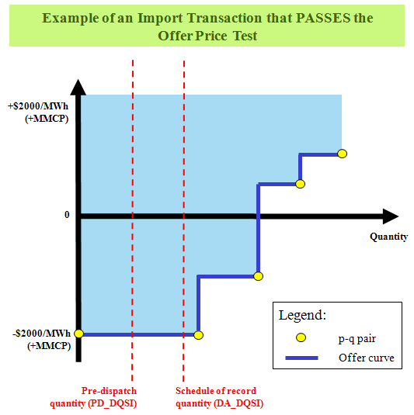
Figure 3-1: Example of an Import Transaction that PASSES the “Offer Price Test”
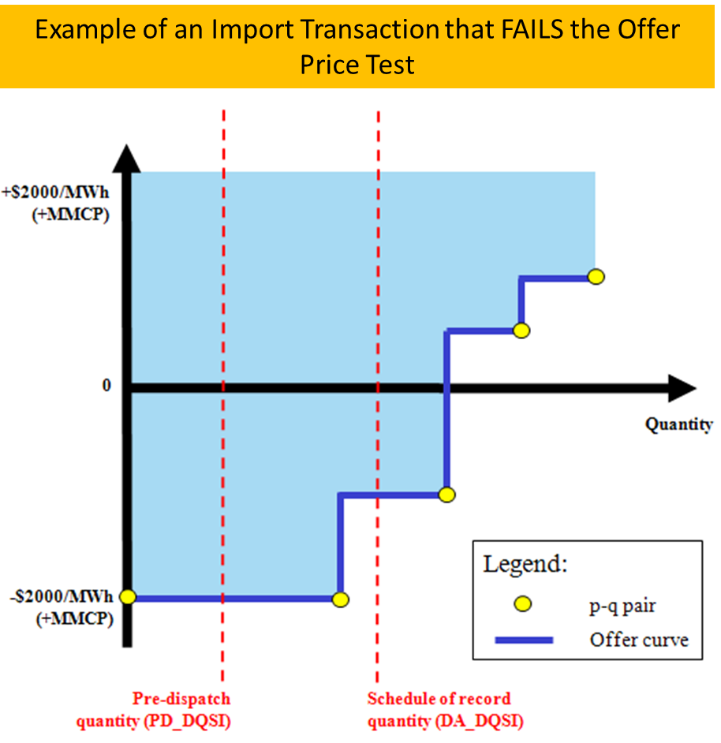
Figure 3-2: Example of an Import Transaction that FAILS the “Offer Price Test”

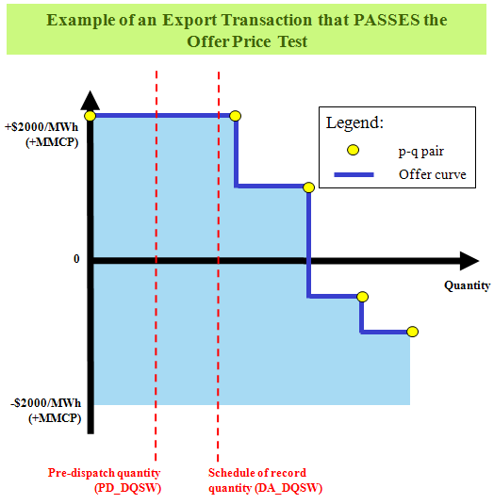
Figure 3-3: Example of an Export Transaction that PASSES the “Offer Price Test”
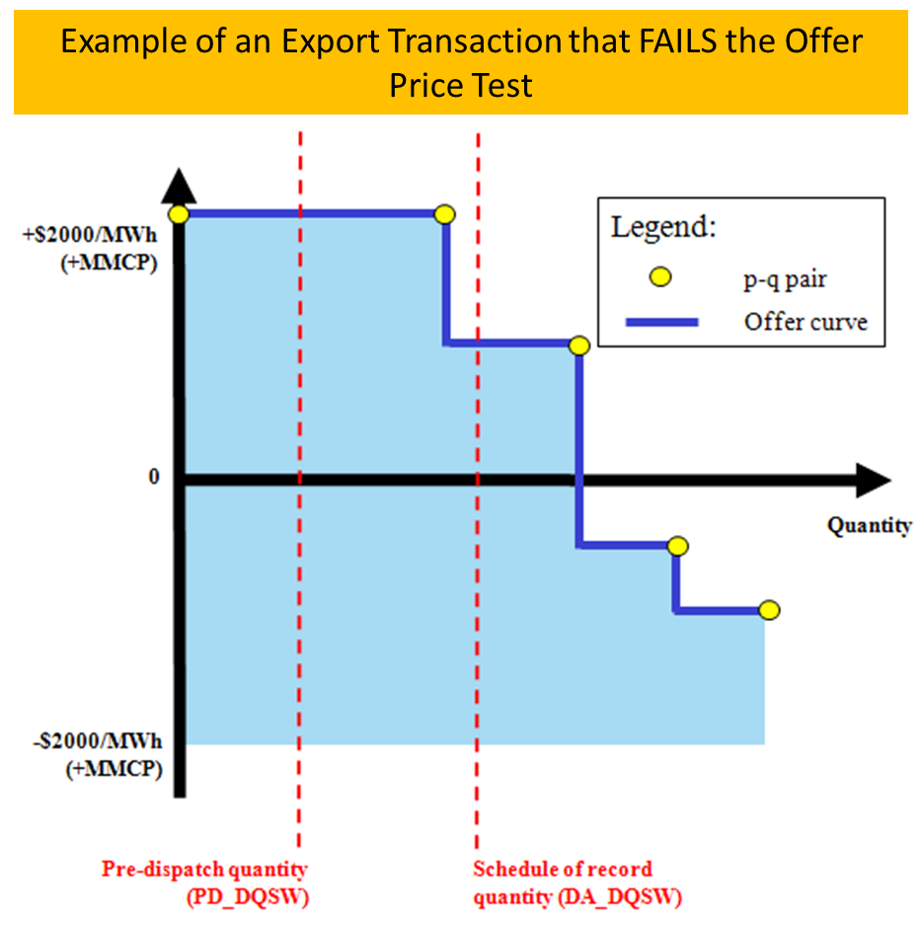
Figure 3-4: Example of an Export Transaction that PASSES the “Offer Price Test”

References
Document Name | Doc ID
Market Rules for the Ontario Electricity Market | RUL-6 to RUL-24
Market Manual 1: Connecting to Ontario’s Power System, Part 1.5: Market Registration Procedures | MAN-108
Market Manual 5: Settlements, Part 5.10: Settlement Disagreements | MAN-120
Format Specifications for Settlement Statement Files and Data Files | IMP_SPEC_0005
Ontario Energy Board Act, 1998
Regulation 436/02
Regulation 330/09
Regulation 98/05
Regulation 314/15
Regulation 442/01
Electricity Act, 1998
Regulation 429/04
Regulation 493/01
Regulation 494/01
Ontario Rebate for Electricity Consumers Act, 2016
Regulation 363/16
Regulation 364/16
Electricity Restructuring Act, 2004
Bill 4, Ontario Energy Board Amendment Act (Electricity pricing), 2003 | Bill 4

– End of Document –

Refer to MM 1.5 https://www.ieso.ca/-/media/Files/IESO/Document-Library/engage/imrm/MM-1-5-market-registration-procedures-20220909.ashxfor adding and updating contact roles with the IESO.
This column discloses the accuracy of a settlement variable appearing on a settlement statement. NOTE: This should not be confused with the number of decimal places allowable in some columns on the settlement statements and data files as set out in Format Specifications for Settlement Statements and Data Files.
Market Rules ref.: Section 3.6.2 of Chapter 9.
The price test for the Day-Ahead Linked Wheel Failure Charge (1134) is used to determine exemption from the RT-EFC-DALW and RT-IFC-DALW portions only.
Specifically, the Real-time Import Failure Charge (charge type 135), the Real-time Export Failure Charge (charge type 136), the Day-Ahead Import Failure Charge (charge type 1135), the Day-Ahead Export Failure Charge (charge type 1136) and the Day-Ahead Linked Wheel Failure Charge (charge type 1134).

