Technical Requirements for Large Computational Loads Connecting to the Ontario Power System

Version 2.0

Connection Assessments Department, IESO

Table of Contents
1. Purpose 3
2. Applicability 3
3. Interconnection Process 4
4. Applicable Reliability Standards 4
5. Project Data Requirement 4
6. Interconnection Requirements for Large Computational Loads 6
6.1 Connection Arrangement 6
6.2 Power Factor/Reactive Power Capability 6
6.3 Damping 6
6.4 Periodic Oscillation 7
6.5 Load Fluctuation 7
6.6 Load Ramping 7
6.7 Ride-through Capabilities 8
6.7.1 Voltage Ride-through 8
6.7.2 Frequency Ride-through 10
6.7.3 Rate of Change of Frequency (RoCoF) Ride-Through 11
6.7.4 Voltage Phase Angle Jump Ride-Through 11
6.7.5 Volts per Hz (V/Hz) Ride-Through 12
6.7.6 Summary of Disturbances Allowing UPS Supply and Concurrent Disturbances 12
6.8 Automatic Under-Frequency Load Shedding (UFLS) 12
6.9 Phasor Measurement 13
6.10 Dynamic Disturbance Recording 14
6.11 Voltage Levels 14
6.12 Short Circuit Levels 14
6.13 Protection Systems 14
6.14 Telemetry 15
6.15 Metering 15
6.16 Commissioning Tests and Performance Validation 16
6.17 Failure to Meet IESO’s Requirements 16
6.18 Specific Interconnection Requirements 16
Appendix A – Detailed System Assessments 17
A.1 Thermal Assessment 17
A.2 Steady-State Voltage Assessment 17
A.3 Stability Assessment 18
A.4 Interface/Interties 18
A.5 Relay Margin 19
A.6 Small-Signal Stability Assessment 19
A.7 Load Fluctuation Assessment 19
A.8 EMT Studies 20
A.9 Global Resource Adequacy Assessment 20

Purpose
This document has been developed to set out the complete technical requirements for connecting large computational loads (LCL) to the Ontario power system. It includes both the existing technical requirements for general load facilities and newly developed technical requirements that aim to address potential adverse impacts on system reliability caused by the specific load behaviors of LCLs.
Computational load refers to loads attributable to information technology computing equipment, including servers, data storage systems, and networking hardware. Such loads are commonly associated with data centres, AI compute clusters, and cryptocurrency mining operations, among other facilities.
Specific load behaviours of LCLs leading to the new requirements in this document include:
- Large load size within one project.
- Electronic-interfaced load characteristics.
- High percentage of voltage-sensitive IT load that needs to switch to Uninterruptible Power Supply (UPS) when system voltage drops below certain levels and switch to backup generation upon the loss of system supply.
- Extremely fast load ramping rate.
- Potential injection of periodic load oscillations.
- Potential frequent and high load fluctuations.
- Potential sudden load reconnection/restoration.

Applicability
This document is applicable to all LCLs whose final System Impact Assessment (SIA) report and Notification of Conditional Approval (NoCA) issued after June 30th, 2026, including:
- LCLs rated higher than 10 MW that are directly connected to the Ontario transmission system and,
- LCLs rated higher than 10 MW connected to a distribution system.

Interconnection Process
According to Market Rules for the Ontario Electricity Market, the IESO needs to complete a System Impact Assessment (SIA) for a new or modified facility to the IESO-controlled grid to ensure the reliability of the integrated power system is not compromised by the new or modified facility.

The IESO has adopted a flexible interconnection process to reflect the level of project information available at different project stages. During the early stage, when detailed project design is not yet available, the IESO conducts steady-state studies only and issues a comfort letter along with a draft report indicating the available capacity for the project.
Based on this comfort letter, the connection applicant is able to proceed with procurement activities and vendor selection. Once specific vendors are selected, the connection applicant shall provide detailed project design including vendor-specific models. The IESO will then complete the remaining SIA studies and issue a Notice of Conditional Approval for the project.
The IESO will continue to refine the interconnection process to make sure that our process is aligned with the project development of most LCL projects while ensure that our system reliability is maintained.

Applicable Reliability Standards
The project shall satisfy all applicable requirements specified in the Market Rules, the Transmission System Code, Distribution System Code, and reliability standards as listed below:
- Market Rules for the Ontario Electricity Market, specifically Appendix 4.3 – Requirements for Connected Wholesale Customers and Distributors Connected to the ICG
- Ontario’s Transmission System Code (“TSC”)
- Ontario’s Distribution System Code (“DSC”)
- North American Electric Reliability Corporation (“NERC”) TPL-001 “Transmission System Planning Performance Requirements” (“TPL-001”)
- Northeast Power Coordinating Council (“NPCC”) Regional Reliability Reference Directory #1 “Design and Operation of the Bulk Power System” (“Directory #1”)
- Ontario Resource and Transmission Assessment Criteria (“ORTAC”)
New requirements proposed in this document will be updated into the Market Rules or relevant standards after the IESO external stakeholdering over these requirements is completed.

Project Data Requirement
To ensure accurate representation of the project during the SIA process, the connection applicant shall provide the following project data for the IESO interconnection studies as a minimum:
- Project development plan including ramping schedule by year and ultimate load level
- Single Line Diagram (SLD) (including medium voltage and low voltage details down to IT loads)
- All primary-voltage equipment data
- Type of LCLs: cloud computing, AI training, AI inference, crypto etc.
- Hardware class: GPU clusters, application-specific integrated circuit (ASIC), CPU-dominant, liquid- vs. air-cooled
- Load composition: load behind UPS and other cooling and heating load, small and large motors
- Type of UPS system deployed and the duration the UPS can support the connected load
- Type of backup generation and the duration it can support partial or full project’s load
- Normal and maximum load ramp-up and ramp-down rates (MW/min)
- Post-disturbance active power restoration time (seconds) from UPS supply to system supply for UPS loads to ride-through a voltage disturbance
- Protection Description Document
- Typical hourly load profile (winter and summer)
- Load fluctuation patterns with 1-minute granularity or 1-second granularity if applicable
- Periodic power oscillations if applicable
- Voltage and frequency operating ranges
- Control Schemes Description including
- voltage/time and frequency/time settings for switching the load to UPS supply,
- voltage/time and frequency/time settings for switching the load back from UPS supply,
- voltage/time and frequency/time settings for switching the load to backup generation
- Operating Philosophy Document including configurations under normal and outage conditions, startup/shutdown sequence, transfer logic and procedure for transferring between the system supply and backup power supplies
- EMT model(s) as per IESO requirements for EMT models
- PERC and generic composite model (preferred) or UDM and generic composite model for PSS/E and DSA tools
- NERC data questionnaire for LCLs
- Restoration Participant Attachment, if applicable
When detailed project design is not yet available, the IESO will conduct steady-state studies only and issue a comfort letter along with a draft report indicating the available capacity for the project.

Interconnection Requirements for Large Computational Loads
The IESO has established the following interconnection technical requirements, which address specific load behaviors of LCLs, to connect these projects while maintaining the reliability of the integrated power system.
Note that it is understood that LCLs may have adverse impacts on power quality, however, power quality performance is within the transmitter’s accountability in the Ontario power system. Thus, this document does not include power quality requirements.

Connection Arrangement
Based on the Market Rules, the connection arrangement of the project shall be agreed by the transmitter to meet the Transmission System Code. In addition, the project’s connection arrangement shall be designed to meet the following requirements:
- No internal single point failure within the project results in a load loss above 600 MW or a different value that has been assessed and confirmed by the IESO as having no material adverse impact on the operation of the IESO-controlled grid.
- For a project having multiple Points of Interconnection (POIs), automatic load transfer between different POIs is not acceptable. This requirement does not apply to automatic load transfer from the system supply to backup generation supply when one system supply is lost by configuration.
Additional requirements may be identified during the detailed system assessments for the project as detailed in Appendix A.

Power Factor/Reactive Power Capability
In accordance with Appendix 4.3 of the Market Rules, the connection applicant shall ensure the project has the capability to maintain the power factor within the range of 0.9 lagging and 0.9 leading as measured at the defined meter point of the project.
A requirement to install additional reactive compensation, either static or dynamic, may be identified based the detailed system studies as per Sections A.2 and A.3.

Damping
The connection applicant shall ensure the project does not introduce any net negative damping to system oscillations within the sub-synchronous frequency range.

Periodic Oscillation
The connection applicant shall ensure the power consumption at the Point of Interconnection (POI) of the project has no periodic power oscillation within the sub-synchronous frequency band exceeding the lesser of +/-2.5 MW or +/-0.25 % of the nominal power of the project unless the connection applicant provides the specific load profile which will be assessed by the IESO. This is to avoid Sub-Synchronous Torsional/Control Interactions (SSTI/SSCI) or other oscillation phenomenon caused by the project.
The oscillation magnitude shall be measured using 1-second Fast Fourier Transform (FFT) window and being averaged over a 10-second rolling window for oscillation frequency equal to or more than 5 Hz, and using a 10-second FFT window and averaged over a 60-second rolling window for oscillation frequency lower than 5 Hz.
The connection applicant shall ensure monitoring equipment can continuously measure high resolution real-time data for analyzing periodic oscillations within the entire sub-synchronous frequency range. The IESO will require the information from the monitoring equipment at its discretion.

Load Fluctuation
The connection applicant shall ensure that the load fluctuation frequency at the project does not exceed the limit specified in Ref 5, Appendix 2 of Transmission System Code, based on the voltage fluctuation magnitude caused by the project.
During the SIA process, if the connection applicant provides information about load fluctuation patterns, the IESO will assess whether the described load fluctuations are acceptable or not as per Section A.7.
The SIA will assume no load fluctuations if the connection applicant has not indicated this information. In the event there are changes at a later stage, the connection applicant shall provide updates to the IESO as soon as the information becomes available, so the IESO can assess this information in a timely manner and avoid any delay to issuing the final approval for the project.

Load Ramping
The connection applicant shall ensure that the project has the capability to operate with ramp rates not exceeding 20 MW per minute (maximum 5 MW over any 15-second period) during normal operation. This maximum ramp rate applies for both ramping up and ramping down active power consumption, unless a different ramp rate has been specified by the IESO.
For a group of projects in Ontario power system whose load ramping are synchronized with each other, the IESO may specify a lower ramp rate for these projects or require staggering load ramping at these projects.
These ramp rate limitations are not intended to restrict the project's response rate during other system events, including but not limited to load reduction programs, frequency excursions, voltage changes, switching loads to and from UPS supply during and after a system disturbance, or Remedial Action Scheme (RAS) runbacks, unless explicitly stated as part of such programs. The IESO reserves the right to require further adjustments to facility ramp rates in accordance with evolving power system operating conditions.

Ride-through Capabilities
In accordance with Appendix 4.3 of the Market Rules, the connection applicant shall ensure the project has the capability to ride-through routine switching events and design criteria contingencies on the transmission system assuming standard fault detection, auxiliary relaying, communication, and rated breaker interrupting times, unless disconnection by configuration or a lower-level ride-through capability has been approved by the IESO.

Voltage Ride-through
The voltage ride-through consists of two parts. The first part is to ensure the project remains connected to the system during and after a system disturbance, unless the disturbance trips the project by configuration. The second part specifies what facility performance is acceptable during system disturbance to respect the special behaviors of LCLs.
- The connection applicant shall ensure that the project has the capability to ride-through voltage disturbances of the magnitude and duration specified in Table 1 and Figure 1 at the POI.
The project shall have the capability to ride-through two consecutive voltage disturbances in Table 1 occurring within a 30 s interval. This is to ensure the project will not be tripped following an unsuccessful auto-reclose attempt to a close-by faulted circuit which does not trip the project by configuration.

Table 1 | Voltage Ride-Through Capability Requirement
System Voltage | Minimum Ride-Through Time (sec)
> 1.2 V_{max} | May trip
≤ 1.2 V_{max} and > 1.05V_{max} | 2
≤ 1.05V_{max} and > V_{max} | 1800
≤ V_{max} and ≥ V_{min} | Continuous
< V_{min} and ≥ 0.8 V_{nom} | 2
< 0.8 V_{nom} and ≥ 0.5 V_{nom} | 0.5
< 0.5 V_{nom} and ≥ 0.2 V_{nom} | 0.25
< 0.2 V_{nom} | 0.16
Notes: (i) Vmax and Vmin are post-continency maximum and minimum system voltages, respectively, specified in Section 2.4.3 of ORTAC. (ii) Vnom is nominal RMS voltage, which is 500 kV, 230 kV, 115 kV for voltage levels 500 kV, 230 kV and 115 kV, respectively.
Figure 1 | Voltage Ride-Through Requirement
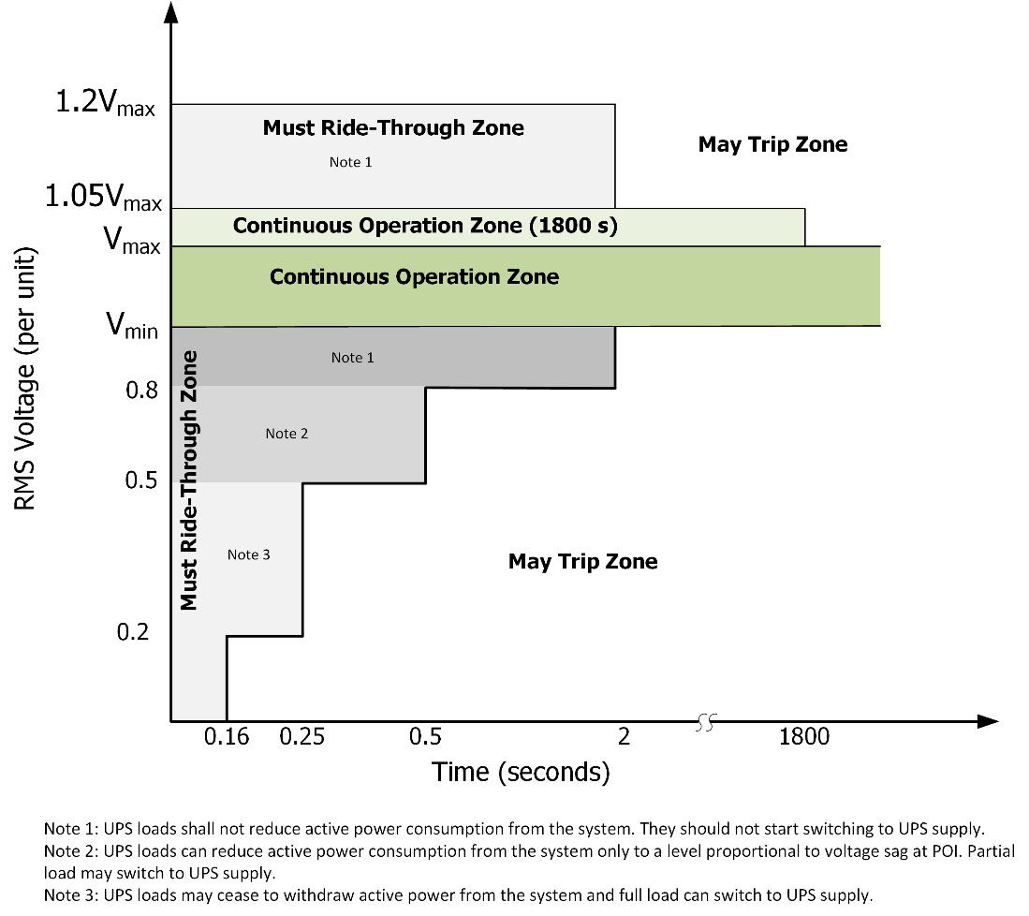
- During a system disturbance causing voltage depression, the UPS loads are allowed to switch to UPS supply and thus reduce its active power withdrawal from the system. The reduction of its active power withdrawal from the system shall be limited to an amount that is proportional to voltage sag when the POI voltage goes between 0.5 and 0.8 pu. The UPS loads may cease to withdraw power from the system when the POI voltage goes below 0.5 pu.
The UPS loads are not allowed to switch to UPS supply for voltage rise at the POI during the ride-through period.
If the whole or partial UPS loads at the project are switched to the UPS supply during voltage depression, after the system disturbance is cleared and the POI voltage recovers within the ORTAC post-contingency voltage range, the UPS loads shall restore its active power withdrawal from the system to the level that exists prior to the system disturbance within a restoration time that is set to 1 second by default and configurable by the IESO based on system assessments.
The load ramp rate limitations specified in Section 6.6 for normal operation shall not be applied to restrict the project's response rate when restoring active power to the UPS loads. However, other ramp rate limitations required for equipment protection may be implemented provided that the required restoration time is achieved.
- The non-UPS loads at the project shall remain connected to the system during and after the system disturbance. Due consideration will be given to inherent limitations of small motors for cooling and mechanical loads which are allowed to be tripped when POI voltage goes below 0.35 pu. Tripping these small motors shall not restrict the operation or delay the restoration of other IT loads after the system disturbance.
- During and following the system disturbance, the project, both UPS and non-UPS loads, shall not be switched to the off-grid backup generation supply unless the disturbance trips the project by configuration.
If the project has been switched to the backup generation supply, it shall not be reconnected automatically without the IESO’s approval. The load ramp rate limitations specified in Section 6.6 shall be complied with when restoring active power during reconnection.

Frequency Ride-through
The connection applicant shall ensure that the project has the capability to ride-through frequency disturbance of the magnitude and duration specified in Table 2 and Figure 2. During the frequency disturbance, the project shall maintain its active power consumption at the level prior to the disturbance. Switching to UPS supply is not allowed during the ride-through period.
Table 2 | Frequency Ride-Through Capability Requirement
System Frequency (Hz) | Minimum Ride-Through Time (sec)
> 61.8 | May trip
>61.2 | 299
≤ 61.2 and ≥ 58.8 | Continuous
<58.8 | 10
<57 | 0

Figure 2 | Frequency Ride-Through Requirement
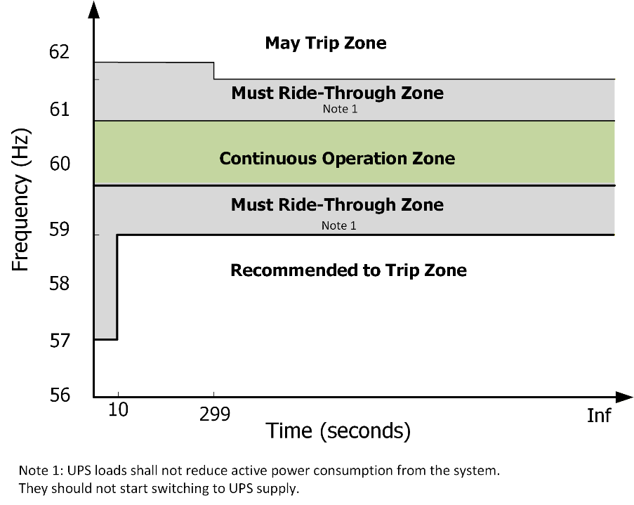
The over-frequency settings in Table 2 are derived from NERC Standard PRC-029-1 for Inverter-Based Resources (IBRs) on frequency ride-through capability. The under-frequency settings are adopted to coordinate the UFLS scheme for the Ontario power system. It is recommended the project be set to trip all loads when system frequency drops below 58.8 Hz for 10 seconds and trip instantaneously when frequency drops below 57 Hz.
Frequency measurements shall be taken at the high side of main power transformer(s) of the project over a period (typically 3-6 cycles). Instantaneous or single points of measurement shall not be used in the determination of frequency.
It is understood that load tripping would be beneficial for system performance for under-frequency system conditions. However, system under-frequency issue could be addressed by automatic UFLS program detailed in Section 6.8, which provides an orderly and controlled load tripping to restore system frequency. This requirement is to avoid uncontrolled load tripping to large amount of LCLs.

Rate of Change of Frequency (RoCoF) Ride-Through
Within the frequency ride-through range per Table 2, the connection applicant shall ensure the project has the capability to ride-through frequency excursions having an absolute RoCoF magnitude that is less than or equal to 5.0 Hz/s. The project shall maintain pre-disturbance active power consumption during the ride-through period. Switching to UPS supply is not allowed during the ride-through period.
RoCoF shall be calculated as the average RoCoF over a rolling 0.5 second averaging window.

Voltage Phase Angle Jump Ride-Through
The connection applicant shall ensure the project has the capability to ride-through positive-sequence phase angle jump initiated by no-fault switching events within a sub-cycle time frame of the POI voltage of less than or equal to 25 electrical degrees.
The project shall maintain pre-disturbance active power consumption during the voltage phase angle jump ride-through period. Switching to UPS supply is not allowed during the ride-through period.

Volts per Hz (V/Hz) Ride-Through
The connection applicant shall ensure the project has the capability to meet both voltage and frequency ride-through requirements in Sections 6.7.1 and 6.7.2 simultaneously except grid disturbances with V/Hz, measured at the POI, exceeding 1.1 per unit for 45 seconds or 1.18 per unit for 2 seconds.
The project shall maintain pre-disturbance active power consumption during the volts per Hz ride-through period. Switching to UPS supply is not allowed during the ride-through period.

Summary of Disturbances Allowing UPS Supply
Table 3 summarizes the above disturbances when switching to UPS supply is allowed during ride-through period. For an event consisting of concurrent disturbances, switching to UPS supply is allowed only when the voltage depression is one of the disturbances in the event.
Table 3: Summary of Disturbances Allowing Switching to UPS Supply
Disturbance |  | Switching to UPS Supply During Ride-through Period
Voltage disturbance | Voltage depression | Allowed
Voltage disturbance | Voltage rise | Not Allowed
Frequency deviation |  | Not Allowed
ROCOF disturbance |  | Not Allowed
Voltage Phase Angle Jump |  | Not Allowed
V/Hz disturbance |  | Not Allowed

Automatic Under-Frequency Load Shedding (UFLS)
This is a general requirement applicable to all load facilities, with minor modifications for LCLs. This requirement shall not be deemed as a contrary performance requirement to the frequency ride-through set by Section 6.7.2. Complying with both sets of requirements is to ensure the loads in the system are orderly tripped when the system frequency drops.
According to Section 10.4.6 of Chapter 5 of the Market Rules and Section 11.3 of the Market Manual 7.1, the connection applicant is required to participate in the UFLS program if it has a total peak load greater than 25 MW at all its owned facilities. The connection applicant must select 35% of total peak load among its owned facilities for under-frequency tripping, based on a date and time specified by the IESO that approximates system peak. However, the connection applicant shall provide the provision and capability to select all UPS-supplied loads in the project for under-frequency tripping, potentially at different tripping thresholds than the current UFLS settings, which may be required by the IESO in the future as the system evolves.
To comply with the short tripping time in the UFLS program, the IT load can be switched to UPS supply firstly, then switched to backup generation supply. They shall not be reconnected back to the system automatically without the IESO’s approval.
Table 3 summarizes UFLS relay settings as a function of the total peak load of all facilities owned by the connection applicant.
Table 4 | UFLS Relay Settings
Aggregate  Summer Peak  Load | UFLS  Stage | Frequency  Threshold  (Hz) | Total Nominal  Operating  Time (s) | Load Shed at stage as % of Connection Applicant’s Load | Cumulative Load Shed at stage as % of Connection Applicant’s Load
25 MW or more and less than 50 MW | 1 | 59.5 | 0.3 | ≥ 35 | ≥ 35
50 MW or more and less than 100 MW | 1 | 59.5 | 0.3 | ≥ 17 | ≥ 17
50 MW or more and less than 100 MW | 2 | 59.1 | 0.3 | ≥ 18 | ≥ 35
100 MW or greater | 1 | 59.5 | 0.3 | 7 – 9 | 7 – 9
100 MW or greater | 2 | 59.3 | 0.3 | 7 – 9 | 15 – 17
100 MW or greater | 3 | 59.1 | 0.3 | 7 – 9 | 23 – 25
100 MW or greater | 4 | 58.9 | 0.3 | 7 - 9 | 32 - 34
100 MW or greater | Anti-Stall | 59.5 | 10.0 | 3 – 4 | 35 - 37

The connection applicant, in conjunction with the transmitter, must also ensure that capacitor banks connected to the same station bus as the load are shed by UFLS facilities at 59.5 Hz with a time delay of 3 seconds.
The maximum load that can be connected to any single UFLS relay is 150 MW to ensure that the inadvertent operation of a single under-frequency relay during the transient period following a system disturbance does not lead to further system instability.

Phasor Measurement
The requirement is applicable for the transmission connected project whose MVA rating is equal or greater than 20 MVA. The IESO is in the process of revising the Market Rules Appendices 4.17 and 4.18 to require provision of synchrophasor data for large load facilities.
The connection applicant is required to install permanent equipment and infrastructure required for phasor measurement and to provide synchrophasor data that comply with Market Manual 1.7.

Dynamic Disturbance Recording
The requirement is applicable for the transmission connected project whose MVA rating is equal or greater than 20 MVA. The IESO is in the process of revising Market Manual 1.6 to require provision of dynamic disturbance recording for large load facilities.
The connection applicant is required to install a permanent device for dynamic disturbance recording that meets the technical specifications provided in Section 2.7 of Market Manual 1.6. The quantities to be recorded and the trigger settings will be provided by the IESO during the Market Registration process.

Voltage Levels
This is a general requirement for all load facilities and nothing specific for LCLs.
The project’s equipment shall meet the voltage requirements specified in Section 2.4.2 and Section 2.4.3 of the ORTAC.

Short Circuit Levels
This is a general requirement for all load facilities and nothing specific for LCLs.
According to Section 6.1.2 of the TSC, the project’s transmission connection equipment shall be designed to withstand the fault levels in the area. According to Section 6.4.4 of the TSC, if any future system changes result in an increased fault level higher than the project’s equipment capability, the connection applicant is required to replace that equipment with higher rated equipment capable of withstanding the increased fault level, up to the maximum fault level specified in Appendix 2 of the TSC.
It is the connection applicant’s responsibility to verify that all equipment and circuit breakers within the project are appropriately sized for the local fault levels.
The connection applicant shall ensure that the circuit breakers/switchers installed at the project have rated interrupting time that satisfies Appendix 2 of the TSC. Fault interrupting devices installed at the project must be able to interrupt fault currents at the applicable maximum continuous voltage as specified in Section 2.4.2 and Section 2.4.3 of ORTAC.

Protection Systems
This is a general requirement for all load facilities and nothing specific for LCLs.
The connection applicant shall ensure that the protection systems are designed to satisfy all the requirements of the TSC. New protection systems must be coordinated with existing protection systems. Protection systems within the project shall only trip the appropriate equipment isolating the fault.
Associated overvoltage protective relaying must be set to ensure that the project’s equipment does not automatically trip for voltages up to 5% above the equipment’s corresponding maximum continuous voltage as specified in section 4.2 of the ORTAC.
BPS elements are deemed by the IESO to be essential to system reliability and security and must be protected by redundant protection systems in accordance with Section 8.2 of the TSC. These redundant protection systems must satisfy all requirements of the TSC, and in particular, they must be physically separated and not use common components, common battery banks, or common instrument transformer secondary windings.
The protection systems for transmission voltage BES elements (whose rated voltage is higher than 100 kV) must be redundant. Redundancy must be present in protective relaying for normal fault clearing and control circuitry associated with protective functions including trip coils of the circuit breakers or other interrupting devices. These redundant protection systems must not use common instrument transformer secondary windings. A single communication system, if used, must be monitored and reported and a single DC supply, if used, must be monitored and reported for both low voltage and open circuit.
As the electrical system evolves, transmission voltage non-BPS or non-BES elements (whose rated voltage is higher than 100 kV) within the project, may be re-classified as BPS elements or BES elements. The connection applicant is recommended to design the protection systems for these elements according to the protection requirements for BPS elements or have adequate provisions for future upgrade to meet those requirements.

Telemetry
This is a general requirement for all load facilities and nothing specific for LCLs.
According to Section 7.5 of Chapter 4 of the Market Rules, the connection applicant shall provide to the IESO the applicable telemetry data listed in Appendix 4.17 of the Market Rules on a continual basis for transmission connected projects, or in Appendix 4.18 of the Market Rules for distribution connected projects. The data shall be provided in accordance with the performance standards set forth in Appendix 4.22, subject to Section 7.6A of Chapter 4 of the Market Rules. The IESO may require additional telemetry quantities if applicable.
The connection applicant must install monitoring equipment that meets the requirements set forth in Appendix 2.2 of Chapter 2 of the Market Rules.

Metering
This is a general requirement for all load facilities and nothing specific for LCLs.
The connection applicant shall ensure the wholesale metering installations comply with (i) the Ontario Market Rules, e.g., Chapter 6 - Wholesale Metering, Chapter 6 - Appendices, Chapter 9 - Settlements and Billing, Chapter 9 - Appendices, Chapter 10-Transmssion Service and Planning, (ii) the applicable market manuals, e.g., Market Manual 3 Series: Metering, and (iii) IESO wholesale metering hardware standards and policies. The connection applicant is encouraged to seek advice from a metering service provider (MSP) or from the IESO in early stages of the project design.

Commissioning Tests and Performance Validation
The connection applicant is required to provide “as-built” equipment data for the project during the IESO Market Registration process. Models and data, including any controls that would be operational, must be provided to the IESO. The connection applicant shall submit generic composite load model and User Defined Models (UDMs) for both PSS/E (Version 36 or later) and DSA (Version 22 or later).
The connection applicant shall also submit a final PSCAD model as well as a study report that benchmarks the generic composite load model and UDM against the EMT model to ensure that the model performance is consistent across different simulation platforms.
The connection applicant must provide evidence to the IESO confirming that the project’s equipment installed meets the Market Rules requirements and matches or exceeds the performance predicted in the SIA assessments. This evidence shall be either type tests done in a controlled environment or commissioning tests done on-site. In either case, the testing must be done not only in accordance with widely recognized standards, but also to the satisfaction of the IESO.

Failure to Meet IESO’s Requirements
The connection applicant will be required to take corrective actions that could include upgrades to the project, if the project is not able to meet the IESO’s requirements specified in the SIA report, and/or the performance of their facilities becomes inadequate or causes any adverse impact on the IESO-controlled grid after the project is in-service. If upgrades are needed, the IESO may direct the transmitter or the distributor to disconnect the project until such upgrades are deployed, to the satisfaction of the IESO. Automatic reconnection of the facilities to the system is not allowed.

Specific Interconnection Requirements
During the SIA process, the IESO will perform the system assessments as detailed in Appendix A to identify any adverse impact of the project on system reliability and if applicable, develop specific interconnection requirements that address the impact to connect the project such as:
- Reactive power compensation,
- Operation restrictions,
- Remedial Action Schemes (RAS),
- Upgrading of equipment, and
- System reinforcements.

Appendix A – Detailed System Assessments
The IESO performs the following detailed system assessments to identify any adverse impact of the project on system reliability and if applicable, develop specific interconnection requirements that address the impact to connect the project.
- Thermal Assessment
Power flow analysis is performed to identify thermal violations caused by the project based on the maximum load of the project and the coincident worst-case system conditions.
If there are violations, the following one or multiple mitigation options will be investigated with the connection applicant and the transmitter:
- Transmission reinforcement: the connection applicant shall work with transmitter to upgrade the conductors of existing circuits or build new circuits to address the thermal violations.
- Remedial Action Scheme (RAS): This option is to reject some load at the project to address post-contingency thermal violations. If the RAS is to be classified as NPCC Type I RAS, it is generally applicable for outage conditions, not applicable for system conditions with all transmission elements in-service. The reliance upon a NPCC Type I RAS for conditions with all transmission elements in-service is reserved only for transition periods when new transmission reinforcements are being brought into service. A RAS classified as NPCC Type I RAS must be designed to satisfy all NPCC requirements for dependability and security.
The transmitter shall agree to build the RAS for the project.
- Voluntary Demand Management (VDM): The option is to curtail partial or whole load at the project as directed by the IESO under some system conditions. If the option is adopted, the connection applicant shall sign an VDM agreement with the IESO and have a detailed demand management plan acceptable to the IESO and the transmitter.
- Reduction to the size of the project: the connection applicant may reduce the size of the project below the remaining system capacity as per thermal constraints.
If the connection applicant still intends to connect the whole proposed size, the remaining load is to be connected after the transmission system is reinforced in the future according the IESO bulk system plan or Integrated Regional Resource Plan (IRRP).
- Steady-State Voltage Assessment
Power flow analysis is performed to identify violations in terms of voltage level and voltage change based on the maximum load of the project and the coincident worst-case conditions in terms of voltage performance. Power-Voltage (PV) analysis is used to identify steady-state voltage instability caused by the project.
If there are any voltage violations, reactive compensation will be required at the project. This is in addition to the power factor requirement for the project.
The reactive compensation needed is generally static capacitive and may need be arranged into several steps determined by further capacitor switching assessment. Each capacitor bank shall be sized to ensure that voltage declines or rises at delivery point buses on switching operations will not exceed 4% of steady state rms voltage before tap changer action.
If static reactive compensation causes pre-contingency over-voltages in the system, dynamic reactive compensation such as SVC or STATCOM shall be used to address post-contingency voltage issues. The SVC/STATCOM will be required to control the high-side voltage of the main transformers at the project with a droop to coordinate with other adjacent dynamic reactive resources. The IESO will provide both voltage and droop settings for this voltage control system. EMT model will be required for the SVC/STACOM.
- Stability Assessment
Time-domain simulations are performed to identify any following stability issues based on the maximum load at the project and coincident worse-case system conditions. The simulations shall adopt the UDM model for the project, and composite load models for load facilities in the existing system.
- Transient voltage stability
- Generator rotor angle stability
The project’s impact on transient voltage stability is expected for a project located in a load area. If there is any adverse impact, dynamic reactive compensation such as SVC or STATCOM will be required. The SVC/STATCOM will be required to control the high-side voltage of the main transformers at the project with a droop to coordinate with other adjacent dynamic reactive resources. The IESO will provide both voltage and droop settings for this voltage control system. EMT model will be required for the SVC/STACOM.
The project’s impact on generator rotor angle stability is expected for a project located in a generation area. The generation area is generally a perfect location for LCLs. However, switching to UPS supply during transients may have adverse effects on the rotor angle stability. If there are any unacceptable adverse impact, the voltage/time settings for switching to UPS supply shall be investigated. After the fault is cleared, the load shall be switched to the system supply as fast as possible. Further generation rejection may be employed if needed. When generation rejection is employed, the same amount of load at the project shall also be switched to its backup generation supply and not reconnected to the system without the IESO’s approval.
- Interface/Interties
As per the limiting phenomenon on the existing interfaces or interties, thermal assessments, voltage assessments, and stability assessments are also used to identify the impact of the project on the interface transfer limit and intertie limit.
According to Section 2.4.1 of ORTAC, the project shall not be permitted to lower power transfer capability or operating security limits by 5% or more.
Options are needed for the project if the transfer capability criterion is violated, including reducing the project size, changing the connection point, and/or transmission reinforcement.
- Relay Margin
Time-domain simulations are also used for relay margin assessments to examine the protection relay settings of a line distance protection to ensure that out-of-zone tripping does not occur because of the project, or modifications made by the transmitter to existing settings to incorporate the project. The situation is usually triggered due to the large size of the project tapped on circuits which result in higher power flow on the connected circuit(s) under certain post-contingency conditions;
According to the Market Rules for the line distance protection, following fault clearing, the margin on all instantaneous and timed distance relays at stations that are part of the BES and BPS must be at least 20% and 10% respectively.
Options are needed for the project if relay margin criterion is violated, such as reducing the project size, changing the connection point into a nearby station and/or installing a new switching station.
- Small-Signal Stability Assessment
As per Section 6.3 in this document, the connection applicant shall ensure the project does not introduce any net negative damping to system oscillations.
The SIA has yet performed small-signal stability assessment using detailed eigenvalue analysis. The damping factor will be measured from time domain simulations by assuming that the oscillations are exponentially damped sinusoids in a second order system. When the UDM model and EMT model are provided during the SIA process, the IESO will perform time-domain dynamic simulations to identify the damping of existing system oscillation introduced by the project.
- Load Fluctuation Assessment
If load fluctuation data of the project is provided during the SIA program, the IESO will perform the following assessments:
- Perform power flow analysis to identify if voltage fluctuations caused by the project will meet the TSC requirement or not.
- Identify the impact of the load fluctuation on interfaces from an operability perspective if applicable. Generally, when the load fluctuation causes the flow fluctuation on an interface, a real-time margin will be applicable on the interface limit, consequently, this will result in a reduction to the limit.
- Identify the impact of the load fluctuation on intertie from an equipment duty perspective if applicable. The load fluctuation may increase the duty of phase shifters on the interties to an unacceptable level.
- Assess impact on frequency regulation (AGC) to identify the cost for additional operating reserve to counteract the adverse impact of the load fluctuation on the system AGC performance.
Based on the overall adverse impact, a corrective action such as Grid Forming (GFM) batteries and E-STATCOMs may be required to mitigate the impact of the project’s load fluctuations.
- EMT Studies
The IESO will perform EMT studies during the SIA process for the following purposes:
- Check if EMT model is acceptable, meeting the IESO modelling requirements in terms of model details and internal settings.
- Verify voltage and frequency protection and control settings to ensure the project’s voltage and frequency ride-through capabilities meet the applicable requirements.
- Identify whether the project would interact with adjacent conventional generators, IBRs, and series capacitive compensation.
- Identify if the project would introduce any negative damping on sub-synchronous oscillations.
- Assess the effectiveness of corrective actions such as GFM batteries and E-STATCOMs in mitigating the impact of the project’s load fluctuations.
After the IESO has confirmed the EMT model is acceptable, the connection applicant shall use the accepted EMT model to benchmark UDM and composite model for the project and submit both models to the IESO.
- Global Resource Adequacy Assessment
During the SIA process, the load forecast at the project will be provided to the IESO Resource Adequacy group for assessment and future resource planning. Generally, it is not expected to have a specific SIA requirement for individual project from this assessment. Only for a project that is too large and results in global resource inadequacy, this assessment may conclude that the project size is required to be reduced, or the load forecast at the project needs to be adjusted to match the IESO resource development plan for the system. Alternatively, the connection applicant is required to agree to curtail all or part of their load when necessary to maintain system balance. This requirement will be reviewed annually as new resources are integrated into the system.

Independent Electricity
System Operator
1600-120 Adelaide Street West
Toronto, Ontario M5H 1T1
Phone: 905.403.6900
Toll-free: 1.888.448.7777
E-mail: customer.relations@ieso.ca
ieso.ca
 @OntarioIESO
linkedin.com/company/IESO

