GUIDE
Transmission Rights Auction System
Participant's Guide

Issue 10.1
This document provides a description of the functionality of the IESO’s Transmission Rights Auction (TRA) System which is available to those
market participants who have registered to be
TR participants.
IMO_GDE_0004
PUBLIC
Public
Disclaimer
The posting of documents on this Web site is done for the convenience of market participants and other interested visitors to the IESO Web site. Please be advised that, while the IESO attempts to have all posted documents conform to the original, changes can result from the original, including changes resulting from the programs used to format the documents for posting on the Web site as well as from the programs used by the viewer to download and read the documents. The IESO makes no representation or warranty, express or implied, that the documents on this Web site are exact reproductions of the original documents listed. In addition, the documents and information posted on this Web site are subject to change. The IESO may revise, withdraw or make final these materials at any time at its sole discretion without further notice. It is solely your responsibility to ensure that you are using up-to-date documents and information.
This market manual may contain a summary of a particular rule. Where provided, the summary has been used because of the length of the market rule itself. The reader should be aware, however, that where a market rule is applicable, the obligation that needs to be met is as stated in the market rules. To the extent of any discrepancy or inconsistency between the provisions of a particular market rule and the summary, the provision of the market rule shall govern.
Document ID IMO_GDE_0004
Document Name Transmission Rights Auction System: Participant’s Guide
Issue Issue 10.1
Reason for Issue Issue released in advance of Baseline 52.0
Effective Date June 25, 2024
Document Change History
Issue | Reason for Issue | Date
For changes prior to 2020, refer to versions 7.0 and previous.
8.0 | Updated hyperlinks and references to other documents | September 4, 2020
9.0 | Updated to meet accessibility requirements pursuant to the Accessibility for Ontarians with Disabilities Act. | December 16, 2020
10.0 | IESO portal replaced with IESO Gateway | September 15, 2021
10.1 | Update to reflect changes resulting from the Transmission Rights Auction Enhancement and Platform Refresh project | June 25, 2024

Related Documents
Document ID | Document Title
MDP_PRO_0029 | Market Manual 4.4 Transmission Rights Auction

Table of Contents
Table of Contents i
Table of Changes ii
1. Introduction 1
1.1 Purpose 1
1.2 Scope 1
1.3 Who Should Use This Document 1
1.4 Where Do I Start 1
1.5 What Are Transmission Rights 1
1.6 Conventions 2
2. TRA Application 3
2.1 Organizations and User Representation 3
2.2 Information Needed for TR Bids 4
2.3 How To Log On 4
2.4 How To View TR Auctions 6
2.4.1 Viewing Active TR Auctions 6
2.4.2 Viewing Future TR Auctions 8
2.4.3 Viewing Previous TR Auctions 9
2.5 How To Submit a New TR Bid 11
2.5.1 Placing a TR Bid 12
2.5.2 Submitting a TR Bid 14
2.6 How To Change an Existing TR Bid 14
2.7 How To Delete an Existing TR Bid 17
2.8 How To Access TR Auction Reports 19
2.8.1 Market Participant Reports 19
2.8.2 Public TR Auction Reports 20
References 23

Table of Changes
Reference (Section and Paragraph) | Description of Change
Throughout | Revised entire document to reflect changes resulting from the Transmission Rights Auction Enhancement and Platform Refresh project.

Introduction

Purpose
This document provides a description of the functionality of the IESO’s Transmission Rights (TR) Auction application (TRA application) that is available to those market participants who have registered to be TR bidders.

Scope
This document describes the Applications functionality of the IESO’s TRA application that is available to market participants through Online IESO.

Who Should Use This Document
Those market participants who intend to bid for TRs through participation in the TR auction process. Individuals must be assigned the Transmission Rights Auction Contact role by their market participant applicant representative.

Where Do I Start
Before you use this document or start using the TRA application (described in section 2), you should review the following documents:
- Market Manual 1.5: Market Registration Procedures
- Market Manual 4.4: Transmission Rights Auction
- Market Manual 5.5: Physical Markets Settlement Statement
- Market Manual 5.7: Financial Markets Settlement Statement
- IESO Gateway User Guide
- Quick Take Issue 15: Retrieving Reports via IESO Report Site
Before you can submit a TR bid, you must be an authorized TR participant and have an individual assigned to a Transmission Rights Auction Contact role by their market participant applicant representative.

What Are Transmission Rights
TRs are financial instruments that entitle the holder to a settlement amount based on locational differences in energy prices, determined in the manner described in Chapter 8, section 4.4 of the market rules (MR Ch.8 s.4.4).
Market participants who trade energy across intertie zones may use TRs to hedge against locational price differences. A TR bidder who receives TRs in the TR auction entitles the TR participant to become the TR holder, and is entitled to receive all settlement amounts associated with the TR.
The settlement of payments due from TR participants for purchases in the TR auction is addressed in Market Manual 5.7 (MM 5.7): Financial Markets Settlement Statement.
The settlement of payments due to a TR holder is addressed in MM 5.5: Physical Markets Settlement Statement.

Conventions
The standard conventions followed for market manuals are as follows:
- The word ‘shall’ denotes a mandatory requirement;
- Terms and acronyms used in this market manual including all Parts thereto that are italicized have the meanings ascribed thereto in Chapter 11 of the “Market Rules”;
- Double quotation marks are used to indicate titles of legislation, publications, forms, and other documents.
− End of Section −

TRA Application

The TRA application is web-based and is accessed through Online IESO via the IESO Gateway.
As a TR bidder, you will use the TRA application to perform TR bidding-related activities.
You can use the TRA application to:
- view a list and details of future TR auction rounds;
- place bids in any active TR auction round;
- view, change and delete any bids already submitted for any current TR auctions; and
- view TR bid history for TR auctions within the last two years.
Note: TR auction reports are available through the IESO Reports Site, which can be accessed through links on the TRA application or at IESO Reports Site.

Organizations and User Representation
A TR bidder (also called a user in regards to accessing and utilizing the TRA application) represents an organization when utilizing the TRA application. Each organization represented in the TR auction can have one or multiple users representing that organization. This means that multiple users can submit TR bids for the organizations they represent. Multiple users representing the same organization should coordinate their TR bids to ensure they are submitted as intended.
Organizations can have one accepted TR bid per path, which can be completed by any of the users.
All users representing an organization will be able to submit, edit, and delete TR bids as long as the TR auction is open for bidding, as well as being able to view organizational bidding limit information and bidding history within the last two years.
A user can toggle between organizations they represent by utilizing the drop down when accessing a TR auction page.
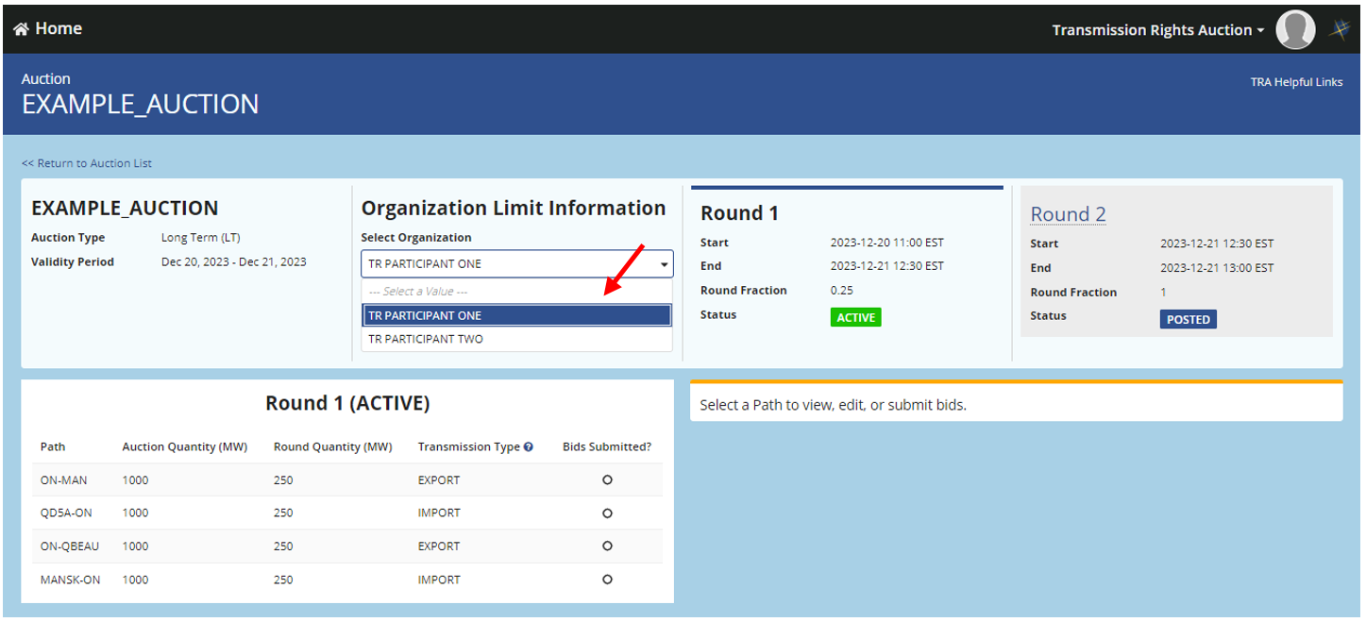

Information Needed for TR Bids
Your TR bid for the purchase of a TR in a TR auction must include:
- your organization name;
- the injection TR zone and the withdrawal TR zone for each TR that you are bidding on;
- the Time Structure (period of validity) of each TR that you are bidding on; and
- one and up to twenty TR laminations, where each TR lamination will express:
- the maximum number of TRs you are bidding on; and

- the maximum price, in Canadian dollars per megawatt ($/MW), that you are willing to pay for each TR that you are bidding on. This price must be a positive amount.
Some of these criteria are automatically applied to your TR bid.

How to Log On
To log into the TRA application you must log on to the IESO gateway. Please note that a TR bidder will be prompted to change the IESO Gateway password every 90 days, upon logging in. Once you’ve logged in, select the Online IESO tile to access the Online IESO website.

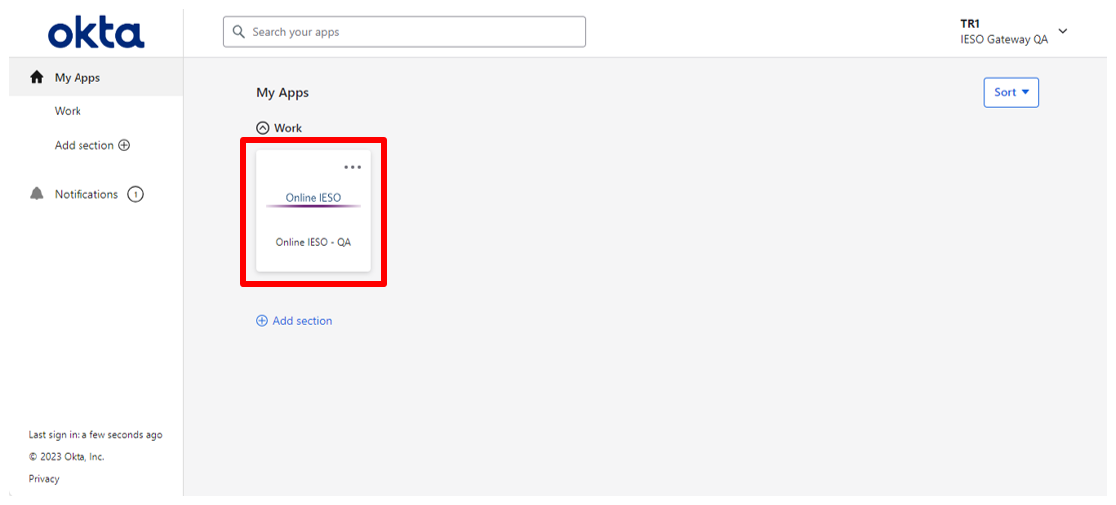
From here select the grid icon, first icon in the top right, and select Transmission Rights Auction.

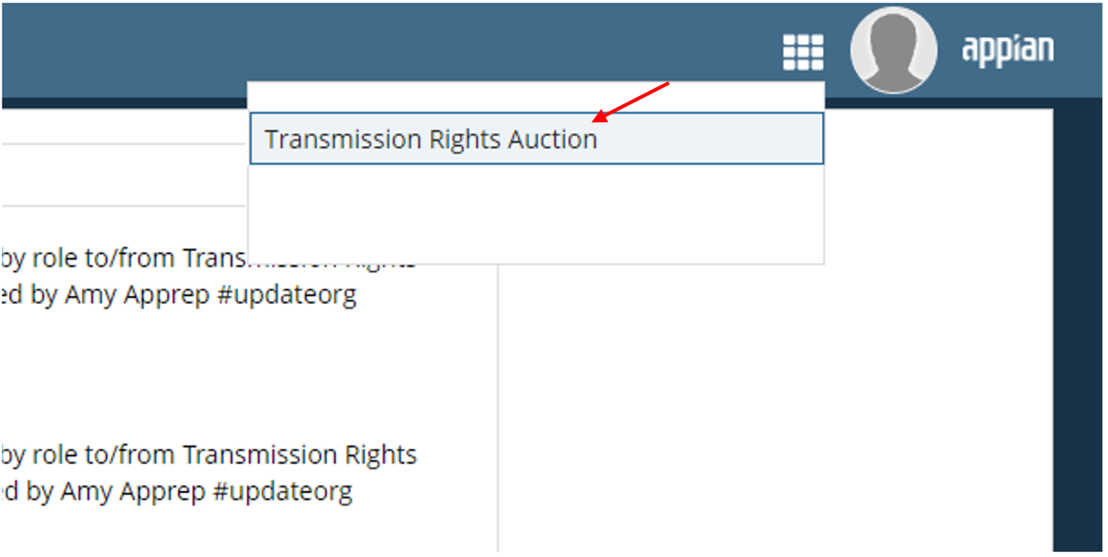

The Transmission Rights Auction Home Page will appear as below, with the header displaying a welcome message for the user. Some helpful links are provided on the right of the webpage header– ‘ISO TRA Calendar’, ‘Market Rules and Manuals Library’, ‘Public TRA Reports’, ‘Training Material’ and ‘Participant Confidential Reports’. The names of all TR auctions within the last two (2) years along with some details are listed.

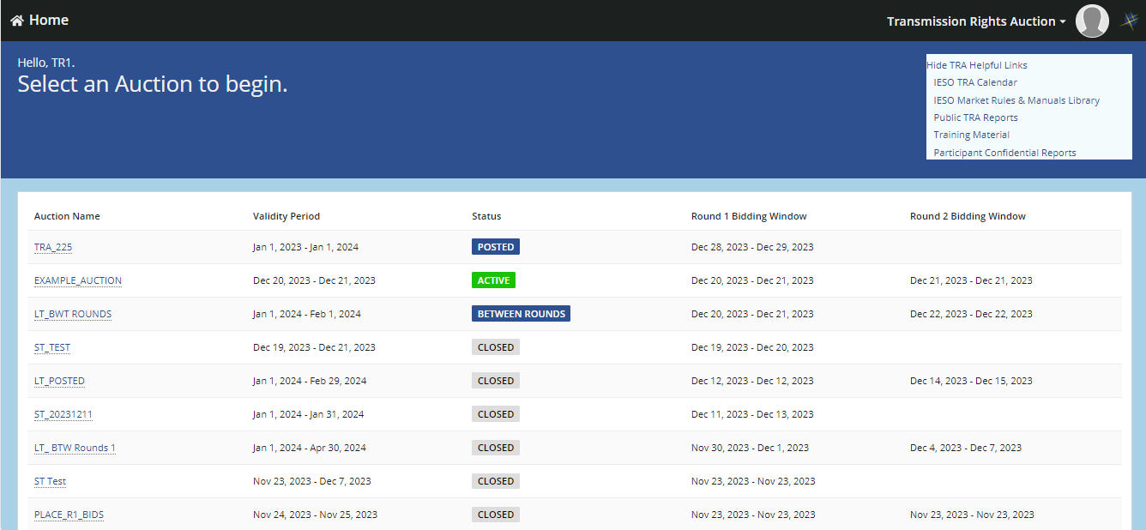
Screen images in this guide may be cropped to emphasize the key elements of the screen. Toolbars and elements of the browser normally will not be shown on the images unless it is required for the screen image.

How to View TR Auctions
When the IESO creates and validates a TR auction, it becomes available for viewing in the TRA application. Once a TR auction becomes active, a TR bidder can place a TR bid.
In order to access the TRA application, you must be a TR bidder. This requires your organization being authorised as an active TR participant and having an individual assigned to a Transmission Rights Auction Contact role by their market participant applicant representative. For more information, contact IESO Customer Relations at customer.relations@ieso.ca or telephone either 1-888-448-7777 or (905) 403-6900.
From the Transmission Rights Auction Home Page you will be able to click on either ‘ACTIVE’, ‘BETWEEN ROUNDS’, ‘POSTED’, or ‘CLOSED’ for TR auctions and will be forwarded to the appropriate TR auction page. This home page displays active TR auctions that you can place a TR bid on, future TR auctions to prepare to submit TR bids, and past TR auctions (within the last 2 years) to view TR bid history.

Viewing Active TR Auctions
TR auctions that are available for bidding, will have an ‘Active’ status.
On the Transmission Rights Auction Homepage, you can see the list of auction names, the validity period (start date to end date) and the bidding window for each round of auctions. Click the auction name that has status ‘ACTIVE’ to view information about this auction.
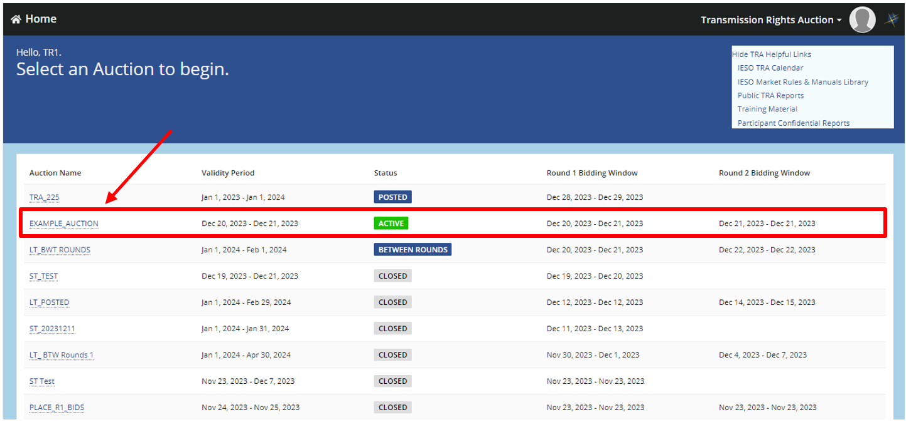
On the Auction page, the Auction Type and Validity Period is detailed. Auction Type can either be short-term (TRs have a validity of one month), or long-term (TRs have a validity of one year). The Validity Period is the period of time for which ownership of the TR and eligibility for payments for TR holders are available.
The round(s) in the auction are also detailed, providing the user with active round (pane is highlighted) as well as information pertaining to when each round’s start date and time, end date and time, round fraction and status (a round accepting bidding will display an Active status, a round that has yet to accept bidding will display a Posted status, an auction in between rounds not accepting bidding will display a Between Rounds status and a round that has been completed will have a Closed status).
A TRA application user can represent multiple organizations. To view the Organization Limit Information, you must select an organization from the drop down.
The Organizational Limit Information section includes the following:
- Bid Limit, which is the maximum dollar amount available to place a TR bid, based on your organization’s TR market deposit.
- Total Bids, which displays the amount that you have already spent on TR bids in the current TR auction.
- Remaining Amount, which shows the amount that you have left to place TR bids in the TR auction.
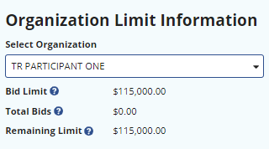

The Auction page provides details on the Auction Quantity and Round Quantity available for each Path (TR zone) active in the auction, as well as the start and end dates and times for the TR auction

- The Auction Quantity is the maximum path quantity less any TR sold in previous TR auctions with the same Period of Validity.
- The Round Quantity is the Auction Quantity times the Round Fraction, or the result of the application of previous TR auction awards in the main or constraining equation.
Long term auctions consist of two rounds. Prior to round one being completed, the Round Quantity for round two will be assumed to be remainder from round one availability (75% of Auction Quantity). Round two’s Round Quantity It will be calculated when round one is processed to determine if any unsold TRs from the previous round should be available in round two.
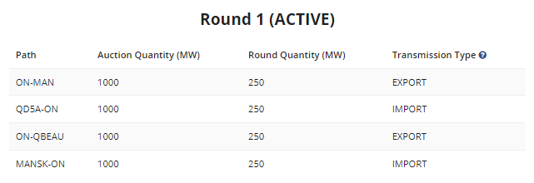
In a long term auction there will be a pause in active status in between rounds. This will show up as the status of ‘Between Rounds’. This is needed for the IESO to calculate the results of the first round and determine the Round Quantity for round two.
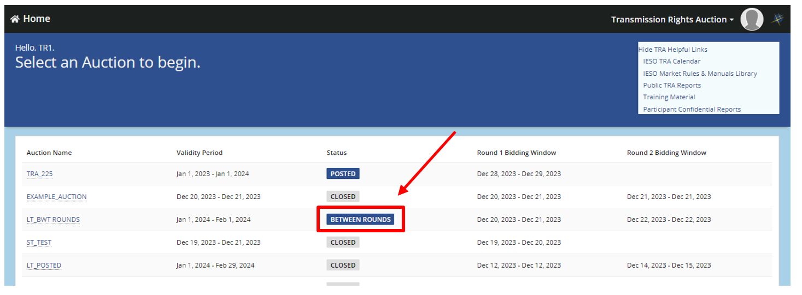
No bidding will be accepted in an auction that displays a Between Rounds status. Bidding will resume when the auction returns to an Active status.

Viewing Future TR Auctions
You can view information related to upcoming TR auction rounds that are not yet open for bidding. You can use this advance information to decide whether to place TR bids in a future TR auction round.
On the Transmission Rights Auction Home Page, any auction with a status of ‘POSTED’ is a future TR auction. To access this future TR auction click the auction name that has status ‘POSTED’.

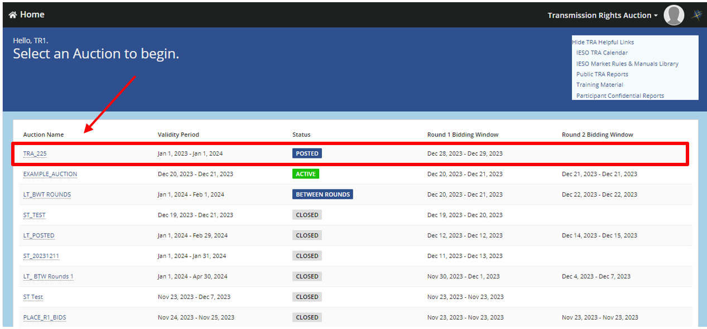

The webpage is similar to the Active Round screen except the user will see a message ‘Round X is not open for bidding at this time. This round will open for bidding at XX/XX/XXX XX:XX XX EST’.
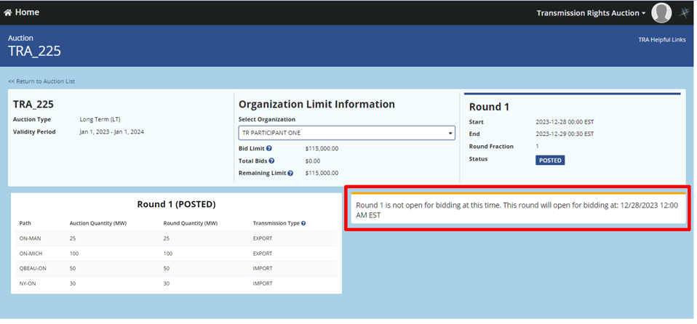
The page provides details on the Auction Quantity and Round Quantity available for each Path (TR zone) as well as the start and end dates and times for the TR auction. It will also provide the user with bidding information for the organizations they represent. Upon selecting the organization, the Organization Limit Information will get populated.

Only the paths where there will be available TRs will show up in a posted auction.

Viewing Previous TR Auctions
You can view information related to previous TR auctions within the last two years. This includes a method to view TR bids that either you, or other TR bidders who are registered for an organization, have submitted for a specific TR auction over the last two years.
You can also view your bid history through Participant Confidential Reports (this is described in section 8)
To view a TR auction that was previously completed, click the auction name that has status ‘CLOSED’.
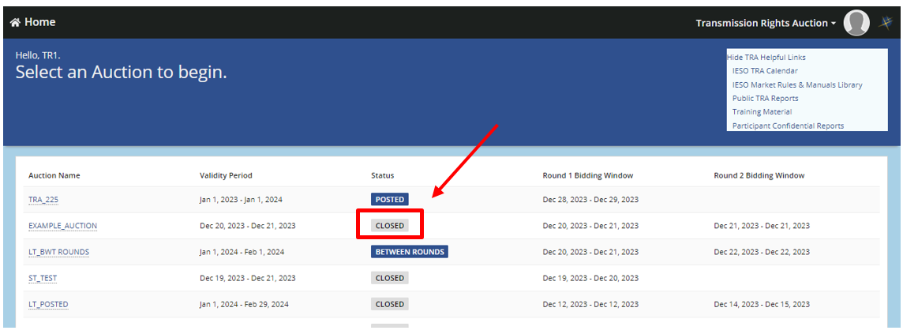
The TR auction page for a ‘CLOSED’ auction is similar to the ‘ACTIVE’ and ‘POSTED’ auction pages. They will detail round details, TRs that were available for the TR auction by path, etc. The auction page displays a message to inform user that the rounds are closed and bids are no longer being accepted. Select the organization name to see which paths TR bids were submitted on. Paths with previous TR bids will have a green checkmark under the ‘Bids Submitted?’ column.
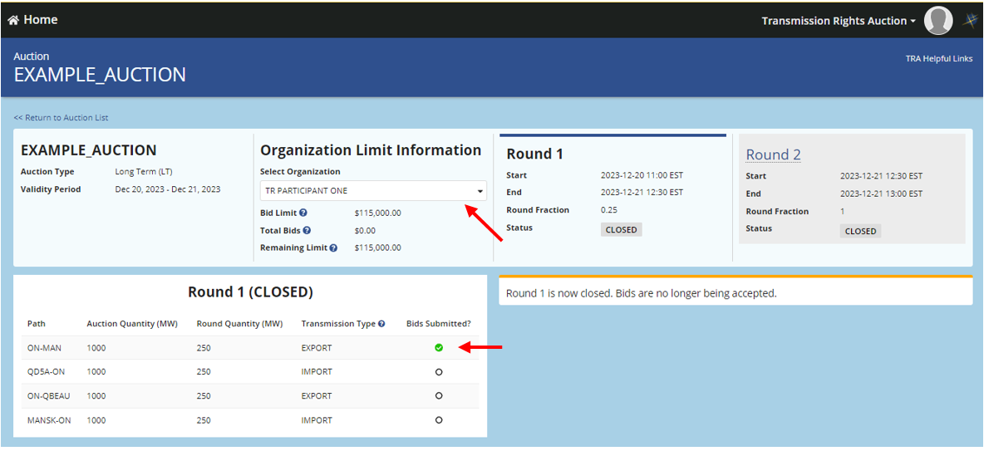
Click the Path with a green checkmark to populate a display in the bottom right of the page for the TR bid submitted and other submission information.
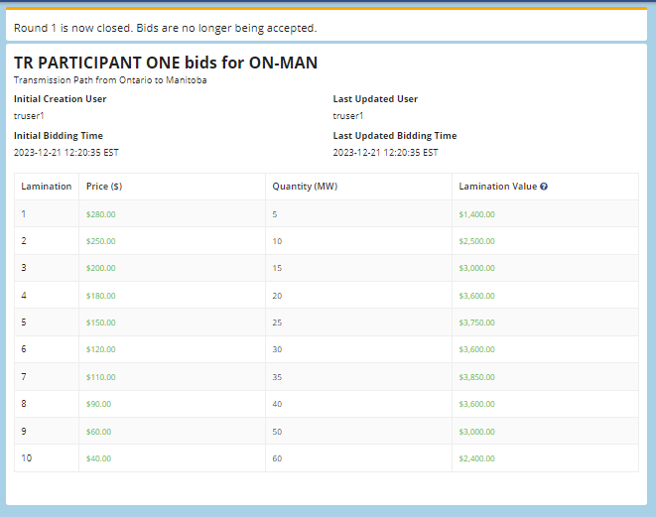

How to Submit a New TR Bid
Each TR bid contains at least one and up to twenty price-quantity pairs that the user can enter called TR laminations. The user, for a specific organization, submits the laminations for a path which represents their TR bid on that path in the TRA application. The following high level description of market rules apply when you submit a TR bid and their TR lamination(s) and through the TRA application:
- your TR participant status must be Active;
- only one TR bid per organization can be active at a time for each product/path being auctioned;
- the MW quantity in a TR lamination cannot exceed the round quantity available in the TR auction;
- zero or negative prices are not accepted;
- all TR lamination prices must be specified in Canadian dollars;
- TR lamination prices must be in descending order, quantities in ascending orders, and no duplicates (the first lamination should be the highest priced lamination and the last lamination should be the highest quantity); and
- the sum of the maximum TR lamination values (price times quantity) from all TR bids cannot exceed your organization’s TR bid limit.

Click on any ‘ACTIVE’ auction to access the page and choose an organization from the Select Organization drop down.
The page displays Organization Limit Information, Path, Auction Quantity, Round Quantity, any existing TR bids for your organization in the auction, as well as additional auction and round information.

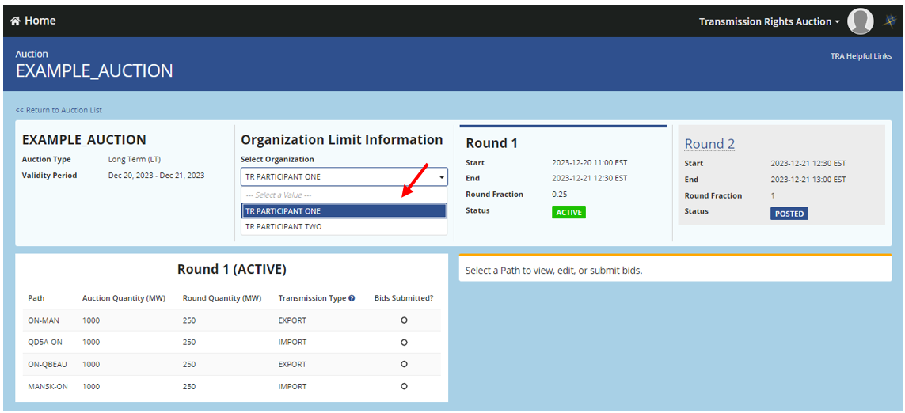
For the selected TR auction, all the Paths are displayed and along with the Auction Quantity (MW), Round Quantity (MW) and Transmission Type for each path.

Placing a TR Bid
To place a TR bid, locate the Path you want to place a TR bid on, and click on Create Bid. If any TR bids have already been submitted the user will see the previous TR bid populated on the bottom right.
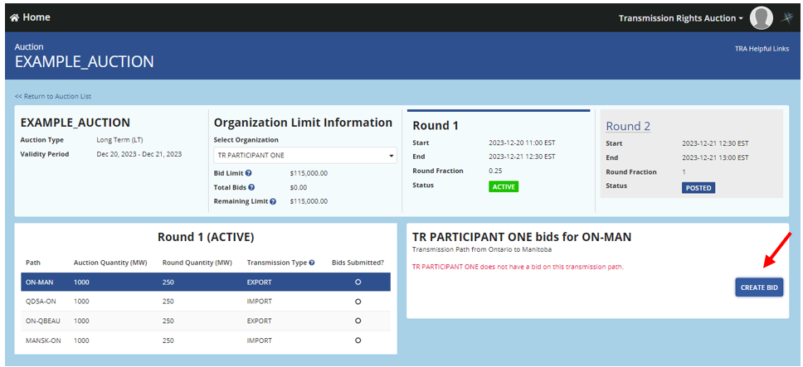

Fill the TR laminations with their respective Price and Quantity pairs. To add more TR laminations, click Add Lamination, then type in the appropriate price-quantity pairs that the organization would like to use in the TR bid. You can delete the TR laminations you do not want to submit by clicking the red X on the right. The Lamination Value (Price times Quantity of the lamination), populates after entering laminations.
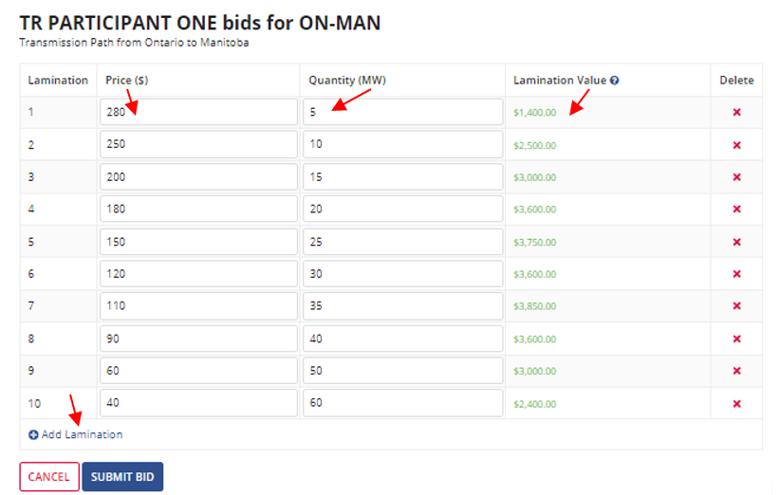
If there is any discrepency in the way the TR laminations or overall TR bid would be submitted, an error message will be displayed: ‘There are errors with your submission’. You will not be allowed to submit a TR bid with any outstanding errors that do not comply with the market rules for TR bid and TR lamination submissions. You should be prompted with the reason for a submission not being able to be submitted.
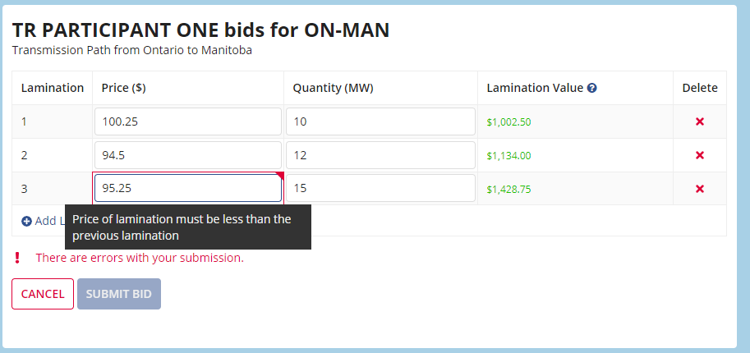
Check the following, along with the market rules, for any errors in your submission:
- Are all Quantities equal to or less than the Round Quantity?
- Are all Lamination Values (Price times the Quantity) less than your Remaining Limit?
- Is the Price and Quantity entered greater than zero?
- Does the Price only have two decimal points and Quantity is a whole number?
- Are Prices in descending order and Quantity in ascending order, with no duplicated values?
If you have met all the requirements in the market rules but still receive an error message, contact IESO Customer Relations for assistance.
To cancel, click the Cancel button. This will prompt a message: ‘Your changes will be lost. Are you sure you want to cancel this submission?’. Click YES and all the entered laminations will get cleared.

Submitting a TR Bid
To submit a TR bid, review your submission and click on the Submit Bid button. All information pertaining to the TR bid will appear along with a message about the successful submission of your TR bid. The user who submitted the TR bid and the TR bid submission time gets displayed along with all laminations. The ‘Bid Submitted?’ checkbox will show a green check mark to denote an existing TR bid.
Additionally, Organization Limit Information will get populated with the Total Bids and Remaining Limit. The Total Bids will take the value of the highest lamination value.
You may edit or delete your laminations after submission until the end of the auction. If any edits are made to the bid, the Last Updated User and Last Updated Bidding Time displays information with be adjusted to the user and time they last edited/submitted the bid.
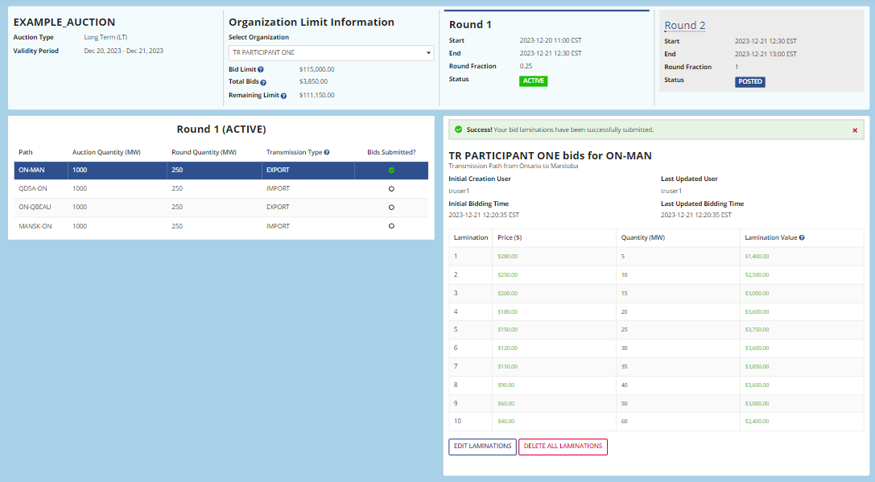

To place another TR bid, click beside the available Path that you want to submit your TR bid. You can continue to place TR bids from this page by repeating the steps above, as long as your organization’s TR bid Remaining Limit is not exhausted.

How to Change an Existing TR Bid
You can only have one TR bid per organization for each product/path being auctioned.
The TRA application allows you to make changes to a previously submitted TR bid as long as the auction is active. You can change TR lamination quantities and/or prices, or delete them entirely at any time before the TR auction round has closed, although the market rules for submitting TR laminations and TR bids will continue to apply.
To change an existing TR bid, select the path where there is an existing bid.
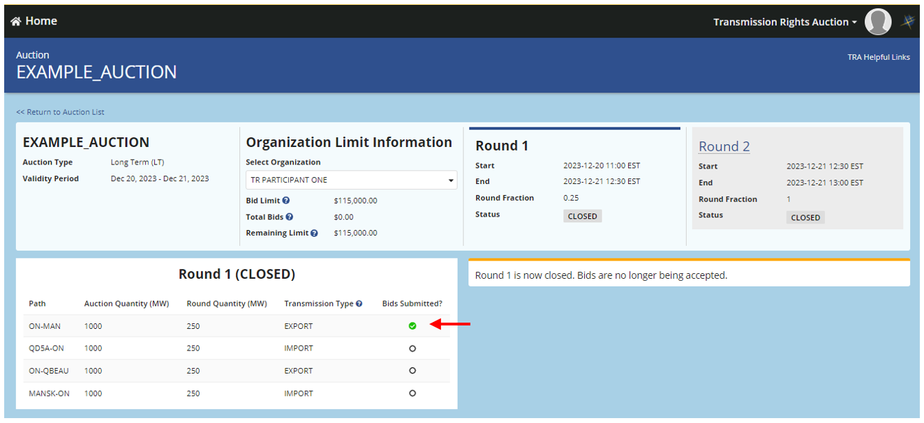

The existing TR bid should populate, and the user can click the ‘EDIT LAMINATIONS’ button.

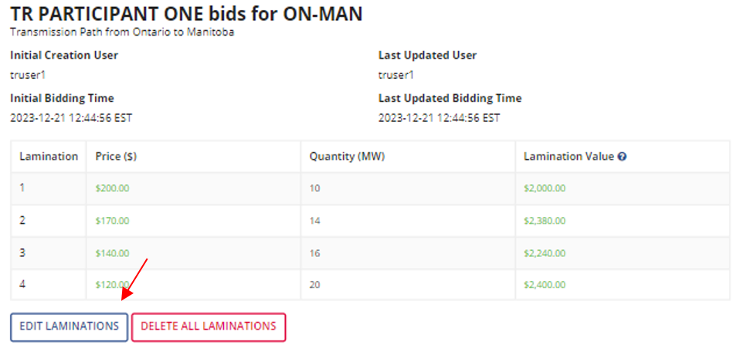

This will display all the laminations as editable. Changes can be made to the Price and Quantity under each lamination. Furthermore, laminations can be deleted by clicking the X button on the right of each lamination.

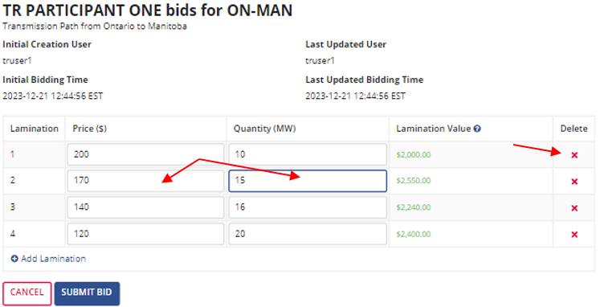

Click Submit bid to save the changes made. A message will appear to notify you of the successful submission of any edits made. The Last Updated Bidding Time and Last Updated User (if submitted by a different user) will get updated.
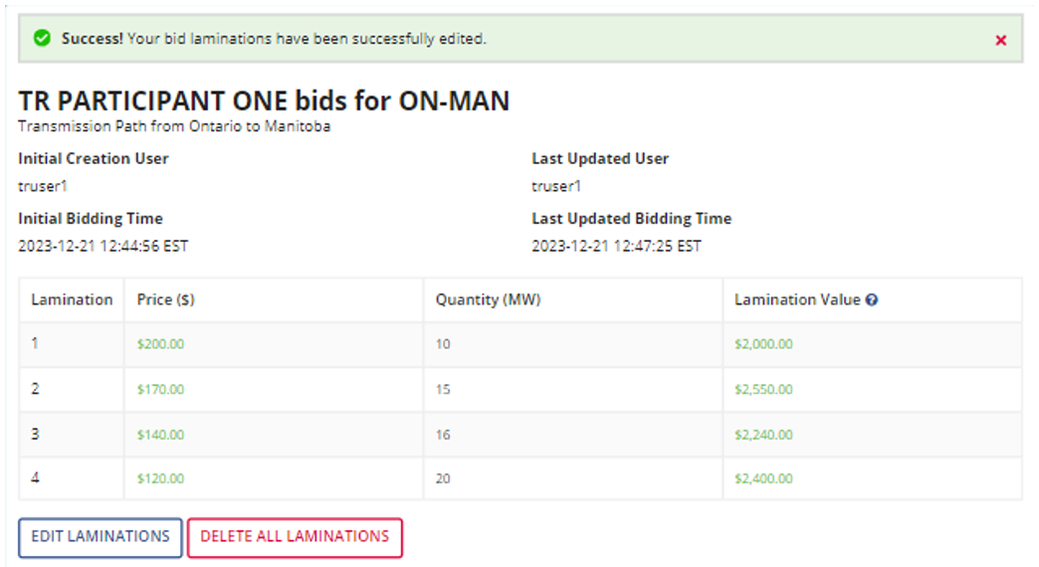

How to Delete an Existing TR Bid
You can delete a TR bid at any time before the TR auction round has closed. To delete an existing TR bid, locate the Path with the existing TR bid you want to delete.

The existing bid should populate. The user can click the ‘DELETE ALL LAMINATIONS’ button.
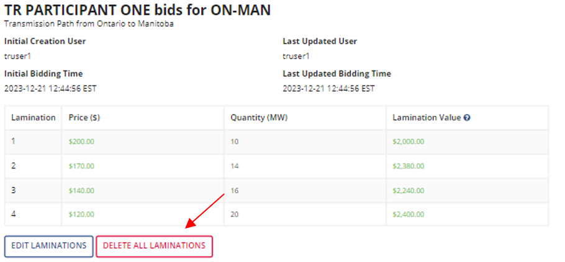

A confirmation screen will open, asking: ‘Are you sure you want to delete all laminations for this transmission path?’. Click ‘YES’ to complete the deletion of the TR bid.

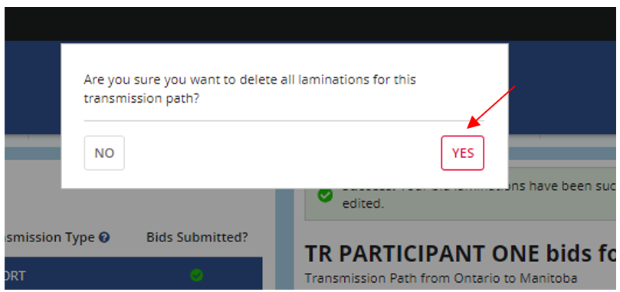

You should receive a notification that the TR bid was successfully deleted and that the organization doesn’t have any existing bid on the transmission path. Your Trade Limit Information will also be updated for the organization that the TR bid was deleted.
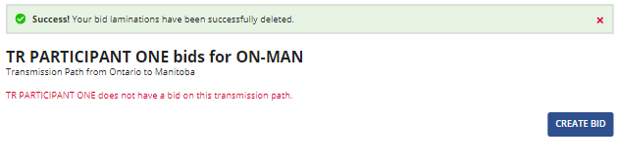

To cancel your request for the deletion, on the ‘Are you sure you want to delete all laminations for this Transmission Path?’ popup, click ‘NO’ to return to the screen. The Quantity and the Price columns should continue to show the values for the last TR bid placed.

How to Access TR Auction Reports
There are multiple ways to access TR auction reports. One way is through the TRA application which has some links to direct you to reports websites. These include the ‘Public TRA Reports’, and Participant Confidential Reports’ as can be seen in in the box on the top right amongst other helpful links.

There are two types of reports available to support the TR auction: confidential Market Participant Reports and Public Reports. Market Participant Reports contain TR data specific to your organization and Public Reports contain generic data about the TR auction.
“Quick Takes Issue 15: Retrieving Reports via IESO Reports Site” details how you can access both these types of reports through the Public Reports and Market Participant Report Sites. This document is found at IESO Training.

Market Participant Reports
Market Participant Reports contain confidential TR auction information related to your organization’s participation in the TR market. To access these reports, your organization must be authorized to participate in the TR market and you must be an authorized TR participant with an IESO user name and password. If you require assistance, please contact IESO Customer Relations via email at IESOCustomerRelations@ieso.ca or telephone (905) 403-6900.
To access the Market Participant Report Site:
- Go to the IESO Report Site
- Select Market Participant Reports
- Log on to your organization’s specific account by entering your User name and Password
- Locate the report you wish to open in the Parent Directory, which lists all available market participant reports applicable to your organization. Reports related to the TR auction are described below.

2.8.1.1 Participant Notification Report
In the Market Participant Reports Parent Directory, the “Participant Notification Report” is labelled TRA-Results.
The TR “Participant Notification Report” contains your organization’s results for a TR auction round. The report is usually available within 1 hour of the completion of a TR auction (but must be available within 24 hours). Your organization must have participated in the specified TR auction round by placing an accepted TR bid in order to receive the “Participant Notification Report.”
This report provides notice of what TRs, if any, have been awarded and the resultant TR market clearing price for the identified auction round in which the organization’s TR bid was submitted, as well as the last of the organizations TR laminations that cleared the TR auction. It also lists the Round End Time and the Validity Period. As long as your organization has entered an accepted TR bid in the TR auction round, a report will be issued, regardless of whether your organization was successful or not.

2.8.1.2 Transmission Rights Auction Bid History Report
In the Market Participant Reports Parent Directory, the “Transmission Rights Auction Bid History Report” is labelled TRA-Bid History.
The “Transmission Rights Auction Bid History Report” provides the TR bids submitted by your organization and their status for the last 18 months. Your organization must have successfully submitted a TR bid in a specified TR auction round in order to receive the “Transmission Rights Auction Bid History Report.”

Public TR Auction Reports
Public Reports contain publicly available TR auction information. These reports can be accessed by any visitor to the IESO website. No password is required.
To access the Public Reports Site:
- Go to the IESO Report Site
- Select Public Reports
- Locate the report you wish to open in the Parent Directory, which lists all available Public Reports. Reports related to the TR auction are described below.

2.8.2.1 Pre-Auction Market Clearing Price (MCP) Report
In the Public Reports Parent Directory, there are separate folders for the long term (LT) and short term (ST) TR auction “Pre-Auction MCP Reports.” The LT report is labelled TRAPreauctionMCPLT while the ST report is labelled TRAPreauctionMCPST.
The “Pre-Auction MCP Report” provides the TR market clearing prices for either long term (LT) or short term (ST) TR auction rounds that have closed in the 18 months prior to the report date.
This report is published at least 30 days prior to the opening of the TR auction.

2.8.2.2 Forecast of Transmission Transfer Capability (TTC) for Transmission Rights Auction
In the Public Reports Parent Directory, there are separate folders for the long term (LT) and short term (ST) “Forecast of Transmission Transfer Capability for Transmission Rights Auction” (or “TRA Preauction TTC” for short). The LT report is labelled TRAPreauctionTTCLT while the ST report is labelled TRAPreauctionTTCST.
The “Forecast of Transmission Transfer Capability for Transmission Rights Auction Report” enables you to view the forecast of transmission transfer capability used to determine the number of TRs that will be offered and the maximum number of TRs that may be available. The maximum number of TRs that may be available for any particular TR auction will be reduced by the number of TRs sold in previous TR auctions with the same period of validity. This actual number for a specific TR auction may be viewed on the TRA application after selecting a TR auction, but may not be valid until all previous TR auctions with the same period of validity have been processed (this number will be updated in the TRA application prior to auction start).
The report also contains a link to the detailed transmission transfer capability assessments used to identify any assumptions and applicable constraints that can limit the number of TRs that can be awarded. This report is published at least 30 days prior to the conducting of the TR auction.

2.8.2.3 TR Hourly Zonal Price Report
In the Public Reports Parent Directory, the “TR Hourly Zonal Price Report” is labelled TRAPreauctionHZMCPMonthly.
The pre-auction “TR Hourly Zonal Price Report” provides the hourly zonal market prices determined on the basis of the last projected market price (the zonal price from the last run of the pre-dispatch unconstrained schedule) for energy.
This report is usually available on a daily basis by approximately 06:30 EST. The report looks backward for 60 days to ensure that any price revisions are captured in the report.

2.8.2.4 Monthly Historical Interface Flows, Schedules, and Transmission Transfer Capability Report
In the Public Reports Parent Directory, the “Monthly Historical Interface Flows, Schedules and Transmission Transfer Capability Report” (or “Monthly TR Historical Interface Report” for short) is labelled TRAPreauctionInterfaceHistoryMonthly.
This report provides the actual hourly average Schedules and Flows as a result of scheduled market-based – and (effective February 6, 2003) off-market – transactions between Ontario and an intertie zone. (Negative values denote flows into Ontario).
The report also provides the transmission transfer capability used for determining the maximum import/export market schedule between Ontario and an intertie zone. (Transmission transfer capability or TTC IN refers to flows from the external intertie zone into Ontario).
This report is usually available on a daily basis by approximately 06:30 EST. The report looks backward for 60 days to ensure that any revisions to the schedule or flows are captured in the report.

2.8.2.5 TRA Post MCP Report
In the Public Reports Parent Directory, there are separate “TRA Post Auction MCP Reports” for each round offered for long-term (LT) TR auctions and short-term (ST) TR auctions. For example, Long-Term Auction Round 1 reports are labelled TRAPostauctionMCPLTr1, Long-Term Auction Round 2 reports are labelled TRAPostauctionMCPLTr2, and Short-Term Auction Reports are labelled TRAPostauctionMCPST.
The “TRA Post Auction MCP Report” provides overall TR auction results after the TR auction round has been completed. The report identifies the total number of TRs awarded and the associated TR market clearing price for a particular path in a TR auction round.
The report is usually available within 1 hour of the completion of a TR auction (but must be available within 24 hours).
− End of Section –

References
Document ID | Document Title
MDP_RUL_0002 | Market Rules for the Ontario Electricity Market
PRO-408 | Market Manual 1.5 Market Registration Procedures
MDP_PRO_0033 | Market Manual 5.5: Physical Markets Settlement Statement
MDP_PRO_0046 | Market Manual 5.7: Financial Markets Settlement Statement
Marketplace Training | IESO Gateway User Guide
Marketplace Training | Transmission Rights
Marketplace Training | Quick Takes Issue 15 – Retrieving Reports via the IESO Reports Site
− End of Document −

Review market rules on the IESO website to understand the full extent of market rules applicable to participate in the TR auction.

