PUBLIC

Market Manual

**Market Manual 14: Market Power Mitigation**

**Part 14.2: Reference Level and Reference Quantity Procedures**

**Issue 3.1**

**December 3, 2025**

This procedure describes the activities to be undertaken by the *IESO* and *market participants* to complete the *reference level* and *reference quantity* procedures required to participate in the *day-ahead market* and the *real-time market*.

Document Change History

| Issue | Reason for Issue | Date |
| --- | --- | --- |
| 1.0 | Market Transition | November 11, 2024 |
| 2.0 | Issued in advance of MRP Go Live – May 1, 2025 | April 25, 2025 |
| 3.0 | Updated in Baseline 54.0 | September 10, 2025 |
| 3.1 | Updated in Baseline 54.1 | December 3, 2025 |

Related Documents

| Document ID | Document Title |
| --- | --- |
| MAN-126 | Market Manual 14.1: Market Power Mitigation Procedures |
|  |  |

Table of Contents

Part 14.2: Reference Level and Reference Quantity Procedures 1

Table of Contents i

List of Figures v

List of Tables v

Table of Changes vi

Market Manual Conventions x

1 Introduction 1

1.1 Purpose 1

1.2 Scope 1

1.3 Contact Information 2

2 Overview of Reference Levels and Reference Quantities 4

2.1 Reference Levels 4

2.2 Reference Quantities 6

3 Determining and Updating Reference Levels and Reference Quantities 8

3.1 Historical Study Period 8

3.2 Supporting Documentation 10

3.3 Procedure Initiation by the Market Participant 13

3.4 Procedure Initiation by the IESO 16

3.5 Independent Review 17

4 Reference Level and Reference Quantity Reports 21

4.1 Reference Level Value Reporting 21

4.2 Reference Quantity Value Reporting 22

5 Temporary Reference Level Change Requests 24

5.1 Request Timing 24

5.2 Supporting Documentation 25

5.3 Use of Higher Fuel Cost Component or an Alternate Cost Profile 26

5.4 Documentation Following Use of Alternate Cost Profile Reference Levels 27

5.5 IESO Review of Documentation and Response to Market Participants 27

6 Cost Components of Financial Dispatch Data Parameters 28

6.1 Costs Related to Fuel 28

6.2 Costs Related to Emissions 28

6.3 Costs Related to Operating and Maintenance 28

6.4 Opportunity Costs 32

6.5 Costs Related to Start-Up Offers 59

6.6 Costs Related to Speed No-Load Offers 59

6.7 Costs Related to Operating Reserve Offers 60

7 Reference Levels for Financial Dispatch Data Parameters 61

7.1 Thermal 61

7.2 Hydroelectric 89

7.3 Solar 104

7.4 Wind 106

7.5 Nuclear 108

7.6 Electricity Storage 114

7.7 Dispatchable Loads 122

7.8 Accounting for Currency Exchange 127

7.9 Late Day Start Reference Levels 127

7.10 Alternate Data for Calculating Reference Level Values 128

8 Reference Levels for Non-Financial Dispatch Data Parameters 130

8.1 Descriptions of Non-Financial Dispatch Data Parameter Reference Levels 130

8.2 Thermal 132

8.3 Hydroelectric 137

8.4 Solar 138

8.5 Wind 138

8.6 Nuclear 139

8.7 Electricity Storage 139

8.8 Dispatchable Loads for Operating Reserve 139

9 Reference Quantities 140

9.1 Thermal 140

9.2 Hydroelectric 141

9.3 Solar 142

9.4 Wind 143

9.5 Nuclear 143

9.6 Electricity Storage 143

9.7 Dispatchable Load 143

9.8 Alternate Data for Calculating Reference Quantity Values 146

10 External Data Retrieval Schedule 147

10.1 Natural Gas Price Indices 148

10.2 Currency Exchange Rates 148

10.3 Carbon Price 149

10.4 ICE NYISO Zone A (West) Monthly Future Prices 149

10.5 NYISO Zone A Day-Ahead Hourly Settled Prices 149

List of Acronyms 150

References 151

List of Figures

Figure 5‑1: DAM Reference Level Change Request Window 24

Figure 5‑2: Real-Time Market Reference Level Change Request Window for HE12 24

List of Tables

Table 2‑1: Reference Levels for Non-Financial Dispatch Data Parameters 5

Table 3‑1:MarketParticipant Request Type for Reference Level or Reference Quantity Changes 14

Table 6‑1: Example of Data Used to Determine the Cascade Group Storage Horizon 38

Table 6‑2: Example of Efficiency Calculation 43

Table 6‑3: Step 1 of Multiple Units Efficiency Calculation Example 44

Table 6‑4: Step 2 of Multiple Units Efficiency Calculation Example 44

Table 6‑5: Step 3 of Multiple Units Efficiency Calculation Example 45

Table 6‑6: Example of Requesting Forebay Refill Opportunity Cost for a Cascade Group Resource 52

[Table 6‑7: Step 1 Example of Determining the Refill Time for Resources   
in a Cascade Group 55](#_Toc180348623)

[Table 6‑8: Step 2 Example of Determining the Refill Time for Resources   
in a Cascade Group 56](#_Toc180348624)

[Table 6‑9: Step 3 Example of Determining the Refill Time for Resources   
in a Cascade Group 57](#_Toc180348625)

[Table 6‑10: Step 4 Example of Determining the Refill Time for Resources   
in a Cascade Group 57](#_Toc180348626)

Table 7‑1: T-ORFEC Tranches for a Thermal Resource 86

Table 7‑2: T-ORFEC Tranches for a Thermal Resource 86

Table 7‑3: Example of EOH Methodology Illustrative 94

Table 7‑4: H-ORFEC Tranches for a Hydroelectric Resource 100

Table 7‑5: Example of Cascade Group Hydroelectric Resource Reference Level Value Methodology 102

Table 8‑1: Reference Levels for Variant D Resources 132

Table of Changes

| Reference | Description of Change |
| --- | --- |
|  |  |
|  |  |
|  |  |
|  |  |
| Section A | Removed Market Transition section |
| Throughout document | Removed zero series references used for market transition |
| 7.1.3.1 | Added clarification on estabishing energy offer reference level for ST resource based on duct-firing capability |
| 7.1.4 | Added clarification on supporting data related to heat rate curves and incremental heat rate curves. |
| 7.1.7.2 | Added clarification on eligible allocation of scheduled maintenace O&M costs to the energy, speed no-load and start-up offer reference levels |
| 7.1.7.3 | Added clarification on eligible allocation of unscheduled maintenace O&M costs to the energy, speed no-load and start-up offer reference levels |
| 7.6.1.1 | Added clarification that historical LMPs from another resource within the same zone can be used to calculate charging costs |
|  | <NTD update to describe other changes> |

Market Manual Conventions

This *market manual* uses the following standard conventions:

* The word 'shall' denotes a mandatory requirement;
* References to *market rule* sections and sub-sections may be abbreviated in accordance with the following representative format: ‘**MR Ch.1 ss.1.1-1.2’** (i.e. *market rules,* Chapter 1, sections 1.1 to 1.2).
* References to *market manual* sections and sub-sections may be abbreviated in accordance with the following representative format: ‘**MM 1.5 ss.1.1-1.2’** (i.e. *market manual* 1.5, sections 1.1 to 1.2).
* Internal references to sections and sub-sections within this manual take the representative format: ‘sections 1.1 – 1.2’
* Terms and acronyms used in this *market manual* in its appended documents that are italicized have the meanings ascribed thereto in **MR Ch.11**;
* All user interface labels and options that appear on the *IESO* gateway and tools are formatted with the bold font style;
* Data fields are identified in all capitals; and
* For the purposes of determining *reference levels* and *reference quantities*, *resources* are categorized according to the technology types at the *facilities* of the *resource*. This categorization impacts how *reference levels* and *reference quantities* are determined for that *resource*. *Resources* that have *facilities* of a particular technology type are denoted as *resources* of that technology type. For example, *resources* that have *generation facilities* that are primarily fueled by natural gas, biomass or oil are referred to as “thermal *resources*”.

## Introduction

This *market manual* describes how the *IESO* determines *reference levels* and *reference quantities* for *dispatchable resources*. Determining *reference levels* and *reference quantities* for a *resource* is a prerequisite for *dispatchable generation resources*, *dispatchable loads*, and *dispatchable electricity storage resources* to participate in the *energy* and *operating reserve markets*.

The *IESO’s* assessment and mitigation of the exercise of market power, including testing and any related step by the *IESO*, shall not constitute a review for compliance with any *market rule*, including **MR Ch.1** **s.10A** or **s.11**.

### Purpose

This *market manual* provides administrative and procedural details to the *market rules* governing the market power mitigation processes, including supplementary information relevant to understanding the rights and obligations of the *IESO* and *market participants*.

*Market* *manuals* must be read in conjunction with the applicable *market rules.* Where there is a conflict between a *market manual* and the *market rules*, the *market rules* shall prevail.

### Scope

This *market manual* supplements the following *market rules*:

* MR Ch.7 s.22.1: Reference Levels – General
* MR Ch.7 s.22.2: Reference Levels for Financial Dispatch Data Parameters
* MR Ch.7 s.22.3: Reference Levels for Non-Financial Dispatch Data Parameters
* MR Ch.7 s.22.4: Resources With Multiple Sets of Reference Levels
* MR Ch.7 s.22.5: Changes to Reference Levels
* MR Ch.7 s.22.6: Reference Quantities
* MR Ch.7 s.22.7: Changes to Reference Quantities
* MR Ch.7 s.22.8: Independent Review
* MR Ch.7 s.22.15.20.1, 22.15.22 and 22.15.23.2
* MR Ch.7 s.22.19.2 and 22.19.3

#### Determining and Updating Reference Levels and Reference Quantities

Section 3 describes the procedures used to determine and update *reference levels* and *reference quantities* for a *resource* and the documentation that may be used to support a requested *reference level* or *reference quantity*.

Section 4 describes the reports that the *IESO* uses to inform *market participants* of the *reference level values* and *reference quantity values*.

Section 6 describes the cost components that may be included when requesting a *reference level* for a *financial dispatch data parameter*.

Section 7 describes, according to generation technology type, how the *IESO* determines *reference levels* for a *resource*’s *financial dispatch data parameters*.

Section 8 describes, according to generation technology type, how the *IESO* determines *reference levels* for a *resource*’s *non-financial dispatch data parameters*.

Section 9 describes, according to generation technology type, how the *IESO* determines a *resource’*s *reference quantities*.

#### Temporary Changes to Reference Levels

Section 5 describes the procedures regarding how a *market participant* may request temporary changes to a *reference level* and the documentation required to support such a request.

#### Related Documents

*Reference levels* and *reference level values* are used to assess ex-ante market power mitigation. For the *market rules* that apply to the ex-ante market power mitigation processes, refer to **MR Ch.7 s.22.14, App.7.5** and **App.7.5A**.

*Reference quantities* and *reference quantity values* are used to assess ex-post market power mitigation for *physical withholding*. For the *market rules* that apply to ex-post market power mitigation for *physical withholding*, refer to **MR Ch.7 s.22**. For the *market manual* that describes ex-post mitigation, refer to **MM 14.1**. *Intertie reference levels*, which are determined to assess *intertie economic withholding,* are also described in **MM 14.1**.

For a detailed description of *settlement* mitigation process, refer to **MM 5.5**.

### Contact Information

Changes to this *market manual* are managed via the [*IESO* Change Management process](http://www.ieso.ca/sector-participants/change-management/overview). Stakeholders are encouraged to participate in the evolution of this *market manual* via this process.

As part of the authorization and registration process[1], *market participants* are required to identify a Market Power Mitigation Contact. If a *market participant* has not identified a specific contact, the *IESO* will seek to contact the Primary Contact for activities within this procedure, unless alternative arrangements have been established between the *IESO* and the *market participant*.

To contact the *IESO*, you can email *IESO* Customer Relations at [customer.relations@IESO.ca](mailto:customer.relations@ieso.ca) or use telephone or mail. Telephone numbers and the mailing address can be found on the [*IESO* website](http://www.ieso.ca/corporate-ieso/contact). *IESO* Customer Relations staff will respond as soon as possible.

– End of Section –

## Overview of Reference Levels and Reference Quantities

### Reference Levels

(MR Ch.7 ss.22.2 – 22.4)

The *IESO* uses information supplied by a *market participant* to determine the *reference levels* for the *resources* registered under that *market participant*.

The *IESO* determines *reference levels* for *financial dispatch data parameters* and *non-financial dispatch data parameters* of each *resource*.

*Reference levels* for *financial dispatch data parameters* are described in more detail in section 6 and section 7. *Reference levels* for *non-financial dispatch data parameters* are explained further in section 8.

If the inputs for a *resource* vary with season, the *reference levels* for that *resource* may also vary according to season. The summer period is from May 1st to October 31st and the winter period is from November 1st to April 30th of the following year.

#### Reference Levels for Financial Dispatch Data Parameters

(MR Ch.7 s.22.2)

When requesting *energy offer reference levels* and *operating reserve offer reference levels*, a *market participant* must indicate the cost components that vary with increased supply. Where a cost component varies with increased supply, the relevant *reference level* requires multiple laminations and the *market participant* must demonstrate its costs accordingly. The formulas the *IESO* uses to determine *energy offer, speed no-load offer, start-up offer,* and *operating reserve offer reference levels* are described in section 7.

A *market participant* may request a *reference level* of $0 for a *financial dispatch data* *parameter*. No supporting documentation is required to support a *reference level* of $0.

#### Reference Levels for Non-Financial Dispatch Data Parameters

(MR Ch.7 s.22.3.1)

Table 2‑1 lists the *reference levels* for *non-financial dispatch data parameters* that the *IESO* will determine for each type of *resource* pursuant to MR Ch.7 s.22.3.1.

Table 2‑1: Reference Levels for Non-Financial Dispatch Data Parameters

| Registered Reference Level Name | Reference Level Registered For |
| --- | --- |
| Energy Ramp Rate Reference Level | * *Dispatchable* *generation resources* * *Dispatchable* *electricity storage resources* |
| Operating Reserve Ramp Rate Reference Level  (A single *reference level* is used to validate all applicable classes of *operating reserve* ramp rates) | * *Dispatchable generation resources* * *Dispatchable loads* * *Dispatchable electricity storage resources* |
| Lead Time Reference Level (for each *thermal state*) | *Non-quick start resources* |
| Minimum Loading Point (MLP) Reference Level | *Non-quick start resources* |
| Minimum Generation Block Run-Time Reference Level | *Non-quick start resources* |
| Minimum Generation Block Down Time Reference Level (for each *thermal state*) | *Non-quick start resources* |
| Maximum Number Of Starts per Day Reference Level | * *Non-quick start resources* * *Dispatchable* hydroelectric *generation resources* |
| Energy per Ramp Hour Reference Level (for each *thermal state*) | *Non-quick start resources* |
| Ramp Hours To MLP Reference Level (for each *thermal state*) | *Non-quick start resources* |

#### Resources with Alternate Cost Profile Sets of Reference Levels

(MR Ch.7 ss.22.4.3)

For *resources* that have an alternate cost profile sets of *reference levels* determined pursuant to **MR Ch.7 s.22.4.3**, the lower-cost profile *reference levels* will be used during the *dispatch hours* when a submitted *offer* is tested for *economic withholding*.

The *IESO* determines the lower-cost profile *reference levels* based on the total hourly *reference level* cost of operating the *resource* at maximum capacity using each set of *reference levels* as follows:

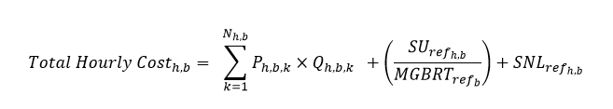

Where:

* $K_{h,b}$ designates the set of *energy offer reference level* laminations for *resource $b$* for hour $h∈\{1,..,24\}$
* $N_{h,b}$ designates the number of laminations for each set of *energy offer reference level* laminations for *resource $b$* for hour $h∈\{1,..,24\}$
* $P_{h,b, k}$ is the *energy offer reference level* price segment of the *price-quantity pair* in hour $h∈\{1,..,24\}$ in association with *energy offer reference level* lamination $k∈K_{h,b}$
* $Q_{h,b, k}$ is the *energy* quantity segment of the *price-quantity pair* in hour $h∈\{1,..,24\}$ in association with *energy offer reference level* lamination $k∈K_{h,b}$
* ${SU}_{ref,,h,b}$ is the *start-up offer reference level* in association with hour $h∈\{1,..,24\}$ for *resource* b, as applicable
* ${MGBRT}_{{ref}_{b}}$ is the *minimum generation block run-time reference level,* as applicable. For *pseudo-unit resources*, the *minimum generation block run-time reference level* is the *minimum generation block run-time reference level* from the combustion turbine resource associated with the *pseudo-unit resource*
* ${SNL}_{ref,h, b}$ is the *speed no-load offer reference level* in association with hour $h∈\{1,..,24\}$ for *resource* b, as applicable

### Reference Quantities

(MR Ch.7 s.22.6)

The *IESO* determines *reference quantity values* for a *dispatch day* in accordance with the methodologies in section 9. The inputs used by the *IESO* to determine *reference quantity values* vary according to the *resource’s* technology type.Inputs required for the calculation of *reference quantity values* may vary seasonally. The *market participant* must submit separate summer and winter values for *parameters* and inputs used in the determination of *reference quantity values,* where applicable.

Section 9 describes the methodologies that the *IESO* uses to determine *reference quantities* for *resources* of different technology types and the applicable supporting documentation that a *market participant* must submit to support requested *reference quantities*.

If the default methodology for calculating *reference quantities* that is detailed in Section 9 of **MM 14.2** does not account for the specific operational characteristics of a *resource* in a complete manner, *market participants* may submit requests for *reference quantity* modifiers. *Market participants* can request modifiers per calendar month to reflect *resource*-specific limits. If the limit affects the *resource* year-round, the same modifier may be requested for the entire year. *Market participants* must submit supporting documentation for *IESO* review and approval in support of the requested modifier(s). Once approved, the modifier will be added/subtracted to the calculated *reference quantities*.

– End of Section –

## Determining and Updating Reference Levels and Reference Quantities

(MR Ch.7 ss.22.1-22.8)

The *IESO* must determine *reference levels* and *reference quantities* for a *resource* before that *resource* is permitted to participate in the *energy* and *operating reserve* *markets*. This section describes the procedures the *IESO* uses to determine a *resource*’s *reference levels* and *reference quantities* and, if required, to update them, pursuant to **MR Ch.7 ss.22.1-22.8**.

The *IESO* determines the *reference levels* and *reference quantities* for a *resource* depending on the technology type of the *resource,* as further specified below.

For *resources* that have multiple *facilities* of different technology types, the *IESO* determines the contribution to each *reference level* or *reference quantity* for each *facility* of the *resource*, as further specified below.

The *IESO* uses technology-specific methodologies to determine *reference levels* and *reference quantities*. During the registration procedures as described in **MM 1.5**, a *market participant* must submit information to support requested *reference levels* or *reference quantities*. *Reference level* workbooks by technology type are available on the *IESO’s* website for a *market participant* to input values for *reference level* components and to log supporting documentation.

The *IESO* uses the supporting documentation submitted by a *market participant* to review and assess the *market participant*-requested *reference levels* or *reference quantities*. Section 3.2 outlines the acceptable types of supporting documentation. Section 7 and section 8 outline technology-specific requirements for supporting documentation.

Sections 3.3 and 3.4 detail the processes used from initiation to registration completion of *reference levels* and *reference quantities*. Once registered, *IESO-*determined *reference levels* and *reference quantities* will not change except in accordance with **MR Ch.7 ss.22.5** and **22.7**.

### Historical Study Period

(MR Ch.7 ss.22.1.3 and 22.6.3)

The *IESO* uses historical study periods when determining *reference levels* pursuant to **MR Ch.7 s.22.1.1** and *reference quantities* pursuant to **MR Ch.7 s.22.6.1**. Data describing costs incurred or operation during a historical study period are acceptable documentation to support a *reference level* or a *reference quantity* requested for a *resource*. The historical study periods for each *resource* technology type are stated in the technology-specific approaches in section 7. This information must be provided pursuant to **MR Ch.7 s.22.1.3**, for *reference levels*, or **MR Ch.7 s.22.6.3**, for *reference quantities*.

If available, a *market participant* must use historical cost information spanning the historical study period when calculating the contribution of a cost to a *reference level*. If cost information for the suggested historical study period is not available, but there is at least one year of cost information available, the *market participant* must use all of the available cost information when determining the contribution of a cost to a *reference level*. If cost information is not available for at least one year and an alternate methodology is not indicated in section 7, the *market participant* may submit one or more of the following forms of documentation to support a requested cost:

* forecasted costs associated with eligible maintenance activities in accordance with the original equipment manufacturer (OEM) recommended maintenance intervals or accepted industry practices;
* independent third-party average cost information applicable for the technology type of the *resource*; or
* certified documentation from the OEM or vendor.

Unless otherwise specified in section 7, to determine the contribution of a cost to a *reference level*, a *market participant* must perform the following steps:

1. Calculate the total annual eligible costs for each year in the historical study period.
2. Calculate the number of relevant events that occurred during each year of the historical study period:
   1. the relevant event for an *energy offer* *reference level* is MWh injected in a year;
   2. the relevant event for a *start-up offer* *reference level* is the number of starts in a year;
   3. the relevant event for a *speed no-load offer* *reference level* is the number of hours when the *resource* was operating during the year; and
   4. the relevant event for an *operating reserve offer reference level* is the *operating reserve* MWh scheduled in a year.
3. Calculate the annual contribution per eligible cost by dividing the total annual eligible costs per year by the number of relevant events per year in the historical study period used.
4. Calculate the number per eligible cost by calculating the average of the annual contributions across the historical study period.

A *market participant* must indicate the historical study period used when requesting *reference levels* and *reference quantities* for a *resource*. The *IESO* will assess the appropriateness of an alternate historical study period. The *IESO* may reject the use of an alternate historical study period if, in the *IESO’s* opinion, the requested historical study period does not reflect the *resource’s* current operating conditions.

### Supporting Documentation

(MR Ch.7 ss. 22.1.3, 22.5.2, 22.6.3, 22.6.5, 22.6.7, 22.7.2, 22.15.20.1, 22.15.22, 22.15.23.2, 22.19.2 and 22.19.3)

This section describes the acceptable forms of documentation that a *market participant* may submit to support a *reference level* or a *reference quantity* requested for a *resource*. Technology-specific supporting documentation is identified in section 7. Supporting documentation is provided pursuant to **MR Ch.7 ss. 22.1.3, 22.5.2, 22.6.3, 22.6.5, 22.6.7, 22.7.2, 22.15.21.1, 22.15.22, 22.15.24.2, 22.19.2** and/or **22.19.3**.

Acceptable forms of supporting documentation include, but are not limited to, the following:

* *metering* *data*;
* electricity bills;
* screen captures showing a *resource’s* current registered *reference levels* or *reference quantities* can be used as supporting documents to confirm those *reference levels* or *reference quantities* if the *market participant* is not requesting changes to those *reference levels* or *reference quantities*. For example, if a *market participant* requests a new *minimum generation block run time reference level reference level*, but is not requesting changes to any other *reference level* or *reference quantity*, the *market participant* may provide screenshots showing all the currently registered *reference levels* and *reference quantities* for all *reference levels* and *reference quantities* other than the *minimum generation block run time reference level reference level*.
* materials from vendors regarding operations, including, but not limited to, information on the following:
  + *resource* efficiency and performance data;
  + equipment test data; and
  + relevant sections from operating and maintenance (O&M) manuals;
* vendor data on vendor letterhead and datasheets. If details are insufficient, the *IESO* may request additional information to be supplied by the vendor;
* relevant invoices or contracts for goods or service provision. Amounts in historical invoices may be adjusted for inflation, if appropriate, from when the cost was paid to what the service or product would cost in the current market based on an appropriate third-party index, including the Statistics Canada Consumer Price Index (CPI). To make adjustments using the CPI, a *market participant* retrieves[2] “all items” CPIs for Ontario for the month and year a cost was invoiced as well as for the present month and year. The *IESO* will make inflation adjustments using CPI by applying the following expression:

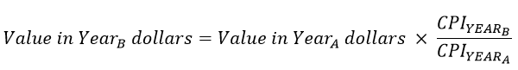

Where:

* ${Year}_{A}$ is the year for which historical costs is available
* ${Year}_{B}$ is the year to which historical costs are being adjusted
* ${CPI}_{{YEAR}_{A}}$ is the CPI value for Year A, and
* ${CPI}_{{YEAR}_{B}}$ is the CPI value for Year B

Where only a portion of the total costs is eligible to be included in a *reference level*, a *market participant* must report the portion of total costs attributed to the *reference level*. The determination of eligible costs must come from either: (i) a cost breakdown in the contract or invoice or in a written communication from the service provider; (ii) paid invoices from contractors or vendors for services or products related to eligible costs; or (iii) from the *market participant*. If a cost in a contract or invoice does not provide costs specific to a particular *resource*, the *IESO* will evaluate these submissions to confirm the following in regards to each cost for the *resource*:

i. The cost is eligible to be included in the *reference level* requested;

ii. The cost is a *short-run marginal cost* of the *resource*; and

iii. The amount of the cost allocated to the *resource* is consistent with the amount of the cost that the *IESO* would reasonably expect the *resource* to incur.

The *IESO* shall reject a submission that does not satisfy all three criteria;

* vendor quotation for a firm commitment that provides details on the scope of services or parts being supplied. These details must provide sufficient information for the *IESO* to ascertain whether the quoted costs are eligible for inclusion in the determination of the *reference level*; and
* any other documentation that is required to support the *market participant*-submitted data in the *reference level* workbook.

Where documentation from the above list is not available, documentation developed by the *market participant* may be submitted. This documentation will be evaluated on a case-by-case basis by the *IESO*. When determining the eligibility of documentation developed by a *market participant*, the *IESO* may compare the documentation to information for similar types of equipment. A *market participant* must include detailed explanations of how each piece of documentation supports the relevant input. If a requested *reference level* requires the *IESO* to convert values from one unit of measurement to another, the *market participant* must submit documentation that describes the relevant conversion factors. The *IESO* will evaluate these submissions to confirm the following in regards to each cost for the *resource*:

1. The cost is eligible to be included in the *reference level*;
2. The cost is a *short-run marginal cost* of the *resource*;
3. The amount of the cost allocated to the *resource* is consistent with the amount of the cost that the *IESO* would reasonably expect the *resource* to incur.

The *IESO* shall reject a submission for a cost that does not satisfy any one of these three criteria.

The *IESO* will not accept supporting documentation that:

* is illegible;
* does not support costs that are eligible for inclusion in the *reference level* that the documentation has been submitted to support; or
* includes incomplete, vague, or unclear information, where that information is relevant to the determination of the requested *reference level*.

The *IESO* may request that a *market participant* submit additional information and may review any other information it deems relevant for completeness, eligibility and correctness. Relevant information may include, but is not limited to, *market participant*-registered data, research papers, reports, news articles and publicly available information.

#### Supporting Documentation Exemptions

Supporting documentation is not required:

* to determine *energy* ramp rate *reference levels* where the requested value does not limit the *resource* to producing *energy* below its maximum generating capability for an interval:
  + if the submitted *energy* ramp rate *reference level value* is greater than or equal to 1/5th of the maximum capacity of the *resource*; or
  + if the submitted *energy* ramp rate *reference level* is equal to the *resource’s* registered maximum *energy offer* ramp rate;
* to determine *operating reserve* ramp rate *reference levels* where the requested value does not limit the *resource* to supplying *operating reserve* below its maximum supply capability for an interval:
  + for a *resource* that is registered as being able to supply *ten-minute operating reserve*, if the submitted *operating reserve* ramp rate *reference level value* is greater than or equal to 1/10th of the maximum *operating reserve* that the *resource* can provide;
  + for a *resource* that is registered as being able to supply *thirty-minute operating reserve*, but not *ten-minute operating reserve*, if the submitted *operating reserve* ramp rate *reference level value* is greater than or equal to 1/30th of the maximum *operating reserve* that the *resource* can provide; or
  + if the submitted *operating reserve* ramp rate *reference level* equal to the *resource’s* registered maximum *energy offer* ramp rate;
* to determine *minimum generation block run time* (MGBRT) or *minimum loading point reference levels* if the submitted *reference level* is equal to (i) the value currently registered or (ii) a value registered for the *resource* within the 24 months prior to the request; and
* to determine an *operating reserve* ramp rate *reference level* equal to the *resource*’s registered maximum *bid* ramp rate.

### Procedure Initiation by the Market Participant

(MR Ch.7 ss.22.1.1 and 22.5.4)

The procedures referenced in this section are found in **MM 1.5**.

#### Initiation

A *market participant* may initiate the Determine Reference Levels and Reference Quantities procedure in the following situations.

##### Registration of a New Resource

An equipment owner initiates the Register Equipment procedure to register a new *resource* to participate in the *energy* and *operating reserve* markets as a *dispatchable* *resource,* which automatically initiates the Determine Reference Levels and Reference Quantities procedure. The Equipment Registration Specialist (Equipment Owner) must complete the Determine Reference Levels and Reference Quantities procedure before the Register Equipment procedure can be completed.

##### Change in Resource Participation

An existing *resource* without determined *reference levels* or *reference quantities* intends to change its participation type to a *dispatchable resource*. When a *market participant* begins the Commission Equipment Process, it automatically starts the Determine Reference Levels and Reference Quantities procedure.

##### Changes to Resources’ Cost Components or Operating Capabilities

A *market participant* may initiate the Determine Reference Levels and Reference Quantities procedure to request an update to a *reference level* for a *financial dispatch data* *parameter* when:

* there has been a material change in an existing *resource’s* costs, equipment or operations or the *market participant* reasonably expects there to be such a change such that the determined *reference levels* and/or *reference quantities* no longer reflect an appropriate estimate of its operations; or
* one or more components of the *reference level* need to be updated.

Table 3‑1 summarizes the request types that a *market participant* may initiate to change a registered *reference level* or *reference quantity*.

Table 3‑1:MarketParticipant Request Type for Reference Level or Reference Quantity Changes

| **Request** | **Description** |
| --- | --- |
| Change existing *reference level* for a *financial dispatch data* *parameter* cost-component value. | A cost component value used in a registered *reference level* of a *resource* no longer accurately reflects the *resource*’s eligible *short-run marginal costs*. |
| Change cost-component approach, including adding new eligible cost components and removal of previously eligible cost components. | The registered *reference level* of a *resource* includes cost components that are no longer eligible to contribute to a *reference level* or does not include cost components that are now eligible to contribute to a *reference level*. |
| Change existing *reference level* for *non-financial dispatch data* *parameter* value. | The *non-financial dispatch data parameter* *reference level* requires updating to reflect significant operational changes of its *resource*. |
| Change *reference quantity*. | There is a change in the operating characteristics of a *resource* which results in a need to alter the methodology to determine the available supply of *energy* or *operating reserve*. This quantity is then used to calculate the *reference quantity* for that *resource*. A *market participant* changes its operations in a manner that fundamentally impacts how *reference quantities* are calculated for its *resource*. |

#### Submission

The Market Power Mitigation Contact for a *resource* determined pursuant to **MM 1.5**must provide its requested values for relevant cost components and *reference levels* for a *resource*. Section 6 and section 7 provide more details on *reference level* components, calculations and required supporting documentation. A *resource* with no previously determined *reference levels* or *reference quantities* cannot participate in the *energy* and *operating reserve* markets as a *dispatchable resource*.

If any part of the methodology used to determine a *reference level* is not applicable to a *resource* and a modification to a formula or cost component is necessary, the details and rationale for the change must be demonstrated to the *IESO*.

A *market participant* may request modifications to a *reference level* for a *financial dispatch data parameter* if any part of the methodology used to determine the *reference level* is not applicable to the *resource*. For example, a *market participant* with a *resource* that switches from one source of a fuel to another may request an update to the *resource’*s relevant *reference levels* to reflect a fuel price index that is representative of the *resource’s* regularly incurred fuel cost.

Modifications may also be requested for *reference levels* for *non-financial dispatch data parameters* or *reference quantities*. For example, changes to environmental laws and regulations that restrict *energy* production by a *resource* could prompt a *market participant* to request a modification to a *reference quantity* formula.

A *market participant* may provide a future effective date while submitting a request to determine or update *reference levels* and *reference quantities* pursuant to **MR Ch.7** **s.22.5.4.1** or **s.22.7.3.1** and must do so when submitting the request pursuant to **MR Ch.7** **s.22.5.4.2** or **s.22.7.3.2**. This proposed effective date may reflect the expected date of when an operational characteristic is likely to change or when a cost component takes effect.

Once a request is received, the *IESO* will inform a *market participant* if additional information is required to complete the review.

#### Preliminary View of the Reference Level Submission

(MR Ch.7 s.22.8.1)

Upon completion of the review, the *IESO* will notify the *market participant* of the *IESO’s* *preliminary view*. The *IESO* will identify any components of a *reference level* or *reference quantity* that are different from the *market participant’s* requested *reference level* or *reference quantity* and provide the *IESO’s* rationale for any differences.

#### Registration

The *reference levels* and *reference quantities* contained in the *preliminary view* will be registered 11 business days after the date of the *preliminary view*, unless the *market participant* initiates the Independent Review Process pursuant to **MR Ch.7 s.22.8.2**. The *IESO* will notify the *market participant* through the Registration Approval Notice of the date when the changes to a *reference level* or *reference quantity* will take effect.

### Procedure Initiation by the IESO

(MR Ch.7 ss.22.5.1.1, 22.5.1.2, 22.5.1.3, 22.5.1.7 and 22.5.2)

#### Initiation

The *IESO* may initiate the Determine Reference Levels and Reference Quantities procedure in the situations set out below.

##### Outdated Information

The *IESO* may elect to initiate the procedure pursuant to **MR Ch.7 s.22.5.1.7** if the *resource*’s market behaviour indicates that its *short-run marginal costs* are lower than the registered *reference level*.

##### Inaccurate Information or Changes to Registered Parameters

The *IESO* may initiate the procedure pursuant to **MR Ch.7 s.22.5.2** if:

1. the *IESO* determines that the supporting documentation used to a support a particular *reference level* or *reference quantity* was not accurate when that *reference level* or *reference quantity* was initially determined; or
2. the *market participant* updates a registered parameter for a *resource* and the *IESO* determines that the updated parameter value is inconsistent with the related *reference level(s).*

##### Changes to Market Rules and Market Manuals

The *IESO* may initiate the procedure pursuant to **MR Ch.7 s.22.5.1.1** if there have been updates to the *market rules* or a *market manual* and the *IESO* concludes that a change to a registered *reference level* or *reference quantity* is necessary to ensure that the registered *reference level* or *reference quantity* is consistent with the updated *market rules* or *market manuals*.

#### Outcomes

(MR Ch.7 ss.22.1.3 and 22.8.1)

After initiating the Determine Reference Levels and Reference Quantities procedure, the *IESO* will take one of the following actions:

* issue a request for information to the *market participant* detailing the rationale of the request, the required information and any associated timelines, pursuant to **MR Ch.7 s.22.1.3**; or
* provide a *preliminary view* along with the supporting rationale pursuant to **MR Ch.7 s.22.8.1**.

### Independent Review

(MR Ch.7 s.22.8)

The *IESO* will use commercially reasonable efforts to meet the timelines set out in this section 3.5.

#### Review Topics

(MR Ch.7 s.22.8.2)

A *market participant* may request an expert review of a *reference level* or *reference quantity* set out in a *preliminary view* on the following topics:

* **Reference Level for a Financial Dispatch Data Parameter:** The expert will determine the *reference level* for a particular *financial dispatch data parameter* or value of a cost component of a *reference level* for that *financial dispatch data parameter* based on the supporting documentation provided and the requirements set out in the applicable *market rules* and *market manuals*.
* **Reference Level for a Non-Financial Dispatch Data Parameter:** The expert will determine the *reference level* for a particular *non-financial dispatch data parameter* based on the supporting documentation provided and the requirements set out in the applicable *market rules* and *market manuals*.
* **Reference Quantity Modifier**: The expert will determine whether a requested *reference quantity* modifier reasonably accounts for the relevant technical operating characteristics of a *resource*, given the provided supporting documentation and the applicable *market rules* and *market manuals*.

#### Review Initiation

(MR Ch.7 s.22.8.2)

A *market participant* may initiate an independent review through Online IESO after receiving the *preliminary view*. The *market participant* will indicate the documents that it views as relevant to the review in Online IESO. The *market participant* must separately complete and submit the Independent Review Process Initiation Form [FORM-139] to the *IESO*.

The *IESO* will review the submitted FORM-139 to ensure that there are no errors in the form content and will notify the *market participant* if any errors are identified. The completed FORM-139 will be provided to the expert as the statement required by **MR Ch.7 s.22.8.5.1**. The *market participant* shall choose the documents that will be provided as part of the process to procure an expert from the list of documents that the *market participant* indicated as relevant to the review in Online IESO. The *IESO* may supplement the list of documents indicated by the *market participant* with any other relevant documents that the *IESO* relied on when determining its *preliminary view* on the *reference level* or *reference quantity* being reviewed.

#### Expert Procurement

(MR Ch.7 s.22.8.3)

##### Procurement Process

The *IESO* will solicit proposals from experts within five *business days* of confirming to the *market participant* that the Independent Review Process Initiation Form [FORM-139] is complete. The selected expert will provide the *IESO* with an estimate of the cost of the review within 10 *business days* following their selection, at which point the *IESO* will provide the *market participant* with the estimate of the cost of the review. The *market participant* must notify the *IESO* within 5 *business days* that it wishes to continue with the review or whether it wishes to withdraw all or a portion of its review request.

The *IESO* will provide the expert with the materials specified in **MR Ch.7 s.22.8.5**, no later than five *business days* following the day on which the *market participant* notifies the *IESO* that it wishes to proceed with the review. The *IESO* will provide the following materials to the *market participant*:

* the materials that were provided to potential experts during the process to procure an expert; and
* the materials that were provided to the selected expert.

##### Expert Independence

An expert will be ineligible to submit a proposal for a particular review if:

* outside of being an expert for a review conducted pursuant to **MR Ch.7 s.22.8**, they are currently assisting or in the last three years has assisted: (i) the *IESO* in determining *reference levels* and/or *reference quantities* for the *market participant* or (ii) the *market participant* in its *reference level* and/or *reference quantity* submissions; or
* they have been an employee or a director in the last three years of: (i) the *IESO*; (ii) the *market participant*;or (iii) an *affiliate* or partner of the *market participant*.

##### Communication with the Expert

The *IESO* will include the *market participant* in all its communications with the expert regarding a determination after the expert has been engaged and prior to registering the *reference levels* or *reference quantities* that are the subject of the determination.

#### Actions Following a Determination

##### Reconsideration

(MR Ch.7 s. 22.8.8)

To request reconsideration pursuant to **MR Ch. 7 s.22.8.8**, the Market Power Mitigation Contact for the *market participant* requesting reconsideration must notify the *IESO* in writing of their desire to exercise the right and the nature of the reconsideration requested. If the *IESO* is requesting reconsideration, it will first notify the *market participant*’s Market Power Mitigation Contact of the request and specify the nature of the reconsideration. The *IESO* will contact the expert to request the reconsideration no later than 10 *business days* following receipt of the expert’s determination, unless it has rejected, or intends to reject, the determination that would be the subject of reconsideration*.*

##### Rejecting a Determination

(MR Ch.7 s. 22.8.10)

The *IESO* will notify the relevant *market participant* within 15 *business days* of receiving a determination if it has rejected a determination and specify the reason for the rejection.

##### Registering Reference Levels and Reference Quantities

(MR Ch.7 s. 22.8.7)

The *IESO* will register *reference levels* and *reference quantities* consistent with the findings of the expert’s determination and the *market rules* within 20 *business days* of receiving the determination or within 10 business days of receiving the expert’s further determination, unless a *reference level* or *reference quantity*:(i) is the subject of a reconsideration request made pursuant to **MR Ch.7 s.22.8.8** or (ii) the *IESO* has rejected a finding in the report pursuant to **MR Ch.7 s.22.8.10** that would affect its ability to register the *reference level* or *reference quantity*.

– End of Section –

## Reference Level and Reference Quantity Reports

(MR Ch.7 ss.22.1.4 and 22.6.4)

### Reference Level Value Reporting

(MR Ch.7 s.22.1.4)

The *IESO* makes a *resource’s* *reference levels* available through Online IESO and a *resource’s* current and past *reference level values* available through the confidential Participant Reports section of the [IESO Reports](http://reports.ieso.ca/) website.

The *IESO* makes *reference level values* for a *resource* for a *dispatch day* available on a confidential basis to a *market participant* through the Day-Ahead Market Financial Reference Level Values Report and the Real-Time Market Financial Reference Level Values Report. The *IESO* uses the *reference level values* in these reports in the ex-ante market power mitigation processes in **MR Ch.7 s.22.14**, **MR Ch.7 App. 7.5** and **MR Ch.7 App. 7.5A***.*

#### Day-Ahead Market Reporting

The Day-Ahead Market Financial Reference Level Values Report contains *reference level values* for *financial dispatch data parameters* fora *resource* for the *day-ahead market*.

For *resources* that have multiple sets of *reference level values* pursuant to **MR Ch.7 s.22.4.3**, the report will contain *reference level values* for both cost profiles and will indicate which cost profile will be used by the *IESO*.

For *resources* that have multiple sets of *reference level values* pursuant to **MR Ch.7 s.22.4.1** and **s.22.4.2**, the report will contain both sets of *reference level values*, where applicable.

The *IESO* *publishes* the Day-Ahead Market Financial Reference Level Values Report daily by 6:00 EPT for the next *dispatch day*. For example, the Day-Ahead Market Financial Reference Level Values Report for the June 20 *dispatch day* will be made available by 6:00 EPT on June 19.

If a *market participant* submits a request for the *day-ahead market*: (i)for a temporary fuel cost component revision pursuant to **MR Ch.7 s.22.5.5** or (ii) that the *IESO* temporarily use alternate cost profile *reference levels* for a *resource* pursuant to **MR Ch.7 s.22.5.6**, and that request is not rejected pursuant to **MR Ch. 7 s.22.5.10.3 or 22.5.10.4**, the *IESO* will update the Day-Ahead Market Financial Reference Level Values Report for that *dispatch day*.

#### Real-Time Market Reporting

The Real-Time Market Financial Reference Level Values Report contains *reference level values* for *financial dispatch data parameters* for a *resource* for the *real-time market*.

For *resources* that have multiple sets of *reference level values* pursuant to **MR Ch.7 s.22.4.3**, the report will contain *reference level values* for both cost profiles and will indicate which cost profile will be used by the *IESO*.

For *resources* that have multiple sets of *reference level values* pursuant to **MR Ch.7 s.22.4.1** and **s.22.4.2**, the report will contain both sets of *reference level values*, where applicable.

The *IESO* publishes the Real-Time Market Financial Reference Level Values Report daily by 17:30 EPT for the next *dispatch day*.

If a *market participant* submits a request for the *real-time market* for a temporary fuel cost component revision pursuant to **MR Ch.7 s.22.5.5** or a request for the *real-time market* that the *IESO* temporarily use an alternate cost profile for a *resource’s* *reference levels* pursuant to **MR Ch.7 s.22.5.6** for one or more *dispatch hours* and that request is not rejected pursuant to **MR Ch.7 s.22.5.10.3 or 22.5.10.4**, the *IESO* will update the Real-Time Market Financial Reference Level Values Report accordingly.

### Reference Quantity Value Reporting

(MR Ch.7 s.22.6.4)

The *IESO* makes a *resource’s* registered modifiers to *reference quantities* available through Online IESO and current and past *reference quantity values* available through the confidential Participant Reports section in the [IESO Reports](http://reports.ieso.ca/) website.

The *IESO* makes *reference quantity values* for a *resource* for a *dispatch day* available on a confidential basis to a *market participant* through the Day-Ahead Market Reference Quantity Values Report and the Reference Quantity Values Real-Time Market Report.

The Day-Ahead Market Reference Quantity Values Report contains *reference quantity values* for a *resource* for the *day-ahead market*. The *IESO* *publishes* version 1 of the Day-Ahead Market Reference Quantity Values Report on a daily basis by 6:00 EPT for the next *dispatch day*. The *reference quantity values* in version 1 of the Day-Ahead Market Reference Quantity Values Report account for all *outages* that were approved at the time the report was created. For example, version 1 of the Day-Ahead Market Reference Quantity Values Report for the June 20 *dispatch day* will be made available by 6:00 EPT on June 19.

The *IESO publishes* version 2 of the Day-Ahead Market Reference Quantity Values Report by 19:00 EPT on day 14 following the *dispatch day*. For example, version 2 of the Day-Ahead Market Reference Quantity Values Report for the *dispatch day* June 20 will be *published* by 19:00 EPT on July 4. The *reference quantity values* in version 2 of the Day-Ahead Market Reference Quantity Values Report are the *reference quantity values* for a *resource* that will be used in the assessment of *physical withholding* and account for all *outages* that were approved and used as inputs into the *day-ahead market* for the *dispatch day*.

The Real-Time Market Reference Quantity Values Report contains *reference quantity values* for a *resource* for the *real-time market*. The *IESO* *publishes* the Real-Time Market Reference Quantity Values Report for a *dispatch day* by 19:00 EPT on day 14 after the *dispatch day*. For example, the Real-Time Market Reference Quantity Values Report for the dispatch day June 20 will be *published* by 19:00 EPT on July 4. The *reference quantity values* in the Real-Time Market Reference Quantity Values Report are the *reference quantity values* for a *resource* that will be used in the assessment of *physical withholding.*

– End of Section –

## Temporary Reference Level Change Requests

### Request Timing

(MR Ch.7 ss.22.5.5 – 22.5.7)

A *market participant* may request that the *IESO* update a *resource’s* *reference level* fuel cost components pursuant to **MR Ch.7 s.22.5.5** or use an alternate cost profile for a *resource* pursuant to **MR Ch.7 s.22.5.6** as illustrated in Figure 5‑1 and Figure 5‑2 below:

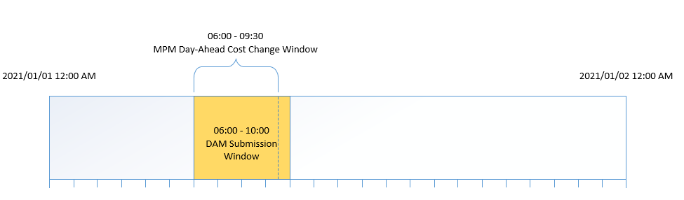

Figure 5‑1: DAM Reference Level Change Request Window



Figure 5‑2: Real-Time Market Reference Level Change Request Window for HE12

### Supporting Documentation

#### Fuel Cost Component Change

(MR Ch.7 s.22.5.5)

The following types of documentation may be submitted to support a request to use a higher fuel cost component in a *resource’s* *reference levels*:

* fuel invoices;
* fuel quotes;
* for day-ahead fuel-cost change requests, the latest available futures price for a day-ahead product on a trading platform for a specific zone in Ontario best representing the *resource’s* location, or, if not practicable, an *offer* submitted by the *market participant* to buy fuel on a trading platform;
* contract terms for fuel procurement;
* documentation related to any process changes used to address varying conditions, such as extreme temperatures and pipeline restrictions;
* written confirmations of the arrangement of fuel purchases at the time the fuel was purchased;
* documentation that shows the average $/MWh charging cost incurred for the last charging cycle, inclusive of historical transmission and distribution charges, prior to the request for the *electricity storage resource*. This documentation should show the metered consumption during this charging cycle as well as the *LMP* of the *electricity storage resource* for each interval of consumption during this set of hours. The documentation should also account for the round trip efficiency of the *electricity storage resource* in the way shown in section 7.6.1.1 below.
* documentation that shows the average $/MWh charging cost expected to be incurred for a future charging cycle based on the prices contained in the Pre-Dispatch Hourly Energy LMP report, inclusive of historical transmission and distribution charges. The documentation should also account for the round trip efficiency of the *electricity storage resource* in the way shown in section 7.6.1.1 below.
* for a *resource* using fuel from its own storage, any of the acceptable documentation from this list and a calculation of its weighted average cost of fuel (WACOF);[3] and
* any other documentation that demonstrates to the *IESO’s* satisfaction that a *resource’s* fuel costs have temporarily increased.

#### Resources with Alternate Cost Profiles

(MR Ch.7 s.22.5.6)

When a *market participant* wishes to request that the *IESO* temporarily use a *resource’s* set of *reference levels* with the highest costs the *IESO* will accept the documentation the *IESO* and the *market participant* agreed upon at the time the *resource’s* *reference levels* were determined pursuant to **MR Ch.7 s.22.4.3**.

### Use of Higher Fuel Cost Component or an Alternate Cost Profile

The *IESO* will use the requested higher fuel cost component or cost profile *reference level* during the applicable *dispatch hours* and will notify the *market participant* of the same, unless the *IESO* finds that:

1. the submitted supporting documentation does not support the request;
2. the *IESO* otherwise rejects the request pursuant to **MR Ch.7 s.22.5.10**; or
3. the value requested for the higher fuel cost component is lower than the fuel cost component value that the *IESO* initially used to calculate *reference level values* for that *dispatch day*.

The *IESO* will notify the *market participant* if it rejects the request.

Rejecting a request for reason (iii) does not permit the *IESO* to carry out any of the actions in **MR Ch.7 s.22.5.10.**

### Documentation Following Use of Alternate Cost Profile Reference Levels

(MR Ch.7 s.22.5.11)

If a *market participant* fails to provide the requested documentation or fails to provide it within the specified time, or the *IESO* finds that the documentation submitted does not support the *market participant’s* request, then the *IESO* may take the actions specified in **MR Ch.7 ss.22.5.10** and **22.5.11**, as the case may be.

### IESO Review of Documentation and Response to Market Participants

Within five *business days* following the *dispatch hours* that were the subject of the request, the *IESO* may review the submitted supporting documentation and will notify the *market participant* if the request was validated or not.

If the *market participant* fails to provide supporting documentation, or if the *IESO* finds that the supporting documentation provided does not support the request, then the *IESO* may take the actions specified in **MR Ch.7 ss.22.5.10.1, 22.5.10.2, 22.5.10.3** and **22.5.10.4**.

– End of Section –

## Cost Components of Financial Dispatch Data Parameters

(MR Ch.7 ss.22.1.1, 22.2.1 and 22.2.2)

This section describes the cost components that are eligible to be included in a *resource*’s *reference level* cost calculation formulas. A *resource’s short-run marginal costs* are eligible cost components for *financial dispatch data* *parameter* calculations. All the cost components described in this section are not applicable for all technology types. Section 7 provides technology-specific guidelines regarding applicable cost components, formulas and supporting documentation required for different *resource* technology types.

### Costs Related to Fuel

Fuel-related costs are the cost of materials used in the operation of a *resource* for the purpose of electricity production.

Fuel commodity costs are adjusted, as applicable, with efficiency or performance metrics to determine fuel-related costs.

#### Performance Factors

Performance factors account for uncertainties across *resources* and changes to *resource* efficiency without having to adjust the heat rate for the *resource*. Changes to *resource* efficiency are measured by the fuel consumption per MWh of production or per start. Performance factors for a *resource* can be impacted by seasonal factors such as ambient conditions and can result in *reference levels* for *financial dispatch data parameters* that differ according to the season. For example, a *resource* could have a higher *energy offer* *reference level* in the season in which the *resource* is less efficient.

### Costs Related to Emissions

Emissions costs are the charges a *resource* incurs associated with regulated emissions that result from *energy* production. The *IESO* will limit the emissions component of the *reference level* calculations to be no less than $0.

### Costs Related to Operating and Maintenance

Operating costs are the costs incurred while operating a *resource*. Maintenance costs are the costs incurred in the upkeep associated with maintaining the *resource*’s systems and equipment in the condition required to perform their intended function. These costs are collectively referred to as O&M costs.

O&M costs incurred are approved by the *IESO* based on information submitted by a *market participant* and are allocated, as applicable, to a *resource*’s:

* *energy offer reference level* ($/MWh);
* *start-up offer reference level* ($/start); and
* *speed no-load offer reference level* ($/hour).

For *energy offers*, the incremental O&M costs needed to produce *energy* are distributed across the total MWh generated for that period to arrive at a $/MWh figure. For *start-up offers*, the eligible incremental O&M costs are those incurred as a result of starting up the *resource*. For *speed no-load offers*, the incremental O&M costs represent the upkeep and expenses incurred for each hour of operation by the *resource*, regardless of loading level or how much *energy* is supplied in a given hour.

Only the portion of O&M costs incurred for the purpose of providing incremental supply of *energy* or *operating reserve* is eligible to be included in a *resource’s* *reference levels*.

The portion of labour costs that is incremental and attributable to eligible maintenance activities may be included in a *resource’s* *reference levels*. Eligible labour costs are limited to staff overtime or contractor labour required for eligible maintenance activities. Staffing costs that do not vary with supply of *energy* or *operating* *reserve* cannot be included into a *resource*’s *reference levels*. For a *resource* that is not continuously staffed and for which a *market participant* can demonstrate that an incremental labour cost is incurred to start or operate the *resource*, the additional costs may be included in the *resource’s* *reference levels*. Incremental costs must be based on actual historical costs or contracts in place for the labour to start or operate the *resource*.

All costs submitted to the *IESO* should be the pre-HST tax amount for the purposes of *reference level* calculations because HST tax is added to any market revenues received by the *market participant*. Non-HST related taxes may be applicable for cost submission.

Maintenance costs associated with the incremental supply of *energy* or *operating reserve* are divided into three categories: major maintenance costs, scheduled maintenance costs and unscheduled maintenance costs. The allocation of eligible O&M costs between incremental *energy offer*, *speed no-load offer*, and *start-up offer reference levels* may vary by *resource* type based on the OEM recommendations for maintenance activities, and by the type of maintenance (major, scheduled or unscheduled maintenance).

O&M costs that do not vary as a result of incremental supply of *energy* or *operating reserve*, referred to as fixed O&M costs, are not eligible costs and cannot be considered when determining a *reference level*. The following costs are examples of fixed O&M costs:

* preventive or routine maintenance that is not directly attributable to incremental supply from the *resource*;
* building maintenance;
* road construction or maintenance;
* landscaping; and
* perimeter security.

#### Major Maintenance Costs

Major maintenance costs are costs related to major component replacements, maintenance activities or inspection of the *resource* that occur during the *resource*’s design life. These costs are necessary to maintain the *resource*’s operational ability for electricity production for its design life and are required as a direct result of incremental electricity production.

The design life of the *resource* is the number of years that the *resource* was expected to operate for at the time that it came into service. As part of determining *reference levels*, the *IESO* determines the design life in discussion with the *market participant*. The initial determination of design life considers any modifications or past improvements undertaken by the *market participant* that may have extended the *resource*’s original design life from when it first entered into commercial operation.

Design life is typically established in the design basis for a *facility*. The design life is used to make key decisions for allowances and material selection in a *facility* (e.g. tube thickness allowances in boilers when the boiler is designed and manufactured).

A *market participant* must submit supporting documentation that identifies the remaining expected design life of a *resource*. Documentation may be in the form of design documentation for a *resource* or studies and assessments of *facility* life.

Any costs associated with performance improvements of a *resource* or any life extension activities beyond the design life established during the initial process to determine *reference levels* are not eligible costs.

Performance improvements are expenditures to improve any of the following characteristics of the *resource* beyond their values determined during the initial process to determine *reference levels*:

* efficiency in the amount of fuel used to produce a fixed MWh quantity of *energy*;
* maximum production capability; or
* availability to supply *energy* or *operating reserve*, including modifications to enable alternate operating modes at the *resource*.

If performance improvement projects are undertaken in lieu of major maintenance, the estimated cost for the major maintenance is eligible for inclusion in the *resource*’s *reference levels*. However, the incremental cost to undertake the performance improving project is ineligible.

Major maintenance conducted on *resources* can vary significantly between different technology types. Section 7 describes the eligible major maintenance components and required supporting documentation by technology type.

#### Scheduled Maintenance Costs

Scheduled maintenance costs are costs associated with routine maintenance tasks performed on electrical and mechanical equipment. A *market participant* may update these costs on an as-needed basis.

Scheduled maintenance costs will only be approved for activities that result from an incremental supply of *energy* or *operating reserve*. Examples of eligible costs include the cost of consumable materials and overtime labour specifically required to perform these maintenance activities above base labour required for fixed O&M.

#### Unscheduled Maintenance Costs

Unscheduled maintenance costs are costs associated with all non-scheduled maintenance activity needed for equipment required for incremental electricity production. Such equipment includes mechanical, electrical and/or instrumentation and controls systems required to return the *resource* to full operation in the event of an equipment failure. Examples of eligible costs include overtime labour or third-party labour contracted to repair the components and materials cost associated with any such repairs.

Eligible costs are limited to unscheduled maintenance for turbine, *generation unit*, transformer, or balance of plant components that result from incremental supply of *energy* or *operating reserve*. Expenses related to any system or equipment needed to remain in-service when a *resource* is not in operation are not eligible costs.

#### Incremental Third-Party Payments

Eligible incremental third-party payments for *resources* are payments that are paid on the basis of incremental generation and which are due to third parties, such as royalties, payments to Indigenous communities, and land lease agreements.

A *market participant* must delineate whether the costs are incurred based on measurements at the *resource* *revenue meter* or via Supervisory Control and Data Acquisition (SCADA) measurements and ensure that the *resource* operational meter is used as the reference for determining the *reference level* cost.

### Opportunity Costs

*Resources* with intertemporal production limitations, such as hydroelectric and *electricity storage resources*, may face an opportunity cost when they submit *offers* for *energy* because they may forego future *energy* or *operating reserve* revenues due to operational limitations. For example, when a hydroelectric *resource* with limited water in storage uses that water to produce *energy* in the current *dispatch day*, it may incur an opportunity cost because it foregoes the chance to use that water to produce *energy* at a higher price in a future *dispatch day*.

Opportunity costs that are related to foregone *energy* or *operating reserve* revenues may be included in the *energy offer reference level* or *operating reserve offer reference level* for *resources* with intertemporal production limitations. Opportunity costs for these *resources* represent the expected future *energy* or *operating reserve* revenues that a *market participant* may forego as a result of submitting *energy* or *operating reserve offers* in the current *dispatch day*.

Only opportunity costs affecting a *resource’s* *energy* or *operating reserve market* revenues may be included in the *resource’s reference levels*.

#### Requesting Additional Opportunity Costs

If a *resource’s* operational characteristics are such that an additional opportunity cost related to material amounts of foregone *energy* or *operating reserve* revenues is incurred that is not already reasonably addressed by market design, a *market participant* may request an additional opportunity cost in the *reference level* submission for that *resource*.

In order to request an additional opportunity cost, the *market participant* must submit the proposed methodology for calculating the opportunity cost and documentation supporting the proposed opportunity cost. The supporting documentation must explain:

* the operational characteristic of the *resource* that is not reasonably addressed by the already-submitted opportunity costs and how this creates an opportunity cost related to foregone *energy* or *operating reserve* revenues;
* the mathematical formulation of the additional opportunity cost; and
* how the *IESO* calculates the additional opportunity cost, including identifying the specific data that would be required to support this calculation.

The *IESO* may deny the request for an additional opportunity cost if, in the *IESO’s* opinion, the request does not meet the above requirements.

In addition, the *IESO* shall not register an additional opportunity cost as part of a *resource’*s *reference levels* if, in the *IESO’s* opinion, any of the following conditions is true:

* the operational characteristic identified is reasonably addressed by the opportunity costs described in section 6.4.3, section 6.4.4 or section 6.4.5;
* submitting *energy* or *operating reserve offers* does not, in practice, create an additional opportunity cost relating to foregone *energy* or *operating reserve* revenues for the *resource*;
* the quantum of the additional opportunity cost, as per the formulation submitted by the *market participant*, is not material;
* it is not reasonable to expect that the foregone *energy* or *operating reserve* revenue would have otherwise been received assuming the *resource* was subject to *unrestricted competition*;
* the opportunity cost is otherwise addressed through market design or system design;
* the proposed formulation does not result in a reasonable estimate of the additional opportunity cost;
* the additional opportunity cost requested addresses foregone revenues that are not *energy* or *operating reserve* revenues; or
* implementing the additional opportunity cost would require the *IESO* to incur IT solution development costs.

#### Opportunity Cost Formula

The opportunity cost component of the *energy offer reference level* is the sum of all subcomponent opportunity costs.

The opportunity cost component of the *energy offer reference level* for a hydroelectric *resource* contains three subcomponents: an intraday opportunity cost, a storage horizon opportunity cost, and a *forebay* refill opportunity cost.

The opportunity cost component of the *energy offer reference level* for a hydroelectric *resource* is:

The Opportunity Cost equation is a measure of the opportunity costs that a resource incurs for incremental production. It is calculated by the summation of the storage horizon opportunity cost adder, the intraday opportunity cost adder and the forebay refill opportunity cost.



#### The Intraday Opportunity Cost

The intraday opportunity cost accounts for the opportunity cost of shifting production for a *dispatch hour* after *day-ahead market* schedules and prices are determined for *resources* that have limited ability to supply *energy* in a *dispatch day*.

##### Eligibility

The intraday opportunity cost is eligible for use for *resources* that are *energy*-limited below their maximum available capacity for a *dispatch day*. *Resources* that submit a *maximum daily energy limit* that is less than the maximum capacity of the *resource* across the *dispatch day* meet this criterion.

*Maximum daily energy limits* are submitted on a *forebay* for *resources* that are registered as part of a *forebay*. When a *maximum daily energy limit* is submitted for a *forebay*, the intraday opportunity cost may be eligible for use in the *energy offer reference level* for *resources* in the *forebay*. A *maximum daily energy limit* submitted for *forebays* that is less than the summation of all *dispatchable* hydroelectric *resources* capacity of the *forebay* across the *dispatch day* meet the criterion to use the intraday opportunity cost.

The intraday opportunity cost is calculated by the *IESO* by default for *generation resources* at *electricity storage resources*. The intraday opportunity cost is also calculated by the *IESO* for hydroelectric *resources* that submit a *maximum daily energy limit* that is less than the available capacity for that *dispatch day*. Available capacity is determined based on the sum of the maximum active power capability of all *generation units* associated with the *resource* less planned *outages*.

Other *resources* that can submit a *maximum daily energy limit* for a *dispatch day* may request use of the intraday opportunity cost adder when registering *reference levels*. The *IESO* will include the intraday opportunity cost in the calculation of *reference level values* for any such *resources* when their *maximum daily energy limit* is less than the *resource’s* available capacity.

*Variable generation resources* are not eligible to request use of the intraday opportunity cost.

##### Application

The intraday opportunity cost is calculated by the *IESO* for all eligible *resources* after *day-ahead market* schedules and prices are set and is added to the *reference level values* for a *resource* that will be used in the *real-time market*.

##### Methodology

The intraday opportunity cost is the maximum of $0/MWh and the maximum *day-ahead market* *LMP* for the *dispatch day* for the *resource*.

#### The Storage Horizon Opportunity Cost

The storage horizon opportunity cost accounts for the opportunity cost for hydroelectric *resources* of foregoing *energy* revenues from future *dispatch days* when producing a MWh of *energy* in the current *dispatch day*.

##### Eligibility

The storage horizon opportunity cost is eligible for use for *dispatchable* hydroelectric *resources* with a storage horizon (measured in days) greater than 1. The storage horizon of a *resource* is calculated when *reference levels* are determined for that *resource*.

A *market participant* that wishes to use the storage horizon opportunity cost for a *resource* must indicate that they intend to do so when *reference levels* are determined for that *resource*. They must also submit the storage horizon calculation to the *IESO* as part of the *reference level* submission.

##### Information Required

In order for the *IESO* to apply the storage horizon opportunity cost for a *resource*, the following information must be submitted in the relevant *reference level* submissions:

* the storage horizon, in days, calculated in accordance with the equation below;

The following data, gathered by the *IESO* on a rolling basis, is also used to calculate the storage horizon opportunity cost:

* historical hourly average *LMPs* of the *resource*;
* Intercontinental Exchange (ICE) NYISO Zone A, Day-Ahead monthly price forecasts for the storage horizon; and
* NYISO Zone A, hourly *day-ahead market* *settled* prices.

**Approach to Determine Base LMPs**

Base *LMPs* are used as the starting point to forecast *LMPs* for the *resource* when evaluating foregone *energy* revenues related to the storage horizon opportunity cost. There are two approaches for calculating the base *LMPs* used in the calculation of storage horizon opportunity cost. These approaches are described below. Under both approaches, the *IESO* smooths extreme values of *LMPs* when determining the storage horizon *LMP*, but the smoothing technique differs by approach. High-level descriptions of the smoothing technique used under these approaches are also found below.

**Approach 1**

Under this approach, the base *LMPs* for the *resource* are based on the historical hourly *LMPs* at the *resource* from year preceding the current year. For example, to determine the base *LMPs* for May 2022 under Approach 1, the *IESO* would use *LMPs* from May 2021 as the historical *LMP* input.

**Approach 2**

Under this approach, the base *LMPs* for the *resource* are based on the historical hourly *LMPs* at the *resource* from the 28 days prior to the calculation date. For example, to determine the base *LMPs* for May 1, 2022 under Approach 2, the *IESO* would use *LMPs* from the 28 days prior to the calculation date as the historical *LMP* input.

**Determining the Storage Horizon**

A *market participant* requesting the storage horizon opportunity cost for a hydroelectric *resource* must submit the storage horizon requested for the *resource*. The *market participant* must also submit supporting documentation that demonstrates that the calculation of the storage horizon was carried out in accordance with the methodology described below.

*Resources* that share a *forebay* must determine the maximum possible water in storage per *resource* based on the pro rata share of installed capacity of *resources* that share the *forebay*, as described below.

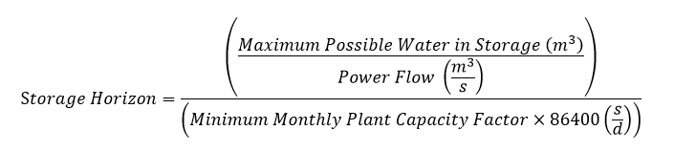

Where:

* Maximum Possible Water in Storage (m3): The volume between the maximum allowed (e.g. lake compliance maximum) and the minimum allowed (e.g. lake compliance minimum) for the *forebay* associated with the *resource*. *Resources* that share a *forebay* allocate the maximum possible water in storage to all *resources* that share the *forebay* pro rata based on installed capacity of the relevant *resources*;
* Power flow (m3/s): Maximum turbine flow (m3/s), aggregated for the *generation units* in the *resource*; and
* Minimum Monthly Plant Capacity Factor: The minimum of the average monthly capacity factor of the *resource*, calculated in the following manner:

1. Calculate the monthly capacity factor for the *resource* for each month in the five-year historical study period. The historical study period is the 5 years preceding the current year.

The monthly capacity factor is:

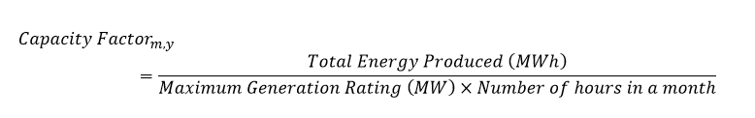  
This creates a data set of 60 monthly capacity factors.

1. For each calendar month in the historical study period, average the five monthly capacity factors.

For example:   
  
January 2020 Capacity Factor =

(Jan 2019 CapFactor + Jan 2018 CapFactor + Jan 2017 CapFactor + Jan 2016 CapFactor + Jan 2015 CapFactor)/5

This creates a data set of 12 monthly average capacity factors.

1. Take the minimum of the 12 monthly average capacity factors from the second step. This is the minimum monthly capacity factor used in the storage horizon calculation above.
2. The calculated storage horizon for the *resource* is capped to to a maximum of 365 days.

**Determining the Storage Horizon for Hydroelectric Resources on a Cascade Group**

*Resources* that are part of a *cascade* *group* calculate the storage horizon for the storage horizon opportunity cost as follows:

1. Calculate the storage horizon for each *resource* in the *cascade group* according to the methodology above.
2. For each *forebay* in the *cascade group* that is at or downstream of the *forebay* of the relevant *resource*, identify the storage horizon at the *resource* at that *forebay* with the maximum storage horizon.
3. Sum the maximum storage horizons for all *resources* identified in step 2.
4. Add the sum from step 3 to the storage horizon calculation for each *resource* that shares the *forebay* of the relevant *resource* in the *cascade group*.
5. The calculated storage horizon for each *resource* in the *cascade group* is capped to a maximum of 365 days.

For example, assume a *cascade group* where *resources* A and B share a *forebay* at the top of the *cascade group*, Resources C and D share a *forebay* in the middle of the *cascade group* and *resources* E and F share a *forebay* at the bottom of the *cascade group*.

The *market participant* for this *cascade group* would first calculate the values in the third column as per the methodology above.

Table 6‑1: Example of Data Used to Determine the Cascade Group Storage Horizon

| **Forebay** | **Resource** | **Storage Horizon** |
| --- | --- | --- |
| 1 | A | 10 |
| 1 | B | 11 |
| 2 | C | 2 |
| 2 | D | 1 |
| 3 | E | 4 |
| 3 | F | 3 |

To determine the *cascade group* storage horizon for Resource A, a *market participant* determines the storage horizon values in the third column.

The storage horizon for Resource A:

= 10 + MAX (2,1) + MAX (4,3)

= 10 + 2 + 4

= 16

Similarly, the storage horizon for Resource B:

= 11 + MAX (2,1) + MAX (4,3)

= 11 + 2 + 4

= 17

The *IESO* would use the 16-day storage horizon to determine the storage horizon opportunity cost for *resource* A and would use the 17-day storage horizon to determine the storage horizon opportunity cost for Resource B.

To determine the *cascade group* storage horizon for Resource C, a *market participant* determines the storage horizon values in the third column.

The storage horizon for Resource C:

= 2 + MAX (4,3)

= 2 + 4

= 6

Similarly, the storage horizon for Resource D:

= 1 + MAX (4,3)

= 1 + 4

= 5

The *IESO* would use the six-day storage horizon to determine the storage horizon opportunity cost for Resource C and would use the five-day storage horizon to determine the storage horizon opportunity cost for Resource D.

To determine the *cascade group* storage horizon for Resource E, a *market participant* determines the storage horizon values in the third column.

The storage horizon for Resource E:

= 4

Similarly, the storage horizon for Resource F:

= 3

The *IESO* would use the four-day storage horizon to determine the storage horizon opportunity cost for Resource E and would use the three-day storage horizon to determine the storage horizon opportunity cost for Resource F.

##### Methodology

The *IESO* calculates the storage horizon opportunity cost in the following manner:

1. First a set of historical LMPs at the *resource* is determined. This profile is referred to as the base *LMPs* for the *resource* and shows what *LMPs* occurred in the past at the *resource*.
2. The base *LMPs* are then adjusted to create the set of forecasted *LMPs* for the *resource*. The *IESO* determines the adjustment based on the relationship between *settled* prices and future prices for NYISO Zone A. If the NYISO Zone A future price trend from the relevant historical period is a 50% increase, then the base *LMP* for that future date is the base *LMP* times 1.5.
3. The *IESO* then adjusts the forecasted *LMPs* to account for efficiency impacts of trading future production at efficiency for production in the current *dispatch day* at a less efficient MW rating. The outcome of this adjustment is efficiency-adjusted forecast *LMPs*.
4. The storage horizon opportunity cost is selected from the efficiency-adjusted forecast *LMP* across the storage horizon for the *resource* as described under Approach 1 and Approach 2, below.

###### Storage Horizon Opportunity Cost Methodology under Approach 1

Determining the Approach 1 Base LMPs

The *IESO* calculates the base *LMPs* for the *resource* in the manner described below, according to the election for the *resource* from section 6.4.4.2.

Using the calculated storage horizon of the *resource*, the *IESO* determines the dates of the *resource’s* storage horizon that immediate follow the current *dispatch day* (the forecast period) and the corresponding dates of the storage horizon from the previous year that will provide the reference data.

The current day and month on which opportunity costs are being determined are denoted $d_{0}$ and $m_{0}$. The storage horizon is $d^{SH}$ days long and the days in the storage horizon are contained in months $\left\{m_{0}, m_{0}+1, …,m^{SH}\right\}$ in the year $y$.

The *IESO* will determine the hourly average *real-time market* *LMPs* at the *resource*, node $n$, for months $\left\{m_{0}, m_{0}+1, …,m^{SH}\right\}$ on the reference dates.

${LMP}_{n, d,h}^{m, y-1}$ is the reference hourly average *real-time market LMP* at node $n$ in hour $h$ of day $d$ of month $m$ in year $y-1$.

Creating the Approach 1 Forecasted LMPs

*Settled* and future *day-ahead market* peak and off-peak prices at NYISO Zone A, sourced from the Intercontinental Exchange (ICE) will be used to adjust base *LMPs* to create the set of forecast *LMPs* for the upcoming storage horizon.

Let

* ${Hours}_{on-peak}^{d,m,y-1}$ be the set of on-peak hours in day $d$ of month $m$ in year [4]
* be the set of off-peak hours in day $d$ of month $m$ in year $y-1$

For each month $mϵ\left\{m_{0}, m_{0}+1, …,m^{SH}\right\}$, the *IESO* will determine the average of the *settled* *day-ahead market* *LMPs* in Zone A from the NYISO market for on-peak hours and for off-peak hours in each month $m$.

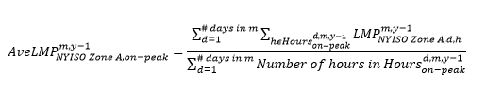

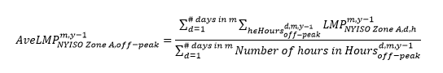

ICE produces futures *day-ahead market* prices for on-peak energy in each month $mϵ\left\{m_{0}, m_{0}+1, …,m^{SH}\right\}$ in year $y$ at NYISO Zone A. Also, ICE produces futures *day-ahead market* prices for off-peak energy in each month $mϵ\left\{m_{0}, m_{0}+1, …,m^{SH}\right\}$ in year $y$ at NYISO Zone A.

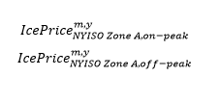

Calculate the factors:

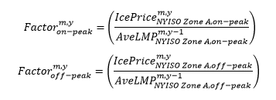

These factors are used to adjust the base *LMPs*, ${LMP}_{n,d, h}^{m,y-1}$ to produce the set of forecasted *LMPs*, ${LMP}_{n, d,h}^{m, y}$.

In the following, assume that hour $h$ on day $d$ in month $m$ of year $y$ and hour $h$ on day $d$ in month $m$ of year $y-1$ are either both on-peak or both off-peak.

If hour $h$ on day $d$ in month $m$ in year $y$ is on-peak, set

The monthly off-peak factor equation is calculated by the NYISO Zone A ICE futures off-peak price divided by the average settled NYISO Zone A off-peak price of the month in the previous year.

If hour on day in month in year is off-peak, set

The off-peak hourly forecast LMP is calculated from the off-peak monthly factor multiplied against the resource’s hourly base off-peak LMPs of the previous year’s storage horizon.

Adjusting the Approach 1 Forecast LMPs for Efficiency

The *IESO* will adjust the Approach 1 forecast *LMPs* by an efficiency factor when determining the Approach 1 selected value.

The following assumptions underpin the rationale for the efficiency adjustment:

* absent ex-ante mitigation, *resources* would produce within the storage horizon at the efficiency rating of the *resource*; and
* when a hydroelectric *resource* is mitigated, it will result in it being dispatched above the efficiency rating of the *resource*.

The following data will be used to determine the efficiency adjustment that will be used for a *resource.*

Efficiency adjustment

The Efficiency Adjustment is a constant factor of 1.07 and reflects the decrease of relative efficiency between the output at the best efficiency point and the maximum output while head is constant.

The efficiency adjustment equation is the incremental flow rate to produce one MWh at best efficiency over the incremental flow rate to produce one MWh at maximum gate.

Where:

To adjust the Approach 1 forecast *LMPs* for efficiency, the *IESO* multiplies each Approach 1 forecast *LMP* by the efficiency adjustment. This creates the set of Approach 1 efficiency-adjusted forecast *LMPs*.

Efficiency adjustment request for a resource with a single generating unit

Should a *market participant* indicate that its unit’s efficiency decrease is higher than the efficiency modifier provided, the *market participant* may request an alternative value by submitting supporting documentation, on a unit-by-unit *resource* basis. This documentation must be submitted during the *reference level* submissions and include one of the following:

1. Hill chart provided by the manufacturer for the unit highlighting efficiency at the peak efficiency point and the maximum output for the unit. The two points must be at the head level at which the peak efficiency is achieved, and within the operating range of the unit.
2. Efficiency curve for the unit at any constant head level within the operating range, which shows either efficiency vs. power, or efficiency vs. gate.
3. Absolute or relative (by index testing) efficiency curves are acceptable
4. Efficiency curves shall be prepared by a third party. A third party is an engineering or consulting service and is not affiliated with the *market participant*.

In the supporting documentation for each unit, the *market participant* shall provide to the *IESO* the following information:

1. Capacity (MW) at best/peak efficiency point of the unit
2. Capacity (MW) at maximum output of the unit
3. Single head value (m) for both best/peak efficiency and maximum output
4. Efficiency (%) at best/peak efficiency
5. Efficiency (%) at maximum output

The following table provides an example of the efficiency calculation.

Table 6‑2: Example of Efficiency Calculation

| **Point** | **Description** | **Head** | **Efficiency** | **Power (% Rated)** |
| --- | --- | --- | --- | --- |
| 1 | Best Efficiency Point | 25 | 92.50% | 81% |
| 2 | Rated Conditions (Head + Power) | 25 | 89% | 100% |

Relative Efficiency is calculated as:

-1 x (89%-92.5%)/92.5%= 3.78%

The *resource*’s efficiency loss is 3.78%

Efficiency adjustment request for a *resource* with multiple aggregated generating units

For *resources* comprised of multiple *generating units*, a *market participant* may use a capacity weighting of the efficiency values of individual units to determine the total efficiency adjustment for the *resource*. The supporting documentation required from the *market participant* remains the same as the requirements for *resource* with a single *generating unit*, which are detailed in the previous section.

The following steps describe how to complete the efficiency adjustment calculation for a *resource* with multiple *generating units*:

1. For each unit, calculate the flow in (m3/s) at best efficiency and maximum output using the gathered inputs. To calculate the flow, use the following equation:

$Capacity×1000/(Head×9.8×Efficiency) = Flow (m^{3}/s)$

Table 6‑3: Step 1 of Multiple Units Efficiency Calculation Example

|  |  | **Unit A** | |
| --- | --- | --- | --- |
| **Variable** | **Unit of Measure** | **Best Efficiency** | **Maximum Output** |
| Capacity | MW | 18 | 20 |
| Head | m | 30 | 30 |
| Efficiency | % | 95% | 90% |
| Flow | m3/s | 64.4 | 75.6 |

1. Sum the capacity and flow values across each unit to get a total value for each variable. The head in meters remains a fixed input and doesn’t change in this calculation. The following table illustrates an example of adding the best efficiency capacity megawatts of Unit A (18 MW), Unit B (4 MW) and Unit C (10 MW) into the Total column (18+4+10= 32 MW).

Table 6‑4: Step 2 of Multiple Units Efficiency Calculation Example

|  | **Unit A** | | **Unit B** | | **Unit C** | | **Total** | |
| --- | --- | --- | --- | --- | --- | --- | --- | --- |
| **Variable** | **Best Efficiency** | **Maximum Output** | **Best Efficiency** | **Maximum Output** | **Best Efficiency** | **Maximum Output** | **Best Efficiency** | **Maximum Output** |
| Capacity | 18 | 20 | 4 | 10 | 10 | 15 | **32.0** | 45.0 |
| Head | 30 | 30 | 30 | 30 | 30 | 30 | 30 | 30 |
| Efficiency | 95% | 90% | 85% | 80% | 92% | 80% |  |  |
| Flow | 64.4 | 75.6 | 16.0 | 42.5 | 37.0 | 63.8 | 117.4 | 181.9 |

1. Calculate, for all the units, the best efficiency and efficiency at maximum output by substituting the total capacity, head and flow using the following equation: $Efficiency=Capacity*1000/(Flow*9.8*Head)$

Table 6‑5: Step 3 of Multiple Units Efficiency Calculation Example

|  | **Total** | |
| --- | --- | --- |
| **Variable** | **Best Efficiency** | **Maximum Output** |
| Capacity | 32.0 | 45.0 |
| Head | 30 | 30 |
| Efficiency | **92.6%** | **84.1%** |
| Flow | 117.4 | 181.9 |

1. Determine the maximum output loss as the difference between the *resource’s* calculated best efficiency and efficiency at maximum output.

Relative Efficiency: -1 x (84.1%-92.6%)/92.6%= 9.18%  
The *resource’s* efficiency loss across all its units is 9.18%

**Determining the Approach 1 Selected Value**

The *IESO* orders the Approach 1 efficiency-adjusted forecast *LMPs*, ${LMP}_{n,d, h}^{m, y}$, over the storage horizon from lowest to highest. The greater of $0/MWh and the value which is greater than 98% ($P\%$) of the *LMPs* over the storage horizon is the Approach 1 selected value.

For example, suppose that the storage horizon starts on day 5 of April and ends on day 4 of August. The storage horizon has 122 days and includes 2,928 hours. Choosing the 98th percentile would set the Approach 1 selected value based on the 58th highest hourly *LMPs* over the storage horizon.

**Storage Horizon Opportunity Cost under Approach 2**

**Creating the Approach 2 Base LMPs**

Using the registered storage horizon length, the *IESO* will determine the dates of the *resource*’s storage horizon that immediately follow the current *dispatch day* (the forecast period). For these calculations, let the current day and month on which opportunity costs are being determined be denoted $d_{0}$ and $m_{0}$. Let the storage horizon be $d^{SH}$ days long and assume that these days in the storage horizon are contained in months $\left\{m_{0}, m_{0}+1, …,m^{SH}\right\}$ in the year $y$.

The *IESO* will also determine the dates for the *resource’s* 28-day study period that immediately precede the current *dispatch day* that will provide the reference data. For clarity, the 28-day reference period ends on the day before the *dispatch day* or two days before the day-ahead *dispatch day*. The *IESO* will calculate the average *LMP* at the *resource’s* node, n, for each hour and day of the week over the study period ($SP$).

Let:

* ${LMP}_{n, d,h}^{SP}$ be the hourly LMP at node $n$ in hour $h$ of day $d$ in $SP$
$δ\left(d,SP\right)=Day of Week of day d in SP$

* DOW be the day of the week for which the average is being calculated.

Calculate:

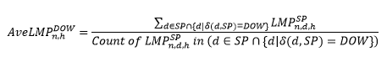

**Creating the Approach 2 Forecasted LMPs**

ICE peak and off-peak futures prices at NYISO Zone A will be used to adjust these average *LMPs* to develop a forecast of hourly *LMPs* over the months in the upcoming storage horizon, months $m_{0}, m_{0}+1, …,m^{SH}$.

Let:

* ${Hours}_{on-peak}^{d,SP}$ be the set of on-peak hours in day $d$ in $SP$
* ${Hours}_{off-peak}^{d,SP}$ be the set of off-peak hours in day $d$ in $SP$

For the study period, determine the average of the *settled* *day-ahead market* *LMPs* in Zone A from the NYISO market for on-peak hours and for off-peak hours in the .

The Average NYISO Zone A On-Peak equation calculates the average hourly on-peak LMP per month of a study period in by taking the sum of all hourly on-peak LMPs of the study period divided by the number of on-peak hours.

The Average NYISO Zone A Off-Peak equation calculates the average hourly off-peak LMP per month of a study period in by taking the sum of all hourly off-peak LMPs of the study period divided by the number of off-peak hours.

ICE produces futures prices for on-peak *energy* in each month $m$ in the storage horizon at NYISO Zone A. Also, ICE produces futures prices for off-peak *energy* in each month $m$ in the storage horizon at NYISO Zone A.

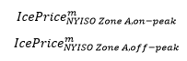

Calculate the factors for each month:

The monthly on-peak factor equation is calculated by the NYISO Zone A ICE futures on-peak price divided by the average settled NYISO Zone A on-peak price of the study period.
The monthly off-peak factor equation is calculated by the NYISO Zone A ICE futures off-peak price divided by the average settled NYISO Zone A off-peak price of the study period.

Multiply the previously calculated average *LMPs* for each hour in the given day of the week by the calculated multipliers to produce an estimate of the future *LMP* for each hour in the storage horizon.

If hour $h$ on day $d$ in month $m$ is on-peak, set

The on-peak hourly forecast LMP is calculated from the on-peak monthly factor multiplied against the resource’s average hourly base on-peak LMPs of the study period.

If hour on day in month in year is off-peak, set

The off-peak hourly forecast LMP is calculated from the off-peak monthly factor multiplied against the resource’s average hourly base on-peak LMPs of the study period.

**Adjusting the Approach 2 LMPs for Efficiency**

Approach 2 uses the same approach to create the set of efficiency-adjusted forecast *LMPs* for the storage horizon as does Approach 1, a short summary of the methodology found above is shown in this section.

The Efficiency Adjustment is a constant factor of 1.07 and reflects the decrease of relative efficiency between the output at the best efficiency point and at maximum output while head is constant.

The efficiency adjustment equation is the incremental flow rate to produce one MWh at best efficiency over the incremental flow rate to produce one MWh at maximum gate.

Where:

A *market participant* may indicate that its unit(s)’ relative efficiency decrease is higher than the efficiency modifier provided. In this case, the *market participant* may request an alternative value for the efficiency adjustment by submitting supporting documentation, on a unit-by-unit *resource* basis. The supporting documentation required is described under the first option.

To adjust the Approach 2 forecast *LMPs* for efficiency, the *IESO* multiplies each Approach 2 forecast *LMP* by the efficiency adjustment. This creates the set of Approach 2 efficiency-adjusted forecast *LMPs*.

**Determine the Approach 2 Selected Value**

The Approach 2 selected value is the maximum of $0/MWh and the largest Approach 2 efficiency-adjusted forecast *LMP* forecast over all hours in the storage horizon.

**Determine the Storage Horizon Opportunity Cost Value**

The storage horizon opportunity cost value for a *resource* is the maximum of the Approach 1 selected value and the Approach 2 selected value for a *dispatch day*.

#### The Forebay Refill Opportunity Cost

(MR Ch.7 ss.22.4.3 and 22.5)

An *energy* *limited* *resource* that is also a hydroelectric *resource* that may submit *offers* for *operating reserve* may incur an opportunity cost if it uses the limited water in its *forebay* to produce *energy* in the current *dispatch day* when the level of water in its *forebay* is sufficiently low, which may result in the *resource* forgoing *operating reserve* revenues in future *dispatch days*.

This opportunity cost reflects the value of these future *operating reserve* revenues when the circumstances are such that if the *resource* produces *energy,* it would be unable to provide *operating reserve* until such a time as sufficient inflows have been received into the *resource’s* *forebay*.

For *resources* that are registered as part of a *cascade group*, the *forebays* of any downstream *resources* are accounted for when determining the *forebay* refill opportunity cost for a *resource*, as described in section 6.4.5.3.

For a *resource* with an established storage horizon of greater than three hours, a *market participant* wishing to include the *forebay* refill opportunity cost in its *energy offer reference level* may request alternate cost profile *reference levels* consistent with **MR Ch.7 s.22.4.3**. In order to request use of the alternate cost profile *reference levels* that include the *forebay* refill opportunity cost in accordance with **MR Ch.7 s.22.5.6**, the *market participant* must notify the *IESO* when the relevant conditions have been met and submit supporting documentation demonstrating that these conditions were met. Specifically, when a *resource* has no more than three hours of water remaining in its *forebay*, it may submit a request to the *IESO* to request use of the alternate cost profile *reference levels* that include this opportunity cost. The window to submit use of this request is described in Section 5.1.

Such supporting documentation includes, but is not limited to:

1. documentation that shows the actual headwater levels and a curve of headwater level versus storage (in hours). If the curve relates only to cubic meters, the *IESO* also requires the flow rate of units to calculate hours of operation; or
2. the following calculation that relies in part on *dispatch data* submitted by the *market participant* for an individual *resource*:

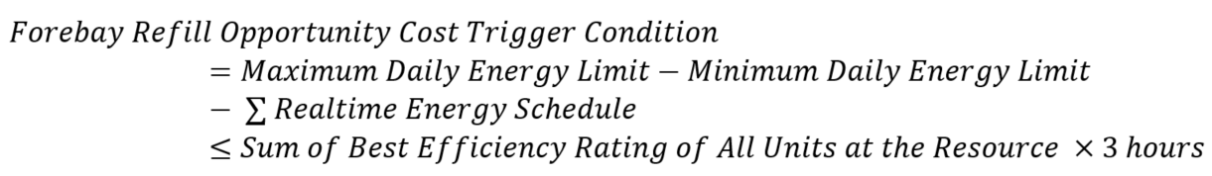

To submit the calculation under b) as a form of supporting documentation, the *resource* must have submitted real-time *energy* schedule data as well as the following *dispatch data*: a *maximum daily energy limit*, *maximum daily energy limit* reason code as ‘Fuel Availability’ and a *minimum daily energy limit* prior to the close of the windows described in section 5.1. Screenshots of these values in the *IESO* submission screens and the relevant reports are required. If real-time *energy* production reduces the available *energy* below the submitted Max DEL throughout the *dispatch day*, then the *market participant* includes the real-time *energy* schedule as supporting data. Supporting documentation required to support the best efficiency rating of a *generation unit* is the same supporting documentation described in the efficiency adjustment portion of the storage horizon opportunity cost in section 6.4.4.3.

Example 1:

Max. DEL = 300 MWh  
Min. DEL = 100 MWh

Real-time energy schedule = 50 MWh  
Best Efficiency Rating = 75 MW

Forebay Refill Opportunity Cost Trigger Condition = 300 MWh – 100 MWh – 50 MWh<= 75 MW x 3

150 MWh <= 225 MWh   
True, therefore, the *resource* is eligible to trigger/request the use of FROC.

1. The following calculation that relies in part on *dispatch data* submitted by the *market participant* for a *resource* that is registered to a *forebay* as part of a *cascade group*:

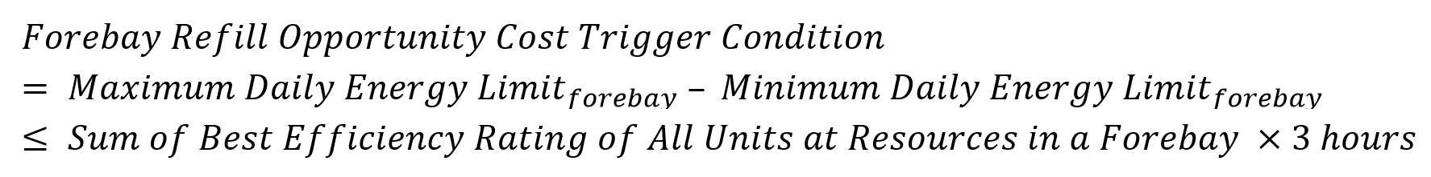

To submit the calculation under c) as a form of supporting documentation, the *forebay* must have submitted the following *dispatch data*: a *maximum daily energy limit*, *maximum daily energy limit* reason code as ‘Fuel Availability’ and *a minimum daily energy limit* prior to the close of the windows described in section 5.1. Screenshots of these values in the IESO submission screens are required. Supporting documentation required to support the best efficiency rating of a *generation unit* is the same supporting documentation described in the efficiency adjustment portion of the storage horizon opportunity cost in section 6.4.4.3.

Example 2:

Max. Forebay DEL = 800 MWh  
Min. Forebay DEL = 400 MWh  
Best Efficiency Rating Resource 1 Unit 1= 60 MW  
Best Efficiency Rating Resource 2 Unit 1= 70 MW  
Best Efficiency Rating Resource 2 Unit 2= 80 MW

Forebay Refill Opportunity Cost Trigger Condition = 800 MWh – 400 MWh <= (60+70+80 MW) x 3

400 MWh <= 630 MWh   
True, therefore, the *resource* is eligible to trigger/request the use of FROC.

Once the request has been submitted to the *IESO*, the *IESO* will begin including this opportunity cost in the *reference level* *value* calculation of the *resource*.

If a *resource* has a storage horizon calculated in accordance with section 6.4.4.2 of less than or equal to three hours (or 0.125 days, which is the unit that storage horizon is expressed in above), the *forebay* refill opportunity cost will always be applied to the *energy offer reference level.* *Market participants* do not need to submit a request to use an alternate cost profile.

##### Eligibility

The *forebay* refill opportunity cost may be used by a *dispatchable* *energy* *limited* *resource* that is a hydroelectric *resource* that provides any class of *operating reserve* into *IESO-administered markets*, including *dispatchable* hydroelectric *resources* that are registered with the *IESO* as part of a *cascade group*. The steps to calculate the *forebay* refill opportunity cost differ for a *resource* that is registered with the *IESO* as part of the last *forebay* of a *cascade group* compared to a *resource* that is not registered with the *IESO* as part of the last *forebay* of a *cascade group*. Section 6.4.5.3 describes the steps used to calculate the *forebay* refill opportunity cost in each approach.

The *market participant* must submit additional data during the process to determine the *resource’s* *energy offer reference level.*

The following information must be submitted to the *IESO* to determine the relevant *energy offer reference level*:

* MW rating at best efficiency;
* volume of water required to refill 1 hour of production at best efficiency rating; and
* five-year historical hourly inflows into the *forebay*.

##### Application

The *forebay* refill opportunity cost is calculated by the *market participant* during the process to determine *reference levels* and is incorporated into the determination of *reference level values* for the *day-ahead market* and the *real-time market*.

This calculation may be updated at the request of either the *market participant* or the *IESO* by using the process to determine *reference levels*.

A *resource* that uses the *forebay* refill opportunity cost will have two *energy offer reference levels:* one that does not account for the *forebay* refill opportunity cost (a lower-cost profile) and one that accounts for the *forebay* refill opportunity cost (a higher-cost profile). The *IESO* will use the lower-cost profile *reference level* by default. If the *resource* meets the conditions described in section 6.4.5, and the *market participant* notifies the *IESO* and submits the relevant supporting information in accordance with **MR Ch.7 s.22.5.6**, the *IESO* will use the higher-cost profile that accounts for the *forebay* refill opportunity cost.

When a *resource* has a storage horizon calculated in accordance to section 6.4.4.2 of less than or equal to three hours (or 0.125 days, which is the unit that storage horizon is expressed in above), the *forebay* refill opportunity cost will always be applied to the *energy offer reference level.* *Market participants* do not need to submit a request to use an alternate cost profile.

Example:  
A *cascade group* has six *dispatchable* *resources* and three *forebays*. Each *forebay* has two *dispatchable* *resources* registered to it. Assume that all six resources have registered the *forebay* refill opportunity cost.

Table 6‑6: Example of Requesting Forebay Refill Opportunity Cost for a Cascade Group Resource

| **Forebay** | **Resource** |
| --- | --- |
| 1 | A |
| 1 | B |
| 2 | C |
| 2 | D |
| 3 | E |
| 3 | F |

Resource A has three hours of water remaining to generate *energy* at the *resource’s* best efficiency rating, and the *market participant* requests use of the *forebay* refill opportunity cost. The request for Resource A will indirectly impact the calculation of *energy offer reference level values* for downstream Resources C, D, E, and F. Note that if Resource B also had three hours of *energy* generation remaining, the relevant *market participant* could have also requested use of the *forebay* refill opportunity cost with similar indirect impacts to the calculation of *energy offer reference level values* for downstream Resources C, D, E, and F.

Now assume that Resource A and B have significantly more than three hours of *energy* generation remaining, but Resource C has only two hours of *energy* generation remaining. In this circumstance, the relevant *market participant* could request use of the *forebay* refill opportunity cost for Resource C, with similar indirect impacts to the calculation of *energy offer reference level values* for downstream Resources E and F.

##### Methodology

This section details two approaches to calculate the time to refill the *forebay*: one for *resources* that are registered as part of a *cascade group* and one for those *resources* that are not.

A *market participant* must carry out the following calculations to determine the *forebay* refill opportunity cost. The *market participant* must submit the data that is used in the calculation and sufficient description of the steps of the calculation for the *IESO* to be able to assess whether the calculation conforms to the below methodology.

The first step of the calculation is for the *market participant* to determine the number of days of *operating reserve* revenues that a *resource* forgoes if it uses the *operating reserve* standby water in a *dispatch* day. The next step is to calculate the time required to refill the *resource’s* *forebay* with enough water to provide one hour of *operating reserve*. This time is measured in days and is calculated as follows:

1. Determine the total volume of water in m3 that would be used by the *resource* or all *resources* that share a *forebay*, as applicable, to produce *energy* at its efficiency rating for one hour. Denote this volume of water by $V^{1hr}$ and the power production at the efficiency ratings by ${Power}^{ER}$.
2. Determine a five-year historical study period, *e.g*. years $y^{0}, y^{0}-1, y^{0}-2, y^{0}-3, y^{0}-4.$ Obtain the historical average rate of inflow into the *forebay* in m3/sec for each day in this study period. Denote the average inflow rate on day $d$ of month $m$ of year $y$ by ${Flow}_{d,m,y}$. Depending upon the number of leap years in the five-year study period, there will be either 1826 days or 1827 days of flow data for the study period.
3. Determine any minimum flow requirement from the *forebay* in m3/sec for each day in the historical study period adjusted for any regulatory changes. Denote the minimum flow rate in m3/sec on day $d$ of month $m$ of year $y$ by ${Flow}_{d,m,y}^{min}$.  
   Calculate the net inflow rate for day $d$ in month $m$ of year $y$ as ${NetFlow}_{d,m,y}={Flow}_{d,m,y}-{Flow}_{d,m,y}^{min}$ 
   .
4. Calculate the average of the historical daily net inflow data over a seven-day rolling period. For each day in the study period, calculate the average of the historical net inflows over the seven days ending on : [5]

1. Determine the 5th percentile level[6] of the seven-day rolling averages[7] of the net daily inflow rate over all seven-day averages calculated in Step 4 for the days in the historical study period. Denote the 5th percentile level by $Net{Flow}^{P5}$. $Let Net{Flow}^{P5}$ occur in month $\hat{m}$ of year $\hat{y}$. Month $\hat{m}$ and year $\hat{y}$ are the month and year in which the 5th percentile level of flow occurs in the historical study period. The following tie-breaking rule will apply only when the 5th percentile level identifies more than one month as $\hat{m}$: the month with the highest occurrence of the 5th percentile level average net inflow is $\hat{m}.$ If the use of the mode continues to produce more than one eligible month as $\hat{m}$, then a secondary tie-breaking rule applies: from the months identified in the first tie-breaking result, the month with the lowest average net inflow is designated as $\hat{m}$. If there is still more than one eligible month, the *market participant* selects $\hat{m}$ from the remaining eligible months after applying the first and second tie-breaking rules.
2. The time in seconds required to refill the volume $V^{1hr}$ at a flow rate of ${NetFlow}_{d,m,y}^{7-day average}$ is given by:

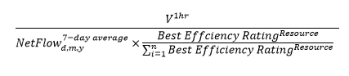

Where n = number of *resources* that share the *forebay*

Let:

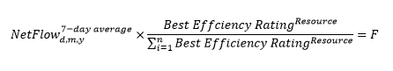

This formula simplifies to volume of 1 hour's worth of water in the forebay denoted as V over F.

1. The 95th percentile of the time in seconds required to fill a volume of $V^{1hr}$ at the seven-day rolling averages of the net flow rates over the study period is given by:

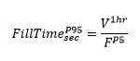

1. Convert ${FillTime}_{sec}^{P95}$ from Step 7 into a number of days figure by dividing the value by 60sec/min ÷ 60min/hr ÷ 24hr/day.

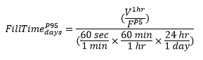

1. The minimum of ${FillTime}_{days}^{P95}$ and 31 days is set as the time to refill the *forebay* (${FillTime}_{days})$ for 1 hour of water to offer as *operating reserve*. If the ${FillTime}_{days}^{P95}$ is determined to be a negative value, then ${FillTime}_{days}$ is 31 days.

The FillTime in days calculation is capped to 31 days.

1. If the *resource* is not part of a *cascade group*, proceed to step 11. If the *resource* is part of a *cascade group*, perform the following steps (a) to (d):
   1. For every *dispatchable resource* associated with any *forebays* from the *cascade group*, complete steps 1-9 to determine the time required to refill the *forebay* for each *resource* in the relevant *cascade group*.

Table 6‑7: Step 1 Example of Determining the Refill Time for Resources in a Cascade Group

| **Forebay** | **Resource** | **Refill Time (days)** |
| --- | --- | --- |
| 1 | A | 5 |
| 1 | B | 22 |
| 2 | C | 6 |
| 2 | D | 3 |
| 3 | E | 2 |
| 3 | F | 7 |

* 1. For each *forebay* downstream of Forebay 1 in the *cascade group*, identify the longest refill time for any associated *resources*. In the example below, Resource C is selected for Forebay 2 and Resource F is selected for Forebay 3.

Table 6‑8: Step 2 Example of Determining the Refill Time for Resources in a Cascade Group

| **Forebay** | **Resource** | **Refill Time (days)** |
| --- | --- | --- |
| 1 | A | 5 |
| 1 | B | 22 |
| 2 | C | 6 |
| 2 | D | 3 |
| 3 | E | 2 |
| 3 | F | 7 |

* 1. For each *resource* in the *cascade group*, determine the sum of the the refill time of that *resource* and the maximum refill times from 10(b) for each *forebay* that is downstream from the selected *resource* to create the “Cascade Forebay Refill Time” shown below.

Table 6‑9: Step 3 Example of Determining the Refill Time for Resources in a Cascade Group

| **Forebay** | **Resource** | **Refill Time (days)** | **Cascade Forebay Refill Time** |
| --- | --- | --- | --- |
| 1 | A | 5 | 5 + 6 + 7 = 18 |
| 1 | B | 22 | 22 + 6 + 7 = 35 |
| 2 | C | 6 | 6 + 7 = 13 |
| 2 | D | 3 | 3 + 7 = 10 |
| 3 | E | 2 | 2 |
| 3 | F | 7 | 7 |

* 1. For each *resource*, take the minimum of the “Cascade” time from step 10(c) and 31 days. This duration is the time to refill the *forebay* for each *resource* of the *cascade group* and accounts for the time required to refill *forebays* of *resources* located at downstream *forebays*.

Table 6‑10: Step 4 Example of Determining the Refill Time for Resources in a Cascade Group

| **Forebay** | **Resource** | **Cascade Forebay Refill Time** | **Refill Time** |
| --- | --- | --- | --- |
| 1 | A | 18 | MIN (31,18)= 18 |
| 1 | B | 35 | MIN (31,35)= 31 |
| 2 | C | 13 | MIN (31,13)= 13 |
| 2 | D | 10 | MIN (31,10)= 10 |
| 3 | E | 2 | MIN (31,2)= 2 |
| 3 | F | 7 | MIN (31,7)= 7 |

1. Calculate the potential foregone *operating reserve* revenue using the number of days required to refill a *forebay*. The number of days required to determine potential foregone *operating reserve* revenues can be referred to in:
   1. Step 9, for a *resource* not registered as part of a *cascade group*; or
   2. Step 10(d), for a *resource* of a *cascade group*.
2. Collect the *real-time market* *operating reserve* schedules and prices for the *resource* for the calendar month $\hat{m}$ selected in Step 5, over all of the years in the study period, $y^{0}, y^{0}-1, y^{0}-2, y^{0}-3, y^{0}-4$.

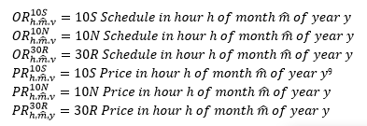

1. Calculate historical *real-time market* hourly *operating reserve* revenue for the *resource* in each hour for during month $\hat{m}$ in the five years of the historical study period.

The operating reserve real-time hourly revenue for the 5th percentile flow month is the sum of all operating reserve prices times the operating reserve schedule for all applicable operating reserve classes.


1. Determine the monthly average hourly *real-time market* *operating reserve* revenue for the *resource* in month $\hat{m}$ in the historical study period.

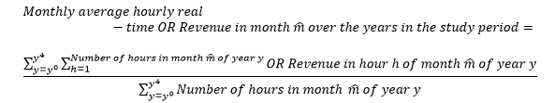

1. Multiply the average from Step 14 by 24 hours to obtain a daily *operating reserve* revenue value.

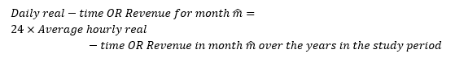

1. Multiply the daily *operating reserve* revenue from Step 15 by the number of days to refill *forebay* from Step 10 (d) for a *resource* that is part of a *cascade group* or by Step 9 for a *resource* that is not part of a *cascade group* to estimate the lost revenue.

The lost revenue is equal to the fill time measured in days multiplied by the daily real-time OR revenue in the low flow month.

1. Divide the Lost Revenue from Step 16 by the *energy* that would be produced in an hour when operating for an hour at the efficiency rating to obtain the *forebay* refill opportunity cost for an hour. This is the $/MWh opportunity cost adder.

The forebay refill opportunity cost is calculated as the lost revenue divided by the power at efficiency rating times 1 hour.

### Costs Related to Start-Up Offers

All costs associated with start-up are eligible for inclusion in a *resource*’s *reference levels*. This includes start-up fuel volume costs related to the amount of fuel needed to start a thermal *resource*. This value may vary depending on how long the *resource* has been offline. Thermal *resources* are allowed to submit different start-up fuel volumes for starting up from a cold, warm and hot *thermal states*. Different *start-up offer* *reference levels* will be determined for each *thermal state* of the *resource*.

For non-thermal *resources* that have start-up costs but do not submit *start-up offers*, these costs are reflected in *energy offer* *reference levels*. Section 7 further identifies relevant cost components for start-up costs for different technology types.

### Costs Related to Speed No-Load Offers

Costs related to *speed no-load offers* include fuel costs and O&M costs.

The fuel cost component is the fuel burn that would be hypothetically consumed if the *resource* were to back down to a zero power output while staying synchronized to the *IESO-controlled grid.*

Depending on the *resource*, heat rate curves may show that there is some level of fuel consumption that is not attributable to incremental production.

For example, if a *resource* had the following heat rate curve and incremental heat rate curve, some fuel cost is fixed and not attributable to incremental production:

Heat rate curve:

This formula is an example of a heat rate curve which can be used to derive a speed-no-load cost.

For this *resource*, the fuel cost related to its *speed no-load offer* is 5GJ/hr multiplied by the applicable total fuel-related costs. Another way of understanding the fuel cost component of *speed no-load offer* is that it is the y-intercept of the heat input curve multiplied by the applicable total fuel-related costs.

The presence of costs related to *speed no-load offers* in *reference levels* does not signify that the *IESO* will model *resources* in this operating state (synchronized but not injecting). Rather, it is a method to allow *reference levels* to more accurately match the shape of cost curves, where appropriate.

The *reference level* methodology uses the approach of separating the fixed hourly costs of synchronized operation from costs associated with incremental production.

For *resources* that have costs related to *speed no-load offers* but do not submit *speed no-load offers*, these costs are reflected in *energy offer reference levels*. *Speed no-load offers* are used by the *IESO* to determine the commitment and scheduling of *GOG-eligible resources*. The speed no-load fuel consumption should be allocated to the *energy offer reference level* for the *minimum loading point* output as follows:



### Costs Related to Operating Reserve Offers

*Operating reserve offer* *reference levels* for 10-minute synchronized, 10-minute non-synchronized and 30-minute non-synchronized *operating reserve* are based on incremental costs associated with posturing a *resource* to be able to provide additional *energy*. These *reference levels* are not based on the costs associated with the injection of additional *energy*.

– End of Section –

## Reference Levels for Financial Dispatch Data Parameters

(MR Ch.7 ss.22.1.1, 22.1.3, 22.2.1 and 22.2.2)

The subsections below describe the technology-specific categorization of *resources* and their *reference level* formulas, cost components calculations, and supporting documentation requirements. These cost components include:

* incremental O&M costs;
* costs related to *speed no-load offers*;
* labour costs;
* opportunity costs;
* emission adders;
* electricity consumption/charging costs;
* fuel costs; and
* *operating reserve* costs.

If applicable, *reference levels* may employ additional performance factors to represent the efficiency of the technology type.

### Thermal

*Resources* that are primarily fueled by natural gas, biomass or oil are categorized within this *market manual* as “thermal” *resources*. Thermal *resources* that use two types of fuel to generate electricity and that offer a choice with respect to the type of fuel that may be used to generate electricity will be required to register *reference levels* for each fuel type.

There are four variants of thermal *resources*. The determination of the variant for a thermal *resource* is based on registered characteristics associated with that *resource*.

Variant A:

Variant A thermal *resources* are thermal *resources* that have registered the following value:

* a quick-start flag value equal to “Y”.

Variant B:

Variant B thermal *resources* are thermal *resources* that have registered the following values:

* a quick-start flag value equal to “N”;
* a start-up and speed no-load eligibility flag equal to “N”; and
* relevant *facility* does not use *pseudo-unit* modelling.

Variant C:

Variant C thermal *resources* are thermal *resources* that have registered the following values:

* a quick-start flag value equal to “N”;
* a start-up and speed no-load eligibility flag equal to “Y”; and
* relevant facility does not use *pseudo-unit* modelling.

Variant D:

Variant D thermal *resources* are thermal *resources* that have registered the following values:

* A quick-start flag value equal to “N”;
* A start-up and speed no-load eligibility flag equal to “Y”; and
* Relevant facility uses *pseudo-unit* modelling.

Variant D thermal *resources* include the physical *resources* at a thermal *facility* that uses *pseudo-unit* modelling as well as the *pseudo-unit* *resources* at the same *facility*.

The following *reference levels* will be registered for each variant:

Variant A:

* *Energy offer reference level;* and
* *Operating reserve offer reference level*.

Variant B:

* *Energy offer reference level;* and
* *Operating reserve offer reference level*.

Variant C:

* *Energy offer reference level;*
* *Start-up offer reference level;*
* *Speed no-load offer reference level*; and
* *Operating reserve offer reference level*.

Variant D:

Variant D *resources* that are *pseudo-unit* *resources* require the following *reference levels* for *financial dispatch data*:

* *Energy offer reference level;*
* *Start-up offer reference level;*
* *Speed no-load offer reference level*; and
* *Operating reserve offer reference level*.

Variant D *resources* that are not *pseudo-unit* *resources* do not require *reference levels* for *financial dispatch data parameters*.

To request a *reference level* that is affected by *thermal state*, a *market participant* determines the ambient conditions associated with its hot, warm and cold *thermal states.* These ambient conditions will be used to determine all *thermal state*-affected *reference levels*.

This section describes how the applicable form should be completed to request a *reference level* and covers the following thermal *resource* technology types:

* combined cycle;
* fossil or biomass steam (biomass);
* simple cycle combustion turbine; and
* cogeneration.

#### Combined Cycle

For the purposes of establishing *reference levels,* a combined cycle technology *resource* is considered to be a *resource* thatuses both a combustion turbine *generation unit* and a steam turbine *generation unit* to generate electricity. The gas turbine exhaust heat flows to a conventional boiler or to a heat recovery steam generatorto produce steam for use by a steam turbine *generation unit* in the production of electricity.

For combined cycle *resources*, the *IESO* will define one *reference level* using one of the configurations for combined cycle mode (e.g., 1x1, 2x1), and another *reference level* for *single cycle mode* for those *resources* that have a bypass stack or can otherwise operate the *resource* in *single cycle mode* absent the steam turbine.

##### Deriving Pseudo-Unit Reference Levels for a Combined Cycle Resource

*Reference levels* for *pseudo-units* are calculated based on *generation unit* parameters in a manner consistent with the translation between *generation* *units* and *pseudo-units* in the *IESO* systems.

For example, *reference levels* for *financial dispatch data parameters* for a *pseudo-unit* in 1x1 configuration will be determined based on aggregating the *reference levels* for the relevant combustion turbine with the *reference levels* for the steam turbine.

The number of *price-quantity pairs* of a *pseudo-unit reference level* should not exceed 20 divided by the number of combustion turbine *resources* registered in the *generation facility* rounded down to the nearest whole number.

##### Treatment of Multiple Generation Facilities Modeled as a Single Resource

The *IESO* determines *reference levels* when modeling multiple *generation facilities* as a single *resource* as described below:

* for combined cycle *resources*, the *IESO* determines two sets of *reference levels* – one for the *single cycle mode* (if applicable) and one for the configuration selected for the combined cycle mode;
* for cogeneration *resources*, the *IESO* determines a single set of *reference levels*.

##### Treatment of Average Costs

This section applies to variant A and variant B thermal *resources*. Pursuant to **MR Ch.7 s.22.4.2**, the *IESO* determines two *energy offer* *reference levels* for a *resource* that has registered a “start-up cost and speed no-load eligibility flag” value of “N” and that has registered a primary fuel type of gas, oil, steam, or biomass.

For these *resources*, the *IESO* determines primary *reference levels* for *energy* and *operating reserve* based on the *resource’s* *short-run marginal costs* and secondary *reference levels* for *energy* based on the *resource’s* average costs. Refer to section 7.1.3.2 for further details on how the *IESO* calculates primary and secondary *reference levels* for these *resources*.

#### Cogeneration Resources

Pursuant to **MR Ch.7 s.22.4.3**, the *IESO* determines two separate *reference levels* with or without steam turbine operations for cogeneration *resources*.

#### Reference Level Equations

This section describes equations that are used to determine *reference levels* for *financial dispatch data parameters* of thermal *resources*. Equations are provided for each variant of thermal *resource*.

These equations show the categories of eligible costs for each *reference level* for a *financial dispatch data* *parameter*.

##### Variant C and Variant D Thermal Resources

The following equations are used to determine the specified *reference levels* for Variant C and Variant D *resources*:

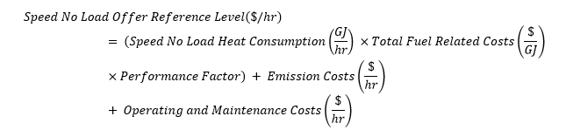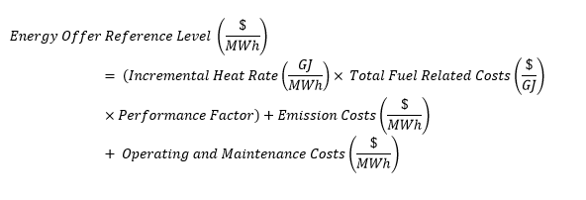

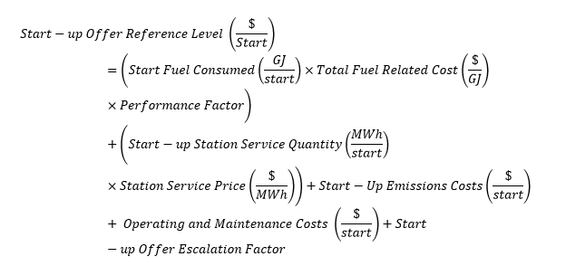

Variant C steam turbines that are modeled as standalone *resources* rather than as part of an aggregate of more than one type of turbine will determine *reference levels* for some of their *financial* *dispatch data parameters* based on the relevant *reference levels* of the combustion turbine resources at the relevant *facility,* and whether the steam turbine *resource* has duct-firing capability as outlined below**.**

**For Standalone Steam Turbine Resources Without Duct-Firing Capability**

*Reference levels* for the *financial* *dispatch data parameters* for the steam turbine *resource* are the relevant *reference level* for a combustion turbine *resource* at the *facility* plus an adder. *Market participants* are free to select the combustion turbine *resource* at the *facility* to use in this process.

The adders that should be used for each *reference level* for a *financial dispatch data parameter* are as follows:

* *Energy offer reference level* adder = $0.10/MWh
* *Start-up offer reference level* adder = $1/start
* *Speed no-load offer reference level* adder = $1/hour

For the steam turbine *financial* *dispatch data parameter reference levels*:

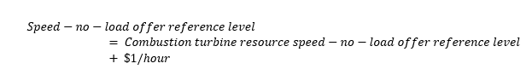



The start up offer reference level is equal to the combustion turbine start up offer reference level plus one dollar per start.

The *energy offer reference level* for the steam turbine *resource* will be determined by adding the adder to the most expensive *energy offer reference level* lamination of the combustion turbine *resource* selected by the *market participant*. The resulting *energy offer reference level* for the steam turbine for its entire MW range will be more expensive than the most expensive tranche of the *energy offer reference level* of the combustion turbine *resource* selected by the *market participant*.

For a steam turbine *resource* that has a *minimum loading point reference level* that is greater than 0 MW, the *energy offer reference level* for that *resource* must have at least one lamination where the maximum quantity in the lamination equals the *minimum loading point reference level* for the *resource*.

**For Standalone Steam Turbine *Resources* With Duct-Firing Capability**

Where a steam turbine *resource* has duct-firing capability and the *short-run marginal costs* of producing *energy* utilizing the duct-firing capability is higher than the *short-run marginal costs* of producing *energy* when the duct-firing capability is not utilized, the *energy offer reference level* for the steam turbine *resource* will follow the same methodology outlined above for steam turbine *resources* without duct firing capability from 0 MW up to the maximum active power capability of the *resource* less duct-firing capability.

The *energy offer reference level* for the *resource* will also have a lamination where the minimum quantity in the lamination equals the maximum active power capability of the *resource* less duct-firing capability plus 0.1 MW, and the maximum quantity in the lamination equals the sum of the maximum active power capability of all *generation units* associated with the *resource*, including duct-firing capability*.* The *energy offer reference level* for this lamination shall be determined using the *energy offer reference level* formula provided in this section, reflecting the *short-run marginal costs* of producing *energy* specific to the utilization of duct-firing capability.

##### Variant A and Variant B Thermal Resources

Pursuant to **MR Ch.7 s.22.4.2**, the *IESO* determines two *energy offer* *reference levels* for a *resource* that has registered a “start-up cost and speed no-load eligibility flag” value of “N” and that has registered a primary fuel type of gas, oil, steam, or biomass.

The *resource’s* primary *energy offer reference level* is calculated as follows:

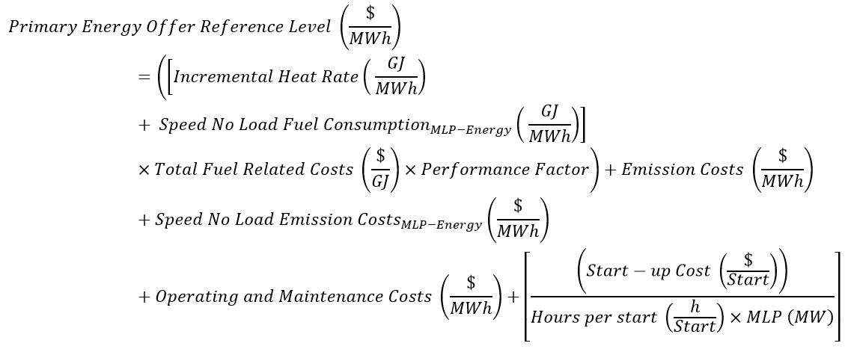

The minimum value of the hours per start is 1 and if the *resource* does not have a registered *MLP*, the “MLP(MW)” value is set equal to the maximum active power capability of all *generation units* associated with the *resource*.

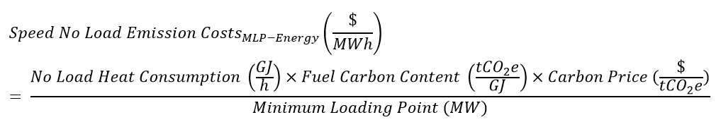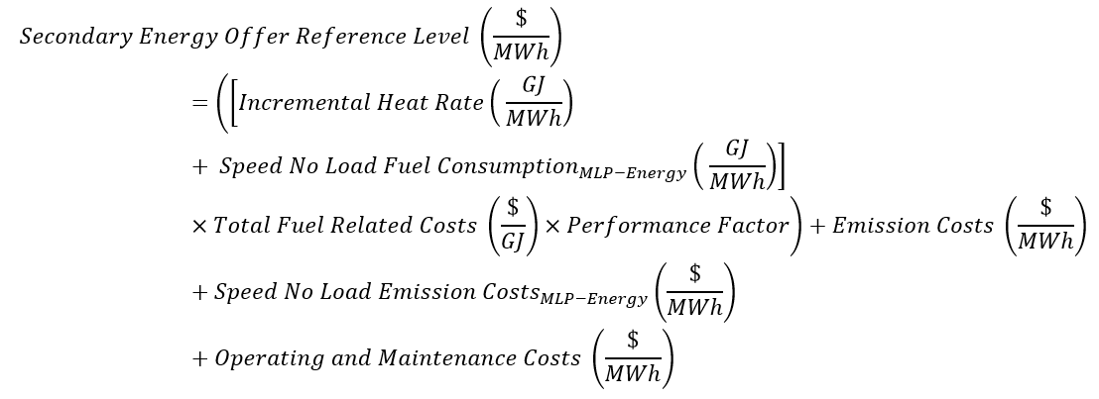The *resource’s* secondary *energy offer reference level* is calculated as follows:

For a *resource* that has a *minimum loading point reference level* that is greater than 0 MW, the *energy offer reference level* for the *resource* will have at least one lamination where the maximum quantity in the lamination equals the *minimum loading point reference level* for the *resource*.

If a *resource* has duct-firing capability and the *short-run marginal costs* of producing *energy* utilizing the duct-firing capability is higher than the *short-run marginal costs* of producing *energy* when the duct-firing capability is not utilized, the *energy offer reference level* for the *resource* will also have at least one lamination where the maximum quantity in the lamination equals the sum of the maximum active power capability of all *generation units* associated with the *resource* less the duct-firing capability of the *resource.*

The *energy offer reference level* for the *resource* will also have at least one lamination where the maximum quantity in the lamination equals the sum of the maximum active power capability of all *generation units* associated with the *resource.*

#### Incremental Heat Rates

A *market participant* must submit heat rate curves to determine the incremental heat rate. These curves show heat rate in GJ/MWh needed per MWh of net electrical output.

Heat rate (HR)equals the GJ heat input (higher heating value (HHV) basis) divided by the MWh of energy output.

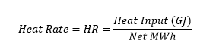

Incremental heat ratedescribes the heat input necessary to produce an additional MWh of output. Mathematically, the incremental heat rate is the first derivative of the heat rate curve. 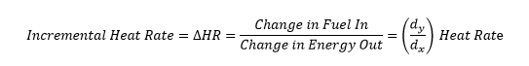

The *market participant* must submit heat rates and incremental heat rates for the *resource*. For a *pseudo-unit resource*, data is provided based on operation of the *generation units* in combined cycle mode. If the *pseudo-unit* *resource* can operate in *single cycle mode*, heat rate data regarding operation in *single cycle mode* should also be provided.

If the *resource* is capable of burning more than one type of fuel, the *market participant* must also submit the incremental heat rate for operation of the *resource* for each fuel type. For example, if a *resource* is capable of burning natural gas and diesel, the *market participant* must submit the incremental heat rate for operation of the *resource* on both fuel types along with the incremental heat rate curves for the *generation units* and *pseudo-unit* *reference levels* for the selected configuration for combined cycle mode and for *single cycle mode* (if applicable).

The HHV heat content of the fuel must also be submitted. HHVis the amount of heat released by a specific quantity (initially at 25oC) once it is combusted and the products have returned to a temperature of 25 o C. The following documentation is accepted to support a requested HHV:

* seller’s quote or invoice;
* contract or nominal value based on industry standards; and
* as burned test, in stock test, as received test, or as shipped test.

The following documentation is required to support a requested incremental heat rate:

* heat rate and incremental heat rate curves must be submitted based on the HHV for each fuel type and for each operating mode;
* heat rate and incremental heat rate curves must be based on either:
  + actual *resource* operating data,
  + OEM data,
  + results from performance tests, or
  + heat balance models

Heat rate curves derived from heat balance models must reflect current operating conditions of the system, where key model parameters are consistent with actual operating data and validated using plant metering data or OEM input. The minimum amount of data to determine the heat rate curve is four hours at stable and consistent operation, where the heat rate curve is based on actual operating data;

* reference conditions for the heat rate curves, provided they are listed in OEM and performance tests;
* heat rate and incremental heat rate curves need to show the corresponding heat rate and incremental heat rate from *minimum loading point* up to the maximum capacity of the *resource*; and
* correction curves provided by the OEM for the equipment performance under different ambient conditions.

#### Total Fuel Related Costs

Eligible total fuel-related costs for thermal *resources* are expressed by the following equation:

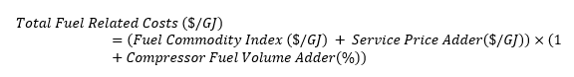

Fixed charges for transportation equipment (e.g., pipelines, train cars, and barges) are ineligible for inclusion in the calculation when calculating the eligible total fuel-related costs.

Fuel costs must converted to $/GJ for consistency.

##### Fuel Commodity Index

A fuel price index is used to determine the commodity price charged by the relevant supplier for the fuel purchased.

The following subsections describe the relevant index that the *IESO* uses to determine *reference levels*. The way that these indices are used is based on the timing of their publication or availability. Timing of publication of the fuel commodity indices and integration into the *reference levels* is determined as part of the consultation process to determine *resource*-specific *reference levels*.

###### Natural Gas

For natural gas, the applicable Day-Ahead Index price for the gas day in $US/MMBtu is the acceptable fuel commodity index and the *IESO* will use the values published daily as outlined in section 10.1. If a value is unavailable, the *IESO* will re-use the last value used by the *IESO*.

*Market Participants* may request that the *IESO* adjust the index value in section 10.1 to reflect a different location (or index). The *IESO* will decide on a case-by-case basis whether it is feasible to adopt an adjusted value, and will consider whether there is a methodology, sufficiently supported by relevant documentation, that appropriately reflects the relationship between the applicable trading hub and the *resource*.

###### Residual Fuel Oil

For residual fuel oil, the fuel commodity price is the weighted average cost of fuel of the fuel inventory using a first in first out (FIFO) calculation methodology at the time of submission of the *reference level*.

*Market participants* may request the same fuel commodity price for summer and winter period for residual fuel oil.

*Market participants* may also elect to request different fuel commodity prices for summer and winter periods. In this case, the *market participant* will determine the weighted average cost of fuel in inventory as of the first day of the most recent applicable season.

The supporting documentation required are past invoices for purchase volumes totaling the current remaining fuel inventory.

###### Ignition Oil

For ignition oil, the fuel commodity price is the weighted average cost of fuel of the existing fuel inventory using a first in first out (FIFO) calculation methodology at the time of submission of the *reference level*.

*Market participants* may request the same fuel commodity price for summer and winter period for ignition oil.

*Market participants* may also elect to request different fuel commodity prices for summer and winter periods. In this case, the *market participant* will determine the weighted average cost of fuel in inventory as of the first day of the most recent of each applicable season (e.g., the weighted average cost of fuel in inventory as at the first day of the most recent winter period and the weighted average cost of fuel in inventory as at the first day of the most recent summer period).

The supporting documentation required are past invoices for purchase volumes totaling the current remaining fuel inventory.

###### Biomass

For biomass fuel, the fuel commodity price is the contract price with the biomass supplier in $CAD/tonne. The supporting documentation required are copies of the contracts showing the prices with the suppliers.

##### Compressor Fuel Volume Adder

Compressor Fuel Volume Adder is the percentage of fuel consumed by the compressor including volumes for injecting or removing gas from storage. This cost is only eligible for natural gas-fired *resources*.

The following supporting documentation is accepted to support a requested Compressor Fuel Volume Adder:

* copies of transportation, storage and load balancing contracts outlining the requirement to provide fuel to acquire the services; and
* copies of current regulatory approved rate schedules showing the percentage fuel requirements, if applicable.

##### Service Price Adder

###### Natural Gas

The service price adder for natural gas-fired thermal *resources* ($CAD/GJ) is added to the fuel price for the additional services related to the commodity charge for transporting, balancing and storing of natural gas, plus the marketer risk premium as described below:

* pipelines, storage providers, and gas utilities provide various services to deal with imbalances between the quantity of gas purchased and the quantity of gas consumed;
* imbalances created from the difference between the quantity of gas purchased and the quantity of gas consumed can be managed by injecting the excess gas into storage or withdrawing the shortfall in gas from storage. Storage services are provided by service providers to meet this need. The same rationale outlining the need for balancing services applies to the need for storage services; and
* a marketer risk premium may be incurred by end-users purchasing smaller volumes relative to large volume buyers.

A *market participant* must submit to the *IESO* the amount of the service price adder applicable to their *resource*. The value would be set out as $CAD/GJ.

The following supporting documentation is required to support a requested service price adder:

* copies of the transportation, storage and load balancing contracts outlining the requirement to provide fuel to acquire the services;
* copies of current regulatory approved rated schedules showing the variable commodity charges as applicable; and
* copies of contracts with gas suppliers showing the marketer premium.

###### Residual Fuel Oil

For residual fuel oil, the eligible costs include an adder paid to the fuel supplier plus the cost of transportation from the point of purchase to the *generation facility*.

The following supporting documentation is required:

* copies of the contracts showing the price adder paid to the fuel supplier; and
* the cost of transportation from the point of purchase to the *generation facility*.

###### Biomass

For biomass, the value includes the sum of a transportation adder plus the heat adjustment factor priced in $CAD/tonne.

The transportation adder is the cost required to move the biomass supply from the point of purchase to the *generation facility*.

The heat adjustment factor is calculated and applied to the price to account for differences between the heating value specified in the contract and the heating value of the biomass actually delivered.

The following supporting documentation is required:

* copies of the contracts showing the prices paid for the transportation adder; and
* independent reports showing the heating values that are used to determine the heat adjustment factor.

##### Co-firing

*Resources* that co-fire more than one fuel must take a weighted average of the cost of the fuel ($), with weights determined on a per GJ basis.

When calculating the total fuel-related costs, fixed charges for transportation equipment, such as pipelines, train cars and barges, are excluded.

##### Performance Factors

Performance factors are the calculated ratio of actual fuel burn to theoretical fuel use (design heat input) and are represented by the following formula:

The performance factor of a fuel is calculated as the total actual fuel consumed over the total theoretical fuel consumed.

A *market participant* must submit the calculated performance factors for their *resources* on a seasonal basis (winter and summer). Thermal *resources* may experience some decline in performance during certain seasons or weather conditions, or due to *resource* age or declining efficiency. The *IESO* will update performance factors, similar to other components of *reference levels*, on an as-needed basis.

Acceptable supporting documentation includes the following:

* actual fuel consumed: measured fuel quantities over five years and heat content of fuel consumed in five-minute intervals;
* theoretical fuel consumption based on design information: heat rate and correction curves for each five-minute interval and MWh of production during the same time period for the actual fuel consumed data;
* reference site conditions for theoretical fuel consumption;
* MWh of production during the time period; and
* OEM-defined new and clean period (first x hours of operation).

#### Emissions Costs

Emissions costs are eligible costs and may be accounted for in the manner described in the following subsections.

**Resources Complying with the Greenhouse Gas Emission Performance Standards**

*Resources* that are part of a *generation facility* and have annual emissions that exceed 50,000 tCO2e per year or *resources* that have opted in to the [Greenhouse Gas Emission Performance Standards](https://www.ontario.ca/laws/regulation/r19241) may submit their emissions costs to the *IESO* for review.

The *IESO* will review and update the contributions of emissions cost to an *energy offer reference level* on an as-needed basis based on the applicable emission performance standard and carbon price for each year.

The contribution of eligible emissions costs are calculated using the following formula:

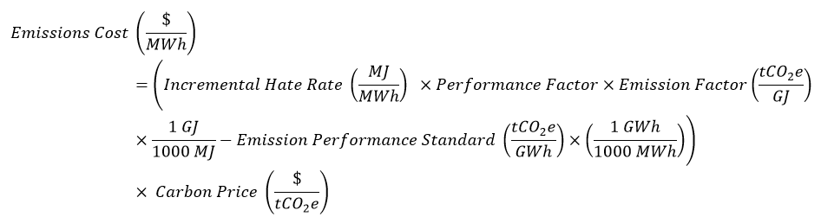

where, tCO2e = tonnes of carbon dioxide equivalent.[8]

Emission Factor must be calculated in accordance with Tables 20-1a, 20-2, 20-3, 20-5, or 20-7 in [Ontario’s guide for reporting greenhouse gas emissions](https://www.ontario.ca/page/guide-greenhouse-gas-emissions-reporting) for section 4(1) of Ontario Regulation 452/09 or other methodology allowed in the guide.

Emission Performance Standard must be calculated in accordance with the applicable value for fossil fuel electricity generation in accordance with [Ontario’s Greenhouse Gas Emission Performance Standards (O. Reg. 241/19)](https://www.ontario.ca/laws/regulation/r19241).

**Other Resources**

For *resources* that do not qualify for the Emission Performance Standard, eligible emissions costs are based solely on fuel consumption, as reflected by the following formula:

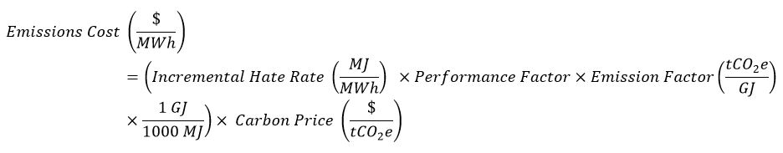

**Supporting Documentation**

Documentation required to support the inclusion of an emissions cost (required in addition to the supporting documentation submitted for total fuel related costs) in a *reference level* is as follows:

* For *resources* in a *generation facility* that have annual emissions that exceed 50,000 tCO2e per year or have opted in to the Greenhouse Gas Emission Performance Standards *resources*:

Emission Factor, as defined in [Guide: Greenhouse Gas Emissions Reporting](https://www.ontario.ca/page/guide-greenhouse-gas-emissions-reporting). If a *resource* specific Emission Factor is proposed by the *market participant* for the *reference level* as applicable, supporting documentation must be submitted to substantiate the calculation of an average Emission Factor based on quality of fuel received at the *generation facility* for the last five years.

* For other *resources*:

Invoices including their emissions charge as justification for emissions charges on a $/GJ basis.

#### O&M Costs

For thermal *resources*, eligible O&M costs are calculated according to the following formula:

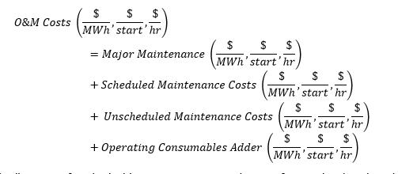

The default allocation of each eligible O&M costs across these *reference levels* is described in the following section discussing the relevant cost (e.g. planned maintenance, unscheduled maintenance, scheduled maintenance).

A *market participant* may elect to allocate their eligible O&M costs to their *energy offer* *reference level*, *start-up offer reference level* or *speed no-load* *offer reference level*. Where the facility’s O&M service agreementdoes not specify any basis for the allocation of eligible O&M costs, the *market participant* must submit the rationale for the allocation of these costs to be included in the applicable *reference levels.*

For *resources* that are capable of burning multiple fuels, the *market participant* must submit O&M costs inputs into the *reference levels* for each fuel type.

##### Major Maintenance

Eligible major maintenance costs for thermal *resources* include maintenance related to the gas turbine, steam turbine, heat recovery steam *generation unit*, or steam *generation unit*, where applicable.

Costs reimbursed by insurance and/or warranty under construction or equipment supply contracts are ineligible.

Eligible costs are determined on the basis of timing that covers one major maintenance inspection cycle. The duration of these inspection cycles varies according to the component or service. These durations take the place of the historical study period described above. The contribution of each major maintenance cost to the relevant *reference level* is determined according to the formula for pro-rating these costs provided in the following sections (either on an equivalent operating hour (EOH)-basis or on a per-start basis).

If such historical information is not available, a *market participant* may submit forecasted major maintenance expenditures based on costs associated with eligible maintenance activities in accordance with the OEM recommended maintenance intervals or prudent industry practices.

The *market participant* must submit sufficient supporting documentation for the forecasts in accordance with section 3.2.

###### OEM-Recommended Interval on EOH or Operating Hour (h) Basis

For all major maintenance with maintenance intervals on an hours (h) or EOH-basis (e.g., 25,000-hour gas turbine inspection interval), the default cost allocation by *offer* type is as follows:

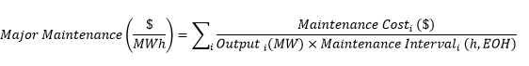

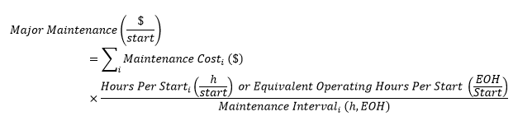

The major maintenance cost formula measured in dollars per hour on an operating hour basis includes the variables: maintenance cost and maintenance interval.

The EOH basis may only be used where the OEM provides a recommendation that includes additional weight for each start to calculate an equivalent life to factor in the impact of operating hours and starts on the equipment.

###### OEM-Recommended Interval on Per-Start Basis

For all eligible major maintenance costs with maintenance intervals on a start basis (e.g. every 2,400 starts), the default cost allocation may be proposed by the *market participant* as follows:

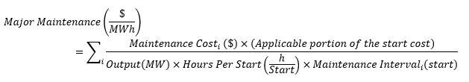

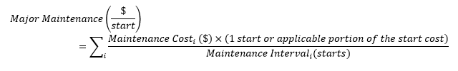

Major maintenance determined per hour is not applicable for OEM recommended intervals on a per-start basis.

###### Gas Turbines

For combustion turbines, either as a standalone *resource* or as part of a combined cycle installation, eligible major maintenance costs include costs for inspections in accordance with the planned maintenance recommendations provided by the OEM including:

* combustion inspection;
* hot gas path inspection;
* major inspection; and
* rotor inspection.

Eligible costs for the above include:

* incremental payments made under a maintenance service agreement. All or a portion of the incremental amounts may be eligible based on the terms of the relevant contracts based on eligible activities;
* replacement or refurbishment of capital parts for the gas turbine or gas turbine *generation unit* consistent with OEM recommendations and prudent industry practice;
* miscellaneous hardware or parts that are normally replaced during a gas turbine inspection;
* *generation unit* inspections;
* consumables required for the outage;
* technical advisors required;
* temporary incremental labour required;
* crane rentals required; and
* temporary infrastructure required (scaffolding, temporary office trailers, washrooms, etc.)

The supporting documentation required from a *market participant* is described in section 3.2.

###### Combined Cycle Steam Resources and Fossil or Biomass Steam Resources

For steam *resources* in a combined cycle *facility* and fossil biomass steam *resources*, the inspections on the heat recovery steam *generation unit* and steam turbine attributed to incremental electricity production are eligible costs where they are consistent with recommendations from the OEMs, which include:

* minor inspection; and
* major inspection.

Eligible costs for the above include:

* turbine blade repair or replacement;
* turbine diaphragm repair;
* casing repair or replacement;
* bearing repair or refurbishment;
* *generation unit* inspection;
* boiler repairs;
* primary air fan repairs;
* stop valve inspection and repairs;
* throttle valve inspection and repairs;
* nozzle block inspection and repairs;
* intercept valve inspection and repairs;
* Primary Air/Induced Draught/Forced Draft Fan repairs;
* consumables required for the outage;
* technical advisors required;
* temporary incremental labour required;
* crane rentals required; and
* temporary infrastructure required (scaffolding, temporary office trailers, washrooms, etc.)

The supporting documentation required from a *market participant* is described in section 3.2.

##### Scheduled Maintenance Costs

Eligible scheduled maintenance costs for thermal *resources* include routine maintenance tasks on balance of plant equipment for combined cycle *generation facilities* and fossil or biomass steam *resources*.

Eligible costs include routine inspections as per the following, where applicable:

* inspection and rebuild of fan motors for the air-cooled condenser;
* heat transfer unit cleaning (air cooler, air heaters, economizers);
* selective catalytic reduction and CO reduction catalyst replacement;
* precipitator repairs;
* membrane replacements;
* reverse osmosis cartridges replacement;
* condensate extraction pumps overhauls;
* boiler feedwater pumps overhauls;
* bypass systems and/or sky vents inspections and parts replacements;
* condenser cooling water pumps overhaul;
* gas compressor inspection and overhaul;
* auxiliary boilers inspection;
* bucket elevator plant repairs;
* cooling tower fan motor and gearbox inspection;
* cooling tower fill and drift eliminators replacement; and
* biomass material handling systems including pulverizer maintenance

The supporting documentation required from a *market participant* is described in section 3.2. The historical study period for scheduled maintenance costs for thermal *resources* is five years.

If a *facility’s* service agreement (e.g., LTSA or MSA) does not specify a basis for allocating scheduled maintenance costs, *market participants* may elect to allocate these costs to a reference level category, as described below.

For eligible O&M costs allocated to the *energy offer reference level,* the incremental O&M costs in the historical study period are those that were incurred to produce energy, and must be distributed across the total MWh generated for that period.

For eligible O&M costs allocated to the *start-up offer reference level*, the incremental O&M costs in the historical study period are those that were incurred as a result of starting up the *resource*, and must be distributed across the total starts for that period.

For eligible O&M costs allocated to the *speed no-load offer reference level*, the incremental O&M costs represent the upkeep and expenses incurred for each hour of operation, regardless of loading level or how much *energy* is supplied in a given hour. Costs allocated to the *speed no-load offer reference level* do not include costs that were incurred for each hour of operation while the *resource* is starting up.

The same cost cannot be allocated to more than one *reference level*.

##### Unscheduled Maintenance Costs

The supporting documentation required from a *market participant* is described in section 3.2. The historical study period for unscheduled maintenance costs for thermal *resources* is five years.

If a *facility’s* service agreement (e.g., LTSA or MSA) does not specify a basis for allocating scheduled maintenance costs, *market participants* may elect to allocate these costs to a reference level category, as described below.

For eligible O&M costs allocated to the *energy offer reference level,* the incremental O&M costs in the historical study period are those that were incurred to produce energy, and must be distributed across the total MWh generated for that period.

For eligible O&M costs allocated to the *start-up offer reference level,* the incremental O&M costs in the historical study period are those that were incurred as a result of starting up the *resource*, and must be distributed across the total starts for that period.

For eligible O&M costs allocated to the *speed no-load offer reference level*, the incremental O&M costs represent the upkeep and expenses incurred for each hour of operation, regardless of loading level or how much *energy* is supplied in a given hour. Costs allocated to the *speed no-load offer reference level* do not include costs that were incurred for each hour of operation while the *resource* is starting up.

The same cost cannot be allocated to more than one *reference level*.

##### Operating Consumables Cost Adder

Eligible operating consumable costs for thermal *resources* are non-labour cost components which account for material and consumable costs and fees incurred as a result of electrical power production. Costs must be incremental and avoidable to be eligible to contribute to the relevant *reference level*.

Eligible costs include:

* make-up water for the steam cycle (combined cycle steam *resources* and fossil or biomass steam *resources* only);
* steam cycle chemicals (combined cycle steam *resources* and fossil or biomass steam *resources* only);
* lubrication oil; and
* reagents for emission abatement equipment (e.g. ammonia or urea), if applicable.

The supporting documentation required from a *market participant* is described in section 3.2. The historical study period for the operating consumable cost adder for thermal *resources* is five years.

Eligible operating consumables may be calculated by either of the following methods depending on whether the *market participant* allocates these costs to the *energy offer* *reference level* or the *start-up offer reference level*:

###### Allocating Operating Consumables Cost Adder to Energy Offer Reference Level

The eligible costs per year in the historical study period are divided by the generation per year for each year of the historical study period. The average across all years in the historical study period is the eligible operating consumables cost adder to the *energy offer* *reference level*. Where a *market participant* allocates operating consumables costs on the basis of starts, these costs are not eligible to be considered in the *energy offer* *reference level*.

The operating consumables cost adder equation for energy reference levels is the historical operating consumable cost over the historical electricity generation.

###### Allocating Operating Consumables Cost Adder to Start-Up Offer Reference Level

A *market participant* may elect to allocate a portion of their operating consumable cost based on the ratio that they typically incur operating consumables during operations. If they typically incur 10% of their operating consumables costs during starts, then 10% of their operating consumables costs are eligible to be allocated on the basis of starts within the historical study period.

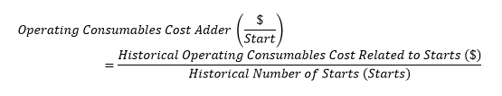

#### Costs Related to Start-Up Offers

Eligible costs related to *start-up offers* for thermal *resources* are all costs associated with start-up. These include costs required to bring the boiler, turbine, and *generation unit* from shutdown conditions to the *MLP* of the *resource*.

Start-up costs for thermal *resources* will vary according to the *thermal state* of the *resource* where appropriate, resulting in *reference level* contributions that vary according to *thermal state*.

##### Start-Up Fuel Consumed

Start-up fuel consumed for thermal *resources* is the quantity of start fuel consumed from the first firing up of the *resource* until its *MLP*. This value can vary depending on how long the *resource* has been offline or the *thermal state* of the *resource*. Thermal *resources* must submit start-up fuel quantities for starting up from a cold, warm and hot state. The *IESO* sets *reference levels* for each *thermal state*. If multiple types of fuel are required for a *resource* to start up, the *market participant* must identify the required quantities for each type of fuel required for the start per *thermal state*.

##### Station Service Quantity

The *station service* quantity is the incremental quantity of electricity withdrawals from the *delivery point* included from the initiation of the start sequence of a *resource* until the *resource* reaches its *MLP*.

The incremental quantity of electricity withdrawals is multiplied by the *station service* rate to determine the cost of *station service*.

##### Station Service Rate

For a *resource* with an electric auxiliary boiler, the incremental *station service* cost associated with operating the auxiliary boiler may be included with the *station service*. This incremental *station service* cost is determined based on the incremental electricity withdrawals above an average baseline consumption of the *resource* when it is not generating electricity.

A *resource* that pays the *LMP* for *station service* must use the 12-month average *LMP* at the *resource* as the *station service* rate.

*Resources* that have fewer than 12 months of historical *LMPs* on record must use the Ontario Energy Board’s Regulated Price Plan Price Reports for the relevant historical study period to determine the *station service* rate, as described below:

* for *resources* that participate in the generation *station service* rebate program, the *station service* rate is the commodity cost plus the variance line item from the RPP Price Report; and
* for *resources* that do not participate in the *generation* *station service* rebate program, the *station service* rate is the commodity cost, plus the global adjustment, plus the variance line item from the RPP Price Report.

##### Start-Up Emissions Costs

Eligible start-up emissions costs for thermal *resources* are the costs based on relevant emissions policy such as the Federal Carbon Pricing Backstop.

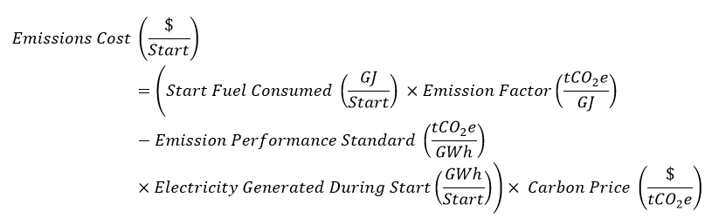

For the *IESO* to calculate the Emissions Charge for each type of start (hot, warm and cold), a *market participant* must submit supporting documentation that demonstrates the electricity generated from the initiation of the start up until the *resource* reaches its *MLP*.

When thermal *resources* burn biomass fuels during start-up, there are no resultant eligible start-up emissions costs.

##### Start-Up Maintenance Adder

A *market participant* may include a start-up maintenance adderin the start-up costs using the methodology prescribed in section 7.1.7.

##### Start-Up Operating Consumables Adder

A start-up operating consumables adder is eligible to beincluded in the start-up costs using the methodology prescribed in Operating Consumables Adder subsection of section 7.1.7.

##### Start-up Offer Escalation Factor

The start-up offer escalation factor is calculated by the *IESO* for each *dispatch hour*. It is added to the *reference level value* for the *start-up offer reference level* for each *dispatch hour* so that the commitment costs of a *resource* are appropriately accounted for in *reference level values* used for the end of a *dispatch day*.

The start-up offer escalation factor for a *dispatch hour* is calculated as follows:

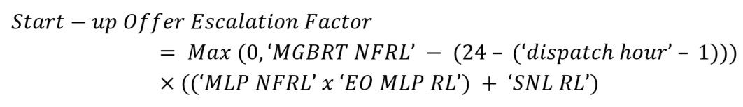

Where

* ‘dispatch hour’ is the numeric value of the *dispatch hour* between 1 and 24
* ‘MGBRT NFRL’ is the *minimum generation block run-time reference level*.
* ‘MLP NFRL’ is the *minimum loading point reference level*.
* ‘EO MLP RL’ is the price of the 2nd lamination of the *energy offer reference level value* for the *dispatch hour*.
* ‘SNL RL’ is the *reference level value* for the *speed no-load offer reference level* for the *dispatch hour.*

#### Speed No-Load Cost

This *reference level* methodology uses the approach of separating the fixed hourly costs of synchronized operation from costs associated with incremental production. It is calculated as follows:

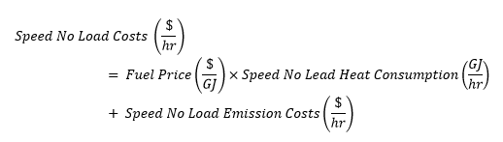

##### Speed No-Load Heat Consumption

Speed no-load heat consumption is the minimum fuel burn that would be hypothetically consumed if the *resource* were to back down to a zero-power output while staying synchronized with the *IESO*-controlled grid.

This quantity should be determined by a *market participant* based on a regression analysis of the heat input as a function of net power output of the *resource*. The data for the regression analysis may be derived from test data or design information of the *resource*.

##### Speed No-Load Emission Costs

Eligible speed no-load emission costs are the costs associated with emissions based on the relevant emissions policy such as the Federal Carbon Pricing Backstop.

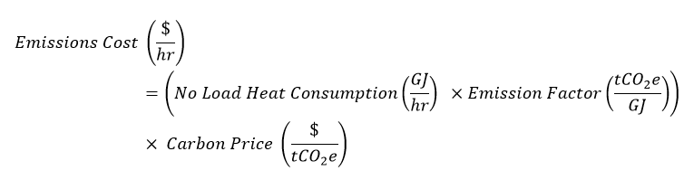Speed no-load emissions costs do not apply when *resources* are firing biomass fuel.

For thermal *resources* that have two *energy offer reference levels* determined pursuant to **MR Ch.7 s.22.4.2**, the following emission charges may be included in those *energy offer reference levels*:

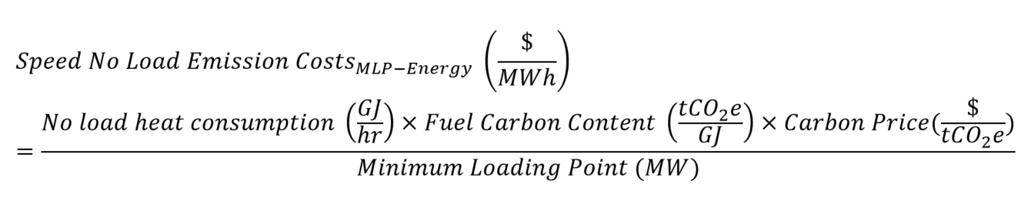

#### Operating Reserve Offer Reference levels

*Operating reserve offer* *reference levels* are determined based on incremental costs incurred by the *resource* to make the *operating reserve* capability available. These are the costs incurred by a *resource* at the time it is supplying *operating reserve*. These costs are not incurred when the *resource* is not providing *operating reserve*. If applicable, a *market participant* must demonstrate the costs associated with the provision of *operating reserve* on a *resource*-specific basis with relevant supporting documentation. No incremental costs are associated with operating and maintaining the equipment for providing *operating reserve*.

##### Thermal Operating Reserve Fuel Efficiency Cost

The Thermal Operating Reserve Fuel Efficiency Cost (T-ORFEC) calculates the cost of extra fuel use associated with inefficient *energy* production for thermal resources that are providing *operating reserve* beyond a certain level.

When thermal *resources* produce *energy* at rates that are less than their baseload level of production, they may use more input per unit of output than would otherwise be the case. When thermal *resources* have an *operating reserve* schedule, this can prevent the thermal *resource* from producing *energy* at baseload, as scheduled *energy* plus scheduled *operating reserve* cannot be more than the maximum installed capacity of the *resource*.

Thermal *resources* that are aggregates combining one or more combustion turbines with a steam turbine may be able to provide duct firing MWs that allow the *resource* to operate at levels of production above baseload. The T-ORFEC only applies to the *operating reserve* MWs that prevent the *resource* from producing *energy* at baseload MW quantities. The T-ORFEC does not apply to *operating reserve* MWs that allow *energy* production above baseload quantities (the MWs associated with duct firing operation discussed above), despite a less efficient incremental heat rate associated with *energy* production beyond baseload. The increased fuel cost resulting from *resources* producing MWs utilizing duct firing capability is managed through the ability to submit higher *energy offer* prices.

For example, for a thermal *resource* that has a MLP of 30 MWs, a baseload capacity of 45 MWs and a maximum installed capacity of 50 MWs, the T-ORFEC can only be requested for the MWs in the *operating reserve offer reference level* after the 5th MW as only an *operating reserve* schedule of 5MW or more would correspond to an *energy* schedule of less than baseload capacity, at 45MW (this *resource* may have duct firing capability to cover the range of 45.1 MWs to 50 MWs). The *operating reserve* *offer reference level* might have the following tranches.

Table 7‑1: T-ORFEC Tranches for a Thermal Resource

| Tranche | Price | Quantity |
| --- | --- | --- |
| 1 | 0 | 5 |
| 2 | (0+TORFEC) | 50 |

In contrast, for a thermal *resource* that has an *MLP* of 20 MWs, a baseload capacity of 100 MWs and a maximum installed capacity of 100 MWs, the T-ORFEC can be requested for the entire range of the *operating reserve* *offer reference level*, since any *operating reserve* schedule would correspond to an *energy* schedule of less than baseload capacity, at 100 MW.

Table 7‑2: T-ORFEC Tranches for a Thermal Resource

| Tranche | Price | Quantity |
| --- | --- | --- |
| 1 | (0+TORFEC) | 100 |

When determining the T-ORFEC, *market participants* must use incremental heat rate data that shows the performance of the thermal *resource* at various points.

**Step 1:**

The first step in the calculation of the T-ORFEC requires the determination of the total fuel that is wasted given the *energy* production below baseload, which is the incremental heat rate at MLP multiplied by the MLP MW rating, subtracted by the product of the incremental heat rate at baseload and the baseload MW rating.

Note that if the incremental heat rate at baseload is higher than the incremental heat rate at MLP, the T-ORFEC value will be zero as *market participants* are able to communicate the increased fuel costs associated with an increased incremental heat rate at baseload in their *energy offers*.

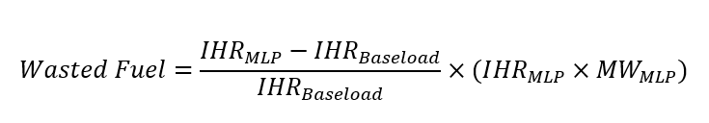

**Step 2:**

The total fuel wasted is then multiplied by the fuel cost to obtain the value of the wasted fuel.



**Step 3:**

Finally, in order to arrive at the $/MW value that will be assigned to the *operating reserve offer reference level*, the total value of the wasted fuel is divided by the difference of the baseload MW rating and the MLP MW rating, as this difference represents the *operating reserve* quantity that, if dispatched, would prevent the efficient *energy* production of the unit.

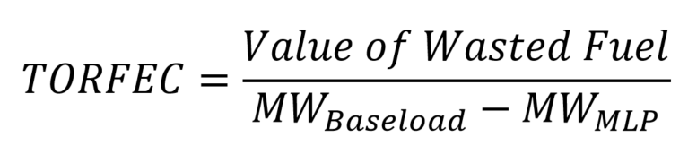

**Formulation:**

Combing the above, the un-factored formula for T-FEOC is:

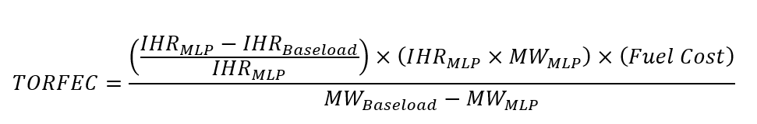

The factored formula is:

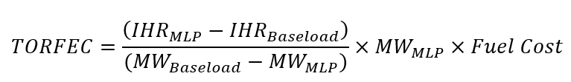

If the fuel cost for the *resource* is a fuel index that is determined dynamically by the *IESO*, then the *market participant* would enter in numbers for all variables except the fuel cost. The T-ORFEC would then be registered as a formula that includes the fuel cost as a dynamic variable.

If the fuel cost for the *resource* is a fixed value, then the *market participant* would enter in numbers for all variables. The T-ORFEC would then be registered as a fixed value.

Note that if the *resource* is more efficient at MLP than baseload, then the value of the T-ORFEC will be a negative number.

**Example 1:**

The following is an illustrative example of a hypothetical T-ORFEC for Resource B, which is a Variant B thermal unit that has an MLP of 30 MW with an incremental HR of 15 GJ/MWh at MLP, a baseload rating of 50 MW and an incremental HR of 12 GJ/MWh at baseload.

The total wasted fuel is determined by solving the following:

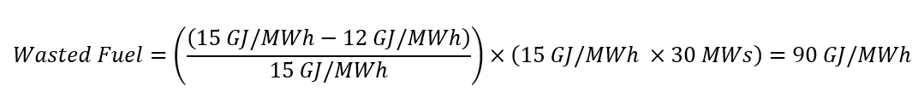

The value of the total wasted fuel for Resource B is determined by solving the following:



If Resource B used a dynamic fuel index rather than a fixed fuel cost, then the *market participant* would submit the following data to register the T-ORFEC:

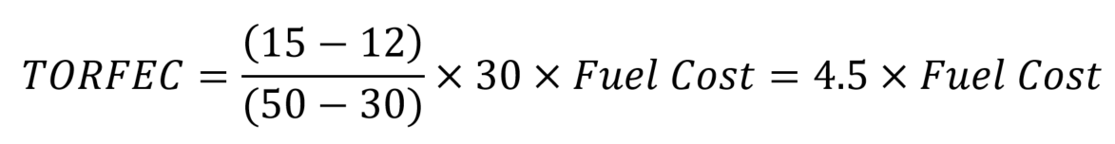

If Resource B used a fixed fuel cost of $3/GJ instead of a dynamic fuel cost, then Resource B would register the following as its T-ORFEC:

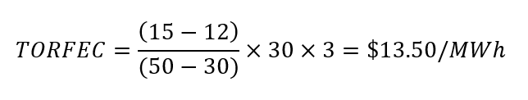

### Hydroelectric

For the purposes of establishing *reference levels*, hydroelectric *resources* are considered to be *resources* that produce electricity by using the power of flowing water. Hydroelectric *resources* have both an *energy offer* *reference level* and an *operating reserve offer* *reference level*.

This section describes how a *market participant* must submit the inputs for the applicable form to facilitate the calculation of each relevant *reference level*.

For hydroelectric *resources*, the *IESO* applies the following equation for the *energy offer* *reference level* and the components are described in subsequent sections.

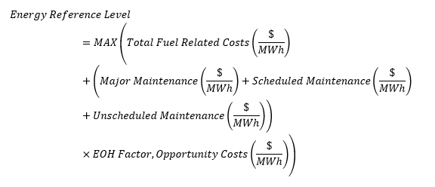

#### Total Fuel-Related Costs

The total fuel-related costs for hydroelectric *resources* includes the gross revenue charges and the pumped hydroelectric fuel costs.

##### Gross Revenue Charges

Hydroelectric *resource* owners pay taxes and charges based on gross revenue on a $/MWh basis. These taxes and charges are known as the gross revenue charges (GRC). GRC is an eligible fuel-related cost for hydroelectric *resources*.

Examples of GRC components include:

* property taxes payable to the Minister of Finance;
* property taxes payable to the Ontario Electricity Financial Corporation;
* water rental charges payable to the Minister of Finance;
* charges from the Niagara Parks Commission; and
* charges from the Province of Quebec.

Supporting documentation for the GRC include invoices issued by the relevant authority.

The following equation specifies the contribution of GRC to the *energy offer* *reference level*:

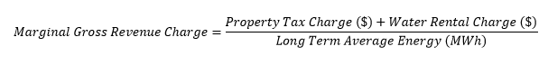Where:

* Property Tax Charge is calculated from the marginal tax rate, the water rental charge and the long term average *energy*.
* Long Term Average Energy is the annual *energy* which is expected to be produced during the average hydrological year, also known as the P50 Energy generation.
* The Long Term Average Energy should be calculated using at least 10 years of actual generation records, or calculated via an hourly simulation model with at least 10 years of hydrological records.

##### Pumped Hydroelectric Fuel Cost

Pumped-storage hydropower is a type of hydroelectric *energy* storage. It is configured with two reservoirs at different elevations that generate power as water moves past a turbine at the lower elevation. The water from the lower reservoir is pumped up into the higher reservoir to refill it for power generation later.

For hydroelectric *resources* that are configured in this way and are not registered as part of an *electricity storage facility*, the cost of *energy* necessary to pump water from the lower reservoir and move it up to the upper reservoir is an eligible cost for the *energy offer* *reference level*.

For hydroelectric *resources* that are configured in this way and are registered as an *electricity storage facility*, refer to Section 7.6 on *reference levels* for *financial dispatch data parameters* pertaining to *electricity storage resources*.

The *IESO* calculates the pumping power cost on a seven-day rolling average basis by multiplying the costs to withdraw power by the power consumed during each hour, divided by the total power consumed over the seven-day period (168 hours) to determine the average cost, as described below:

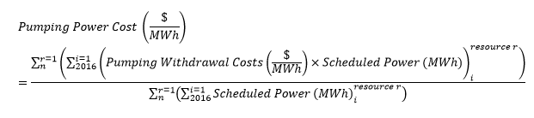

Where n is the nth number of *dispatchable load resources* associated with the pumped hydroelectric *facility*.

The Pumping Withdrawal Costs include the *real-time market LMP* paid for pumping withdrawals for all *dispatchable loads* associated with the pumped hydroelectric *facility*.

Pumping power cost includes a fixed $/MWh adder for related *energy* regulatory charges incurred during withdrawal operations. This adder will be added to the total fuel-related costs.

If no water has been pumped during the previous seven-day period, the *IESO* uses the last non-zero value for pumping power cost calculated for the hydroelectric *resource*.

The pumped storage fuel cost is calculated by dividing the pumping power cost by the pumping efficiency, as described below:

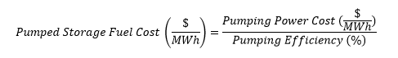

Pumping efficiency is measured using the ratio of generation produced to the amount of generation used as fuel. It is calculated as the generation produced in MWh over the *energy* consumed to pump that MWh of generation produced. This component is applicable to pumped storage hydroelectric generation *resources* only.

This formula depicts pumping efficiency calculation using generation produced and pumping energy consumed.

Supporting documentation for this cost is the calculation of pumping efficiency by the *market participant*, using the *resource*’s *revenue meter* data to determine the generation produced in MWh. A *market participant* may also calculate and submit seasonal pumping efficiencies for the *resource* to the *IESO*.

#### O&M Costs

Eligible maintenance costs included in the *reference levels* must be related to expenses incurred as a result of *energy* production and considered variable costs that are directly attributable to the production of *energy*. Costs must be incremental and avoidable to be considered eligible for the *reference level* determination for the *resource*.

Costs that do not vary due to increased electricity production are considered ineligible. Examples of ineligible costs include, but are not limited to:

* building maintenance;
* roads,dams anddam safety;
* hydroelectric-mechanical equipment;
* penstocks and water conveyance systems;
* HVAC systems;
* service air and water systems;
* water treatment; and
* drainage and dewatering.

##### Major Maintenance Costs

Eligible major maintenance costs for hydroelectric *resources* include:

* turbine refurbishment;
* runner blade repair;
* turbine/*generation unit* bearing refurbishment or replacement;
* refurbishment or replacement of turbine moving components including wicket gates, gate linkages and lubrication systems;
* refurbishment or replacement of the main generation components of *generation unit* synchronizing breaker and field breaker;
* refurbishment or replacement of the main generation component of brushgear and excitation systems (including rotation exciters);
* breaker service;
* service of compressed air systems related to braking systems;
* wear ring replacement;
* *generation unit* rewinds;
* stator core refurbishment/replacement;
* rotor pole rewinding;
* governor/hydraulic power unit refurbishment;
* transformer oil filtration/replacement; and
* transformer replacement.

Costs reimbursed by insurance and/or not directly incurred by the *market participant* due to warranty of the *resource* or any sub-component under construction or equipment supply contracts are excluded.

The supporting documentation required from a *market participant* is described in section 3.2. The historical study period for major maintenance costs for hydroelectric *resources* is 40 years.

##### Scheduled Maintenance Costs

Eligible scheduled maintenance costs for hydroelectric *resources* include:

* oil and lubricant replacement;
* filter replacements;
* feedwater piping repair;
* water treatment plant service;
* service of trash rack, rack cleaner and associated equipment;
* service of headgate and draft tube (including hoists);
* mechanical seal replacement; and
* consumable materials for the maintenance of turbine/*generation unit* components.

The supporting documentation required from a *market participant* is described in section 3.2. The historical study period for scheduled maintenance costs for hydroelectric *resources* is five years.

##### Unscheduled Maintenance Costs

Section 6.3 describes the eligible unscheduled maintenance costs that may be included in the *reference level* calculations. The supporting documentation required from a *market participant* is described in section 3.2. The historical study period for unscheduled maintenance costs for hydroelectric *resources* is five years.

#### Modifying Historical Eligible Maintenance Costs to Account for Changing Operational Profiles

The contributions of the eligible maintenance costs described above (major maintenance, scheduled maintenance, unscheduled maintenance) to the *energy offer* *reference level* are derived based on the historical operation of the unit.

There might be changes in how a *resource* was *dispatch*ed in the most recent year of operation, which is referred to as the current operating period, compared to how a *resource* was *dispatch*ed in the historical study period. To account for these changes, a *market participant* may elect to apply a correction factor to eligible historical maintenance costs based on the equivalent operating hours (EOH) methodology. This correction factor is applied to improve how accurately the *energy offer* *reference level* reflects historical eligible costs under the current operating period of a hydroelectric *resource*.

The EOH should be calculated for the relevant historical study period according to the type of maintenance cost as discussed above. An updated EOH may be determined if fundamental attributes of the *resource* have significantly changed due to upgrades or modifications. To determine the baseline EOH of the *resource*, only those years in the historical study period are used in which the *resource* had fundamental attributes that are consistent with the current attributes of the *resource*. The EOH should also be calculated for the last year of operation (the current operating period).

The ratio of the EOH from the historical study period to the EOH from the current operating period is the correction factor. The correction factor is used to index eligible maintenance costs from all maintenance cost categories (major maintenance, scheduled maintenance and unscheduled maintenance).

The value of EOH for a given year is calculated using the following equation:

This formula depicts the equivalent operating hour calculation using the hours of operation, number of start/stops and start/stop equivalent hours.

Where:

* hours of operation are the total number of hours the unit is used for generating electricity;
* # of start/stops are the total number of start/stop cycles of the unit; and
* start/stop equivalent hours are the number of hours of operation associated with each start/stop. A *market participant* must state their assumptions and submit supporting documentation for this value, which may include research studies in determining EOH start/stop hours.

The following case study illustrates example calculations for the EOH multiplier.

Table 7‑3: Example of EOH Methodology Illustrative

| **Parameter** | **Historical Annual Operation (last 5 years)** | **Current Operating Period (last year)** |
| --- | --- | --- |
| Hours of operation | 5000 h | 5000 h |
| # of start/stops | 100 | 300 |
| Start/stop equivalent hours | 5 hours per start/stop | 5 hours per start/stop |

Historical EOH is calculated as:

This is a numeric example to calculate the historical equivalent operating hours. The historiacl hours of operation is added to the product of the historical number of starts-stops and the historical start-stop equivalent hours.

And current operating regime EOH is calculated as:

This is a numeric example to calculate the current regime equivalent operating hours. The current hours of operation is added to the product of the current number of starts-stops and the current start-stop equivalent hours.

Therefore, the appropriate correction factor is calculated as:

6,500/5,500 = 1.18

#### Operating Reserve Offer Reference Levels

*Operating reserve offer reference levels* are determined based on incremental costs incurred by the *resource* to make the *operating reserve* capability available.

##### Synchronized Ten-Minute Operating Reserve Offer Reference Levels

##### Costs Associated with Condense Mode to Support Provision of Synchronized Ten-Minute Operating Reserve

*Market participants* relying on condense mode costs to establish a synchronized *ten-minute* *operating reserve offer reference level* must provide supporting documentation that shows the presence of the condenser at the *resource*. These supporting documents must also show unit rating tables for the *resource* detailing the condense mode operation and drawdown levels.

The components of condenser costs apart from the *IESO* annual escalation are registered values that are fixed. The *IESO* annual escalation is determined dynamically by the *IESO* as part of calculating *reference level values* for a *resource* and a *dispatch day*.

The condenser costs *operating reserve reference level value* component is determined using the following equation:

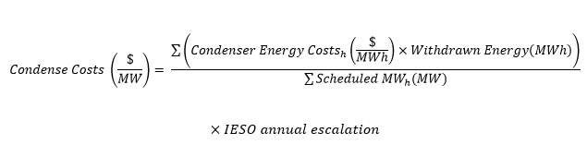Where,

Condenser *energy* costs are the average *real-time LMPs* paid by the resource over the historical study period when the condenser is in operation providing synchronized *ten-minute operating reserve* plus a fixed $/MWh adder for related *energy* regulatory charges incurred. For clarity, global adjustment charges are not eligible to be included as condenser *energy* costs, as these charges are not incurred if the *resource* receives a synchronized *ten-minute operating reserve schedule*.

Consumed *energy* is the MWh withdrawn in each *dispatch hour* to operate the condenser for each *dispatch hour* when the *resource* is operating in the condense mode across the historical study period.

Scheduled MWhis the scheduled synchronized *ten-minute* *operating reserve* MWs for each *dispatch hour* when the *resource* is operating in the condense mode across the historical study period.

*IESO* annual escalation for condenser costs is the LMP or Ontario Zonal Price paid by the *market participant*, as applicable, escalated by the calendar year-over-year electricity price increase, if any, that is determined by the *IESO* and is relevant for the *resource*. This escalation factor is the change in the simple average hourly electricity price between the previous year and the current year and is limited to a value no smaller than one.

The historical study period for total condenser *energy* costs and total condense synchronized *ten-minute operating reserve* MWs is five years.

##### Costs Associated with Speed No-Load Operations to Support Provision of 10-minute Spinning Operating Reserve

*Market participants* that do not rely on the use of a condenser to establish their synchronized *ten-minute operating reserve offer reference levels* can instead rely on costs associated to operate in speed no-load mode, where the *resource* is synchronized but not injecting *energy*, to set this *reference level*. This cost component is referred to as “SNL Cost”.

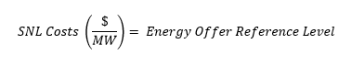SNL Cost is determined dynamically by the *IESO* as part of calculating *reference level values* for a *resource* and a dispatch day and is determined using the equation below:  
Where the *energy offer reference level* is the *reference level value* calculated for the *resource* for *dispatch day* d and hour h. This *reference level* component is a dynamic component and the *IESO* calculates the *reference level values* daily.

*Resources* with a condenser cannot establish a synchronized *ten-minute* *operating reserve* *offer reference level* based on speed no-load mode costs.

##### 10N Operating Reserve Offer Reference Levels

*Operating reserve offer reference levels* are determined based on incremental costs incurred by the *resource* to make the *operating reserve* capability available.

##### 30R Operating Reserve Offer Reference Levels

*Operating reserve offer reference levels* are determined based on incremental costs incurred by the *resource* to make the *operating reserve* capability available.

##### Operating Reserve Offer Reference Levels for Any Class

Costs Associated with Fuel Efficiency Impacts of Providing Operating Reserve. The Hydroelectric - Operating Reserve Fuel Efficiency Cost (H-ORFEC) is the cost of extra fuel use associated with inefficient *energy* production for hydroelectric *resources* that are providing *operating reserve* beyond a certain level. As hydroelectric *resources* can provide *operating reserve* for the MWs above their efficiency rating up to their maximum capacity, the H-ORFEC only applies to the *operating reserve* MWs that prevent the *resource* from producing *energy* at its most efficient rate of production.

The H-ORFEC applies only to the last Y MWs of the *operating reserve reference level*, where Y equals the maximum capacity of the *resource* less the number of MWs equal to the *energy* schedule when the *resource* is producing *energy* at its most efficient rate of production.

When a hydroelectric *resource* produces *energy* at rates below its most efficient level of production, it uses more water per unit of output than would otherwise be the case. When a hydroelectric *resource* is scheduled for more than a certain amount of *operating reserve*, this prevents the hydroelectric *resource* from producing *energy* at its most efficient production level, as scheduled *energy* plus scheduled *operating reserve* cannot be more than the capacity of the resource. This inefficient *energy* production can result in wasted fuel.

When determining the registered components of the H-ORFEC, *market participants* must use data that shows the performance of the hydroelectric *resource* under reference head conditions. The *IESO* uses a three-step process to determine the H-ORFEC.

**Step 1:**

The first step to determine the value of the H-ORFEC is for the *market participant* to choose a combination of *energy* schedules and *operating reserve* schedules for a hypothetical *dispatch hour* for which the following are true:

1. *Energy* schedule is less than the *resource’s* best efficiency production level; and
2. *Energy* schedule plus *operating reserve* schedule is equal to the maximum installed capacity of the *resource*.

This combination of *energy* schedule and *operating reserve* schedule is referred to as “Point X” for the purpose of determining the H-ORFEC.

Example:

Resource A has a maximum installed capacity of 20MW and its best efficiency level of *energy* production is 18 MW.

The *market participant* for Resource A can choose Point X anywhere that the conditions set out in (i) and (ii) above are true. *Market participants* are free to determine Point X as any combination of *energy* and *operating reserve* schedules where these conditions are met. In this case, the market participant chooses Point X such that the *energy* schedule is 13 MW and the *operating reserve* schedule is 7 MW.

The calculation of the H-ORFEC requires the determination of the total fuel that is wasted given the *energy* production at Point X. Calculating the wasted fuel first involves determining the percentage difference in efficiency ratings by comparing the efficiency ratings at the best efficiency level of production to the efficiency rating when the *energy* schedule is at the level in Point X. When determining this percentage difference, *market participants* can express efficiency either in % terms or in terms of cms/MWh, at their discretion. When choosing which units to use to express efficiency differences, *market participants* should be cognizant of which data can be supported with documentation that can be provided to the *IESO*.

**Step 2:**

Multiply the efficiency difference determined in Step 1 by the *energy* schedule at Point X to determine the total wasted fuel at Point X (expressed as a MW quantity).

The value of the wasted fuel is then calculated by multiplying this quantity by the *energy offer reference level value* of the resource. This product is determined dynamically by the *IESO* as it calculates a *resource’s* *reference level values* for each *dispatch day*. The value of this product is the total value of the wasted fuel at Point X.

Example:

In the example above, say Resource A has an efficiency level of 80% at the efficiency level of production (18 MWs) and an efficiency level of 60% at the *energy* schedule from Point X (13 MWs).

The total wasted fuel is determined by solving the following:

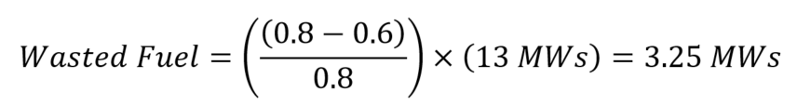

If the *resource’s* *energy offer reference level value* is $400/MWh in this case, then the value of the wasted fuel is equal to 3.25 times this *energy offer reference level value* of $400/MWh:



**Step 3:**

The final step is to determine the $/MW value that will be assigned to the *operating reserve offer reference level*. This is done by dividing the total value of the wasted fuel at Point X into the *operating reserve* schedule at Point X.

Example:

Continuing the example above, the value of the H-ORFEC is determined by dividing the value of the wasted fuel ($1,300) by the *operating reserve* schedule at Point X (7 MWs):

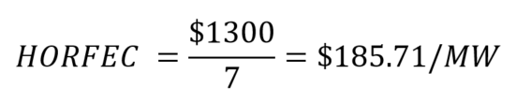

In this example, the H-ORFEC is equal to $185.71/MW for a particular *dispatch day* given the *energy offer reference level value* of $400/MWh.

**Registering the H-ORFEC Reference Level Component:**

Considerations Regarding Choice of Point X:

The value of the H-ORFEC is impacted by a number of factors. The value of the H-ORFEC will increase as: (i) the difference in efficiency ratings between the best efficiency level of production and the *energy* schedule at Point X increases; and (ii) the *energy* schedule at Point X increases. The value of the H-ORFEC will decrease as the *operating reserve* schedule at Point X increases.

Reference Level Registration:

The *energy offer reference level value* is determined by the *IESO* on a dynamic basis for each *dispatch day*. As a result, when *market participants* register the H-ORFEC, they do not register a particular value for the *energy offer reference level value* in the H-ORFEC. All other terms in the H-ORFEC are registered and the value of the H-ORFEC is determined as part of the calculations to determine a *resource’s* *reference level values* for each *dispatch day*.

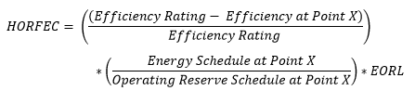As a result, to register the H-ORFEC component, the formula that is used by the *market participant* to register the H-ORFEC is:

Where:

* EORL is the *energy offer reference level value* that is determined for each *dispatch day* by the *IESO*;
* Efficiency Rating is the efficiency rating that the *resource* produces *energy* at the most efficiency level of production; and
* Efficiency at Point X is the efficiency rating that the *resource* produces *energy* at the *energy* schedule from Point X.

The efficiency data, *energy* schedule and *operating reserve* schedule at Point X are all known at the point of registration. The only unknown at that time is the *energy offer reference level value*.

Application:

*Market participants* also provide information about the level of production at the most efficient level of production. This informs the MW tranche of the *operating reserve* *reference level* which the H-ORFEC is applied to. The H-ORFEC only applies to MWs in the *operating reserve reference level* that are greater than the maximum installed capacity of the *resource* less the production level at the most efficient level of production.

Example:

Continuing the example in Steps 1-3, Resource A would provide the following information to register the H-ORFEC:



The *market participant* would register the H-ORFEC equal to 0.465 times the *energy offer reference level value* for Resource A, given the *resource’s* operational parameters and the choice of *energy* schedule and *operating reserve* schedule at Point X.

In this example, Resource A produces at the most efficient level at 18 MWs and has a maximum capacity of 20 MWs, so the H-ORFEC is not applied to *the operating reserve offer reference level* for MWs 0 – 2. The H-ORFEC is applied to the *operating reserve offer reference level* for the tranche(s) that include MWs from 2.1 MW to 20 MWs.

In this example, the H-ORFEC component requested would be as listed in the following table.

Table 7‑4: H-ORFEC Tranches for a Hydroelectric Resource

| **MW Range** | **H-ORFEC Component Value** |
| --- | --- |
| 0 – 2 | 0 |
| 2.1 – 20 | 0.465×EORL |

Combining the H-ORFEC with other operating reserve reference level cost components:

The H-ORFEC is mutually exclusive of the SNL fuel cost and the condense mode cost for synchronized *ten-minute* *operating reserve*. This means that a *market participant* could request the SNL fuel cost or the condense mode cost for synchronized *ten-minute* *operating reserve* for the MW range from 0 – 2 MWs and the H-ORFEC for the MW range from 2.1 – 20 MWs, but could not request the H-ORFEC and the SNL cost or condense cost for the MW range from 2.1 – 20 MWs. The reason for this restriction is that the H-ORFEC assumes some *energy* production, while both the SNL cost and the condense cost assume that *energy* production is 0 MW. As the underlying scenarios are contradictory, *market participants* cannot request more than one of the H-ORFEC, the SNL cost or the condense mode cost for a particular tranche of their synchronized *ten-minute* *operating reserve reference level*.

In the example of Resource A, it would be possible for the *market participant* to request use of the condense or SNL mode cost for synchronized *ten-minute* *operating reserve* for the MW range from 0 – 2 MW and the H-ORFEC for the MW range from 2.1 MW to 20 MW.

#### Energy Offer Reference Levels for Hydroelectric Resources that are Part of Cascade Groups

*Energy offer reference levels* of *resources* that are part of a *cascade group* account for the operational interdependencies of the *resources* in the *cascade group*.

A *market participant* must provide the information described below when requesting *reference levels* for a *resource* that is part of a *cascade group*. This information enables the *IESO* to identify the appropriate *resources*. The *IESO* uses this information to determine *reference levels* for these *resources* as described below.

##### Registering Energy Offer Reference Levels for Hydroelectric Resources that are Part of Cascade Groups

A *market participant* must register the following information for eligible *resources*:

* The *forebays* within the *cascade group*;
* The sequence of the *forebays* within the *cascade group;*
* The *resources* within each *forebay; and*
* The relevant cost components that will contribute to the *energy offer reference level* and *operating reserve offer reference level* for each *resource* in the *cascade group*.

Refer to **MM 1.5** for more details on the registration process for *cascade groups.*

##### Calculating Energy Offer Reference Levels for Hydroelectric Resources that are Part of a Cascade Group

*Reference level values* increase in price from the top of a *cascade group* to the bottom of a *cascade group*. *Resources* at the top of the *cascade group* will have the lowest *reference level values* and *resources* at the bottom of the *cascade group* will have the highest *reference level values*.

The *IESO* carries out the following steps to determine *reference level values* for *resources* in a *cascade group*:

1. Calculate *energy offer reference level values* for *resources* that share the *forebay* at the top of the *cascade group*.
2. Calculate the *reference level values* for *resources* at *forebay* 2 per the relevant registered *reference level* for the *resources* based on either the maximum *reference level value* of the *resources* at *forebay* 1 plus a $20/MWh adder or based on the registered cost components of the relevant *resource* (whichever is higher).
3. For *cascade* *groups* with more than 2 *forebays*, repeat step 2 for *resources* at each subsequent *forebay* in the *cascade group* until all *reference level values* have been calculated.

For example, assume a *cascade group* exists where Resources A and B share a *forebay* at the top of the *cascade group*, Resources C and D share a *forebay* in the middle of the *cascade group* and Resources E and F share a *forebay* at the bottom of the *cascade group*.

In this example, the *IESO* calculates the *energy offer reference level values* for Resources A and B in a manner consistent with the registered *reference levels* for Resources A and B.

To determine the *energy offer reference level values* for Resources C and D, the *IESO* determines the maximum of:

* Resource A’s and Resource B’s *energy offer reference level values* plus $20/MWh; and
* the registered cost component(s) for Resource C and Resource D respectively.

To determine the *energy offer reference level values* for Resources E and F, the *IESO* determines the maximum of:

* Resource C’s and Resource D’s *energy offer reference level values* plus $20/MWh; and
* the registered cost component(s) for Resource E and Resource F respectively.

The $20/MWh adder creates *reference level values* that increase from resources at the top *forebay* to resources at the bottom *forebay*.

Table 7‑5: Example of Cascade Group Hydroelectric Resource Reference Level Value Methodology

| **Cascade Position** | **Resource** | **Reference Level Value** |
| --- | --- | --- |
| 1 | A | $100 |
| 1 | B | $95 |
| 2 | C | MAX($120, $60) |
| 2 | D | MAX($120, $55) |
| 3 | E | MAX($140, $40) |
| 3 | F | MAX($140, $42) |

### Solar

For the purposes of setting *reference levels,* solar *resources* are considered to be *resources* that use photovoltaic cells to convert solar radiation to electricity.

This section describes the inputs that a *market participant* must submit to request an *energy offer reference level*.

For solar *resources*, the following equation for *energy offer reference level* is applied and the components are described in subsequent subsections:

This formula depicts energy reference level calculation for solar resources is the operating and maintenance cost.

#### O&M Costs

This section describes the eligible maintenance costs for solar *resources* that may be included into the *reference levels*.

##### Major Maintenance Costs

Eligible major maintenance costs for solar *resources* include costs to replace inverter units. Costs reimbursed by insurance and/or warranty are excluded.

The supporting documentation required from a *market participant* is described in section 3.2. The historical study period for major maintenance costs for solar *resources* is 10 years.

For new solar installations, the statistical *energy* output given in a P50 *resource* assessment may be used when historical injection data is not available.

##### Scheduled Maintenance – Electrical and Mechanical

Eligible scheduled maintenance costs for solar *resources* include:

* inverter annual maintenance;
* combiner box inspections;
* standard cleaning of electronics; and
* racking bolt torque checking.

The supporting documentation required from a *market participant* is described in section 3.2. The historical study period for scheduled maintenance costs for solar *resources* is five years.

##### Unscheduled Maintenance Costs – Electrical

Eligible unscheduled maintenance costs for solar *resources* include overtime labour or third-party labour contracted to repair the components and the materials costs associated with any such repairs in the event of equipment failure.

The supporting documentation required from a *market participant* is described in section 3.2. The historical study period for unscheduled maintenance costs for solar *resources* is five years.

##### Incremental Third-Party Payments

Section 6.3 describes eligible incremental third-party payments that must be included in the calculation of the *reference levels* for solar *resources*.

### Wind

For the purposes of setting *reference levels,* a wind *resource* is considered to be a *resource* that converts the kinetic *energy* of the wind into electric power through a wind turbine. The wind turbine produces electricity by collecting and transforming wind power into rotational mechanical *energy* to drive a *generating unit*.

For wind *resources*, the *IESO* applies the following equation to determine the *energy offer reference level*. The components are described in subsequent subsections.

This formula depicts energy reference level calculation for wind resources is the operating and maintenance cost.

#### O&M Costs

The following subsections list the eligible major, scheduled and unscheduled maintenance costs that may be included in the *reference level* calculations for wind *resources*.

##### Major Maintenance Costs

Eligible major maintenance costs for wind *resources* include:

* blade (blade structure, complete blade, lightning protection system, leading edge protection (lep) coating);
* pitch system (bearing change, hydraulics);
* drive train (main shaft / bearing changeout);
* gearbox (bearing change, complete gearbox change); and
* *generation unit* (bearing change, complete *generation unit* changeout).

Costs reimbursed by insurance or warranty under construction or equipment supply contracts are excluded.

The supporting documentation required from a *market participant* is described in section 3.2. The historical study period for major maintenance costs for wind *resources* is 10 years.

For new wind installations, the statistical *energy* output given in a P50 *resource* assessment may be used when historical injection data is not available.

##### Scheduled Maintenance Costs

Eligible scheduled maintenance costs for wind *resources* include:

* converter and main cabinets checks;
* power cables – stator and rotor check;
* bus bar and power cables inspection;
* *generation unit* and gearbox inspections and monitoring program;
* yaw and pitch system inspection;
* lubrication and oil changes;
* bearing inspection and lubrication;
* bearing sealing inspection and insulation test;
* stator winding inspection;
* cooling circuit and heat exchanger inspection;
* blade heating inspection;
* standard cleaning;
* vibration check (*generation unit* frame, bearing housing);
* bolt torque tightening;
* shaft alignment check; and
* blade inspection and minor repair.

The supporting documentation required from a *market participant* is described in section 3.2. The historical study period for scheduled maintenance costs for wind *resources* is five years.

##### Unscheduled Maintenance Costs

Eligible unscheduled maintenance costs for solar *resources* include overtime labour or third-party labour contracted to repair the components and materials costs associated with any such repairs in the event of equipment failure.

The supporting documentation required from a *market participant* is described in section 3.2. The historical study period for unscheduled maintenance costs for wind *resources* is five years.

##### Incremental Third-Party Payments

Section 6.3.4 describes the eligible incremental third-party payments that may be included in the *reference level* calculations for wind *resources*.

##### Operational Costs Related to Start-Up

Eligible operational costs related to start-up include costs to consume *energy* to warm up the *resource* to enable it to respond to *dispatch* *instructions*. Examples of wind *resources* that are expected to incur these costs include those with cold climate packages or blade heating.

The cost of power is eligible to be included in the *energy offer* *reference level* on a $/MWh basis based on the total cost of starting the unit divided by *energy* production across the historical study period.

Unit SCADA data must be submitted as supporting documentation to show warm-up stage consumption, and hence cost. The supporting documentation required from a *market participant* is described in section 3.2.

The historical study period for operational costs related to start-up for wind *resources* is one year.

### Nuclear

For the purposes of establishing *reference levels,* a nuclear *resource* is considered to be a *resource* that is licensed to produce commercial power from controlled nuclear reactions to heat water to produce steam that drives a steam turbines *generation unit*.

Nuclear *resources* have an *energy offer reference level*. This section describes the inputs for the applicable form that a *market participant* should complete to request an *energy offer reference level*.

For nuclear *resources*, the *IESO* applies the following equation for the *energy offer reference level* and the components are described in subsequent subsections.

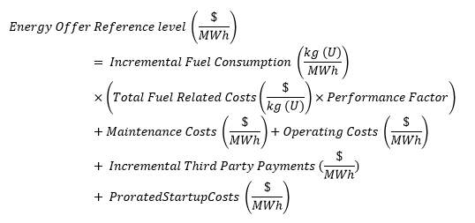

#### Fuel-Related Costs

Eligible fuel-related costs for nuclear *resources* may be grouped into *resource* generation capacity data and total fuel-related costs.

##### Resource Generation Capacity Data

The following sections define the *resources* power production capacities and efficiencies.

###### Net Power, MW (net)

Net power is equal to the power (MW) delivered to the grid. This is the gross *generation unit* output minus the house loads (the auxiliary power consumption of the *resources*) required to operate the *resource* for power production.

This formula depicts the new power calculation using gross output and house loads.

###### Maximum Licensed Reactor Power (RP)

This is the current maximum thermal power, MW(th) at which the nuclear *resource* is approved to operate according to their Canadian Nuclear Safety Commission (CNSC) Operation License.

###### Heat Rate

Heat rate is the *resource*’s heat input, MW(th) divided by its net electrical energy output, MWh.

This formula depicts the heat rate calculation using max licensed RP and net electrical production.

###### Incremental Fuel Consumption

Incremental fuel consumption (kg(U)/MWh) is the relationship between an additional MWh of output and the additional uranium fuel input in kg necessary to produce it. This is determined from the ratio of the change in fuel input to the change in *resource* MWh output.

This formula depicts the incremental fuel consumption calculation using fuel burn rates and heat rates.

Fuel Burn Rate, kg(U)/MW(th) is the actual burn rate of the uranium fuel as reported in the station Annual Fuel Performance Report or the Station Safety Report.

###### Capacity Factor

Capacity factor is the ratio of actual electrical *energy* output for the *resource* over a given period of time to the maximum possible electrical *energy* output over that period. Capacity factor indicates the extent of the use of the *resource*. If the *resource* is always running at its rated capacity, then the capacity factor is 100% or 1.

###### Performance Factors

The performance factor is the calculated ratio of actual fuel burn to the theoretical fuel burn (design heat input) to achieve a required *generation unit* output.

In the nuclear industry, this is known as the Thermal Performance Indicator (TPI) as defined by World Association of Nuclear Operators (WANO). The WANO specifications dictate the data collection and analysis requirements.

The TPI is the ratio of overall actual cycle efficiency to the design cycle efficiency. In this regard, the TPI encompasses the entire reactor-boiler-turbine‑condenser cycle. This indicator is an integrated measure that includes unnecessary heat loads, turbine cycle and condenser performance. Performance factor is expressed as a percentage, where 100% indicates perfect thermal performance.

##### Total Fuel Related Costs (TFRC)

Eligible total fuel related cost is the sum of eligible basic fuel costs and eligible fuel disposal costs. All of these costs are expressed in $/kg(U).

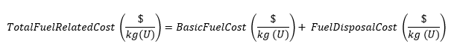

###### Basic Fuel Costs

Eligible basic fuel costs are the total costs of fuel, including natural uranium cost, conversion to UO2 and fabrication. These costs are supplied by the fuel vendor and are expressed in $/kg.

###### Fuel Disposal Costs

Eligible fuel disposal costs are the costs associated with transportation and disposal of spent fuel and are expressed in $/kg (U).

Fuel disposal costs are added directly to the basic fuel costs to determine eligible total fuel-related costs. These costs must be supported by with invoices for the long-term storage costs of spent fuels.

On-site storage costs for spent fuel is not an eligible cost as this is considered part of the fixed operating costs of the *resource*.

#### O&M Costs

Eligible operating costs are those costs directly attributed to consumable materials and services required for operation of the reactor and *energy* production. These are non-labour cost components accounting for materials and consumable costs incurred as a result of electrical power production and safe operation of the nuclear reactor.

They include the cost of:

* lubricants;
* chemicals;
* gases;
* demineralized water;
* acids;
* caustics and heavy water (deuterium oxide);
* tritium removal;
* ion exchange resins procurement and disposal; and
* filters.

The supporting documentation required from a *market participant* is described in section 3.2. The historical study period for operating costs for nuclear *resources* is five years.

##### Major Maintenance Costs

Eligible major maintenance costs for nuclear *resources* include:

* turbine and *generation unit* refurbishment and rebuilds;
* turbine and *generation unit* control and power systems refurbishment and rebuilds;
* all major pump and motor repairs, boiler feed, condenser cooling water, primary heat transport, or moderator cooling;
* all systems heat exchanger tube plugging and tube bundle replacements;
* all critical system valves and valve operators repair or replacement;
* trash rack breakdown or equipment failure repair;
* repair or replacement of reactivity control units;
* feeder and pressure tube inspection, assessment and replacement;
* main output and unit transformer inspection, repair and replacement;
* isolated phase bus inspection and repair;
* all critical electrical systems, transformers, switchgear, bus duct, breakers, protective relays, motor control equipment, surge protection, rectifiers, inverters and batteries; and
* maintenance or replacement of emergency power systems.
* Costs reimbursed by insurance and/or covered by warranty under construction or equipment supply contracts are excluded.

The supporting documentation required from a *market participant* is described in section 3.2. The historical study period for major maintenance costs for nuclear *resources* is 10 years.

##### Scheduled Maintenance

Eligible scheduled maintenance costs for a nuclear *resource* include maintenance tasks during major *outages* and or during operating periods including inspections and work such as:

* turbine blade inspection;
* turbine diaphragm repair; casing inspection;
* turbine and *generation unit* seal inspections repair or replacement;
* heat exchanger cleaning;
* turbine emergency stop and control valves, reheat stop and intercept valve inspections and repairs;
* turbine and *generation unit* control and power systems inspections;
* all major pump and motor inspection and repairs, boiler feed, condenser cooling water, primary heat transport, or moderator cooling;
* all systems heat exchanger tube bundle inspections;
* all critical system valves and valve operator inspections;
* scheduled maintenance of reactivity control units;
* heavy water purification, ion exchange equipment, filters and strainers;
* containment systems inspection and maintenance;
* feeder and pressure tube inspection, assessment and replacement;
* main output and unit transformer inspection, repair and replacement;
* isolated phase bus inspection and repair;
* fueling machine service and maintenance;
* primary and secondary spent fuel bay systems inspection and repair;
* repairs to any safety related systems where its current condition is resulting in an impairment and forcing unit derate or shutdown;
* all electrical systems, transformers, switchgear, bus duct, breakers, protective relays, motor control equipment, surge protection, rectifiers, inverters and batteries; and
* scheduled maintenance of emergency power systems.

The supporting documentation required from a *market participant* is described in section 3.2. The historical study period for scheduled maintenance costs for nuclear *resources* is five years.

##### Unscheduled Maintenance Costs

Eligible unscheduled maintenance costs for nuclear *resources* are expenses incurred as a result of electrical production resulting from run-to-equipment-failure maintenance strategies and unplanned equipment failures.

Eligible costs include only maintenance costs related to:

* electrical production;
* reactor safety margin management;
* environmental qualification maintenance;
* radiation safety management;
* conventional safety;
* environmental safety; and
* regulator code compliance requirements (CNSC RD/GD-201, RD/GD-98).

Eligible costs incurred for corrective action and root cause investigations include:

* temporary repair;[9]
* repair,
* overhaul;
* refurbishment;
* replacement; or
* modification costs.

In addition, costs incurred as a result of corrective action and root cause investigations (inspection and equipment failure diagnosis) are also eligible.

The supporting documentation required from a *market participant* is described in section 3.2. The historical study period for unscheduled maintenance costs for nuclear *resources* is five years.

##### Incremental Third-Party Payments

Section 6.3.4 describes the eligible incremental third-party payments that may be included in the *reference level* calculations for nuclear *resources*.

##### Operational Costs Related to Start-Up

Eligible operational costs related to start-up are costs incurred as a result of a cold start of a nuclear *resource*, where nuclear fuel, consumables, and *energy* from the grid are consumed during the course of the start-up phase.

In cases where a *resource* is *dispatched*, but needs to consume *energy* and fuel to start up, a *market participant* may include this cost into the incremental *energy* for the *resource* on a $/MWh basis based on the total cost per start divided by *energy* production across the historical study period.

*A market participant* must submit the unit SCADA data as supporting documentation to show warm-up stage consumption, and hence the cost.

Total per start costs are calculated according to the following formula:

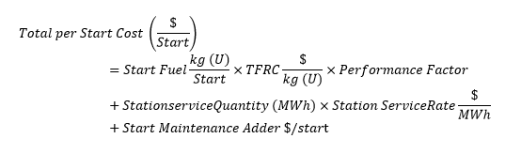

Where:

* Start fuel is the fuel consumed from cold to licensed full power operation.
* *Station service* quantity is the grid power consumed during the start-up phase to the point of the nuclear *resource* powering its own house loads.
* Start maintenance adder ($/start)is eligible maintenance costs required specifically and only for the *resource* start-up.

The supporting documentation required from a *market participant* is described in section 3.2. The historical study period for operational costs related to start-up for nuclear *resources* is 1 year.

### Electricity Storage

For the purposes of establishing *reference levels*,an *electricity storage resource* is considered to be a *resource* whose sole-purpose is to capture *energy* produced at one point in time for use at a later point in time. There are various electricity storage technologies, including technologies that rely on mechanical, electromechanical and chemical means to produce electricity.

A *dispatchable electricity storage resource* will have an *energy offer reference level* and an *operating reserve offer reference level* for the *resource* associated with its injections and an *operating reserve offer reference level* for the *resource* associated with its withdrawals. This section describes the inputs that a *market participant* must submit in the applicable form to request the relevant *reference level*.

For the *electricity storage resource* that intends to inject, the *IESO* applies the following equation for the *energy offer reference level* and the components are described in the subsequent sections.

The *energy offer reference level* is equal to the greater of either the incremental costs for discharging the *electricity storage resource* or the opportunity cost.

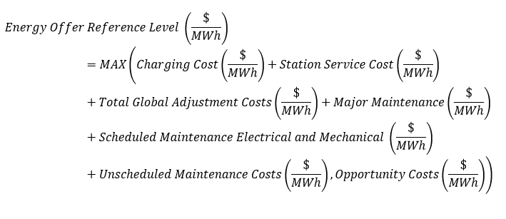

#### Fuel-Related Costs

This section describes the fuel-related costs associated with charging costs and *station service* costs for an *electricity storage resource*.

##### Charging Costs

The *short-run marginal costs* of an *electricity storage resource* include the charging costs for the *resource*.

The *IESO* calculates the eligible charging costs per month by using the following equation:

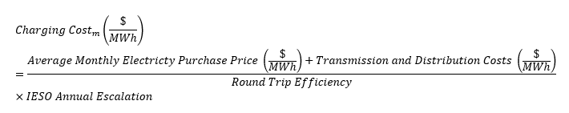

Average Monthly Electricity Purchase Price

This calculation is completed by the *market participant* and is submitted to the *IESO* for review. For *resources* that have historical charging price data of greater than one year, the average monthly electricity purchase pricing for the *resource* is based on the average price the withdrawals of the *electricity storage resource* paid in the same calendar month of the previous year.

If the *electricity storage resource* has been operating for less than one year or if there is no charging data for a particular month in the historical study period, it is assumed the *electricity storage resource* is charging between 23:00 and 06:00 EST. The average *LMP* at the *electricity storage resource* registered to withdraw energy for those hours from the same month of the previous year is used to calculate the charging costs. If the *resource* has no historical *LMP* data at the *resource* registered to withdraw energy, the *day-ahead market* Ontario zonal price or the represented *IESO*-*published* nodal prices as agreed to with the *IESO* may be used in this calculation to base the *electricity storage resource*’s theoretical charging cost.

Round-Trip Efficiency

The round-trip efficiency of an *electricity storage resource* is analogous to the heat rate of a thermal *resource*.

The round-trip efficiency of the *electricity storage resource* is the amount of *energy* that can be discharged compared to the amount of *energy* that was required to recharge the *electricity storage resource*.

The efficiency of an *electricity storage resource* is calculated using the following equation:

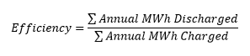

The MWh charged is calculated using *meter data* based on the electricity purchased by the *market participant* to recharge the *electricity storage resource* after discharging. This amount also includes the *energy* used to recharge the *electricity storage resource* as a result of the *electricity storage resource’s* natural self-discharge.

Round-trip efficiency may be updated on an as-needed basis.

There are two options for the historical study period for round-trip efficiency for *electricity storage resource*:

* where a *market participant* indicates a year-round round-trip efficiency factor is desired for a particular *electricity storage resource*, the relevant historical study period is one year; or
* a seasonal round-trip efficiency factor may be used for a particular *electricity storage resource* at the request of a *market participant*. In this case, the relevant historical study period is six months for the summer round-trip efficiency and six months for the winter round-trip efficiency.

IESO Annual Escalation

The electricity consumption price is escalated by the calendar year-over-year electricity price increase, if any, that is imposed by the *IESO* and is relevant for the *resource*. This escalation factor is determined by taking the maximum of zero year-over-year change and the change in the simple average *LMP* or *Ontario zonal price* paid by the *market participant*, as applicable, from the current calendar year from the simple average of the relevant price from the previous calendar year.

Transmission and Distribution Costs

Distribution costs that an *electricity storage* *resource* incurs on a volumetric basis (per KWh consumed or per KW-demand) to charge are eligible to be included in the *resource*’s *energy offer reference level*. Determining the volumetric component will vary depending on the rate structure of the relevant *distributor*. Transmission costs that are incurred on a volumetric basis are also eligible to be included in an *electricity storage resource*’s *energy offer reference level*.

The portions of an *electricity storage resource’*s distribution and transmission costs that are not determined on a volumetric basis are not eligible for inclusion in the *resource*’s *energy offer reference level*.

A *market participant* must provide monthly invoices to support the incremental portions for a historical study period of 1 year.

The contribution of the eligible transmission and distribution costs to an *energy offer reference level* is determined using the equation:



#### Station Service Costs

There are two potential configurations for *station services* supply for an *electricity storage resource*:

* *station services* are supplied behind the meter, with a tap off the low voltage side of the step-up transformer. Effect of *station services* in this case is captured in the round-trip efficiency calculation; or
* *station services* are supplied using a separate feed with a *revenue meter* for electricity consumed to serve *station services* and auxiliary loads.

Most *electricity storage resource* have auxiliary services and *station services*. In some cases, these services are separately metered.

The *station service* costs adder is only eligible for an *electricity storage resource* in the second configuration; where auxiliary loads are supplied by a separate metered connection or where the auxiliary loads have been removed from the efficiency using a meter on the auxiliary feed. Eligible *station service* costs are incurred by an *electricity storage resource* due to higher auxiliary consumption during discharging (i.e. cooling or heating of batteries). It does not include normal auxiliary or *station* *services* loads required regardless of operating status: protection and controls, controls, lighting, monitoring, security, communications, etc.

The historical study period for *station service* costs for an *electricity storage resource* is the corresponding calendar month from the previous calendar year.

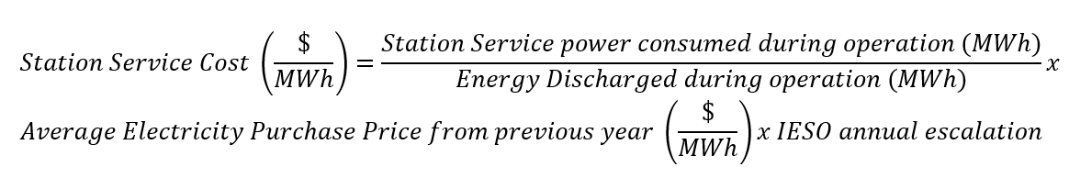

Eligible *station services* costs are calculated on a monthly average based on the same calendar month from the previous year.

A *market participant* must submit supporting documentation demonstrating station service power consumed during operation and *energy* discharged during operation using the first available method of the following:

1. *Energy* discharged during operation: Discharged *energy* sold to the grid based on historical meter data from the same month from the previous year. This approach is preferred by the *IESO* where data is available.
2. Station service power consumed during operation: Consumption at the meter is compared during periods of discharging and periods of idling for the same month from the previous year.
3. Vendor data:A*market participant* may submit datasheets or performance documentation from the vendor outlining the increased station service power demands during discharging.

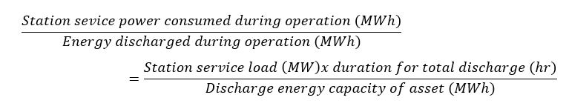

#### Total Global Adjustment Costs

*Electricity storage resources* may incur global adjustment costs for charging the *electricity storage resource* and *station service* costs to provide an incremental unit of energy to the *IESO-administered markets*. A *market participant* may include average global adjustment costs, in $/MWh, for an *electricity storage resource* if the *resource* is Class B and is not exempt from paying global adjustment costs. *Electricity storage resources* with Class A *load resources* are not eligible to include global adjustment costs into their *energy offer reference level* as Class A *load resources* are able to manage their exposure to global adjustment charges by shifting consumption to non-peak hours.

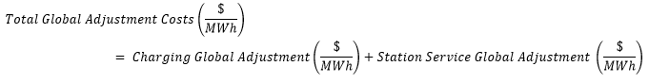The total global adjustment costs of an *electricity storage resource’s* *energy offer reference level* includes the charging global adjustment component and the *station service* global adjustment component. This is shown in the formula below:

The charging global adjustment is calculated based on the *energy* used to charge the *electricity storage resource* across the historical study period less the *energy* discharged by the *electricity storage resource* across the same period. This is called the “global adjustment net charging cost”. For *electricity storage resources* that have a behind-the-meter load *resource* that is not related to the *electricity storage facility*, consumption associated with such behind-the-meter load is not eligible to be included in the global adjustment cost calculation.

charging global adjustment is equal to the global adjustment net charging cost over the energy discharged during period.The calculation for determining charging global adjustment is:

The historical study period for calculating the charging global adjustment is one calendar year. Eligible supporting documentation includes *settlement statements* and meter data of charging and discharging operations during the period.

*Electricity storage resources* where *station services* are supplied using a separate feed with a *revenue meter* for electricity consumed to serve *station services* and auxiliary loads may include the global adjustment costs incurred on the *station service* in the *energy offer reference level.* The calculation for determining *station service* global adjustment is:

The historical study period for calculating the *station service* global adjustment is one calendar year. Eligible supporting documentation includes *settlement statements* and meter data of charging and discharging operations during the period.

#### O&M Costs

Section 6.3 describes the eligible maintenance costs included into the *reference level* calculations for an *electricity storage resource*.

##### Major Maintenance Costs

Eligible major maintenance costs for an *electricity storage resource* include:

* costs to replace or maintain inverter units;
* major maintenance to maintain a good state of repair and performance for the major storage or generation components. Some examples include:
* compressed air energy storage – maintenance inspections associated with incremental operation of the compressor, expander, turbine, storage cavern;
* hydrogen storage – maintenance of the electrolyzer, fuel cell, storage vessel;
* flywheels - vacuum system maintenance or maintenance of the rotating body/housing;
* lithium ion battery[10] - battery cell replacement for cycle-related degradation; and
* flow batteries - battery electrolyte rebalancing or replacement for flow batteries.

The *IESO* uses the vendor estimates for these costs based on the current pricing at the time of determining or updating *reference levels* as the indicator of the appropriate cost of the relevant product or service.

Costs reimbursed by insurance and/or covered by warranty of an *electricity storage resource* or sub-components of an *electricity storage resource* provided under a construction or equipment supply contracts are excluded.

The historical study period for major maintenance costs for an *electricity storage resource* is 10 years.

##### Scheduled Maintenance Costs

Eligible scheduled maintenance costs for an *electricity storage resource* include costs incurred for routine inspections and work such as:

* annual (or bi-annual) vendor maintenance program;
* inverter annual maintenance;
* standard cleaning of electronics; and
* SCADA inspections.

The supporting documentation required from a *market participant* is described in section 3.2. The historical study period for scheduled maintenance costs for an *electricity storage resource* is five years.

##### Unscheduled Maintenance Costs

Eligible unscheduled maintenance costs for an *electricity storage resource* includes overtime labour or third-party labour contracted to repair the components and materials costs associated with any such repairs in the event of equipment failure. The supporting documentation required from a *market participant* is described in section 3.2. The historical study period for unscheduled maintenance costs for an *electricity storage resource* is five years.

##### Operating Reserve Offer Reference Levels from Injections

A *dispatchable* *electricity storage resource* that is registered to inject energy and can provide *operating reserve* to the grid from those injections needs to have an *operating reserve offer reference level* determined for the *dispatchable electricity storage resource* registered to inject energy according to the methodology in this section.

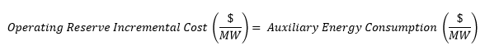Auxiliary *energy* consumption is *energy* consumed by auxiliary services necessary for the *electricity storage resource* to respond to *dispatch instructions*. The following equation shows how auxiliary *energy* consumption is calculated:

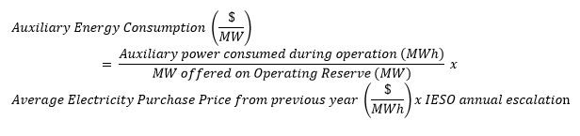

Eligible costs that may be included in this calculation are the costs of auxiliary services necessary for the *electricity storage resource* to respond when *dispatched* (e.g. heating/cooling of batteries, keeping the expander/turbine available for compressed air energy storage, etc.). Eligible costs do not include costs related to components that are not directly related to *energy* generation (lighting, security etc.) or costs required to keep the *electricity storage resource* operating safely (protection and controls, controls, communications, etc.).

Submissions regarding consumption of auxiliary power for *reference levels* must be supported by energy consumption meter data showing periods of idling (no *operating reserve* provided) and periods when *operating reserve* is provided to *IESO*. This data is used to assess the difference in auxiliary load when providing *operating reserve* versus when the *resource* is in operating mode.

Average electricity price paid by the *electricity storage resource* for its withdrawals is calculated based on the prices paid by the *electricity storage resource* that is withdrawing from the same month in the previous year, escalated by the *IESO* annual escalation rate.

The historical study period for auxiliary *energy* consumption for an *electricity storage resource* is one year. If one year of data is not available for a *resource*, a *market participant* must use a year of *LMP* data for a *resource* that is electrically proximate to the *market participant’s* *resource*.

##### Operating Reserve Reference Levels – from Withdrawals

A *dispatchable* *electricity storage resource* that is registered to withdraw *energy* and can provide *operating reserve* to the grid from those withdrawals needs to have an *operating reserve offer reference level* determined for the *dispatchable electricity storage resource* registered to withdraw *energy* according to the methodology in this section.

*Operating reserve offer reference levels* are based on incremental costs incurred by the *resource* to supply *operating reserve*. If applicable, costs associated with provision of *operating reserve* are required to be demonstrated by the *market participant* on a *resource*-specific basis with relevant supporting documentation.

No incremental costs are associated with providing *operating reserve* for operating and maintaining the equipment.

### Dispatchable Loads

*Dispatchable loads* have an *operating reserve offer reference level*.

This section describes how the inputs should be completed to request an *operating reserve offer reference level*.

For *dispatchable loads*, the *IESO* applies the following equation for the *operating reserve offer reference level* and the components are described in subsequent subsections.

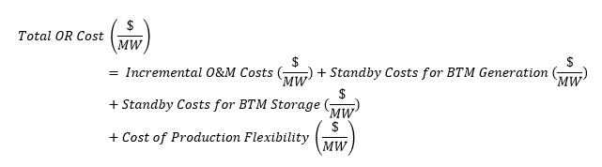

The following subsections provide details on the cost components of a *dispatchable load resource’s operating reserve offer reference level*.

#### O&M Costs

##### General Eligibility of O&M Costs

Eligible costs for *reference level* calculations for *dispatchable loads* include:

O&M costs related to the supply of *operating reserve* and regular operation of the *dispatchable load*;

incremental O&M costs; and

incremental labour costs required to support eligible maintenance activities.

The following costs are not eligible for *reference level* calculations for *dispatchable* loads:

O&M costs of equipment related to the requirement to vary the *resource’s* load in response to *dispatch instructions*. These costs are expected to be included within the *resource*’s energy *bid*, and hence are excluded for the purposes of supplying *operating reserve*;

preventative maintenance, routine maintenance and other operating costs that are not directly attributable to the supply of incremental *operating reserve*;

fixed or non-avoidable costs such as maintenance costs for *metering*, control or communications equipment or the general routine maintenance of behind the meter (BTM) generation or storage; and

* staffing costs (including staff overtime) required for operations of the *resource*.

##### Cost Components

The O&M costs may be broken down into common categories of accounting that a *market participant* must submit to the *IESO* to verify and validate the *operating reserve offer reference level* curve for the *resource*.

The appropriate period for analysis of historical records may vary depending on the nature of the *resources* due to changes in the operations or production of the *dispatchable load facility*. An average of costs over three years is recommended as many costs are not expended on an annual basis. An alternative appropriate timeframe may be proposed by the *market participant* with a justification of the period selected.

##### Incremental Operating or Maintenance Costs ($/MW)

This cost component is related to any operating or maintenance costs associated with providing the incremental *operating reserve* services in accordance with the *IESO’s* requirements that are in addition to the costs associated with acting as a *dispatchable load*. For example, incremental O&M costs would include costs incurred to operate a *dispatchable load* in a way that it is available to reduce load more rapidly in response to *operating reserve* activation than it would normally require for a *dispatchable load*.

Incremental Operating or Maintenance Costs is calculated as follows:

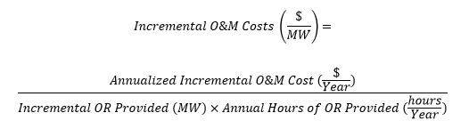

The supporting documentation required from a *market participant* is described in section 3.2. The historical study period for incremental operating or maintenance costs for *dispatchable* loads is three years. The appropriate historical study period may vary depending on the nature of the *dispatchable* load due to changes in the operations or production of the *dispatchable* load. A *market participant* may propose an alternative appropriate historical study period with an explanation of why this proposed period results in a more accurate estimate of current costs than the default three-year historical study period.

#### Standby Costs for BTM Generation or Storage

##### General Eligibility of Standby Costs for BTM Generation or Storage

If a *dispatchable load* employs a BTM *generation unit* or *electricity storage unit* in order to vary its net load in response to *dispatch* *instructions*, a component of the *facility’s* costs is reflected in the standby and operating costs of the BTM *unit*.

Costs included into the *reference levels* for *operating reserve* must be related to expenses incurred as a result of the provision of *operating reserve* and be incremental to the regular operation of the *dispatchable load* *resource* to provide *operating reserve* capabilities.

Variable costs of operating a BTM *generation unit* or *electricity storage unit* to reduce the *facility’s load* in response to *dispatch instructions* are expected to be included within the *resource’s* *energy bid*. Therefore, they are excluded for the purposes of *operating reserve*.

Standby costs incurred to enable the *dispatchable load* to provide incremental *operating reserve* quantities such as costs associated with incremental maintenance or standby losses are eligible costs if they are incremental to those costs incurred under normal operation as a *dispatchable load* and avoidable.

Ineligible O&M expenses include capital costs of BTM equipment and costs associated with routine maintenance of equipment. In general, any O&M costs that would be incurred, regardless of whether the *resource* is providing *operating reserve*, are ineligible.

To determine eligible costs for *resources* with a BTM *generation unit* or *electricity storage unit*, a *market participant* should refer to the relevant subsection of section 8 of this document and the relevant *reference level* workbook.

The following sections list eligible standby costs associated with BTM *unit* used to enable *dispatchable loads* to provide *operating reserve*.

##### Standby Costs for BTM Generation

In cases where a BTM *generation unit* must operate in a standby mode exclusively to enable the *resource* to provide *operating reserve*, only the fuel and O&M costs associated with standby mode operation of the BTM *unit* are eligible costs.

For example, a *dispatchable load* that cannot achieve the minimum ramp rates required to provide *operating reserve* without having the BTM *unit* on standby.

Fuel and O&M costs associated with operating the BTM *unit* to respond to *dispatch instructions* are not eligible because they are reflected in the *energy bid*.

Unit SCADA data may be used as supporting documentation of hours of standby operation and fuel consumption.

Standby Costs for BTM Generation *unit* is calculated as follows:

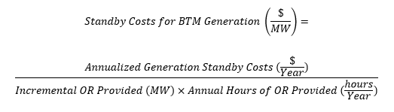

A *market participant* must refer to the applicable *reference level* workbooks and guidance documents relevant to the generation technology employed and submit documentation in accordance with these documents, as applicable.

The supporting documentation required from a *market participant* is described in section 3.2. The historical study period for standby BTM generation *unit* costs for *dispatchable loads* is one year.

##### Standby Costs for BTM Storage

Eligible costs for *dispatchable loads* that use BTM *electricity storage* *unit* to respond to *dispatch* *instructions* for the *dispatchable load* include the costs of self-discharge or standby power requirements (e.g. for controls, or heaters), provided the BTM *electricity storage* *unit* is being utilized exclusively for the purposes of providing incremental *operating reserve* capability.

Losses and costs associated with operating the BTM *electricity storage* *unit* in response to *dispatch* *instructions*, such as charging costs, are expected to be included in the *energy* *bid* of the *resource*.

SCADA and/or submetering data may be used to support requested standby power requirements for energy storage and hours of operation.

Standby costs for BTM *electricity storage* *unit* is calculated as follows:

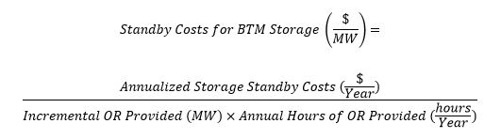

The supporting documentation required from a *market participant* is described in section 3.2. The historical study period for standby BTM *electricity storage* *unit* costs for *dispatchable* loads is one year.

##### Cost of Production Flexibility

Eligible costs of production flexibility include incremental costs of performance guarantees or of supply and/or delivery contracts for production inputs as a result of the provision of *operating reserve* capacity (such as premiums for flexibility in supply volumes).

Eligible costs of production flexibility are only those costs that would have been avoided had the *dispatchable load* not provided *operating reserve*.

Costs that are required as part of the normal operations as a *dispatchable load* are ineligible.

Cost of Production Flexibility is calculated as follows:

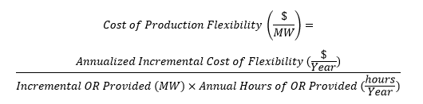

The supporting documentation required from a *market participant* is described in section 3.2. The historical study period for costs of production flexibility for *dispatchable loads* is three years. The appropriate historical study period may vary depending on the nature of the *dispatchable load* due to changes in the operations or production of the *dispatchable load*.

A *market participant* may propose an alternative appropriate historical study period with an explanation of why this proposed period results in a more accurate estimate of current costs than the default three-year historical study period.

### Accounting for Currency Exchange

A *market participant* must indicate the portion of costs that are incurred in a foreign currency in their *reference level* submissions to help calculate the *reference level values* on a daily basis. These include, but are not limited to, O&M and fuel costs that are denominated in USD or other foreign currencies.

Conversion to CAD from another currency to calculate *reference level values* for a particular *dispatch day* is based upon the applicable end of day foreign exchange rate as posted by the Bank of Canada.

### Late Day Start Reference Levels

*Non-quick start* *resources* submit *start-up offers* on an hourly basis. This allows them to submit higher *start-up offers* if they cannot run for their entire MGBRT within the period being scheduled. Such *offers* become higher towards the end of the day as a *market participant* shift the costs associated with their *energy* and *speed no-load offers* for the next-day operation into their *start-up offers*. A *market participant* is allowed to do so to help ensure that the *resource* is economical even when the *IESO* only evaluates the remaining hours in the day.

The *IESO* includes *minimum loading point energy* and *speed no-load costs* into the *start-up offer reference levels* for every hour that extends into the next day after HE 24.

The *IESO* includes costs related to *energy offers* and *speed no-load offers* into a *resource’s* *start-up offer reference levels* for every hour where the *resource’s* MGBRT extends into the next *dispatch day* after HE 24.

The *IESO* determines the escalating *start-up offer reference levels* based on the *reference levels* for *start-up offers*, *energy offers*, and *speed no-load offers*:

This formula depicts the calculation of the Escalating Start-up Offer Reference Level.

Where:

* N is the number of hours of a *resource*’s MGBRT that spills into the next *dispatch day*.
* IE is the cost to produce at *MLP*, derived from the *energy offer reference level value*.
* SNL is the *speed no-load offer reference level value*.
* SU is the total *start-up offer reference level value*.

### Alternate Data for Calculating Reference Level Values

(MR Ch.7 s.22.1.1)

The *IESO* uses historical data and data created by external parties as part of calculating *reference level values* for the *reference levels* for *financial dispatch data parameters* set out in this section. When determining these *reference levels* for a *resource*, the *IESO* also determines if it is necessary to designate alternate data to enable the *IESO* to calculate the associated *reference level values*. During the process to determine a *resource’*s *reference levels*, the *IESO* will inform the *market participant* of the alternate data that will be used.

#### Historical Data

##### New Resource

When historical data for a *resource* is not available because it is a newly-registered *resource*, the *IESO* uses proxy data that approximates the unavailable data.

For example, a new hydroelectric *resource* that registers to participate in the *energy* market will not have historical *LMPs*, which are necessary inputs to calculate opportunity cost components of an *energy reference level value* for the hydro *resource*. The *IESO* will designate a *resource* node that is electrically proximate to the new hydro *resource* and use its *LMPs* to calculate opportunity cost components of the hydro *resource*’s relevant *reference level values*.

##### New Data Type or insufficient historical data

Where historical data for a data type is not available because it is either a new data type or there is insufficient historical data for an existing data type to determine a reference level or a reference quantity, the IESO uses proxy data that approximates the unavailable data.

#### Alternate External Data

When external data that the *IESO* uses to calculate *reference level values* for a *resource* are not available, the *IESO* uses the most recent version of this data set available.

For example, if the natural gas price index report that the *IESO* uses as an input to calculate *reference level values* for a thermal *resource* is not available for a particular day due to a tool failure, the *IESO* uses the most current version of this natural gas price index report that it has successfully downloaded to calculate relevant *reference level value(s)*.

#### Alternate Reference Level Value Data

If the *IESO* is unable to calculate *reference level values* for a *resource*, the *IESO* will use the most recently successfully calculated *reference level values* available for that *resource* for the relevant timeframe.

For example, if there is a tool failure on January 20 and the *IESO day-ahead market reference level* calculations fail to solve for the *day-ahead market* for the *dispatch day* January 21, the *IESO* will use the *day-ahead market* *reference level values* that were successfully calculated on January 19 in their place.

– End of Section –

## Reference Levels for Non-Financial Dispatch Data Parameters

(MR Ch.7 ss.22.1.1, 22.1.3 and 22.3.1)

This section provides guidelines that a *market participant* should follow to register *reference levels* for *non-financial dispatch data parameters* during the Facility Registration process, including the supporting documentation required by the *IESO* for verification. The *reference levels* described in the following subsections are fixed for the entire *dispatch day* and a *market participant* may request the *IESO* determine seasonal *reference levels*, if applicable.

### Descriptions of Non-Financial Dispatch Data Parameter Reference Levels

(MR Ch.7 s.22.3.1)

#### Energy Ramp Rate Reference Level

The *energy* ramp rate *reference level* is determined for *dispatchable generation* and *electricity storage resources*. It contains up to five quantity-ramp rate couplets that describe the rates, in megawatts per minute (MW/min), during normal operation across the entire *output* range, at which a *resource* can increase or decrease its output.

The *IESO* estimates an *energy* ramp rate *reference level* as the ramp rates of the *resource* across the entire *output* range under a competitive environment. This differs from the registered maximum *bid/offer* ramp rate value (a single value), which is the maximum ramp rate capability of the *resource*.

For example, if a *market participant* requests an *energy ramp rate* *reference level* that is equal to or greater than 1/5th of the *resource*’s maximum capacity, then no supporting documentation is required. In this case, the requested *reference level* would allow the *resource* to ramp the entire capacity of the *resource* in one five-minute interval. An *energy ramp rate* *reference level* this high could not be used to withhold the *resource* and so it is unnecessary to submit supporting documentation for *energy ramp rate* *reference levels* that meet this requirement.

#### Operating Reserve Ramp Rate Reference Level

The *operating reserve* *ramp rate reference level* is determined for *dispatchable generation* *resources, storage resources* and *load resources*. It is the rate, in megawatts per minute (MW/min), during normal operation, at which a *resource* can increase or decrease its output upon the activation of *operating reserve*.

When a *resource* that is registered to provide *ten-minute* *operating reserve* submits a request for an *operating reserve* ramp rate that is at least 1/10th of the maximum *resource* capacity, the *resource* is exempt from providing supporting documentation for its *operating reserve* ramp rate *reference level*.

When a *resource* that is registered to provide *thirty-minute* *operating reserve* (but is not registered to provide *ten-minute* *operating reserve*) submits a request for an *operating reserve* ramp rate that is at least 1/30th of the maximum *resource* capacity, the *resource* is exempt from providing supporting documentation for their *operating reserve* ramp rate *reference level*.

#### Lead Time Reference level

The *lead time* *reference level* is determined for *dispatchable* thermal *non-quick start* *resources*. It is the amount of time, in hours, needed for a *resource* to start up and reach its *MLP* from an offline state. The length of the *lead time* depends on the *thermal state* of the *resource* as either hot, warm or cold.

#### Minimum Loading Point Reference Level

The *minimum loading point reference level* is determined for *dispatchable* thermal *non-quick start resources* and is the minimum MW output that a *resource* must maintain to remain stable without the support of ignition.

#### Minimum Generation Block Run Time Reference Level

The *minimum generation block run-time reference level* is determined for *dispatchable* thermal *non-quick start* *resources* and presents the minimum number of consecutive hours a *resource* must be scheduled to its *MLP*, in accordance with the technical requirements of the *resource*.

#### Minimum Generation Block Down Time Reference Level

The *minimum generation block down time reference levels* are determined for each *thermal state* (hot, warm and cold) for *dispatchable* thermal *non-quick start* *resources*. It is the time between when a *resource* was last at its *MLP* before de-synchronization and the time the *resource* can be scheduled back to its *MLP* after re-synchronizing.

#### Maximum Number of Starts Per Day Reference Level

The *maximum number of starts per day reference level* is determined for *dispatchable* hydroelectric *resources* and all *dispatchable* thermal *non-quick start* *resources* except nuclear *resources*. This *reference level* is the maximum number of times a *resource* can be physically started within a *dispatch day*.

#### Energy Per Ramp Hour (Upper Bound) Reference Level

The *energy per ramp hour* (upper bound) *reference level* is determined for *dispatchable* thermal *non-quick start resources*. It is the maximum quantity of *energy*, in MWh, a *resource* is expected to produce in any ramp hour from the time of synchronization to the time it reaches its *MLP* during normal operation. *Energy per ramp hour* (upper bound) is required for the hot, warm and cold *thermal states* of the *resource*.

#### Energy Per Ramp Hour (Lower Bound) Reference Level

The *energy per ramp hour* (lower bound) *reference level* is determined for *dispatchable* thermal *non-quick start* *resources*. It is the minimum quantity of *energy*, in MWh, a *resource* is expected to produce in any ramp hour from the time of synchronization to the time it reaches its *MLP* during normal operation. *Energy per ramp hour* (lower bound) is required for the hot, warm and cold *thermal states* of the *resource*.

#### Ramp Hours to Minimum Loading Point Reference Level

*Ramp hours to* *MLP* *reference level* is determined for *dispatchable* thermal *non-quick start* *resources*. It is the number of hours required for the *resource* to ramp from synchronization to its *MLP* during normal operation. *Ramp hours to* *MLP* is required for the hot, warm and cold *thermal states* of the *resource*.

### Thermal

Thermal *resources* will be required to register the following *reference levels* for *non-financial dispatch data parameters*:

Variant A:

* *Energy ramp rate reference level;* and
* *Operating reserve ramp rate reference level*.

Variant B:

* *Energy ramp rate reference level;*
* *Operating reserve ramp rate reference level*;
* *Lead time reference level;*
* *Minimum loading point reference level;*
* *Minimum generation block run time reference level;*
* *Minimum generation block down time reference level*;
* *Maximum number of starts per day reference level; and*
* *Ramp up energy to MLP reference level.*

Variant C:

* *Energy ramp rate reference level;*
* *Operating reserve ramp rate reference level*;
* *Lead time reference level;*
* *Minimum loading point reference level;*
* *Minimum generation block run time reference level;*
* *Minimum generation block down time reference level*;
* *Maximum number of starts per day reference level; and*
* *Ramp up energy to MLP reference level.*

Variant D:

Variant D *resources* that are *pseudo-unit* *resources* require the following *reference levels* for *non-financial dispatch data*:

* *Energy ramp rate reference level; and*
* *Operating reserve ramp rate reference level*.

Variant D *resources* that are not *pseudo-unit* *resources* require the following *reference levels* for *non-financial dispatch data*:

Table 8‑1: Reference Levels for Variant D Resources

| **Combustion Turbine Resource** | **Steam Turbine Resource** |
| --- | --- |
| *Lead time reference level* | *Minimum Loading Point reference level (all configurations)* |
| *Minimum loading point reference level* | *Ramp up energy to MLP reference levels* |
| *Minimum generation block run time reference level* |  |
| *Minimum generation block down time reference level* |  |
| *Maximum number of starts per day reference level* |  |
| *Ramp up energy to MLP reference levels* |  |

To determine *reference levels* that are affected by *thermal states*, a *market participant* determines the ambient conditions associated with hot, warm and cold *thermal state* *reference levels*. These ambient conditions are used to determine all *thermal state*-affected *reference levels*.

*Market participants* must identify the transition points that are used to distinguish the hot *thermal state* from the warm *thermal state* from the cold *thermal state*. The transition points must be the same for the following *reference levels*:

* *lead time reference level;*
* *minimum generation block down-time reference level;*
* *ramp hours to minimum loading point reference level; and*
* *minimum and maximum energy per ramp hour reference levels.*

#### Energy Ramp Rate

A *market participant* must submit ramp rate and supporting documentation from OEM data with relevant sections from O&M manuals for the *resource* or performance tests.

The *energy ramp rate reference level* for a *pseudo-unit* can be set based on a single MW/min value that is the slowest *energy* ramp rate over the entire output range, from zero MW to the maximum capacity, of the *pseudo-unit* for the selected configuration for combined cycle mode and for *single cycle mode* (if applicable).

Market participants may instead request an *energy ramp rate reference level* with multiple MW/min values that reflect the operational capabilities of the *resource*.

#### Operating Reserve Ramp Rate

A *market participant* must submit ramp rate and supporting documentation from OEM data with relevant sections from O&M manuals for the *resource* or performance tests. The *operating reserve* ramp rate *reference level* for a *pseudo-unit* is a single MW/min value that is the slowest *operating reserve* ramp rate for the *pseudo-unit* for the selected configuration for combined cycle mode and for *single cycle mode* (if applicable).

#### Lead Time – Hot, Warm and Cold

A *market participant* must submit *lead time*s and supporting documentation from OEM data from contract or performance tests.

*A market participant* may choose points on their *lead time* curve to determine their hot, warm and cold *lead time* *reference levels*.

The choice of the cold *lead time* *reference level* is limited to allow the *resource* to be scheduled in a 24-hour look-ahead period.

The limitation on the cold *reference level* is expressed via the following equation:

This formula shows the cold thermal state lead time limitation calculated using the minimum generation block run time reference level and cold lead time reference level.

This relationship can be re-stated as:

This formula shows the cold thermal state lead time limitation calculated using the minimum generation block run time reference level and cold lead time reference level.

The value 6 in the above equation is derived from the aggregate of conduct thresholds for *lead time* (3 hours) and MGBRT (3 hours).

This limit is necessary because a cold *lead time* *reference level* higher than this value would make it possible for a *market participant* to withhold the *resource* through use of submitting a *lead time* parameter.

The *market participant* should manage occasions when a *resource* has a *lead time* that is longer than this limit through use of outage slips as the *resource* is unavailable.

#### Minimum Loading Point

A *market participant* must submit OEM data, a contract or performance tests to support a requested *MLP* *reference level*.

#### Minimum Generation Block Run Time

A *market participant* must submit a letter from an OEM that states a recommended *minimum generation block run-time* for the *resource* to support a *minimum generation block run-time reference level*.

Where a *market participant* already has a registered *minimum generation block run-time* and is satisfied with the same *minimum generation block run-time reference level* for winter and summer, no additional supporting documentation must be submitted and the *IESO* will use the currently-registered value of *minimum generation block run-time* as the *minimum generation block run-time reference level*.

#### Minimum Generation Block Down Time

When requesting a *minimum generation block down-time reference level* for the hot *thermal state*, a *market participant* must submit a letter from an OEM that states a recommended *minimum generation block down time* for the *resource*.

This documentation must include the *resource* shutdown curve and relevant limitations on the equipment recommended by the OEM before the *resource* can be restarted after a shutdown.

When requesting *minimum generation block down-time reference levels* for the warm and cold *thermal states,* a *market participant* must provide documentation that clearly identifies the transition points that are used to distinguish the hot *thermal state* from the warm *thermal state* from the cold *thermal state*.

#### Maximum Number of Starts Per Day

The *maximum number of starts per day* is determined based on *reference levels* for *non-financial dispatch data parameters* for *minimum generation block run-time* and *minimum generation block down time* (hot), rounded down to the nearest whole number, as follows:

This formula depicts the maximum number of starts per day using lead time, minimum generation block run time and minimum generation block down time.

#### Ramp Up Energy to MLP (Upper/Lower Bounds)

Start-up curves from the OEM or designer of a *resource* or operational data demonstrating a representative sample may be submitted to support *reference levels* for the following *non-financial dispatch data parameters*:

* *Ramp hours to MLP* – Hot
  + The number of hours required for the *resource* to ramp from synchronization to its *MLP* during normal operation when the *resource* is in a hot *thermal state*.
* *Energy per ramp hour* (upper bound) – Hot
  + The maximum quantity of *energy* in MWh that the *resource* is expected to produce in each ramp hour during normal operation when the *resource* is in a hot *thermal state*.
* *Energy per ramp hour* (lower bound) – Hot
  + The minimum quantity of *energy* in MWh that the *resource* is expected to produce in each ramp hour during normal operation when the *resource* is in a hot *thermal state*.
* *Ramp hours to MLP* – Warm
  + The number of hours required for the *resource* to ramp from synchronization to its *MLP* during normal operation when the *resource* is in a warm *thermal state*.
* *Energy per ramp hour* (upper bound) – Warm
  + The maximum quantity of *energy* in MWh that the *resource* is expected to produce in each ramp hour during normal operation when the *resource* is in a warm *thermal state*.
* *Energy per ramp hour* (lower bound) – Warm
  + The minimum quantity of *energy* in MWh that the *resource* is expected to produce in each ramp hour during normal operation when the *resource* is in a warm *thermal state*.
* *Ramp hours to* *MLP* – Cold
  + The number of hours required for the *resource* to ramp from synchronization to its *MLP* during normal operation when the *resource* is in a cold *thermal state*.
* *Energy per ramp hour* (upper bound) – Cold
  + The maximum quantity of *energy* in MWh that the *resource* is expected to produce in each ramp hour during normal operation when the *resource* is in a cold *thermal state*.
* *Energy per ramp hour* (lower bound) – Cold
  + The minimum quantity of *energy* in MWh that the *resource* is expected to produce in each ramp hour during normal operation when the *resource* is in a cold *thermal state*.

### Hydroelectric

#### Energy Ramp Rate

A *market participant* must submit the *energy* ramp rate and supporting documentation from OEM data along with relevant sections from the O&M manuals or performance tests for the *resource*.

For hydroelectric *resources*, *applicable law* may limit the rate of change of flow through any of the units or the *resource*. Accepted supporting documentation includes:

* water management plans, highlighting change of flow limitations;
* operating agreements that may limit the ramp rate, highlighting limitations;
* environmental approval documentation related to flow restrictions, if applicable; and
* supporting calculations converting rate of change of flow to MW/min.

#### Operating Reserve Ramp Rate

A *market participant* must submit the *operating reserve* ramp rate and supporting documentation from OEM data with relevant sections from O&M manuals for the *resource* or performance tests.

#### Maximum Number of Starts per Day

Submission of the *dispatch data* parameter *maximum number of starts per day* is an option for hydroelectric *resources*. Establishing a *maximum number of starts per day reference level* is a pre-requisite for being able to submit the *maximum number of starts per day* *dispatch data* parameter. *Market participants* that intend to submit the *maximum number of starts per day* *dispatch data* parameters for a *resource* must request a *maximum number of starts per day* *reference level* and submit the following supporting documentation:

* recommendations from OEM data along with relevant sections from the O&M manuals for the *resource*;
* equipment specification from procurement of equipment;
* design basis for the *resource*; or
* historical *outage* data showing forced *outages* at the *resource* that are caused by the *resource* not being able to start any more times during the *dispatch day*.

### Solar

#### Energy Ramp Rate

A *market participant* must submit ramp rates and supporting documentation such as *resource* specifications that show the ramp rates (MW/min) for the *resource* across its *dispatchable* range.

### Wind

#### Energy Ramp Rate

A *market participant* must submit ramp rates and supporting documentation with relevant sections from O&M manuals for the *resource* that show the *energy* ramp rates (MW/min) for the *resource* across its *dispatchable* range.

### Nuclear

#### Energy Ramp Rate

A *market participant* must submit ramp rates and supporting documentation with relevant sections from O&M manuals for the *resource* that show the *energy* ramp rates (MW/min) for the *resource* across its *dispatchable* range.

If nuclear ramp rate capabilities vary for the same range of production depending on reactor conditions, the *energy* ramp rate *reference level* for nuclear *resources* are set based on the least flexible profile of the *resource*.

### Electricity Storage

#### Energy Ramp Rate

A *market participant* must submit ramp rates and supporting documentation with relevant sections from O&M manuals for the *resource* that show the *energy* ramp rates (MW/min) for the *resource* across its *dispatchable* range.

#### Operating Reserve Ramp Rate

A *market participant* must submit ramp rate and supporting documentation, which may be the same documentation as submitted to support a requested *energy* ramp rate if the rates are the same.

The *market participant* must submit supporting documentation from the operating manual to support a slower *operating reserve* ramp rate than the *energy* ramp rate. These include delays due to start-up, particularly for energy storage technologies with rotating generation or which need to be heated prior to starting.

### Dispatchable Loads for Operating Reserve

#### Operating Reserve Ramp Rate

A *market participant* must submit *operating reserve* ramp rate and supporting documentation from the O&M manuals for the *resource*.

– End of Section –

## Reference Quantities

(MR Ch.7 ss.22.6.1 and 22.6.3)

This section describes the methodology the *IESO* uses to determine *reference quantities* for *resources* that are registered to supply *energy* and *operating reserve*.

### Thermal

Variants A, B, C and D thermal *resources* use the methodology in section 9.1.1 and section 9.1.2 to determine *reference quantity*.

#### Energy

To determine the *reference quantity* for the available capacity of thermal *resources*, the *IESO* uses the same approach as the methodology to determine *resource* capability of the Generator Output and Capability Report as published by the *IESO* on the public [IESO Reports](http://reports.ieso.ca/) website.

In this report, capability is measured as the maximum potential output of the *resource* under current conditions, which includes the maximum unit derates and *outages* for that hour.

#### Operating Reserve

The *IESO* applies the following formulas for calculating the *reference quantities* for *operating reserve*. The supporting documentation required from a *market participant* is described in section 3.2.

For variant A thermal *resources*, *MLP* is assumed to be 0 MW for the purpose of determining *operating reserve reference quantities*.

#### 10-Minute Reserve (Synchronized)

The *reference quantity* for *ten-minute* *operating reserve* for thermal *resources* is calculated as follows:

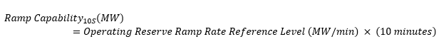

Operating Reserve Reference Quantity_10S (MW) is the Ramp Capability_10S (MW), but cannot exceed nameplate capacity minus *MLP* (MW) and planned derate/outage (MW) of the *resource*.

#### 10-Minute Reserve (Non-Synchronized)

For non-synchronized *ten-minute* *operating reserve*, the *reference quantity* for thermal *resources* is calculated as follows:

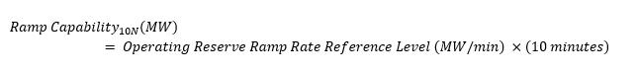

Operating Reserve Reference Quantity_10N (MW) is the Ramp Capability_10N (MW), but cannot exceed nameplate capacity minus *MLP* (MW) and planned derate/outage (MW) of the *resource*.

#### 30-Minute Reserve (Non-Synchronized)

For non-synchronized *thirty-minute* *operating reserve*, the *reference quantity* for thermal *resources* is calculated as follows:

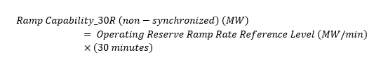

Operating Reserve Reference Quantity_30R (MW) is the Ramp Capability_30R (MW), but cannot exceed nameplate capacity minus *MLP* (MW) and planned derate/outage (MW) of the *resource*.

### Hydroelectric

#### Energy

Hydroelectric *resources* use the following methodologies to determine *energy reference quantities*:

* for each *resource*, the *market participant* submits documentation that indicates the minimum head-based capability for each *generation unit* in that *resource*. This documentation is used by the *IESO* to verify the indicated numerical value of the maximum production for each *generation unit* in each *resource* when the head is at its minimum level;
* the *reference quantity* for each hydroelectric *resource* is the sum of the minimum head-based capability across all *generation units* in that *resource*; and
* the MW amount that each *generation unit* contributes to the *reference quantity* can be no lower than 0 MW. This amount is reduced to account for *outages* and derates on that *resource*.

The following information must be provided for each *generation unit* within the *resource*:

* Minimum Head (m)  – Upstream water level, downstream water level, headloss, supported by:
  + a water management plan or similar documentation describing the operating limits of the head pond and tail pond; and
  + headloss curves and tailwater curves;
* Flow (m3/s) – Supported by the equipment Hill chart or performance data; and

Eff (%) - Supported by the equipment Hill chart or performance data.

#### Operating Reserve

Hydroelectric *resources* use the following methodologies to determine *operating reserve reference quantities*:

* for each *resource*, the *market participant* submits documentation that indicate the minimum head-based capability for each *generation unit* in that *resource*. This documentation is used by the *IESO* to verify the indicated numerical value of the maximum production for each *generation unit* in each *resource* when the head is at its minimum level;
* the *reference quantity* for each hydroelectric *resource* is the sum of the minimum head-based capability across all *generation units* in that *resource*; and
* the MW amount that each *generation unit* contributes to the *reference quantity* can be no lower than 0 MW. This amount is reduced to account for *outages* and derates on that *resource*.

### Solar

#### Energy

A solar *resource’s* *energy reference quantity* for each *dispatch hour* is equal to the *IESO’s* centralized day-ahead forecast for that *resource*. In the process to determine the *day-ahead schedule*, a *market participant* has the option to submit their self-determined hourly *variable generation* forecast to the *IESO*. Where submitted, the *market participant*-submitted value becomes the *reference quantity*. The *reference quantity* is adjusted by the *IESO* for completed *outages* and derates in an after-the-fact process.

### Wind

#### Energy

A wind *resource’s* *energy reference quantity* for each *dispatch hour* is equal to the *IESO’s* centralized day-ahead forecast for that *resource*. In the process to determine the *day-ahead schedule*, a *market participant* has the option to submit their self-determined hourly *variable generation* forecast to the *IESO*. Where submitted, this *market participant*-submitted value becomes the *reference quantity*. The *reference quantity* is adjusted by the *IESO* for completed *outages* and derates in an after-the-fact process.

### Nuclear

#### Energy

The available capacity of nuclear *resources* is based on the methodology to determine the *resource* capability of the Generator Output and Capability Report as *published* on the public [IESO Reports](http://reports.ieso.ca/) website.

In the report, capability is measured as the maximum potential output of the *resource* under current conditions, which includes maximum unit derates and *outages* for that hour.

### Electricity Storage

#### Energy

The *energy* *reference quantity* for the *generation resource* at the *electricity storage facility* is the *resource*’s the maximum potential output of the *resource* less outages or derates times 1 hour of discharging for each *dispatch* *day*.

For the *load resource* at the *electricity storage facility*, the *energy reference quantity* is not registered.

#### Operating Reserve

The *operating reserve reference quantity* is zero for the *generation resource* and *load resource* of an *electricity storage* *facility*.

### Dispatchable Load

*Dispatchable load resources* may *offer* up to 100% of their *dispatchable* *demand* as *operating reserve*, subject to the minimum requirements for *offering operating reserve*.

However, there may be considerations that prevent a *resource* from *offering* the full capability of its *dispatchable load* for *operating reserve*. The *market participant* must identify any such conditions to the *IESO* along with the supporting documentation listed in the following subsections.

#### Operating Reserve

The *operating reserve reference quantity* for a *dispatchable load resource* is the maximum amount of *dispatchable load*, as defined by the operating profile. The operating profile describes expected operation of the *resource* and must be submitted to the *IESO* when the *market participant* requests an *operating reserve reference quantity*. If the *market participant* does not submit information regarding the operating profile of the *dispatchable load*, the *operating reserve* *reference quantity* is the maximum quantity of *operating reserve* the *resource* is registered to *offer*.

As *dispatchable load resources* operate based on a combination of operational needs as well as the *energy market*, their capacity will vary according to their operating schedule.

The methodology to develop a *resource*-specific *reference quantity* for *operating reserve* for a *dispatchable load* involves the following steps:

1. Determine the *dispatchable* *energy* range:

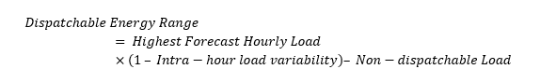

1. Determine the maximum 10-minute or 30-minute ramp rate:
   1. If providing *ten-minute* *operating reserve*:

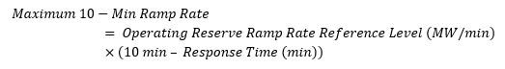

* 1. If providing *thirty-minute* *operating reserve*:

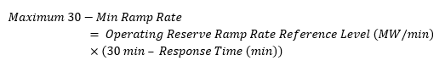

10-minute and 30-minute ramp rate are bounded by the rated capacity of the *resource*.

1. Determine the maximum hourly *operating reserve* capacity:
   1. If Dispatchable Energy Range > Maximum 10 or 30-Min Ramp Rate

Maximum Hourly OR Capacity = Maximum 10 or 30-Min Ramp Rate

* 1. If Dispatchable Energy Range < Maximum 10 or 30-Min Ramp Rate

Maximum Hourly OR Capacity= Dispatchable Energy Range

If a *resource’s* submitted *operating reserve reference quantity* varies from the maximum quantity of *operating reserve* that the *resource* is registered to *offer*, then the *market participant* must submit supporting documentation that describes the relevant operating characteristics of the *resource*. These supporting documents must provide relevant information, including but not limited to:

* operating schedule and hourly *dispatchable load* forecast;
* details of intra-hour *load* variability and characteristics including equipment descriptions and historical *load* profile examples;
* expected response time; and
* other *resource*-specific considerations impacting the *resource*’s ability to provide *operating reserve*.

###### Operating Schedule and Hourly Dispatchable Load Forecast

*Dispatchable load resources* must submit supporting documentation that shows the operating schedules for the *resource* and the rationale for these operating schedules, along with their forecasted amount of *dispatchable load*.

###### Intra-Hour Variability of Load

Information to support intra-hour variability of *load* include characteristics including equipment descriptions and historical *load* profile data. When a *load* varies by a percentage within the hour, given a specific level of *dispatch*, the *operating reserve* *reference quantity* must correspond to the minimum *load* within that hour. For example, if a *resource* that is *dispatched* as a 30 MW load has a *load* that may vary by 10% during the hour, the *operating reserve* *reference quantity* should be 30 x (100 - 10%) = 27 MW.

###### Expected Response Time

The *market participant* must submit documentation to support a *resource*’s response time, in minutes, after being *dispatched* before it will begin ramping its *load* and its *energy* ramp rate when requesting an *operating reserve reference quantity*. For example, if the response time for a *resource* with a 1 MW/minute *energy* ramp rate is two minutes, then the 10-minute *operating reserve reference quantity* cannot be higher than 8 MW and the 30-minute *operating reserve reference quantity* cannot be higher than 28 MW.

###### Other Considerations

Other factors may impact a *dispatchable load resource’s* ability to make its full registered *dispatchable load* capacity available for *operating reserve*. If those factors affect a *market participant’s* request for an *operating reserve reference quantity*, the *market participant* must describe such factors and provide relevant documentation to support the requested *reference quantity*.

The methodology for determining the *operating reserve* *reference quantity* for a *dispatchable load resource* assumes its *operating reserve* capacity is not limited by specific factors associated with BTM generation or storage, but may be adapted, upon *IESO* approval, to account for the operational characteristics of the *resource*.

Some *dispatchable load resources* respond to an *operating reserve* activation by using behind the meter storage unit or generation to reduce net withdrawals rather than reduce consumption at the load facilities. The *IESO* determines these *resources’ operating reserve reference quantities* according to the technology type of the behind the meter facilities. The *reference quantity value* for each *dispatch hour* shall reflect the MWs that can be displaced by the behind-the-meter storage or *generating unit*.

### Alternate Data for Calculating Reference Quantity Values

(MR Ch.7 s.22.6.1)

#### Alternate Reference Quantity Value Data

If the *IESO* is unable to calculate *reference quantity values* for a *resource*, the *IESO* will use the most recently successfully calculated *reference quantity values* available for that *resource* for the relevant timeframe.

For example, if there is a tool failure on January 20 and the *IESO reference quantity* *day-ahead market* calculations fail to solve for the *day-ahead market* for the *dispatch day* January 21, the *IESO* will use the *day-ahead market* *reference quantity values* that were successfully calculated on January 19 in their place.

– End of Section –

## External Data Retrieval Schedule

(MR Ch.7 ss.22.2.1 and 22.2.2)

This section describes the external data retrieval and the *reference levels* calculation schedules. Refer to section 4 on details related to timing of *publication* of *reference level values* reports.

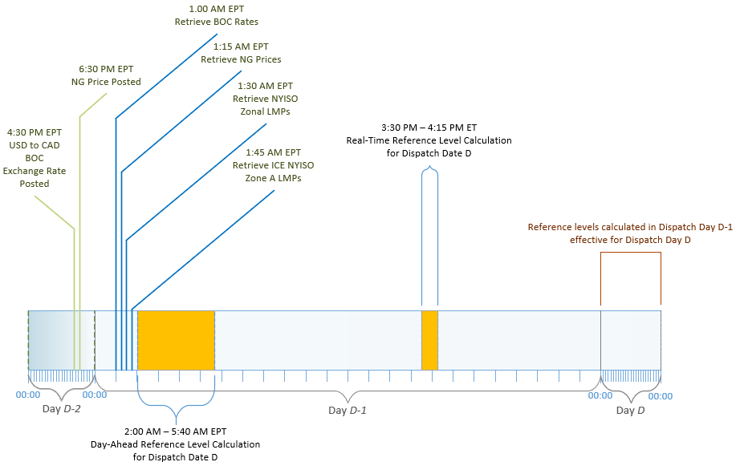

Figure 10-1: Timings of External Data Retrieval and Reference Levels Calculation

### Natural Gas Price Indices

The *IESO* retrieves natural gas price data from the following indices from the Natural Gas Intelligence platform, which are published each business day by 6:30 PM EPT:

* Dawn Hub Daily Day-Ahead Index ($USD/MMbtu)
* Henry Hub Daily Day-Ahead Index ($USD/MMbtu)

For financial *reference levels* utilizing either of these natural gas price indices as the fuel commodity cost, the *IESO* retrieves the latest published index prices daily as of 1:15 AM EST to calculate:

* *Day-ahead market* *reference level values* for *dispatch day* *D* on day *D-1* using the index price published on day *D-2*, if day *D-2* is a business day; and
* *Real-time market reference level* values for *dispatch day* *D* on day *D-1* using the applicable natural gas price index published on day *D-2*, if day *D-2* is a business day.

When day *D-2* is a not a business day, and thus no gas price index was published, then the *IESO* will use the most recently available gas price index that was published on the most recent previous business day. For example, *reference level* calculations performed on Monday will use the gas index price published on Friday.

### Currency Exchange Rates

The foreign currency to CAD daily exchange rates are sourced from the Bank of Canada, which are normally posted each business day by 4:30 PM EPT.

*For financial reference levels* that utilize a cost component incurred in a foreign currency (e.g., USD), the *IESO* retrieves the latest posted exchange rate daily as of 12:55 AM EST to calculate:

* *Day-ahead market* *reference level values* for *dispatch day* *D* on day *D-1* using the exchange rate posted on day *D-2*, if *D-2* is a business day; and
* *Real-time market reference level values* for *dispatch day* *D* on day *D-1* using the exchange rate posted on day *D-2*, if *D-2* is a business day.

When day *D-2* is a not a business day, and thus no exchange rate was posted, then the IESO will use the available exchange rate that was posted on the most recent previous business day. For example, *reference level* calculations performed on Monday will use the exchange rates posted on Friday.

### Carbon Price

The Carbon Price, which is used in determining Emissions Costs as described under section 7.1.6, is based upon the Federal Carbon Pricing Program.

When calculating financial *reference levels* that include the Carbon Price as a cost component, the calculation will use the Carbon Price that will be effective on the same *dispatch day*, not the Carbon Price that is effective on the date of the calculation. For example, the *reference level* calculations on March 31st for the April 1st dispatch day, will use the Carbon Price that is effective on April 1st, of that year.

### ICE NYISO Zone A (West) Monthly Future Prices

The Intercontinental Exchange (ICE) New York ISO Zone A (West) Futures electricity prices measured in ($USD/MWh) are inputs used for the storage horizon opportunity cost calculation described in section 6.4.4.3. The current month and upcoming 12 monthly strips are stored for the following future contracts:

* AOP-NYISO Zone A Day-Ahead Off-Peak Fixed Price Future (Commodity: AOP)
* NAY-NYISO Zone A Day-Ahead Peak Fixed Price Future (Commodity: NAY)

ICE publishes the ICE Futures End-of-day (“EOD”) reports on business days between 8:30 PM to 11:00 PM EST. On a daily basis, the latest ICE Futures EOD report available as of 1:45 AM EST is retrieved and parsed for the two NYISO Zone A West monthly products (i.e., off-peak and on-peak periods).

The storage horizon opportunity cost calculated for dispatch day *d+1* will be calculated using each day’s updated strip pricing.

### NYISO Zone A Day-Ahead Hourly Settled Prices

The NYISO Zone A settled prices measured in ($USD/MWh) are inputs used for the storage horizon opportunity cost calculation. The prices are day-ahead locational based marginal prices (LBMP) settled for NYISO’s on-peak hours, off-peak hours and NERC-defined holidays. NYISO publishes the “Day-Ahead Market LBMP – Zonal” for the dispatch day at approximately 9:33 AM EPT. Historic NYISO Day-Ahead Market LBMPs are retrieved on a daily basis for the past year and are used in the storage horizon calculation. Refer to section 6.4.4.3 for more information on how the information is used.

List of Acronyms

| Acronym | Term |
| --- | --- |
| BTM | Behind the meter |
| CPI | Consumer Price Index |
| EOH | Equivalent operating hour |
| GRC | Gross Revenue Charge |
| H-ORFEC | Hydroelectric – *Operating Reserve* Fuel Efficiency Cost |
| HHV | Higher heating value |
| HR | Heat rate |
| ICE | Intercontinental Exchange |
| MGBRT | *Minimum generation block run-time* |
| MLP | *Minimum loading point* |
| MW | Megawatt |
| NFRL | Non-financial *reference level* |
| NRCan | Natural Resource Canada |
| O&M | Operations and maintenance |
| OEM | Original equipment manufacturer |
| OR | *Operating reserve* |
| RL | *Reference level* |
| SCADA | Supervisory Control and Data Acquisition |
| SNL | Speed no-load |
| T-ORFEC | Thermal – *Operating Reserve* Fuel Efficiency Cost |
| TPI | Thermal Performance Indicator |
| WACOF | Weighted average cost of fuel |
| WANO | World Association of Nuclear Operators |

– End of Section –

References

| Document ID | Document Title |
| --- | --- |
| [RUL-6](http://www.ieso.ca/-/media/Files/IESO/Document-Library/Market-Rules-and-Manuals-Library/market-rules/guidetodocsinbaseline.pdf) to RUL-24 | Market Rules |
| [MAN-107](http://www.ieso.ca/-/media/Files/IESO/Document-Library/Market-Rules-and-Manuals-Library/market-manuals/market-entry/me-pki-ops-guide.pdf) | Market Manual 1.3: Identity Management Operations Guide |
| MAN-108 | Market Manual 1.5: Market Registration Procedures |
| [MAN-116](https://iesoonline.sharepoint.com/sites/collaboration/Projects/MRP/Energy%20Implementation/Market%20Manual%205:%20Settlements%20Part%205.5:%20Physical%20Markets%20Settlement%20Statements) | Market Manual 5.5: IESO-Administered Markets Settlement Amounts |
|  |  |

* – End of Document –

1. Refer to **MM 1.5** for adding and updating contact roles with the *IESO*.
2. CPI values can be retrieved from the Statistics Canada’s website at [Consumer Price Index, monthly, not seasonally adjusted (statcan.gc.ca)](https://www150.statcan.gc.ca/t1/tbl1/en/tv.action?pid=1810000401&pickMembers%5B0%5D=1.14&cubeTimeFrame.startMonth=03&cubeTimeFrame.startYear=2018&cubeTimeFrame.endMonth=04&cubeTimeFrame.endYear=2019&referencePeriods=20180301%2C20190401)
3. The formula to calculate WACOF is:

   ]
4. For weekend days, this set will be empty.
5. Flows and minimum flows on days for up to six days before the start of the study period may be needed to calculate the seven-day rolling average of daily net inflows for the days at the start of the study period.
6. Let $X$ be a set and let $Card\left(X\right)$ be the number of data points in the set $X$. For the historical flow data over the study period, find ${NetFlow}^{P5}$, the flow level for which

   The 5th percentile is determined as the 5th percent of the number of flow data points in set X where X is the total number of data points in the study period.
7. Seven-day rolling average would be calculated by moving one day with every calculation of the net daily inflow, for example, the first ${NetFlow}_{d,m,y}^{7-day average}=\left({\sum_{i=0}^{6}{{NetFlow}_{d-i,m,y}}}/7\right)$, then the second ${NetFlow}_{d,m,y}^{7-day average}=\left({\sum_{i=0}^{6}{{NetFlow}_{d+1-i,m,y}}}/7\right),$ and so on. In plain language, today we would take the average net inflow of the past seven days and for each subsequent day, we repeat the same calculation taking the past seven-day average net inflow relative to each subsequent day.
8. A “tonne” is a metric ton, equal to 1,000 kilograms.
9. Repairs can be considered temporary to allow equipment to last until the next *outage* due to limitations of downtime or inability to adequately conduct the repair outside of an *outage*.
10. For batteries, cell or electrolyte replacement must be like-for-like. The *energy* and power capacity of the *electricity storage resource* should be equal to or less than the beginning of life capacity of the *resource*.