Transmission Rights Workbook

IESO Training

TRAIN-841
Issue 2.1
June 25, 2024

AN IESO MARKETPLACE TRAINING PUBLICATION

This guide has been prepared to assist in the IESO training of market participants and has been compiled from extracts from the market rules or documents posted on the web site of Ontario’s Independent Electricity System Operator. Users of this guide are reminded that they remain responsible for complying with all of their obligations under the market rules and associated policies, standards and procedures relating to the subject matter of this guide, even if such obligations are not specifically referred to herein. While every effort has been made to ensure the provisions of this guide are accurate and up to date, users must be aware that the specific provisions of the market rules or particular document shall govern.

Attention: Customer Relations
The Independent Electricity System Operator Box 4474, Station A
Toronto, Ontario M5W 4E5

Customer Relations: Tel: (905) 403-6900
Toll Free 1-888-448-7777
Website: www.ieso.ca

Table of Contents
1. Introduction 1
1.1 Objectives 1
2. Overview 2
2.1 Who can participate in the TR market? 2
2.2 Ownership 2
2.3 What are the characteristics of TRs? 2
3. Pre-Auction 3
3.1 How do we determine how many rights to auction? 3
3.2 Determining Transmission Transfer Capability (TTC) 3
3.3 Determining TR Base Quantity 3
3.4 Determining Financial Upper Limit (FUL) 4
3.5 Dead-band 4
3.6 Long-Term (LT) Rights 5
3.7 Short-Term (ST) Rights 6
3.8 Transmission Rights Clearing Account 7
4. Auction Process 8
4.1 How do you access the transmission rights auction tool? 8
4.2 How can you find TR auction timelines? 8
4.3 Preparing to Bid 8
4.4 Pre-Auction Reports 8
4.5 Bidding 9
4.6 Long-Term Auctions 10
4.7 Treatment of Market Deposits During an Auction 11
4.8 Letter of Credit Market Deposit 11
4.9 Cash Deposits 12
4.10 Rounding 13
4.11 Contingencies 13
5. Auction Results: Prices and Awards 15
5.1 Market Clearing Price 15
5.2 Tie-breaking 15
5.3 Post-Auction Reports 16
5.4 Public Reports 16
5.4.1 TR Post Auction MCP 16
5.5 Participant Specific Reports 16
5.5.1 Auction Results 16
5.5.2 Bid History 16
6. Settlement 17
6.1 TR Payout 17
6.2 Statements and Invoices 18
6.3 Reassignment of Transmission Rights 20
7. Additional Information 21
7.1 References 21
7.2 Tool Simulations 21
8. Skill Check 22
8.1 Skill Check Questions 22
8.2 Skill Check Answers 24

Introduction
Although there is a uniform energy market price within Ontario, each of the intertie zones can have a different settlement price. This difference is caused by congestion on the interties.
Congestion occurs when the quantity of economic offers or bids exceeds the intertie’s physical transfer capability:
- If the price in an intertie zone is lower than the Ontario price, the intertie is import-congested.
- If the price in an intertie zone is higher than the Ontario price, the intertie is export-congested.
These price differences present a risk to importers and exporters. The transmission rights (TR) market provides a financial hedge against congestion that might otherwise discourage market activity.
We sell transmission rights through an auction process. TRs entitle the owner to a payment if the price of energy in Ontario is different from the price in an intertie zone. Payouts are specific to the direction of the congestion, for example:
- If the Ontario-Michigan intertie is export congested, transmission rights holders who have Ontario-Michigan path rights will receive payment.
- Holders of any Michigan-Ontario path transmission rights will not receive any payment (nor will they have to pay, as they would in some other markets).
Please note that transmission rights are purely financial instruments and do not guarantee the physical transmission of energy, nor do they affect scheduling.

Objectives
After completing this workbook, you will be able to:
- Describe the differences between long-term and short-term transmission rights
- Describe the criteria for determining how many rights are offered at each auction
- Describe timing of market deposits and explain the impact of cash versus a letter of credit on your bid limit during an auction
- Given a set of conditions, calculate a transmission rights payout
- Describe the settlement process for transmission rights

Overview

Who can participate in the TR market?
You must be an authorized market participant to participate in the transmission rights market. There are no other requirements – it is a financial market open even to those who do not participate in the physical markets.

Ownership
We settle TR participants for any rights they purchase in an auction.

What are the characteristics of TRs?
Path
All transmission rights are sold on a path basis, and are directional. Rights are sold only on paths that are available for physical market bids and offers (certain radial ties are not available for market transactions). The path indicates the injection and withdrawal zone, one of which is always Ontario. We name paths using an abbreviation for Ontario and for each of the intertie zones, where the first term is always the injection zone, for example:
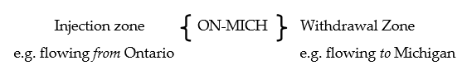
Owning this transmission right indicates that you anticipate the Michigan interties to be export congested, i.e., a higher energy price in the Michigan intertie zone than Ontario
Size
All transmission rights are sold in 1 megawatt (MW) increments: 1 TR = 1 MW on a given path.
Validity Period (Time Structure)
Transmission rights are sold as either long-term or short-term:
- Long-term rights: valid for all hours of all days for one year
- Short-term rights: valid for all hours of all days for one month

Pre-Auction

How do we determine the number of rights to auction?
The transmission rights market must be self-funding. The congestion rents collected due to real-time price differences must be sufficient to pay the transmission rights holders on the congested paths.
To avoid overselling on a path, the number of transmission rights available for each type of auction is based on the forecast transfer capability, reduced by a confidence level. The confidence level reflects anticipated conditions, equipment outages, and system security requirements.
The criteria we use to determine the available transmission rights for sale is different for long-term and short-term auctions, but both are based on the forecast total transfer capability of the interties.

Determining Transmission Transfer Capability (TTC)
The forecast TTC reflects the anticipated scheduling capacity of an intertie, which may be quite different for each direction (import and export) and season (winter and summer). TTC considers anticipated operating conditions, and it respects stability and voltage limits, equipment ratings, and operating practices.
- The published transfer capability normally reflects an ‘all elements in service’ condition – but it may be reduced for outages affecting a path for more than 2.5 or 30 days for short-term or long-term TR auctions, respectively.
- Impractical or emergency modes of operation are excluded from the Quebec intertie TTC calculations.
- For interties where the thermal limits are restrictive, there are different limits for summer (May 1– Oct 31) and winter (November 1 – April 30), which is shown below.
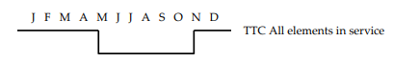

Determining TR Base Quantity
The TR base quantity is the maximum number of cumulative rights on a path available for long-term auctions. The base quantity of each path is determined as the minimum of the summer and winter Available Transfer Capability (ATC – which is the TTC reduced by a transmission reliability margin (TRM), so as to provide an additional safety measure when determining acceptable flows) with all elements in-service, de-rated for any expected long-term operational constraints on the path, and then dividing by a factor of 4 and rounded to the nearest multiplier of 4. For example, if a certain path’s minimum of the summer and winter ATC with all elements in-service, de-rated for any expected long-term operational constraints on the path, is 1500, then base quantity for this path is equal to 376 (1500 divided by a factor of 4 and rounded to the nearest multiplier of 4).

Determining Financial Upper Limit (FUL)
The financial upper limit for each path for each month determines the maximum number of TRs (combined long-term and short-term) that can be offered in the long-term and short-term auctions conducted for that month. It is calculated based on the net cumulative balance between the congestion rents and TR payouts on a per path basis.
The financial upper limit is adjusted to target a cumulative per path-based balance of zero (i.e. cumulative congestion rents collected on a specific path are sufficient to cover the cumulative TR payment obligations for the same path). Path-based adjustments to the financial upper limit will be made only when the cumulative difference between congestion rents and TR payments exceeds a specified dead-band for each path.
The financial upper limit for the upcoming month is equal to the minimum of the latest available summer and winter ATCs with all elements in-service, and the financial upper limit for the current month which is adjusted based on the following algorithm:
Table 1: Financial Upper Limit Adjustment Algorithm
Transmission Rights Clearing Account (TRCA) | Cumulative Difference between Congestion Rents Collected and TR Payments (by each TR path) | Impact on Monthly TRs (by TR path)
N/A | Between the upper and lower limits of the dead-band | No change
TRCA balance is greater than the TRCA threshold* | Exceeds upper limit of the dead-band (Congestion rent is greater than TR payout) | Increase financial  upper limit by 4%
TRCA balance is less than or equal to the TRCA threshold* | Exceeds upper limit of the dead-band (Congestion rent is greater than TR payout) | No change**
N/A | Less than lower limit of the dead-band (Congestion rent is less than TR payout) | Decrease financial  upper limit by 4%
* The Transmission Rights Clearing Account (TRCA) threshold is currently $20M
** Transmission Rights (TR) offered will not be increased when TRCA balance is below threshold

Dead-band
The objective of dead-band is to limit the number of manual interventions and it is to allow time for any adjustments to impact the financial balance before further adjustments are made. The dead-band can vary for each path and can be modified when a given path is not achieving a balance between congestion rents and TR payments.

Long-Term (LT) Rights
The number of transmission rights offered on each path at a long-term auction is limited to the lowest of the following:
- 25% of the established TR base quantity;
- The financial upper limit;
- Expected ATC with consideration for outages (single/multiple, internal/external, planned/foreseeable or concurrent/consecutive) that have an impact for more than 30 days;
- Expected ATC with consideration for non-tieline or operational constraints (for example, a constraint on an internal/external interface that imposes a limit on import/export).
The actual number of TRs available for bidding may further be reduced in order to ensure the TR base quantity and the financial upper limit are not exceeded when accounting for the TRs sold in previous three applicable long-term auctions

(refer to Figure 1 below).
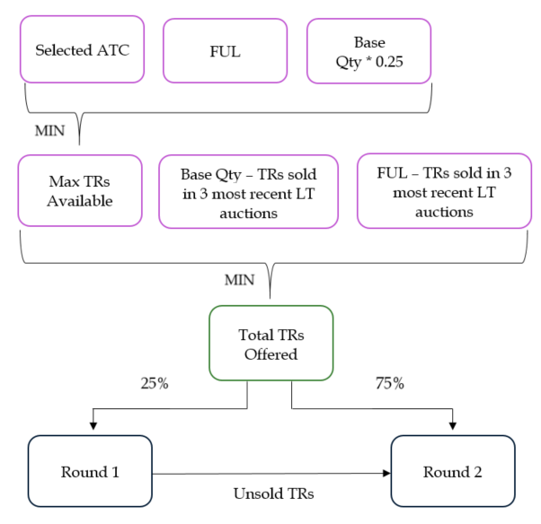
Figure 1: Determining TRs Offered for LT Auctions

Short-Term (ST) Rights
The number of transmission rights offered on each path at a short-term auction is limited to the lowest of the:
- The financial upper limit;
- Expected ATC with consideration for outages (single/multiple, internal/external, planned/ foreseeable or concurrent/consecutive) that have an impact for more than 2.5 days; or
- Expected ATC with consideration for non-tieline or operational constraints (for example, a constraint on an internal/external interface that imposes a limit on import/export).
Note: The actual number of TRs available for bidding may further be reduced in order to account for the TRs sold in previous four applicable long-term auctions.

Figure 2 below illustrates how the quantity of TRs offered are determined for ST auctions.
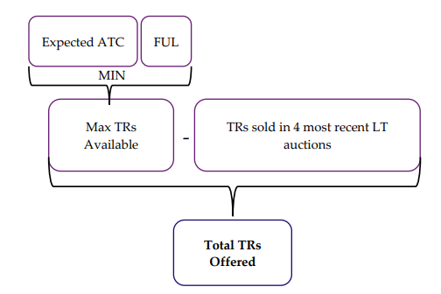
Figure 2: Determining TRs Offered for ST Auctions
Example: Assume there are no outages on the Michigan paths and the financial upper limit is at its maximum. The number of short-term rights available for the July auction equals:
- Unsold long-term (LT) rights from previous auctions covering July (up to the base amount)
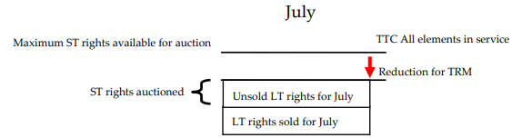

Transmission Rights Clearing Account
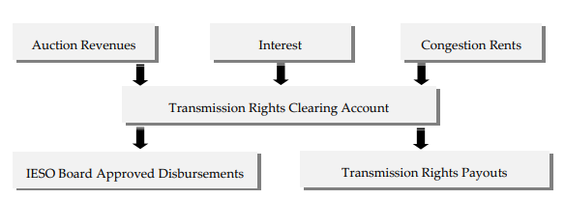
Figure 3: Transmission Rights Clearing Account
The Transmission Rights Clearing Account (TRCA) has a threshold set by the IESO Board ($20 million). We manage fluctuations in the account’s balance by adjusting the quantity of short-term transmission rights offered in the following quarter. To ensure that the congestion rents collected by the IESO are balanced against the IESO’s TR payment obligations for each path, a confidence level is established on a per path basis. This is achieved by introducing a financial upper limit for the number of TRs offered in any month for each path. The financial upper limit is adjusted from one month to the next based on the most current reported balance between the congestion rents and TR payouts on a per path basis and the applicable dead-band for each path.
Example 1: Assume that the TRCA currently stands at $10M. The latest financial data shows that the congestion rent collected for the MAN-ON TR path was $7,000 and the TR payout was $10,000. Since the TR payout is greater than congestion rent collected by $3,000, and assuming this amount is lower than the specified dead- band for MAN-ON TR path, therefore the FUL will decrease by 4% from the last auction. Note that the value of the TRCA does not matter in the case of a FUL decrease.
Example 2: In this case, assume that the TRCA currently stands at $40M. The latest financial data shows that the congestion rent collected for the ON-MICH TR path was $100,000 and the TR payout was $80,000. Since the TR payout is less than congestion rent collected, and if the amount is higher than the dead-band, therefore the FUL will increase by 4% from the last auction (ex. from 1000 MW to 1040 MW). However, FUL can never exceed the ATC value of a given TR path.
Example 3: Lastly, consider Example 2 but where the TRCA stands at $15M. In this case, even though the TR payout is less than congestion rent collected by $20,000, the Financial Upper Limit cannot be increased due to the TRCA being less than the threshold of $20M.

Auction Process

How do you access the transmission rights auction application?
The transmission rights auction (TRA) application is available in Online IESO.
To access the application you must first log on to the IESO Gateway. Please note that a TR participant will be prompted to change the IESO Gateway password every 90 days, upon logging in. The Applicant Representative of your organization will need to ensure that your account is configured correctly via Online IESO (https://online.ieso.ca). The Applicant Representative will need to assign the “Transmission Rights Auction” Access Role to your account (Online IESO -> Actions -> Manage System Access). If you need to reset your password, refer to the “IESO Gateway User Guide”.

Once you’ve logged in Gateway, select the Online IESO tile. To access the TRA application select the grid icon in the top right of the page the Online IESO home page and select the “Transmission Rights Auction” application. Participant specific reports can also be accessed, directly, or through a hyperlink in the TRA application, on the Reports website.
Detailed procedures on how to access the TRA application are found in the IESO Training publications’ “Transmission Auction System User Guide”.

How can you find TR auction timelines?
We publish the annual transmission rights calendar every fall, specifying the dates for the monthly (short-term rights) and quarterly (long-term rights) auction for the next year. The calendar also gives you other important dates in the auction process, such as when the bid window is open and when payment is due. The calendar is available on the Market Calendars web page.

Preparing to Bid
The TR market is a financial market, so participant creditworthiness is not managed using the physical market’s prudential requirements. Instead, you must post a market deposit in the form of cash or a letter of credit.
- We must receive your market deposit at least five (5) business days before an auction or you will receive a notice of revocation (Form 1374 – Notice of Revocation of Transmission Rights) and you will not be able to participate.
- Your bid limit is normally ten times your market deposit, e.g., you can bid for up to $50,000 of transmission rights if your deposit is $5,000. We may reduce this multiplier for participants who have previously defaulted. You can view your current bid limit through the TRA application just prior to an auction.

Pre-Auction Reports
Pre-auction reports are available on both our Public Reports website and via hyperlink to the same site from the TRA application. We publish the following information at least 30 days prior to each TR auction:
- Hourly prices determined on the basis of the last projected market price for energy published for that hour for each TR zone during the preceding twelve months;
- The TR market clearing price for each transmission right sold during any TR auctions conducted in the preceding eighteen months;
- Actual and scheduled hourly flows over each interconnection during the preceding twelve months;
- The hourly transmission transfer capability of each interconnection during the preceding twelve months; and
- Identification of any transmission transfer capability limits, parallel flow assumptions, outage IDs, and other applicable constraints that may limit the number of transmission rights that can be awarded in the TR auction, the operating assumptions established in respect of the TR auction pursuant to and forecasted amount of TRs available.

Bidding
- The bid window is open from 09:00 two days before the auction date until 17:00 on the day before the auction date (all times are EST).
- Your bid consists laminations which has three (3) elements: path, quantity, and price ($/MW).
- All bids are time-stamped and you may only have one bid per path at any time, (i.e. bids with a later time-stamp will overwrite earlier time-stamped bids).
- You can view, revise and delete your bids via the TRA application.
- You can submit one lamination up to 20 laminations, but at least one (1) lamination is required to submit a bid
- Bids are accepted in real-time after pressing the “submit” button.
- Laminations can be rejected in real-time, where you will be unable to submit the bid (the participant will need to adjust their bid/lamination to be able to submit), if any of the following conditions are met:
- The MW of the lamination quantity exceeds the maximum MW being offered;
- The lamination quantity is not a whole number zero, or a negative value;
- The lamination price exceeds two decimal points;
- Total cost of your highest lamination (price x quantity) exceeds your remaining bid limit;
- The lamination price is not greater than $0; or
- Laminations are not placed in monotonically increasing quantities with decreasing prices. This also prohibits duplicative laminations. For clarity, the first bid must be the lowest total quantity (each quantity will be representative of the total number of MWs/TRs that the participant is willing to purchase at the price), with the highest price (reflecting the maximum price they are willing to pay for TRs), with each subsequent bid lamination having a higher total quantity and lower price from the previous lamination.
Your bid limit is automatically adjusted throughout the auction after the submission of any bids and after Round 1 of a long term auction to reflect your available bid limit. The sum of your largest/max laminations (price x quantity) on each path must not exceed your bid limit. For short-term auctions this is applicable for the single round. For a long-term auction this is applicable for Round 1, and will be recalculated in Round 2 based on the value of rights awarded from the first round, and will use any of the largest/max laminations (price x quantity) to continue to subtract from this new bid limit for Round 2 of a long-term auction.

Long-Term Auctions
Long-term auctions occur quarterly, with approximately 25% of the annual total TR rights offered at each auction. Since these rights are valid for an entire year, each auction is done in two rounds to allow price discovery:
- The first round is for 25% of the total available for that auction.
- The second round is for the remaining 75%, in addition to any TRs that were unsold in the first round.
The transmission rights application and related reports refer to ‘round fractions’. A round fraction is the percent (in decimal form) of the rights being offered. So for Round 1 the round fraction is 0.25 and for Round 2 the round fraction is 1 (that is, 100% of the remaining rights).
Example:
Assume there are 800 MW of MICH-ON long-term rights available for the year:
- 200 MW are auctioned each quarter.
- At each auction, 50 MW (round fraction = .25) are offered in Round 1 and if all 50 MWs of TRs were sold in Round 1, the remaining 150 MW (round fraction = 1) are offered in Round 2.

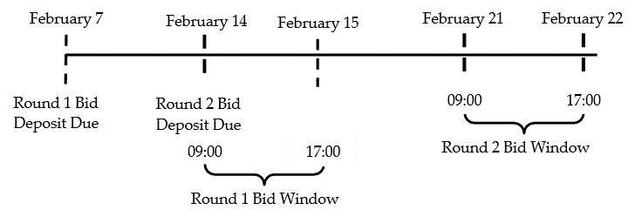
Figure 4: Examples of the Timelines for a February Long-Term Auction
Note that most participants post a large enough market deposit by the Round 1 deadline to meet their anticipated needs for both rounds of a long-term auction.

Short-Term Auctions
Short-term auctions occur monthly and the entire quantity available is offered in one round.
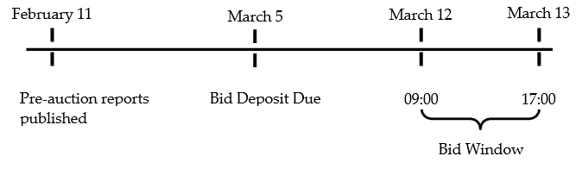
Figure 5: Example of the Timelines for a March Short-Term Auction

Treatment of Market Deposits during an Auction
Your bidding limit adjustment during an auction depends on whether it is in the form of a letter of credit or cash.

Letter of Credit Market Deposit
If your market deposit is a letter of credit, at the end of each auction we will reduce your market deposit by 10% of the value of rights awarded to you, until we receive payment.

Example
You enter a short-term auction with a letter of credit of $10,000. This means your bidding limit is $100,000.
If you successfully purchase $5,000 worth of TRs in this auction, your deposit is reduced by $500.00 to $9,500.00. Reducing the book value of your market deposit gives you a new bidding limit of $95,000 until you have paid the invoiced amount of $5,000.
We issue invoices six business days after the end of the trade week in which the awards are made. Until the invoice is issued and paid, the market deposit remains reduced.
Table 2 shows an example of the market deposit management process for letters of credit. Looking at the figures, you’ll notice that the letter of credit deposit is reduced by 10% of the award amount until an issued invoice is paid.
Table 2: Letter of Credit Management Deposit
 | Short- Term Auction | Market Deposit / Bid Limit Available Post- Auction | Six  Business Days After Trade Week | Two  Business Days After Invoice | Market Deposit / Bid Limit After Payment Received
Market Deposit | $10,000 | $9,500 |  |  | $10,000
Bid Limit | $10,000 | $95,000 |  |  | $100,000
Awards | $5,000
Book Value of Market Deposit Balance after 10% reduction for awards | $9,500
Invoice |  |  | $5,000
Payment |  |  |  | $5,000

Cash Deposits
We deal with cash deposits in a similar manner to letter of credit market deposits. However, at the end of the auction, we apply the deposit to the purchase price of the rights awarded, rather than holding it until an invoice is paid. Where the market deposit is not sufficient to cover the rights awards, the invoice shows the net amount still owing. Table 3 shows the treatment of the cash market deposit.
In the same example of a short-term auction with a starting deposit of $10,000 and an award of $5,000, the deposit is applied to the award. In this case, the resulting invoice shows a debit for the $5,000 and a credit for the same amount. You can elect to have any remaining cash deposit carry forward or be returned after auction. Use Form 1361 to indicate your preference.

Table 3: Cash Market Deposit
 | Short- Term Auction | Market Deposit / Bid Limit Available Post- Auction | Six  Business Days After Trade Week | Two  Business Days After Invoice | Market Deposit / Bid Limit After Payment Received
Market Deposit | $10,000 | $5,000 |  | $5,000 | $5,000
Bid Limit | $100,000 | $50,000 |  | $50,000 | $50,000
Awards | $5,000
Book Value of Market Deposit Balance after 10% reduction for awards | $5,000
Invoice |  |  | $5,000
Payment (Deposit Applied) |  |  | $5,000

Looking at the figures in the tables above, you’ll notice that the letter of credit deposit is reduced by 10% of the award amount until an issued invoice is paid. Contrast this to the cash situation in Table 4 where the entire award amount is deducted from the deposit at the end of the auction, reducing the bidding limit for the cash deposit below the bidding limit for the line of credit deposit.

If your initial market deposit was $10,000.75 cash and you are awarded $975.50 in an auction, you your market deposit will be reduced by the amount of your award, or $975.50, for the purposes of determining the bid limit for the next auction.
That is, you should expect the book value of your TR market deposit to become $10,000.75 minus $975.50 or $9,025.25 which provides a bidding limit of $90,252.50.

Contingencies
When a failure of a component of the TR hardware, software, or communications system has occurred, the IESO will declare that the TRA has experienced a contingency through a public advisory process via the IESO website that explains the cause of the delay (if known) and the expected duration. The IESO will notify all TR participants who are affected as soon as practicable of any TRA cancellation, and/or contingency procedures, revised timelines, and revised activity schedules which may be implemented.
Subsequently, the IESO may, for reasons of a failure in the TR bidder’s or the IESO’s software, hardware, or communication systems associated with a TR auction:
- Conduct a TRA using contingency procedures; or
- Conduct a TRA and related activities along timelines other than those specified in the market rules; or
- In the event that the IESO cannot conduct an effective TRA in a commercially reasonable manner using contingency procedures and/or modified timelines, cancel all or part of a TRA.
The IESO will notify all TR participants who are affected as soon as practicable of any TRA cancellation, and/or contingency procedures, revised timelines and revised activity schedules that the IESO intends to implement (the IESO must notify all TR participants before taking any of these steps). TR participants who wish to participate in a TRA being conducted under contingency procedures and/or revised timelines shall comply with any applicable contingency procedure, revised activity schedules, or revised timelines specified by the IESO. Depending upon the type of contingency (component failure or a fall-back to an alternate server), a TR participant may be requested to:
- Hold all bids;
- Submit bids through an alternative method; or
- Review and resubmit bids.
TR participants are responsible for risk assessment and preparation for contingencies on their side. This includes providing alternative communications pathways, Business Recovery Procedures (BRP) centres, etc.

Auction Results: Prices and Awards

Market Clearing Price
Rights are awarded according to the participant’s willingness to pay. Laminations are stacked, from highest to lowest price and the clearing price is based on marginal cost. The clearing price is the lamination value of the last transmission right (MW) awarded in that auction or round. All participants pay the clearing price for the TRs they are allocated and awarded up to their lamination amount (pending lamination was not tied at the market clearing price (MCP) and there are adequate TRs to accommodate the entire lamination).

Tie-breaking
Tie breaking could be required when two or more market participants have submitted the same lamination price that is equal to the corresponding MCP on a path and there are not enough TRs to satisfy all participants at the MCP.
There are multiple stages of tie breaking if required. For example the IESO will first award rights proportionally on their laminations at the MCP (this will be based on the full quantity if it’s the participants first lamination or the incremental value between their previous lamination and the one that is tied at the MCP if it’s a subsequent lamination), when two or more participants submit laminations at the same price and there are not enough TRs to satisfy all participants. Table 4 contains an example where participants there are 60 MWs of TRs remaining and four participants submit the same bid at $90.
Table 4: Tie-breaking Example
Available Rights | Participant | Lamination | Award
60 MW | A | 60 MW @ $90 | 60/120 X 60 = 30 MW
 | B | 30 MW @ $90 | 30/120 X 60 = 15 MW
 | C | 20 MW @ $90 | 20/120 X 60 = 10 MW
 | D | 10 MW @ $90 | 10/120 X 60 = 5 MW

If there are still TRs unallocated from the initial tiebreak then the IESO will use the highest remainders from the proportional calculation, highest lamination quantity (this will be based on the full quantity if it’s the participants first lamination or the incremental value between their previous lamination and the one that is tied at the MCP if it’s a participant’s subsequent lamination), and then earliest timestamp of the participant’s bid in order allocate those TRs. There could be situations where TRs are unallocated if it cannot be determined who should receive them from the tie-breaking. In situations where the last awarded TR was awarded at a higher priced lamination, then the MCP will be adjusted to that last awarded lamination.

Post-Auction Reports
There are two types of post-auction reports: public and participant-specific. Both are published within one business day of the auction (usually within one hour). Public reports are available on both our public website and via the TRA portal. Participant- specific reports are only available via the TRA portal.

Public Reports

TR Post Auction MCP
- The quantities sold and clearing price for each of the paths sold in that auction.

Participant-specific Reports

Auction Results
- Your bid price and quantity as well as the clearing price and quantity awarded to you for each path successfully bid upon. This report will indicate if you have no winning bids.

Bid History
- Your bid history over the last 18 months.

Settlement

TR Payout
Payment for TRs occurs when there is congestion on an intertie. This congestion is reflected in different prices in Ontario and an intertie zone. Payouts are always positive and you must hold the right that is in the same direction as the congestion to receive payment.
TR Payout = MAX(0, Price in Withdrawal Zone – Price in Injection Zone )
Assume the Michigan/Ontario interface is export congested:
- Participant A holds 100 TRs on the MICH – ON path
- Participant B holds 100 TRs on the ON – MICH path
- MICH intertie zone price is $60
- ON zone price is $50
Participant A does not receive any payout since their TR hedges import congestion
TR Payout = MAX(0,$50 - $60)
= 0

Participant B receives a payout since their TR hedges export congestion
TR Payout = MAX(0,$60 - $50)
Total Payout = $10 x 100
= $1,000

Note that most of the time the TR payout will equal the intertie congestion price (ICP) calculated in pre-dispatch. The exception to this is when either zone’s price is at the boundary of +MMCP or -MMCP. For example, if the ICP was $50 and the real-time Ontario price was $1960, the TR payout would be limited to $40, as the intertie zone price cannot exceed $2,000.

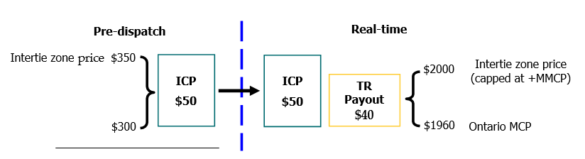
Figure 6: Example of the Timelines for a March Short-term Auction
For a complete outage to an intertie, ICP and TR payouts are set to zero. If the outage occurs partway through an hour, TR holders will receive a payout for the full hour in which the reduction in transmission transfer capability first occurs (provided there is an ICP). Also, during an administrative pricing event, TR payouts are based on the difference between the administered intertie zone price and the administered Ontario price, which may be different from the ICP created in pre-dispatch. (Refer to Quick Take 4: Administrative Pricing)

Statements and Invoices
Transmission rights use both the financial and physical market settlement processes:
- Payment for rights purchased in an auction are settled in the financial market.
- Payout to TR holders is settled in the physical market.
(For more information on the settlement process, refer to the Commercial Reconciliation workbook available on the Training Materials web pages).
Please note: You retrieve your statements and invoices from the IESO Reports site, if your Applicant Representative has provided you with the Settlement Data Viewer, Settlement, and/or Settlement Data and file Submitter contact role in your account.

The statements are published according the schedule shown on the Financial and Physical Market Settlement Schedule and Payment Calendars on the Market Calendars web page. The settlement timelines for each of the markets is shown in Table 5.
Table 5: Settlement Timelines
Item | Physical Markets | Financial Market
Preliminary settlement statements | Issued 10 business days after trading day | Issued two (2) business days after close of auction
Final settlement statements | Issued 10 business days after preliminary statement issued | Issued four (4) business days after preliminary statement issued
Invoices | Issued 10 business days after end of billing period | Issued six (6) business days after end of billing period
Payment due to IESO | Two (2) business days after invoice issued | Two (2) business days after invoice issued
Notice of disagreement | Six (6) business days after the preliminary, final or RCSS-1 to RCSS-6 settlement statements are issued | Two (2) business days after preliminary, final or RCSS-1 settlement statements are issued
Recalculated Settlement Statements (RCSS) 1 | Issued on the invoice date that occurs one (1) month after the trading day was first invoiced  (Optional) | Issued on the last business day of the month following the trade month  (Optional)
Recalculated Settlement Statements (RCSS) 2 | Issued on the invoice date that occurs two (2) months after the trading day was first invoiced  (Optional) | Not Applicable
Recalculated Settlement Statements (RCSS) 3 | Issued on the invoice date that occurs five (5) months after the trading day was first invoiced  (Optional) | Not Applicable
Recalculated Settlement Statements (RCSS) 4 | Issued on the invoice date that occurs eight (8) months after the trading day was first invoiced  (Optional) | Not Applicable
Recalculated Settlement Statements (RCSS) 5 | Issued on the invoice date that occurs 11 months after the trading day was first invoiced  (Optional) | Not Applicable
Recalculated Settlement Statements (RCSS) 6 | Issued on the invoice date that occurs 17 months after the trading day was first invoiced  (Optional) | Not Applicable
Recalculated Settlement Statements (RCSS) F, 7 | Issued on the invoice date that occurs 23 months after the trading day was first invoiced | Issued on the last business day of the month, 22 months after the trade month
Dispute resolution | For any statements prior to final recalculated settlement statement:  File within 20 business days of either:  (1) Issuance of the settlement statement containing the unsatisfactory NOD adjustment; or  (2) Receipt of a decision letter in the NOD application informing you that no adjustments will be made  For the final recalculated settlement statement:  No NOD can be filed. File the notice of dispute within 20 business days of issuance of the final recalculated settlement statement. | For any statements prior to final recalculated settlement statement:  File within 20 business days of either:  (1) Issuance of the settlement statement containing the unsatisfactory NOD adjustment; or  (2) Receipt of a decision letter in the NOD application informing you that no adjustments will be made  For the final recalculated settlement statement:  No NOD can be filed. File the notice of dispute within 20 business days of issuance of the final recalculated settlement statement.
Access to settlement statements and invoices | IESO confidential Reports site  https://reports.ieso.ca | IESO confidential Reports site  https://reports.ieso.ca

Participants who do not pay their TR invoice by the due date will lose their awarded rights and will receive a notice of revocation (Form 1374). We may also require them to use cash market deposits in the future or may reduce their bid limit from 10 times the deposit to something smaller. We do not award forfeited rights to the next highest bidder, but instead we sell them in a future auction.

Reassignment of Transmission Rights
TR holders may reassign their TRs to another registered participant subject to IESO verification. TR holders must submit the following forms to forwardmarkets@ieso.ca to initiate the process:
- FORM-84: Application for Recognition of the Assignment of Transmission Rights. With this form a TR holder can request that the IESO recognize, for settlement purposes, an assignment of the TR holder’s right to all settlement amounts to the Assignee (a TR Participant), and
- FORM-85: Agreement to Recognize the Assignment of Settlement Amounts Under a Transmission Right. With this forms the IESO recognizes, for settlement purposes, the assignment of the TR holder’s right to all settlement amounts under the assigned TR to the Assignee. Once this form is signed by the TR holder, the Assignee and the IESO, the Assignee is deemed to be the TR holder in respect of the settlement amounts under the assigned TR with effect from the billing period immediately following the effective date mentioned in the agreement.

Additional Information

References
- Market Rules, Chapter 8, Section 4: The Transmission Rights Market
- Market Manual 4.4 Transmission Rights Auction
- Transmission Rights Auction System - Market Participant User Guide (IMO_GDE_0004)
- IESO Gateway User Guide

Skill Check

Skill Check Questions
1. Which of the following statements are True?
- Short-term rights are valid for all hours of all days for one quarter of the year.
- Transmission rights are sold in 10 MW increments
- To avoid overselling a path, the number of transmission rights available for an auction is based upon the forecast transfer capability, reduced by a confidence level.
- We consider outages longer than one week when we derive the number of long-term transmission rights for auction

2. If your market deposit is $900, which of the following would be valid individual laminations?
  - 100 MW @ $100
  - 100 MW @ $0
  - 100 MW @ $80
  - 50 MW @ $80

3. If you own 100 MW of MICH-ON TRs, and the settlement prices are $100 in Ontario and $95 for the Michigan intertie zone, what is your TR payout?

4. If your market deposit is a letter of credit for $10,000 and you are awarded $5,000 of TRs, your new bid limit is $95,000. What would be your new bid limit if you had a cash deposit instead?

5. Which of the following statements is False?
a. 100% of ON-MICH TRs sold ≤ maximum ON-MICH TRs available
b. 25% of ON-MICH TRs sold + 75% of ON-NY TRs sold ≤ maximum ON-MICH TRs available
c. 100% of ON-NY TRs sold ≤ maximum ON-NY TRs available
d. 25% of ON-MICH TRs sold + 75% of ON-NY TRs sold ≤ maximum ON-NY TRs available

6. How many days after an auction is the invoice posted?
a. 6 days
b. 4 business days
- 6 business days
- 2 business days

7. If the cumulative balance for the MIN-ON path is -$428K, what would happen to the Financial Upper Limit (FUL) on this specific path for the next ST auction?
a. The FUL will increase by 4% because the TRCA balance is above threshold.
b. The FUL will decrease by 4% because the path’s cumulative balance is negative.
c. The FUL will decrease by 2% because the TRCA balance is below threshold.
d. The FUL will increase by 2% because the negative cumulative balance is less than the TRCA balance.

Skill Check Answers
1. Which of the following statements are True?
        - Short-term rights are valid for all hours of all days for one quarter of the year.
b. Transmission rights are sold in 10 MW increments
c. Answer: To avoid overselling a path, the number of transmission rights available for an auction is based upon the forecast transfer capability, reduced by a confidence level.
d. We consider outages longer than one week when we derive the number of long-term transmission rights for auction

2. If your market deposit is $900, which of the following would be valid individual laminations?
a. 100 MW @ $100
b. 100 MW @ $0
c. Answer: 100 MW @ $80
d. Answer: 50 MW @ $80

3. If you own 100 MW of MICH-ON TRs, and the settlement prices are $100 in Ontario and $95 for the Michigan intertie zone, what is your TR payout?
TR Payout = MAX( 0, Price in Withdrawal Zone – Price in Injection Zone )
= MAX(0,$100 - $95)
= $5 x 100
= $500

4. If your market deposit is a letter of credit for $10,000 and you are awarded $5,000 of TRs, your new bid limit is $9,500. What would be your new bid limit if you had a cash deposit instead?
Answer: $50,000

5. Which of the following statements is False?
              - 100% of ON-MICH TRs sold ≤ maximum ON-MICH TRs available
        - Answer: 25% of ON-MICH TRs sold + 75% of ON-NY TRs sold ≤ maximum ON-MICH TRs available
        - 100% of ON-NY TRs sold ≤ maximum ON-NY TRs available
d. 25% of ON-MICH TRs sold + 75% of ON-NY TRs sold ≤ maximum ON-NY TRs available

6. How many days after an auction is the invoice posted?
              - 6 days
              - 4 business days
c. Answer: 6 business days
d. 2 business days

7. If the cumulative balance for the MIN-ON path is -$428K, then what would happen to the Financial Upper Limit (FUL) on this specific path for the next ST auction?
- The FUL will increase by 4% because the TRCA balance is above threshold.
- Answer: The FUL will decrease by 4% because the path’s cumulative balance is negative.
- The FUL will decrease by 2% because the TRCA balance is below threshold.
- The FUL will increase by 2% because the negative cumulative balance is less than the TRCA balance.

Independent Electricity
System Operator
1600-120 Adelaide Street West
Toronto, Ontario M5H 1T1
Phone: 905.403.6900
Toll-free: 1.888.448.7777
E-mail: customer.relations@ieso.ca
ieso.ca
@IESO_Tweets
linkedin.com/company/IESO

Refer to the Interjurisdictional Energy Trading workbook and the Scheduling Limits and Intertie Prices quick take document on the IESO Training Materials webpage for more information about energy imports and exports.
In this workbook the terms ‘TR’ and ‘rights’ are used interchangeably to mean transmission rights.
‘We’, ‘us’ and ‘our’ mean the IESO. ‘You’ means the market participant.
The payment is the deposit on account being applied.
For more information on intertie pricing, refer to the Interjurisdictional Energy Trading workbook, available on the Marketplace Training web pages.

